COMPARATIVE STUDY OF OPTIMIZERS AND REGULARIZATION TECHNIQUES
Systematic evaluation of training choices using a fixed CNN on the Fashion-MNIST dataset
A Project Report Submitted in Partial Fulfilment of the Requirements for the
7th Semester Evaluation of B.Tech (Artificial intelligence & Machine Learning)
Subject: Deep Learning
Submitted by (Group – II)
Name | Roll No.
Gouri Nandana V | FET-BAML-2024-28-005
Irshita Yadav | FET-BAML-2024-28-006
Mohit Biswal | FET-BAML-2024-28-007
Oam Prakash Sharma | FET-BAML-2024-28-008

Guide / Trainer Name : Yugansh Varshney
Department of Engineering and Technology
Faculty of Sri Sri University
Academic Year : 2026 – 2027
DECLARATION
We, the undersigned members of Group-[II] (Semester [V], B.Tech Artificial Intelligence & Machine Learning), hereby declare that the project report entitled "Comparative Study of Optimizers and Regularization Techniques" submitted for the Deep Learning evaluation under the guidance of Yugansh Varshney is an original and authentic record of the work carried out by us. The matter presented in this report has not been submitted, in part or in full, to any other university, institute, or examining body for the award of any degree or diploma.
We further declare that all sources of information, ideas, algorithms, and datasets used in the preparation of this report have been duly acknowledged and cited in the References section, and that this work does not, to the best of our knowledge, infringe upon any existing copyright.
Team Members:
- Gouri Nandana V FET-BAML-2024-28-005
- Irshita Yadav FET-BAML-2024-28-006
- Mohit Biswal FET-BAML-2024-28-007
- Om Prakash Sharma FET-BAML-2024-28-008
Place: Sri Sri University
Date: 25-09-2026

ACKNOWLEDGEMENT
We take this opportunity to express our sincere gratitude to everyone who supported us throughout the completion of this project. We are deeply thankful to our Yugansh Varshney for his invaluable guidance, technical insights, and constant encouragement throughout this project.
We would also like to thank the faculty members of the Department of Artificial Intelligence & Machine Learning for providing us with the necessary academic support, computing resources, and a suitable environment for experimentation using TensorFlow and Google Colab.
Finally, we would like to acknowledge the effort and cooperation of every member of our team, whose collective contribution, discussions, and dedication made this project possible.

ABSTRACT
Training a convolutional neural network depends not only on its architecture but also on the optimizer, learning-rate schedule, and regularization strategy. The same CNN can show different training speed, validation performance, and generalization depending on these choices. This project therefore studies these training choices systematically on Fashion-MNIST while keeping the main CNN architecture fixed.
A fixed sequential CNN with two convolutional blocks, ReLU activations, max-pooling, a 128-unit dense layer, and a 10-class softmax output was used as the common architecture. SGD, SGD with momentum, RMSprop, and Adam were compared. Adam was then combined with step decay and cosine annealing, followed by individual and combined experiments using L2 regularization, Dropout, early stopping, and batch normalization.
Fashion-MNIST contains 60,000 training images and 10,000 test images of size 28×28 across 10 clothing classes. The project normalized pixel values to [0,1], added a channel dimension, and split the original training set into 48,000 training and 12,000 validation images. Each experiment used sparse categorical cross-entropy, batch size 64, a maximum of 20 epochs, and validation monitoring. The reported metrics were validation accuracy/loss, final training and validation accuracy, test accuracy/loss, and training time.
The best validation accuracy was 93.33% for L2 + Dropout + Batch Normalization, while the highest test accuracy was 92.79% for Dropout + Batch Normalization. The baseline SGD model achieved 88.60% test accuracy, so the best test configuration improved the observed test accuracy by 4.19 percentage points. The results show that regularization and normalization choices can materially affect generalization even when the CNN architecture is fixed.

TABLE OF CONTENTS
1. INTRODUCTION
1.1 Background
1.2 Motivation
1.3 Problem Statement
1.4 Objectives
1.5 Scope
2. LITERATURE REVIEW & EXISTING SYSTEM
2.1 Existing Methods
2.2 Deep-Learning-Based Approaches
2.3 Limitations of Existing Systems
2.4 Proposed Improvement
3. PROPOSED SYSTEM / METHODOLOGY
3.1 System Overview
3.2 Workflow
3.3 Dataset
3.4 Preprocessing
3.5 Algorithm / Model
4. SYSTEM DESIGN & IMPLEMENTATION
4.1 Architecture Details
4.2 Technologies Used
4.3 Implementation Steps
4.4 Important Code Snippet
5. EXPERIMENTAL SETUP & RESULTS
5.1 Dataset Details
5.2 Training Configuration
5.3 Evaluation Metrics
5.4 Results
6. RESULTS ANALYSIS & DISCUSSION
6.1 Confusion Matrix
6.2 Predictions and Output Quality
6.3 Comparison with Baseline
6.4 Observations
6.5 Strengths
6.6 Limitations
7. CONCLUSION, FUTURE SCOPE & REFERENCES
7.1 Conclusion
7.2 Future Scope
7.3 Limitations Recap
7.4 References

1. INTRODUCTION

1.1 Background
Convolutional neural networks (CNNs) are widely used for image classification because convolutional filters can learn spatial patterns such as edges, textures, and shapes. In practical deep-learning systems, however, the final performance is influenced by training choices in addition to the network architecture. Optimizers determine how model parameters are updated, learning-rate schedules control the step size during training, and regularization methods are intended to improve generalization.

1.2 Motivation
Fashion-MNIST provides a compact and reproducible image-classification benchmark for studying these effects. A controlled comparison is useful because changing the CNN architecture at the same time as the optimizer or regularization method would make it difficult to attribute performance differences to the training choice itself. This project therefore fixes one CNN architecture and changes the training strategy systematically.

1.3 Problem Statement
Fix a single CNN architecture on the Fashion-MNIST or CIFAR-10 dataset and systematically study how training choices affect performance. Compare SGD, SGD with momentum, RMSprop and Adam, along with learning-rate schedules such as step decay and cosine annealing. Then apply L2 regularization, Dropout, early stopping and batch normalisation individually and in combination. Produce training and validation curves for every experiment, diagnose underfitting and overfitting, and recommend the best configuration with justification. (Modules 3, 4)

1.4 Objectives
1. To implement a fixed Convolutional Neural Network (CNN) architecture for image classification using the Fashion-MNIST dataset.
2. To compare the performance of SGD, SGD with Momentum, RMSprop, and Adam optimizers under a controlled experimental setup.
3. To evaluate the effect of Step Decay and Cosine Annealing learning-rate schedules on CNN training.
4. To study the individual effects of L2 regularization, Dropout, Early Stopping, and Batch Normalization.
5. To evaluate selected combinations of regularization and normalization techniques and their effect on generalization.

1.5 Scope
This project focuses on comparing different optimizers, learning-rate schedules, and regularization techniques for a fixed CNN trained on the Fashion-MNIST dataset. The study includes SGD, SGD with Momentum, RMSprop, Adam, Step Decay, Cosine Annealing, L2 Regularization, Dropout, Early Stopping, and Batch Normalization.
The project evaluates training/validation performance, test accuracy, test loss, training time, and train-validation gaps. It is limited to one CNN architecture and Fashion-MNIST and does not include extensive hyperparameter tuning, transfer learning, data augmentation, or class-wise metrics such as precision, recall, and F1-score.

2. LITERATURE REVIEW & EXISTING SYSTEM

2.1 Existing Methods
Traditional image-classification systems often relied on hand-crafted features followed by classifiers such as k-nearest neighbours, support vector machines, or decision trees. Such pipelines require the designer to select or engineer useful image descriptors before classification. For a controlled CNN study, these methods serve mainly as background because the present project focuses on how training choices affect a learned feature extractor rather than comparing different classifier families.

2.2 Deep-Learning-Based Approaches
Deep learning introduced end-to-end feature learning for image classification. CNNs learn convolutional filters directly from labelled images, while optimizers such as SGD and Adam control parameter updates. Dropout was proposed as a method to reduce co-adaptation of units, L2 regularization adds a penalty on large weights, and batch normalization normalizes layer inputs during training. Learning-rate scheduling, including cosine-based schedules, changes the learning rate over the course of training. These techniques motivate the controlled experiments performed here.

2.3 Limitations of Existing Systems
- Changing the model architecture together with the training strategy can make it difficult to isolate the effect of an optimizer or regularizer.
- A single validation accuracy value does not fully describe generalization; training curves and held-out test results are also useful.
- Different regularization techniques can interact, so individual and combination experiments are needed to observe whether their effects complement one another.

2.4 Proposed Improvement
The proposed study addresses these limitations through a controlled experimental design: the same CNN structure, data preprocessing, loss function, batch size, and maximum epoch count are retained while optimizer, learning-rate schedule, and regularization/normalization settings are changed. This makes the resulting differences more directly attributable to the training choice under study. The project also records training/validation histories and evaluates every trained model on the same held-out test set.

3. PROPOSED SYSTEM / METHODOLOGY

3.1 System Overview
The complete pipeline begins with Fashion-MNIST loading, followed by normalization and channel-dimension expansion. The 60,000 training images are divided into 48,000 training and 12,000 validation images, while the official 10,000-image test set is kept separate. A fixed CNN is instantiated for each experiment, trained with the specified optimizer and optional callback/regularization settings, and then evaluated using validation and test metrics. Results from all 15 experiments are collected into data frames for comparison.

3.2 Workflow
1. Input: 28×28 grayscale Fashion-MNIST images with integer labels from 0 to 9.
2. Preprocessing: convert pixel values to float32, divide by 255.0, and add a single channel dimension to obtain tensors of shape 28×28×1.
3. Feature Extraction / Core Processing: two convolutional blocks (32 and 64 filters) with ReLU activations and 2×2 max-pooling learn spatial features; a Flatten layer and 128-unit dense layer perform classification processing.
4. Model / Decision Step: train the CNN using one of the specified optimizer/schedule/regularization configurations with sparse categorical cross-entropy and accuracy as the training metric.
5. Output: a 10-class softmax probability vector for each image; experiment-level outputs include validation accuracy/loss, test accuracy/loss, training accuracy, and training time.

3.3 Dataset
Fashion-MNIST contains 70,000 grayscale images in 10 fashion categories: 60,000 training images and 10,000 test images. Each image is 28×28 pixels. In this project, the 60,000 training images were split by index into 48,000 training images and 12,000 validation images; the 10,000 official test images were not used for training. The classes are T-shirt/top, Trouser, Pullover, Dress, Coat, Sandal, Shirt, Sneaker, Bag, and Ankle boot.

3.4 Preprocessing
- Pixel normalization: x = x / 255.0, converting the original 0–255 grayscale values to floating-point values in the [0,1] range.
- Channel expansion: the arrays were changed from (N, 28, 28) to (N, 28, 28, 1) so that they match the expected four-dimensional CNN input format.
- No data augmentation or feature engineering was used, so that the effect of the specified training choices could be studied without an additional source of variation.

3.5 Algorithm / Model
The common CNN is a Sequential model. The first convolutional layer uses 32 filters of size 3×3 with same padding and ReLU activation, followed by 2×2 max-pooling. The second convolutional layer uses 64 filters of size 3×3, again followed by 2×2 max-pooling. The feature maps are flattened and passed to a 128-unit ReLU dense layer and then a 10-unit softmax output layer. The baseline architecture contains 421,642 trainable parameters. Optional L2 penalties are attached to convolutional and dense kernels; Dropout with rate 0.5 is inserted after the dense layer; Batch Normalization is inserted after each convolution when enabled.

4. SYSTEM DESIGN & IMPLEMENTATION

4.1 Architecture Details
The main architecture is kept fixed across experiments. Only the optional L2 penalty, Dropout layer, Batch Normalization layers, optimizer, learning-rate schedule, and early-stopping callback are changed. This design isolates the training-choice effects while keeping the feature-extraction capacity comparable.
Stage | Layer Type | Output Size | Parameters
Stage 1 | Conv2D 3×3, 32 filters + ReLU | 28×28×32 | 320
Stage 2 | MaxPooling2D 2×2 | 14×14×32 | 0
Stage 3 | Conv2D 3×3, 64 filters + ReLU | 14×14×64 | 18,496
Stage 4 | MaxPooling2D 2×2 | 7×7×64 | 0
Stage 5 | Flatten | 3,136 | 0
Stage 6 | Dense 128 + ReLU | 128 | 401,536
Stage 7 | Dense 10 + Softmax | 10 | 1,290

4.2 Technologies Used
- Python with TensorFlow/Keras for model definition, training, callbacks, and evaluation.
- NumPy and Pandas for numerical processing and experiment-result tables.
- Matplotlib for sample-image display, training/validation curves, and comparison plots.
- Google Colab with Python 3 runtime. The recorded notebook run reported TensorFlow 2.20.0 and no detected GPU, so the experiments were executed on CPU.

4.3 Implementation Steps
1. Load Fashion-MNIST and define the ten class names.
2. Normalize image pixels and reshape the data for CNN input.
3. Implement the fixed CNN with optional L2, Dropout, and Batch Normalization controls.
4. Implement optimizer selection, learning-rate schedules, training callbacks, and a common training function.
5. Train the 15 specified configurations, record histories, and plot training/validation accuracy and loss curves for each experiment.
6. Evaluate every trained model on the held-out test set and compare validation accuracy, test accuracy, loss, training time, and train–validation gaps.

4.4 Important Code Snippet
Snippet 1 — Core Training Function
model = build_cnn(
l2_strength=l2_strength,
dropout_rate=dropout_rate,
use_batch_norm=use_batch_norm
)
model.compile(
optimizer=optimizer,
loss="sparse_categorical_crossentropy",
metrics=["accuracy"]
)
history = model.fit(
x_train, y_train,
validation_data=(x_val, y_val),
epochs=epochs,
batch_size=64,
callbacks=callbacks
)
Snippet 2 — Representative Experiment Configuration
result = train_experiment(
experiment_name,
optimizer_name="Adam",
learning_rate=0.001,
schedule="cosine",
l2_strength=0.0001,
dropout_rate=0.5,
use_batch_norm=True,
epochs=TOTAL_EPOCHS
)

5. EXPERIMENTAL SETUP & RESULTS

5.1 Dataset Details
The project uses the standard Fashion-MNIST split of 60,000 training images and 10,000 test images. From the 60,000 training images, the notebook uses the first 48,000 as the training set and the remaining 12,000 as validation data. Therefore, relative to the complete 70,000-image dataset, the working split is 68.57% training, 17.14% validation, and 14.29% test. No test image is used during training.

5.2 Training Configuration
Parameter | Value
Input Size | 28×28×1
Batch Size | 64
Optimizer | SGD / Momentum / RMSprop / Adam; Adam + Step Decay or Cosine Annealing
Loss Function | Sparse Categorical Cross-Entropy
Epochs | 20 maximum; Early Stopping may terminate earlier
Hardware | Google Colab CPU

5.3 Evaluation Metrics
Accuracy is used to measure the proportion of correctly classified images. Validation accuracy is used for model-comparison during development, while test accuracy measures performance on the held-out test set. Sparse categorical cross-entropy is the training/evaluation loss. Training time measures the wall-clock duration of each experiment. The train–validation accuracy gap is calculated as final training accuracy minus final validation accuracy and is used as a simple generalization-gap diagnostic.

5.4 Results
Model | Accuracy | Precision | Recall | F1-Score
Baseline - SGD (test) | 88.60% | Not computed | Not computed | Not computed
Dropout + Batch Normalization (test) | 92.79% | Not computed | Not computed | Not computed

Across the 15 experiments, the best validation accuracy was 93.33% for L2 + Dropout + Batch Normalization. The highest test accuracy was 92.79% for Dropout + Batch Normalization. The baseline SGD model achieved 88.60% test accuracy. The complete notebook also generated training-versus-validation accuracy and loss curves for each experiment, enabling visual inspection of convergence and generalization.
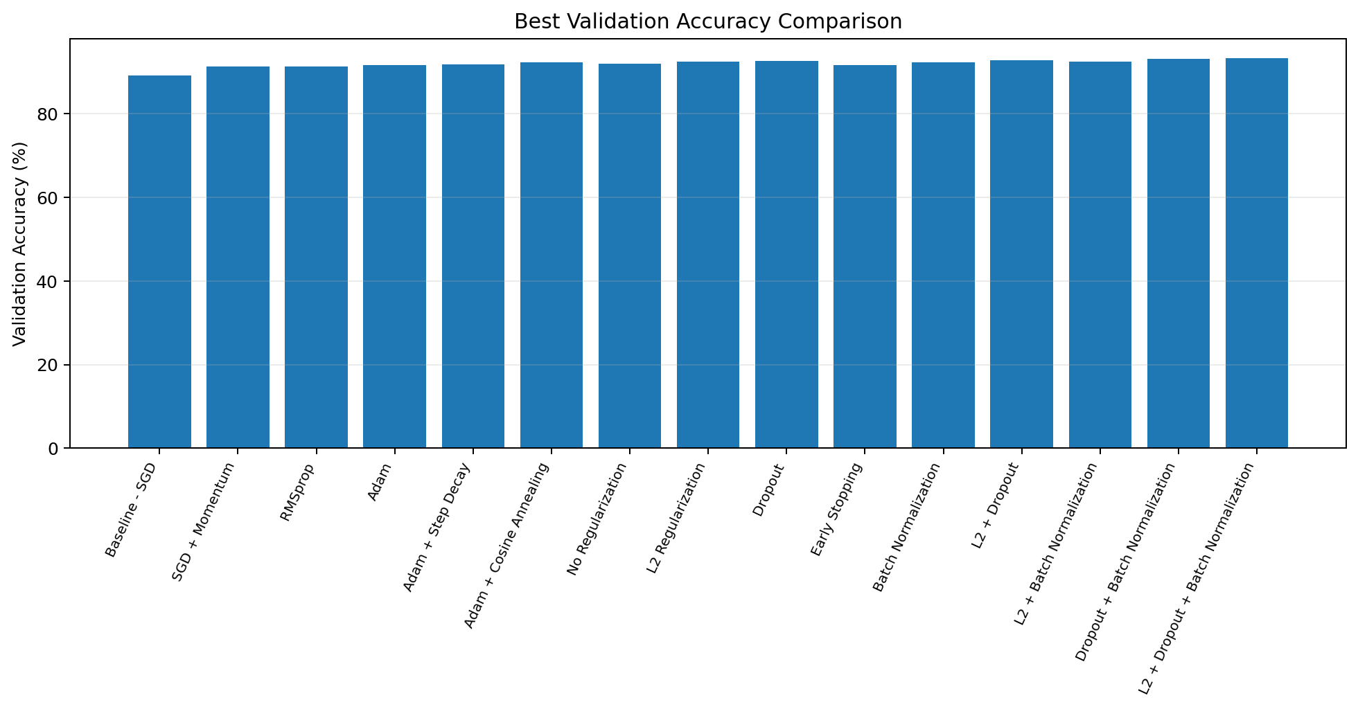
Figure: Best validation accuracy comparison across all 15 experiments.
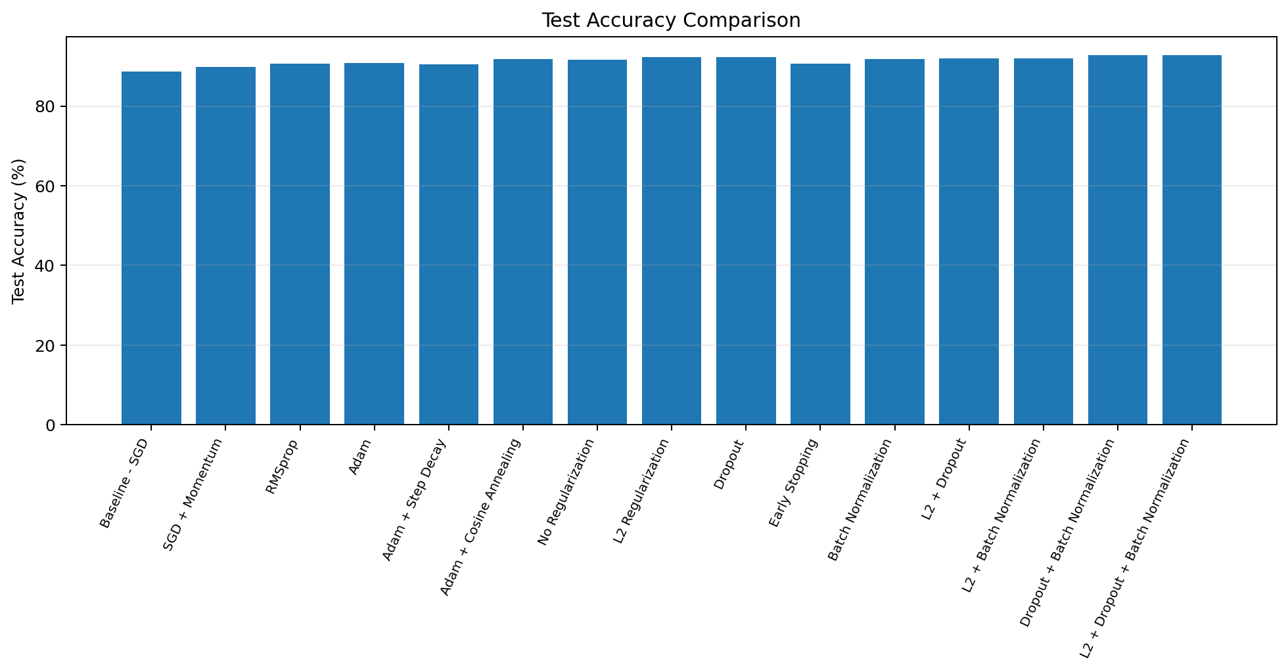
Figure: Test accuracy comparison across all 15 experiments.
Experiment |  | Test Loss |  | Test Accuracy
Baseline - SGD |  | 0.3200 |  | 88.60%
SGD + Momentum |  | 0.3845 |  | 89.90%
RMSprop |  | 0.6591 |  | 90.60%
Adam |  | 0.5103 |  | 90.85%
Adam + Step Decay |  | 0.5231 |  | 90.48%
Adam + Cosine Annealing |  | 0.3525 |  | 91.84%
No Regularization |  | 0.3557 |  | 91.66%
L2 Regularization |  | 0.3163 |  | 92.29%
Dropout |  | 0.2410 |  | 92.37%
Early Stopping |  | 0.2618 |  | 90.67%
Batch Normalization |  | 0.5228 |  | 91.87%
L2 + Dropout |  | 0.2917 |  | 92.02%
L2 + Batch Normalization |  | 0.4546 |  | 91.95%
Dropout + Batch Normalization |  | 0.2953 |  | 92.79%
L2 + Dropout + Batch Normalization |  | 0.3279 |  | 92.73%
Experiment | Best Val. Acc. | Best Val. Loss | Final Train Acc. | Final Val. Acc. | Time (s)
Baseline - SGD | 89.23% | 0.3009 | 89.91% | 89.23% | 1416.52
SGD + Momentum | 91.36% | 0.2578 | 97.25% | 89.92% | 1299.90
RMSprop | 91.32% | 0.2393 | 99.13% | 91.03% | 1310.52
Adam | 91.63% | 0.2431 | 98.94% | 91.22% | 1227.88
Adam + Step Decay | 91.82% | 0.2430 | 99.82% | 91.13% | 1321.77
Adam + Cosine Annealing | 92.34% | 0.2454 | 99.39% | 92.33% | 1324.62
No Regularization | 92.08% | 0.2461 | 99.44% | 92.08% | 1433.49
L2 Regularization | 92.42% | 0.2961 | 98.69% | 92.35% | 1327.30
Dropout | 92.68% | 0.2142 | 95.85% | 92.67% | 1466.87
Early Stopping | 91.60% | 0.2413 | 96.70% | 91.47% | 623.02
Batch Normalization | 92.40% | 0.2404 | 100.00% | 92.37% | 1523.38
L2 + Dropout | 92.82% | 0.2630 | 95.60% | 92.73% | 1331.55
L2 + Batch Normalization | 92.56% | 0.3088 | 100.00% | 92.56% | 1561.31
Dropout + Batch Normalization | 93.24% | 0.2262 | 97.40% | 93.16% | 1550.88
L2 + Dropout + Batch Normalization | 93.33% | 0.2778 | 97.82% | 93.33% | 1550.81

6. RESULTS ANALYSIS & DISCUSSION

6.1 Confusion Matrix
Confusion Matrix | Status | Evidence
Class-wise matrix | Not generated | The notebook reports aggregate test loss/accuracy only.
Highest-test configuration | 92.79% accuracy | Dropout + Batch Normalization on 10,000 test images.

The current notebook does not compute or display a confusion matrix, so class-wise error counts cannot be reported from the recorded results. The aggregate test evaluation reports 10,000 held-out test images and produces test loss and test accuracy for each experiment. For the highest-test-accuracy configuration, Dropout + Batch Normalization, the recorded test accuracy is 92.79% with test loss 0.2953.
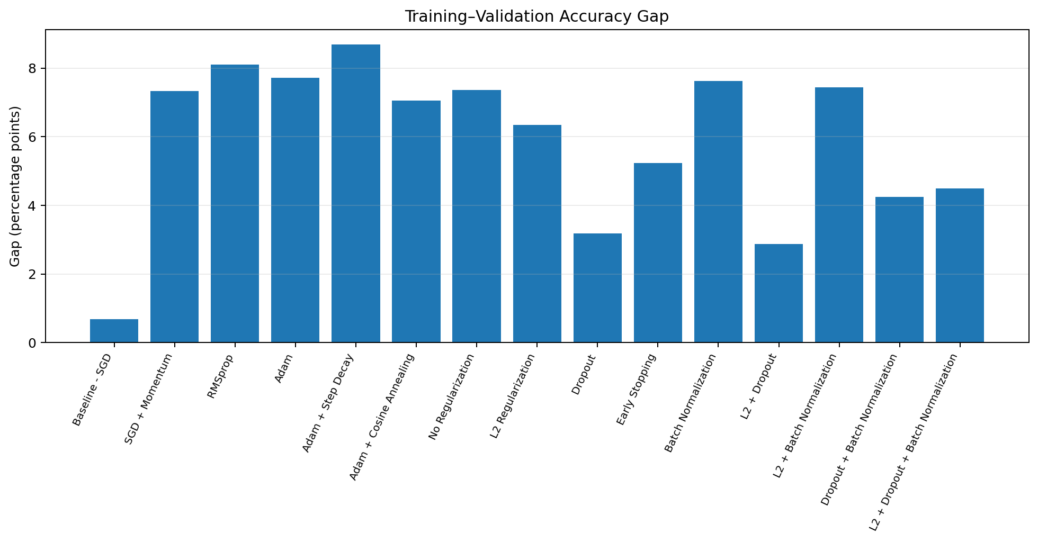
Figure: Final training–validation accuracy gap across experiments.

6.2 Predictions and Output Quality
The notebook does not save a per-image prediction analysis or class-wise precision/recall/F1 table. Therefore, this report does not claim a class-specific strength or weakness. The available evidence is aggregate accuracy/loss and the training/validation histories generated during the experiments.

6.3 Comparison with Baseline
Relative to the baseline SGD configuration, the highest test accuracy increased from 88.60% to 92.79%, an absolute improvement of 4.19 percentage points. The best validation accuracy increased from 89.23% for the baseline to 93.33% for L2 + Dropout + Batch Normalization, an absolute improvement of 4.10 percentage points. The results suggest that adding regularization and normalization can improve generalization, although the best validation and best test configurations were not identical.

6.4 Observations
- Optimizer comparison: the best validation accuracy among the four optimizer-only configurations was Adam at 91.63%, while the baseline SGD recorded 89.23%. SGD + Momentum and RMSprop also improved validation accuracy relative to baseline.
- Learning-rate schedules: Adam + Cosine Annealing achieved 92.34% best validation accuracy and 91.84% test accuracy, while Adam + Step Decay achieved 91.82% best validation accuracy and 90.48% test accuracy in this run.
- Regularization: Dropout reduced the final train–validation gap to 3.18 percentage points, while L2 + Dropout produced a 2.86-point gap. The combined Dropout + Batch Normalization and L2 + Dropout + Batch Normalization configurations produced the highest test/validation accuracies.
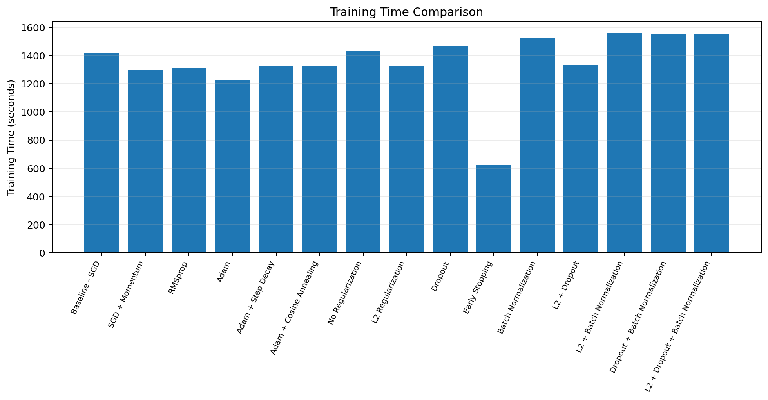
Figure: Recorded training time for each experiment.

6.5 Strengths
- Controlled comparison: the main CNN architecture, preprocessing, batch size, loss, and maximum epoch count were held constant across experiments.
- Broad coverage: the study evaluates optimizer choice, learning-rate scheduling, individual regularization/normalization methods, and combinations.
- Reproducibility: a fixed random seed of 42 and a common training function were used, and the validation/test results were exported to CSV files.

6.6 Limitations
- The experiments were run on CPU in the recorded notebook, resulting in long training times; the reported timings are specific to that execution environment.
- The notebook uses a single fixed CNN and a single set of hyperparameters for each method; broader hyperparameter search could change the relative results.
- The current analysis does not include confusion matrices or class-wise precision, recall, and F1-score, so conclusions about class-specific errors are outside the available evidence.

7. CONCLUSION, FUTURE SCOPE & REFERENCES

7.1 Conclusion
This project presented a comparative study of optimizers, learning-rate schedules, and regularization techniques for training a Convolutional Neural Network on the Fashion-MNIST dataset. A fixed CNN architecture was used throughout the experiments so that the observed performance differences could be associated with changes in the training and regularization strategies rather than changes in model architecture.
The study evaluated SGD, SGD with Momentum, RMSprop, and Adam, along with Step Decay and Cosine Annealing learning-rate schedules. L2 regularization, Dropout, Early Stopping, and Batch Normalization were also evaluated individually and in selected combinations.
The baseline SGD configuration achieved a test accuracy of 88.60%. Among the experiments, Dropout + Batch Normalization achieved the highest test accuracy of 92.79%, representing an improvement of 4.19 percentage points over the baseline. L2 + Dropout + Batch Normalization achieved the highest validation accuracy of 93.33%. These two results are reported separately because validation performance and held-out test performance are different evaluation stages.
Overall, the results show that optimizer choice, learning-rate scheduling, and regularization strategy can affect CNN training and generalization. For the recorded experimental setup, Dropout + Batch Normalization produced the highest held-out test accuracy. The conclusions are specific to the Fashion-MNIST dataset, the fixed CNN architecture, and the hyperparameters used in this controlled run.

7.2 Future Scope
1. Extend the hyperparameter study to different learning rates, Dropout rates, L2 strengths, batch sizes, and additional learning-rate scheduling strategies.
2. Evaluate additional CNN architectures and deeper networks to study whether the observed effects remain consistent across model capacities.
3. Add confusion matrices and class-wise precision, recall, and F1-score for more detailed analysis of classification errors.
4. Compare the same methodology on CIFAR-10, CIFAR-100, or another more challenging image-classification dataset.
5. Investigate data augmentation, weight decay, learning-rate warm-up, and other regularization strategies.
6. Explore model optimization and deployment as a lightweight image-classification application.

7.3 Limitations Recap
The study is limited to the Fashion-MNIST dataset and one fixed CNN architecture. The experiments use a predefined set of hyperparameters for each configuration rather than an exhaustive hyperparameter search. The recorded notebook was executed on CPU, so training times are specific to that environment. The current implementation primarily evaluates accuracy, loss, training time, and train-validation gaps; class-wise precision, recall, F1-score, and a confusion matrix were not computed. In addition, the experiments use a single random seed, so the results should be interpreted as observations from this controlled run rather than universal rankings of optimizers or regularization methods.

7.4 References
[1] Han Xiao, Kashif Rasul, Roland Vollgraf, “Fashion-MNIST: a Novel Image Dataset for Benchmarking Machine Learning Algorithms,” arXiv:1708.07747, 2017.
[2] Diederik P. Kingma, Jimmy Ba, “Adam: A Method for Stochastic Optimization,” arXiv:1412.6980, 2014.
[3] Nitish Srivastava, Geoffrey Hinton, Alex Krizhevsky, Ilya Sutskever, Ruslan Salakhutdinov, “Dropout: A Simple Way to Prevent Neural Networks from Overfitting,” Journal of Machine Learning Research, 15, 1929–1958, 2014.

