This a library for the CC1101 radio module.

Datasheet: <http://www.ti.com/lit/ds/symlink/cc1101.pdf>

It has been tested with these low cost 433 MHZ modules found on ebay and many other places.

[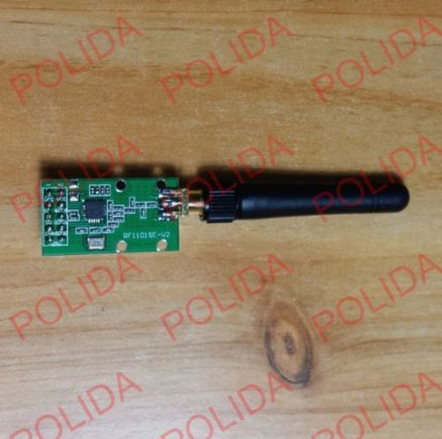](javascript:;)[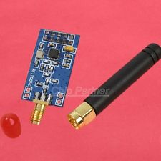](http://www.ebay.com/itm/CC1101-Wireless-RF-Transceiver-315-433-868-915MHZ-SMA-Antenna-Wireless-Module-/400795786377?hash=item5d514a5c89:g:Y6oAAOSwVL1WFTKx)

There a many different CC1101 boards and not all will work together. I have 7 different versions. All with 2*5 pins. All my green boards work great together and all my blue boards work well together. But I am often not able to get the green and blue boards to work together. This is not very scientific and may be a coincidence. I prefer the green type boards becourse they are smaller, have mounting holes and the antenna is not placed in middle.

Many boards don’t have silkscreen. On all my boards the pin layout is like this.

**VCC**

**VCC**

**GND**

**GND**

**GDO1**

**SCK**

**GDO0**

**MOSI**

**MISO**

**CSN**

Top view

(solder side)

The library works on Particle Photon, Arduino Uno, Arduino Mini, Arduino Mega and Arduino Due. When using with Arduino Mega, level shifting is needed, but is properly best on all 5v boards, though I only experienced problems with the Mega board.

For 5v, I used this different level shifter modules , but like the TXB0108 chip, ex. this board:

[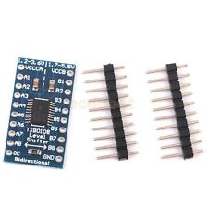](http://www.ebay.com/itm/Bi-Directional-Level-Shifter-Logic-Level-Converter-8-Channel-for-Arduino-DIY-/141670629695?hash=item20fc3a413f:g:moIAAOSweW5VWvWb)

**The CC1101Radio library:**

The CC1101 low level part of the library is more or less copied from panStamps CC1101 library. I have merged it into 2 files (.h & . CPP), changed the SPI parts, removed the eeprom stuff and implemented a simple form of message protocol.

**SPI & GDO**

The library can use standard pins for SPI Slave Select pin and the GDO/interrupt pin. You can overwrite this in the constructor event.

Se standard setup in CC1101Radio.h.

Example:

#include CC1101Radio

CC1101Radio radio(); // use the standard pins

CC1101Radio radio(x,y); // use pin x for SPI Slave Select and y for interrupt pin