部门表

DEPTNO部门编号

DNAME部门名称

LOC 部门地址

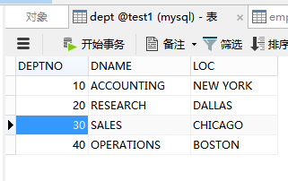

员工表

EMPNO员工编号

ENAME员工姓名

JOB 员工工作

MGR员工直属领导编号

HIREDATE入职时间

SAL 工资

COMM奖金

DEPTNO对应dept表的外键

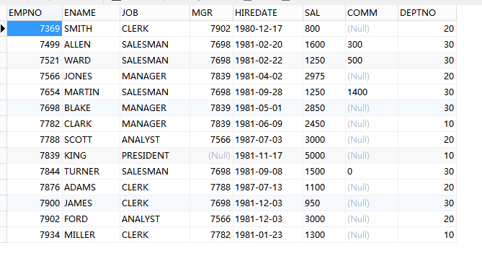

1. 查询奖金多于基本工资60%的员工信息。

|  |
| --- |
| SELECT * FROM EMP WHERE EMP.COMM > EMP.SAL * 0.6 |

1. 找到名字长度为6个字符的员工信息。

|  |
| --- |
| SELECT * FROM EMP WHERE LENGTH(EMP.ENAME) = 6 |

1. 名字中不包含R字符的员工信息。

|  |
| --- |
| SELECT * FROM EMP WHERE locate('R',EMP.ENAME) = 0; |

1. 返回雇员的雇佣日期早于其经理雇佣日期的员工及其经理姓名。

|  |
| --- |
| SELECT  A.ENAME AS 'EMPLOYEE',  B.ENAME AS 'MANAGER_NAME' ,  B.DEPTNO AS 'DEPTNO'  FROM EMP A,EMP B  WHERE  A.HIREDATE < B.HIREDATE  AND  B.JOB = 'MANAGER'  AND  A.DEPTNO = B.DEPTNO |

1. 返回部门号、部门名、部门所在位置及其每个部门的员工总数

|  |
| --- |
| SELECT  DEPT.DEPTNO,  DEPT.DNAME,  DEPT.LOC,  COUNT( EMP.ENAME ) AS '人数'  FROM  EMP,  DEPT  WHERE  EMP.DEPTNO = DEPT.DEPTNO  GROUP BY  DEPT.DEPTNO |

1. 计算出员工的年薪，并且以年薪排序

|  |
| --- |
| SELECT  ENAME,  EMP.SAL * 12 AS 'SALARY'  FROM  EMP  ORDER BY  EMP.SAL * 12 DESC |