THINK CHAMP PVT LTD
Internship Mini Project
AI Chatbot Web Application

Project Report


SUBMITTED TO:
THE CEO OF THINKCHAMP Pvt.Lmt
GURU LOKESH SIR

SUBMITTED BY:
GNANA PRASHANTH

Table of Contents

No. | Chapter Title | Page No.
1 | Introduction | 3
2 | History of the Project | 4
3 | Requirements | 5
4 | Objectives | 6
5 | Project Description | 7
6 | Source Code | 8
7 | Screenshots / Output | 10
8 | Conclusion | 12

1. Introduction

The AI Chatbot Web Application is an internship mini project developed as part of the Think Champ PVT LTD internship program. The project demonstrates the integration of web technologies with basic Artificial Intelligence and Machine Learning concepts to create an interactive, browser-based chat assistant.

In today's digital era, chatbots have become one of the most widely used AI applications. From customer service to education, chatbots help automate conversations and provide instant responses. This project simulates that experience in a simple, beginner-friendly manner using Python and Flask as the backend and HTML, CSS, and JavaScript for the frontend.

1.1 What is an AI Chatbot?
An AI Chatbot is a software application that can simulate a conversation with human users. It accepts text input, processes it using predefined logic or machine learning models, and generates appropriate responses. The chatbot in this project uses a pattern-matching approach powered by a JSON-based knowledge base.

1.2 Project Overview
- Platform: Web Browser (localhost via Flask)
- Backend: Python with Flask framework
- Frontend: HTML5, CSS3, Vanilla JavaScript
- AI Logic: NLP-based pattern matching with weighted scoring
- Knowledge Base: JSON file with 11 topic categories

2. History of the Project

The concept of chatbots has evolved significantly over the past six decades. Understanding this history provides context for why this project was built and how modern chatbots differ from their predecessors.

2.1 Evolution of Chatbots
Year | Milestone | Description
1966 | ELIZA | First chatbot by MIT, simulated a psychotherapist using pattern matching
1972 | PARRY | Simulated a paranoid patient; first to pass a form of Turing Test
1995 | A.L.I.C.E. | Used AIML (Artificial Intelligence Markup Language) for richer conversations
2011 | Siri / Watson | Apple and IBM introduced commercial AI assistants
2016 | Chatbot Boom | Facebook Messenger bots, Microsoft Bot Framework launched
2022+ | LLM Era | ChatGPT and large language models revolutionized conversational AI

2.2 About This Project
This project was developed during the Think Champ PVT LTD internship program. The goal was to build a functional AI chatbot from scratch using foundational web and Python skills, without relying on external AI APIs. The project started with basic HTML/Flask integration, then expanded to include NLP-style pattern matching, a dynamic frontend, and an attractive UI design.

The development followed these phases:
- Phase 1 – Project planning and folder structure setup
- Phase 2 – Building the Flask backend and JSON knowledge base
- Phase 3 – Implementing NLP pattern-matching logic in chatbot.py
- Phase 4 – Designing the frontend with chat bubbles and animations
- Phase 5 – Testing, debugging, and pushing to GitHub

3. Requirements

3.1 Software Requirements
Software | Version | Purpose
Python | 3.8 or above | Core programming language
Flask | 2.x or above | Web framework / backend server
VS Code | Latest | Code editor / IDE
Git | Latest | Version control
GitHub | Cloud | Remote repository hosting
Google Chrome / Edge | Latest | Run and test the web app
pip | Latest | Python package manager

3.2 Hardware Requirements
Component | Minimum Specification
Processor | Intel Core i3 or equivalent
RAM | 4 GB or above
Storage | 500 MB free space
Operating System | Windows 10 / macOS / Linux
Internet | Required for GitHub and Google Fonts
Display | 1024 x 768 resolution or higher

3.3 Python Libraries Used
- flask — Web server and routing
- json — Reading the responses.json knowledge base
- random — Selecting random responses from matched category
- re — Regular expressions for NLP text preprocessing
- os — File path handling for cross-platform compatibility

4. Objectives

The primary objective of this project is to develop a fully functional AI-powered chatbot web application using Python, Flask, and basic Machine Learning concepts. The application should run in a web browser and provide an interactive, user-friendly chat experience.

4.1 Primary Objectives
- Build a web-based chat interface that users can access through any browser
- Accept user text messages and generate intelligent, context-aware responses
- Implement NLP-style pattern matching to identify the topic of each user message
- Connect the HTML/CSS/JS frontend with the Python Flask backend via REST API
- Display conversation dynamically without page reload using JavaScript fetch API
- Handle multiple user queries accurately across 11 different topic categories

4.2 Secondary Objectives
- Design an attractive, modern UI with dark theme and smooth animations
- Include suggestion chips for quick-access common questions
- Show a typing animation to simulate real chatbot behavior
- Make the application responsive and mobile-friendly
- Maintain clean, well-documented, and modular code structure
- Push the complete project to GitHub with proper folder structure

4.3 Learning Objectives
- Understand Flask routing and REST API design (POST /chat endpoint)
- Learn how NLP preprocessing works — lowercasing, punctuation removal, tokenization
- Practice weighted scoring for pattern matching in ML-style classification
- Gain experience with frontend-backend integration using JSON and fetch()
- Develop version control skills using Git and GitHub

5. Project Description

5.1 System Architecture
The application follows a classic client-server architecture with three main layers:

Layer | Technology | Role
Presentation | HTML, CSS, JavaScript | Chat UI, input handling, dynamic display
Application | Python Flask | API routing, request/response handling
Logic / Data | chatbot.py + responses.json | NLP matching, knowledge base

5.2 How It Works (Flow)
- Step 1 — User types a message and clicks Send (or presses Enter)
- Step 2 — JavaScript sends a POST request to /chat with { message: '...' }
- Step 3 — Flask receives the request and calls get_response() in chatbot.py
- Step 4 — chatbot.py preprocesses input (lowercase, remove punctuation)
- Step 5 — Pattern matching scores each category; longer patterns score higher
- Step 6 — Best matching category's response is randomly selected
- Step 7 — Flask returns JSON { response: '...' } to the browser
- Step 8 — JavaScript displays the response as a chat bubble with animation

5.3 Project Folder Structure
AI_Chatbot/
├── app.py # Flask backend
├── chatbot.py # NLP pattern matching logic
├── responses.json # Knowledge base (11 topics)
├── templates/
│ └── index.html # Chat interface
├── static/
│ └── style.css # Dark theme styling
└── README.md # Project documentation

5.4 Key Features
- Welcome message on page load
- Real-time chat with typing animation
- Suggestion chips for quick queries
- 11 topic categories: Greetings, ML, AI, Deep Learning, Python, Data Science, NLP, Flask, Chatbot, Thanks, Farewell
- Fallback default response for unknown queries
- Fully responsive design for mobile and desktop

6. Source Code

6.1 app.py — Flask Backend
from flask import Flask, render_template, request, jsonify
from chatbot import get_response

app = Flask(__name__)

@app.route('/')
def index():
return render_template('index.html')

@app.route('/chat', methods=['POST'])
def chat():
data = request.get_json()
if not data or 'message' not in data:
return jsonify({'error': 'No message provided'}), 400
user_message = data['message'].strip()
if not user_message:
return jsonify({'error': 'Empty message'}), 400
bot_reply = get_response(user_message)
return jsonify({'response': bot_reply})

if __name__ == '__main__':
app.run(debug=True)

6.2 chatbot.py — NLP Logic
import json, random, re, os

BASE_DIR = os.path.dirname(os.path.abspath(__file__))
with open(os.path.join(BASE_DIR, 'responses.json'), 'r') as f:
RESPONSES = json.load(f)

def preprocess(text):
text = text.lower().strip()
return re.sub(r'[^\w\s]', '', text)

def pattern_matches(pattern, cleaned_text):
if ' ' in pattern:
return pattern in cleaned_text
elif len(pattern) <= 2:
return bool(re.search(r'\b' + re.escape(pattern) + r'\b', cleaned_text))
else:
return pattern in cleaned_text

def get_response(user_message):
cleaned = preprocess(user_message)
best_category, best_score = None, 0
for category, data in RESPONSES.items():
if category == 'default': continue
score = sum(1 + p.count(' ') for p in data.get('patterns', [])
if pattern_matches(p, cleaned))
if score > best_score:
best_score = score
best_category = category
if best_category and best_score > 0:
return random.choice(RESPONSES[best_category]['responses'])
return random.choice(RESPONSES['default']['responses'])

6.3 responses.json — Knowledge Base (sample)
{
"greetings": {
"patterns": ["hello", "hi", "hey", "good morning"],
"responses": ["Hi! How can I help you today?", "Hello! What can I do for you?"]
},
"machine_learning": {
"patterns": ["machine learning", "what is ml", "ml"],
"responses": ["Machine Learning is a branch of AI that allows systems
to learn from data and improve over time."]
},
"default": {
"responses": ["I am not sure I understand. Try asking about AI or ML!"]
}
}

7. Screenshots / Output

The following section shows the expected output of the AI Chatbot Web Application when run locally using Flask.

7.1 Sample Conversation Output
User Input | Bot Response
Hello | Hi! How can I help you today?
What is Machine Learning? | Machine Learning is a branch of AI that allows systems to learn from data and improve over time.
What is NLP? | NLP powers chatbots, translation, sentiment analysis, and more!
Tell me about Python | Python is a popular high-level programming language widely used in AI, Data Science, and web development.
Who are you? | I'm an AI Chatbot built with Python and Flask!
Bye | Goodbye! Have a great day.

7.2 Application Features Visible in UI
- Dark violet-themed chat interface with 'Assistant - Online' status indicator
- Bot messages appear on the left with robot avatar
- User messages appear on the right with user avatar
- Typing animation (three bouncing dots) shown before each bot reply
- Suggestion chips at the bottom: What is ML?, Python, Deep Learning, Data Science, NLP
- Input box with send button — supports both click and Enter key

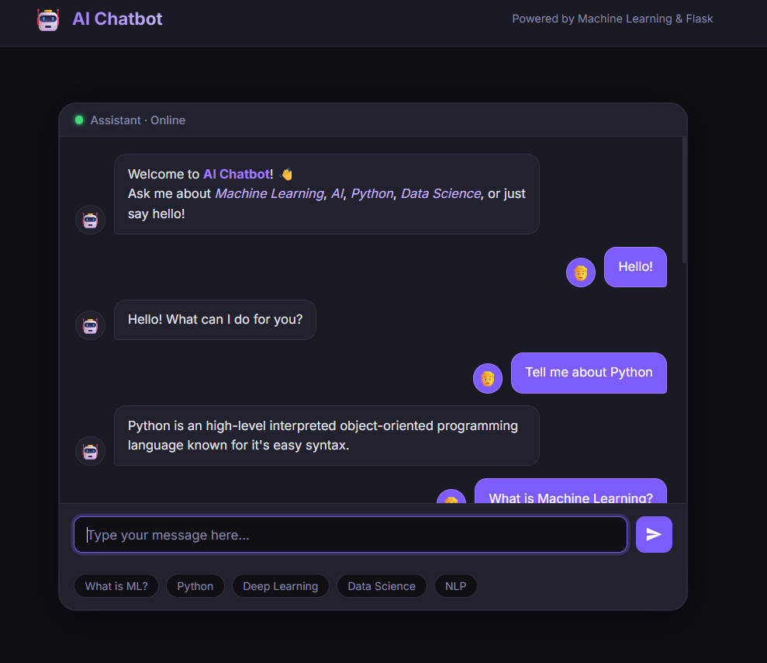
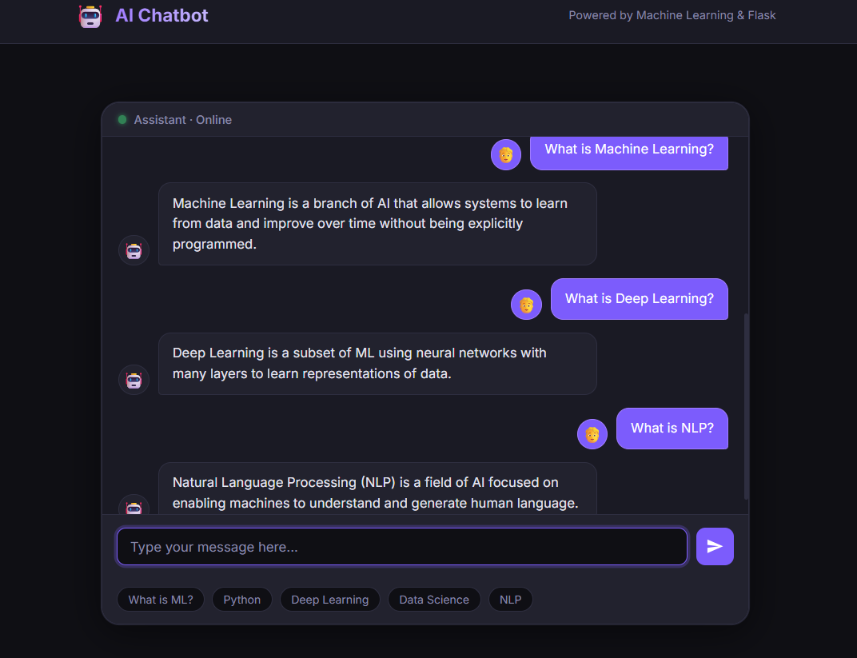

8. Conclusion

The AI Chatbot Web Application was successfully developed and deployed as a local web application using Python, Flask, and core web technologies. The project achieved all its primary objectives — accepting user input, generating intelligent responses, displaying conversations dynamically, and providing an attractive, responsive user interface.

Through this project, the following skills were gained and demonstrated:

- Python programming — file handling, functions, modules, regular expressions
- Flask web development — routing, REST APIs, JSON request/response handling
- NLP fundamentals — text preprocessing, pattern matching, weighted scoring
- Frontend development — HTML5 structure, CSS3 animations, JavaScript fetch API
- Version control — Git initialization, commits, and GitHub repository management

8.1 Limitations
- The chatbot uses rule-based pattern matching, not a trained ML model
- It cannot understand context across multiple messages
- The knowledge base is limited to 11 predefined topic categories
- No persistent chat history between sessions

8.2 Future Enhancements
- Integrate a real ML model (e.g., scikit-learn TF-IDF + cosine similarity)
- Add OpenAI / Gemini API for LLM-powered responses
- Implement user login and chat history with a database (SQLite)
- Deploy on cloud platforms like Render, Railway, or AWS
- Add voice input/output using Web Speech API
- Enable dark/light mode toggle

This project served as a strong foundation for understanding how AI-powered web applications are designed and built. It bridges the gap between theoretical AI knowledge and practical software development, making it a valuable experience for any aspiring Data Scientist or AI Engineer.

— End of Report —

