House Price Prediction — Summary
Internship Project, Week 1 | Regression analysis on a housing dataset (545 properties, 12 features)

Approach
The dataset was loaded and cleaned (no missing values or duplicates found), with categorical fields one-hot encoded, then split 80/20 into train and test sets. Two regression models were trained to predict price from property features: Linear Regression and a Random Forest Regressor (500 trees).

Model Performance
Model | MAE | RMSE | R² Score
Linear Regression | 970,043 | 1,324,507 | 0.653
Random Forest | 100,786 | 1,390,260 | 0.618
Linear Regression explains about 65% of the variation in price (R² = 0.653) and slightly outperformed Random Forest (R² = 0.618) despite no hyperparameter tuning — with only 545 rows of data, the simpler linear model generalized a bit better on the held-out test set.

Actual vs. Predicted Price (Random Forest)
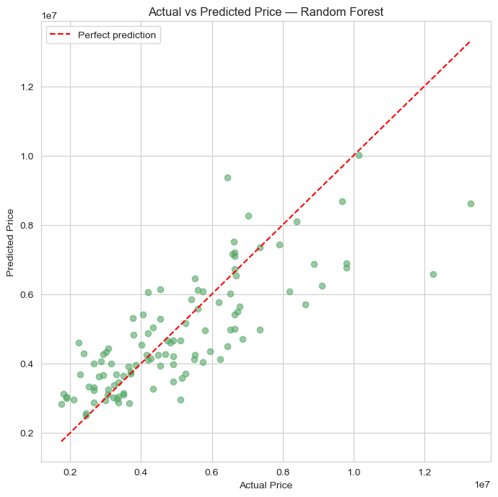

Key Insights
- Area and bathrooms are the strongest predictors of price (correlations of 0.54 and 0.52), followed by airconditioning, stories, and parking.
- Unfurnished homes show a notably negative correlation with price (–0.28) — furnishing status matters more than several physical attributes.
- Hot water heating had almost no effect on price (correlation of just 0.09) despite being a commonly marketed amenity.
- Recommendation: anchor pricing/listing strategy on area and bathroom count first; consider furnishing or staging unfurnished homes before listing to lift perceived value.

