Sales Forecasting & Demand Intelligence
Executive Summary — Prepared for Head of Supply Chain & CFO

Executive Summary
Over the past four years our sales have grown overall, but they swing heavily with the seasons: September through December is consistently the strongest stretch, driven by back-to-school and year-end holiday buying, while January and February are reliably the slowest months. We built and compared three different forecasting approaches and found a machine-learning model (XGBoost) gives the most accurate 3-month forecast. We also built automatic tools to flag unusual sales weeks and to group our products into four demand patterns, so stocking decisions can be tailored instead of one-size-fits-all. The net result: a repeatable system that turns four years of order history into a concrete, monthly restocking plan.

Key Findings
- Technology is our top revenue-generating category ($827K), narrowly ahead of Furniture ($729K) and Office Supplies ($705K).
- The East region shows the most consistent year-over-year growth — sales rose every single year from 2015 to 2018.
- Seasonality is strong: November and December sales run 3-5x higher than the January/February low, every year without exception.
- Average delivery time is about 4 days company-wide and does not meaningfully differ by region — this points to a company-wide shipping policy rather than a regional bottleneck.
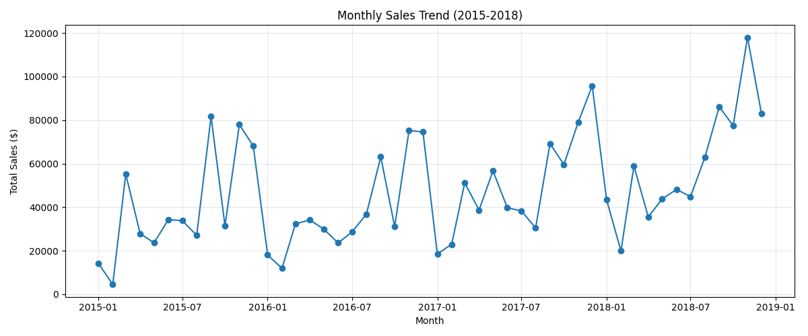

3-Month Sales Forecast
We tested three forecasting methods on a held-out 3-month window to see which best predicts sales it hadn't seen yet:
Model | MAE | RMSE | MAPE | Fcst M1 | Fcst M2 | Fcst M3
SARIMA | $20,581 | $22,191 | 21.9% | $54,758 | $88,414 | $92,558
Prophet | $20,296 | $22,487 | 21.9% | $51,084 | $90,045 | $89,661
XGBoost ✓ | $18,710 | $20,853 | 19.1% | $68,953 | $87,130 | $66,202

XGBoost was the most accurate of the three and is our recommended model going forward. In plain terms: after the December peak, company-wide sales are expected to dip into the new year before picking back up — this is the normal seasonal pattern, not a red flag. The forecast comes with a reasonable margin of error (roughly 19% average deviation), so we recommend treating it as a planning guide, refreshed monthly, rather than an exact number.

Top Anomalies Detected & Likely Cause
- Week of Mar 22, 2015 — sales spiked to over 30x a typical week, most likely one very large single order (e.g., a bulk furniture or technology purchase) rather than a broad demand shift.
- Week of Sep 13, 2015 — an unusually large spike consistent with an early-autumn promotional push or a large B2B order.
- Weeks in early Feb 2015 — unusually quiet weeks, consistent with the well-known post-holiday lull.
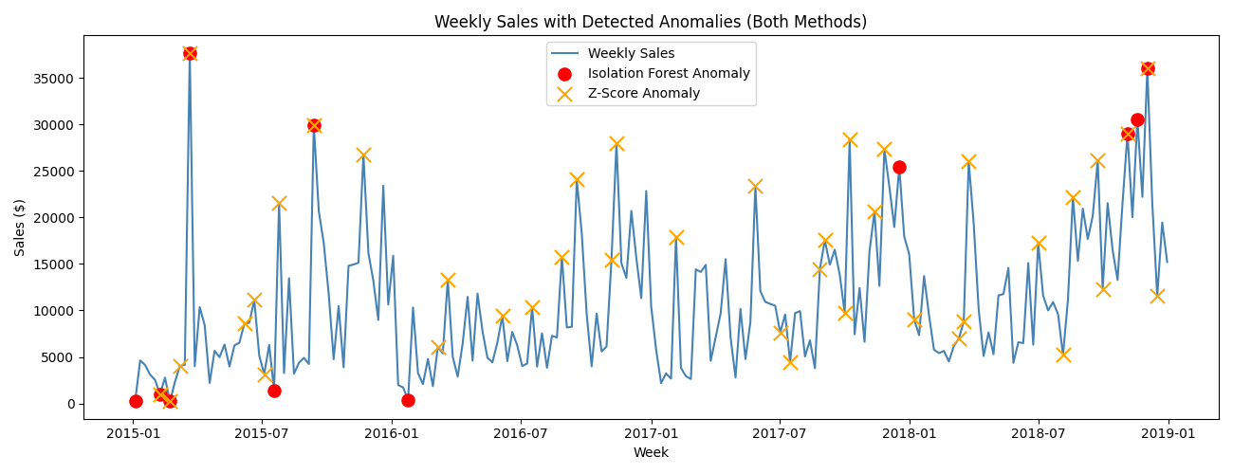

Product Demand Segmentation & Stocking Strategy
We grouped our 17 product sub-categories into four demand patterns based on sales volume, growth rate, volatility, and typical order size:
Segment | Demand Pattern | Recommended Stocking Strategy
Low Volume, Stable  (Bookcases, Labels, Art, Paper, etc.) | Predictable, low volatility | Keep lean; standard reorder points, minimal safety stock
Declining, High-Value  (Machines) | Shrinking demand, big-ticket orders | Reduce committed inventory; shift toward made-to-order
High Volume, Growing  (Chairs, Tables, Storage, Phones, Binders) | Core, healthy growth | Prioritize warehouse space and safety stock as they scale
Explosive Growth  (Copiers) | Very high value, infrequent, volatile | Track closely; moderate safety stock, strong supplier ties

Business Recommendations
- Shift safety stock toward Sep-Dec: since sales in this window are consistently 3-5x the January low every year, pre-positioning inventory ahead of September avoids the stockout risk that a flat, year-round stocking plan would create.
- Move Copiers and Machines to a more made-to-order/just-in-time model: both show high volatility and either explosive growth (Copiers, +480%) or decline (Machines, -30%), so holding large fixed stock ties up capital without matching how erratically these categories actually sell.
- Prioritize warehouse investment in Chairs, Tables, Storage, Phones, and Binders: this cluster combines high volume with healthy, steady growth, making it the safest place to expand stocking capacity for immediate ROI.

Risks & Limitations
This system is trained on four years of historical data from one retailer; it does not know about future one-off events (new competitors, supply shocks, marketing campaigns) unless we retrain it regularly with fresh data. The 3-month forecast's ~19% average error means it should inform decisions, not replace judgment — especially for any single very large order, which our anomaly detection shows can swing a week's sales by 10-30x on its own.

