Apply PCA on CC dataset

Using principal component analysis algorithm we are taking 3 columns data. And by using head method we are getting the top 5 records 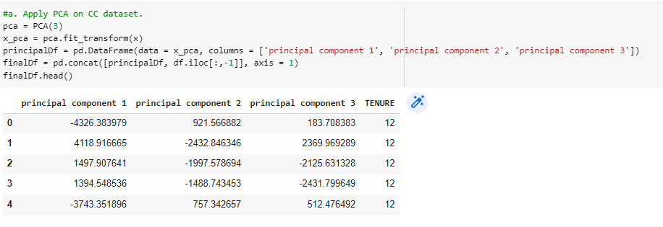

Apply k-means algorithm on the PCA result and report your observation if the silhouette score has improved or not?

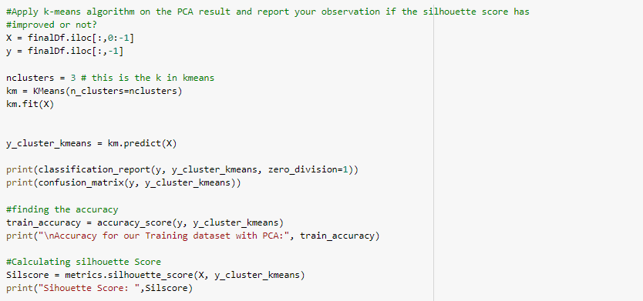

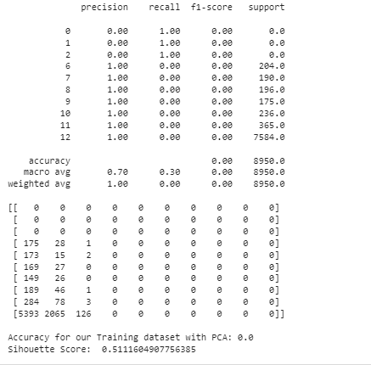

Perform Scaling+PCA+K-Means and report performance.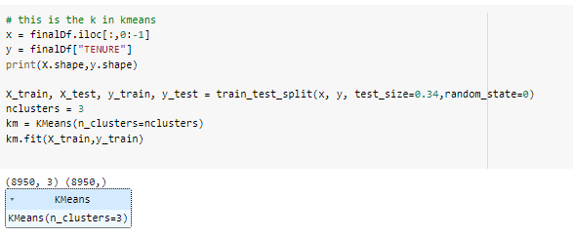

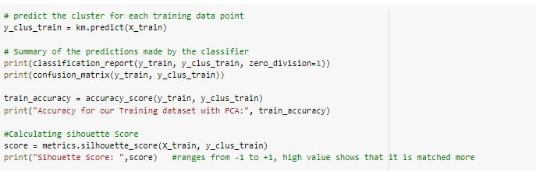

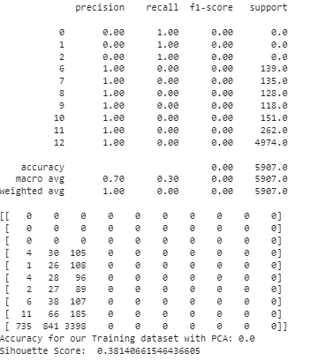

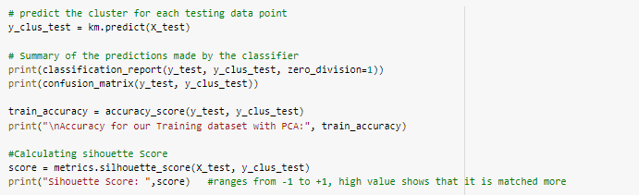

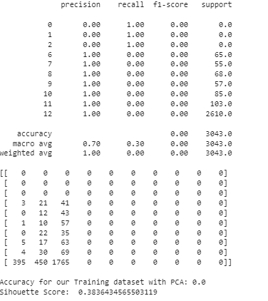

Use pd_speech_features.csv

a. Perform Scaling

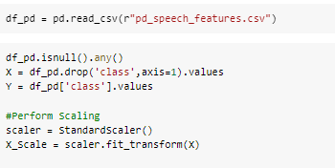

Apply PCA (k=3)

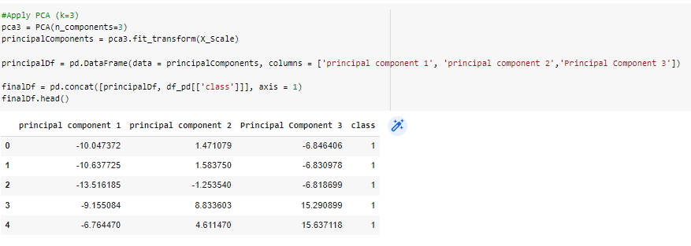

Use SVM to report performance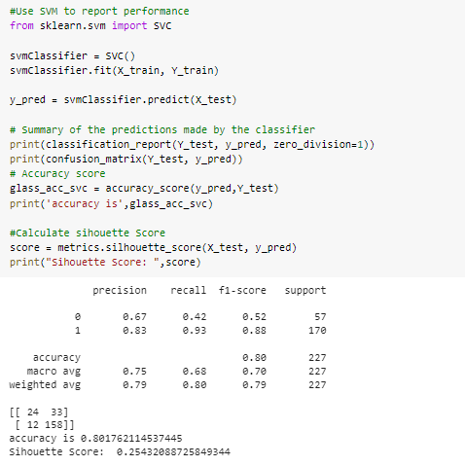

Apply Linear Discriminant Analysis (LDA) on Iris.csv dataset to reduce dimensionality of data tok=2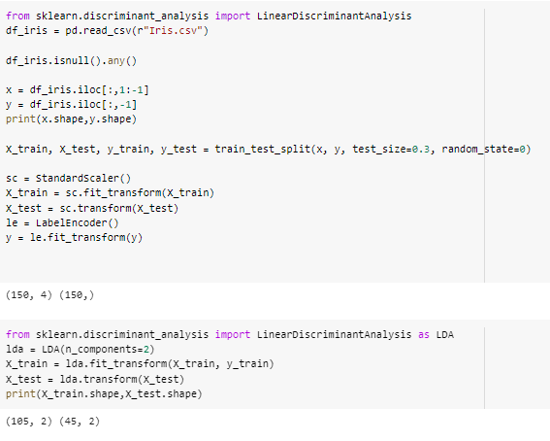

Briefly identify the difference between PCA and LDA

