**KGiSL INSTITUTE OF TECHNOLOGY**

(Approved By AICTE, New Delhi, Affiliate to Anna University Recognized by UGC, Accredited by NBA(IT)

265, KGISL Campus, Thudiyalur Road, Saravanampatti, Coimbatore-641035**.)**

**DEPARTMENT OF**

**ARTIFICIAL INTELLIGENCE AND DATA SCIENCE**

**NAAN MUDHALVAN - INTERNET OF THINGS**

**PUBLIC TRANSPORT OPTIMIZATION**

**NAME:** GNANA CHANDRU K R

**REG NO:** 711721243027

**NM ID:** au711721243027

**TEAM MENTOR:** Mr**.** Mohankumar M

**TEAM EVALUATOR:** Ms. Akilandeeshwari M

**Implementation Plan: Public Transport Optimization**

# Introduction

This document outlines the comprehensive steps and actions required to transform the proposed solution for "Public Transport Optimization" into a reality. The goal is to create a more efficient, passenger-centric, and environmentally sustainable public transportation system by leveraging data, technology, and innovative strategies.

# Phase 1: Data Collection and Analysis

# Step 1: Data Gathering

* Identify and collaborate with data sources, including GPS systems on vehicles, ticketing systems, traffic monitoring, and passenger surveys.
* Establish data sharing agreements and data collection protocols.

# Step 2: Data Analytics

* Employ data analysts and data scientists to analyze the collected data for insights, including passenger demand, congestion patterns, and historical travel behaviors.
* Identify key metrics for performance evaluation, such as on-time performance, passenger loads, and environmental impact.

# Phase 2: Route Optimization

# Step 3: Dynamic Routing Implementation

Develop dynamic routing algorithms that consider real-time data, including traffic conditions, passenger demand, and road closures.

Implement software that communicates with vehicles to provide real-time route adjustments.

# Step 4: Last-Mile Solutions

* Collaborate with micro-mobility service providers to integrate options like bikesharing and electric scooters for the first and last mile of passengers' journeys.
* Ensure seamless transitions between modes and payment systems.

# Phase 3: Real-time Information Systems

# Step 5: Passenger Information Systems

* Develop user-friendly mobile apps that offer real-time updates on routes, schedules, and delays.
* Install digital signage at transit stops and stations to display real-time information.

# Step 6: Predictive Maintenance

* Implement predictive maintenance systems that use vehicle sensor data to anticipate and prevent breakdowns.
* Schedule routine maintenance based on vehicle health and usage patterns.

# Phase 4: Demand Forecasting

# Step 7: Passenger Demand Prediction

Utilize machine learning models to predict passenger demand for different routes and times.

Use historical data and real-time information to optimize resource allocation.

# Phase 5: Environmental Impact Reduction

# Step 8: Eco-friendly Vehicles

* Procure and deploy eco-friendly vehicles, such as electric buses or hybrid systems, to reduce emissions and environmental impact.
* Retrofit existing fleets with green technologies where feasible.

# Step 9: Idling Reduction

* Implement idling reduction strategies, including automatic engine shutdown and restart technology.
* Promote eco-friendly driving habits among operators.

# Phase 6: Fare Integration

# Step 10: Fare Integration

* Collaborate with other public transportation providers, such as subway or commuter rail systems, to create a unified fare system.
* Develop a seamless payment system, allowing passengers to use different modes without extra charges.

# Phase 7: Monitoring and Feedback

# Step 11: Continuous Monitoring

Implement a real-time monitoring system to track vehicle locations, on-time performance, and environmental data.

Set up alerts for system anomalies, delays, and maintenance requirements.

# Step 12: User Feedback

* Establish channels for gathering passenger feedback through mobile apps, websites, and surveys.
* Act upon user feedback to make continuous improvements.

# FLOWCHART:

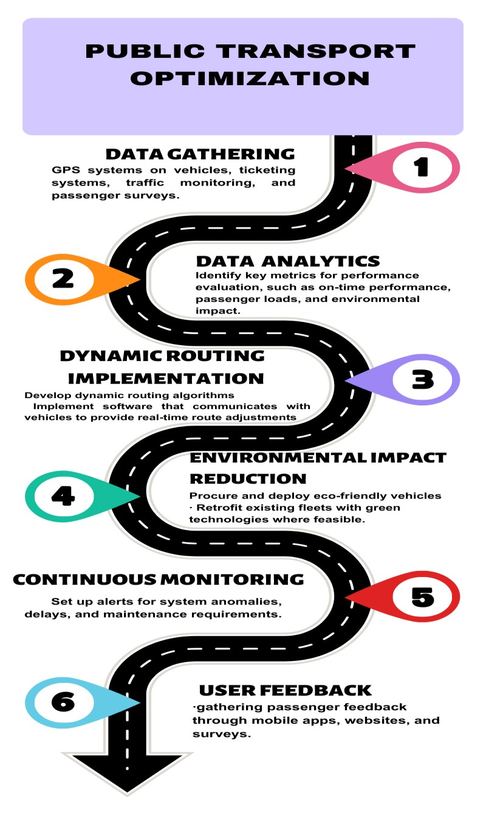

# Implementation Plan

To implement this solution, the following steps should be taken:

**Data Infrastructure:** Establish a robust data infrastructure for data collection and analysis.

**Technology Integration:** Integrate GPS tracking, sensors, and passenger information systems.

**Route Optimization:** Develop and implement dynamic routing algorithms.

**Real-time Information Systems**: Create mobile apps and signage for real-time information dissemination.

**Fleet Upgrade:** Transition to eco-friendly vehicles and implement predictive maintenance.

**Fare Integration:** Collaborate with different transportation providers for seamless fare integration.

**Monitoring and Feedback:** Continuously monitor system performance and gather user feedback for improvements.

# Conclusion:

The transformation of public transport optimization requires a multidisciplinary approach, including collaboration with data experts, technology providers, transportation authorities, and urban planners. By following the detailed steps outlined in this document, a more efficient, passenger-centric, and eco-friendly public transportation system can be realized. Continuous monitoring, data analysis, and user feedback will be essential for maintaining high standards of performance and service quality.