**1) Write a program that takes number as input, print the sum of odd digits in the given number**

**input: 54213**

**output: 9**

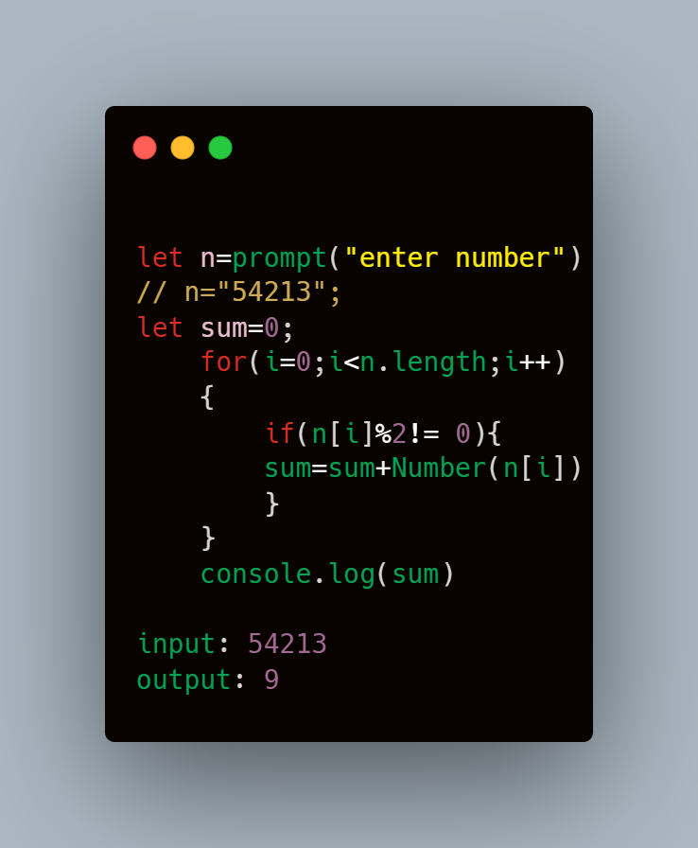

**2) Write a program to print the sum of even digits in the given numbers**

**input:542**

**output: 6**

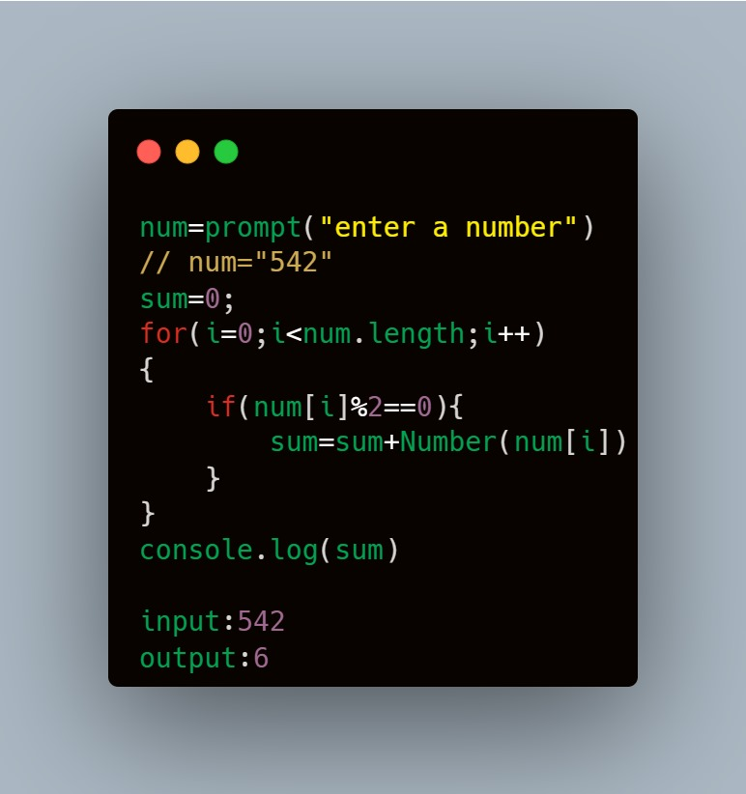

**3) Write a program to print the difference between even sum and odd sum in the given number.**

**input: 16534**

**Output:1**

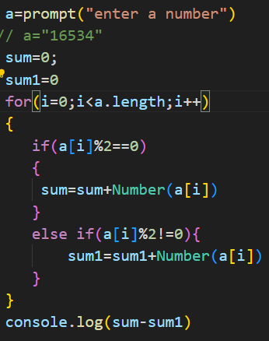

**4) Write a program to print the largest sum between odd sum and even sum.**

**input: 9474**

**output: Odd sum is bigger**

**input: 1658**

**output: Even sum is bigger**

