GIT
GIT is a distributed version control system which allows developers to collaborate on a project more effectively. It is used to store projects and to track the complete history of all changes to the projects. The projects and their related information are stored in a storehouse called repository. In repository we have three options.
- creating a repository – If we are starting from scratch, we have to create a new repository for our project in Bitbucket Cloud.
- importing a repository – If we have existing code with us, we can import it by pulling the repository into Bitbucket.
- cloning a repository – We can get the copy of a repository in our local system by cloning it and then we can push our works into Bitbucket.

CREATING REPOSITORY

If we are starting from scratch and have zero files, we have to create a new repository in Bitbucket Cloud and clone it in our local system.

1. Click repository ---> create a new repository

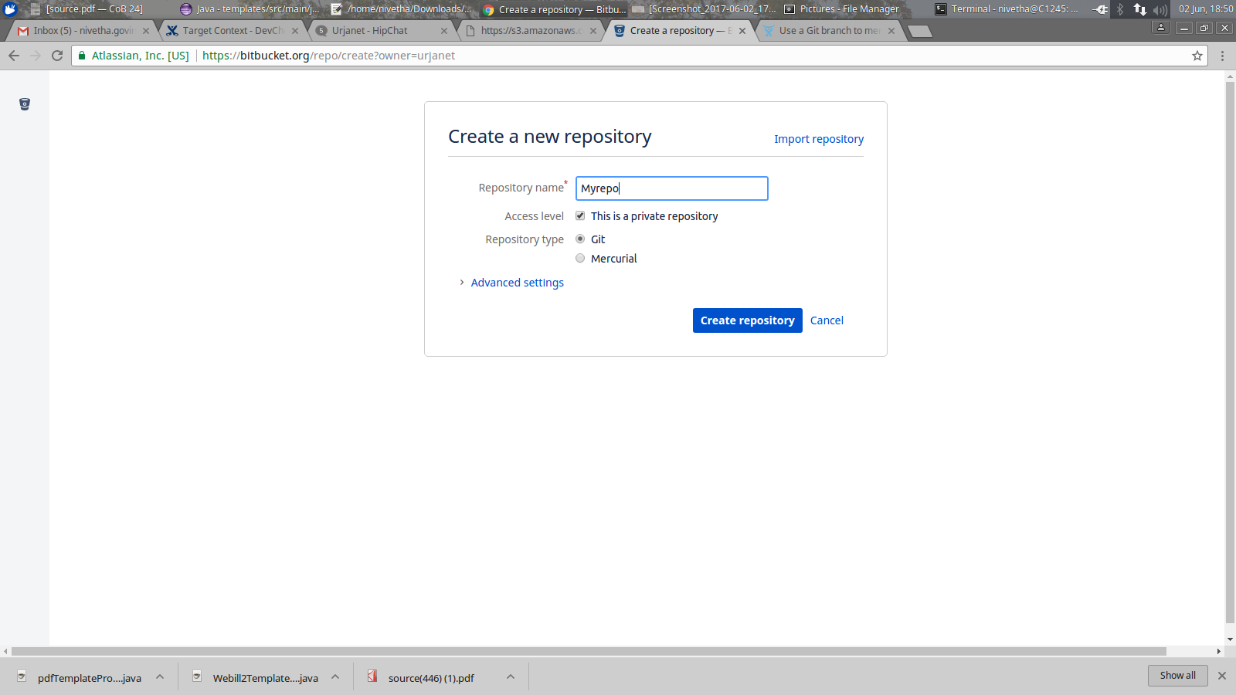
2. Enter the name for your repository

3. You can make your repository as private by clicking the private repository(by default it is set)so that only selected people can view it

4. Select repository type

5. Create repository
CLONING REPOSITORY
Getting a copy of a repository onto your local machine is called cloning. Cloning also connects the remote and local repositories so that you can start pushing and pulling changes between both places. git clone command is used for cloning th repository.
1. Create a directory to contain your repository and navigate to that directory.
$ cd ~
$ makdir myrepo
$ cd ~/myrepo
2. For the git clone command select your project in bitbucket and copy the url on top right.

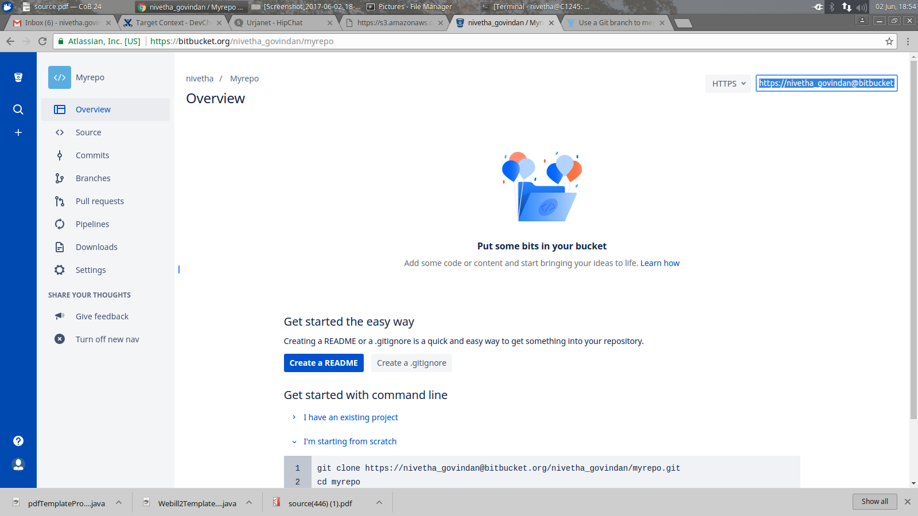
3. Give the git clone command in the terminal followed by the copied url.
$ git clone https://user_name@bitbucket.org/user_name/myrepo.git
Cloning into 'myrepo'...
Password for 'https://user_name@bitbucket.org':
warning: You appear to have cloned an empty repository.
Checking connectivity... done.
4. If the clone was successful, a new sub-directory appears on your local drive with the same name as the repository that you cloned.

Creating files and exploring GIT commands
The following command will create a file named “firstfile.txt” with the content ‘hello bitbucket!!’.
$ echo "hello..bitbucket!!" >> firstfile.txt

Git status - The git status command tells you about how your project is progressing in comparison to your Bitbucket repository.

$ git status
On branch master
Initial commit
Untracked files:
(use "git add <file>..." to include in what will be committed)
firstfile.txt
nothing added to commit but untracked files present (use "git add" to track)
The file is untracked which means it is not a part of previous commit.

Git add - The git add command moves changes from the working directory to the Git staging area. The staging area is where you have a set of changes before committing them to the official history.
$ git add firstfile.txt
$ git status
On branch master
Initial commit
Changes to be committed:
(use "git rm --cached <file>..." to unstage)
new file: firstfile.txt
Git commit - The git commit commit command commits the changes in staging area to the repository.The-mflag is for the message (“first commit”) on the commit - every commit needs a commit message. It tells the purpose of your commit.

$ git commit -m "first commit"
[master (root-commit) 3636b2c] first commit
1 file changed, 1 insertion(+)
create mode 100644 firstfile.txt

NOTE:At the time of first commit, it shows message like given below if you are not configured your identity . Hence, you have to execute git config comand by giving your username and password for BitBucket to set your identity. After doing this, if you execute git commit it will be as follows.
$ git commit -m "First Commit"
*** Please tell me who you are.
Run
git config --global user.email "you@example.com"
git config --global user.name "Your Name"
to set your account's default identity.
Omit --global to set the identity only in this repository.

Git push origin master – It pushes the commits made on your local machine to the remote repository. This command takes two arguments a remote name(origin) and a branch name(master)."origin" is the repository from where you cloned your repository from , the one on bitbucket. “master" is the name of the default branch.

$ git push origin master
Password for 'https://user_name@bitbucket.org':
Counting objects: 3, done.
Writing objects: 100% (3/3), 246 bytes | 0 bytes/s, done.
Total 3 (delta 0), reused 0 (delta 0)
To https://user_name@bitbucket.org/user_name/myrepo.git
* [new branch] master -> master

Creating a file in bitbucket
1.From the Source page, click New file in the top right corner.This button only appears after you have added at least one file to the repository.

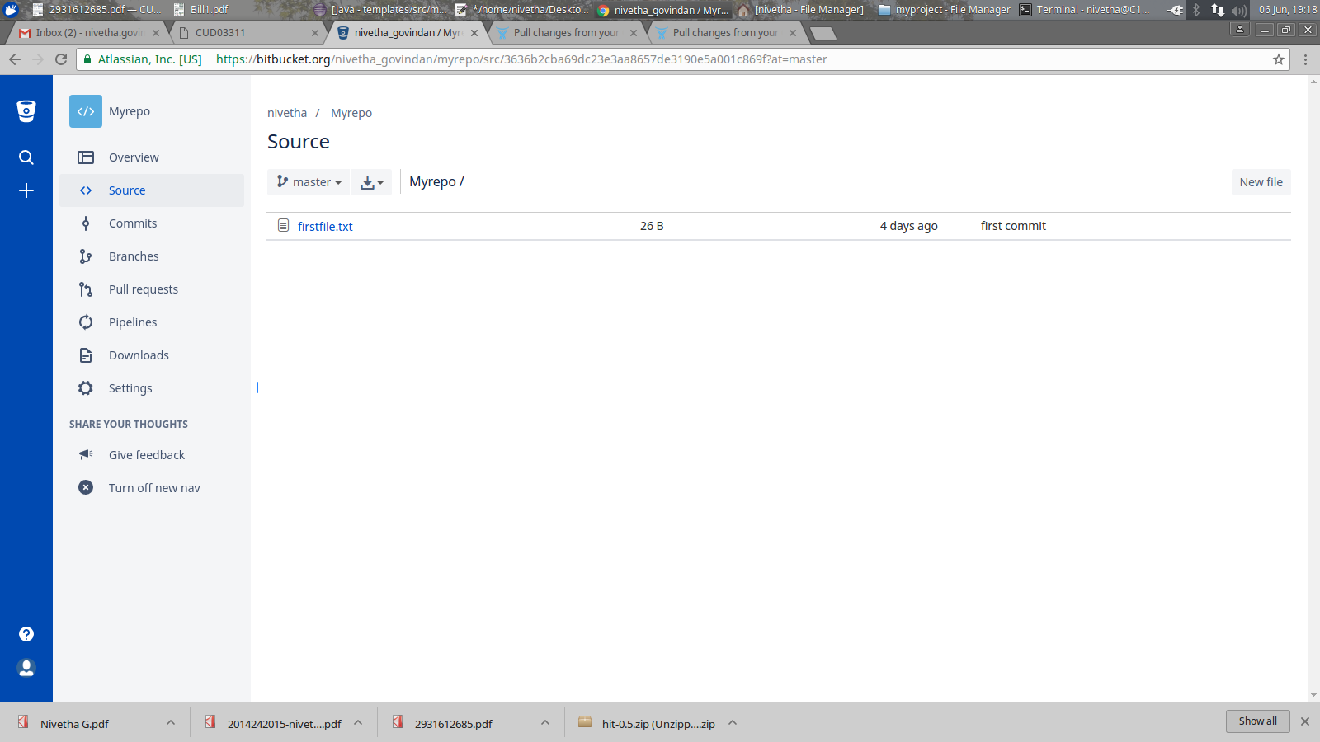
2. A page for creating the new file opens. And you can create your file.

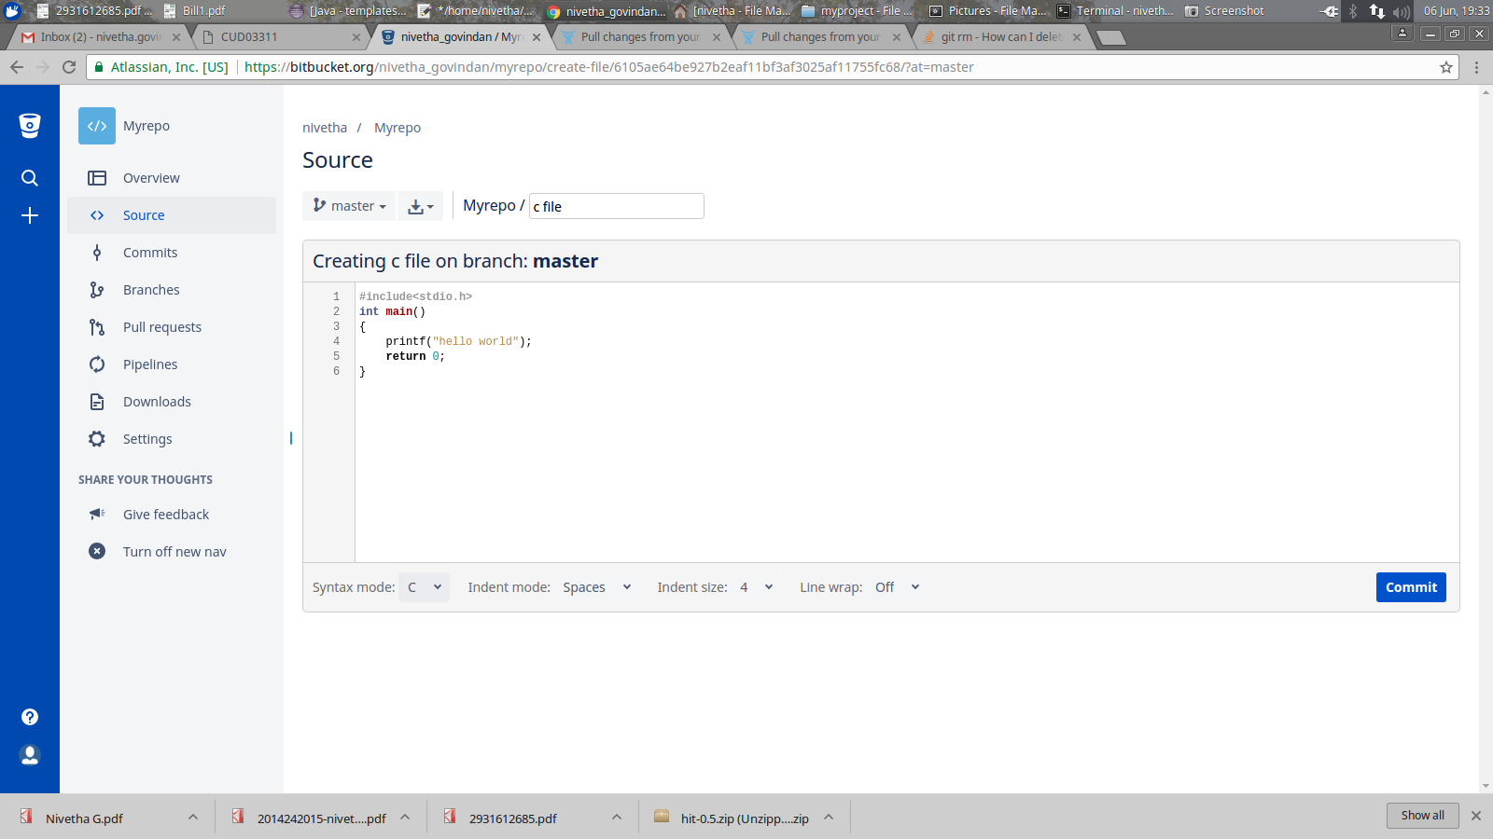

3. Click commit. Commit message will appear as shown below. Click commit to commit the file.

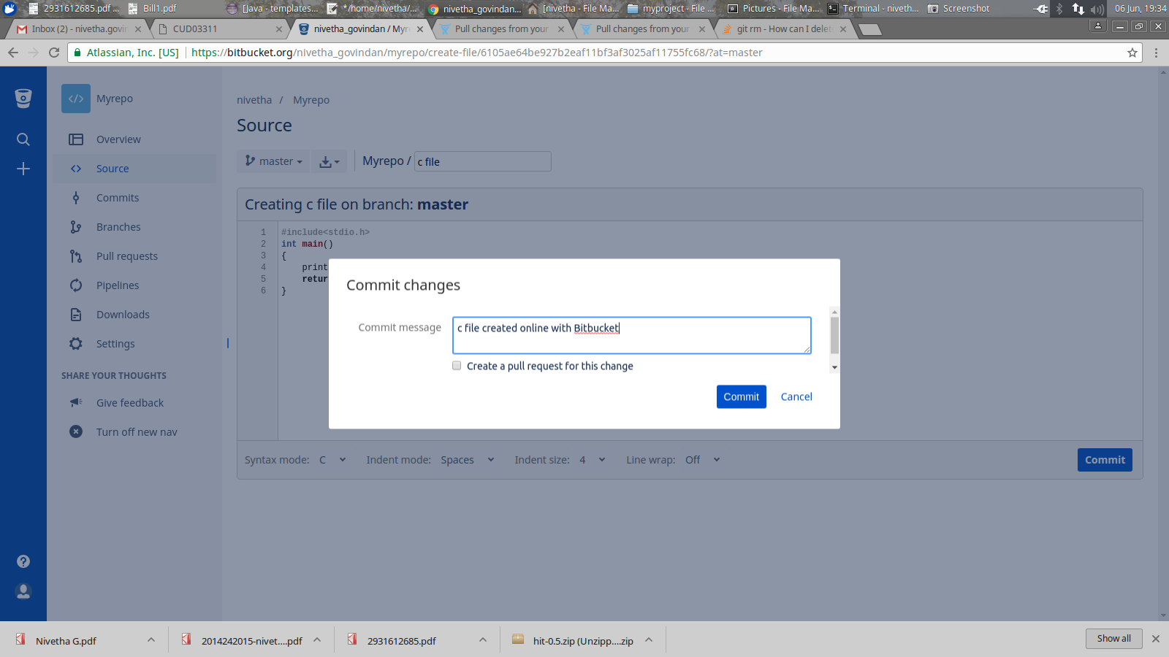

Git pull all - It pulls all the changes from Bitbucket. The git pull command merges the file from your remote repository (Bitbucket) into your local repository with a single command.
$ git pull --all
Fetching origin
Password for 'https://user_name@bitbucket.org':
remote: Counting objects: 3, done.
remote: Compressing objects: 100% (3/3), done.
remote: Total 3 (delta 0), reused 0 (delta 0)
Unpacking objects: 100% (3/3), done.
From https://bitbucket.org/user_name/myrepo
3636b2c..6105ae6 master -> origin/master
Updating 3636b2c..6105ae6
Fast-forward
second file (java) | 6 ++++++
1 file changed, 6 insertions(+) create mode 100644 c file
Git branch – A branch represents an independent line of development. Branching enables you to isolate different types of work. Changes in the other branches will not affect your current branch, unless you decide to pull the latest changes from those branches.It is a common practice to create a new branch for each task (eg. bug fixing, new features etc.).
This command creates a branch.
$ git branch myrepobranch

Git checkout - Git branch just creates a branch and if you want to work on the branch you have to checkout. Git checkout command is used to switch branches.

$ git checkout myrepobranch
Switched to branch 'myrepobranch'

Creating file in new branch
$ echo "hi new branch :)" >> file.txt
$ git add file.txt
$ git commit file.txt -m "file in branch demo"
[myrepobranch 26dfd90] file in branch demo
1 file changed, 1 insertion(+)
create mode 100644 file.txt
Git merge - The git merge command lets you take the independent lines of development created by git branch and integrate them into a single branch.
$ git merge myrepobranch
Updating 11a7890..26dfd90
Fast-forward
file.txt | 1 +
1 file changed, 1 insertion(+)
create mode 100644 file.txt

Listing the branches
$ git branch
* master
myrepobranch
Deleting a branch
$ git branch -d myrepobranch
Deleted branch myrepobranch (was 26dfd90).
Git log - This command is used to view the commit logs.
$ git log file.txt
commit 26dfd90ea9147c4af29748f600fba70451c2c092
Author: user_name <user_name@urjanet.com>
Date: Wed Jun 7 18:15:42 2017 +0530
file in branch demo

Git stash - It stashes(stores) the changes that you have made to your working copy temporarily.

$ git status
On branch master
Your branch is based on 'origin/master', but the upstream is gone.
(use "git branch --unset-upstream" to fixup)
Changes to be committed:
(use "git reset HEAD <file>..." to unstage)

new file: check.txt

Untracked files:
(use "git add <file>..." to include in what will be committed)

check2.txt

$ git stash
Saved working directory and index state WIP on master: 78f3373 Initial commit
HEAD is now at 78f3373 Initial commit

Git stash pop will remove the single stashed state from the stash list.
$ git stash pop
On branch master
Your branch is based on 'origin/master', but the upstream is gone.
(use "git branch --unset-upstream" to fixup)
Changes to be committed:
(use "git reset HEAD <file>..." to unstage)

new file: check.txt

Untracked files:
(use "git add <file>..." to include in what will be committed)

check2.txt

Dropped refs/stash@{0} (ee06fe1857f6c86647f48f56c74cf288c64ca8d5)

Git show- It shows the details of recent commit.
$ git show
commit 26dfd90ea9147c4af29748f600fba70451c2c092
Author: nivetha_govindan <nivetha.govindan@urjanet.com>
Date: Wed Jun 7 18:15:42 2017 +0530
file in branch demo
diff --git a/file.txt b/file.txt
new file mode 100644
index 0000000..86a48f8
--- /dev/null
+++ b/file.txt
@@ -0,0 +1 @@
+hi new branch :)

Git diff- It shows the modified changes after your last commit.
$ git diff
diff --git a/file.txt b/file.txt
index 86a48f8..7c035cc 100644
--- a/file.txt
+++ b/file.txt
@@ -1 +1,2 @@
hi new branch :)
+hello

Git grep- It prints the lines matching a given pattern.

$ git grep "hello"
c file: printf("hello world");
file.txt:hello
firstfile.txt:hello..bitbucketcd myrepo

Git cherry-pick- It is used to choose a commit from one branch and apply it to another branch. The commit hash ( a unique string representing a particular commit) should be given which can be found from git show command.

$ echo "hi!!!" >> newfile.txt
echo "higit checkout myrepobranch!" >> newfile.txt
$ git add newfile.txt
$ git commit -m "new file in a branch"
[myrepobranch bfde724] new file in a branch
1 file changed, 1 insertion(+)
create mode 100644 newfile.txt
$ git show
commit bfde724b4d8cbaf86288edb87b02074316282fa3
Author: nivetha_govindan <nivetha.govindan@urjanet.com>
Date: Fri Jun 9 18:24:21 2017 +0530

new file in a branch

diff --git a/newfile.txt b/newfile.txt
new file mode 100644
index 0000000..8b218f8
--- /dev/null
+++ b/newfile.txt
@@ -0,0 +1 @@
+higit checkout myrepobranch!
$ git checkout master
M file.txt
Switched to branch 'master'
Your branch is ahead of 'origin/master' by 3 commits.
(use "git push" to publish your local commits)

$ git cherry-pick bfde724b4d8cbaf86288edb87b02074316282fa3
[master af33105] new file in a branch
Date: Fri Jun 9 18:24:21 2017 +0530
1 file changed, 1 insertion(+)
create mode 100644 newfile.txt

IMPORTING REPOSITORY
To add the existing code to Bitbucket Cloud, we have to import it. The importer works if your code is in any of the following hosting site.
- CodePlex
- Git
- Google Code
- Mercurial
- SourceForge
- Subversion
If your hosting site doesn’t fall into this or if you don’t have the url, convert your code to Git or Mercurial.

1. Repository ------> import repository
2. Select the source for your import
3. Based on the source, the system asks you for some information (like
username,password)
4.Enter a Name for your new repository.
5.Uncheck Private if you want the repository to be Public.
6.Select a Language.
7.Click Issue tracking and/or Wiki if you want those features.
8.Enter a Description and Website if you wish.
9.Press Import.

