# **Tasks**

**Learners have to develop a dashboard to support the answers to the following questions and suggestions for places for newer restaurants.**

**Objective Questions**:

1. What is the total no. of tables present in the data?

The total no. of tables present in the data are **2.**

i.e. Raw data, Country description.

1. What is the total no. of attributes present in the data?

The total no. of attributes present in the data are **22.**

1. How many categorical columns are there in the data? [Search about categorical and continuous data, and try to answer this question]

Categorical data, on the other hand, consists of **discrete values** that fall into distinct categories or groups, such as gender, ethnicity, or product types.

The total no. of categorical columns in the data are **10.**

Categorical- Restaurant name, city, locality, cuisines, currency. Etc.

1. The data consists of some inconsistent and missing values so ensure that the data used for further analysis is cleaned.

First, I used the **COUNTBLANK()** function in Excel to locate any blank cells within my dataset, allowing me to identify missing or incomplete data points.

Next, I determined the mode of the dataset, which represents the most frequently occurring value within the relevant column. This involved either using Excel functions like **MODE()** or manually inspecting the data to find the mode.

With the mode identified, I proceeded to fill in the missing values within the dataset. For instance, if **"North Indian**" cuisine emerged as the mode of a particular column, I replaced any blank cells with "North Indian" to ensure comprehensive data coverage.

Finally, I double-checked the dataset to confirm that all missing data points had been effectively addressed and replaced with the appropriate mode value, thereby ensuring the dataset's completeness and accuracy for subsequent analysis.

1. Using the LookUp functions, fill up the countries in the original data using the country code.

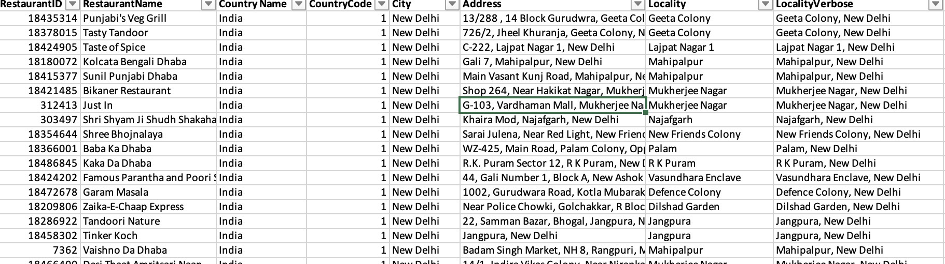

The below formula had been used to fill up the countries in the original data.

**=VLOOKUP(D2,'country description'!$A$1:$B$16,2,0)**

1. Create a table to represent the number of restaurants opened in each country.

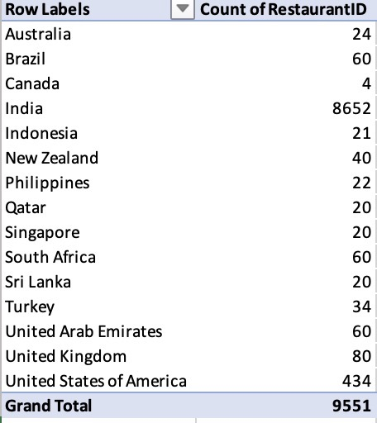

The above pivot table provides the relationship between the number of restaurants opened in each country.

1. **Also, the management wants to look at the number of restaurants opened each year, so provide them with something here.**

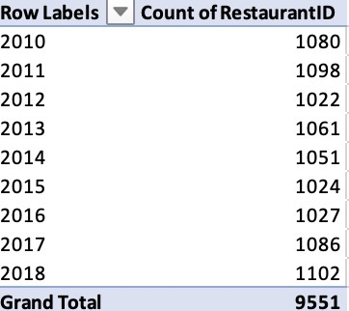

The above pivot table provides the relationship between the number of restaurants opened in each year.

1. What is the total number of restaurants in India in the price range of 4?

The total number of restaurants in India in the price range of 4 are **388**.

This can be achieved using the formula,

**=COUNTIFS(C2:C9552,"India",Q2:Q9552,4)**

1. What is the average number of voters for the restaurants in each country according to the data?

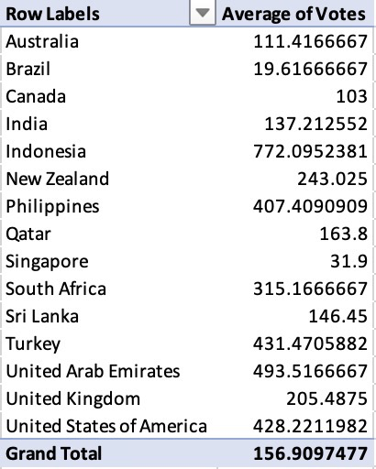

The above pivot table provides the relationship between the average number of voters for the restaurants in each country.

1. Calculate the average rating for all the restaurants that have price range < 4 and provide online delivery. Use only the “IF” function, Logical Operators, and Aggregation functions to solve this problem. **[Note: Don’t use Conditional aggregation in this question.]**

The **average rating** for all the restaurants that have price range < 4 and provide online delivery is **3.27381151.**

We fill in the rows using this formula =IF(AND(Q2<4,N2="Yes"),T2,"")

and then calculate the average using =AVERAGE(W2:W9552).

1. Using Conditional formatting highlight the rows of restaurants that are located in the countries or cities that you’ve suggested to the management for opening new restaurants.

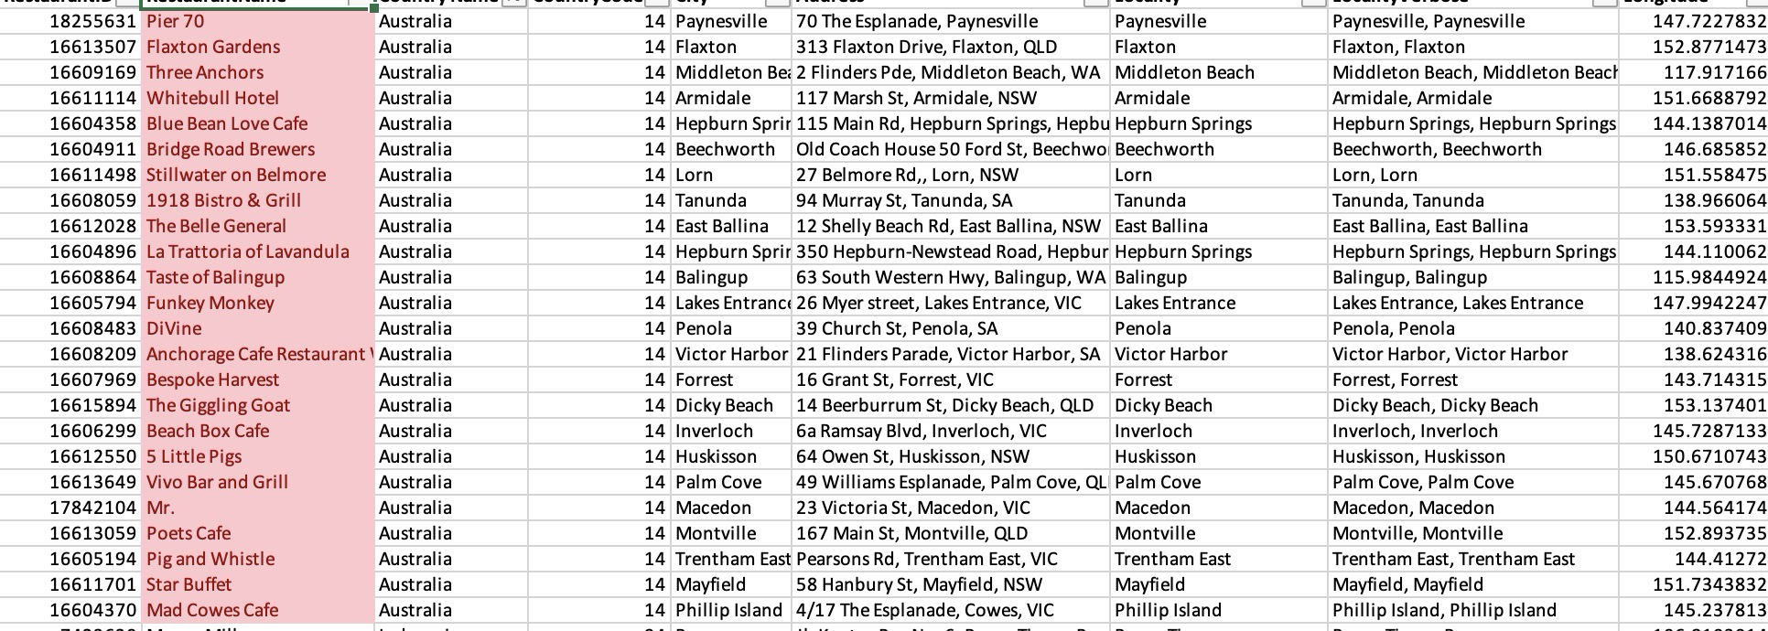

1. Create a new customized price column that consists of the abbreviation/symbol of the currency along with the Average_cost_for_two value. [Use string operations to do this task]

This formula can be used to solve the above problem.

**=CONCATENATE(L2," ",S2)**

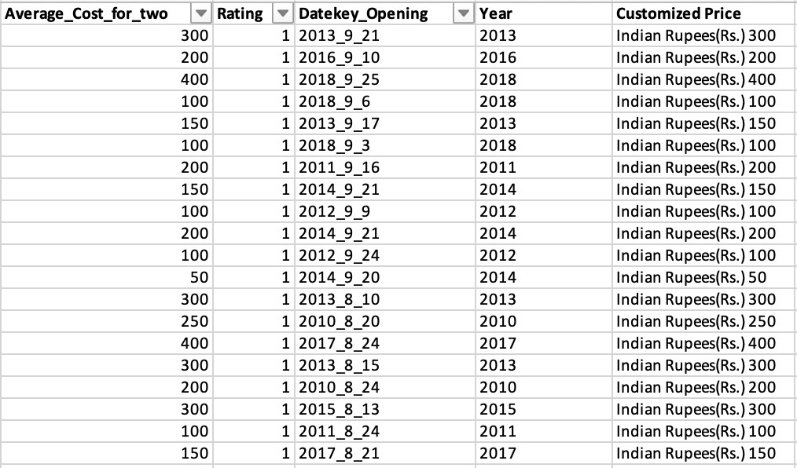

1. How can you create an array formula in Excel or Google Sheets to count the number of restaurants listed that do not offer online delivery, are in the lowest price range, and have an average cost for two people less than or equal to 250 Indian Rupees?

{=SUM((‘Raw Data'!02:09552="No")*('Raw Data'!R2:R9552=1)*('Raw Data'! T2: T9552<=250))}

Using the above formula the result is **1834.**

**Subjective Question:**

1. Suggest a few countries where the team can open newer restaurants with lesser competition. Which visualization/technique will you use here to justify the suggestions?

After conducting a comprehensive analysis of the number of restaurants and their respective ratings across various countries, I have decided to open new restaurants in **Canada, Singapore, Australia, Brazil, and Sri Lanka**. This decision is based on identifying these countries as having both the **least number of restaurants** and the **lowest average ratings**, indicating potential gaps in the market that we can capitalize on.

The below line chart compares the average ratings provided by the users with the respective country.

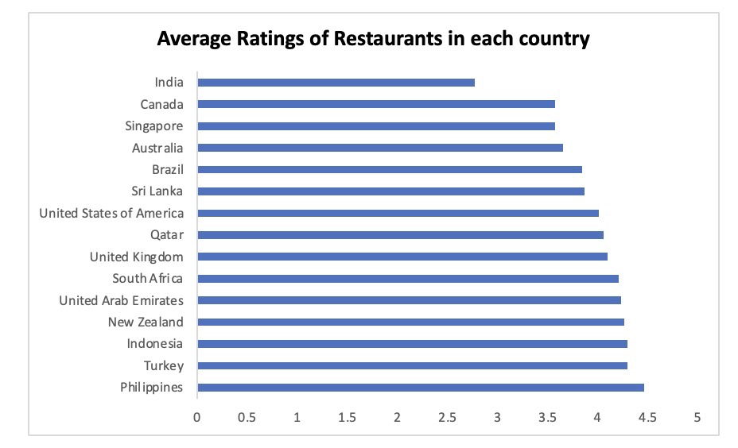

Although, India has a low rating among all the countries but the number of restaurants in there are so large in number. Hence, India cannot be the optimal place to open a restaurant.

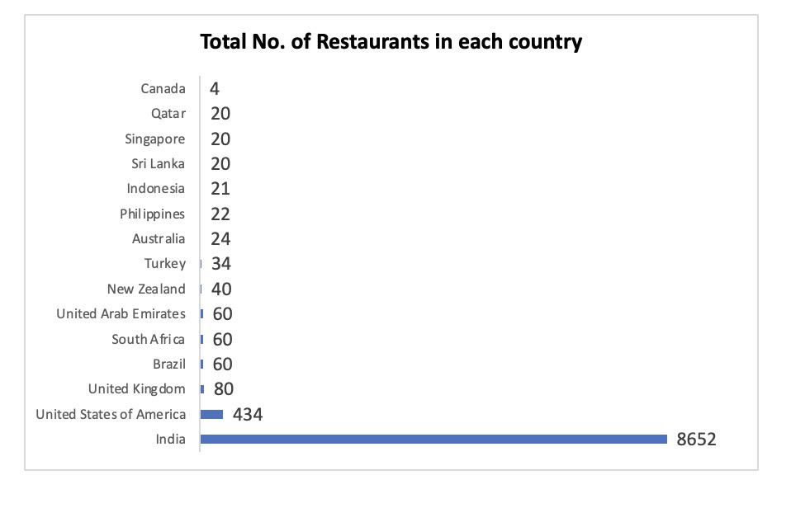

The above column chart depicts the number of restaurants in each country which can help us analyse the optimal competition we are going to face if we open a new restaurant.

1. **Come up with the names of States and cities in the suggested countries suitable for opening restaurants.**

After selecting the countries for our restaurant expansion—**Canada, Singapore, Australia, Brazil, and Sri Lanka**—the next step involved identifying the specific states and cities within these countries to target. The process was data-driven, focusing initially on the number of restaurants in each city and then refining our choices based on customer satisfaction metrics(Rating). we ensure a strategic approach to opening new restaurants. This method not only balances competition but also targets areas where customer dissatisfaction suggests an opportunity to provide superior dining experiences.

In Australia, we chose **Montville, Paynesville, Mayfield, Balingup, Penola** based on the rating.

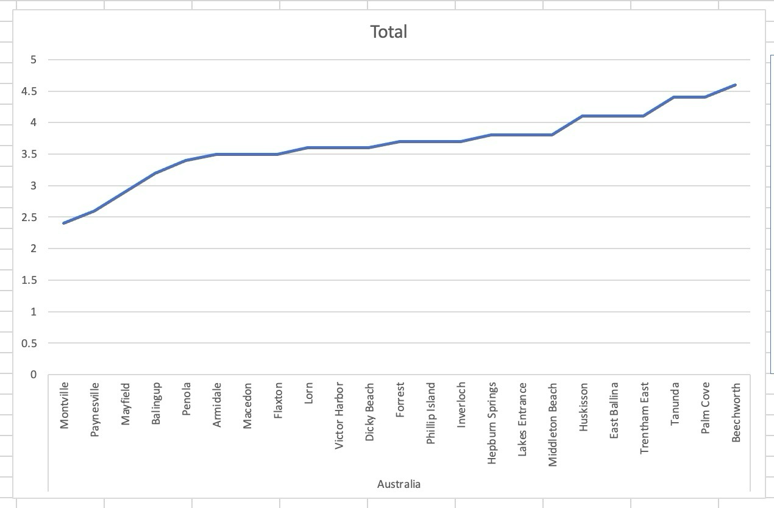

In Brazil, we chose **Brazilia** based on the rating.

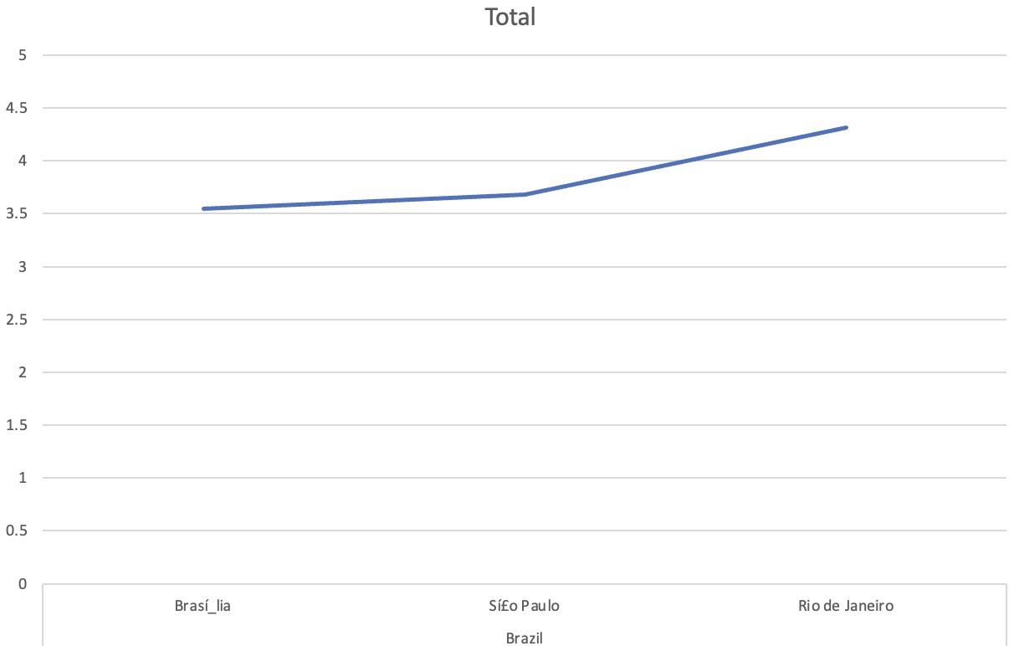

In Canada, we chose **consort, Yorkton** based on the rating.



In Singapore and Sri Lanka we choose **Singapore city, Colombo city** based on their ratings.

after choosing the countries we fix the states to open the restaurants based on the number of restaurants in each city and since all the cities have almost equal number of restaurants we finalize the cities to open the restaurants based on the cities which have lowest rating and pick the cities which have average rating of less than 3.5

In summary, our chosen cities in Canada, Singapore, Australia, Brazil, and Sri Lanka represent markets with optimal conditions for introducing new restaurants. By focusing on locations with significant potential for improvement in customer satisfaction, we aim to establish a strong presence and address the unmet needs in these cities.

1. **According to the countries you suggested, what is the current quality regarding ratings for restaurants that are open there?**

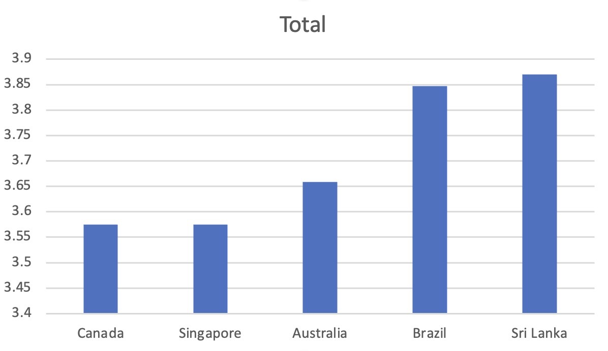

The chart below illustrates the relationship between the average rating of existing restaurants and the countries chosen for opening new restaurants. This visual representation highlights how each selected country offers an opportunity for market entry based on lower customer satisfaction scores, indicating a potential gap in the quality of dining experiences.

### Chart Explanation

* **X-Axis**: Countries (Canada, Singapore, Australia, Brazil, Sri Lanka)
* **Y-Axis**: Average Rating of Restaurants
* **Data Points**: Average rating values for each country, where all chosen cities have ratings less than 4

1. Also, what is the current expenditure on food in the suggested countries, so we can keep our financial expenditure in control?

The table that shows the relationship between the countries selected for restaurant expansion and the average cost per meal for two people in each country, both in their respective local currencies and converted to a common currency (USD) for better comparison.

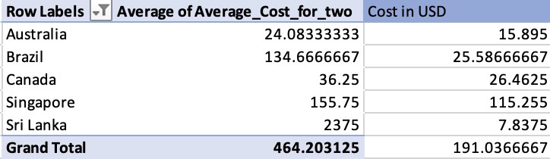

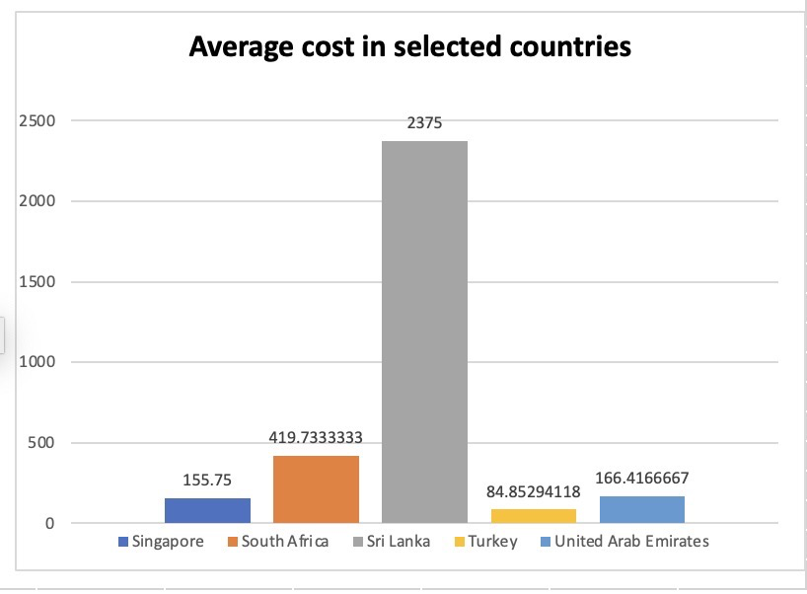

**Condition in countries where Average expenditure is low**

* Financial expenditure in Sri Lanka is the lowest amongst the suggested countries , this can be due to various reasons such as low purchasing power of people, status of general economy, existing price ranges of restaurants and mismatch of it with the earning and spending and purchasing power of population etc. while investing in these country with lowest average expenditure it should be kept in mind that pulling the population and earning through it would be a difficult task , hence rather than establishing upper price ranged restaurant with heavy infrastructure it would be beneficial to establishing upon kiosk models with less investment value which will focus just on the extremely important factors of food and time like specific taste and cost cutting in production by using management methods should be done as the profit margin would be very competitive to achieve profitability .

**Condition in countries where Average expenditure is high**

* For the countries like Singapore where the average expenditure of people has a good power which means population is ready to pay for the various services like taste of food, presentation of food, quality of food, type and quality of ambience etc.

**Condition in countries where Average expenditure is medium**

* And for the countries where the average expenditure of people is medium, such population values the taste and quality of food more, but also if they get a good deal of overall services in an affordable price range then they are ready to pay more. Hence in countries like Brazil, Canada and Australia the investment plans and strategy made should be primarily focused on food and then secondarily focused on other services inclusive of a good and competitive price range price range with a reasonable profit margin in services which is not to high and not too low .

1. **Come up with the names of restaurants from the recommended states that are our biggest competitors and also those that are rated in the lower brackets, i.e. 1-2 or 2-3.**

The names of restaurants from the recommended states that are our biggest competitors and also those that are rated in the lower brackets, i.e. 1-2 or 2-3 are:

Australia: Pier 70, Poets Café, Star Buffet

Brazil: Sandubas cafi, Chez Michou, Cantinho da Gula, Super Grill, Quiosque chopp, Divino FogiEo.

Canada: Consort Restaurant

Singapore: Makansutra Restaurant

Sri Lanka: Elite Indian Restaurant, Queen’s Café.



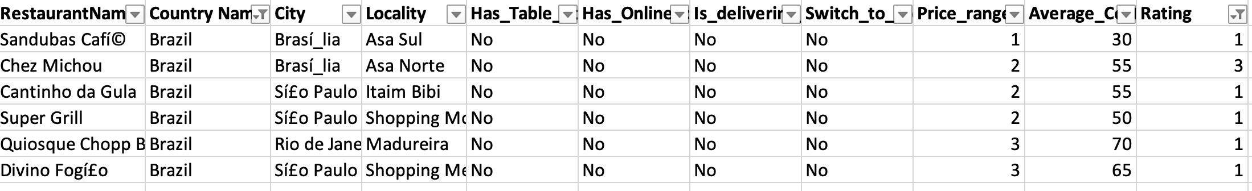







1. **Which cuisines should we focus on in the newer restaurants to get better feedback? Does the choice of cuisines affect the restaurant ratings?**

Based on the analysis from the Excel sheet for previous questions, it is evident that cuisines found in higher-rated restaurants are also present in lower-rated ones across different countries. This pattern indicates that there is no direct correlation between the type of cuisine and restaurant ratings. The choice of cuisine does not appear to significantly influence ratings, as evidenced by the presence of modern Australian cuisine in both high and low-rated restaurants in Australia. This suggests that factors such as service, quality, and taste are more critical than the cuisine itself.

The data also shows that in many cases, cuisines in lower-rated restaurants are also present in higher-rated establishments. This implies that the rating is not solely dependent on the type of cuisine but rather on the quality of the food and service. For instance, in Australia, modern Australian cuisine is common in both lower and higher-rated restaurants. By examining the differences between these restaurants and understanding what higher-rated restaurants are doing better, we can make improvements in our new restaurants, keeping the price range in mind.

In conclusion, while planning the menu, it is essential to choose cuisines that are generally well-received by the local population and appropriate for their tastes. For example, extremely spicy cuisines might not be suitable for an English locality. After selecting the appropriate cuisines, focus on the factors that contribute to higher ratings in similar restaurants, such as quality and service. This strategy will help achieve good ratings, customer satisfaction, and overall profitability.

1. According to our current data, should we go for online delivery and table booking? Does that affect the customer’s ratings?

The only countries which do both online delivery and table booking are India and UAE. We can observe significant improvement in ratings of the restaurants if we provide table booking.

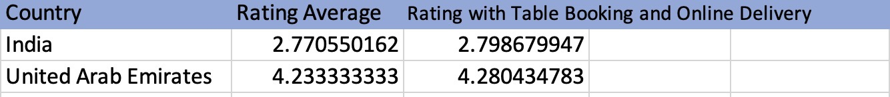

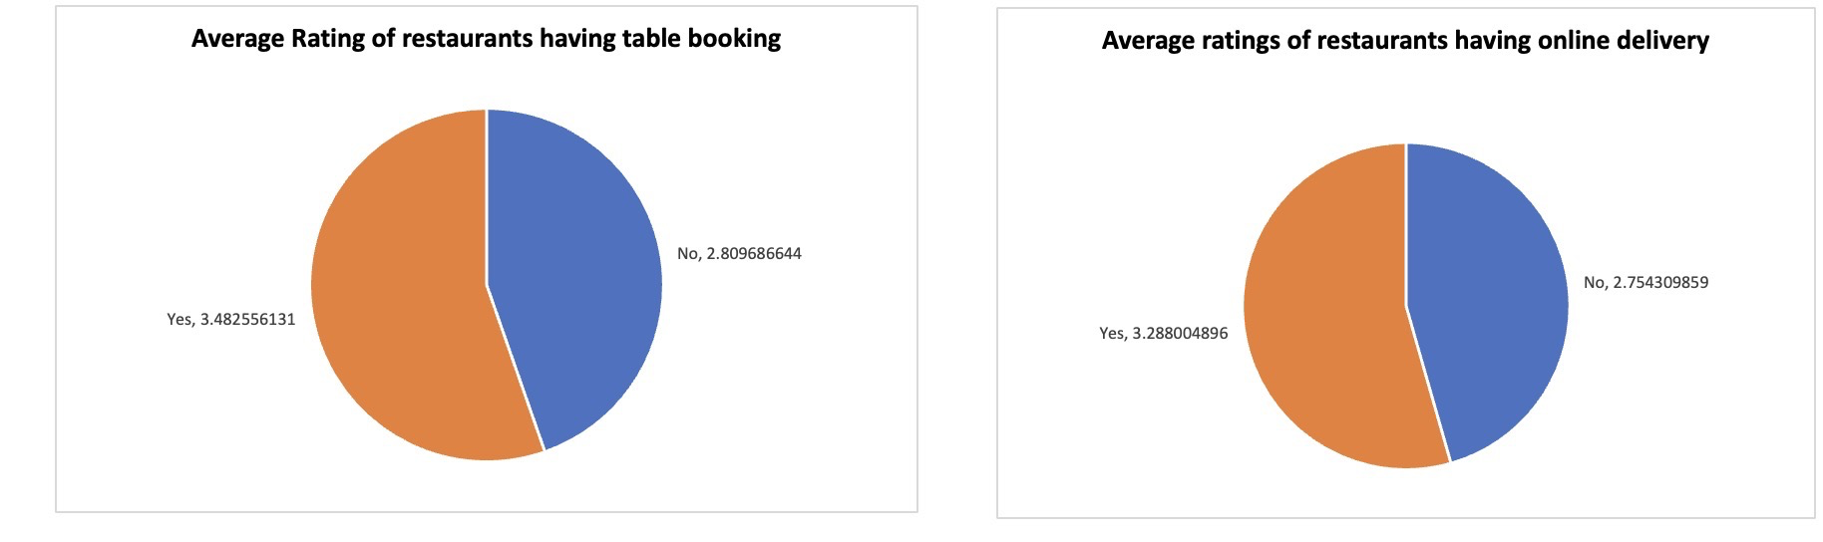

Above are the ratings for the restaurants comparison which has Table booking, Online Delivery.

**Conclusion**

* Hence is can be concluded that difference is there when the restaurants choses to keep the options of table bookings and online delivery open vs close.
* Hence it can be recommended to keep the option of table booking and online delivery open in the newer restaurants planning to be opened. And **YES we should definitely go for option of online delivery and table booking.**

Implementing online services like delivery and table booking is crucial in the modern restaurant industry. These services enhance customer convenience and are now necessary for customer satisfaction. Restaurants have the option to either collaborate with existing online service providers or develop their own online portal, though the latter requires additional logistics support. Partnering with established service providers simplifies management by outsourcing logistics and delivery, even though it incurs a small fee. Key aspects of managing online delivery include ease of ordering, online marketing, timely delivery, and proper packaging. Overall, collaborating with established online service providers helps streamline operations and improve customer service.

1. **Should the team keep the rate of cuisines higher? Will that affect the feedback? According to our data are the rates of cuisines and ratings, correlated?**

Relation between any two features in excel can be found using CORREL function.

We can find the relation between Rates of cusines and Ratings by using the below formula,

**=CORREL('Raw Data'!Q2:Q9552,'Raw Data'!T2:T9552)**

We got a correlation value of 0.462939 between the two features.

A correlation value of **0.462939294** indicates a moderate positive correlation between the two features, meaning as one feature increases, the other tends to increase as well. This suggests a noticeable but not very strong relationship. While there is a positive association, it’s not strong enough for accurate predictions based solely on this correlation. Further analysis, such as creating scatter plots or conducting regression analysis, is recommended to better understand the relationship and other influencing factors.

1. What is the distribution of the number of restaurants of different price ranges in all the countries?

Below are the insights developed for distribution of the number of restaurants of different price ranges in all the countries.

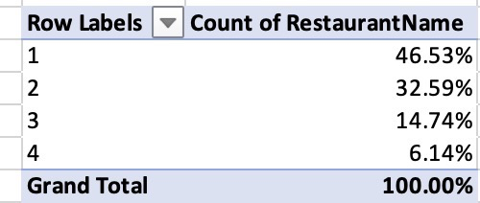

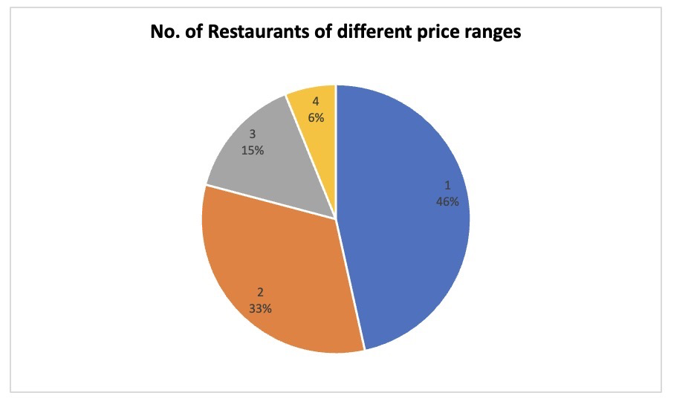

Observation:

Among the restaurants analysed, approximately 46.53% fall within price range 1, while approximately 32.59% are in price range 2. Price range 3 accommodates around 14.74% of the restaurants, and price range 4 encompasses a similar percentage, also at approximately 32.59%.

1. **Explain your approach in brief for suggesting countries/cities in order to open new restaurants, if the objective and subjective questions would have not been given to assist you. [you have to give bullet pointers in order to answer this question]**

In the absence of specific questions, organizing the data based on relevant criteria becomes essential.

Country Assessment

- Identification of countries with a lower number of restaurants serves as a starting point.

- Further examination involves comparing these countries according to their standard of living.

- An analysis of the average cost for two people in these countries can shed light on the affordability of dining options.

Cuisine Investigation

- Filtering countries based on the diversity of cuisines offered provides insights into culinary preferences.

- Exploring potential correlations between types of cuisines and the ratings they receive helps understand consumer preferences.

Rating Evaluation

- Sorting countries based on the ratings assigned to restaurants allows for an assessment of dining experiences across different regions.

- Identifying trends or patterns in ratings aids in understanding consumer satisfaction levels.

Through these structured analyses, valuable insights can be derived regarding factors such as affordability, culinary preferences, and their impact on restaurant ratings across diverse geographical locations.