Software Requirements Specification
for
Inventory Management System
Version <1.0>

Prepared by
Group Number : 8
Gnana Prakash P | B200840CS | puligundla_b200840cs@nitc.ac.in
Deepak | B200802CS | chekurthideepak_b200802cs@nitc.ac.in
Ramnivas P | B200838CS | polineni_b200838cs@nitc.ac.in
Pramodh P | B200852CS | podety_b200852cs@nitc.ac.in
Sai Krishna T | B200816CS | tirukkovalluri_b200816cs@nitc.ac.in

Instructor: | Prabhu M
Course: | DBMS
Lab Section: | A Batch
Teaching Assistant: | Prabhu M
Date: | 25th October, 2022
Contents
Contents ii
Revisions ii
1 Introduction 1
1.1 Document Purpose 1
1.2 Product Scope 1
1.3 Intended Audience and Document Overview 1
1.4 Definitions, Acronyms and Abbreviations 1
1.5 Document Conventions 1
1.6 References and Acknowledgments 2
2 Overall Description 2
2.1 Product Overview 2
2.2 Product Functionality 3
2.3 Design and Implementation Constraints 3
2.4 Assumptions and Dependencies 3
3 Specific Requirements 4
3.1 External Interface Requirements 4
3.2 Functional Requirements 4
3.3 Use Case Model 5
4 Other Non-functional Requirements 6
4.1 Performance Requirements 6
4.2 Safety and Security Requirements 6
4.3 Software Quality Attributes 6
5 Other Requirements 7
Appendix A – Data Dictionary 8
Appendix B - Group Log 9

Revisions
Version | Primary Author(s) | Description of Version | Date Completed
Draft Type and Number | Full Name | Information about the revision. This table does not need to be filled in whenever a document is touched, only when the version is being upgraded. | 00/00/00

Introduction
The inventory management system can be used by the manager or administrator of the company to get comprehensive data on the raw materials, components, and finished goods as well as the storage and processing of goods for the warehouse. The computerization makes the company's analysis process simple.

Document Purpose
This document's goal is to give a thorough explanation of the specifications for the inventory management system. The application assists the business in keeping track of all the items, including components, finished goods, and raw materials. The document includes a general summary, a list of other relevant application attributes, application usage scenarios, and use case diagrams, as well as the functional, interface, and specific requirements for the application. The inventory management system can be designed, built, and ultimately tested from this SRS.

Product Scope
We give the company analysis software so they can use it to improve their products. The software typically gives data about the products, and using historical data, we can give analysis for things like growth and other things that benefit the company and make it possible to track everything.

The employees entered all the information regarding the items at various stages, such as raw material deliveries, storage of the items, manufacturing, and shipping. All of the data is tracked by the system, and the administrator can access it.

Intended Audience and Document Overview
Since keeping track of products, or any other items, and revenue earned is the main goal. So the software can be used by any business or individual that deals with products. The system would be helpful for both small- and large-scale industries.

Definitions, Acronyms and Abbreviations
Acronyms:
1. IM – Inventory Management
Definitions:
1. Admin – Person who manages the system
2. Worker/ Employee – Person who adds/ modifies the database.

Document Conventions
H1 heading

Font Name | Arial
Font Size | 18

H2 heading

Font Name | Arial
Font Size | 14

H3 heading

Font Name | Arial
Font Size | 11

References and Acknowledgments
IEEE. IEEE Std 830-1998 IEEE Recommended Practice for Software Requirements Specifications. IEEE Computer Society, 1998

Overall Description

Product Overview
Workers will update product avilability,check active brands.Workers will take orders from customers and confirm them by checking payments.
Admins will create workers login and approve stock purchase from suppliers.Admins also keep track of turnover vs investment.

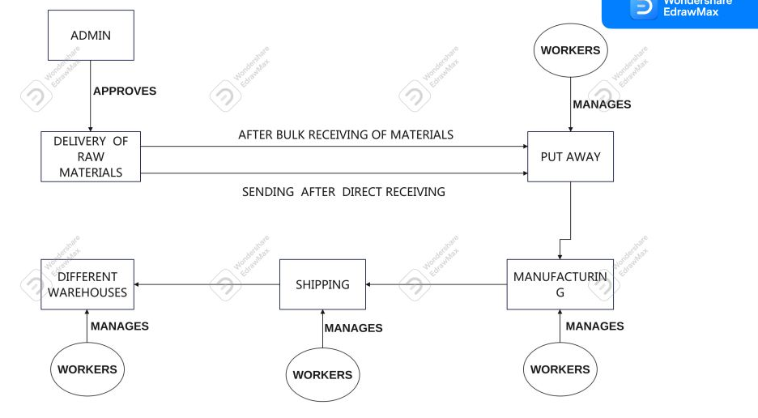

Product Functionality
The IM system allows,

F1. Admin logins to the website.
F2. Admin creates account for workers and shares details of it.
F3. Workers can login,logout of the site.
F4. Workers can change the avilability of a product as avilable and not avilabe.
F5. Workers have to update brands as total brands registered vs active brands.
F6. Workers have to order and verify the stock.
F7. If the stock recieved is expired Workers have to return the product.
F8. Workers can confirm and cancel the orders from customers.
F9. Workers have to generate reports of sales,stock and payments.
F10. Admin approves companies payment for stock purchase.
F11. Workers have to keep track of supplier and payments from supplier.
F12. Admin analyse and keep track of investment vs turnover.

Design and Implementation Constraints
- The developed system should run under any platform such as Unix, Linux, Mac, Windows etc...
- Student details can update or change by only administrator or database manager
- All mandatory fields should be filled by an individual
- Details provided by the individual during his sign up should be stored in databas.

Assumptions and Dependencies
- The details related to the student, rooms, hostel managers.
- Administrator is created in the database already
- Roles and tasks are predefined.

Specific Requirements

External Interface Requirements

User Interfaces
There are 2 types of user interfaces they are

1. Admin Interface
2. Worker Interface/ Employess Interface

Admin Interface would be able to see the tracking and all other details of the item. Whereas the employee interface would be able to add/ modify the data from the database.

Hardware Interfaces
Hardware interfaces exists in computing systems between many of the components such as the various storage devicers, other I/O devices, etc. These are the following for this project

- Processor : Pentium or higher
- RAM : 512 MB
- Hard Disk : Min 4GB (Depends on the data)
- Keyboard
- Monitor

Software Interfaces
- OS : Linux/Windows
- Database : SQL

Functional Requirements

Admin logins to the website.

Admin creates account for workers and shares details of it.

Workers can login,logout of the site.

Workers can change the avilability of a product as avilable and not avilabe.

Workers have to update brands as total brands registered vs active brands.

Workers have to order and verify the stock.

If the stock recieved is expired Workers have to return the product.

Workers can confirm and cancel the orders from customers.

Workers have to generate reports of sales,stock and payments.

Admin approves companies payment for stock purchase.

Workers have to keep track of supplier and payments from supplier.

Admin analyse and keep track of investment vs turnover.

Use Case Model
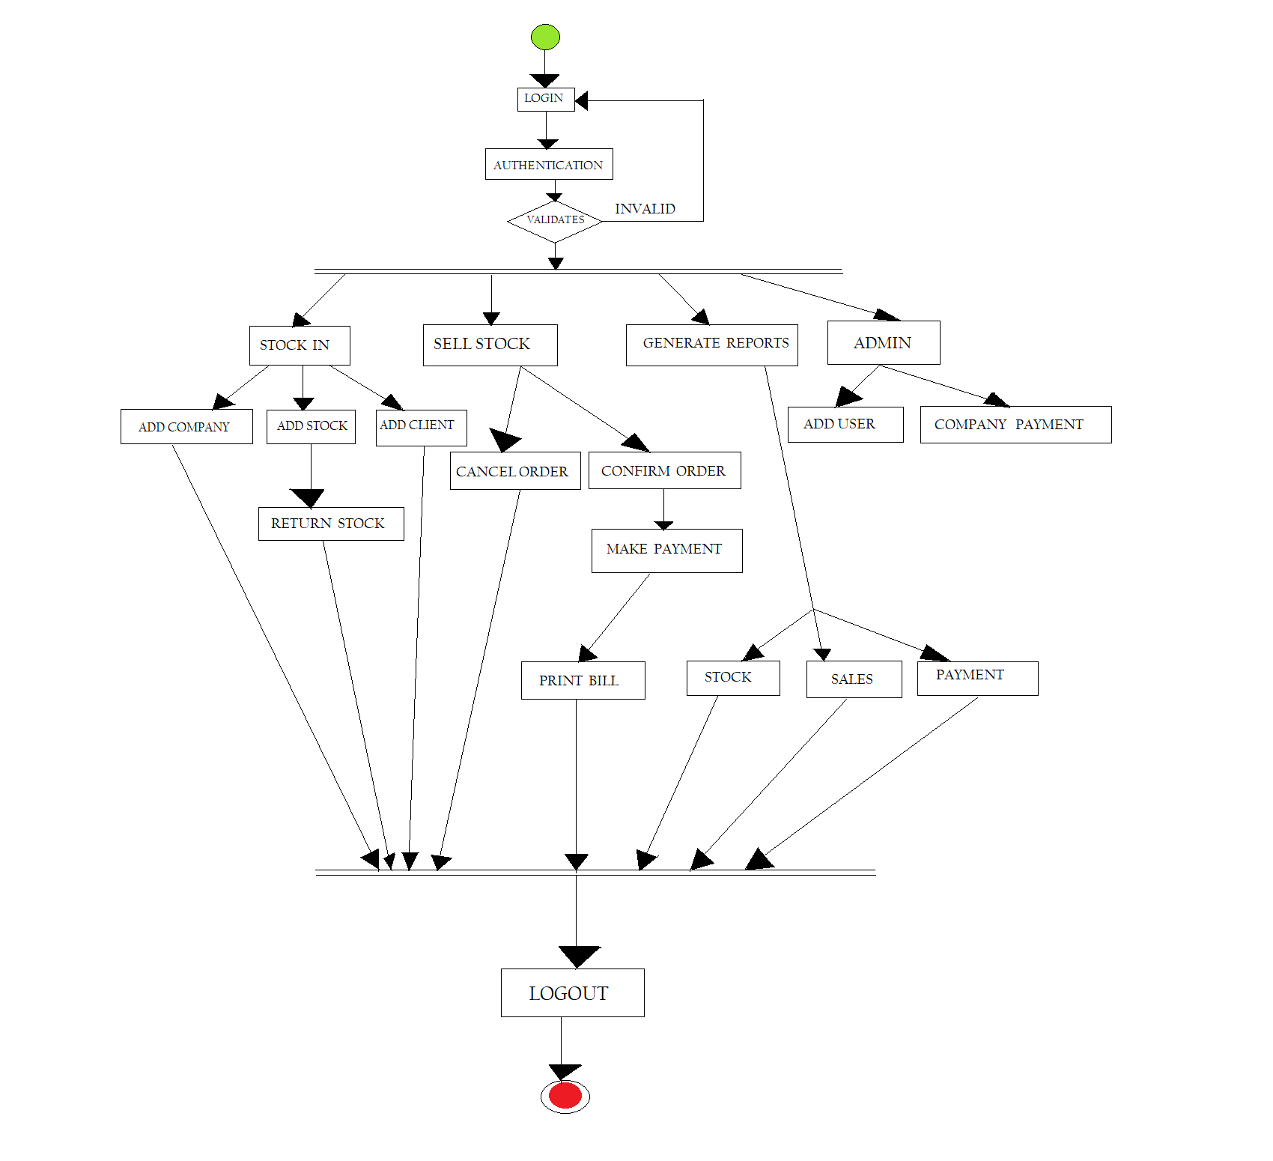

Use Case #1 (Admin logins to the website. U1)
Author – Gnana Prakash P
Purpose – Admins need to sign in to track the products.
Requirements Traceability – F1
Priority - High
Preconditions – Only the admin can have the access to the details of products and employees.
Post conditions – The admin logins to the system.
Actors – Admin
Extends – None
Flow of Events
  - Basic Flow
  - The admins opens the website.
  - system prompts admin to Sign Up or Sign In in the admin page.
  - Admin can create worker accounts and can remove worker accounts, have access to the data.
  - system sends admin information to his or her email for confirmation - admin verifies and the registration is successful.
  - Alternative Flow
  - If one of the required fields (such as email) in the signup page does not meet the requirements, a warning message will be shown by the system to correct.
  - If all the required fields are properly filled, the system redirects the admin to the sign in page.
Includes - None

Use Case #2 (Admin creates account for workers and shares details of it. U2)
Author – Gnana Prakash P
Purpose – Admin creates account for employees and shares the login details.
Requirements Traceability – F2
Priority - High
Preconditions – Admin must login to the system.
Post conditions – Employee's accounts would be created.
Actors – Admin, Employee
Extends – None
Flow of Events
  - Basic Flow
  - Worker’s accounts would be generated and the worker can login in with the details shared by admin in the worker’s page.
Includes - None

Use Case #3 (Workers can login,logout of the site. U3)
Author – Sai Krishna T
Purpose – Employees can login and modify the details
Requirements Traceability – F3
Priority - Medium
Preconditions – Worked must be approved by the admin.
Post conditions – Workers can modify the details of the products
Actors – Worker
Extends – None
Flow of Events
  - Basic Flow
  - Workers need to login in inorder to enter the details of the products.
  - Alternative Flow
  - In can of wrong details of workers, the workers can raise a query where the admin can verify.
Includes - None

Use Case #4 (Workers can change the avilability of a product as avilable and not avilabe. U4)
Author – Sai Krishna T
Purpose – Employees can change the details of the product by updating it.
Requirements Traceability – F4
Priority - Medium,
Preconditions – Worker must login through worker’s page, worker’s account must be created by the admin.
Post conditions – The tracking of item can be seen by the admin when worker inputs the data.
Actors – Worker
Extends – None
Flow of Events
  - Basic Flow
  - Workers change or update the product details.
  - Different process involve like manufacturing, put away so the details of these products changes through the process.
  - Alternative Flow
  - Some errors may arise when the details of the items entered are wrong.
Includes - None

Use Case #5 (Workers have to update brands as total brands registered vs active brands. U5)
Author – Sai Krishna T
Purpose – Workers work on the active brands, when they enter the products the system shows the active brands vs the total brands.
Requirements Traceability – F5
Priority - High
Preconditions - Worker must login through worker’s page, worker’s account must be created by the admin.
Post conditions - The tracking of item can be seen by the admin when worker inputs the data.
Actors – Worker
Extends – None
Flow of Events
  - Basic Flow
  - By updating the brands we can see the number of active brands vs the overall registered brands.
Includes - None

Use Case #6 (Workers have to order and verify the stock. U6)
Author – Pramodh P
Purpose – By verifying the stock the worker knows weather to order the raw materials or not.
Requirements Traceability – F6
Priority - Medium
Preconditions - Worker must login through worker’s page, worker’s account must be created by the admin.
Post conditions - The tracking of item can be seen by the admin when worker inputs the data.
Actors – Worker
Extends – None
Flow of Events
  - Basic Flow
  - By verifying the stocks the workers raises for the required items through the worker’s account.
  - Alternative Flow
  - If the verification of stocks are not correct then many problems arise on the raw materials and the flow of new products.
Includes - None

Use Case #7 (If the stock recieved is damaged Workers have to return the product. U7)
Author – Pramodh P
Purpose – If a received stock is damaged, workers must return the raw products.
Requirements Traceability – F7
Priority - High
Preconditions - Worker must login through worker’s page, worker’s account must be created by the admin.
Post conditions – The damaged products would be replaced.
Actors – Worker
Extends – None
Flow of Events
  - Basic Flow
- The damaged raw materials would be returned by the worker.
Includes - None

Use Case #8 (Workers can confirm and cancel the orders from customers. U8)
Author – Ramnivas P
Purpose – Worker would be able to confirm and cancel orders of customers.
Requirements Traceability – F8
Priority - Low
Preconditions - Worker must login through worker’s page, worker’s account must be created by the admin and check the products of customers.
Post conditions – The customers gets the notification on their request.
Actors – Worker
Extends – None
Flow of Events
  - Basic Flow
  - Customers places orders and workers need to either conform it or reject it.
Includes - None

Use Case #9 (Workers have to generate reports of sales,stock and payments. U9)
Author – Ramnivas P
Purpose – Generating sales, stocks and payments.
Requirements Traceability – F9
Priority - High
Preconditions - Worker must login through worker’s page, worker’s account must be created by the admin.
Post conditions – Reports would be generated on sales, stocks and payments.
Actors – Worker
Extends – None
Flow of Events
  - Basic Flow
  - By using the current flow workers generate reports on stocks, sales and payments.
Includes - None

Use Case #10 (Admin approves companies payment for stock purchase. U10)
Author – Deepak
Purpose – Approval of payments for the raw materials.
Requirements Traceability – F10
Priority - High
Preconditions – Workers must give an indication on the required raw materials.
Post conditions – When approved the raw materials request confirms.
Actors – Admin
Extends – None
Flow of Events
  - Basic Flow
  - Workers requests for the raw materials and the payments need to be accepted by the admin.
Includes - None

Use Case #11 (Workers have to keep track of supplier and payments from supplier. U11)
Author – Deepak
Purpose – Keep track of all details regarding the suppliers.
Requirements Traceability – F11
Priority - Medium
Preconditions - Worker must login through worker’s page, worker’s account must be created by the admin.
Post conditions – Every thing gets updated through the database.
Actors – Worker
Extends – None
Flow of Events
  - Basic Flow
  - All the details regarding the supplier their raw materials, payments need to be updated by the worker.
Includes - None

Use Case #12 (Admin analyse and keep track of investment vs turnove. U12)
Author – Gnana Prakash P
Purpose – By analyzing the revenue need to keep track of investment vs turnover.
Requirements Traceability – F12
Priority - High
Preconditions – After selling the products we get to know the revenue.
Post conditions – This helps us in forecasting and improvement of the products.
Actors – Computer
Extends – None
Flow of Events
  - Basic Flow
  - Analyzing must be done done by the system and keep track of investment vs income.
Includes - None

Other Non-functional Requirements

Performance Requirements
- The database shall be able to accommodate around thousand records to store.
- The software shall support use of multiple users at a time.
- The website would be functional for 24 hours a day to enable user interaction at any point of time.

Safety and Security Requirements
- There must be database backup because of possibilities of system crash due to virus or any system failure.
- The password of admin must be highly confidential.
- The password of users must be confidential.
- The database should be carefully maintained by the admin any loss may lead to chaos.

Software Quality Attributes
- Performance
The application shall be based on java and has to be run on any platform. The application shall take initial load time depending on performance of Operating System. The performance shall depend upon hardware & software components of the computer.

- Reliability & availability
The project shall provide storage of all databases on redundant computers with oracle database.

- Security
This project provides a genuine security to all those individuals who are having there account on the database as they are password protected. This is very important aspect of the design and should cover areas of hardware reliability, fall back procedures, physical security of data and provision for detection of fraud and abuse.

- Maintainability
Inventory Management System will be maintainable as long as there are no Hardware & software problems also databases should be updated.

- Portability
The project is made in java as front end & sql database as back end and will work upon all OS efficiently.

Other Requirements
<This section is Optional. Define any other requirements not covered elsewhere in the SRS. This might include database requirements, internationalization requirements, legal requirements, reuse objectives for the project, and so on. Add any new sections that are pertinent to the project.>

