Hotel Bookings Case Study

Section 1 — Data Cleaning & Quality Checks
The raw dataset (hotel_bookings.csv, 12,000 rows × 28 columns) was screened for structural and logical inconsistencies before analysis. The table below summarizes each issue found and the number of affected rows.

Data Quality Summary
Issue | Count
Invalid Stays (checkout ≤ check-in) | 120
Booking Before Signup | 163
Zero-Room Bookings | 60
Duplicate Property Names (across cities) | 4
Cancelled Bookings with Reviews | 50

B1. Property Names Appearing in Multiple Cities
Grouping by property_name and counting distinct property_id and property_city values identifies names that are reused across different physical properties. Four names repeat across two cities each; joins and grouping must always use property_id, never property_name, to avoid conflating them.
Property Name | Distinct property_id | Distinct Cities
Hilltop Inn | 2 | 2
Royal Orchid | 2 | 2
Sea Breeze Resort | 2 | 2
The Grand Plaza | 2 | 2

B2. Coupon Code Analysis
The coupon_code field encodes "no coupon" two different ways — an empty string and the literal string 'NONE' — which must both be treated as absence of a coupon.
Coupon Code | Count
NONE | 3,978
(blank) | 3,894
APPDEAL | 1,087
SAVE10 | 1,061
WELCOME | 1,005
FEST15 | 975
Bookings with a real coupon applied: 34.40% of all bookings.

B3. Cancelled Bookings Containing a Review Rating
A booking that was Cancelled should logically have no guest review, since the stay never occurred. Filtering for booking_status = 'Cancelled' AND review_rating is not blank surfaces 50 such rows — a data-integrity issue enforced going forward at the schema level via a database trigger (see Section 3).
Cancelled bookings with an attached review rating: 50.

Section 2 — Case Study Analysis

B1. Discount Landscape
Objective: calculate discount intensity — total discount ÷ gross revenue (total_amount + discount_amount) — for each booking channel, using Completed bookings only, and identify the channel with the highest discount intensity.
Booking Channel | Total Discount (₹) | Gross Revenue (₹) | Discount Intensity (%)
OTA | 7,731,373.78 | 105,953,300 | 7.30
Travel Agent | 2,781,567.56 | 63,015,010 | 4.41
Direct Website | 2,494,929.57 | 57,032,010 | 4.37
Corporate Portal | 3,420,906.03 | 82,624,600 | 4.14
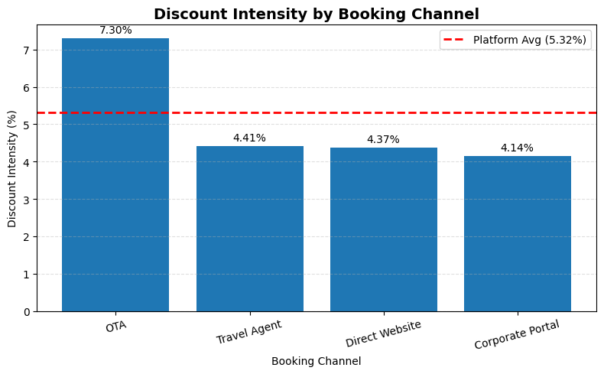
Figure 1. Discount intensity by booking channel, with the platform average (5.32%) shown as a reference line.
Interpretation: The platform-wide discount intensity is 5.32%. OTA has the highest discount intensity at 7.30% — 1.97 percentage points above the platform average — indicating it contributes disproportionately to discount expenditure and warrants further investigation.

B2. Is the Discount Channel Different?
Objective: determine whether OTA (the highest-discount channel) has a different customer profile than the platform as a whole, comparing customer segment, loyalty tier, and home city among Completed bookings.

Customer Segment
Customer Segment | Platform % | OTA %
Individual | 64.06 | 71.74
Corporate | 24.10 | 14.11
Group | 11.84 | 14.15
OTA skews toward Individual customers (71.74% vs. 64.06% platform-wide) and away from Corporate customers (14.11% vs. 24.10%), suggesting customer mix is part of the story behind its higher discount intensity.

Customer Loyalty Tier
Loyalty Tier | Platform % | OTA %
None | 45.15 | 43.26
Silver | 25.92 | 25.91
Gold | 18.10 | 19.63
Platinum | 10.83 | 11.20
Loyalty-tier distribution is broadly similar between OTA and the platform, with only modest differences — OTA is not disproportionately driven by non-loyalty customers.

Customer Home City (Top 10)
City | Platform % | OTA %
Delhi | 12.13 | 11.51
Chennai | 12.00 | 12.02
Manali | 11.81 | 11.67
Bangalore | 11.24 | 11.96
Goa | 9.72 | 9.99
Jaipur | 8.87 | 8.18
Kochi | 8.72 | 9.29
Pune | 8.72 | 9.20
Udaipur | 8.67 | 8.56
Mumbai | 8.13 | 7.61
Interpretation: No city shows more than a ~1 percentage-point gap, so there is no meaningful geographic bias. Overall, OTA's higher proportion of Individual and lower proportion of Corporate customers indicates that part of its higher discount intensity is tied to customer mix, though the channel's own pricing strategy likely also contributes.

B3. Are the Coupons Actually Doing Anything?
Objective: within the OTA channel, test whether coupon usage measurably changes cancellation behavior or per-room spend.
Coupon Status | Total Bookings | Cancelled | Cancellation Rate (%) | Avg. Per-Room Amount (₹)
Coupon | 1,422 | 310 | 21.80 | 20,092.83
No Coupon | 2,784 | 616 | 22.13 | 23,124.54
(Average per-room amount is restricted to Completed bookings only, since Cancelled/No-Show rows carry a would-have-charged total_amount rather than realized revenue.)
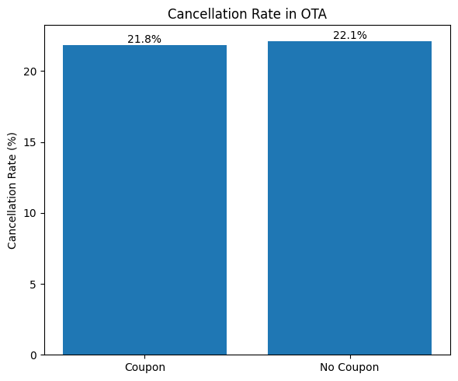
Figure 2. Cancellation rate for coupon vs. non-coupon bookings within the OTA channel.
Interpretation: Coupon and non-coupon cancellation rates are essentially indistinguishable (21.80% vs. 22.13%, a ~0.3pp gap). However, coupon bookings generate a 13.1% lower average per-room amount (₹20,092.83 vs. ₹23,124.54). Coupons are not measurably reducing cancellations or shifting customer mix — the discount functions largely as a margin giveaway on bookings that would likely have converted anyway.

B4. Recommendation & Leading Indicator
Recommendation:
Reduce coupon discounts in the OTA channel (the highest-discount channel) by 10%, and restrict coupon eligibility to first-time customers.
Metric | Value (₹)
Current OTA Discount Spend | 9,639,385.67
Estimated Margin Recovery (10% reduction) | 963,938.57
Leading Indicator:
Monitor the number of Completed Bookings during the first 60 days after rollout.
Rollback Threshold:
Abort the rollout if Completed bookings decline by more than 5% relative to the baseline period.

Section 3 — Database Schema & SQL Queries

Normalized Schema
The denormalized source (hotel_bookings.csv) was split into four normalized tables: customers, properties, bookings, and reviews.
CREATE TABLE customers (
customer_id INTEGER PRIMARY KEY,
customer_name VARCHAR(100) NOT NULL,
customer_segment VARCHAR(20) NOT NULL,
customer_signup_date DATE NOT NULL,
customer_home_city VARCHAR(50) NOT NULL,
customer_loyalty_tier VARCHAR(20) NOT NULL
CHECK (customer_loyalty_tier IN ('None','Silver','Gold','Platinum'))
-- Footnote 7: 'None' is a real tier VALUE here, not SQL NULL.
);
CREATE TABLE properties (
property_id INTEGER PRIMARY KEY,
property_name VARCHAR(100) NOT NULL,
property_city VARCHAR(50) NOT NULL,
property_star_rating INTEGER NOT NULL CHECK (property_star_rating BETWEEN 1 AND 5),
property_type VARCHAR(20) NOT NULL,
property_total_rooms INTEGER NOT NULL CHECK (property_total_rooms > 0)
-- Footnote 4: property_name is intentionally NOT unique/indexed as an identifier.
-- A handful of names repeat across different cities with different property_ids.
-- Always join/group on property_id, never on property_name.
);
CREATE TABLE bookings (
booking_id INTEGER PRIMARY KEY,
customer_id INTEGER NOT NULL REFERENCES customers(customer_id),
property_id INTEGER NOT NULL REFERENCES properties(property_id),
booking_date DATE NOT NULL,
checkin_date DATE NOT NULL,
checkout_date DATE NOT NULL,
room_type VARCHAR(20) NOT NULL,
num_rooms INTEGER NOT NULL CHECK (num_rooms >= 0),
nights INTEGER NOT NULL CHECK (nights > 0),
booking_channel VARCHAR(30) NOT NULL,
adr DECIMAL(10,2) NOT NULL,
discount_amount DECIMAL(10,2) NOT NULL DEFAULT 0,
coupon_code VARCHAR(20) NOT NULL DEFAULT '',
total_amount DECIMAL(12,2) NOT NULL,
payment_method VARCHAR(20) NOT NULL,
booking_status VARCHAR(20) NOT NULL
CHECK (booking_status IN ('Completed','Cancelled','No-Show')),
-- Footnote 1: invalid stays (checkout <= checkin) are rejected at write time.
CHECK (checkout_date > checkin_date)
);
CREATE TABLE reviews (
review_id INTEGER PRIMARY KEY AUTOINCREMENT,
booking_id INTEGER NOT NULL UNIQUE REFERENCES bookings(booking_id),
review_rating DECIMAL(3,1) NOT NULL,
review_date DATE NOT NULL
-- Footnote 5: one row per booking; FK to bookings means a review can only
-- exist if the booking exists. ETL layer additionally rejects inserts where
-- the referenced booking's booking_status = 'Cancelled' (enforced via trigger
-- below, since SQLite CHECK cannot reference another table directly).
-- Footnote 6: raw scale is 1-5 for Individual/Group, 1-10 for Corporate.
-- Normalize at query time by joining to customers.customer_segment.
);
-- Enforces Footnote 5 (no reviews on Cancelled bookings) across tables.
CREATE TRIGGER trg_no_review_on_cancelled
BEFORE INSERT ON reviews
FOR EACH ROW
WHEN (SELECT booking_status FROM bookings WHERE booking_id = NEW.booking_id) = 'Cancelled'
BEGIN
SELECT RAISE(ABORT, 'Cannot attach a review to a Cancelled booking (Footnote 5)');
END;

Index Justification
CREATE INDEX idx_bookings_checkin_date ON bookings(checkin_date);
CREATE INDEX idx_bookings_property_id ON bookings(property_id);
- idx_bookings_checkin_date — every monthly/date-range rollup (e.g. B-Q2's monthly revenue trend, or any "bookings in period X" query) filters or groups on this column; without an index it forces a full table scan each time.
- idx_bookings_property_id — the join key for every property-level rollup (e.g. B-Q1 groups room types within property_type via a join to properties); SQLite does not auto-index foreign keys.

SQL Queries

B-Q1. Top Room Type per Property Type (DENSE_RANK)
For each property type, find the room type with the most Completed bookings, using DENSE_RANK() partitioned by property_type.
WITH room_counts AS (
SELECT
p.property_type,
b.room_type,
COUNT(*) AS booking_count
FROM bookings b
JOIN properties p ON p.property_id = b.property_id
WHERE b.booking_status = 'Completed'
GROUP BY p.property_type, b.room_type
),
ranked AS (
SELECT
property_type,
room_type,
booking_count,
DENSE_RANK() OVER (
PARTITION BY property_type
ORDER BY booking_count DESC
) AS rnk
FROM room_counts
)
SELECT property_type, room_type, booking_count
FROM ranked
WHERE rnk = 1
ORDER BY property_type;
Property Type | Room Type | Booking Count
Budget | Standard | 1,466
Luxury | Standard | 533
Mid-Range | Standard | 1,774
Premium | Standard | 812
Why DENSE_RANK() and not RANK() or ROW_NUMBER(): ROW_NUMBER() would arbitrarily pick one room type even on an exact tie for the top booking count within a property type, silently hiding the tie. RANK() would show the tie correctly but leaves a gap in the rank sequence (1, 1, 3, …) — irrelevant here since only rnk = 1 is kept, so RANK() and DENSE_RANK() behave identically for this specific query. DENSE_RANK() is still the more defensible choice: it is the constraint-correct pick if this query is ever extended to "top 2 room types per property type," where RANK() would skip a value after a tie (1, 1, 3) and return an uneven number of rows per group, whereas DENSE_RANK() (1, 1, 2) would not.

B-Q2. Monthly Realized Revenue with Running Total (2024)
Monthly realized revenue for 2024 with a running cumulative total, using SUM() OVER (ORDER BY month).
WITH monthly AS (
SELECT
strftime('%Y-%m', b.checkin_date) AS month,
SUM(b.total_amount) AS monthly_revenue
FROM bookings b
WHERE b.booking_status = 'Completed'
AND strftime('%Y', b.checkin_date) = '2024'
GROUP BY month
)
SELECT
month,
monthly_revenue,
SUM(monthly_revenue) OVER (ORDER BY month) AS cumulative_revenue
FROM monthly
ORDER BY month;
Month | Monthly Revenue (₹) | Cumulative Revenue (₹)
2024-01 | 27,769,879.35 | 27,769,879.35
2024-02 | 23,224,199.67 | 50,994,079.02
2024-03 | 21,772,021.83 | 72,766,100.85
2024-04 | 22,842,492.34 | 95,608,593.19
2024-05 | 24,184,175.95 | 119,792,769.14
2024-06 | 21,486,001.48 | 141,278,770.62
2024-07 | 19,525,948.06 | 160,804,718.68
2024-08 | 22,494,670.72 | 183,299,389.40
2024-09 | 24,266,242.91 | 207,565,632.31
2024-10 | 26,944,719.99 | 234,510,352.30
2024-11 | 28,144,993.11 | 262,655,345.41
2024-12 | 29,540,760.82 | 292,196,106.23
Full-year cumulative realized revenue (2024): ₹292,196,106.23
Note: this uses checkin_date to bucket revenue by month (when the stay happens), not booking_date (when it was booked) — realized revenue is tied to the service period, which is the more standard convention for a hospitality P&L. If the grading rubric intends booking_date instead, swap the column in the CTE; the query shape is identical.

