**MAQ Software**

**MAQ Software** is a privately held [software](http://www.wow.com/wiki/Software) services company based in [Redmond](http://www.wow.com/wiki/Redmond,_Washington), [Washington](http://www.wow.com/wiki/Washington_(state)), [United States](http://www.wow.com/wiki/United_States). The company was founded in 2000 by [Rajeev Agarwal](http://www.wow.com/wiki/Rajeev_Agarwal). MAQ Software is a digital marketing, analytics, and technology [solutions](http://www.wow.com/wiki/Solution) company that helps its clients service their markets effectively. The company's projects include custom solutions built around Analytics, Business Intelligence, Mobile, CRM, and Azure. MAQ Software is a [Microsoft](http://www.wow.com/wiki/Microsoft) Preferred Vendor and Silver Certified Business Intelligence Partner, as well as an Amazon Consulting Partner.

MAQ Software specialises in Data Management and Reporting to help business users support their intuition with data. MAQ Software has worked closely with marketing, operations, and product groups across Fortune 500 companies. More than 50,000 Product, Sales, and Marketing Managers around the globe use custom applications (both on-premise and Cloud hosted), Line-of-Business (LOB), and Data Analytics & Business Intelligence (BI) solutions created and managed by organisation. Using the latest Agile engineering techniques in a disciplined manner, the company accelerates software initiatives that enable customers to transform their industries.

MAQ Software has accomplished the rare achievement of ranking on the Inc. 5000 list for the ninth time. Only 1% of Inc. 5000 companies demonstrate sustained growth by appearing nine or more times. The highly prestigious list has tracked the nation's fastest-growing private companies for 35 years.

The list serves as evidence of significant accomplishments by America’s most successful independent businesses. Companies such as Microsoft, Domino’s Pizza, Pandora, Intuit, LinkedIn, Yelp, and many others gained their first national exposure as Inc. 5000 honorees.

“We thank our customers for trusting us with their most demanding software initiatives that are transforming their industries. Our customers choose us because we accelerate their software projects through our unique techniques and processes,” says MAQ Software Founder and Managing Consultant Rajeev Agarwal. “I am proud of our team members’ expertise and their relentless focus on adopting the latest technologies quickly.”

In the past 10 years, from more than 23 million businesses in the United States, only 23,674 companies made it onto to the Inc. 5000. Just three other companies from Washington state have made it onto the list nine or more times.

Area of expertise:

* Data Management
* Artificial Intelligence
* Power BI
* App Development
* Cloud Transformation

1. **Transact-SQL**

Transact SQL or better known as T-SQL is a set of programming extensions from Sybase and Microsoft that add several features to the Structured Query Language ([SQL](http://searchsqlserver.techtarget.com/definition/SQL)), including transaction control, exception and error handling, row processing and declared variables.

T-SQL is used to interact with [relational databases](https://en.wikipedia.org/wiki/Relational_database). T-SQL expands on the SQL standard to include [procedural](https://en.wikipedia.org/wiki/Procedural_programming) programming, [local variables](https://en.wikipedia.org/wiki/Local_variable), various support functions for string processing, date processing, mathematics, etc. and changes to the [DELETE](https://en.wikipedia.org/wiki/Delete_(SQL)) and [UPDATE](https://en.wikipedia.org/wiki/Update_(SQL)) statements.

Transact-SQL is central to using [Microsoft SQL Server](https://en.wikipedia.org/wiki/Microsoft_SQL_Server). All applications that communicate with an instance of SQL Server do so by sending Transact-SQL statements to the server, regardless of the user interface of the application.

Difference between T-SQL and SQL

* T-SQL adds a number of features that are not available in SQL. This includes procedural programming elements and a local variable to provide more flexible control of how the application flows.
* A number of functions were also added to T-SQL to make it more powerful; functions for mathematical operations, string operations, date and time processing, and the like.
* These additions make T-SQL comply with the Turing completeness test, a test that determines the universality of a computing language. SQL is not Turing complete and is very limited in the scope of what it can do.
* Another significant difference between T-SQL and SQL is the changes done to the DELETE and UPDATE commands that are already available in SQL. With T-SQL, the DELETE and UPDATE commands both allow the inclusion of a FROM clause which allows the use of JOINs. This simplifies the filtering of records to easily pick out the entries that match a certain criteria unlike with SQL.
* SQL is non-procedural language since it deals with what data to be extracted. Whereas T-SQL is procedure language since it deals with what data to be executed and how it should be displayed.
* The SQL queries in SQL are submitted individually to the database server, while in T-SQL the batch program is written where in all commands are submitted to the server in a single go.

T-SQL's transaction and journaling system, handles just about anything - including a power cycle or hardware failure - without database corruption, and if something gets messed up it fixes it automatically.

T-SQL support CTE. A common table expression (CTE) can be thought of as a temporary result set that is defined within the execution scope of a single SELECT, INSERT, UPDATE, DELETE, or CREATE VIEW statement. A CTE is similar to a derived table in that it is not stored as an object and lasts only for the duration of the query. Unlike a derived table, a CTE can be self-referencing and can be referenced multiple times in the same query. It simplifies complex queries and most importantly enables you to recurse.

T-SQL is the SQL dialect that the product SQL Server is using. Transact-SQL is central to using SQL Server. All applications that communicate with an instance of SQL Server do so by sending Transact-SQL statements to the server, regardless of the user interface of the application. SQL Server is tied to Transact-SQL ([T-SQL](http://searchsqlserver.techtarget.com/definition/T-SQL)), an implementation of SQL from Microsoft that adds a set of proprietary programming extensions to the standard language.

1. **Power BI**

Power BI is a cloud-based business analytics service from Microsoft that empowers anyone to experience any data – structured or unstructured – via simple drag-and-drop ease. Unlike many other dashboard solutions, Power BI can render live dashboards with moving charts and continuously updated visualizations for monitoring real-time streams from supported data sources.

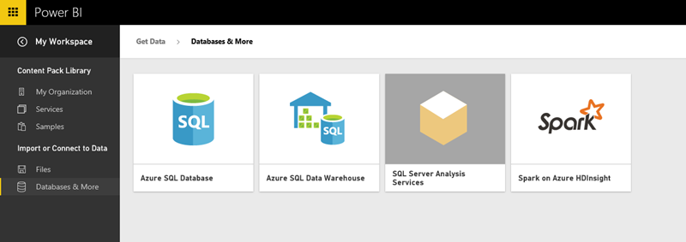

Figure 1: Power BI Connection

As shown in figure 1, we can use the [Power BI REST API](https://powerbi.microsoft.com/en-us/developers) with any data source or Azure Streaming Analytics to render live Power BI Dashboards automatically. Alternatively, you can get near real-time analytics using simple “direct connect” data sources such as [Analysis Services](http://www.jenunderwood.com/2015/01/20/tip-how-to-power-bi-ssas/), Azure SQL Database, Azure SQL Data Warehouse or Spark with Power BI Reports.

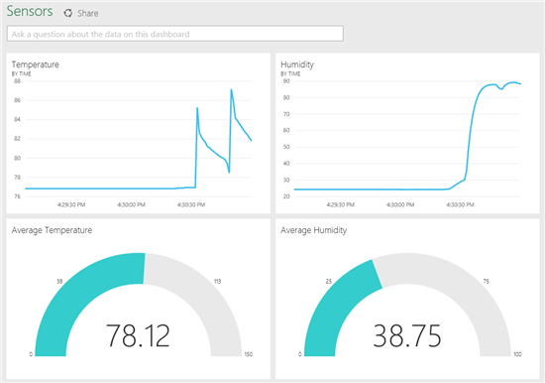

Figure 2: Power BI report

As shown in fig 2, We can get any type of visuals from Power BI ,Microsoft Power BI tools makes the reporting part so easy that we can create our reports in short period of time with so much attractive and correct and real time data, milliseconds refresh data we can retrieve with our job scheduling.

You can import the data which is required to make the power BI report from various sources. It can be an excel sheet, CSV (comma separated value) file, database on your local machine, data in cloud etc.

Power BI has Q&A feature to explore your data using intuitive, natural language capabilities and receive answers in the form of charts and graphs. Q&A is different from a search engine -- Q&A only provides results about the data in Power BI.

Data visualizations (aka visuals) helps us to interact with data to find business insights. The types of visualization generally used in Power BI reports are:

* Bar and column chart
* Cards ( multi row or single number)
* Line chart
* Stacked chart
* Gauge chart
* Matrix
* Pie chart
* Scatter and Bubble chart
* Slicer
* Table
* Tree Maps
* Waterfall chart

**Power BI** provides with self-service [business intelligence](https://en.wikipedia.org/wiki/Business_intelligence) capabilities, where end users can create reports and dashboards by themselves, without having to depend on [information technology](https://en.wikipedia.org/wiki/Information_technology) staff or [database administrators](https://en.wikipedia.org/wiki/Database_administrator).