1. Complete the configuration of the Angular and Springboot application from your PC
2. Create MYSQL schema in name of “link_shortener”
3. Run the Angular project using cmd = “ng serve”
4. Run the springboot application.

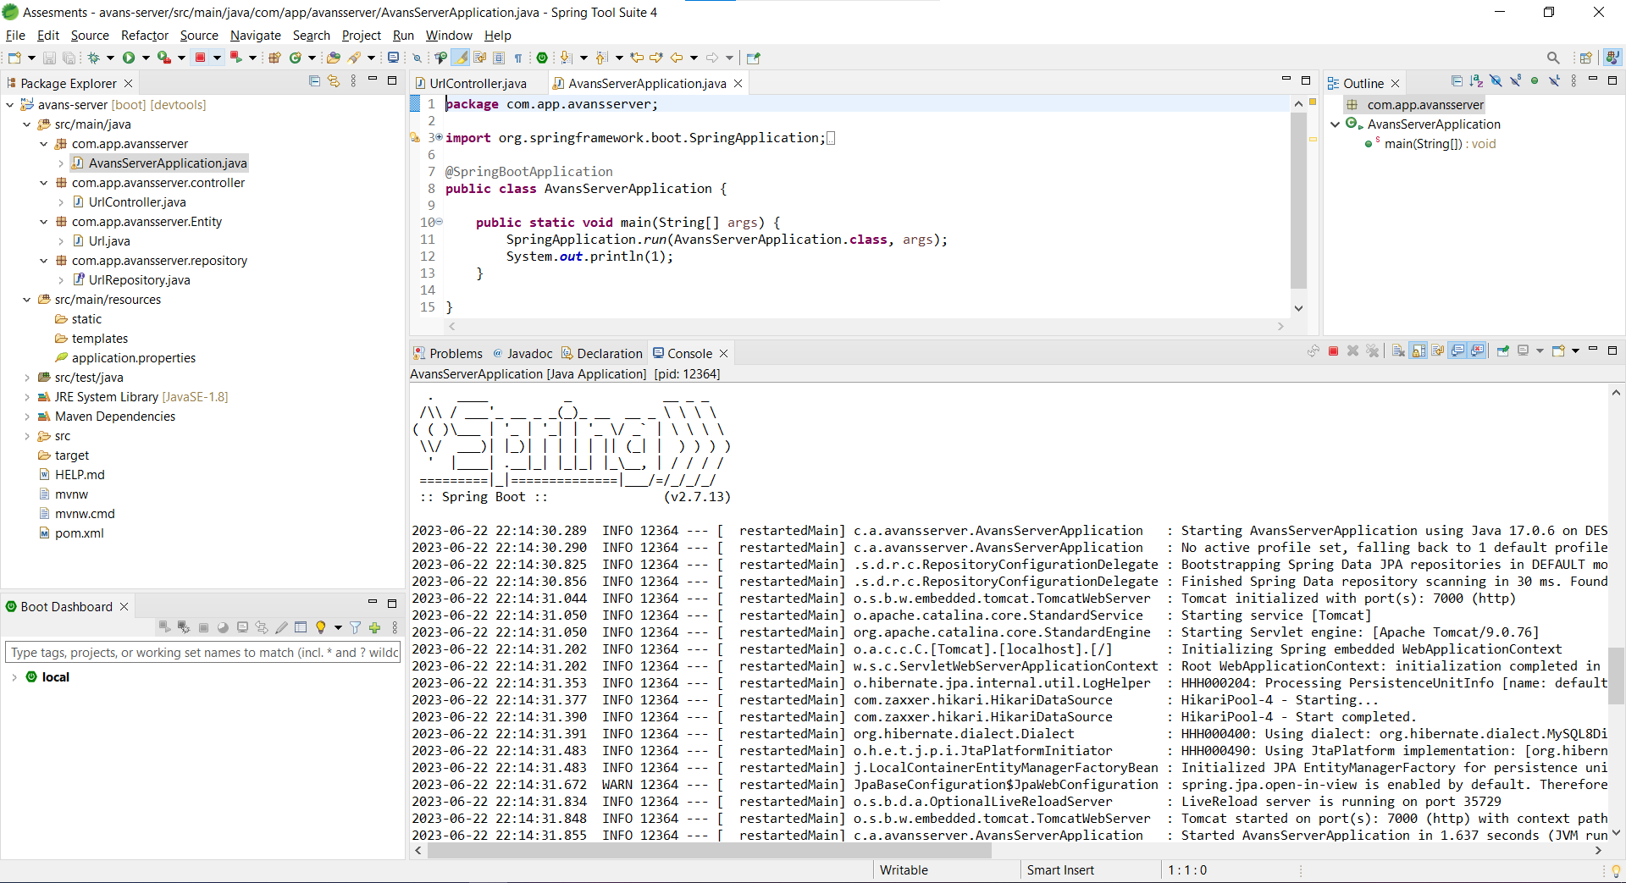

1. After running them you will get the client side interface like this

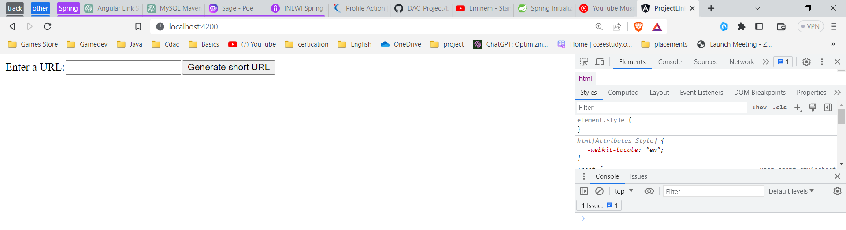

1. Enter the URL like this in the below

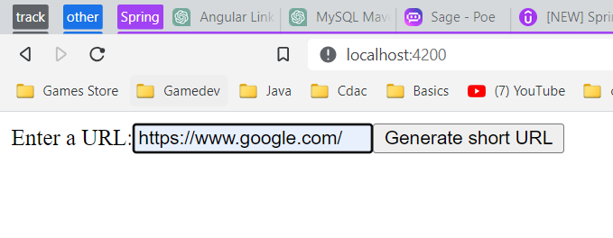

1. Click on the generate short URL
2. Goto database and copy the short url

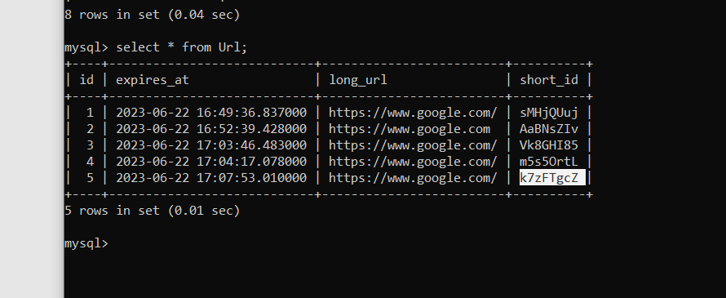

1. Search with this format = http://localhost:7000/urls/ + shorturl generated in database

In this case this is the url

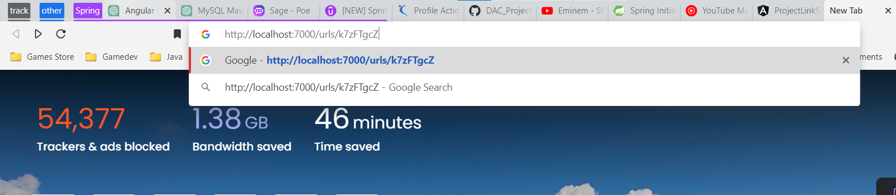

1. If I click enter it will redirect to google

Like this

