**SOFTWARE AS A PRODUCT**

**EXPERIMENT – 23**

**AIM:**

To demonstrate Storage as a Service (SaaS) by creating and configuring a new VM image in Azure.

**PROCEDURE:**

1. Log in to the Azure Portal.
2. Click on **Virtual Machines** and then click **+ Create** to launch the Create a virtual machine wizard.
3. Fill in basic details such as subscription, resource group, VM name, and region.
4. Choose an image (e.g., Ubuntu Server or Windows Server) and configure the size according to requirements.
5. Set the administrator username and password or SSH key for access.
6. In the **Disks** section, configure the OS disk type and optionally attach additional data disks.
7. Under the **Networking** section, configure the virtual network, subnet, and public IP if needed.
8. Click **Review + Create** and then **Create** to deploy the VM.
9. After deployment, go to the VM’s **Settings → Disks** to manage and confirm the attached storage.
10. Verify that the storage service is active by logging into the VM and checking the mounted volumes.

**OUTPUT:**

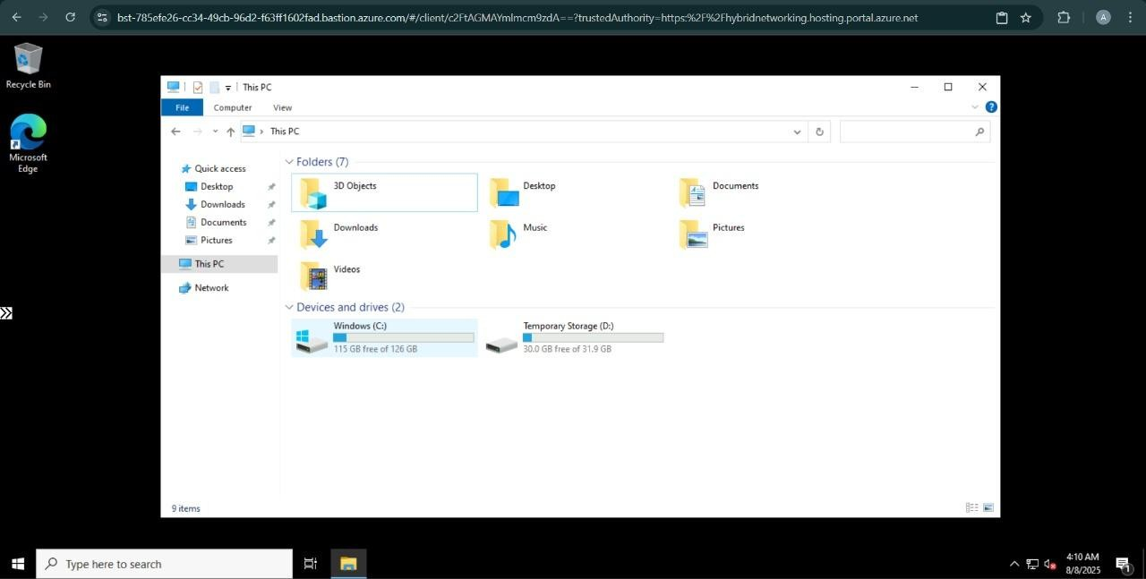

**RESULT:**

Successfully demonstrated Storage as a Service (SaaS) by configuring a new VM image and verifying attached storage in Azure.