**SOFTWARE AS A PRODUCT**

**EXPERIMENT – 24**

**AIM:**

To create a storage service in Azure and check the public accessibility of the stored file to demonstrate Storage as a Service.

**PROCEDURE:**

1. Log in to the Azure Portal.
2. Go to **Storage accounts** and click **+ Create**.
3. Fill in basic details such as subscription, resource group, and a unique storage account name.
4. Choose the region, performance, and redundancy options as required.
5. Click **Review + Create** and then **Create**.
6. Once the storage account is deployed, go to the **Containers** section under **Data storage**.
7. Click **+ Container** to create a new container and set the access level to **Blob (anonymous read access)**.
8. Upload a file (e.g., a text file or image) into the container.
9. After upload, click on the file and copy the **URL** provided.
10. Paste the URL in a browser to check public access and verify successful storage service configuration.

**OUTPUT:**

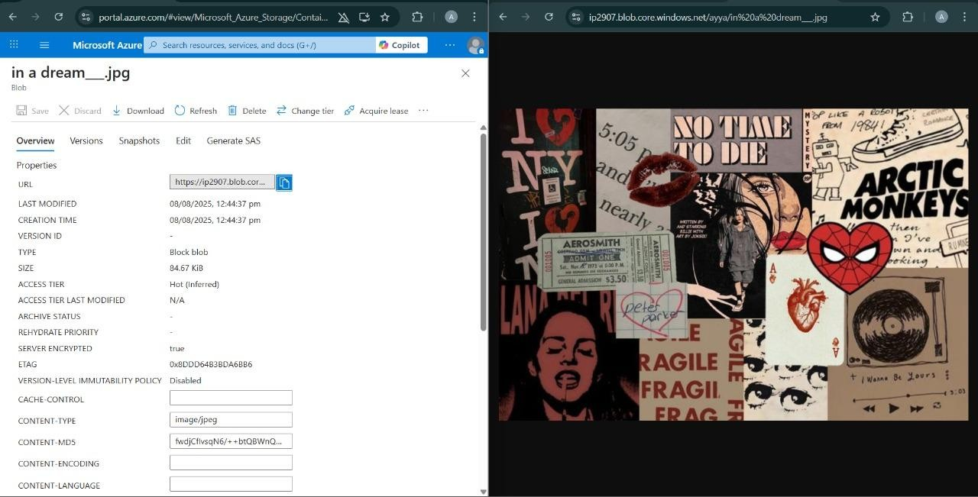

**RESULT:**

Successfully created a storage service in Azure and verified public accessibility of the stored file to demonstrate Storage as a Service.