PROPERTY MANAGEMENT APP

EXPERIMENT -3

AIM:

To Create a simple cloud software application on Property Management and provide it as a service using any Cloud Service Provider to demonstrate Software as a Service (SaaS)

PROCEDURE:

1. Go to https://creator.zoho.com on your browser. If you already have a Zoho account, click Sign In and enter your details; if not, click Sign Up Now and create a new account by following the on-screen instructions.
2. Once logged in, you'll be taken to your Zoho Creator dashboard. Look for the Create Application button (usually on the homepage or top-right corner) and click on it to start building your app.
3. You'll see options to create using a template, import data, or start fresh. Choose Create from Scratch so you can build the app exactly the way you want, without any predefined structure.
4. A prompt will appear asking you to name your application. Enter a meaningful name like "Property Management App" or any name that suits your purpose, then click the Create button to proceed.
5. Inside your new app workspace, click on Create New Form to design your first data entry form. Give your form a descriptive name that matches what data you plan to collect.
6. Use the form builder to add fields by dragging and dropping from the left panel. You can add text fields, date pickers, number fields, dropdowns, and more, renaming each field as needed to match your data requirements.
7. After arranging and customizing all the fields, click the Done button (usually at the top-right) to save your form. This ensures your design is stored and ready to be used.
8. Zoho Creator will now automatically create a report linked to your form. This report usually appears as a table view where you can see and manage all the submitted data entries.
9. Finally, click on Access this Application (often shown as a green button or link) to preview and test your app. Try adding a sample record to see how your form and report work together.

FORM 1:

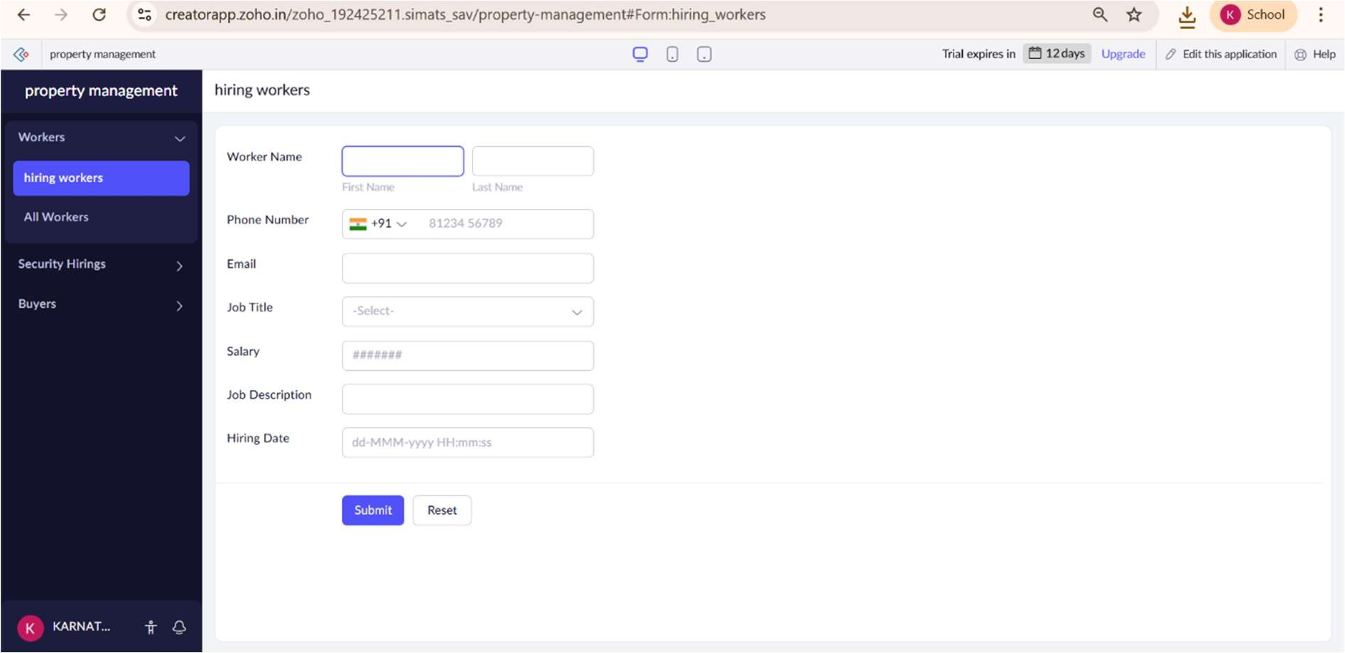

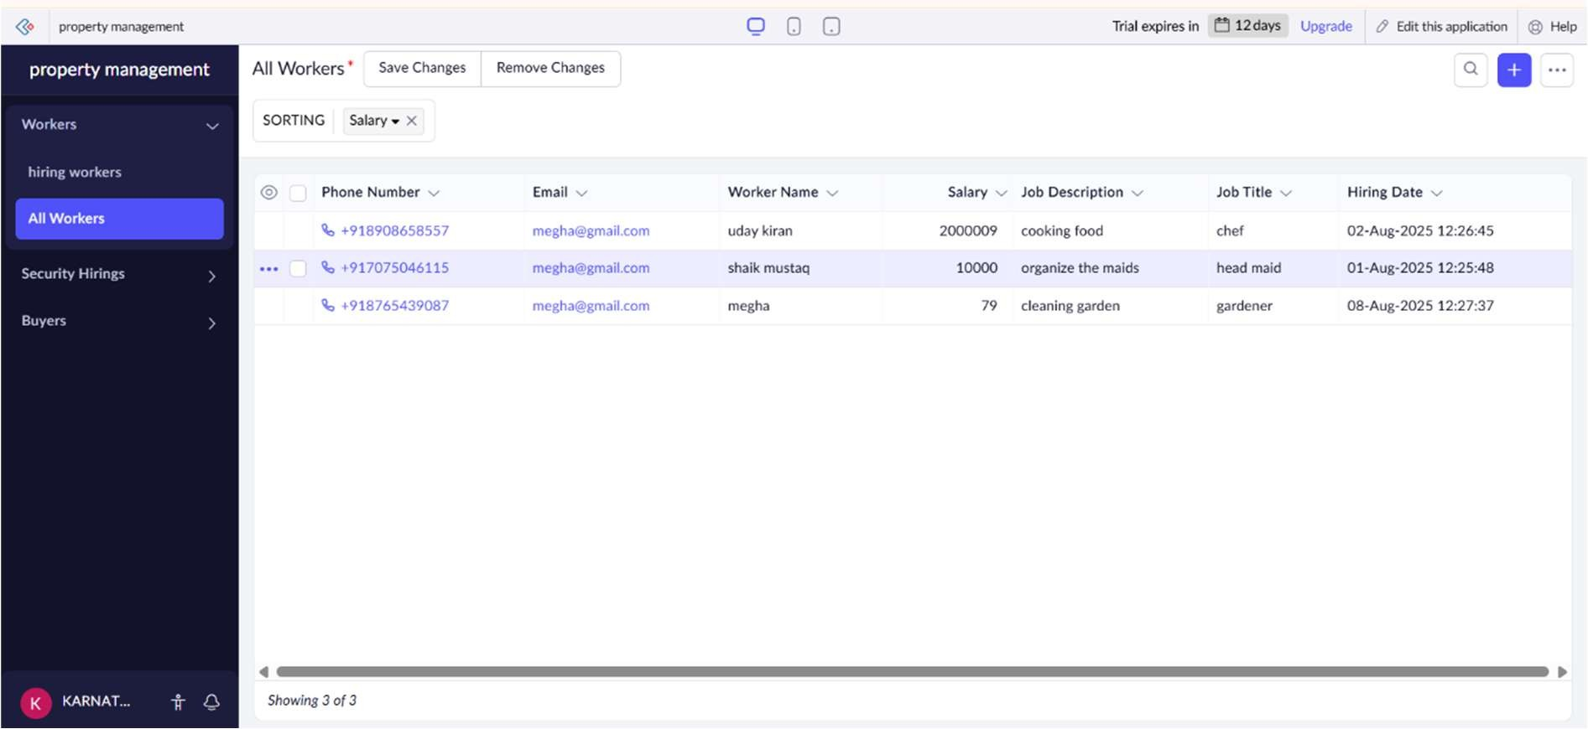

FORM 2:

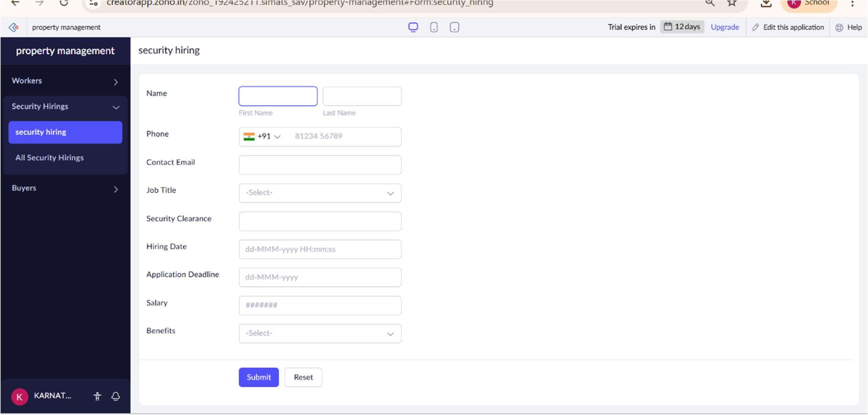

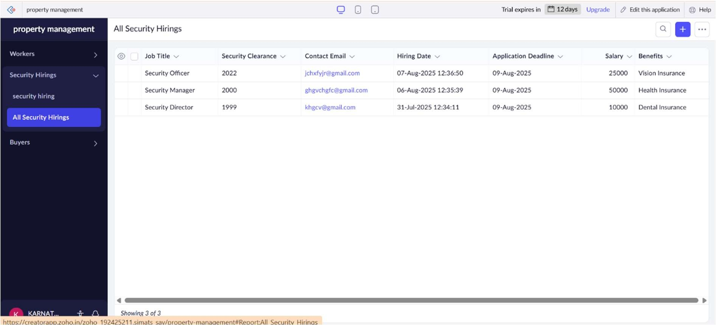

FORM 3:

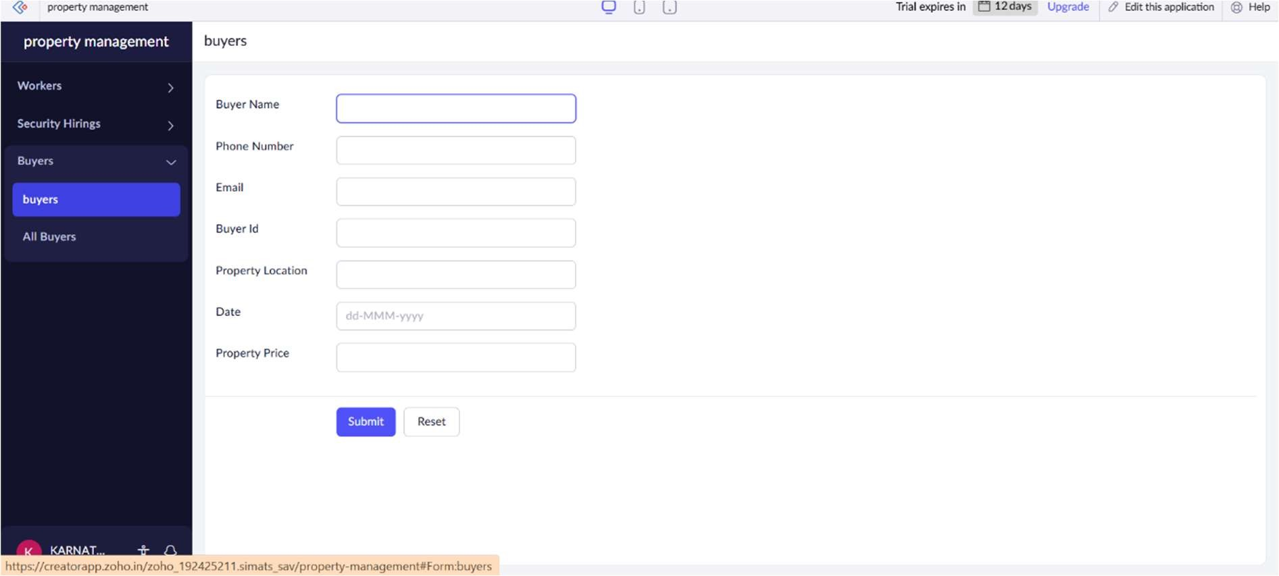

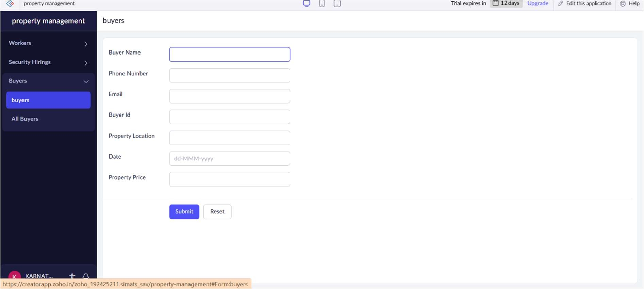

RESULT:

Thus, the app is created on Zoho Creator and it has been tested and verified to ensure everything runs smoothly.