Case Analysis – Avoiding Misleading Proportions
Question 1: Truncated Y-Axis in Sales Growth
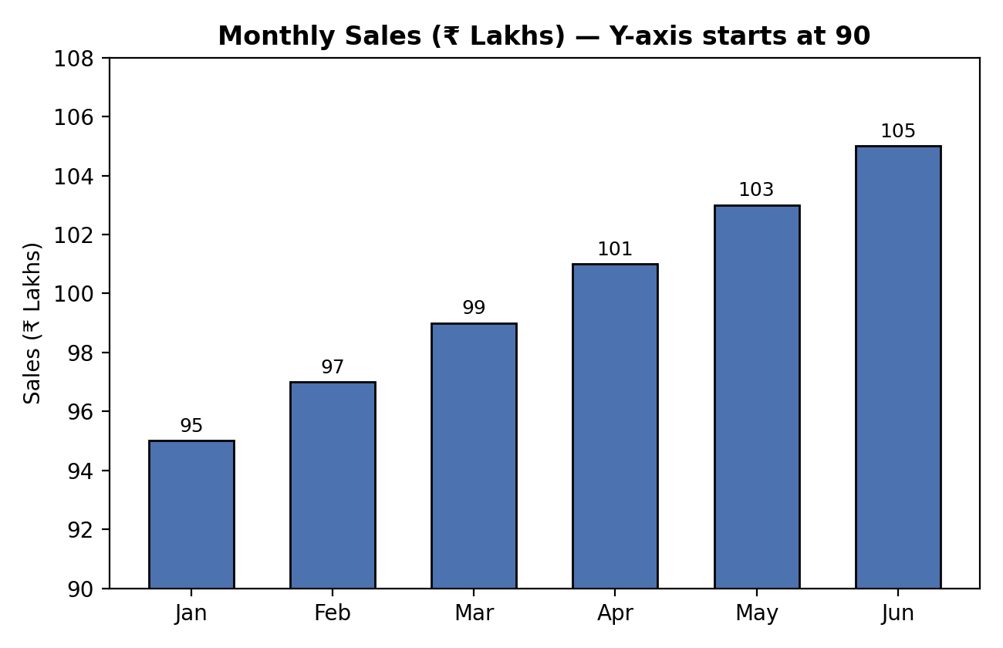
1. Why the chart is misleading
The Y-axis starts at 90 instead of 0, so the small rise in sales from ₹95 lakhs in January to ₹105 lakhs in June gets stretched out visually. This makes June's sales look almost double January's, when the actual increase is only about 10.5%.
2. Visualization principle violated
This violates the zero-baseline principle. Bar charts must start at zero because bar length is what viewers use to judge magnitude, and a truncated axis breaks that proportional relationship.
3. Better visualization method
Use a bar chart with the Y-axis starting at 0, or a line chart showing the monthly trend with actual values labelled on each point.
4. Effect on business decisions
Management could assume sales are growing much faster than they really are and over-invest in stock, staffing, or marketing. Investors or stakeholders may also form an overly optimistic view of the company's performance.
Question 2: Pie Chart with Incorrect Proportions
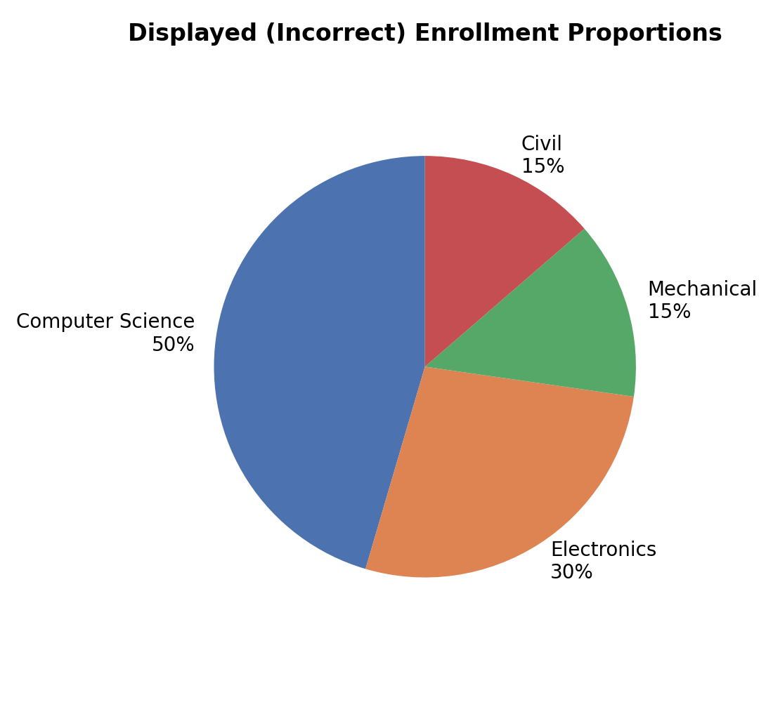
1. Correct percentages
Total students = 420 + 280 + 200 + 100 = 1000
• Computer Science: 420/1000 × 100 = 42%
• Electronics: 280/1000 × 100 = 28%
• Mechanical: 200/1000 × 100 = 20%
• Civil: 100/1000 × 100 = 10%
2. Why the displayed chart is misleading
The chart shows slices of roughly 50%, 30%, 15%, and 15%, which do not match the correct values of 42%, 28%, 20%, and 10%. This exaggerates Computer Science and Civil while understating Mechanical, giving a false picture of department sizes.
3. Alternative chart
A horizontal bar chart with the actual student numbers or percentages labelled would let viewers compare departments accurately, since bar length is easier to judge correctly than pie slice angle.
4. Effect on institutional planning
If Computer Science appears larger than it really is, the university might over-allocate faculty, classrooms, or budget to it while under-resourcing departments like Civil, leading to poor planning decisions.
Question 3: Unequal Bar Widths in Revenue Comparison
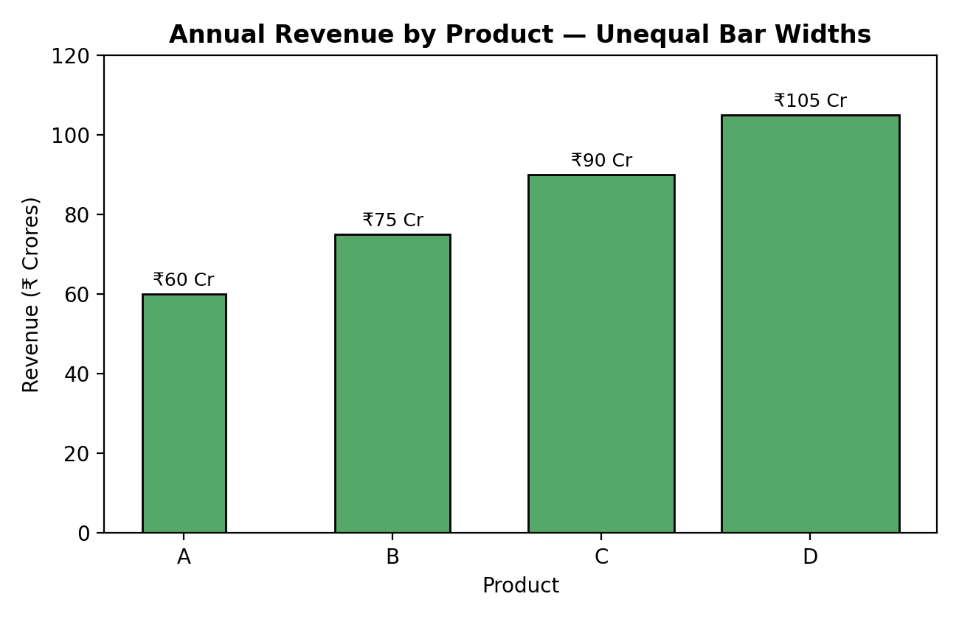
1. Graphical error
The bar widths increase along with the revenue values instead of staying equal. This means both height and width change together, so the visual area no longer represents the data correctly.
2. Effect of unequal bar widths
Since area depends on both height and width, a wider and taller bar for Product D makes it look close to three times larger than Product A, even though the actual revenue ratio is only 105/60 = 1.75 times.
3. Correct redesign principles
• Keep all bar widths equal.
• Start the value axis at 0.
• Label exact revenue values on or above each bar.
4. Possible impact on investors
Investors may believe Product D is performing far better than it actually is compared to Product A, which could lead to misallocated investment or wrong strategic decisions about which product to back.
Question 4: 3D Column Chart Distortion
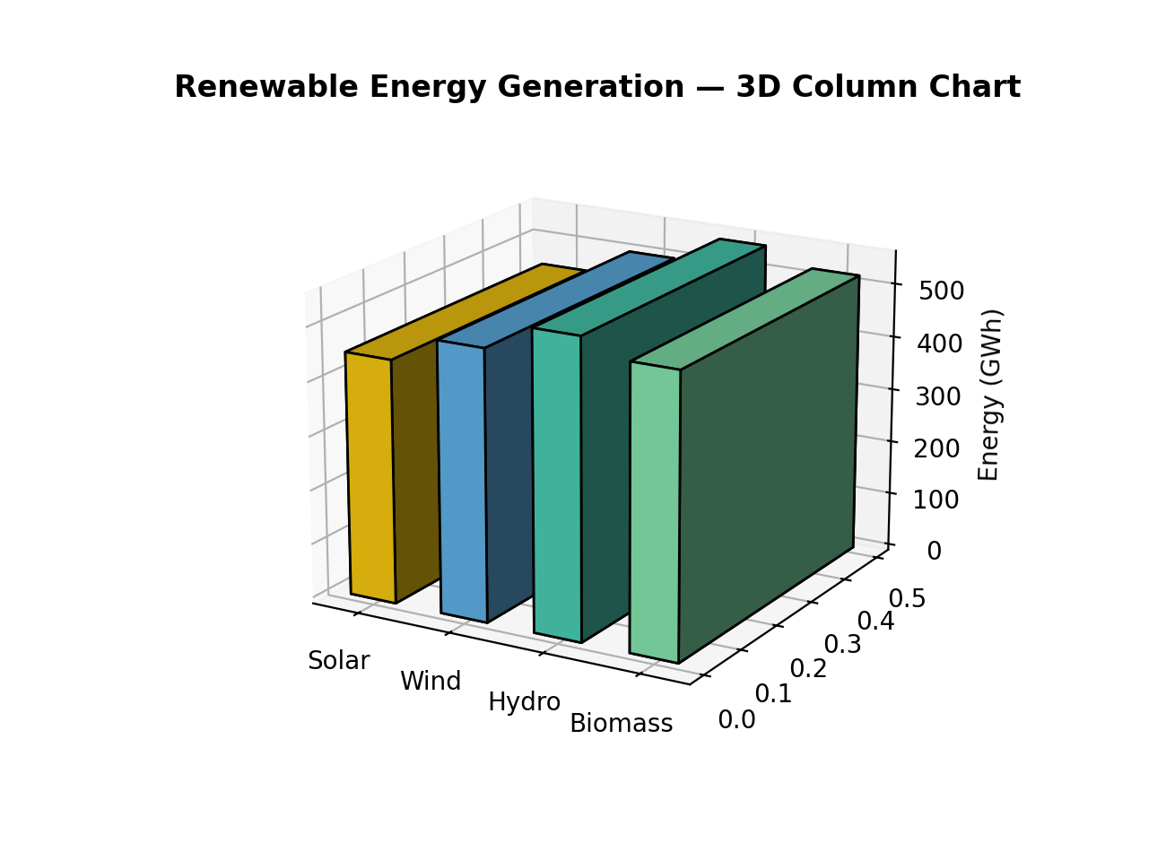
1. Why 3D charts can be misleading
3D charts add depth and perspective, so bars placed farther back or at certain angles can appear larger or smaller than their actual value. The viewing angle distorts height perception, making comparisons unreliable.
2. Perceived vs actual difference
The Hydro bar appears about 40% larger than Wind due to the 3D angle, but the actual difference is only (550 − 500)/500 × 100 = 10%.
3. Better visualization
A plain 2D column chart with values labelled directly on each bar would represent the data accurately without perspective distortion.
4. Importance in sustainability reporting
Sustainability reports are used by regulators, investors, and the public to judge environmental performance. Distorted charts can be seen as misleading or as greenwashing, damaging trust and credibility.
Question 5: Bubble Chart with Incorrect Scaling
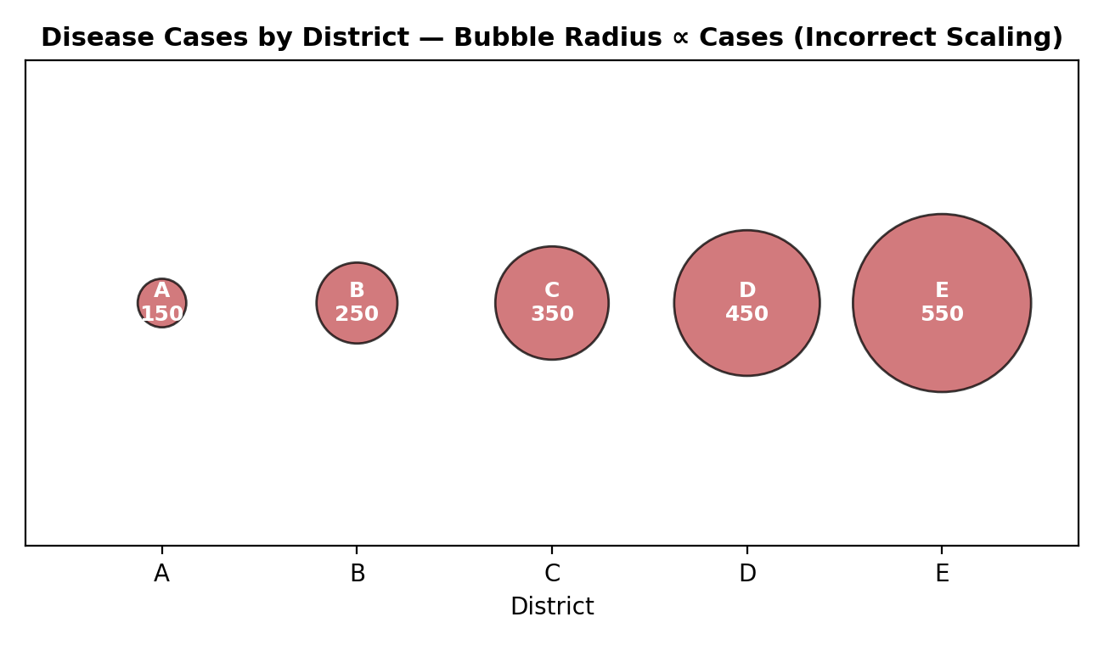
1. Why scaling the radius is misleading
Bubble area, not radius, is what viewers perceive as size. Since area = πr², scaling the radius directly to the case count makes the area grow much faster than the actual data, so District E looks more than ten times larger than District A even though it has only about 3.7 times as many cases (550/150).
2. Correct method for proportional bubble sizing
The bubble radius should be scaled to the square root of the value (radius ∝ √cases), so that the bubble area, not the radius, is proportional to the actual data.
3. Alternative visualization
A simple bar chart would represent the case counts across districts more accurately and is easier to compare than bubble sizes.
4. Effect on public health resource allocation
If District E's cases look exaggerated, health authorities might over-allocate medical resources and staff to it while under-resourcing other districts with genuine but understated needs, resulting in inefficient or unfair distribution of care.

