DSA0603 Data Handling and Visualization
CO2 - Assessment Tool - Chart Construction Test
Slot B
Question 1: Healthcare Analytics
R Code:
library(ggplot2)

# Dataset
patient_data <- data.frame(
Patient = c("P1","P2","P3","P4","P5","P6","P7","P8"),
Age = c(24,32,41,48,56,65,38,29),
BMI = c(19.8,24.5,28.1,30.3,33.2,36.5,26.2,22.1),
BloodPressure = c(110,118,132,145,152,168,124,116),
DiseaseSeverity = factor(
c("Low","Medium","High","High","Critical","Critical","Medium","Low"),
levels = c("Low","Medium","High","Critical")
)
)

# Scatter plot: Age vs Blood Pressure, colour = Severity, size = BMI
ggplot(patient_data, aes(x = Age, y = BloodPressure,
color = DiseaseSeverity, size = BMI)) +
geom_point(alpha = 0.8) +
scale_color_viridis_d(option = "plasma", end = 0.9) +
labs(
title = "Blood Pressure vs Age by Disease Severity",
x = "Age (years)", y = "Blood Pressure (mmHg)",
color = "Disease Severity", size = "BMI"
) +
theme_minimal(base_size = 13)

Visualization:
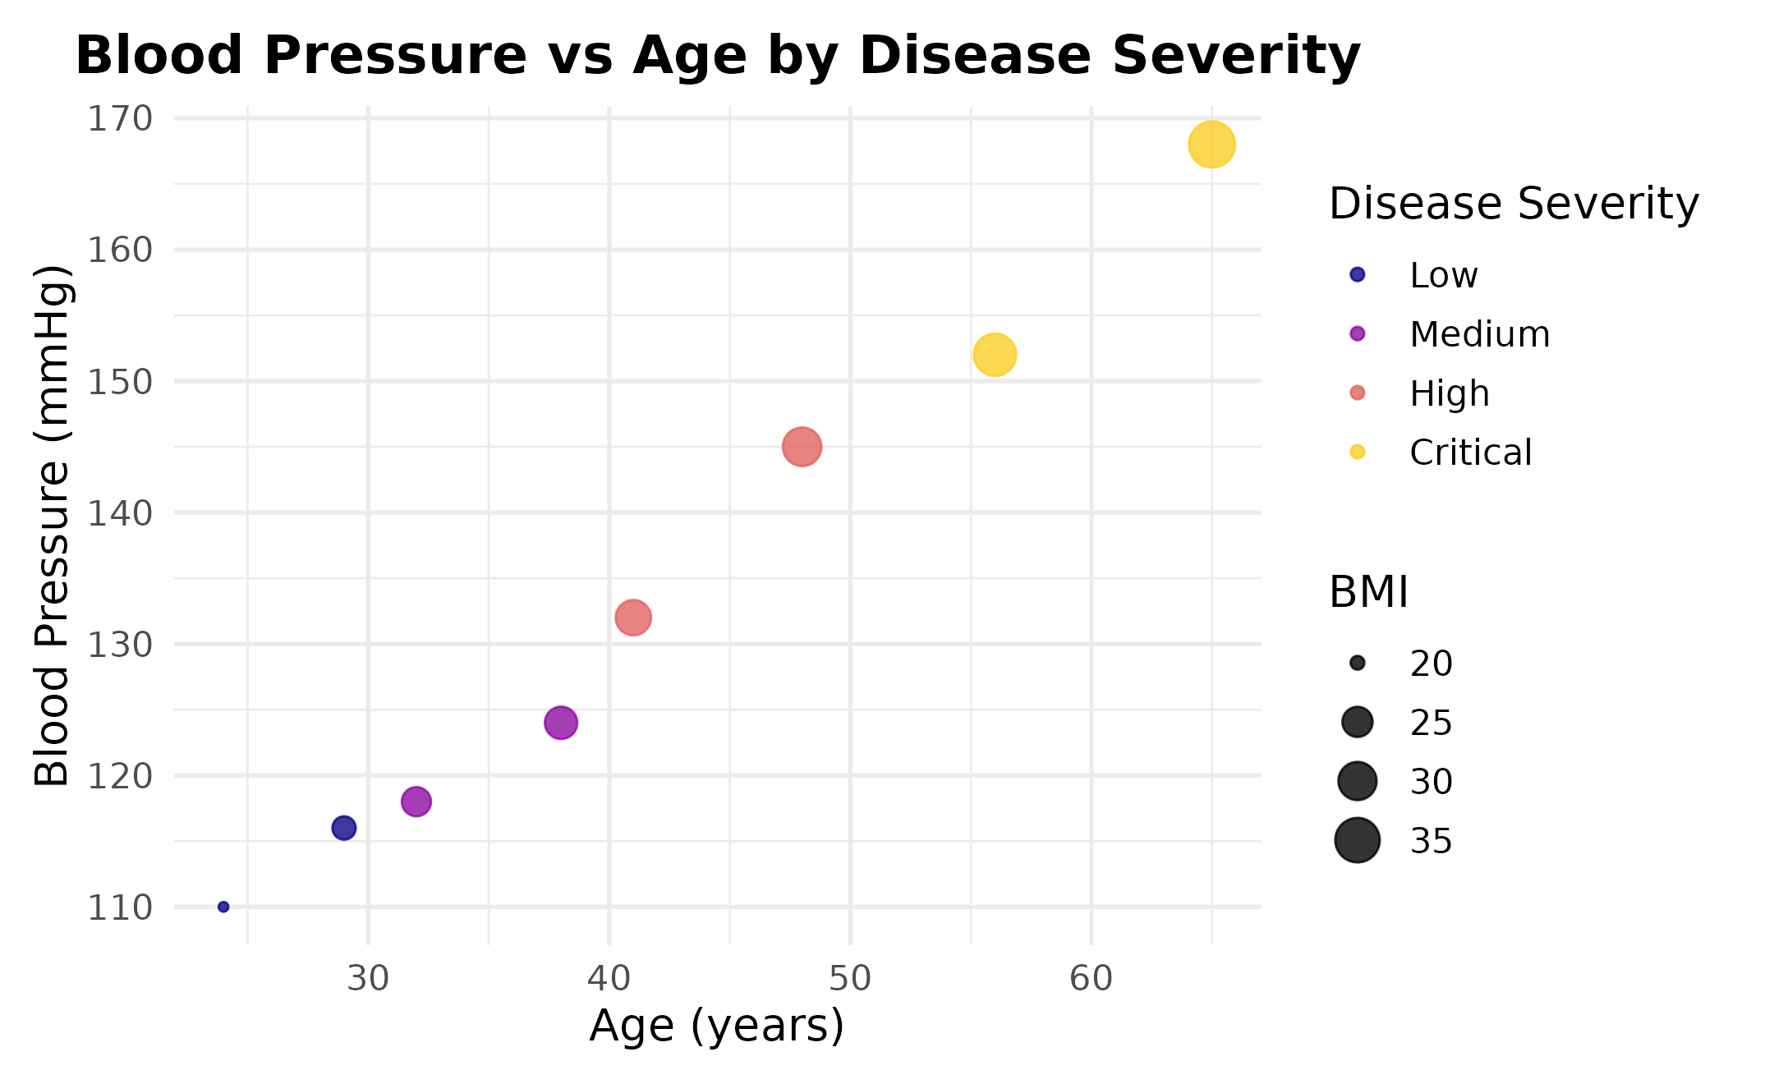
Design Justification:
Colour is mapped to Disease Severity because colour is the most effective channel for distinguishing categories at a glance. Point size is mapped to BMI so a second health indicator is visible without adding another axis. The plasma colour palette is perceptually uniform and works well for the ordered categories Low to Critical. Together, position, colour and size let three health indicators be read from a single plot.
Interpretation:
Blood pressure rises steadily with age, and the highest values occur in patients above 55 years. Patients with Critical severity also show the largest point size, meaning high BMI and high blood pressure occur together in older patients. Low and Medium severity patients cluster at younger ages with lower blood pressure and BMI. This suggests age, BMI and blood pressure jointly relate to disease severity in this sample.
Question 2: Climate Science
R Code:
library(ggplot2)

# Dataset
climate_data <- data.frame(
Month = factor(c("Jan","Feb","Mar","Apr","May","Jun",
"Jul","Aug","Sep","Oct","Nov","Dec"),
levels = c("Jan","Feb","Mar","Apr","May","Jun",
"Jul","Aug","Sep","Oct","Nov","Dec")),
Temperature = c(20,23,29,35,39,36,32,31,30,28,24,21),
Rainfall = c(25,18,12,8,5,65,150,170,120,85,45,30)
)

# 1. Cartesian line chart - Temperature
ggplot(climate_data, aes(x = Month, y = Temperature, group = 1)) +
geom_line(color = "#d62728", linewidth = 1.1) +
geom_point(color = "#d62728", size = 2.5) +
labs(title = "Monthly Temperature Variation",
x = "Month", y = "Temperature (deg C)") +
theme_minimal(base_size = 13)

# 2. Polar coordinate chart - Rainfall
ggplot(climate_data, aes(x = Month, y = Rainfall, fill = Rainfall)) +
geom_col() +
scale_fill_viridis_c(option = "mako", direction = -1) +
coord_polar() +
labs(title = "Annual Rainfall Distribution",
x = "", y = "Rainfall (mm)", fill = "Rainfall (mm)") +
theme_minimal(base_size = 13)

Visualization - Line Chart:
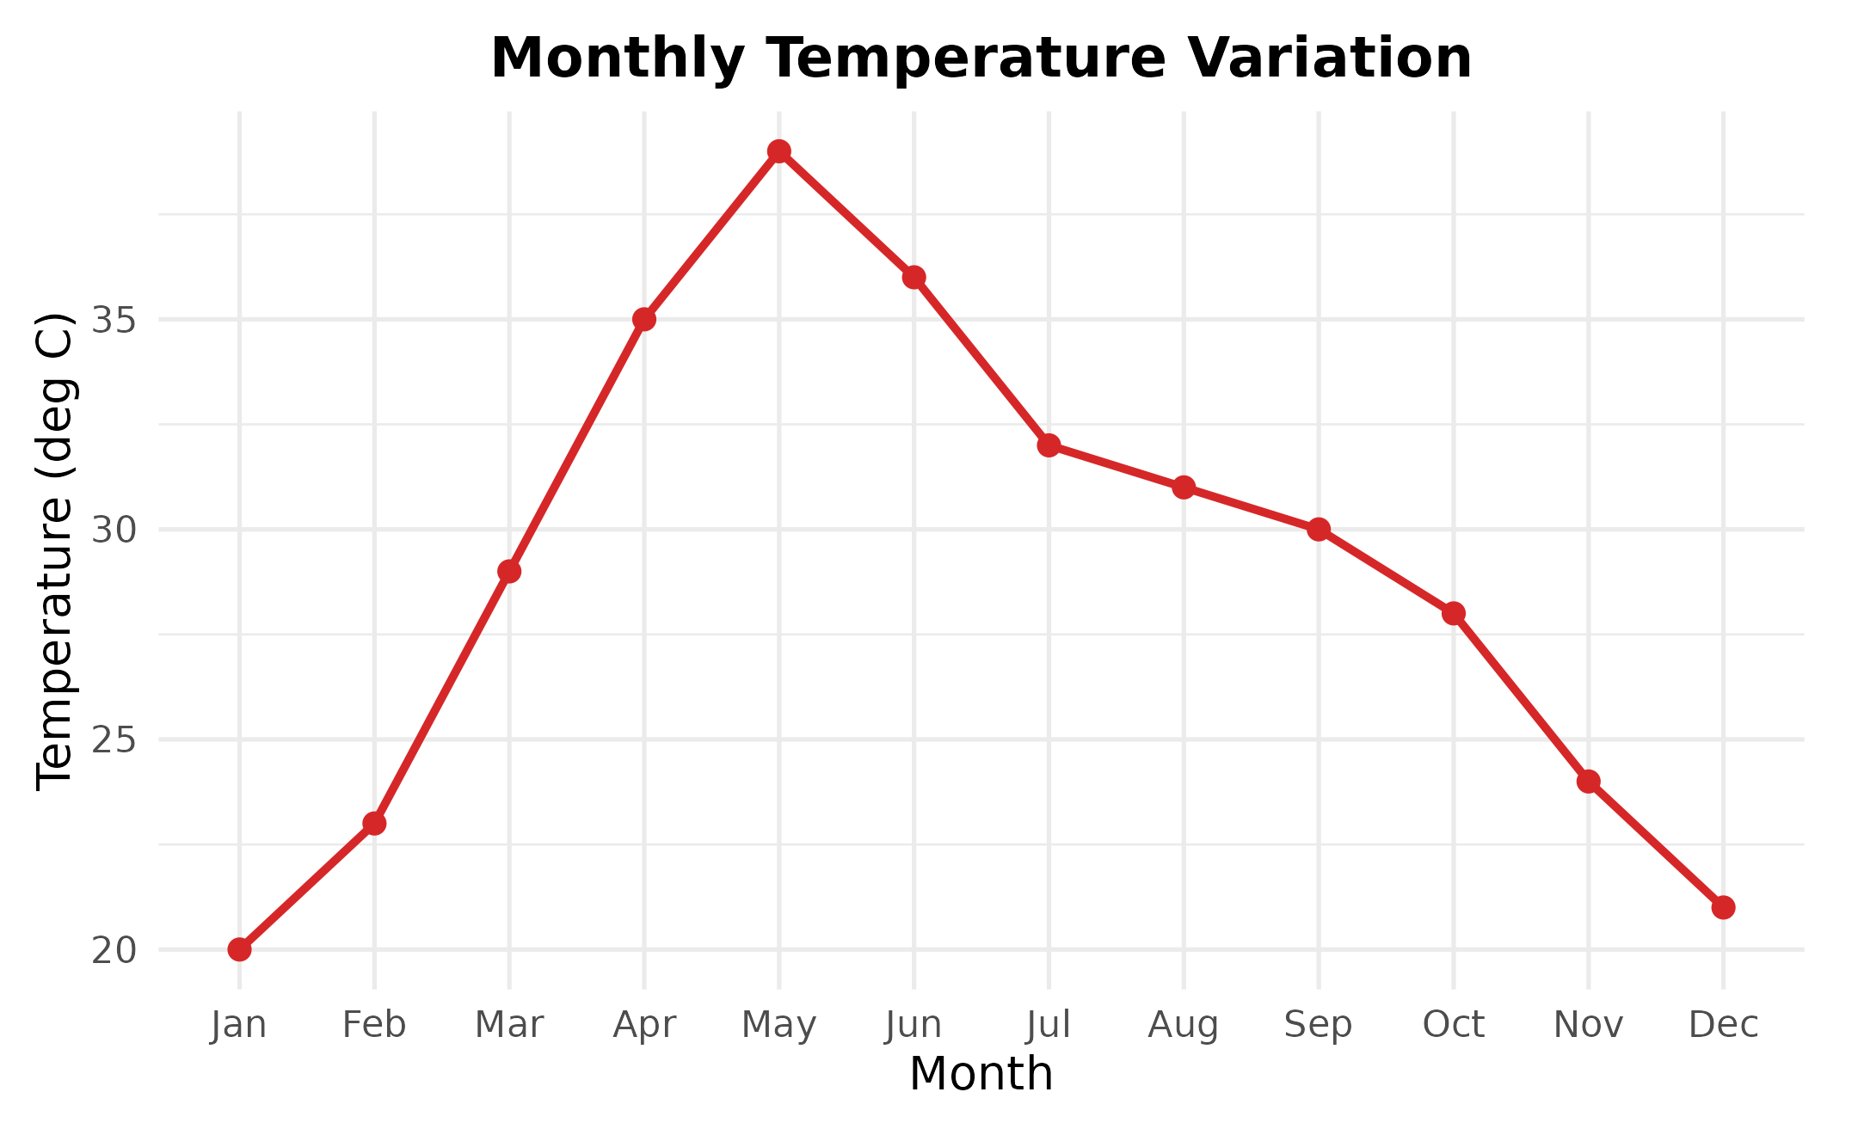
Visualization - Polar Chart:
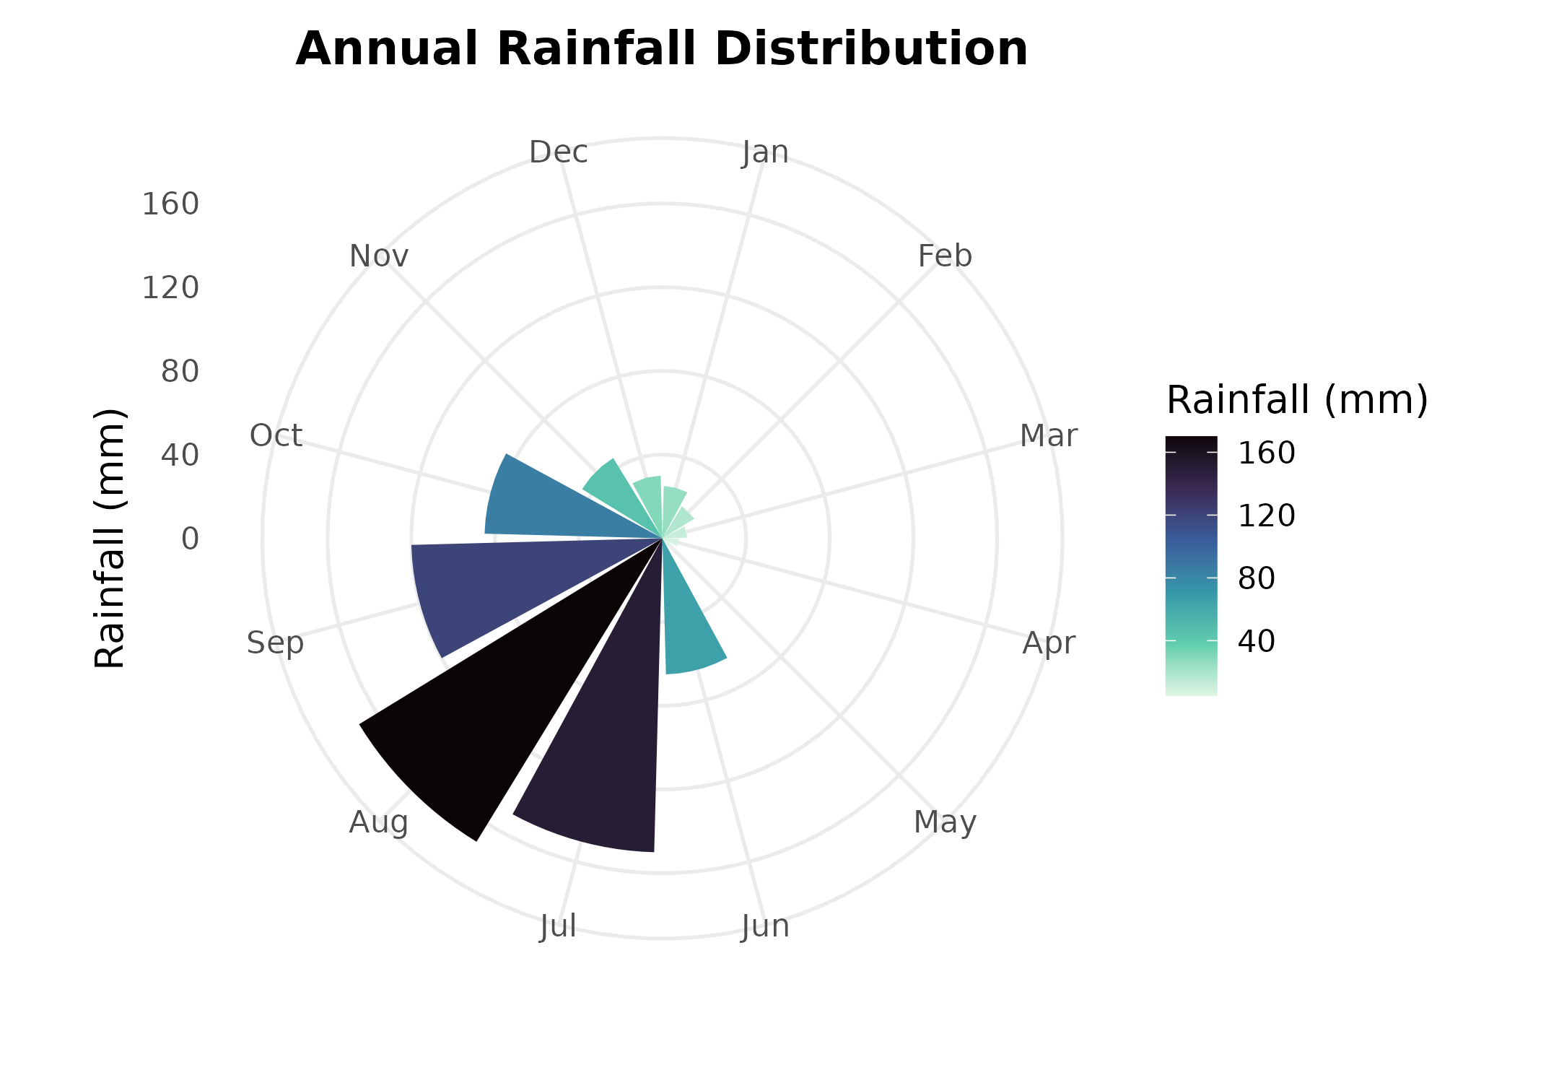
Comparison:
Cartesian coordinates make it easy to read exact temperature values and compare month-to-month change along a straight axis. Polar coordinates naturally represent cyclical, seasonal data since the chart loops back to January after December. Exact values are harder to read precisely on a polar chart than on a Cartesian one. For this dataset, the Cartesian line chart is more suitable for tracking the gradual temperature trend, while the polar chart is more suitable for highlighting the seasonal monsoon peak in rainfall. Overall, Cartesian coordinates suit continuous trend data better, and Polar coordinates suit cyclical seasonal data better.
Question 3: Business Analytics and Marketing
R Code:
library(ggplot2)
library(dplyr)

# Dataset
product_data <- data.frame(
Product = c("A","B","C","D","E"),
Sales = c(210,185,260,145,120),
Profit = c(18,14,25,12,10),
MarketShare = c(24,20,28,15,13)
)

product_data <- product_data %>%
mutate(Highlight = ifelse(MarketShare == max(MarketShare),
"Highest Share", "Other"))

# Bar chart: Sales (height), Profit % (colour), highest share highlighted
ggplot(product_data, aes(x = Product, y = Sales, fill = Profit)) +
geom_col(color = "black") +
geom_col(data = filter(product_data, Highlight == "Highest Share"),
aes(x = Product, y = Sales), fill = NA,
color = "red", linewidth = 1.2) +
scale_fill_gradient(low = "#fee5d9", high = "#a50f15") +
labs(title = "Product Sales with Profit % and Market Share Highlight",
x = "Product", y = "Sales (Rs. Lakhs)", fill = "Profit (%)") +
theme_minimal(base_size = 12)

Visualization:
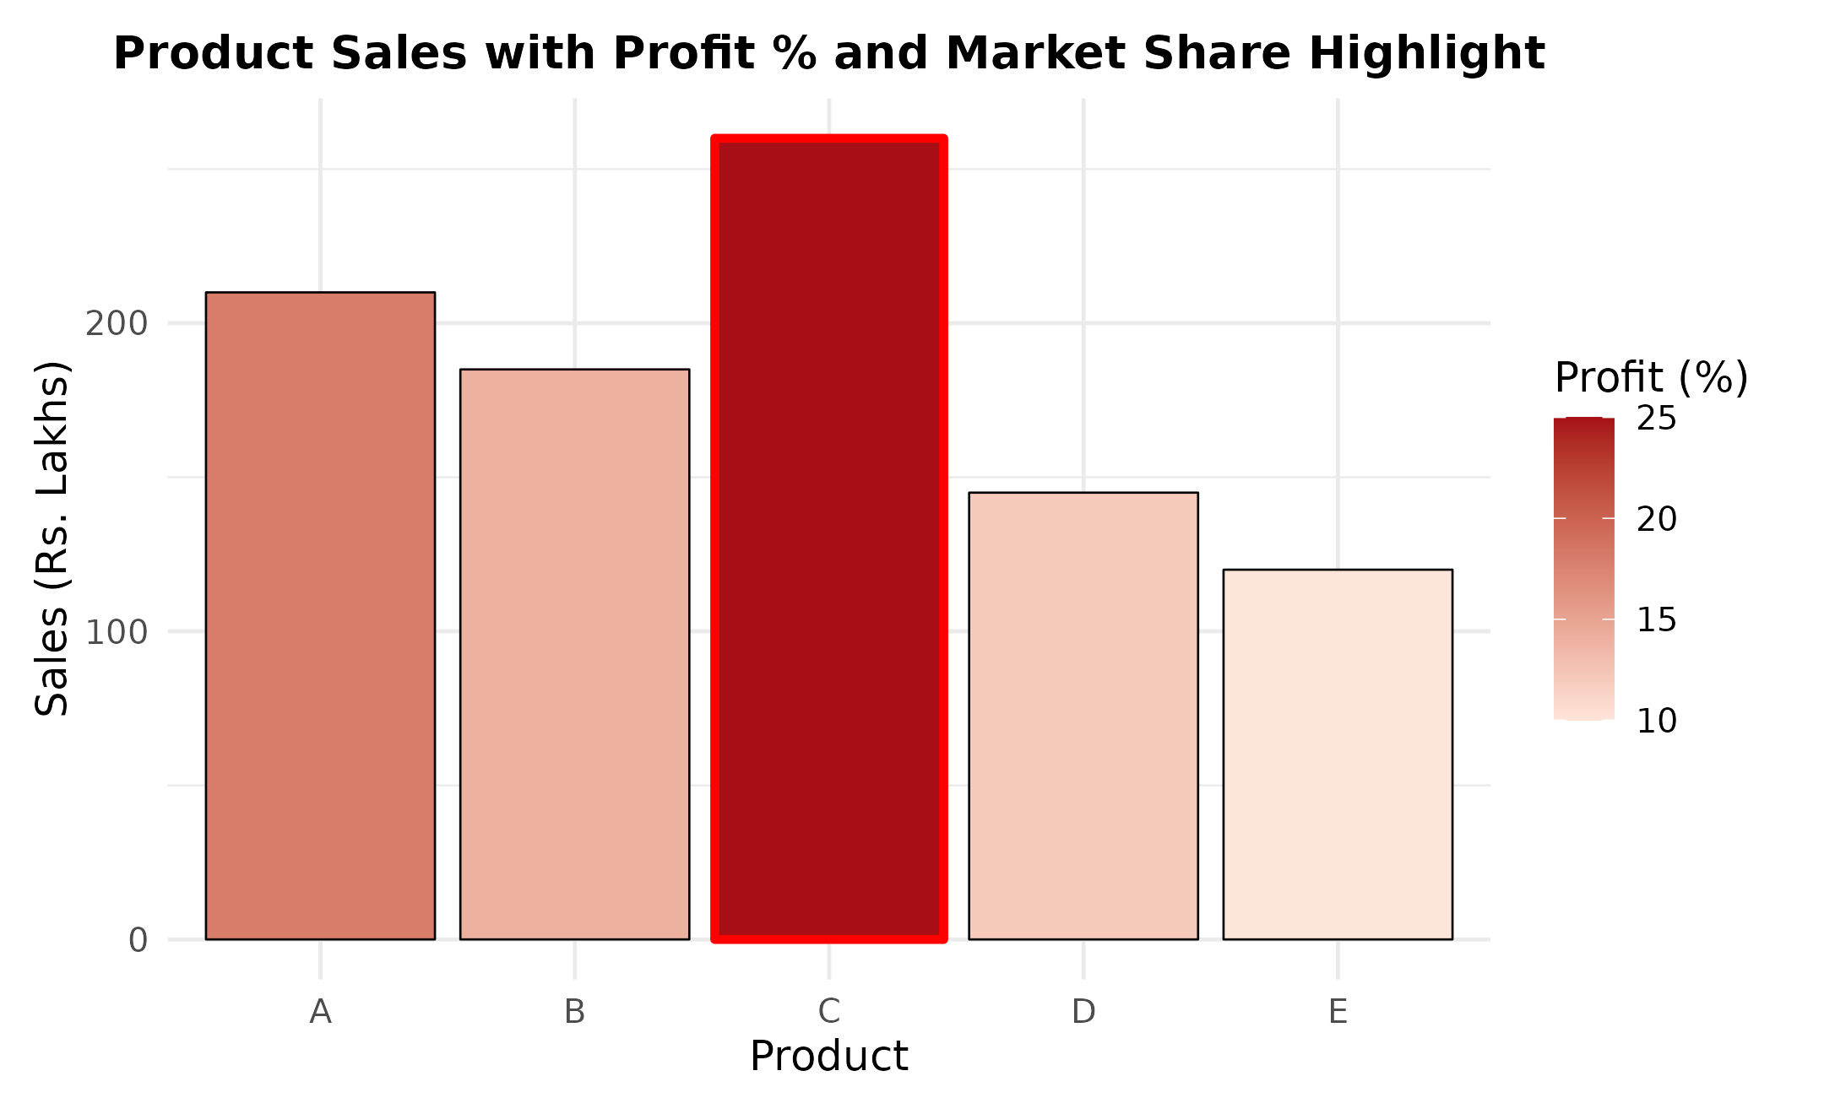
Design Justification:
Bar height directly shows sales performance, which is the primary metric for comparing products. A sequential red colour scale for profit percentage lets a viewer quickly identify the most profitable products without reading exact numbers. A red outline marks the product with the highest market share so it stands out immediately. This combination helps decision-makers identify products that are strong in sales, profit and market share together.
Interpretation:
Product C has the highest sales, highest profit percentage and highest market share, making it the strongest overall performer. Product A also performs well, with high sales despite a lower profit percentage than C. Products D and E have the lowest sales, profit and market share, and may need a review of pricing or marketing strategy. Sales and profitability appear positively related across the five products.
Question 4: Transportation Engineering
R Code:
library(ggplot2)

# Dataset
traffic_data <- data.frame(
Direction = factor(
c("North","North-East","East","South-East",
"South","South-West","West","North-West"),
levels = c("North","North-East","East","South-East",
"South","South-West","West","North-West")
),
Vehicles = c(980,760,1240,890,1420,1130,860,720)
)

# Polar bar chart of traffic flow by direction
ggplot(traffic_data, aes(x = Direction, y = Vehicles, fill = Vehicles)) +
geom_col(width = 0.9, color = "white") +
scale_fill_viridis_c(option = "inferno", direction = -1) +
coord_polar() +
labs(title = "Traffic Flow by Direction",
x = "", y = "Vehicles/hour", fill = "Vehicles/hour") +
theme_minimal(base_size = 12)

Visualization:
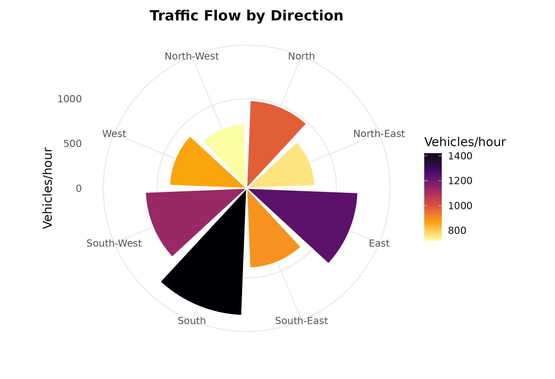
Design Justification:
A polar chart aligns each bar with its real-world compass direction, so traffic flow can be read the way it is physically oriented. A Cartesian bar chart would lose this directional meaning because its x-axis has no compass alignment. Colour intensity encodes vehicle density, so the busiest directions stand out immediately. This makes polar coordinates more suitable than Cartesian coordinates for directional traffic analysis.
Interpretation:
South records the highest traffic volume, followed by East and South-West, indicating these are the main traffic corridors. North-East and North-West carry the lowest traffic volume. Traffic is not evenly distributed across directions, so signal timing could prioritise the South and East approaches. This pattern suggests a dominant south-east traffic axis in the study area.
Question 5: Environmental Sustainability Dashboard
R Code:
library(ggplot2)
library(patchwork)

# Dataset
city_data <- data.frame(
City = c("A","B","C","D","E","F"),
AQI = c(48,82,135,165,72,95),
GreenCover = c(45,32,21,18,38,30),
CO2 = c(1.8,3.5,5.6,7.4,2.9,4.2),
Population = c(9,15,22,28,12,18)
)

# Panel 1: AQI by city
p_aqi <- ggplot(city_data, aes(x = reorder(City, AQI), y = AQI, fill = AQI)) +
geom_col() +
scale_fill_gradientn(colors = c("#1a9850","#fee08b","#d73027")) +
labs(title = "AQI by City", x = "City", y = "AQI", fill = "AQI") +
theme_minimal(base_size = 11)

# Panel 2: Green Cover vs CO2 Emission, size = Population, colour = AQI
p_scatter <- ggplot(city_data, aes(x = GreenCover, y = CO2,
size = Population, color = AQI)) +
geom_point(alpha = 0.85) +
scale_color_gradientn(colors = c("#1a9850","#fee08b","#d73027")) +
labs(title = "Green Cover vs CO2 Emission",
x = "Green Cover (%)", y = "CO2 Emission (Mt)",
size = "Population (Lakhs)", color = "AQI") +
theme_minimal(base_size = 11)

# Panel 3: Population by city
p_pop <- ggplot(city_data, aes(x = reorder(City, -Population),
y = Population, fill = Population)) +
geom_col() +
scale_fill_viridis_c(option = "viridis") +
labs(title = "Population by City", x = "City",
y = "Population (Lakhs)", fill = "Population") +
theme_minimal(base_size = 11)

# Panel 4: CO2 Emission by city
p_co2 <- ggplot(city_data, aes(x = reorder(City, -CO2), y = CO2, fill = CO2)) +
geom_col() +
scale_fill_viridis_c(option = "magma", direction = -1) +
labs(title = "CO2 Emission by City", x = "City",
y = "CO2 Emission (Mt)", fill = "CO2") +
theme_minimal(base_size = 11)

# Combine into one dashboard
(p_aqi | p_pop) / (p_scatter | p_co2) +
plot_annotation(title = "Environmental Sustainability Dashboard")

Visualization:
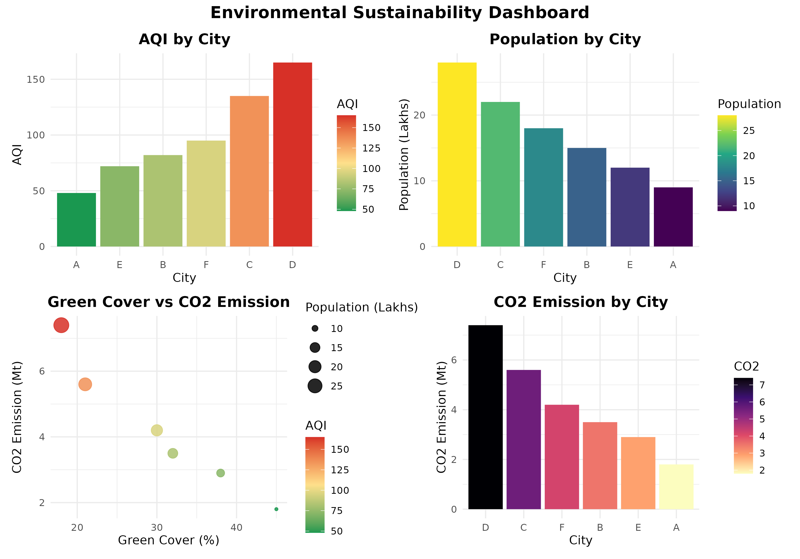
Design Justification:
The dashboard combines four panels so that AQI, population, green cover and CO2 emission can be compared across cities in one view. A red-yellow-green scale is used for AQI because it matches standard air quality colour conventions, making high-risk cities easy to spot. Point size in the scatter panel encodes population, adding a fourth variable without extra axes. Viridis and magma palettes are used for population and CO2 because they are perceptually uniform and colour-blind friendly.
Interpretation:
City D has the highest AQI, highest CO2 emission and lowest green cover, showing the greatest environmental pressure. City A has the lowest AQI and highest green cover, indicating better environmental conditions. Green cover tends to fall as CO2 emission rises across cities, suggesting a trade-off between urbanisation and vegetation. Larger, more populated cities tend to show higher pollution levels in this dataset.

