DSA0603 Data Handling and Visualization

CO1 AT3: Visualization Design Exercise - Answer Document

Question 1: Retail Sales Visualization

R Code

library(ggplot2)
library(scales)

retail <- data.frame(
Branch=c("B1","B2","B3","B4","B5","B6","B7","B8","B9","B10",
"B11","B12","B13","B14","B15","B16","B17","B18","B19","B20"),
Region=c("North","South","East","West","North","South","East","West",
"North","South","East","West","North","South","East","West",
"North","South","East","West"),
Category=c("Electronics","Furniture","Clothing","Food","Electronics",
"Furniture","Clothing","Food","Electronics","Furniture",
"Clothing","Food","Electronics","Furniture","Clothing",
"Food","Electronics","Furniture","Clothing","Food"),
Sales=c(450000,620000,180000,920000,350000,720000,250000,1080000,
560000,670000,195000,980000,430000,760000,280000,1150000,
510000,690000,220000,1250000),
Profit=c(45000,95000,-12000,185000,25000,120000,18000,225000,
72000,98000,-8000,205000,51000,132000,24000,250000,
69000,115000,15000,285000),
Customers=c(1200,2500,980,4200,1800,3000,1250,5200,
2100,3300,1100,4700,1750,3600,1450,5600,
2200,3900,1600,6100)
)

p1 <- ggplot(retail, aes(x=Sales, y=Profit, size=Customers, color=Category)) +
geom_point(alpha=0.8) +
facet_wrap(~Region) +
scale_x_continuous(labels=comma) +
scale_y_continuous(labels=comma) +
scale_size(range=c(2,10)) +
labs(title="Sales vs Profit by Category, Customers and Region",
x="Sales (INR)", y="Profit (INR)", size="Customers", color="Category") +
theme_minimal(base_size=12) +
theme(plot.title=element_text(face="bold", size=13))

ggsave("plots/q1_retail.png", p1, width=8, height=5.5, dpi=150)

Visualization:

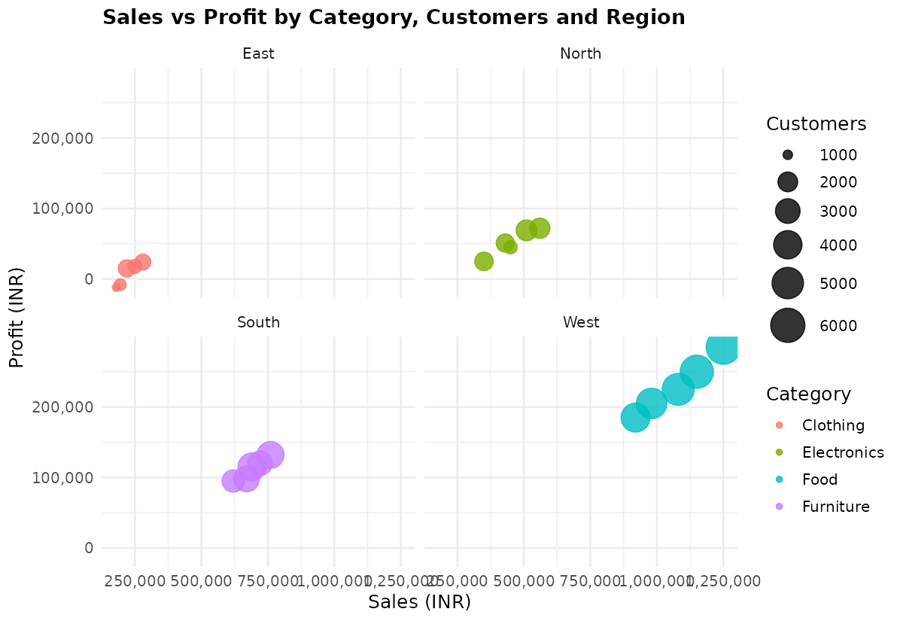

Aesthetic Mapping & Scale
Sales (x) and Profit (y) show revenue vs earnings; size = Customers; colour = Category; faceted by Region. Comma-formatted scales keep large values readable.
Interpretation
Food and Electronics branches lead in sales and profit; Clothing branches perform weakest, with East region even showing losses.

Question 2: Energy Generation - Cartesian vs Polar

R Code
library(ggplot2)
library(tidyr)
library(dplyr)

energy <- data.frame(
Month=month.abb,
Coal=c(620,580,590,605,640,670,690,720,700,680,650,630),
Gas=c(310,295,305,320,340,355,360,370,365,350,335,320),
Solar=c(45,60,90,130,180,230,250,245,210,160,90,50),
Wind=c(80,95,120,150,170,185,195,190,175,150,110,90),
Hydro=c(140,150,160,170,180,195,205,210,200,185,165,150)
)

energy$Month <- factor(energy$Month, levels=month.abb)

energy_long <- pivot_longer(energy, cols=Coal:Hydro, names_to="Source", values_to="Generation")

# Cartesian
p2a <- ggplot(energy_long, aes(x=Month, y=Generation, color=Source, group=Source)) +
geom_line(linewidth=1) +
geom_point(size=1.5) +
labs(title="Monthly Electricity Generation (Cartesian Coordinates)",
x="Month", y="Generation (MWh)", color="Source") +
theme_minimal(base_size=12) +
theme(plot.title=element_text(face="bold", size=13))

ggsave("plots/q2a_cartesian.png", p2a, width=8, height=5, dpi=150)

# Polar
p2b <- ggplot(energy_long, aes(x=Month, y=Generation, color=Source, group=Source)) +
geom_line(linewidth=1) +
geom_point(size=1.5) +
coord_polar(theta="x") +
labs(title="Monthly Electricity Generation (Polar Coordinates)",
x="Month", y="Generation (MWh)", color="Source") +
theme_minimal(base_size=12) +
theme(plot.title=element_text(face="bold", size=13))

ggsave("plots/q2b_polar.png", p2b, width=8, height=6, dpi=150)

Cartesian (left) and Polar (right) Visualizations:

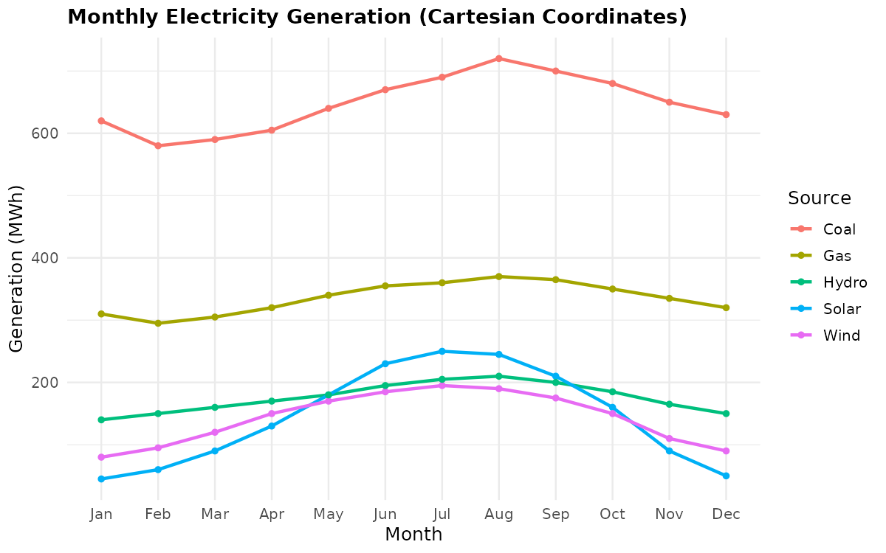 | 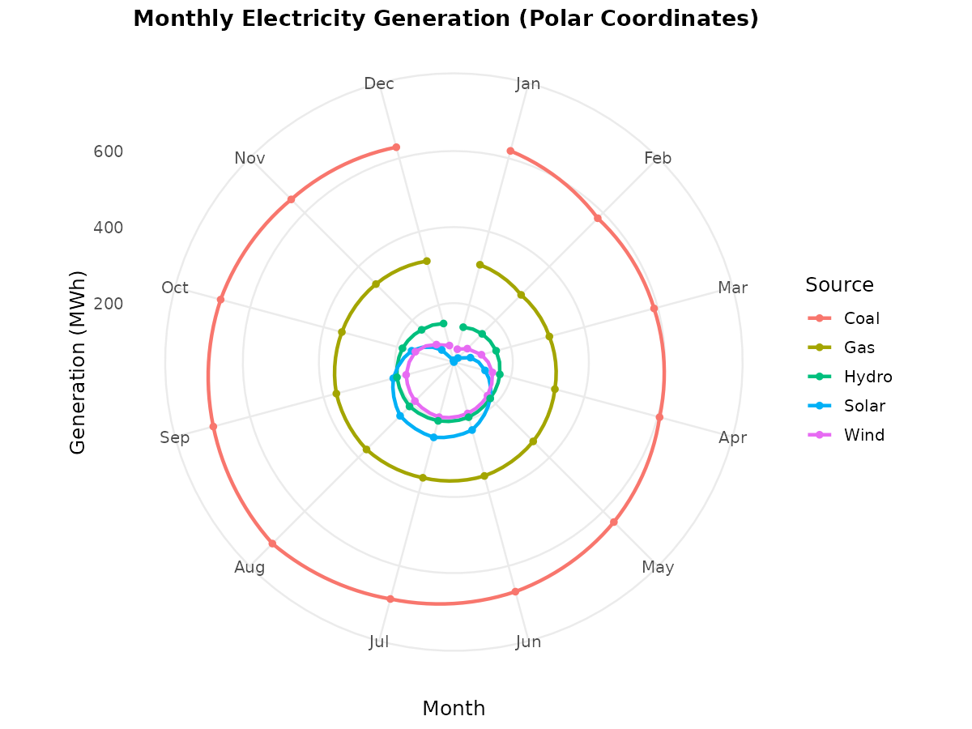

Comparison

The Cartesian chart reads exact monthly values easily; the polar chart highlights seasonal cycles but is harder to read precisely. Cartesian gives better analytical insight here since accurate value comparison matters more than cyclical pattern.

Question 3: Climate Data Visualization

R Code
library(ggplot2)
library(viridis)

climate <- data.frame(
City=c("Delhi","Mumbai","Chennai","Kolkata","Hyderabad",
"Bangalore","Pune","Ahmedabad","Jaipur","Lucknow",
"Bhopal","Patna","Goa","Kochi","Nagpur","Indore",
"Surat","Visakhapatnam","Coimbatore","Mysuru"),
Temperature=c(44,35,38,40,39,31,33,43,45,39,
38,40,32,30,41,37,36,34,29,28),
Humidity=c(22,84,78,72,48,66,58,26,18,42,36,45,89,91,30,34,76,82,68,64),
Rainfall=c(6,280,220,190,85,120,95,2,1,35,
48,72,360,410,12,20,180,240,130,145),
AQI=c(365,110,125,180,160,72,84,290,320,240,
175,220,58,52,270,190,145,98,60,55)
)

p3 <- ggplot(climate, aes(x=Temperature, y=Humidity, size=Rainfall, color=AQI)) +
geom_point(alpha=0.85) +
scale_color_viridis(option="plasma") +
scale_size(range=c(2,10)) +
labs(title="Temperature, Humidity, Rainfall and AQI across Indian Cities",
x="Temperature (°C)", y="Humidity (%)", size="Rainfall (mm)", color="AQI") +
theme_minimal(base_size=12) +
theme(plot.title=element_text(face="bold", size=13))

ggsave("plots/q3_climate.png", p3, width=8, height=5.5, dpi=150)

Visualization:

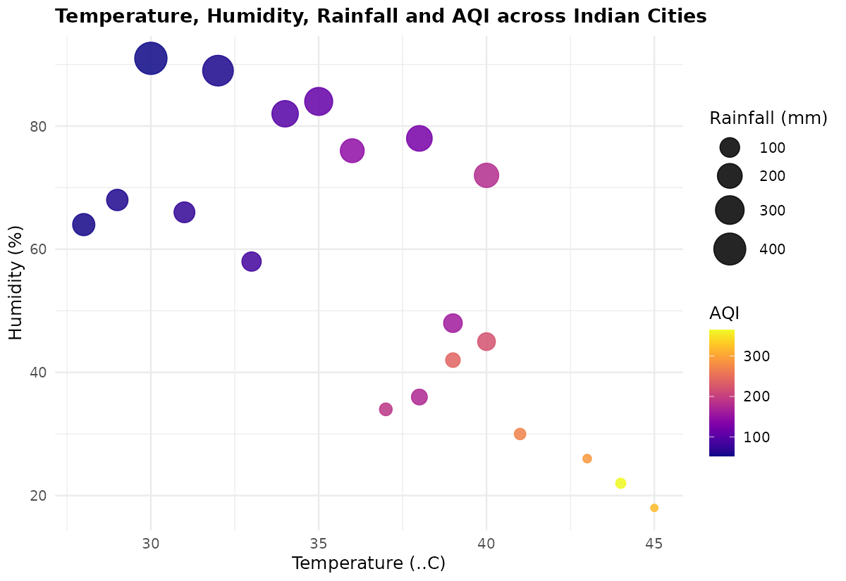

Color Palette & Justification
The viridis 'plasma' scale maps AQI (dark = low, yellow = high). It is perceptually uniform and color-blind-friendly, unlike red-green scales.
Interpretation
Hot, dry cities like Delhi and Jaipur show high AQI and low humidity; humid coastal cities like Goa and Kochi show low AQI, indicating cleaner air.

Question 4: Software Team Statistics - Nonlinear Scale

R Code
library(ggplot2)
library(scales)
library(patchwork)

software <- data.frame(
Team=paste("T",1:20,sep=""),
LinesOfCode=c(12000,18000,25000,35000,48000,
62000,81000,96000,120000,150000,
185000,240000,310000,390000,480000,
620000,810000,1050000,1350000,1800000),
Bugs=c(35,52,60,72,88,
110,125,142,165,188,
205,240,280,320,365,
420,490,560,640,720),
Developers=c(5,7,9,10,12,
14,16,18,20,22,
25,28,30,34,38,
42,46,50,55,60),
Complexity=c(2.1,2.4,2.7,3.0,3.2,
3.5,3.8,4.1,4.5,4.8,5.1,5.4,5.8,6.2,6.6,
7.1,7.6,8.0,8.5,9.0)
)

p4_log <- ggplot(software, aes(x=LinesOfCode, y=Bugs, size=Developers, color=Complexity)) +
geom_point(alpha=0.85) +
scale_x_log10(labels=comma) +
scale_color_viridis_c(option="viridis") +
scale_size(range=c(2,9)) +
labs(title="Log10 Scale", x="Lines of Code (log10)", y="Bugs",
size="Developers", color="Complexity") +
theme_minimal(base_size=11) +
theme(plot.title=element_text(face="bold", size=12))

p4_lin <- ggplot(software, aes(x=LinesOfCode, y=Bugs, size=Developers, color=Complexity)) +
geom_point(alpha=0.85) +
scale_x_continuous(labels=comma) +
scale_color_viridis_c(option="viridis") +
scale_size(range=c(2,9)) +
labs(title="Linear Scale", x="Lines of Code (linear)", y="Bugs",
size="Developers", color="Complexity") +
theme_minimal(base_size=11) +
theme(plot.title=element_text(face="bold", size=12))

combined <- p4_log + p4_lin + plot_layout(guides="collect") +
plot_annotation(title="Lines of Code vs Bugs: Log10 vs Linear Scale",
theme=theme(plot.title=element_text(face="bold", size=13)))

ggsave("plots/q4_software.png", combined, width=11, height=5.5, dpi=150)

Visualization: Log10 (left) vs Linear (right):

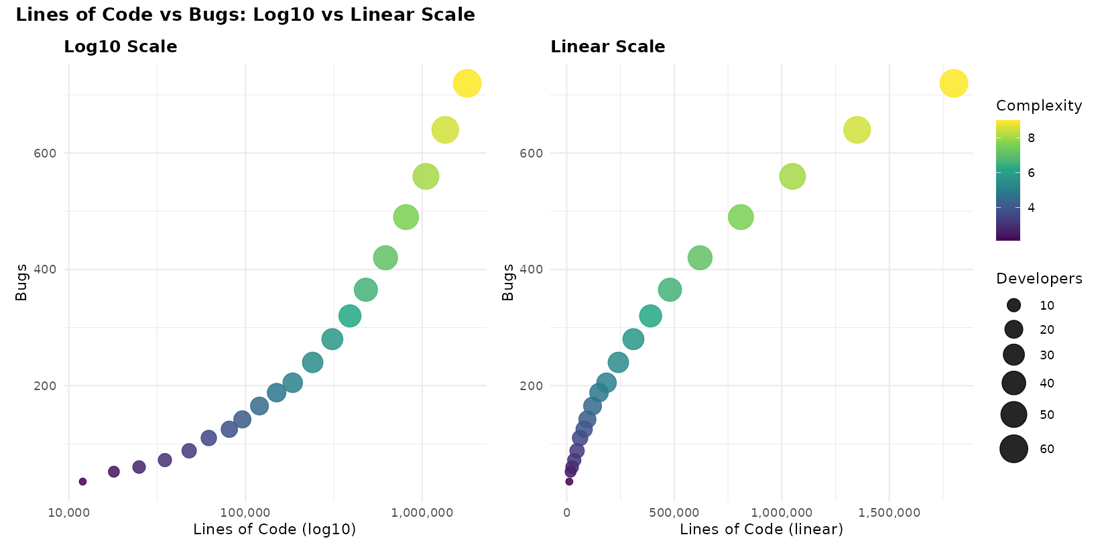

Transformation & Justification
scale_x_log10() is applied to Lines of Code, which ranges from 12,000 to 1,800,000. The log scale spaces out skewed values evenly instead of compressing them near zero.
Comparison with Linear Scale
On the linear scale, most teams crowd the left side; the log scale spreads points evenly, making the trend across all team sizes clearly visible.

Question 5: Company Performance Visualization

R Code
library(ggplot2)
library(scales)

companies <- data.frame(
Company=paste("C",1:20,sep=""),
Sector=c("IT","Banking","Healthcare","Retail","Energy",
"IT","Banking","Healthcare","Retail","Energy",
"IT","Banking","Healthcare","Retail","Energy",
"IT","Banking","Healthcare","Retail","Energy"),
Revenue=c(420,580,720,850,980,
1150,1320,1480,1650,1820,
2050,2280,2550,2840,3150,
3480,3860,4250,4680,5200),
ProfitMargin=c(8.2,15.6,11.4,9.3,18.5,
20.4,17.8,14.2,10.5,22.1,
24.5,19.8,16.7,13.4,26.2,
28.1,21.5,18.3,15.2,30.4),
Employees=c(1500,3200,2100,4200,2800,
5100,6800,3900,7200,4500,
8100,9500,6200,10300,7200,
11800,13200,8600,14500,16000),
MarketCap=c(8500,12000,9800,7600,14500,
18200,21500,16800,13200,24500,
28500,32500,24800,19200,38200,
42500,46800,35600,29800,52000)
)

p5 <- ggplot(companies, aes(x=Revenue, y=ProfitMargin, size=MarketCap, color=Sector)) +
geom_point(alpha=0.85) +
scale_x_continuous(labels=comma) +
scale_size(range=c(2,12), labels=comma) +
scale_color_viridis_d(option="turbo") +
labs(title="Revenue vs Profit Margin by Market Cap, Employees and Sector",
x="Revenue (in million INR)", y="Profit Margin (%)",
size="Market Cap (million INR)", color="Sector") +
theme_minimal(base_size=12) +
theme(plot.title=element_text(face="bold", size=13))

ggsave("plots/q5_companies.png", p5, width=8.5, height=5.5, dpi=150)

Visualization:

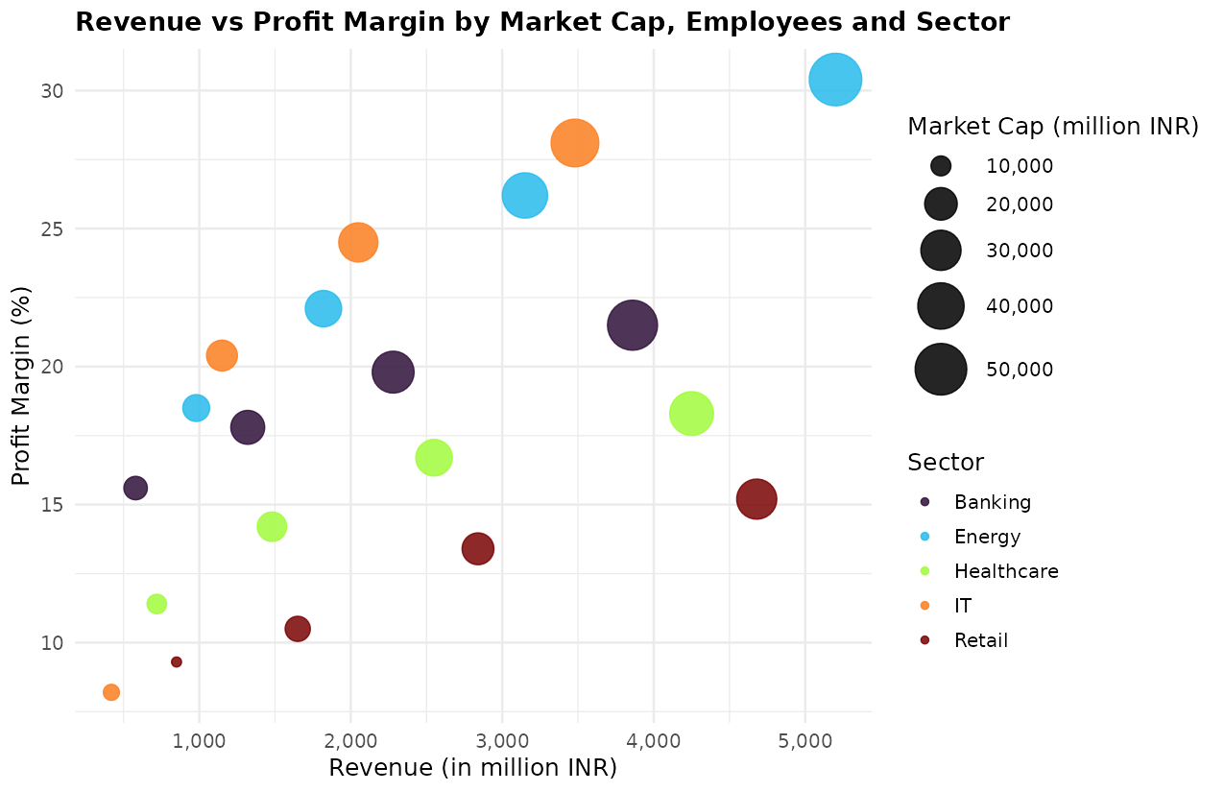

Aesthetic, Scale & Colour
Revenue (x), Profit Margin (y), size = Market Cap, colour = Sector (viridis 'turbo', colour-blind-friendly). Comma-formatted continuous scale keeps Revenue readable.
Interpretation
Energy companies show the highest profit margins; Retail shows the lowest despite large employee counts. Market cap rises broadly with revenue across sectors.

