Advanced Data Visualization – Practical Solutions
1. Geospatial Data Visualization
library(ggplot2)
library(ggrepel)
library(maps)

cities <- data.frame(
City = c("Chennai","Bangalore","Hyderabad","Mumbai","Delhi",
"Pune","Kolkata","Ahmedabad","Jaipur","Kochi"),
Latitude = c(13.08, 12.97, 17.38, 19.07, 28.61, 18.52, 22.57, 23.02, 26.91, 9.93),
Longitude = c(80.27, 77.59, 78.48, 72.87, 77.21, 73.85, 88.36, 72.57, 75.79, 76.26),
Population = c(11, 13, 10, 20, 32, 7, 15, 8, 4, 2)
)
india_map <- map_data("world", region = "India")

base_map <- ggplot() +
geom_polygon(data = india_map, aes(x = long, y = lat, group = group),
fill = "grey95", color = "grey60") + coord_fixed(1.1) +
theme_minimal(base_size = 13)

# Q1
p1 <- base_map + geom_point(data = cities, aes(Longitude, Latitude), color = "steelblue", size = 3) +
labs(title = "Scatter Map of Indian Cities", x = "Longitude", y = "Latitude")
ggsave("t1_q1_scatter_map.png", p1, width = 6.5, height = 6, dpi = 200)

# Q2
p2 <- base_map + geom_point(data = cities, aes(Longitude, Latitude, size = Population), color = "darkorange", alpha = 0.8) +
labs(title = "Bubble Map of City Population", x = "Longitude", y = "Latitude", size = "Population (M)")
ggsave("t1_q2_bubble_map.png", p2, width = 6.5, height = 6, dpi = 200)

# Q3
p3 <- p1 + geom_text(data = cities, aes(Longitude, Latitude, label = City), vjust = -1, size = 3.5) +
labs(title = "City Labels on Map")
ggsave("t1_q3_labeled_map.png", p3, width = 6.5, height = 6, dpi = 200)

# Q4
p4 <- base_map + geom_point(data = cities, aes(Longitude, Latitude, color = Population, size = Population)) +
geom_text_repel(data = cities, aes(Longitude, Latitude, label = City), size = 3.5) +
scale_color_gradient(low = "yellow", high = "red") +
labs(title = "Population - Color and Size Encoding", x = "Longitude", y = "Latitude")
ggsave("t1_q4_color_population.png", p4, width = 6.5, height = 6, dpi = 200)

cities[which.max(cities$Population), ]
Q1. Scatter map
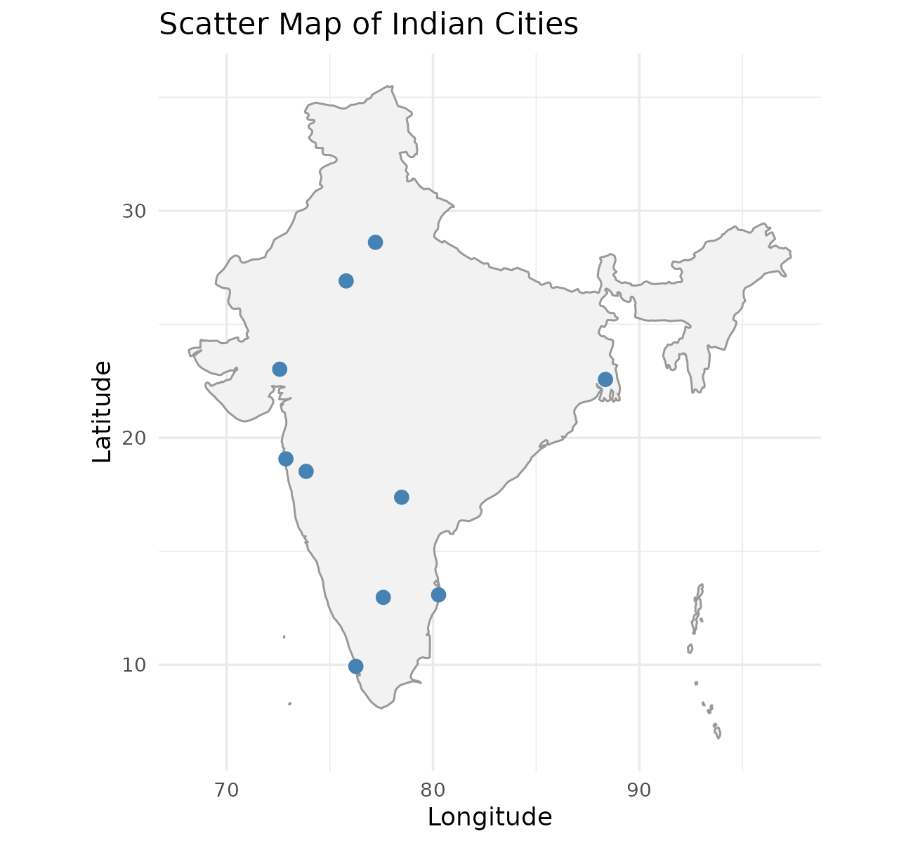
Each city is plotted at its exact longitude and latitude on the map of India, showing the spread of cities from south to north.
Q2. Bubble map (size = population)
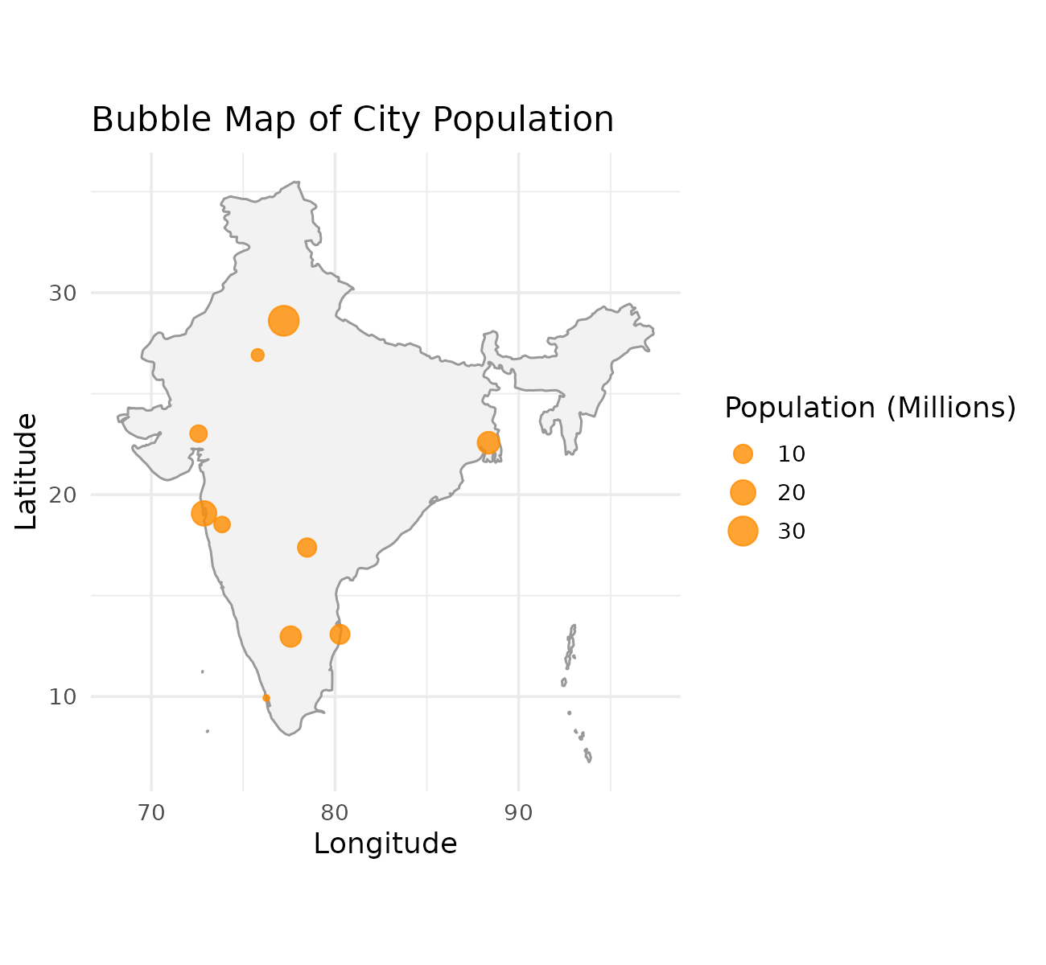
Bubble size represents population; Delhi and Mumbai show the largest bubbles, while Kochi and Jaipur are the smallest.
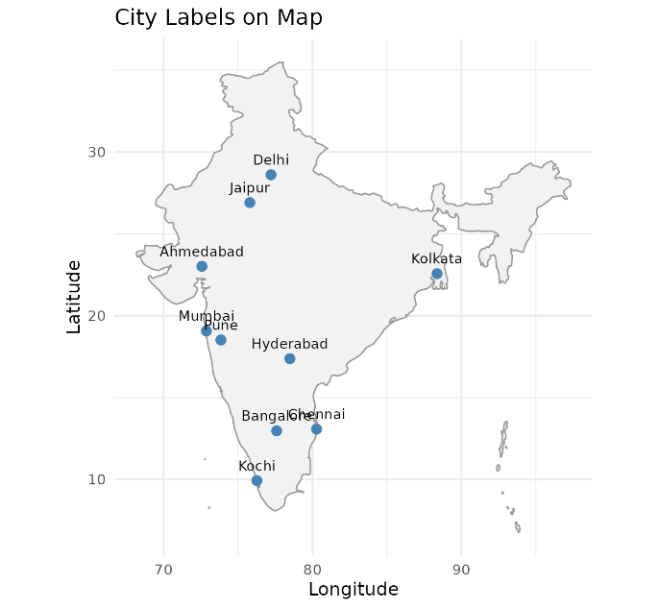
Q3. City labels (geom_text)

geom_text() adds each city name above its point so every location can be identified directly on the map.
Q4. Color by population size
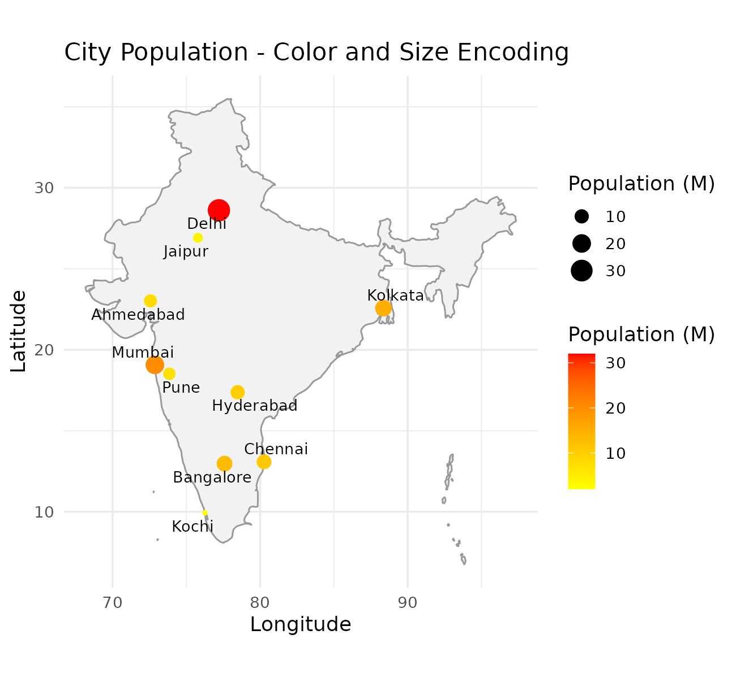
Color and size both encode population on a yellow-to-red scale, making high-population cities like Delhi stand out clearly.
Q5. City with highest population
Delhi has the highest population (32 million), visible as the largest and most intensely coloured bubble.
2. Network Visualization
library(igraph)

edges <- data.frame(
From = c("A","A","B","C","C","D","E","F","G","H"),
To = c("B","C","D","D","E","E","F","G","H","A")
)
g <- graph_from_data_frame(edges, directed = TRUE)

# Q1, Q2
png("t2_q1q2_network_graph.png", width = 1300, height = 1000, res = 200)
set.seed(42)
plot(g, vertex.color = "lightblue", vertex.size = 30, vertex.label.color = "black",
vertex.label.cex = 1.1, edge.arrow.size = 0.6, edge.color = "grey40",
main = "Network Graph of Nodes A to H")
dev.off()

# Q3
degree_table <- data.frame(Node = names(degree(g)), Degree = as.integer(degree(g)))
degree_table[order(-degree_table$Degree), ]

# Q5
png("t2_q5_circular_layout.png", width = 1300, height = 1000, res = 200)
plot(g, layout = layout_in_circle(g), vertex.color = "lightgreen", vertex.size = 30,
vertex.label.color = "black", vertex.label.cex = 1.1, edge.arrow.size = 0.6,
edge.color = "grey40", main = "Network Graph - Circular Layout")
dev.off()
Q1 & Q2. Network graph with labels and colors
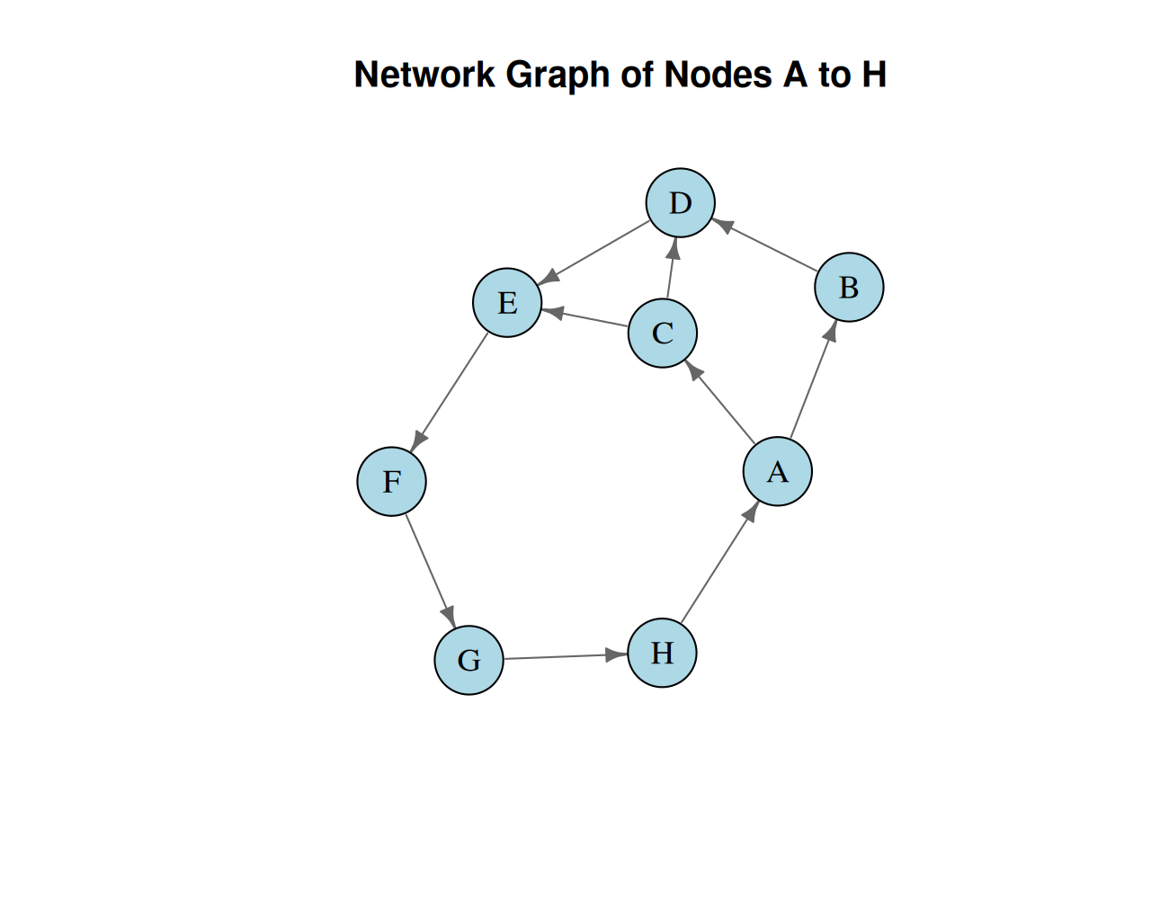
The graph is built with graph_from_data_frame() and plotted using igraph; nodes are light blue with black labels and arrows show edge direction.
Q3. Degree of each node
Node | Degree
A | 3
C | 3
D | 3
E | 3
B | 2
F | 2
G | 2
H | 2
Q4. Node with highest connections
Nodes A, C, D and E are tied for the highest degree (3 each), acting as junction points in the network.
Q5. Circular layout
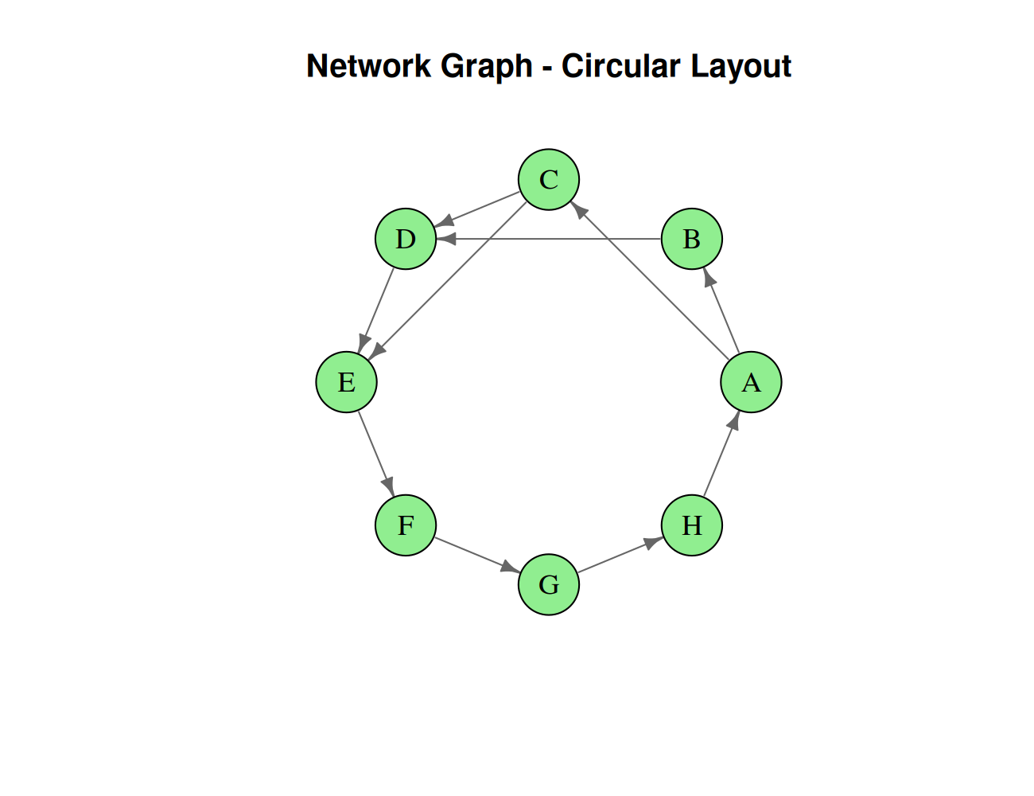
layout_in_circle() arranges all nodes evenly around a circle, making the main cycle and shortcut edges (A-C, C-D, C-E) easy to trace.
3. Temporal Data Representation
months <- c("Jan","Feb","Mar","Apr","May","Jun","Jul","Aug","Sep","Oct","Nov","Dec")
sales <- c(120, 135, 150, 170, 190, 220, 210, 230, 250, 270, 290, 320)

png("t3_line_chart.png", width = 1400, height = 900, res = 200)
plot(1:12, sales, type = "n", xaxt = "n", xlab = "Month", ylab = "Sales (Rs. Lakhs)",
main = "Monthly Sales Trend")
grid(col = "grey80", lty = "dotted")
lines(1:12, sales, col = "steelblue", lwd = 2)
points(1:12, sales, pch = 19, col = "darkred")
axis(1, at = 1:12, labels = months)
dev.off()

months[which.max(sales)]; max(sales)
Q1-Q4. Line chart with custom axis, markers, and grid
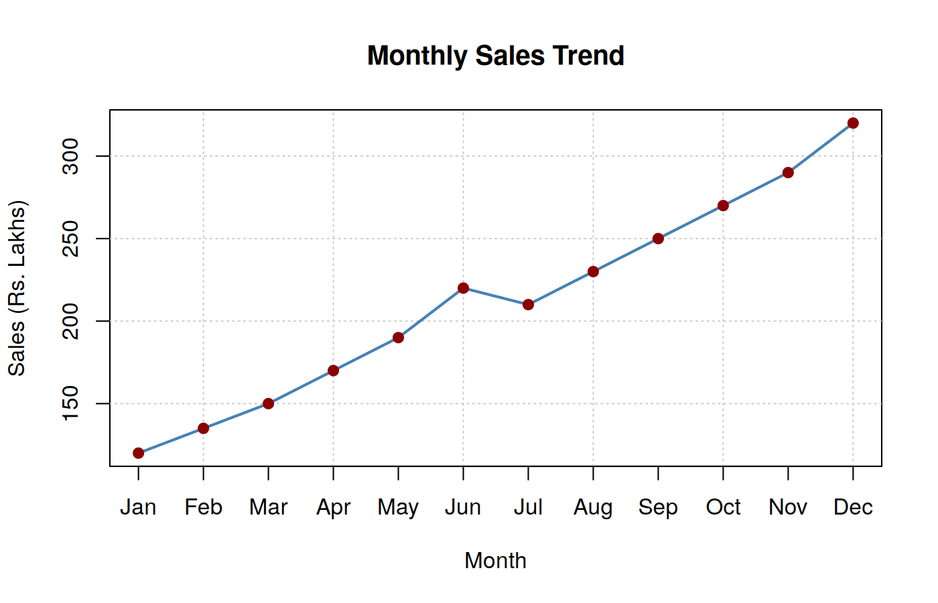
lines() draws the sales trend, axis() replaces numeric ticks with month names, points(pch=19) highlights each value, and grid() adds background gridlines for readability.
Q5. Month with maximum sales
December recorded the highest sales at Rs. 320 Lakhs, the topmost point on the chart.
4. Multivariate Data Visualization
library(ggplot2)
library(reshape2)

students <- data.frame(
Student = c("A","B","C","D","E","F","G","H","I","J"),
Marks = c(60, 68, 74, 79, 82, 85, 88, 91, 94, 97),
Attendance = c(75, 80, 84, 88, 90, 92, 94, 95, 97, 99),
StudyHours = c(2, 3, 4, 5, 5, 6, 6, 7, 8, 9),
Projects = c(1, 2, 2, 3, 3, 4, 4, 5, 5, 6)
)

# Q1
p1 <- ggplot(students, aes(Marks, Attendance, size = StudyHours, label = Student)) +
geom_point(color = "steelblue", alpha = 0.7) + geom_text(vjust = -1.3, size = 3.5) +
labs(title = "Marks vs Attendance (Bubble = Study Hours)", x = "Marks", y = "Attendance (%)") +
theme_minimal(base_size = 13)
ggsave("t4_q1_bubble_plot.png", p1, width = 6.5, height = 4.8, dpi = 200)

# Q2
png("t4_q2_pairs_plot.png", width = 1400, height = 1400, res = 200)
pairs(students[, c("Marks","Attendance","StudyHours","Projects")],
main = "Scatter Plot Matrix", pch = 19, col = "darkblue")
dev.off()

# Q3
cor(students[, c("Marks","Attendance","StudyHours")])

# Q4
students[which.max(students$Marks), ]

# Q5
melted_cor <- melt(cor(students[, c("Marks","Attendance","StudyHours","Projects")]))
p5 <- ggplot(melted_cor, aes(Var1, Var2, fill = value)) +
geom_tile(color = "white") + geom_text(aes(label = round(value, 2)), size = 4) +
scale_fill_gradient2(low = "blue", mid = "white", high = "red", midpoint = 0, limit = c(-1, 1)) +
labs(title = "Correlation Heatmap", x = "", y = "") + theme_minimal(base_size = 13)
ggsave("t4_q5_heatmap.png", p5, width = 6, height = 5, dpi = 200)
Q1. Bubble plot (Marks, Attendance, Study Hours)
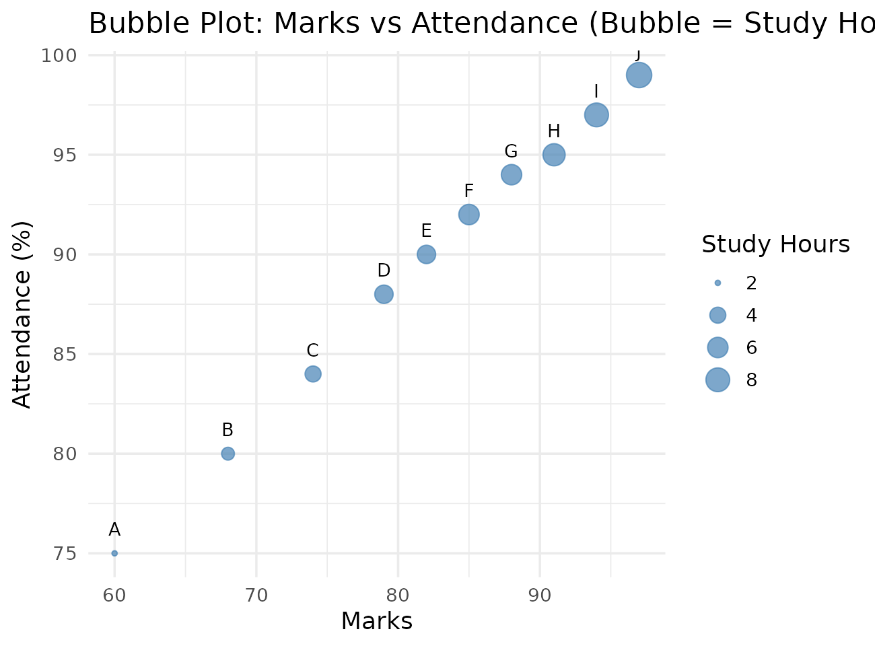
Marks, attendance, and bubble size (study hours) all increase together, showing students who study more score higher and attend more.
Q2. Scatter plot matrix
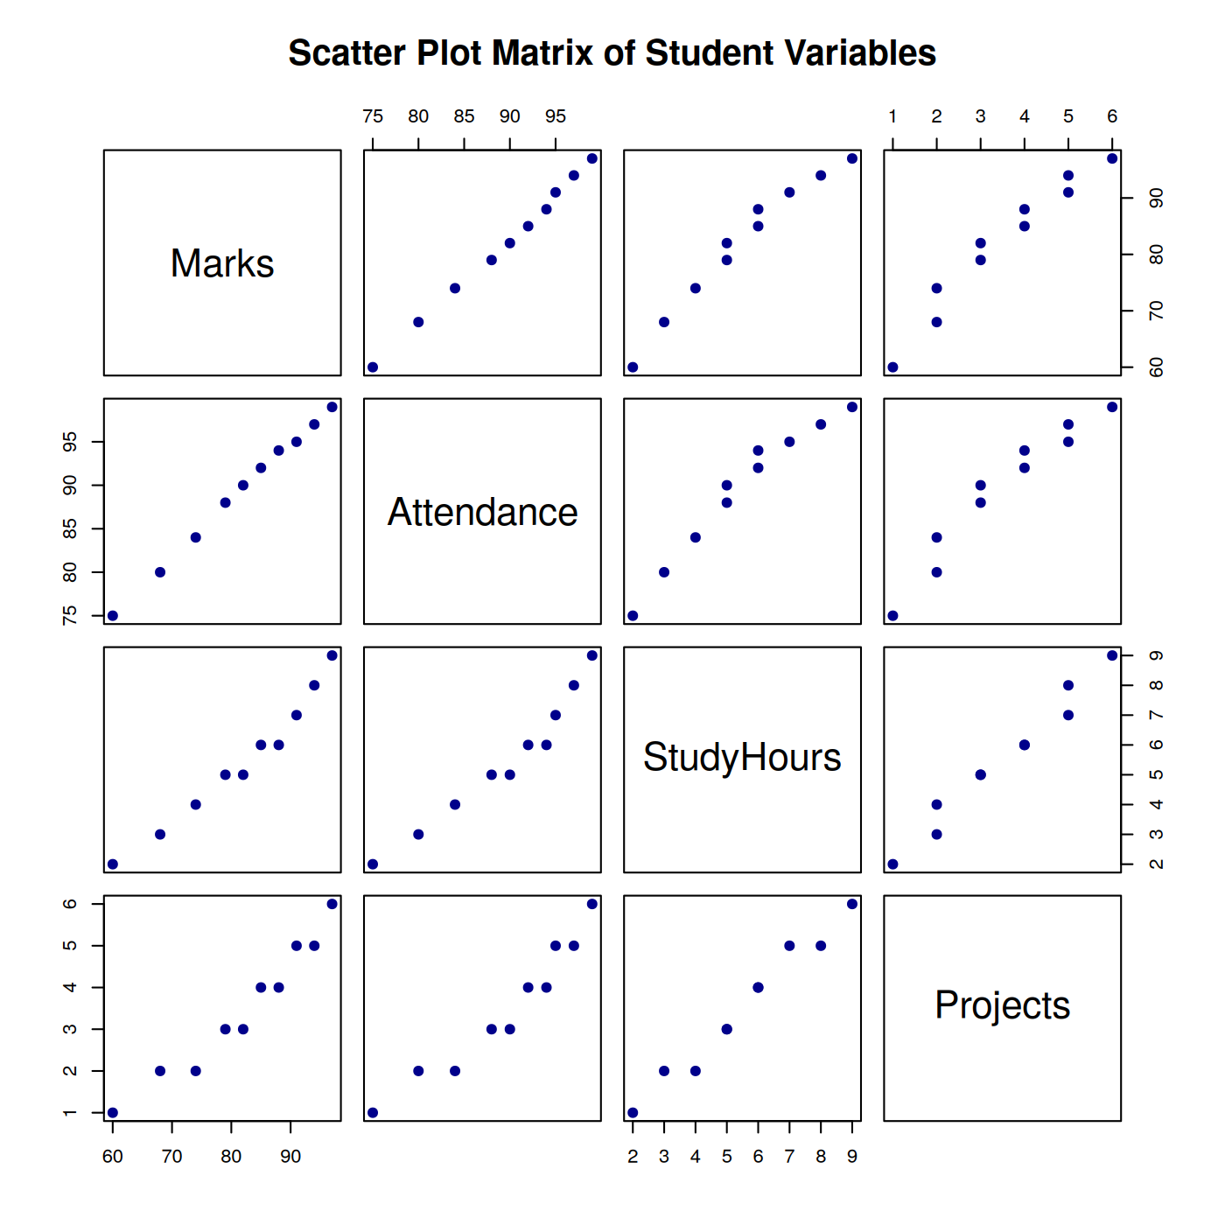
Every pair of variables shows a near straight-line positive relationship across students A to J.
Q3. Correlation (Marks, Attendance, Study Hours)
 | Marks | Attendance | Study Hours
Marks | 1.000 | 0.998 | 0.981
Attendance | 0.998 | 1.000 | 0.974
Study Hours | 0.981 | 0.974 | 1.000
Q4. Highest marks and largest bubble
Student J has the highest marks (97) and the largest bubble, with the most study hours (9) and highest attendance (99%).
Q5. Correlation heatmap
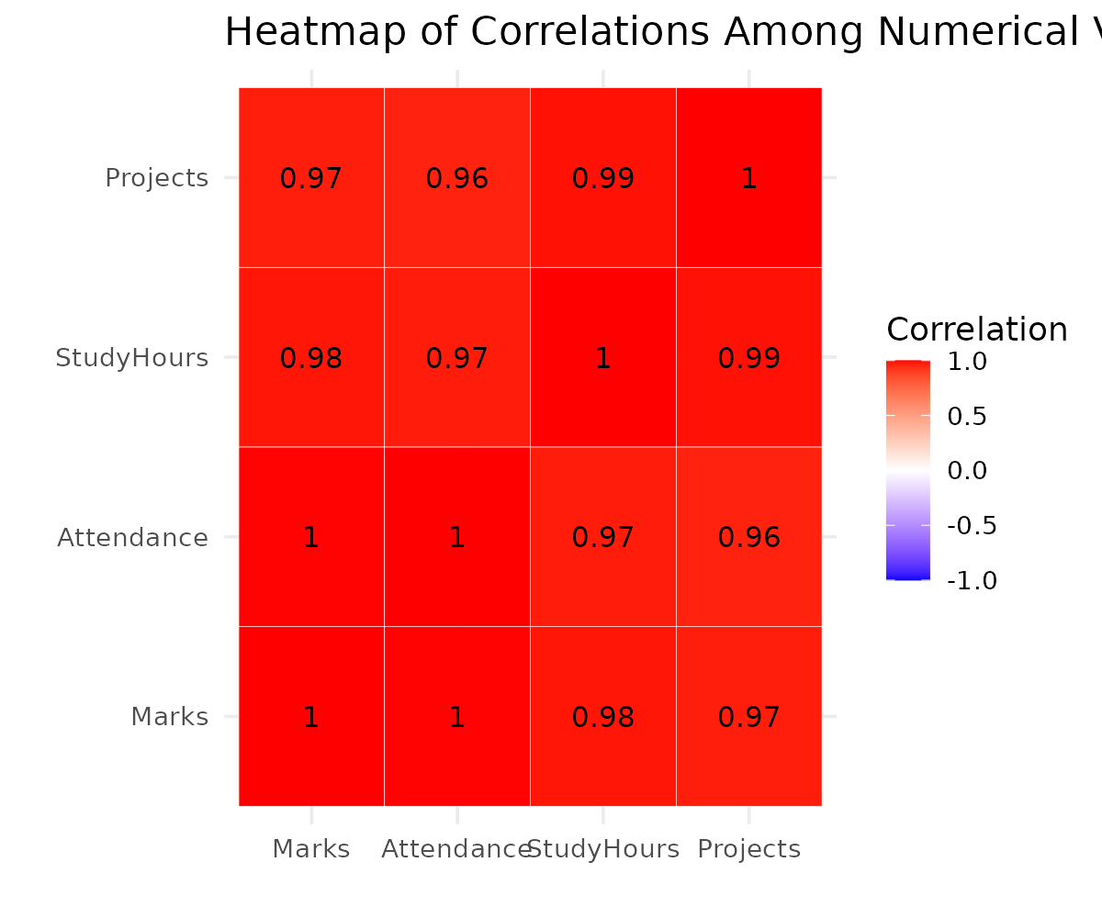
All variable pairs are shaded dark red with values near 1, confirming strong positive correlation throughout the dataset.
5. Integrated Data Visualization Exercise
library(ggplot2)

company <- data.frame(
Year = 2016:2025,
Sales = c(150, 170, 200, 240, 260, 300, 340, 390, 430, 480),
Profit = c(20, 25, 32, 40, 42, 55, 65, 72, 82, 95),
Customers = c(1200, 1500, 1800, 2200, 2400, 2800, 3300, 3800, 4200, 4700),
Branches = c(5, 6, 7, 8, 8, 10, 11, 12, 13, 15)
)

# Q1
p1 <- ggplot(company, aes(Year, Sales)) + geom_line(color = "steelblue", linewidth = 1) +
geom_point(color = "darkred", size = 2) + scale_x_continuous(breaks = company$Year) +
labs(title = "Yearly Sales Trend", x = "Year", y = "Sales (Rs. Lakhs)") +
theme_minimal(base_size = 13) + theme(axis.text.x = element_text(angle = 45, hjust = 1))
ggsave("t5_q1_sales_trend.png", p1, width = 6.8, height = 4.5, dpi = 200)

# Q2
p2 <- ggplot(company, aes(Sales, Profit, size = Customers, label = Year)) +
geom_point(color = "darkorange", alpha = 0.7) + geom_text(vjust = -1.3, size = 3.2) +
labs(title = "Sales vs Profit (Bubble = Customers)", x = "Sales", y = "Profit") +
theme_minimal(base_size = 13)
ggsave("t5_q2_bubble_plot.png", p2, width = 6.8, height = 4.8, dpi = 200)

# Q3
cor(company[, c("Sales","Profit","Customers","Branches")])

# Q4
png("t5_q4_pairs_plot.png", width = 1400, height = 1400, res = 200)
pairs(company[, c("Sales","Profit","Customers","Branches")],
main = "Scatter Plot Matrix", pch = 19, col = "darkgreen")
dev.off()
Q1. Yearly sales trend
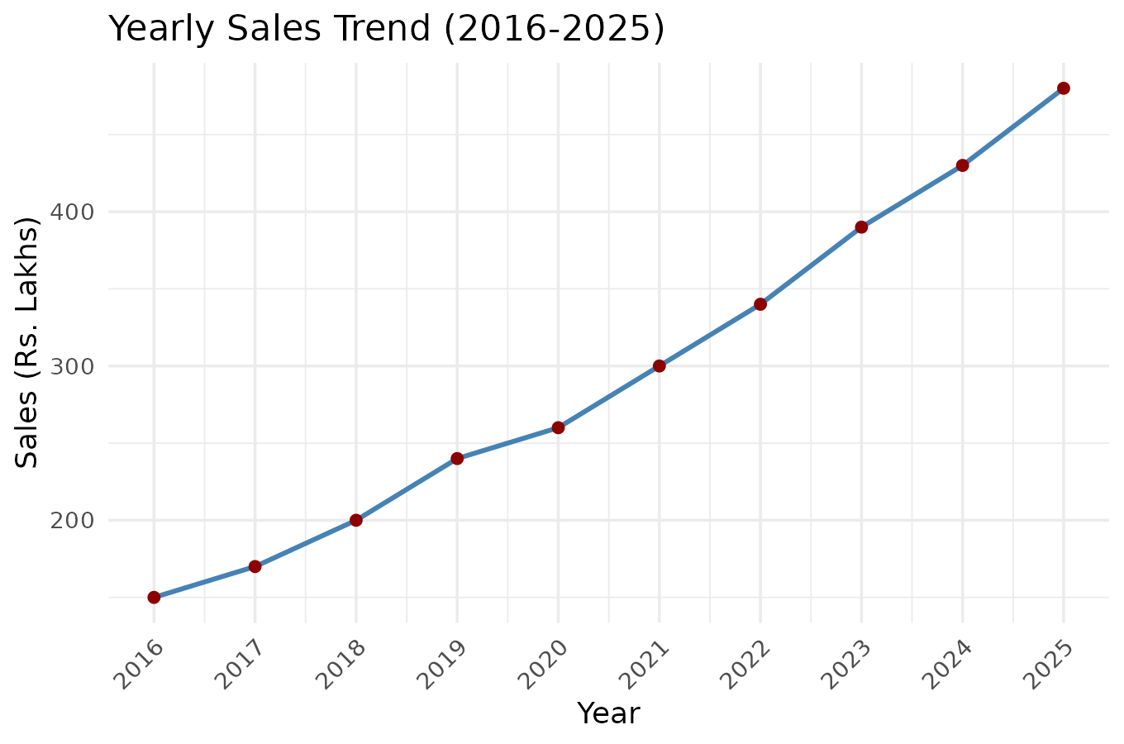
Sales rise every year from 2016 to 2025 with no decline, showing consistent growth.
Q2. Bubble plot (Sales, Profit, Customers)
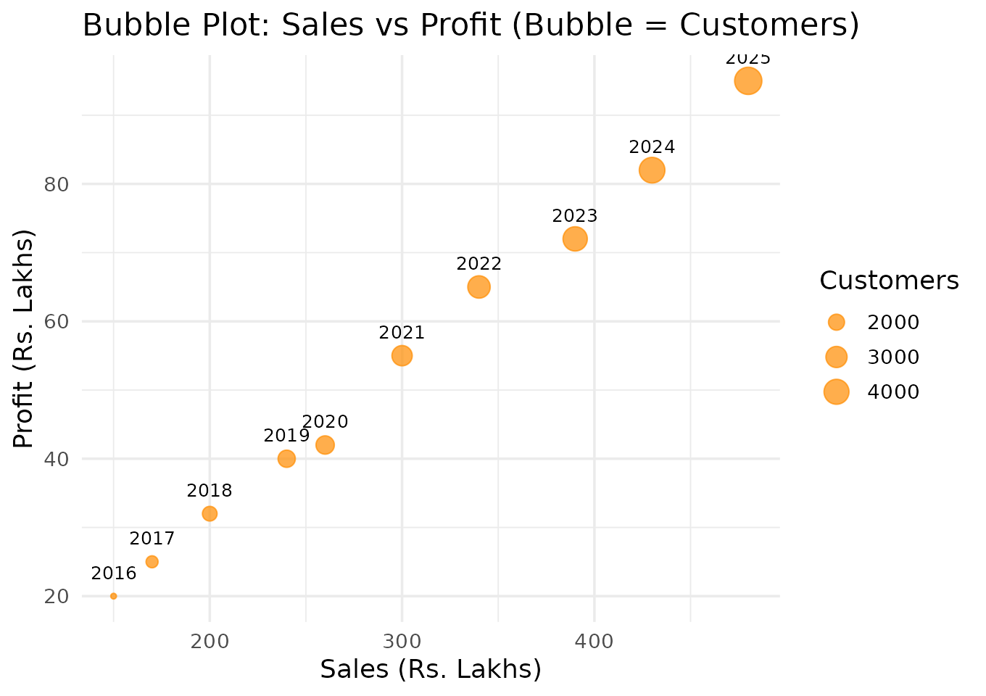
As sales and profit rise, bubble size (customers) also grows steadily, indicating customer growth tracks sales and profit growth.
Q3. Correlation matrix
 | Sales | Profit | Customers | Branches
Sales | 1.000 | 0.998 | 1.000 | 0.996
Profit | 0.998 | 1.000 | 0.998 | 0.999
Customers | 1.000 | 0.998 | 1.000 | 0.996
Branches | 0.996 | 0.999 | 0.996 | 1.000
Q4. Scatter plot matrix
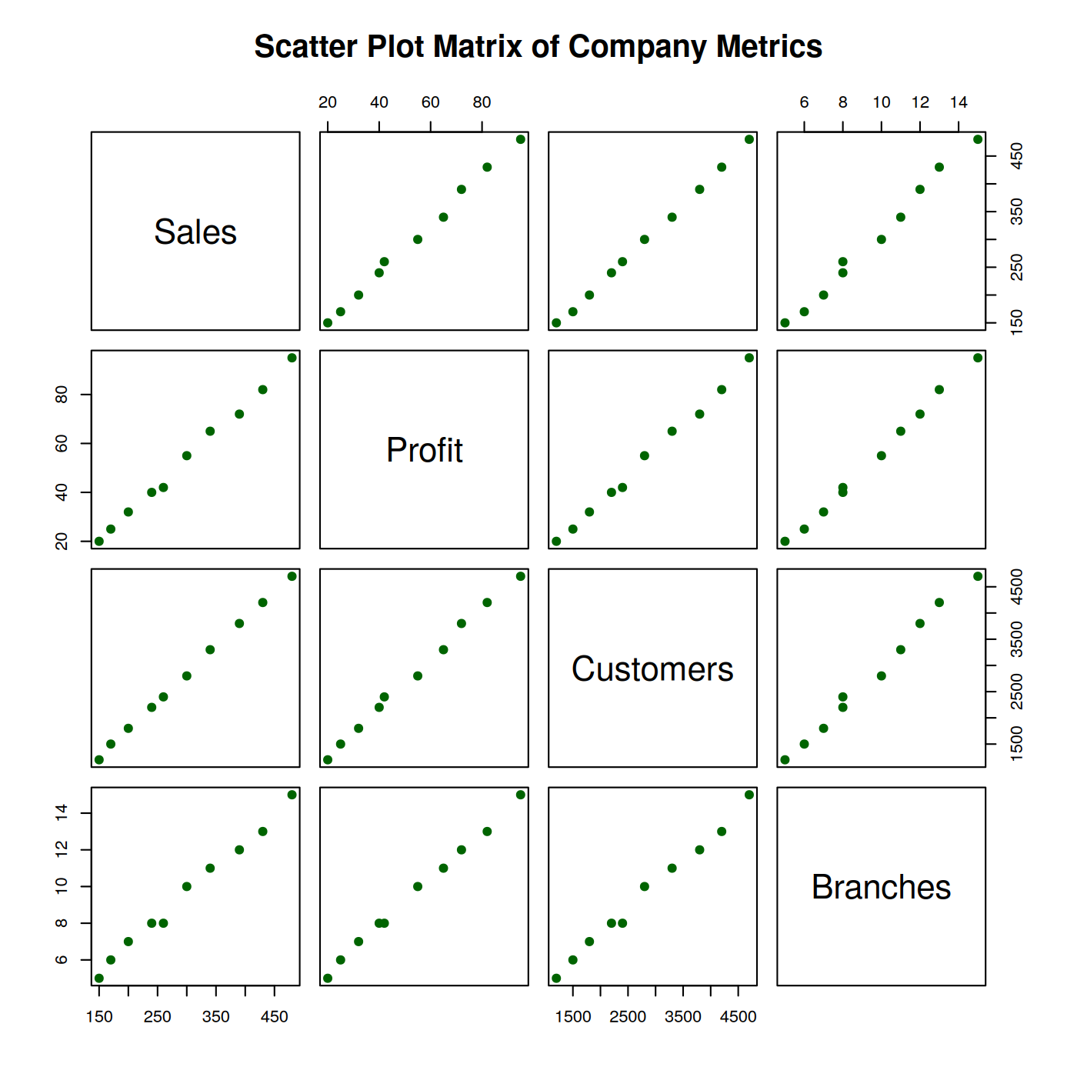
All pairs show a tight upward line, confirming the strong correlations seen in the matrix above.
Q5. Do more branches relate to higher sales/profit?
Yes — branches correlate 0.996 with sales and 0.999 with profit, and both scatter plots show a clear upward trend, so branch expansion has closely tracked the company's sales and profit growth.

