ARTIFICIAL INTELLIGENCE
Introduction:
- Jhon McCarthy first coined the term Artificial Intelligence in the year 1956.
- Artificial Intelligence (AI) as a field was first introduced in 1956 at the Dartmouth Conference.
What is Artificial Intelligence?
Artificial Intelligence (AI) means making computers or machines smart enough to do tasks that normally need human intelligence.
It helps machines to think, learn, and make decisions like humans.
Examples of AI:
- Google Assistant / Siri / Alexa → Answering questions, playing music.
- Netflix / YouTube → Suggesting movies and videos.
- Self-driving Cars → Cars that can drive on their own. Ex: Tesla
- Healthcare → AI predicting diseases.
- Chatbots → Talking to customers on websites.
Programming Languages Used in AI
- Python – Most popular, easy to learn, used for machine learning and deep learning.
- R – Used for data analysis and statistics.
- Java – Used in big applications like chatbots and banking systems.
- C++ – Used in games and fast AI programs.
How AI is used in technology?
AI is used in many technologies around us to make systems smarter and more efficient. It helps in automation, decision-making, prediction, and personalization.
Examples: Smartphones, Social-Media, Healthcare, Transportation, Banking and Finance, E-commerce and entertainment.

MACHINE LEARNING
- Arthur Samuel first coined the term in Machine Learning in the year 1959.
What is Machine Learning?
Machine Learning (ML) is a part of Artificial Intelligence (AI) that allows computers to learn from data and improve their performance without being directly programmed.
Example: Just like humans learn from experience, machines learn from data.
Machine Learning Process:
The ML process involves building a predictive model that can be used to find a solution for a problem statement.
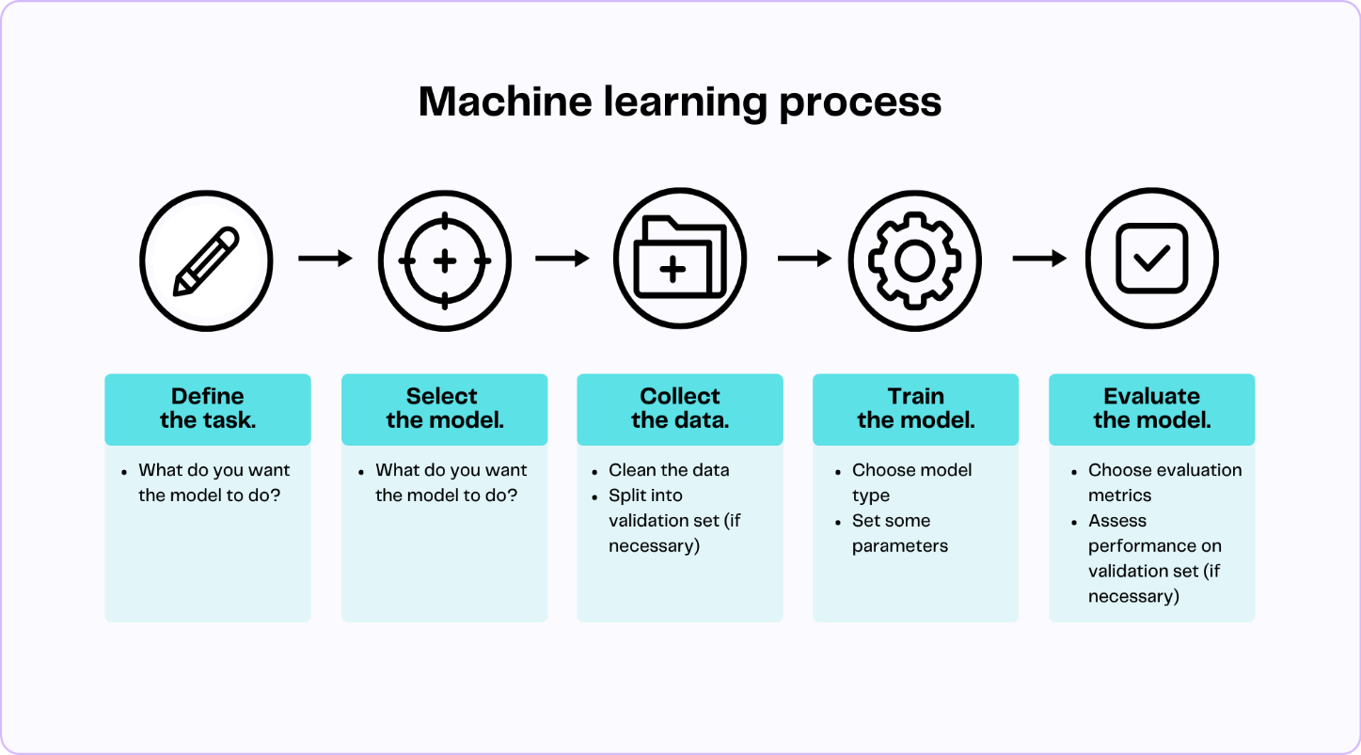
- Define Objective
  - Identify the problem you want to solve.
  - Example: Predict student marks, forecast sales, detect spam, etc.
- Data Gathering
  - Collect relevant data from sources (databases, files, sensors, etc).

- Preparing Data
  - Clean the data (handle missing values, duplicates, errors).
  - Transform into suitable format for analysis.
- Data Exploration
  - Analyse patterns, relationships, and insights in the data.
  - Use statistical tools and visualization.
- Building a Model
  - Choose a machine learning algorithm (e.g., regression, decision tree, neural networks).
  - Train the model on the prepared dataset.
- Model Evaluation
  - Test the model using metrics like accuracy, precision, recall, etc.
  - Compare with baseline or other models.
- Predictions
  - Deploy the trained model to make predictions on new data.
  - Continuously monitor and update the model for better performance.

NUMPY
Definition:
NumPy (Numerical Python) is a Python library used for working with numbers and arrays.
It helps in doing mathematical, statistical, and scientific calculations quickly and easily.
Practical tasks:
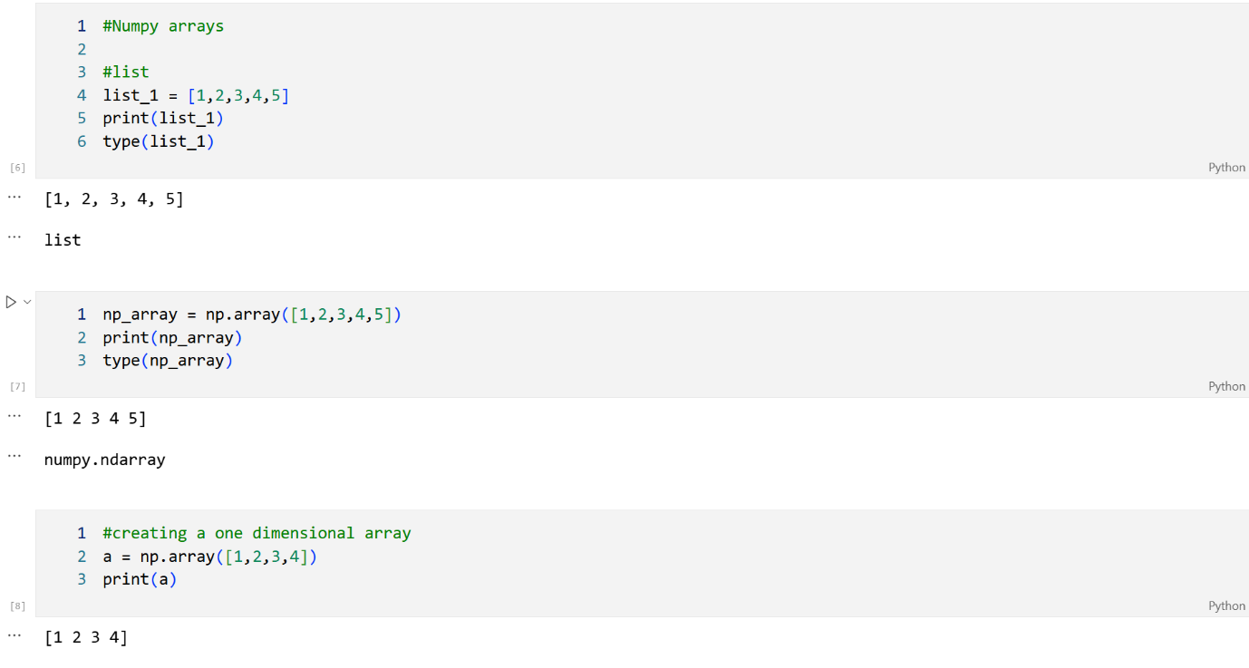

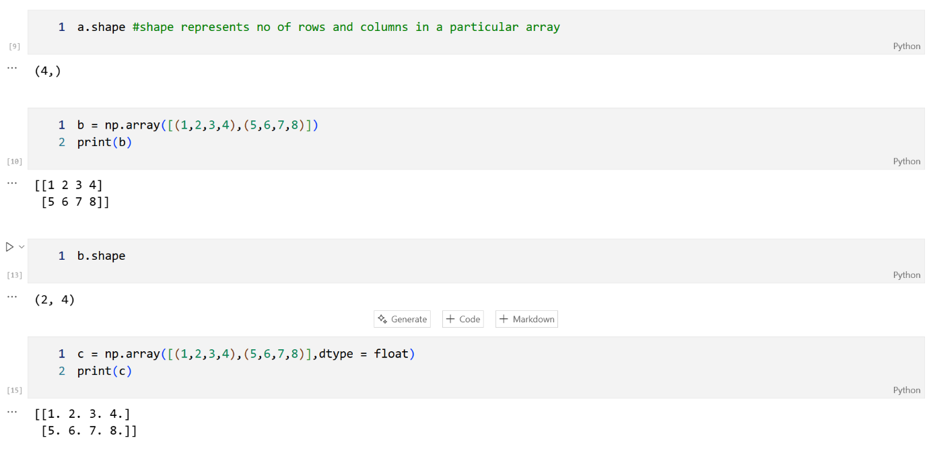

- np.vstack() → stacks arrays vertically (row-wise)

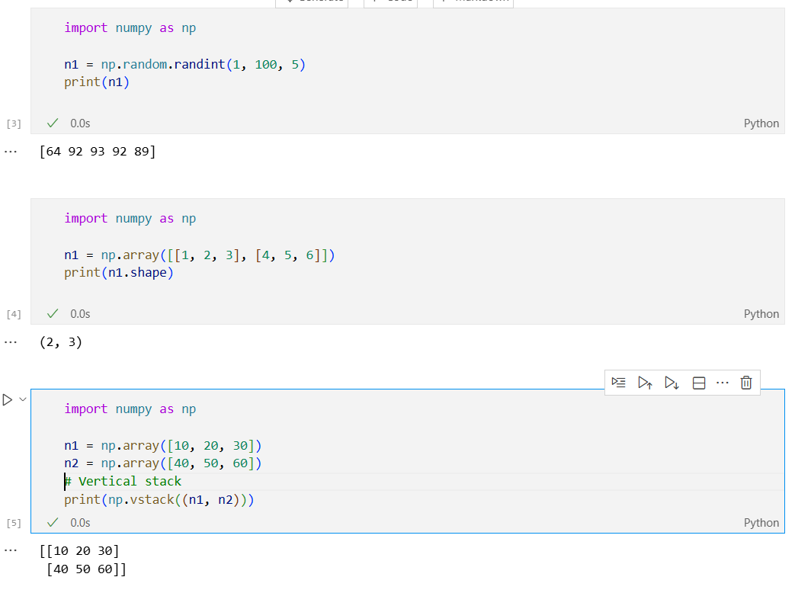

- np.hstack() → stacks arrays horizontally (column-wise)
- np.column_stack() → stacks arrays as columns side by side

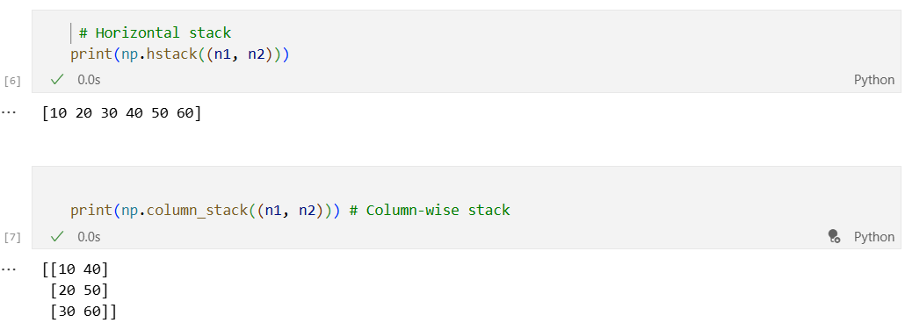

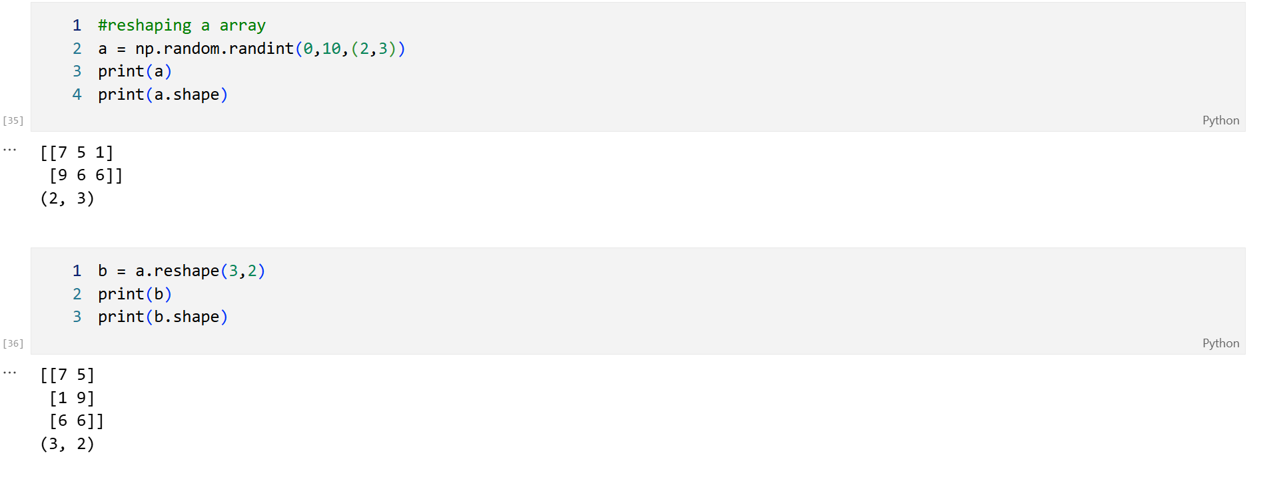

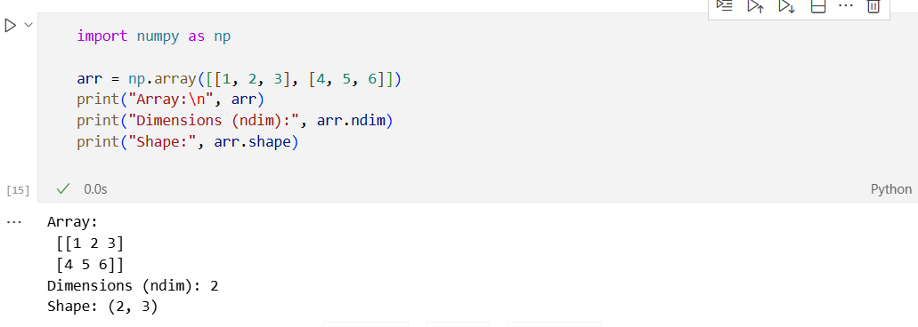

- n1
→ A 3×3 2D array.
- n1[0]
→ First row (index 0) = [1 2 3].
- n1[:,1]
→ All rows (:) but only the 2nd column (1) → [2 5 8].
- n1.transpose()
→ Swaps rows ↔ columns.
Original rows → become columns
Original columns → become rows
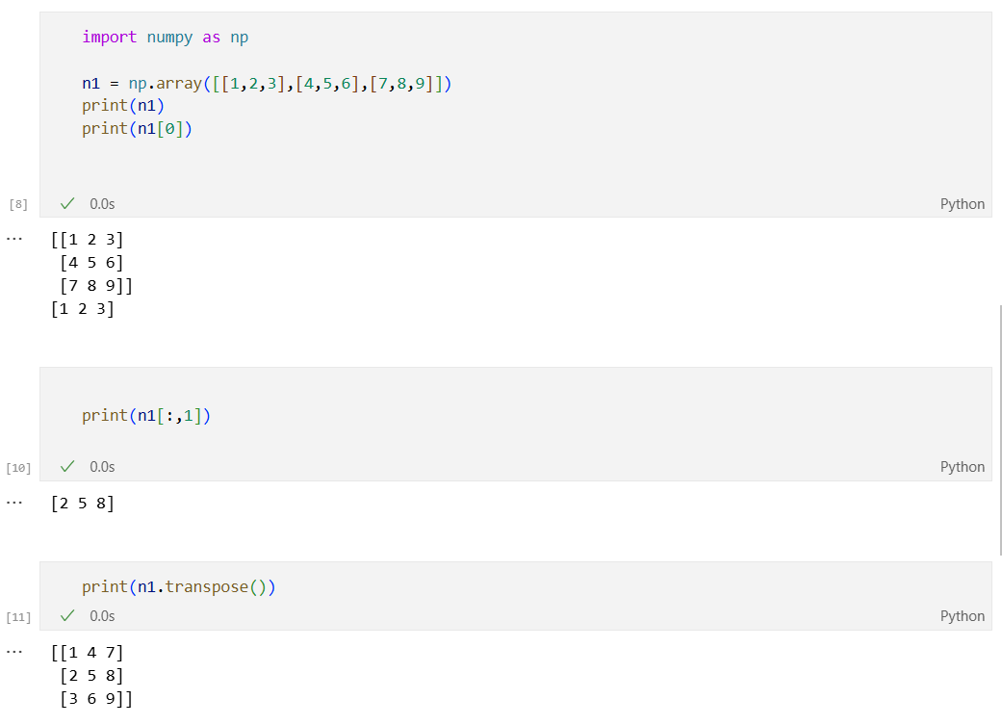

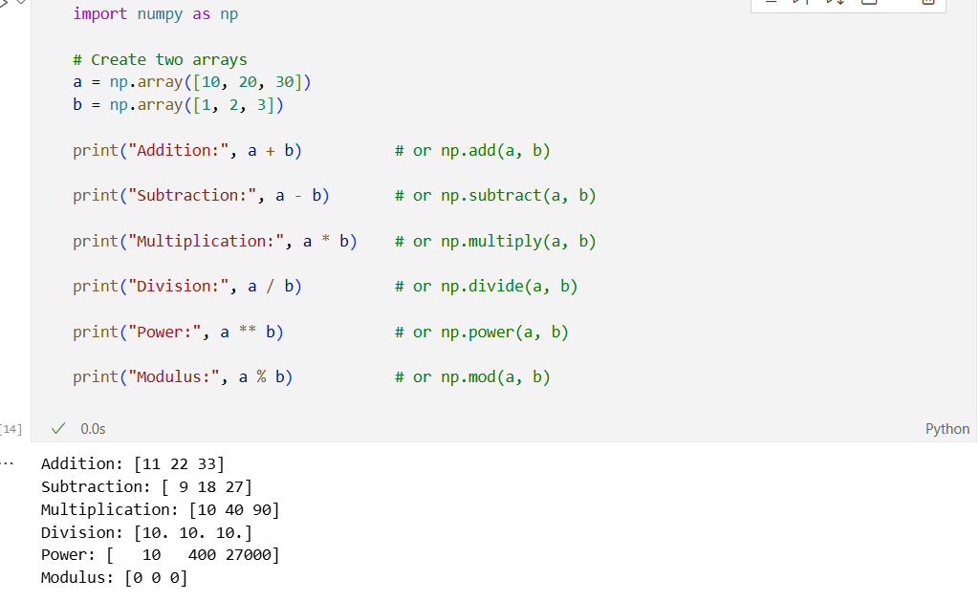
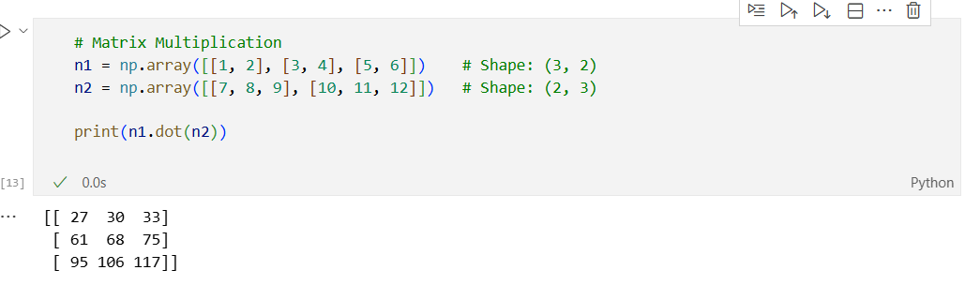

- n1.shape
→ (2, 3) means 2 rows and 3 columns.
- np.mean(n2)
→ Average = (10 + 20 + 30 + 60) / 4 = 30.0
- np.std(n2) (Standard Deviation)
→ Measures how spread out the numbers are ≈ 18.71
- np.median(n2)
→ Middle value when sorted = [10, 20, 30, 60] → middle between 20 and 30 → 25.0

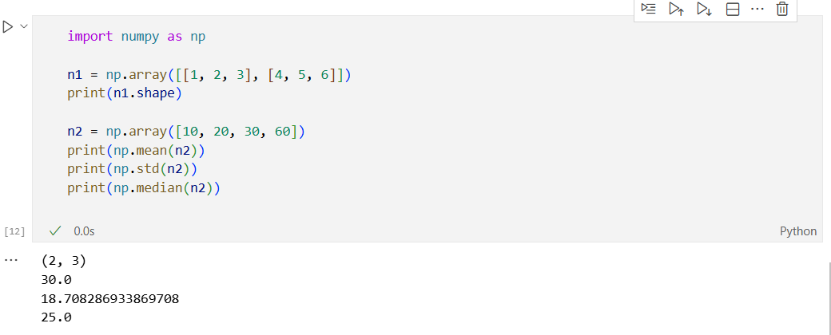

PANDAS
Pandas is a Python library used for data analysis and data manipulation.
Practical Tasks:

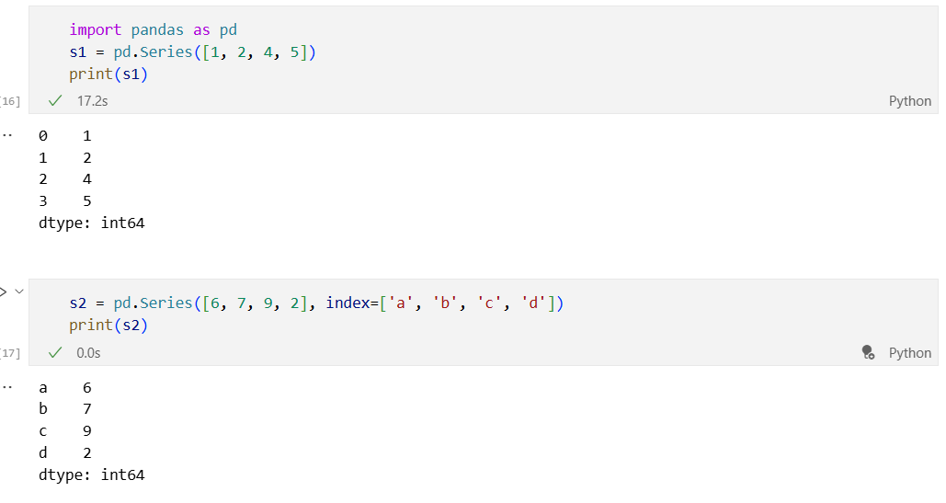

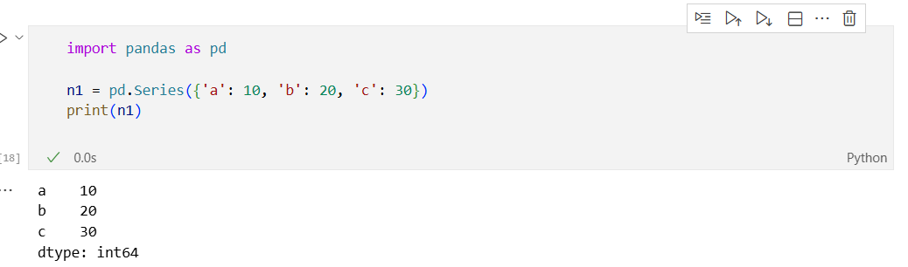

- pd.Series({key: value}) → creates a Series from a dictionary.
- The keys become the index labels (a, b, c)
- The values become the data (10, 20, 30).

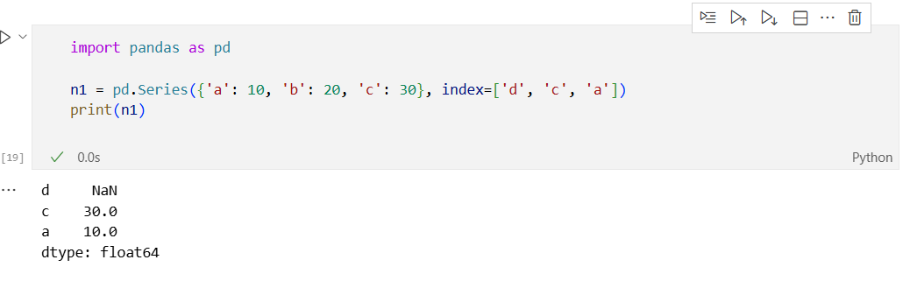

- Pandas tries to match it with the dictionary keys:
- 'c' → found → value 30
- 'a' → found → value 10
- 'd' → not found → NaN

->The output dtype becomes float64 because of the NaN.

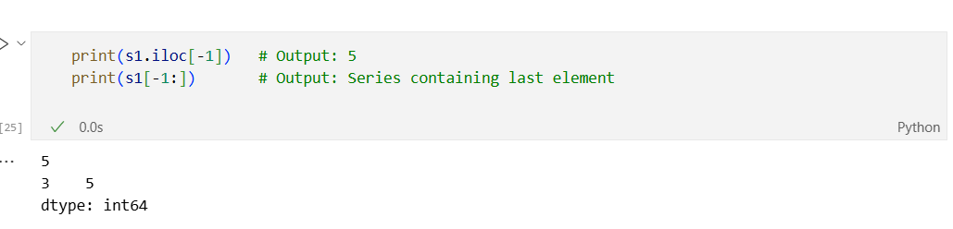
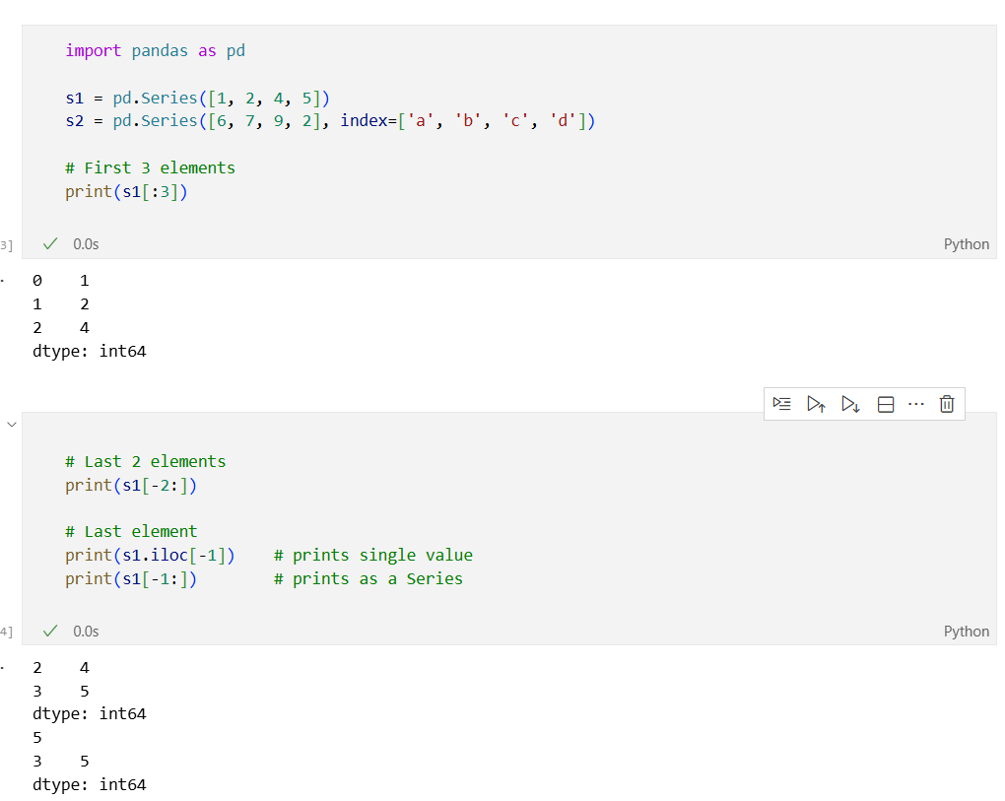
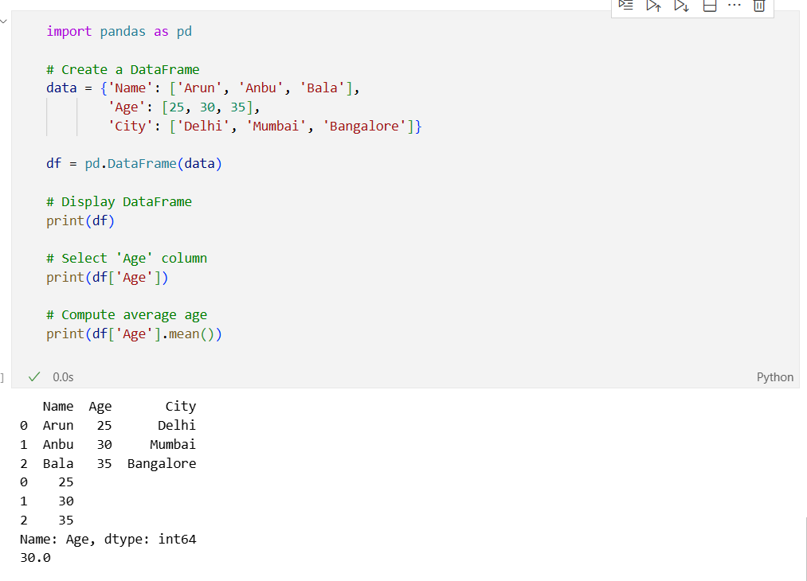

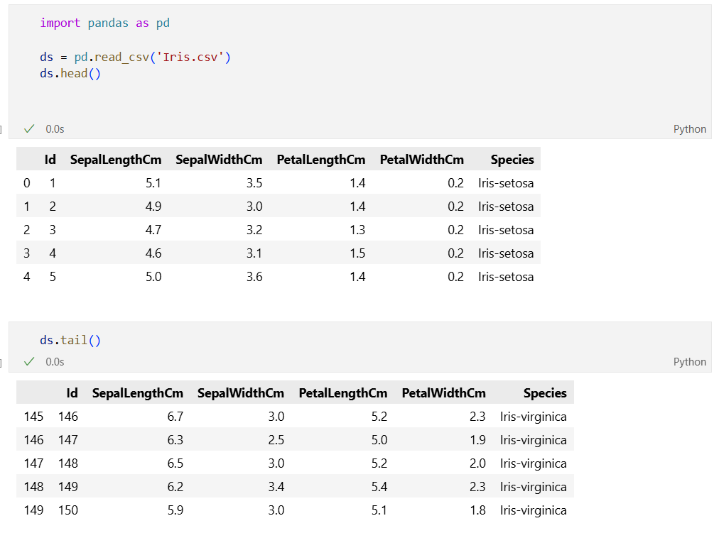

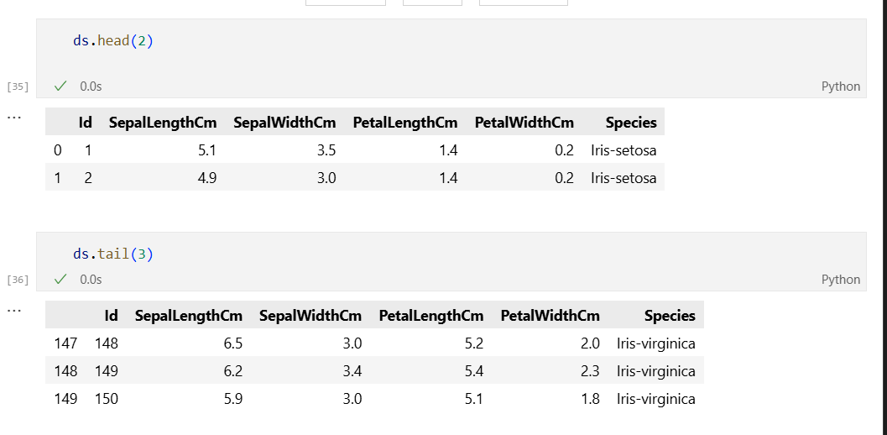

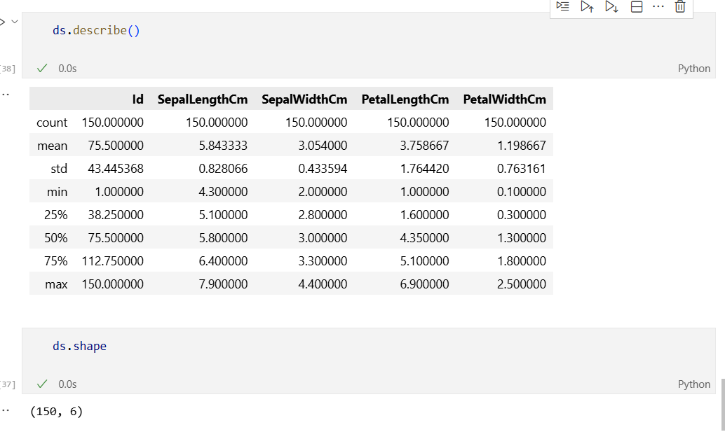

Summary Table

Function | Purpose
read_csv() | Load CSV file into a DataFrame
head(n) | Show first n rows (default 5)
tail(n) | Show last n rows (default 5)
shape | Get number of rows and columns
describe() | Get summary statistics of numeric columns

MATPLOTLIB
Matplotlib is a Python library used for creating graphs, plots, and charts.
It helps to visualize data in different forms like line charts, bar graphs, pie charts, scatter plots, etc.
Practical Tasks:
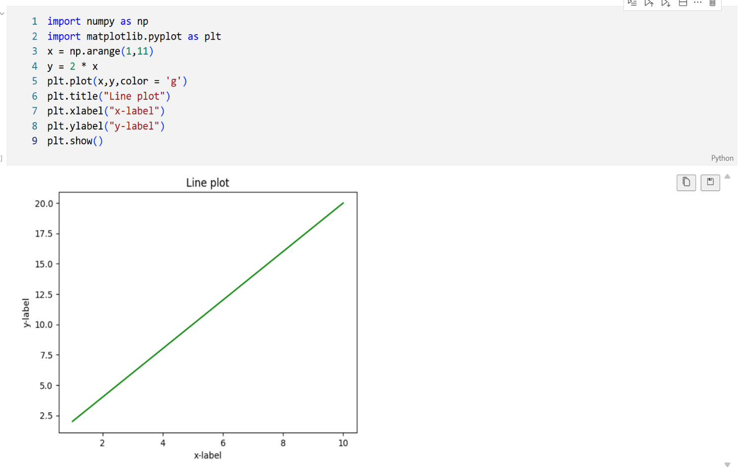

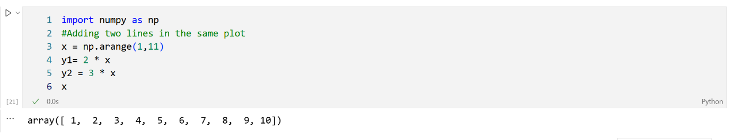

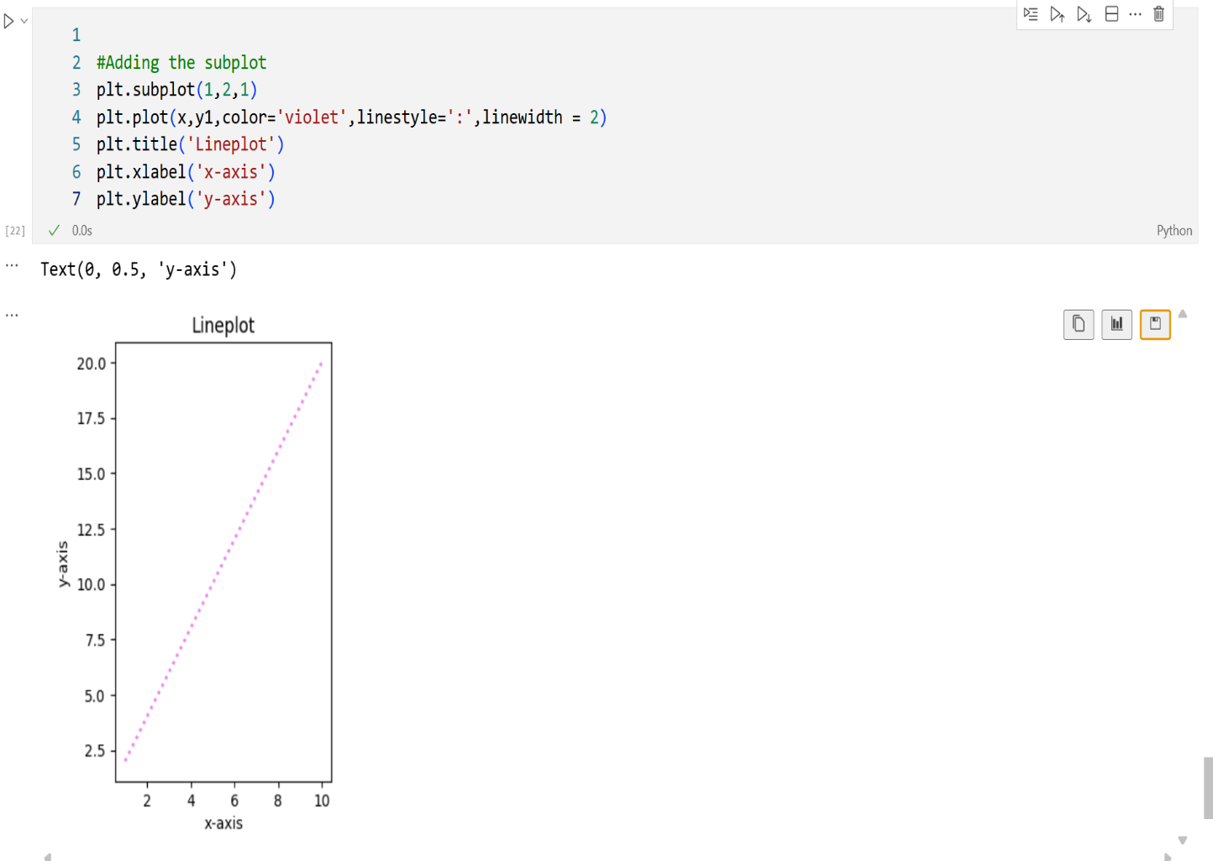

Submitted By: Seela Harshitha

