Predicting Customer Repeat Purchase Behavior in E-Commerce:
A Data-Driven Approach to Retention Strategy
Business Analytics Individual Case Study
Student: KHANDAVILLI V V S D GNANESH
Register Number: CB.SC.U4CSE23662
Class / Section: CSE G
Domain: E-Commerce

1. Problem Statement and Objectives
Online retailers routinely rely on blanket discounting to bring customers back, without clear evidence of which customer characteristics actually predict who returns. Understanding whether repeat purchasing is driven more by service satisfaction or by price sensitivity is important because it determines whether a retention budget is better spent on service quality improvements or on promotional spend — two very different strategies with very different costs.
This case study analyses primary survey data from e-commerce shoppers to examine behavioural, satisfaction-related, spending, and demographic factors associated with repeat purchase behavior, and builds classification models to estimate repeat-purchase likelihood. The analysis is observational: results identify associations and predictive usefulness, not causal effects.

Objectives
- Identify behavioural, satisfaction-related, spending, and demographic factors associated with repeat purchase behavior.
- Build and evaluate classification models (Logistic Regression, Random Forest) to estimate the likelihood of repeat purchase.
- Compare satisfaction-related factors against discount/spending-related factors using the same evaluation framework, and translate the results into actionable business recommendations.

2. Data Collection and Dataset Description
The dataset was collected through a Google Forms questionnaire designed for e-commerce shoppers, capturing demographic characteristics, shopping behavior, satisfaction factors, spending-related information, and repeat-purchase behavior. This is primary survey data collected for this case study rather than a ready-made Kaggle, UCI, or GitHub dataset.

Dataset summary
- Raw records collected: 11,401
- Columns: 13
- Exact duplicate records removed: 5,242
- Rows after duplicate removal: 6,159
- Final modeling population: 6,158 shoppers
- Target variable: repeat purchase (Yes / No)
- Target distribution: 50.70% Yes, 49.30% No
The questionnaire used skip logic: In the raw workbook, 5,240 records were marked as not having shopped online in the previous six months. Because the questionnaire uses skip logic, these records did not contain the downstream shopper-specific responses. After exact duplicate removal, the unique dataset contained 6,158 shopper responses and one non-shopper record; the non-shopper record was excluded from modeling by design.

Key variables
- Monthly shopping frequency and most-used e-commerce platform
- Satisfaction ratings: delivery speed, product-match accuracy, ease of use
- Return / refund issue history
- Discount importance in purchase decisions
- Age group, occupation, monthly spending capacity, and average order value
- Repeat purchase behavior (target variable)

3. Data Preparation and Exploratory Analysis
The following cleaning and preprocessing steps were applied before analysis:
- Stripped whitespace from all text responses (e.g. a trailing-space ‘Blinkit ’ entry was otherwise counted as a platform separate from ‘Blinkit’).
- Removed 5,242 exact duplicate rows.
- Cleaned and standardized column names.
- Restricted the modeling population to respondents who shopped online in the previous six months, per the survey's skip logic.
- Encoded the repeat-purchase target as a binary variable.
- Split predictors from the target and used a stratified train/test split.
- Performed imputation and encoding inside scikit-learn pipelines, fit on the training fold only, to avoid preprocessing leakage.

Target distribution
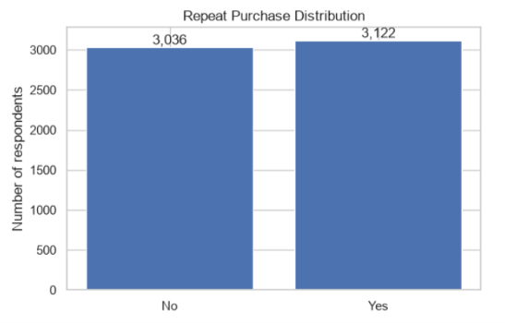
Figure 1. Repeat-purchase target is close to balanced (3,122 Yes vs. 3,036 No), not the ~89/11 skew assumed at the proposal stage.

Demographic and behavioral distributions
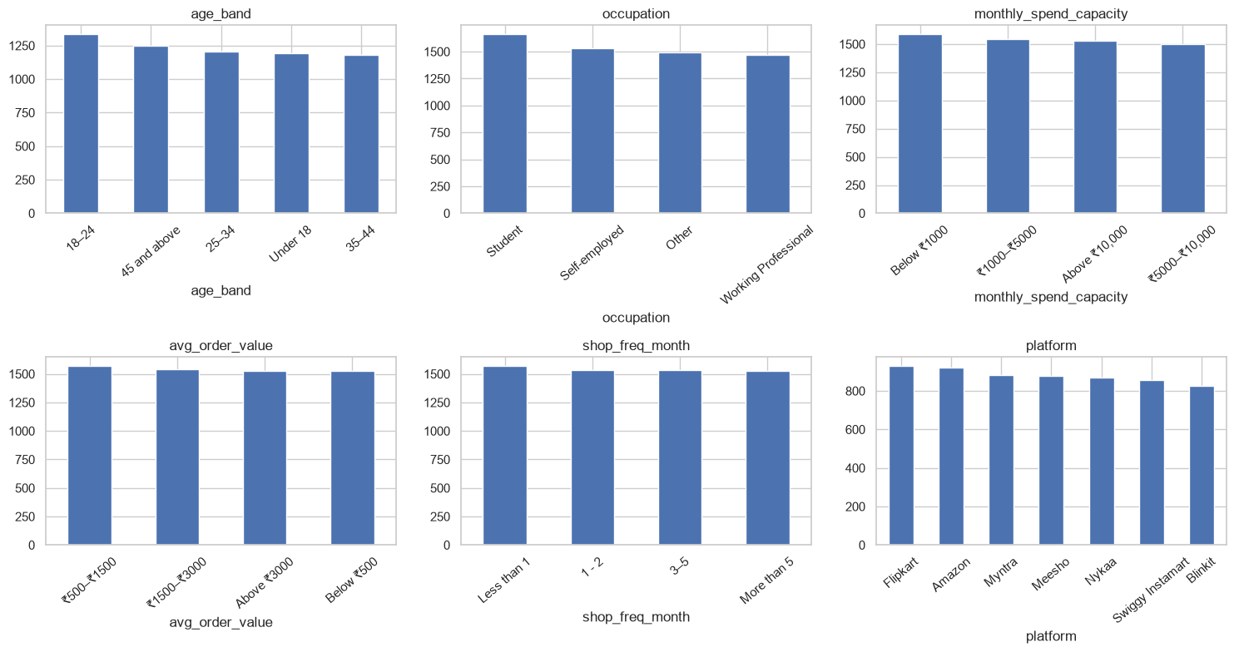
Figure 2. Age, occupation, spending capacity, order value, shopping frequency and platform distributions among the 6,158 shoppers.
A notable pattern across Figure 2 and the satisfaction/discount ratings below is that response counts are relatively uniform across categories for nearly every question. This may reflect the questionnaire design or respondent composition and is considered as a limitation when interpreting the generalizability of the study.
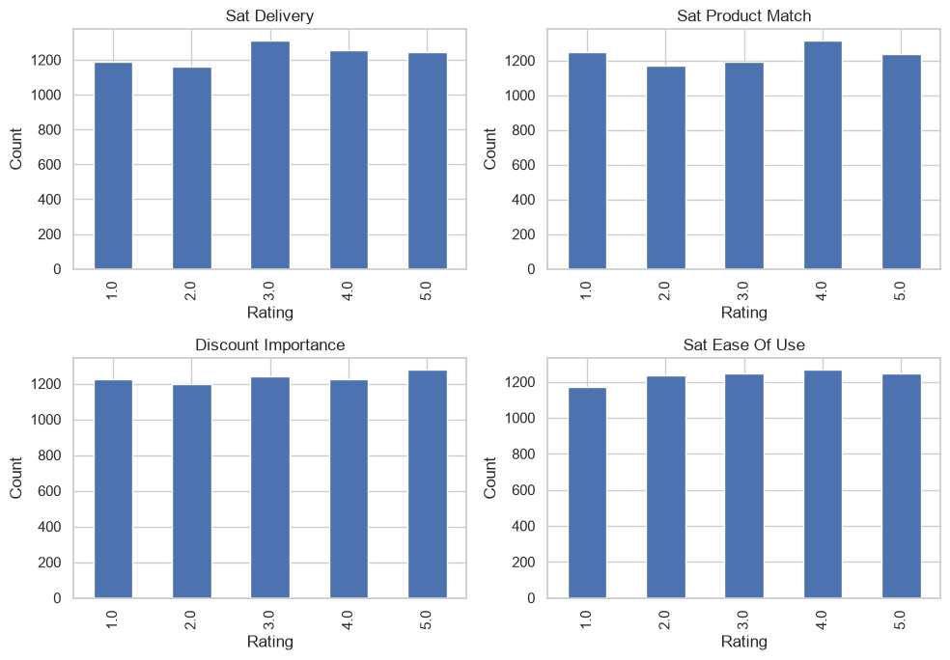
Figure 3. Distribution of the four 1–5 satisfaction and discount-importance ratings.

4. Analytics Method and Implementation
Two classification approaches were applied, matched to the Business Analytics syllabus coverage of predictive classification methods:
- Logistic Regression — an interpretable linear baseline for estimating repeat-purchase likelihood.
- Random Forest — an ensemble method capable of capturing nonlinear relationships and interactions among the survey variables that a linear model cannot.
Both models were built inside a single scikit-learn [4] Pipeline (imputation → encoding → classifier) so that preprocessing statistics were learned only from the training fold, avoiding data leakage into the test set. Models were evaluated on an 80/20 stratified train/test split and, for a more stable estimate, with 5-fold stratified cross-validation on the full feature set. A majority-class baseline (DummyClassifier) was computed under the identical 5-fold scheme so that model performance could be read against a simple reference point rather than accuracy alone.
Before modeling, each candidate predictor was tested independently against the target: Mann–Whitney U tests for the ordinal satisfaction/discount-importance variables, and Chi-square tests with Cramér's V effect sizes for the nominal variables (age band, occupation, platform, spend capacity, order value, return-issue history, shopping frequency). These tests are used as exploratory evidence of association only, not as evidence of causation.
Models were evaluated using Accuracy, Precision, Recall, F1 Score, and ROC-AUC, following standard practice for binary classification with a near-balanced target.

5. Comparison with State-of-the-Art Methods
Three recent published studies on repeat-purchase / repurchase prediction in e-commerce — Mauludiah, Arif, Faisal & Putra (2024) [1], Duan & Hariyanto (2024) [2], and Yang (2026) [3] — were identified and compared against this case study's approach and results. Each was independently verified against its publisher record before inclusion. Because the compared studies use substantially different datasets (larger transactional logs rather than a satisfaction/demographic survey) and experimental settings, the comparison below focuses on method, data richness, and interpretation rather than treating a higher reported score as proof of a better method.
Published Study / Year | Dataset | Method Used | Evaluation Metric | Key Result | Comparison with Your Work
Mauludiah, Arif, Faisal & Putra (2024) [1] | ~250,000-record Kaggle e-commerce transaction dataset | Logistic Regression, Random Forest; feature engineering, SMOTE, RandomizedSearchCV tuning | Accuracy, Precision, Recall, F1, ROC-AUC | LR accuracy ≈ 0.50, ROC-AUC ≈ 0.505; RF accuracy ≈ 0.50, ROC-AUC ≈ 0.50–0.503; tuning gave only marginal gains | Same two algorithms and the same near-baseline outcome as this study, despite using roughly 40× more records and transaction-level (not survey) data. Supports the finding that the ceiling observed here is not unique to a small survey sample.
Duan & Hariyanto (2024) [2] | Online shopping website transaction dataset (four positive:negative sampling ratios, 1:3 to 1:14) | Logistic Regression, XGBoost, LightGBM, with and without merchant-status-influence features | AUC (test-set AUC) | LightGBM achieved the highest test-set AUC (0.7411) at a 1:14 sample ratio when merchant-status-influence features were included — roughly 1–2% higher than the same models without that feature group | Uses boosted-tree models and richer transactional/merchant features not available in this survey-based study. The reported gain over plain Logistic Regression (AUC 0.6968 at the same ratio) is consistent with this study's own near-zero LR/RF gap when the underlying features carry weak signal.
Yang (2026) [3] | Kaggle e-commerce repurchase dataset (1,450 users) and a large-scale 2.3M-session benchmark dataset | DGA-EVMN (CNN + Enhanced LSTM tuned by a Dynamic Genetic Algorithm), benchmarked against NB, DT, RF, SVM, LR, XGBoost, LightGBM and ANN | Accuracy, Precision, Recall, F1, ROC-AUC; 5-fold CV; paired t-test | DGA-EVMN: Accuracy 0.984, F1 0.960, ROC-AUC 0.971, outperforming all baseline models | Uses much larger transactional/behavioral datasets and a purpose-built deep architecture unavailable in this study. The difference in reported performance is consistent with the possibility that richer transactional and behavioral features contribute substantially to predictive performance; however, the datasets, target definitions, and experimental settings are not directly comparable.

6. Results, Business Insights and Recommendations

Key results
Model | Evaluation Setting | Accuracy | Precision* | F1 Score | ROC-AUC
Majority-class baseline | 5-fold CV | 0.5070 ± 0.0003 | — | — | 0.5000
Logistic Regression (all features) | 5-fold CV | 0.5036 ± 0.0073 | — | 0.5325 ± 0.0103 | 0.5040 ± 0.0116
Random Forest (all features) | 5-fold CV | 0.5158 ± 0.0177 | — | 0.5307 ± 0.0211 | 0.5196 ± 0.0158
Logistic Regression — satisfaction features only | Held-out split | — | — | 0.5891 | 0.5170
Logistic Regression — discount/spending features only | Held-out split | — | — | 0.5000 | 0.5080
* Precision is reported in the notebook's full classification report rather than summarized here; Accuracy, F1 and ROC-AUC are the headline comparison metrics used throughout this study.
None of the eleven tested predictors reached statistical significance against the repeat-purchase target at the 5% level (Chi-square / Mann–Whitney p-values ranged from 0.0825 to 1.0000; Cramér's V values were all below 0.04).
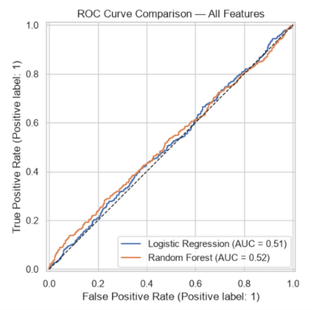
Figure 4. ROC curves on the held-out 20% test set. The displayed AUC values correspond to the held-out split and therefore differ slightly from the 5-fold cross-validation estimates reported in the results table.

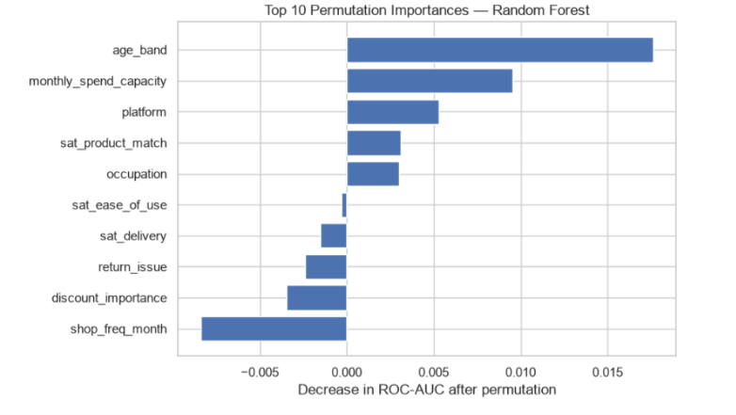
Figure 5. Permutation importance for the Random Forest model. The absolute change in ROC-AUC is small across all features, indicating limited individual predictive contribution.
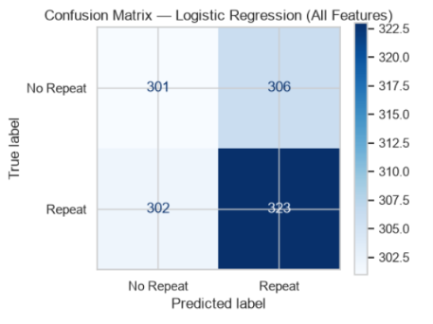
Figure 6. Logistic Regression confusion matrix on the held-out test set

Business insights
- The collected survey variables do not provide sufficient predictive signal for reliable customer-level repeat-purchase targeting.
- Statistical tests found no significant relationship between any tested variable and repeat purchase at the 5% level.
- Both classification models perform close to the majority-class baseline under cross-validation.
- Satisfaction-only and discount/spending-only feature groups show only a small difference on one held-out split (ROC-AUC 0.517 vs. 0.508); this is not sufficient to establish a stable feature-group advantage, and the state-of-the-art studies in Section 5 provide additional context, while their different datasets and experimental settings prevent direct performance comparison.
- The current analysis is therefore more useful as a baseline assessment of the information contained in this survey than as a production-ready retention prediction system.

Recommendations
- Future retention models should incorporate transaction-level behavioural data — purchase recency, purchase frequency, monetary value, number of previous orders, and customer tenure — which the studies reviewed in Section 5 report alongside stronger predictive performance.
- Capture richer retention signals in future data collection: coupon usage, product returns, delivery delays, customer-support interactions, loyalty-program participation, and stated reasons for repeat purchasing or switching.
- Do not deploy the current model for automated customer targeting; its predictive performance remains close to the majority-class baseline.
- Use this study as a documented baseline for future retention-modeling work on richer data sources.
- Expand and diversify future sampling to test whether the weak relationships observed here persist in a broader e-commerce customer population.

7. Conclusion and Limitations
The collected survey data does not provide sufficient statistical or predictive evidence to reliably explain or predict repeat purchase behavior using the measured variables. Both classification models achieve performance close to the majority-class baseline under cross-validation, and no individual predictor reaches statistical significance. The study instead provides a documented baseline understanding of the predictive information available in this survey and identifies a clear need for richer transaction-level and behavioural data in future customer-retention modeling — a direction directly supported by the higher-performing, richer-data studies reviewed in Section 5.

Limitations
- Self-reported survey data may contain recall or response bias.
- The observational survey design identifies associations and predictive usefulness, not causation.
- Survey respondents may not represent the complete population of e-commerce customers.
- Respondents who did not shop online in the previous six months are outside the repeat-purchase modeling population because of the questionnaire's skip logic.
- Model performance may change on a new customer population, platform mix, or future time period.
- The survey measures customer characteristics retrospectively, so the model should be treated as an analytical scoring exercise rather than a proven real-time intervention system.
- Several survey variables have relatively even response distributions across nearly every question (Figures 2 and 3); this may reflect the questionnaire design or respondent composition and should be considered when interpreting the generalizability of the study.

References
[1] Mauludiah, S. F., Arif, Y. M., Faisal, M., & Putra, D. D. (2024). Struggling Models: An Analysis of Logistic Regression and Random Forest in Predicting Repeat Buyers with Imbalanced Performance Metrics. Applied Information System and Management (AISM), 7(2), 31–38. https://doi.org/10.15408/aism.v7i2.39326
[2] Duan, L., & Hariyanto, D. T. (2024). Machine Learning Modeling for Forecasting Repeat Purchases in Online Shopping. MALCOM: Indonesian Journal of Machine Learning and Computer Science, 4(3), 863–874. https://doi.org/10.57152/malcom.v4i3.1388
[3] Yang, S. (2026). Predicting repurchase behavior and optimizing marketing for e-commerce users with genetic algorithms and deep learning. Scientific Reports, 16, Article 16035. https://doi.org/10.1038/s41598-026-45903-5
[4] Pedregosa, F., Varoquaux, G., Gramfort, A., Michel, V., Thirion, B., Grisel, O., ... & Duchesnay, E. (2011). Scikit-learn: Machine Learning in Python. Journal of Machine Learning Research, 12, 2825–2830.

