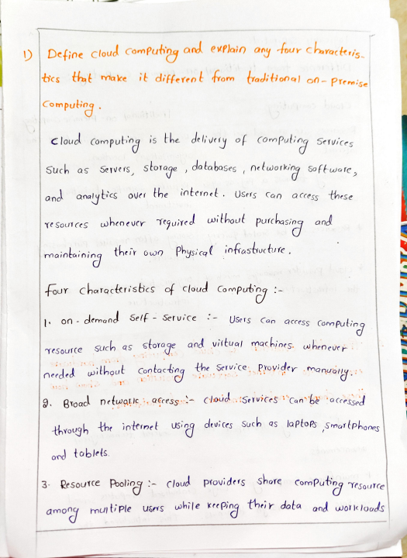
)Defioe cloud Computing and evflain any four chracteri tcs that ake it differeot trom traditional on- Premitel
|Computiog
claud ompuhinyis the dhhoy f (onpuin ^{Setvices} Such as Servets, storage ,,databases ,networking softwoe, and anayties^{Ouet the} internet. Users Can acess these
TeSoutces wheoeurr ^{wheoevCr} guired uoithou purchasing ond
their own Physical infrastucture
ourchotoclerisbcs cloud Gomputipg :
mainboining
on demand Self - Service i- USe1s (an^{acess} Computing resour _{(e} such as storage and vittual machioes. wheneve nerded without _{Contacng}the Service, ^{Proyider}.manualy 9. Broad netwo lc:, acress: cloud Services 'Canba 'acress
_{through} the inttinet devi ces Such as la Ptops Smattphoes ond ^{toblets.}
3- ResouTCe _{Pooli}cloud ^{provi} ders ^{shafe ComPuting} Tesoute ameyrmutiple usrs while keping their dota and workloads
l9gicany Seforotrd.
Diffeeoe frorm tradi bioa) ^{on -premise} CornPuti: Cloud ^{co} Putig fiodition on- _{Pirmise}
Resources are acressed over the internet
Resources are rmaintained at the _{| gnijefions} loroton.
*UsUany ^{follaus a}a ^{Poy Pay-as}-Jou- ^{Requires} Signifcant _{inibial} +Resouts Can be ^{Sro d} gucry
USe ^{model.} investmeot
|al ^{often} teguies ^{Pur} chesina
bardwore,
claud _{Provider monages} ^{uch} of the infrastucture.
o ^{Joni3abon} mana ^{ges} _{its} ^{its} oon infrastructure.
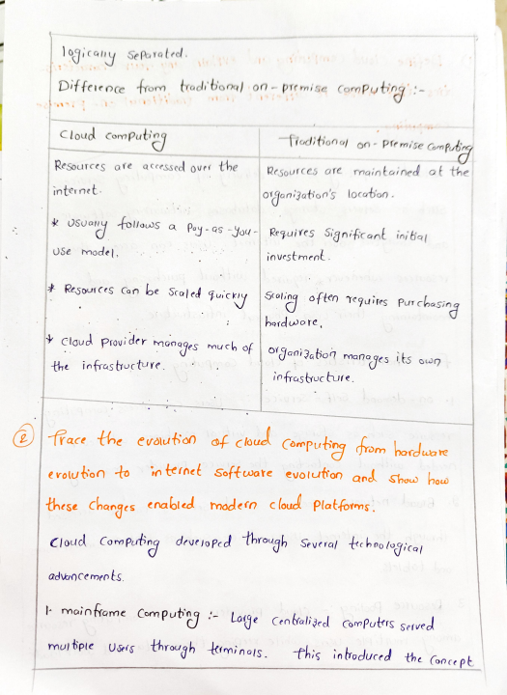
race the evaution of cbud Computing fom bordaoe eYalubioo to in ternet Software evolut'on and shou bod _{how}
these changes erabled modein cloud Platforms.
Cloud Conmputing drueioPcd Through ^{Several} tchoological adncemeots.
^{maintame} Computngi- _{Loge} ^{Centalijed} Computrs _{served} mul tple ^{USets}s ^{through} timinal. fhis ^{intoduced} the _{(once pt}
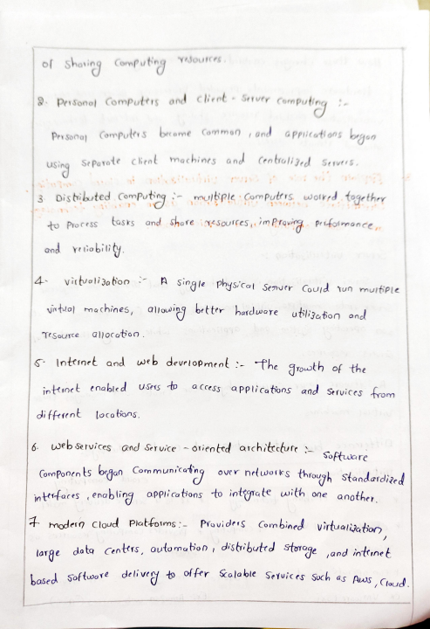
.^{Ysources}
f Shoting CoPutig
_{Person Computtrs} and client ^{.Serurr}conpulieg
Prysono) Compulrs become Common ond appicottons baun.
Se Povote cient machints and Centoli 3+d Serutr5,
uSing
3 Disbibted ComPuting mubple Computrrs woirrd togethry to Process tasks and shore ineSources, im Proving prfotrmance
^{and yr} tiobiiy
4 vitbwoli3obon ^{A single} physical ^{Senuer} Coujd tun _{muitiple} t ochines ,alol9 ^{brtter hard} uere ubi3oton ond TeSource alocatoo.
Inteinct and wb devrloPmenl -The South the _{inttinet} enabied ^{USers to} a ^{ccess} applications and _{Services trom} diffeent locatons.
6. webservices and sruice -otieoted architctureSoftucre Cornponrn ts bgan Communiong ^{over} netwoiks ^{through} standardized jot ares .enab ling oPplicatoos to inttate with one anothey.
hodero Cloud Piatfotns:- ^{ProviderS Conbined}virtuatiator
_{large}dota Centrs, outomabon distrbutrd Storageand inttrnet _{based softwore} delive t fr ^{Scola ble} SeYuice Soch as Aus Cw
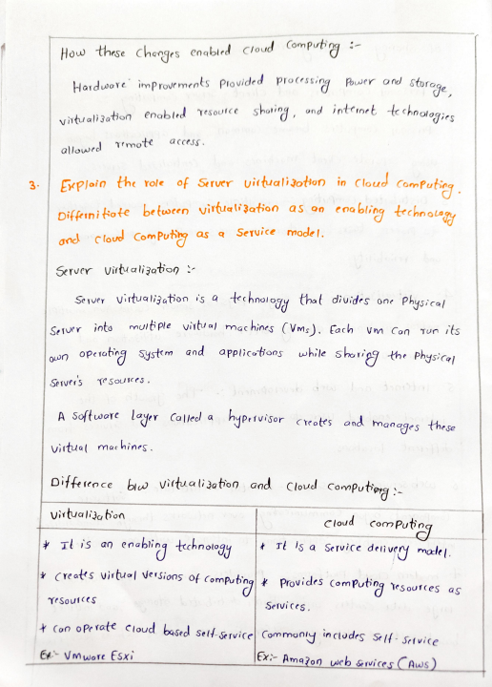
How these _{chorges} enablrd _{Cloud} Computig -
Hordwore improve ments Plovided processing Pwtr ,rd_{storoge,} Power and
_{vitu ali3ation} enabted ^{Tesource} shoing, ^{ond inttnet} te_{choatogirs} _{allowrd} Tmote ^{acceSS.}
3 GPloin the role Sruer uirtualiaothon in Cloud Comnfutie
Difkuni fote between virtral'3aton as on eoabling ttchnoegy and cloud _{Com Putiy} as q Service model.
Server vitualizatiop
Server virtualigaton is a tchnalogy that diuides one Physical Seruer ^{into} muttple virta) mac hins (Vms).Each Vm Can Tun its on operating systm and applicotios while sborigg the Physiral _{Server's} ^{TeSoujCeS.} res
A Softwore ^{lagpr Called a} hyprtuisor cCreotes ^{and ond} manages _{these} _{virtual} machines
^{Ditfeeoce b} Vittualiation and ^{Cloud} Computiog
uirtuali3a bon
^{cloud} com_{Puteg}
^{is an}encbing _{tchnowgy}|+ ^{Tt is} a _{Service deti}^{very male|.} |Creats ^{virtu l} VerSions p _{computig}*^{Provides} (omPutig _{esoutces as}
YeSoufes_{Services.}
Con ^{oPe ratt} cloud ^{based selfservicel} Commany _{inclodes Se|f- Setvice} ^{EA Vmwore ESxi |EX} Ama?o9 wcb _{Grvices Aws)}
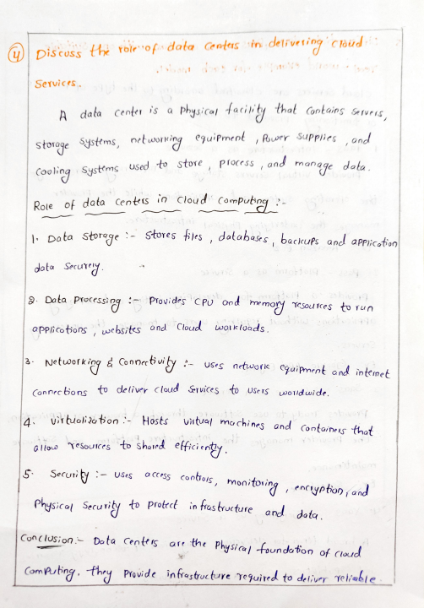
u)piscuSs ^{the roleof} data _{Centus} in deliveting Chud Services.
A data center is a physical tacilty that Contains _{Servris,} saturi5 storoge _{Systms,} ntworting ^{eguiPmenl} Rr_{Supplies} ond _{(ooling Systtms used} to ^{store Procrss,},and _{man} ^{qge} data pae dota Cents io Cloud ComPutp :
Data storage -Stores tles ,databases,baclufs and appicotion 8.Dota Processigg:Piovides CP Ond rmo Tsoul tres to run ³ Netuofkpg d _{Conoe uy:Uses} ^{netuoik} cyupnnt ond _{inteinet}
^{dota} Sorury
appi cotons websites and Cloud woktoads
(onnecbo ns to deliver claud &rvice to use iS woduwi de. 4 ^{uttoli} oton- ^{Hosts Vitu mochines} and _{(onforne thot}
alouo Tesoutes to shaed efici enty.
5 ^{Securiy i- Uses acoss} contos, ^{monitoring} ,^{encypton} and Physical Seru vity to ^{Protrct in tres} brocture ond _{data.}
Conclusion- Data _{Centtis are the} ^{Physica} foundobon of _{Cloud} ComPuing. thry Provide infrastructure eguited to delivr Telieble
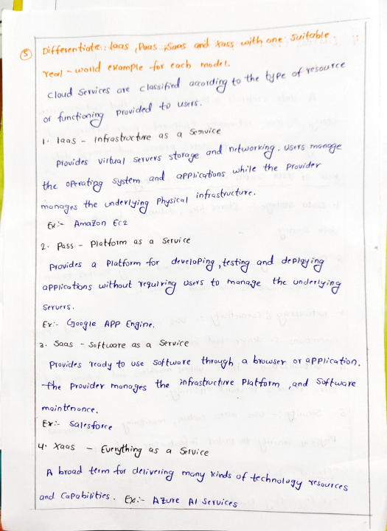
_{Differentate:} ^{laas} PoasSaes ^{ond tass} _{oith} one ^{Suitable} Yeal ~wold _{eKomple} fox _{eoch} mode ^{t,}
_{acordiryto} the^{tyee} of ^{yesouto}
Cloud ^{services} _{are classifd} acordig
_{Provide} to ^{users.}
l._{laas} - _{Infes boctre} as a Se vice
_{Piovides} Virhal ^{Servevs} _{stoTage}and networking. ^{users rmange} h/le ^{the Prouidrr}
the ^{oPeratipg} _{System and} QPP'otons ^{while}
_{manages} the ^{nderiying Physical} intrastructure.
G-Anazon ^{€c2}
2 Pass - _{Plattotm} as a ^{Seruice}
Provides a Platform for develoPg,testing and _{deeig'} appicatons without Tegul _{ring} ^{users to manage the} nder'ying
Servers.
Ev:-goo le APP €ngne.
Saas -_{S ftoare aS a} Service
_{Provicdes} Teady to use ^{Software} _{tware} hrough ^{browser} or aPp)'caton - he ^{Prouidey} _{fnonages} the infrastroctre Pla tform ,and Softwere
maintnonce.
Ex Salesforce
^{| .XaoS}_{€vryhig} Qs a _{Se1Uice}
broad tm-to ^{deliveing} mony ^{kinds} technalog
onl _{CapPabilibes.} ^{e} Azure ^{Al} _{Seruices}TeSoUrces

