1. Create one vpc in N.virginia region.

**Select the region and Goto VPC -🡪 Create VPC**

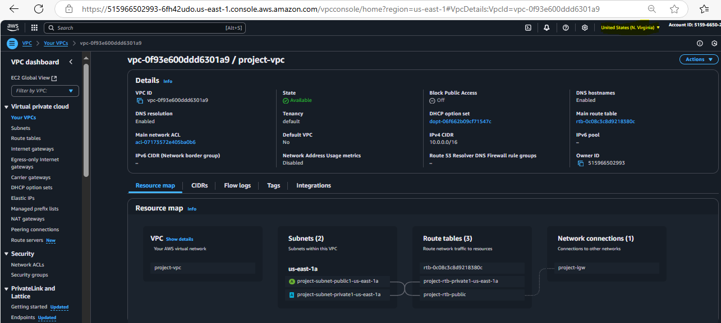

1. Create two subnets. One Public subnet and one private subnet.

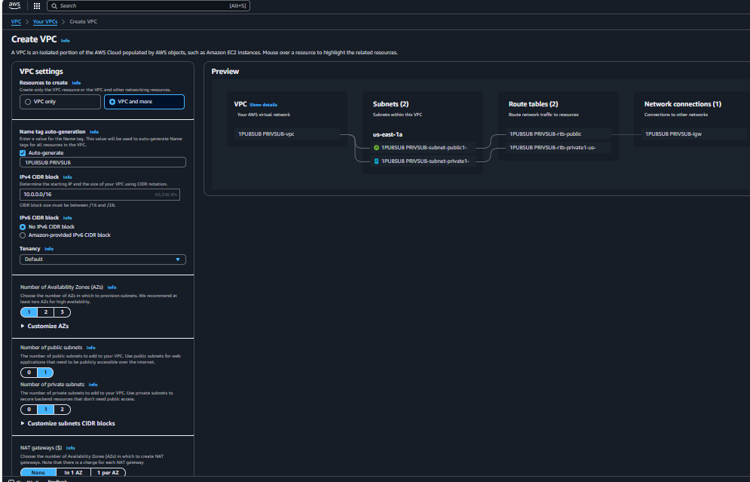

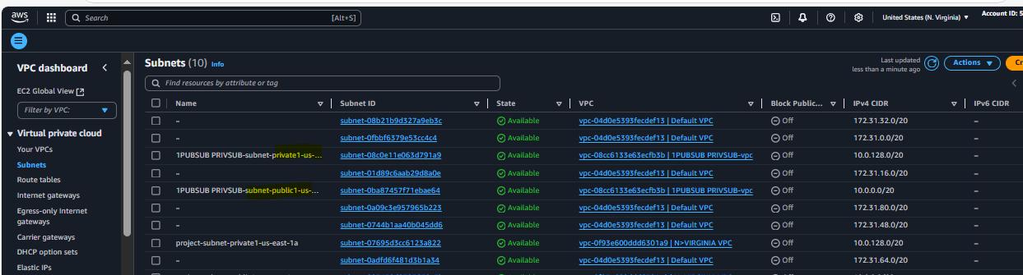

3) Provide the IGW to the vpc.

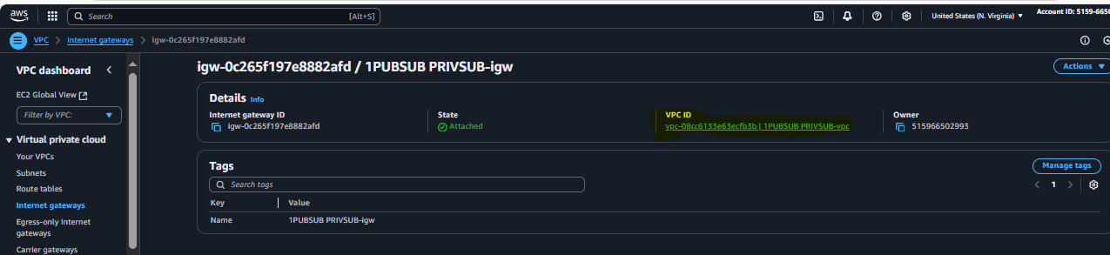

4) Create One public RT and one private RT.

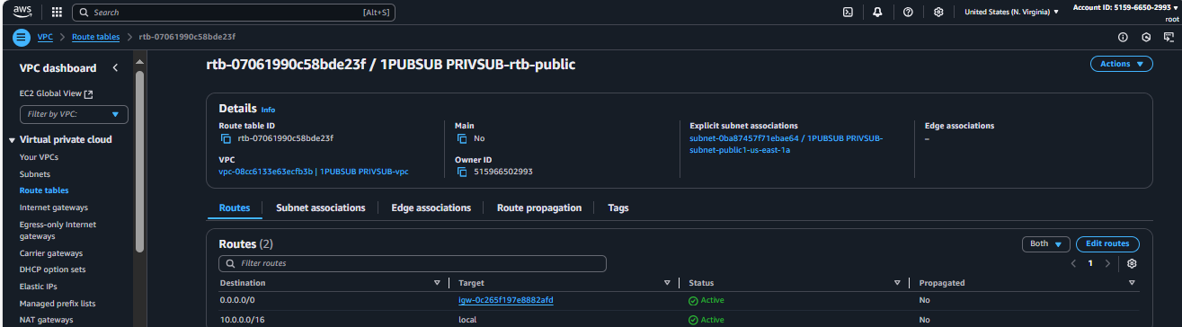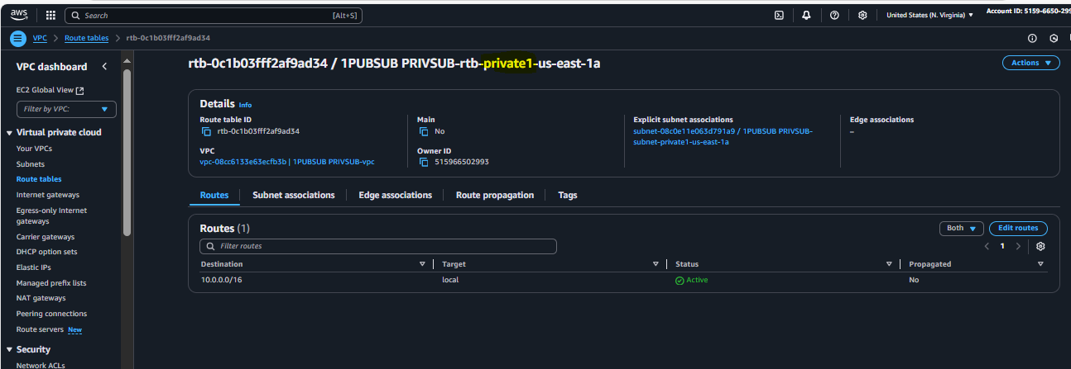

5) Deploy NAT gateway on public subnet and attach the NAT gatewat to private subnet.

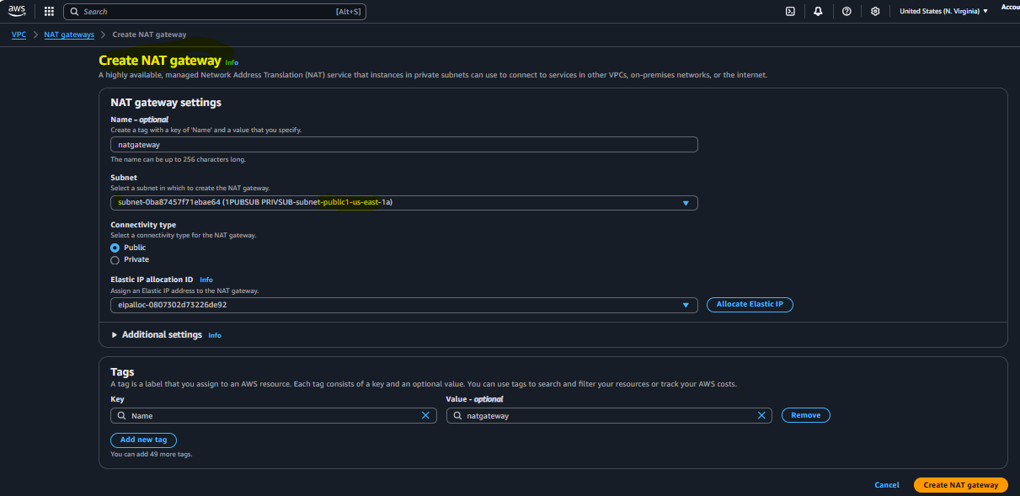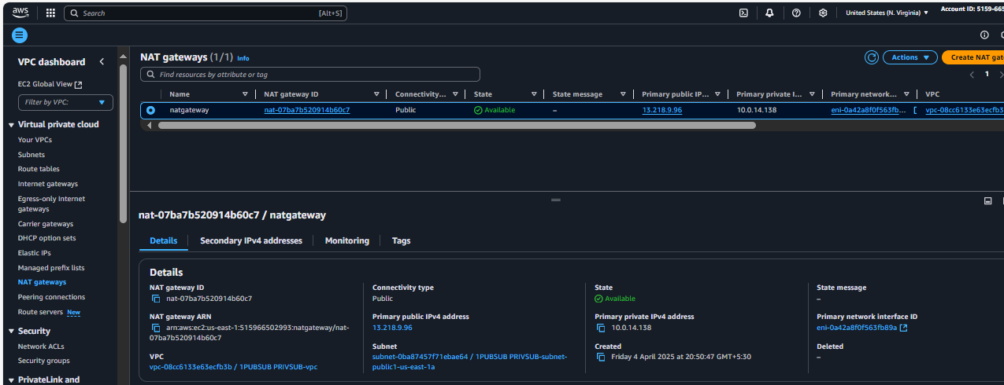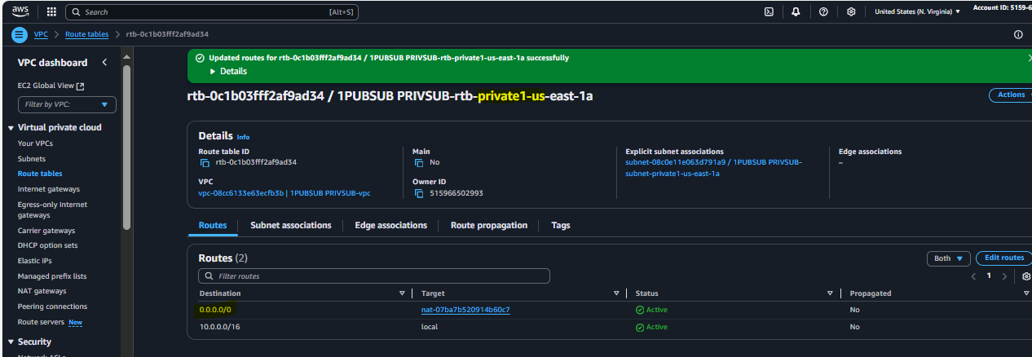

6) Create Two instances,one in public subnet and one in private subnet.

Ec2 in public subnet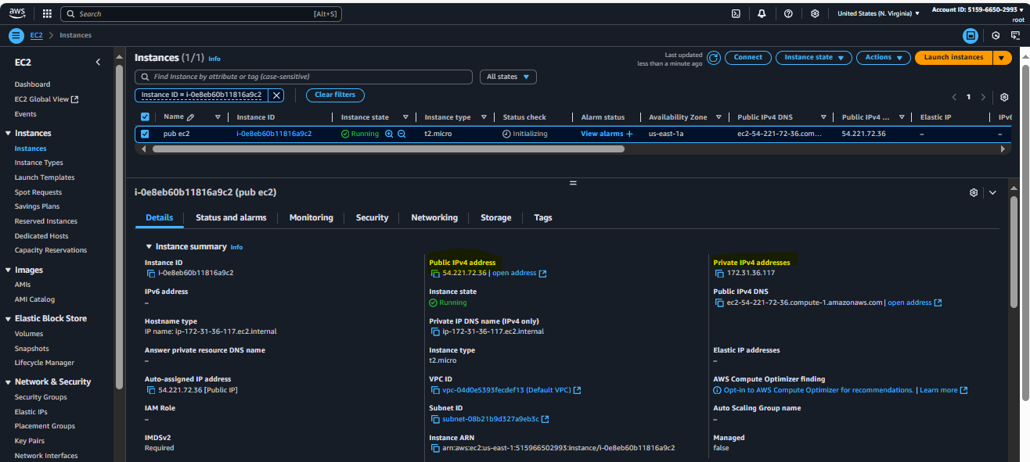

Ec2 in private subnet

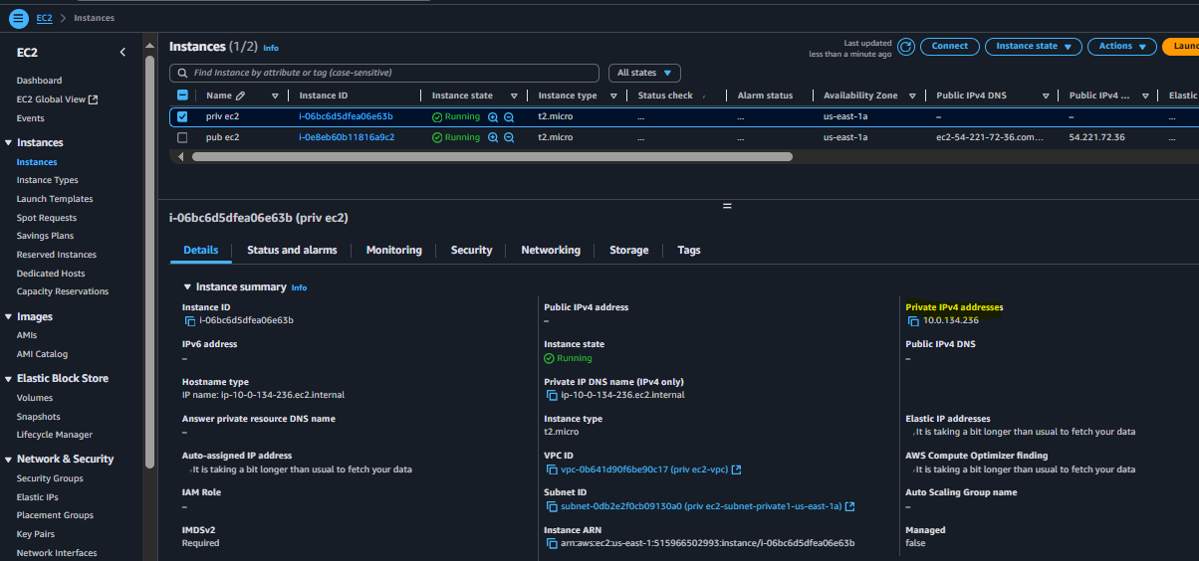

7) Deploy Apache server on both the ec2 instances with sample index.html file.

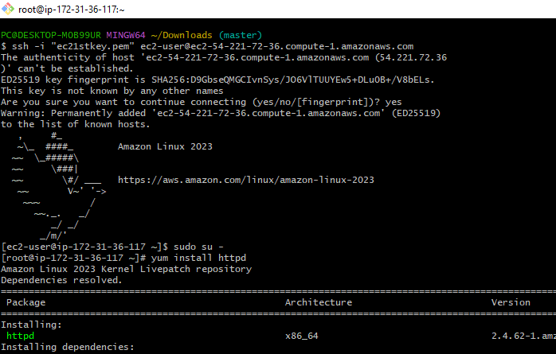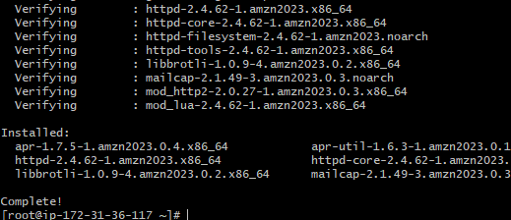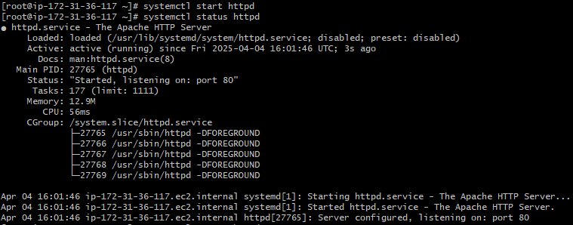

-Added Index.html in /var/www/html for Public Instance

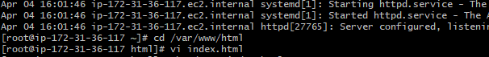

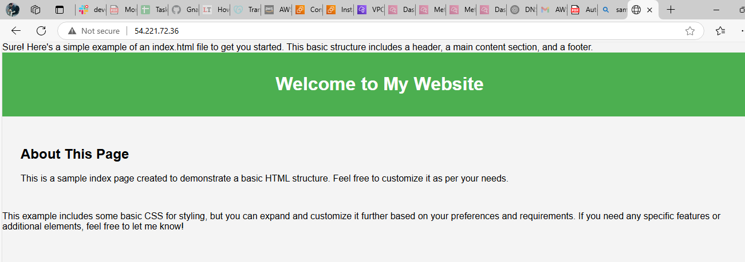

Connected To Private Instance through Public Instance

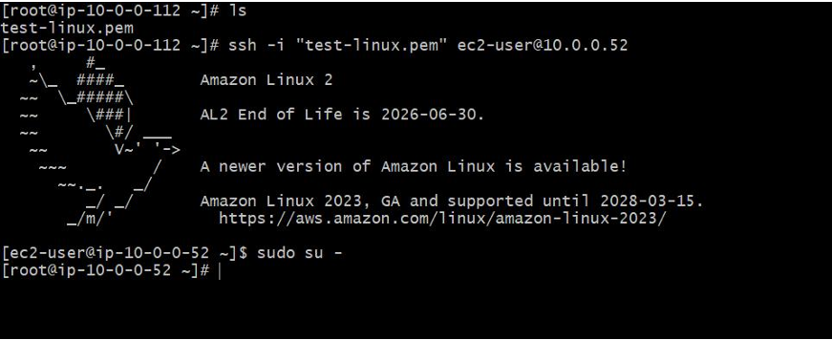Added Index.html in dir /var/www/html/ with the content “ Hi Chimtu”

8) Create one application load balancer and attach the load balancer to both the ec2 instances.

Create a Load balancer and attach with ec2 instance

Register a target to the Target groups

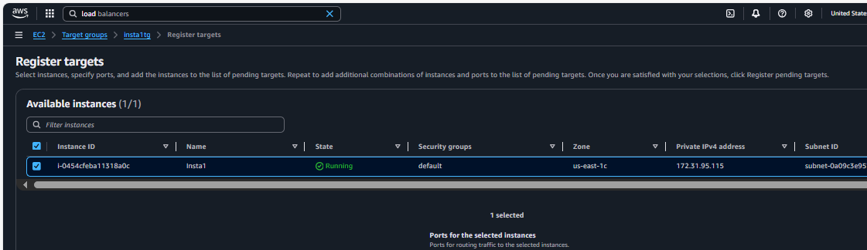

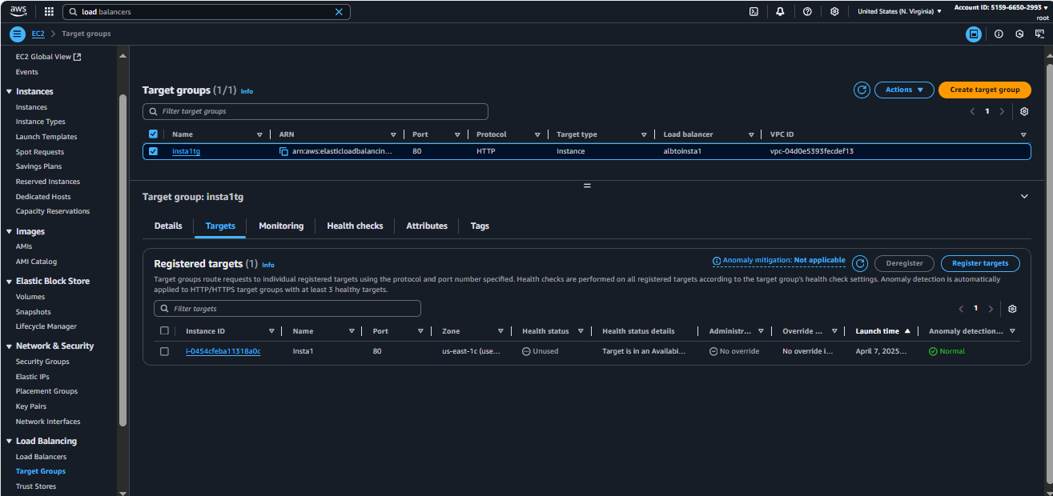

Check with DNS name working or not

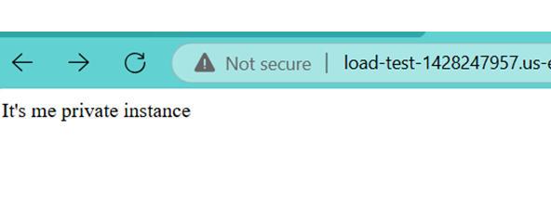

9) Store Application load balancer logs to s3.

Step1: create s3 bucket and add bucket policy for giving permission for access logs [,](https://docs.aws.amazon.com/elasticloadbalancing/latest/application/enable-access-logging.html)  edit the policy according to the region

Step2: go to your application load balancer > actions > edit load balancer attributes> Scroll down and add s3 bucket

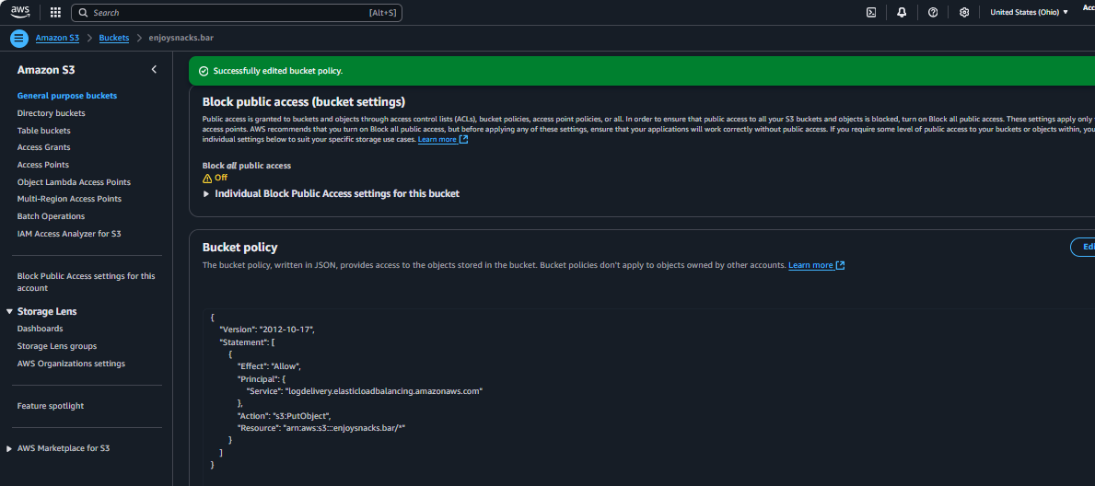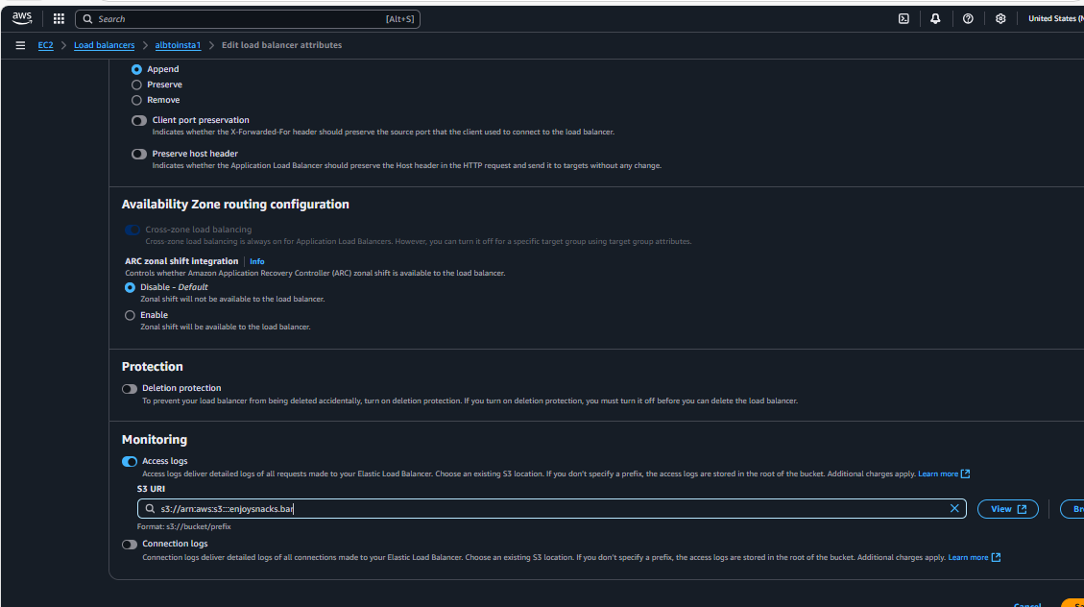

10) Store the vpc flow logs to cloudwtach group.

Create a VPC and add a IAM role with policy 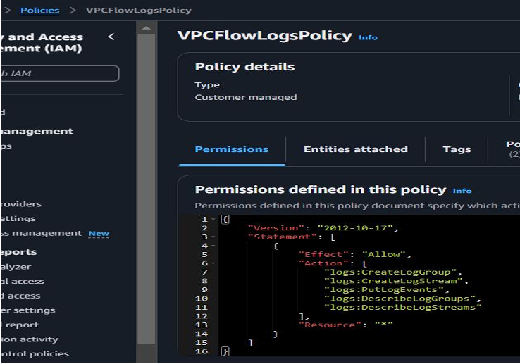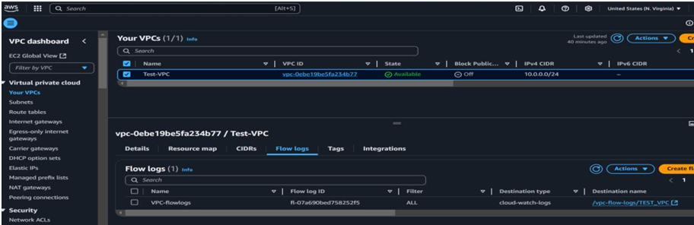

Create a log group in Cloudwatch to store VPC flowlogs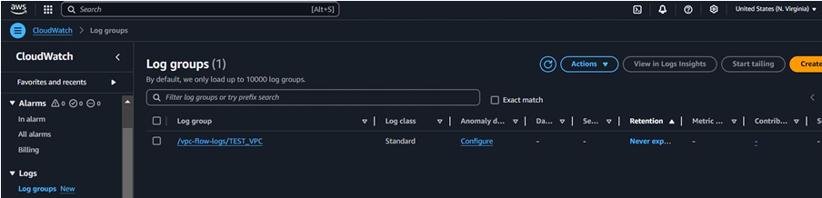

Now we can see the log events and log streams shown as below

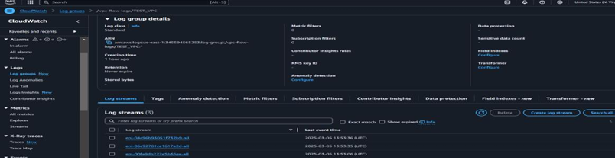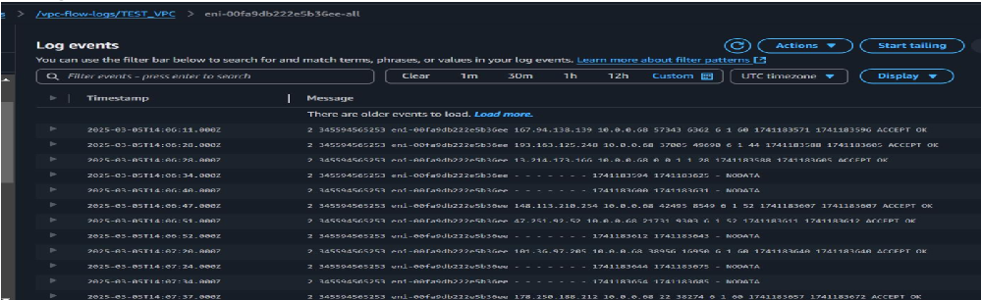

11) Create Monitoring Dashboards to monitor cpu utilization and to monitor apache service.

**Goto Cloud watch-🡪Dashboaards--🡪Create dashboard-🡪Choose widget type as Number**

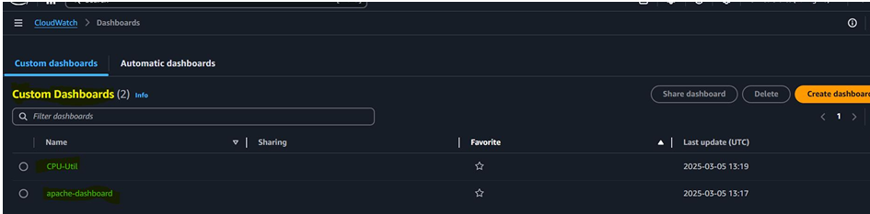

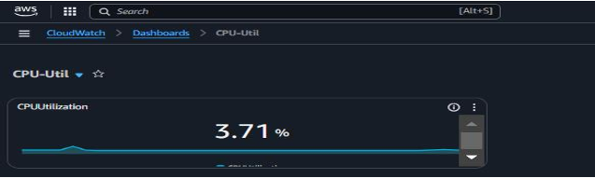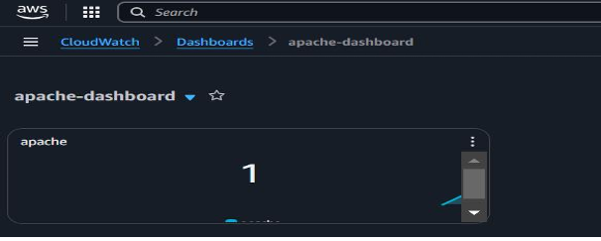

12) CPU utilizationis more than 70% then it should triggere Autoscaling and launch new instance.

**Create a Launch template and an Auto scaling group** 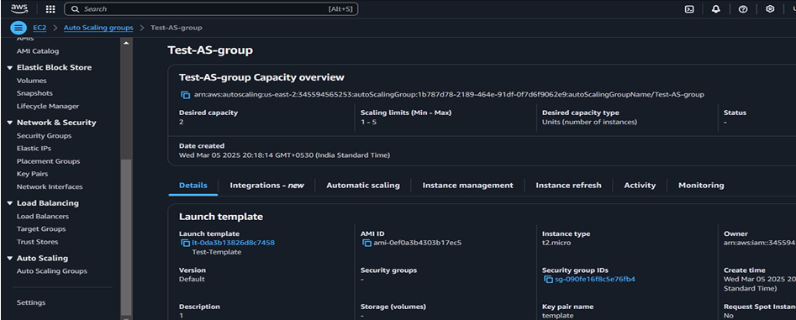

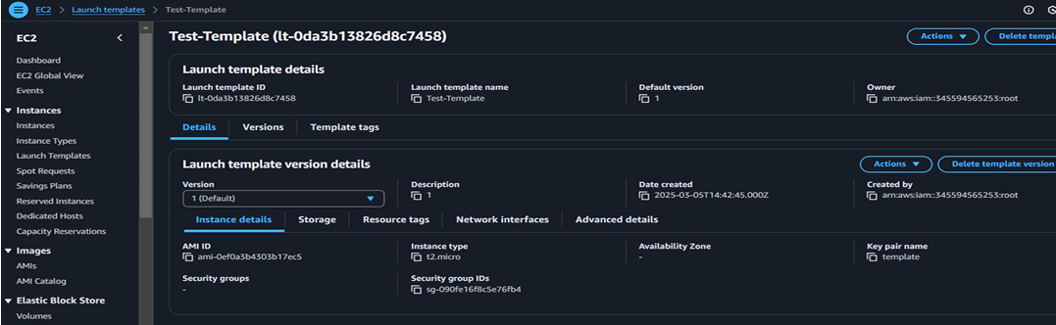

Added capacity on unhealthy condition