1. Configure VPC peering in cross regions.

**Create 2 instances in 2 different regions,one instance with public subnet**

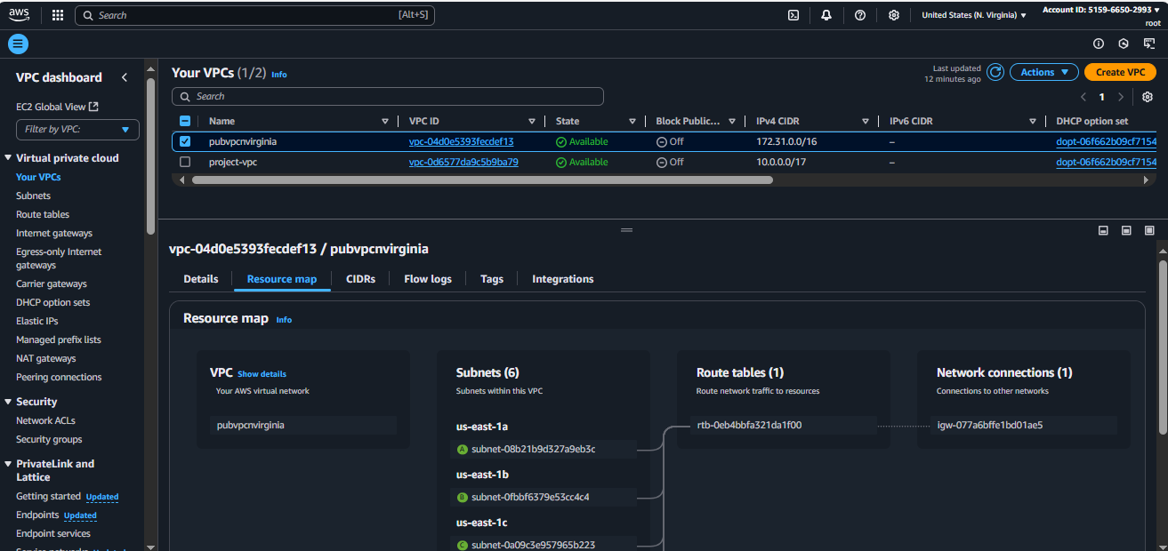

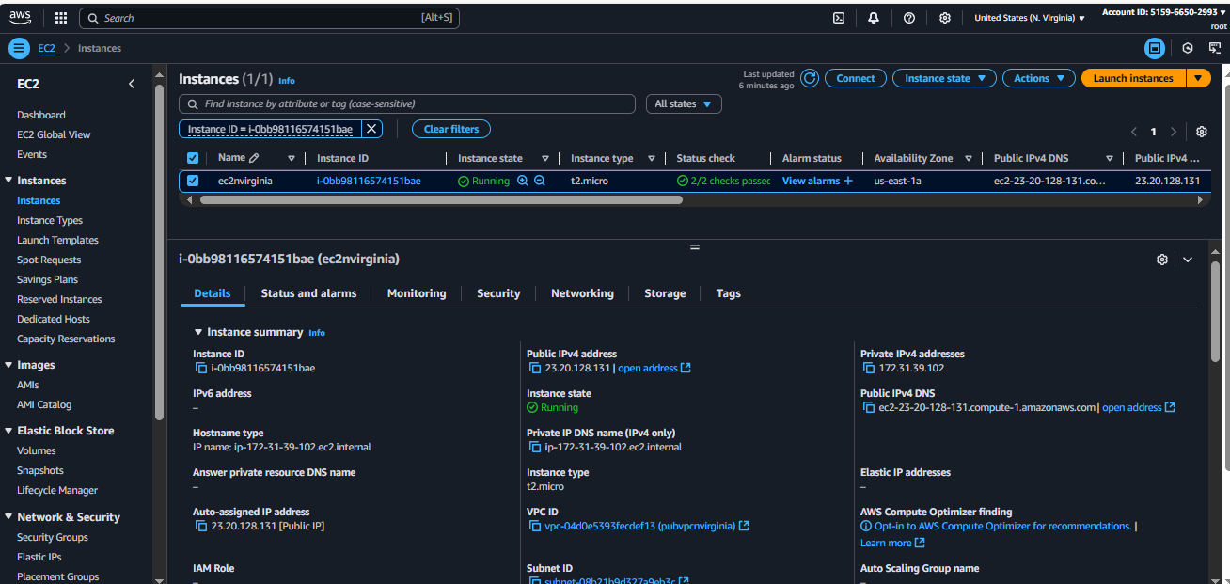

**And another instance with public subnet**

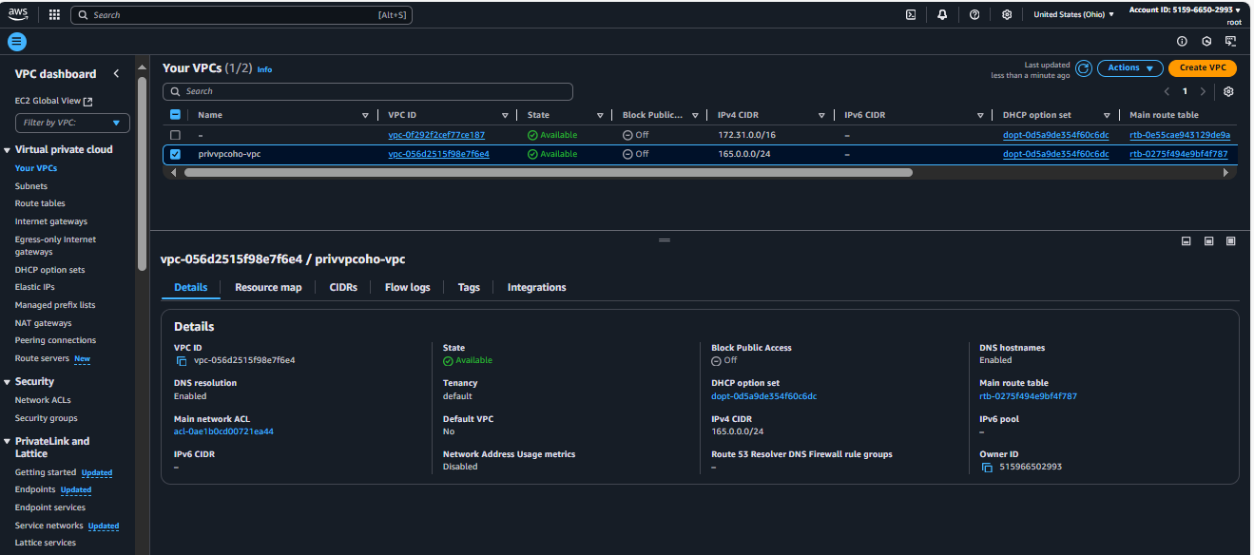

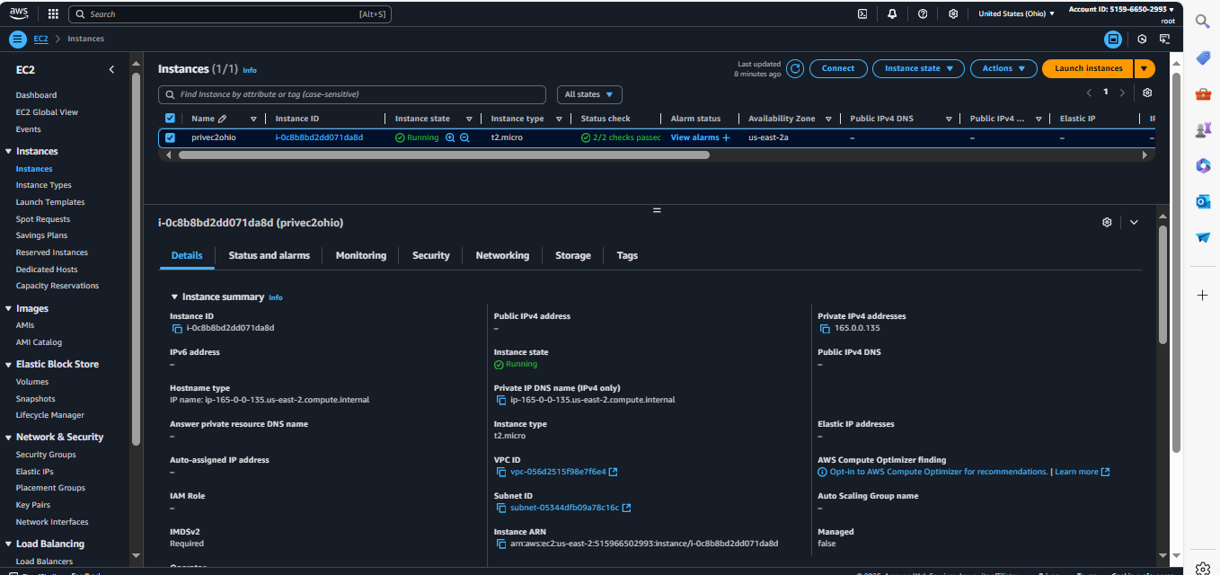

Now create Peering connection

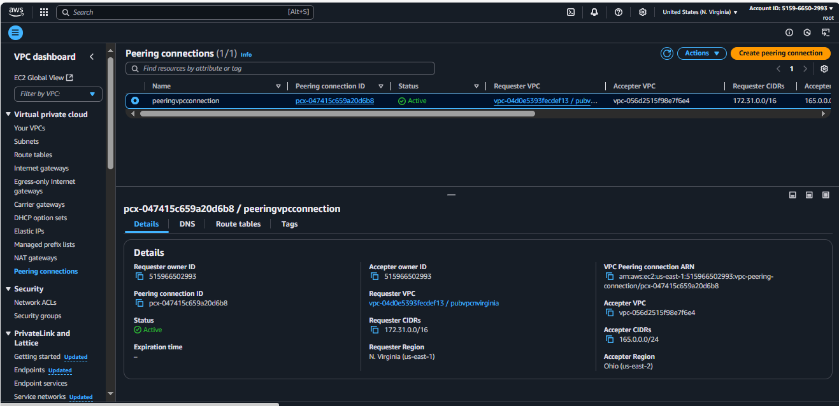

Now add the peering connection ID to the Route tables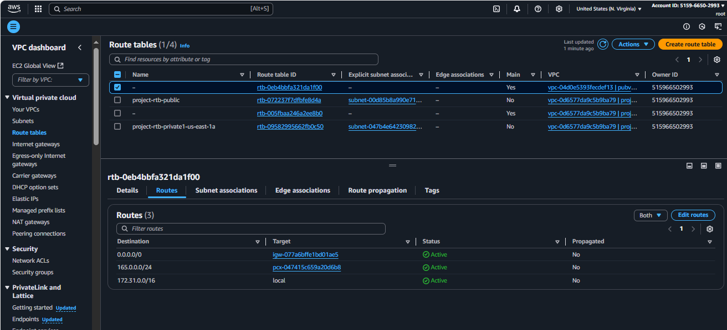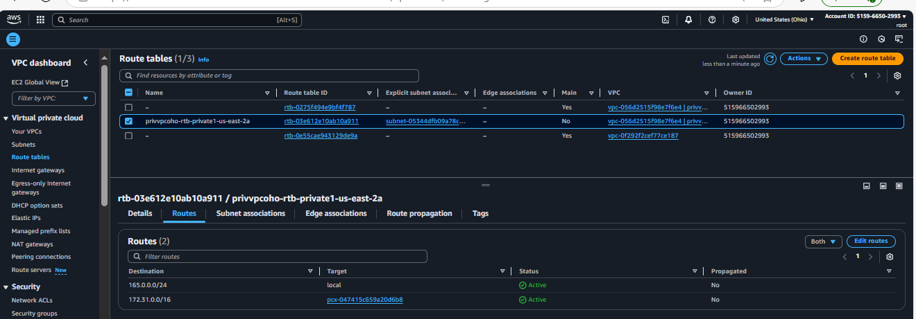

NOW we able connect the private IP address of instance which is inn different region

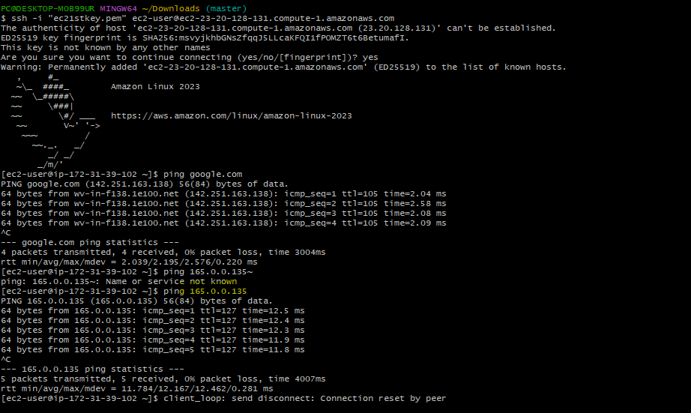

1. Purchase one domain from GoDaddy.

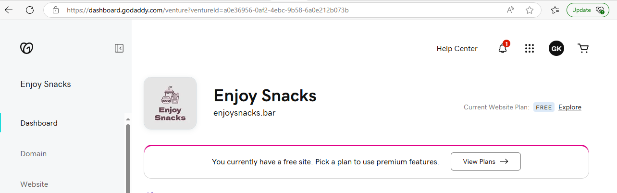

3) Deploy static website in s3.

4) Create CDN and attach one SSL certificate.

5) Create Route53 hosted zone and MAP the domain with CDN.

6) Update the index.html in s3 bucket and the updated file should be accessible by using domain name.

7) Share the Domain name in slack to test the connectivity.