**News app**

News app returns the news that the user searches and tracks all the search activities performed and stores them individually for each users in the database.

In this application I have used the third party News API (<https://newsapi.org/>).

1. This is the home page/login page.

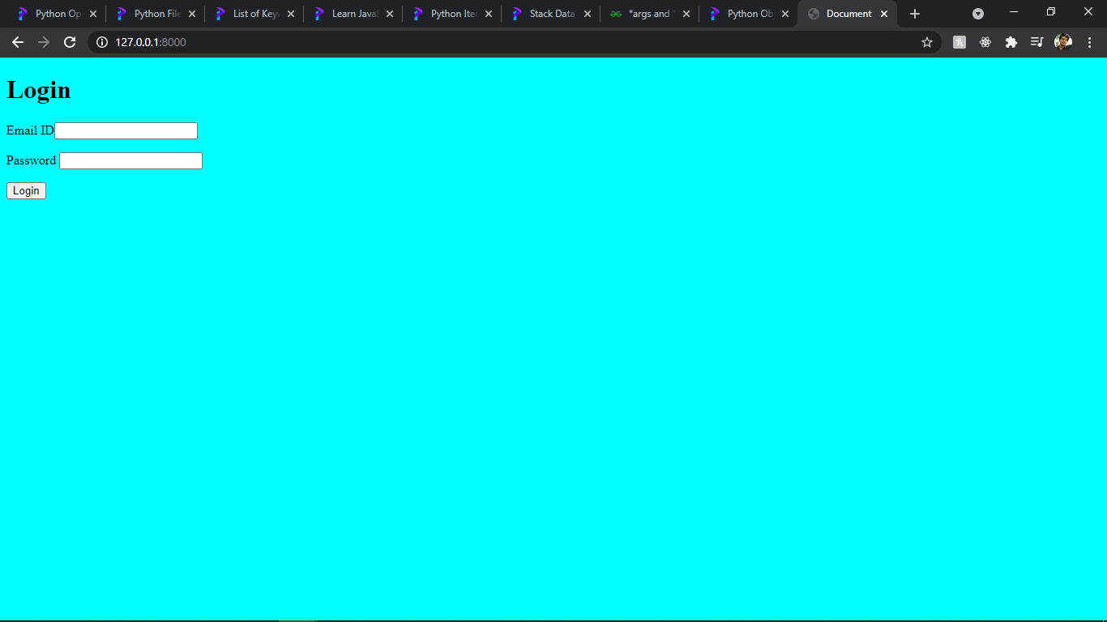

After user enters the credentials it checks the database and if the authentication is successful the user gets logged into the news search page. If the Email ID entered is not present in the Database then it redirects to the sign up page.

1. This is the SignUp page.

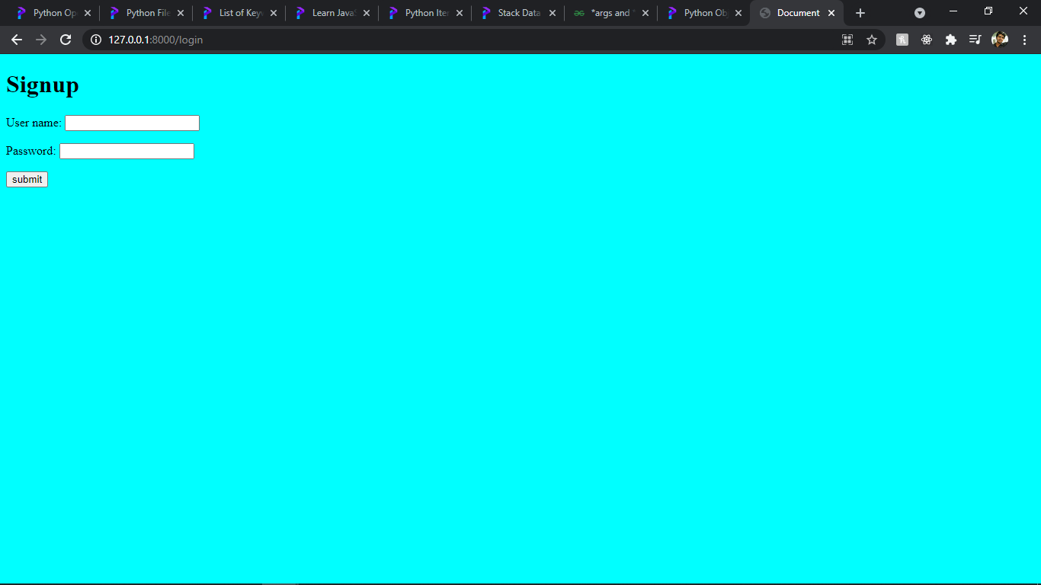

Once the user enters the details the email id is checked in the database and if the email is not present the details are updated in the database and redirects to the login page. If the email id is already present it returns a message user already exist and redirects to the login page.

1. This is the News Search Page.

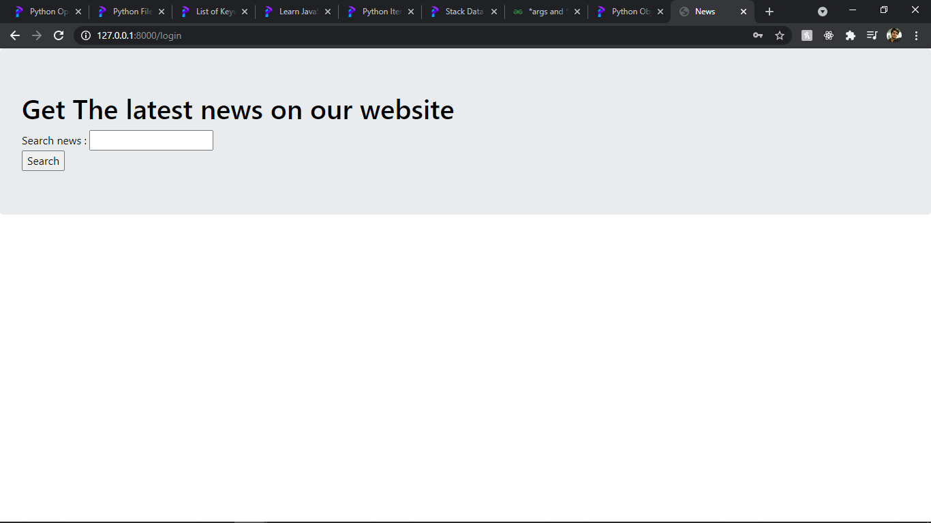

When the user searches for a news the third party API is hit and returns a Json response. The json response is read and the data is displayed in the UI.

1. This is News Result page.

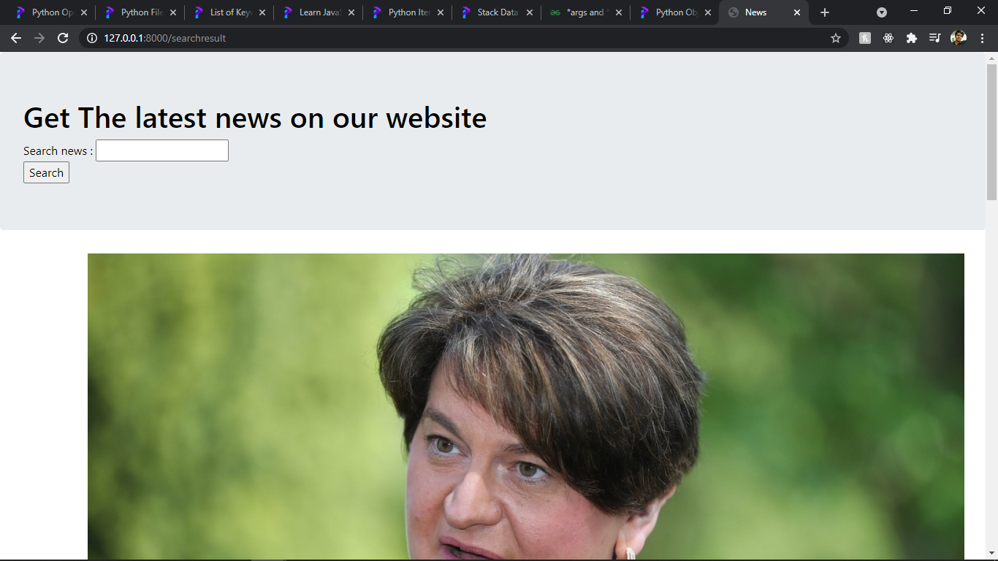

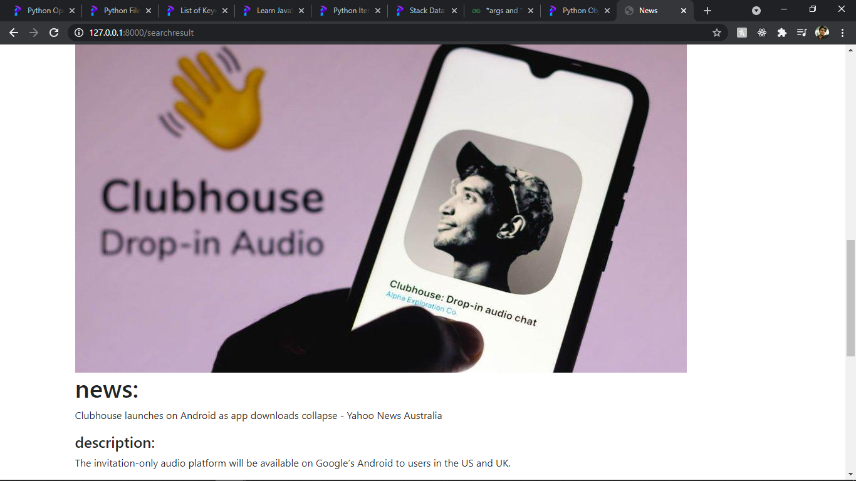

Based on the user searched news the results are displayed as above. The user search data is stored in the database and for further enhancement the data can be used to suggest users with the news that they prefer more.