CHAPTER 1
INTRODUCTION
1.1 Synopsis
Now a day in cloud the data security is the major problem. various third party provide cloud storage to us but person who use that don’t know whether the data is secured in cloud are not to avoid data hacking from cloud here the data are fragmented and stored into various data servers the fragmentation of data is done using fragmented key and using that key the data is again retrieved an given back to the user due to fragmentation data and data also protected using an T-Coloring theorem the data are fragmented and stored in various data servers the hacker would get only an small part of information which would not be useful to him.
1.2 Objective
The DROPS methodology is a cloud storage security scheme that collectively deals with the Security and performance in terms of retrieval time. The data file was fragmented and the fragments are dispersed over multiple nodes No node in the cloud, stored more than a single fragment of the same file.
1.3 Existing System
The off-site data storage cloud utility requires users to move data in cloud’s virtualized and shared environment that may result in various security concerns. Pooling and elasticity of a cloud, allows the physical resources to be shared among many users. The data outsourced to a public cloud must be secured. Unauthorized data access by other users and processes must be prevented as discussed above any weak entity can put the whole cloud at risk. In such a scenario, the security mechanism must substantially increase an attacker’s effort to retrieve a reasonable amount of data even after a successful intrusion in the cloud.

Disadvantages
- The data compromise may occur due to attacks by other users and nodes within the cloud.
- The employed security strategy must also take into account the optimization of the data retrieval time

1.4 Proposed System
Here collectively approach the issue of security and performance as a secure data replication problem. Division and Replication of Data in the Cloud for Optimal Performance and Security (DROPS) that judicially fragments user files into pieces and replicates them at strategic locations within the cloud. The division of a file into fragments is performed based on a given user criteria such that the individual fragments do not contain any meaningful information. Each of the cloud nodes contains a distinct fragment to increase the data security.

Advantages
- The implications of TCP in cast over the DROPS methodology need to be studied that is relevant to distributed data storage and access
- To improve data retrieval time, the nodes are selected based on the centrality measures that ensure an improved access time.

CHAPTER 2
LITERATURE SURVEY
Kashif Bilal, Marc Manzano, Samee U. Khan, Eusebi Calle, Keqin Li and Albert Y. Zomaya proposed the structural robustness of the state-of-the-art Data Center Network (DCN) architectures. Our results revealed that the DCell architecture degrades gracefully under all of the failure types as compared to the FatTree and Three Tier architecture. Because of the connectivity pattern, layered architecture, and heterogeneous nature of the network, the results demonstrated that the classical robustness metrics are insufficient to quantify the DCN robustness appropriately. Henceforth, signifying and igniting the need for new robustness metrics for the DCN robustness quantification. We proposed deterioration metric to quantify the DCN robustness. The deterioration metric evaluates the network robustness based on the percentage change in the graph structure. The results of the deterioration metric illustrated that the DCell is the most robust architecture among all of the considered DCNs. The DCN robustness analysis revealed the inadequacy of the classical robustness measures for the DCN architectures. Based on the hierarchical and pattern-based connectivity of the DCN architectures, new robustness metrics are necessary. Moreover, network traffic and throughput analysis in various DCN component failure scenarios also need to be performed. High level of network robustness leads to higher cost. New cost-effective robust DCNs are required to deliver the required level of robustness at minimum cost. Moreover, the performances aspects of the network, such as bisection bandwidth and bottleneck degree need to be considered for DCN performance quantification. On the Characterization of the Structural Robustness of Data Center Networks.

Dejene Boru, Dzmitry Kliazovich, Pascal Bouvry, Fabrizio Granelli and Albert Y. Zomaya demonstrated the topic of data replication in geographically distributed cloud computing data centers and proposes a novel replication solution which in addition to traditional performance metrics, such as availability of network bandwidth, optimizes energy efficiency of the system. Moreover, the optimization of communication delays leads to improvements in quality of user experience of cloud applications. The performance evaluation is carried out using GreenCloud – the simulator focusing on energy efficiency and communication processes in cloud computing data centers [15]. The obtained results confirm that replicating data closer to data consumers, i.e., cloud applications, can reduce energy consumption, bandwidth usage, and communication delays significantly. Energy-Efficient Data Replication in Cloud Computing Datacenters.

Yves Deswarte, Laurent Blain and Jean-Charles Fahe stated that intrusion tolerance approach looks very promising for open distributed systems whose elements cannot be all trusted. In particular, the intrusion-tolerant authentication and authorization servers enables a consistent security policy to be implemented on a set of heterogeneous, untrusted sites, administrated by untrusted (but nonconspiring) people. A prototype of the persistent file server presented in this paper has been successfully developed and implemented as part of the Delta4 project of the European ESPRIT programme. An intrusion-tolerant security server, gathering the authentication function and the directory and authorization function, is currently being developed for the Delta4 project; completion of a prototype is planned for the end of 1991. In parallel, application of the fragmentationredundancy- scattering technique to data processing is explored [8,23]: in that case, process parallelism and distribution m used to prevent information disclosure, while process replication is used to ensure availability and integrity. Intrusion Tolerance in Distributed Computing Systems.

Bernd Grobauer, Tobias Walloschek and Elmar Stocker proposed computing is in constant development; as the field matures, additional cloud-specific vul-nerabilities certainly will emerge, while others will become less of an issue. Using a precise definition of what constitutes a vulnerability from the Open Group’s risk taxonomy and the four indicators of cloud-specific vulnerabilities we identify here offers a precision and clarity level often lacking in current discourse about cloud computing security. Control challenges typically highlight situations in which otherwise successful security controls are inef-fective in a cloud setting. Thus, these challenges are of special interest for further cloud computing secu-rity research. Indeed, many current efforts—such as the development of security metrics and certification schemes, and the move toward full-featured virtual-ized network components - directly address control challenges by enabling the use of such tried-and-tested controls for cloud computing. Understanding Cloud Computing Vulnerabilities.

M. Schulze and J. Zapata Riveros proposed a special focus on energy conversion and storage is one of the main characteristics of the energy hub concept. When modeling the impact of electric vehicles on the existing and prospective grid, the hub approach has the advantage of coupling area-based data with energy flows. The domains of transportation and energy supply can be merged in one model and be optimized simultaneously. The applied survey is typical for the Swiss case and might not be transferable on other countries, especially when SNG or FFV technologies are present. PHEVs can be treated like EV s with reduced load, since their propulsion is partially covered by a conventional combustion engine. Hence, the worst case scenario would be a fleet of pure EVs. The contribution of the electric vehicles to the new load varies widely depending on the inherent built-up of each hub. A special investigation of PHEV s seems only usefully when the chemical propulsion part is of importance for the case study, e.g. with natural gas driven hybrids. Impact of Electrical Vehicles on Strategic Planning of Energy Infrastructure.

Wayne A. Jansen presented emphasizing the cost and performance benefits of the cloud, some fundamental security problems have receded into the background and been left unresolved. Several critical pieces of technology, such as a solution for federated trust, are not yet fully realized, impinging on successful deployments. Determining the security of complex computer systems is also a long-standing security problem that overshadows large scale computing in general. Attaining the high assurance qualities in implementations has been an elusive goal of computer security researchers and practitioners, and is also a work in progress for cloud computing. Security of the cloud infrastructure relies on trusted computing and cryptography. Organizational data must be protected in a manner consistent with policies, whether in the organization’s computing center or the cloud. Having a list of common outsourcing provisions, such as privacy and security standards, regulatory and compliance issues, service level requirements and penalties, change management processes, continuity of service provisions, and termination rights, provides a useful starting point. The migration to a cloud computing environment is in many ways an exercise in risk management. Both qualitative and quantitative factors apply in an analysis. Too many controls can be inefficient and ineffective, if the benefits outweigh the costs and associated risks. An appropriate balance between the strength of controls and the relative risk associated with particular programs and operations must be ensured. Cloud Hooks: Security and Privacy Issues in Cloud Computing.

Alessandro Mei, Luigi V. Mancini and Sushil Jajodia proposes a model to measure the assurance level of static and dynamic file allocation schemes in a large-scale distributed system, and then discusses and analyzes an optimal dynamic allocation algorithm that provides high assurance, availability, performance, and scalability. Though a subset of these constraints may be considered as traditional research topics, however, they are only partially satisfied by the classical infrastructures (future community may grow up to millions of members). In the future infrastructures, a large number of geographically distributed, autonomous servers should use peer-to-peer algorithms in order to provide data storage and ubiquitous access and update to clients in a scalable and dynamically reconfigurable way. This paper focuses mainly on dynamic secure file allocation in such large-scale distributed infrastructures. Related future works also include the issues of load-balancing, job scheduling, and the effects of malicious node and denial of service attacks. We also plan some experimental evaluations to define and tune the parameters to preserve the scalability of the solutions. Secure Dynamic Fragment and Replica Allocation in Large-Scale Distributed File Systems.

John Harauz and Lori M. Kaufman stated that in addition to NIST’s efforts, the industry itself can affect an enterprise approach to cloud security. If it applies due diligence and develops a policy of self-regulation to ensure that security is effectively implemented throughout all clouds, then this policy can serve to facilitate law-making as well. By combining industry best practices with the oversight NIST and other entities are developing, we can effectively address cloud computing’s future security needs. To achieve a recognized and actionable security policy, SCAP recommends that organizations demonstrate compliance with security requirements in mandates such as the US Federal Information Security Management Act (FISMA). By adhering to this approach, the policy needed to en-sure cloud security can provide effective governance to both industry and lawmakers. Data Security in the World of Cloud Computing.

Yang Tang, Patrick P.C. Lee, John C.S. Lui and Radia Perlman proposed a practical cloud storage system called FADE, which aims to provide access control assured deletion for files that are hosted by today’s cloud storage services. We associate files with file access policies that control how files can be accessed. We then present policy-based file assured deletion, in which files are assuredly deleted and made unrecoverable by anyone when their associated file access policies are revoked. We describe the essential operations on cryptographic keys so as to achieve access control and assured deletion. FADE also leverages existing crypto-graphic techniques, including attribute-based encryption and a quorum of key managers based on threshold secret sharing. We implement a prototype of FADE to demonstrate its practicality, and empirically study its performance overhead when it works with Amazon S3. Our experimental results provide insights into the performance-security trade-off when FADE is deployed in practice. Secure Overlay Cloud Storage with Access Control and Assured Deletion.

Manghui Tu, Peng Li, Qingkai Ma, I-Ling Yen and Farokh B. Bastani considered the optimal allocation of multiple dependent data objects in the network. The network consists of multiple clusters with general graph topology, and the network connecting the clusters is also a general graph. We propose an approach integrating partial replication, lazy replication and secret sharing techniques to guarantee performance and security constraints. On the Optimal Placement of Secure Data Objects over Internet.

Jens-Matthias Bohli, Nils Gruschka, Meiko Jensen, Luigi Lo Iacono and Ninja Marnau shown that there is no single optimal approach to foster both security and legal compliance in an omni applicable manner. Moreover, the approaches that are favorable from a technical perspective appear less appealing from a regulatory point of view, and vice versa. The few approaches that score sufficiently in both these dimensions lack versatility and ease of use, hence can be used in very rare circumstances only. Security and Privacy-Enhancing Multicolor Architecture.

Yogesh Sharma, Bahman Javadi and Weisheng Si said that cloud computing platforms are widely used today, there still exist plenty of research gaps to be addressed. Reliability of cloud services still remains a big challenge. On the other hand, with the increase in the infrastructure and design complexity of clouds, they are becoming big consumers of energy and leaving enormous carbon footprints. Energy efficiency, reliability and scalability are among the foremost concerns in cloud computing in these days. Researchers are striving to find the optimized and applicable solutions for the challenges. In this paper, we identified the need of a reliability-aware and energy-aware resource provisioning policy to improve the availability of the services of cloud by reducing the energy consumption. On the Reliability and Energy Efficiency in Cloud Computing.

G. Aruna Kranthi and D. Shashi Rekha developed algorithms to allocate correlated data shares in large-scale peer-to-peer data grids. To support scalability, we represent the data grid as a two-level cluster based topology and decompose the allocation problem into two subproblems: the OIRSP and OISAP.The OIRSP determines which clusters need to maintain share replicas, and the OISAP determines the number of share replicas needed in a cluster and their placements. Heuristic algorithms are developed for the two subproblems. First, the secure storage mechanisms developed in this paper can also be used for key storage. In this alternate scheme, critical data objects are encrypted and replicated. Protected data objects replication in data grid.

Dr. S.G. Bhirud and Vijay Katkar stated the use of Firewall within the organization network along with IDS is very effective away of implementing a security. Distribution of NIDS among different departments makes it more immune to Intrusion and avoids the problem of single point of failure. Distributed nature of NIDS results in early Detection of attacks launched from organizations against organization itself. DoS/DDoS/Probing attack launched from the organization can’t affect the entire organization as it gets detected and blocked at NIDS of the Department itself. Novel Architecture for Intrusion-Tolerant Distributed Intrusion Detection System using Packet Filter Firewall and State Transition Tables.

Dimitris Zissis and Dimitrios Lekkas identified that cloud computing will support a surplus of information systems as the benefits outnumber its shortcomings. Cloud computing offers deployment architecture, with the ability to address vulnerabilities recognized in traditional IS but its dynamic characteristics are able to deter the effectiveness of traditional countermeasures. In this paper we have identified generic design principles of a cloud environment which stem from the necessity to control relevant vulnerabilities and threats. To do so, software engineering and information systems design approaches were adopted. Security in a cloud environment requires a systemic point of view, from which security will be constructed on trust, mitigating protection to a trusted third party. A combination of PKI, LDAP and SSO can address most of the identified threats in cloud computing dealing with the integrity, confidentiality, authenticity and availability of data and communications. The solution, presents a horizontal level of service, available to all implicated entities, that realizes a security mesh through federations, within which essential trust is maintained. Addressing cloud computing security issues.

CHAPTER 3
SYSTEM SPECIFICATION
3.1 Software Specification
The requirements specification is a technical specification of requirements for the software products. It is the first step in the requirements analysis process it lists the requirements of a particular software system including functional, performance and security requirements. The software requirements specification is produced at the culmination of the analysis task. The function and performance allocated to software as part of system engineering are refined by establishing a complete information description as functional representation of system behavior, an indication of performance requirements and design constraints, appropriate validation criteria.
3.2 System Requirements
3.2.1 Hardware Requirements
RAM : 3 GB and above
Processor : 2.93 GHz and above
Hard Disk : 120 GB and above
Keyboard : 1 quantity
Mouse : 1 quantity
Monitor : 1 quantity
Video memory : 512 MB

3.2.2 Software Requirements
Operating System : Windows 7 (32 bit) Pro, Ultimate
Language : Asp.net MVC 4, C#.
Documentation Tool : MS word 2007
Dot Net Framework : MVC 4.5
Development Tool : MS Visual Studio 2012
Database Server : SQL Server 2012
Cloud Tool : Azure Emulator
3.3 Software Description
The software requirements are the specification of the system. It should include both a definition and a specification of requirements. It is a set of what the system should do rather than how it should do it. The software requirements provide a basis for creating the software requirements specification. It is useful in estimating cost, planning team activities, performing tasks and tracking the team’s and tracking the team’s progress throughout the development activity.
3.3.1 ASP .NET
ASP.NET is a part of the .NET Framework, a new computing platform from Microsoft optimized for creating applications that are highly distributed across the Internet. Highly distributed means that the components of the application, as well as the data, may reside anywhere on the Internet rather than all being contained inside one software program somewhere. Each part of an application can be referenced and accessed using a standard procedure ASP.NET is the part that provides the features necessary to easily tie all this capability together for coherent web-based applications. It is a programming framework, and one of the primary differences between it and traditional ASP is that it uses a common language runtime (CLR) capable of running compiled code on a web server to deploy powerful wed-based applications.

3.3.1.1 Introduction to ASP.NET
ASP.NET still use HTTP to communicate to the browser and back, but it brings added functionality that makes the communication process much richer. If any files have the appropriate extension or contain code, the server routes those files to ASP.NET for processing prior to sending them out to the client. The script or code is then processed and the appropriate content is generated for transmission back to the browser/client. Because processing takes place before the results are delivered to the user, all manner of functionality can be built-in such as database access, component usage and the ordinary programmatic functionality available with scripting languages.
ASP.NET applications can be coded using a plain text edited such as notepad, although this not the most efficient method to use. Developing all the other resources that might be required for a particular ASP.NET application, especially for the user interface, may involve range of specialized tools including image-editing programs, database programs and HTML editors.
To create dynamic web pages by using server-side scripts. Microsoft has introduced ASP. ASP.NET is the .NET version of ASP. ASP.NET is a standard HTML file that contains embedded server-side scripts. ASP.NET provides the following advantage of server-side scripting.
ASP.NET enables you to access information from data sources, such as back-end database and text files that are stored on a web server or a computer that is accessible to a web server.
ASP.NET enables you to use a set of programming code called templates to create HTML documents. The advantage of using template is that you can dynamically insert content retrieved from data sources, such as back-end database and text-files, into an HTML document before the HTML document is displayed to users. Therefore, the information need not be changed manually as and when the content s retrieved from data source change.
ASP.NET also enables you to separate HTML design from the data retrieval mechanism. Therefore changing the HTML deign does not affect the program that retrieve data from the databases. Similarly, server-side scripting ensures that changing data sources does not require a change in HTML documents.
ASP.NET has a number of advance features that help you develop robust web applications. The advance features of ASP.NET are based on the .NET Framework.

3.3.1.2 ASP.NET in .NET Framework
ASP.NET, which is the .NET version of ASP, is built on Microsoft .NET Framework. Microsoft introduced the .NET Framework to help developers create globally distributed software with Internet functionality and interoperability.ASP.NET application include WEB Forms, configuration files and XML, web service files. Web forms enable you to include user interfaces, such as Textbox, list box controls and application logic of Web applications, and configuration files enable you to store the configuration settings of an ASP.NET application. The elements of an ASP.NET application also include Web service to provide a mechanism for programs to communicate over the Internet.

3.3.1.3 Features of ASP.NET
Compiled Code - Code written in ASP.NET is compiled and not interpreted. This makes ASP.NET applications faster to execute than other server- side scripts that are interpreted, such as scripts written in a previous of ASP.
Enriched Tool Support - The ASP.NET Framework is provided with a rich toolbox and designer in VS.NET IDE (Visual Studio .NET integrated development environment). Some of the features of this powerful tool are the WYSIWTG (What You See Is What You Get) editor, drag-and-drop server controls and automatic deployment.
Power and Flexibility - ASP.NET applications are based on Common Language Runtime (CLR). Therefore, the powerful and flexibility of the .NET platform is available enable you to ensure that the .NET Framework class library, messaging and data access solutions are seamlessly over the web. ASP.NET is also language-independent. Therefore, you can choose any .NET language to develop your application.
Simplicity - ASP.NET enables you to build user interfaces that separate application logic from presentation content. In addition, CLR simplifies application development by using managed code services, such as automatic reference counting and garbage collection. Therefore, ASP.NET makes it easy to perform common tasks ranging from submission and client authentication to site configuration and deployment.
Manageability - ASP.NET enables you to manage Web application by storing the configuration information in an XML file. You can open the XML file in the visual Studio .NET IDE.
Scalability - ASP.NET has been designed with scalability in mind. It has features that help improve performance in a multiprocessor environment.
Security - ASP.NET provides a number of options for implementing security and restricting user access to a web application. All these options are configured within the configuration file.
3.3.1.4 IIS- Internet Information Service
The most important server you can install is internet information server (IIS) because you will need it to run your ASP.NET applications. There a number of other servers specifically designed to work with the .NET Framework.

3.3.2 ADO.NET
ADO.NET is all about data access. Data is generally stored in a relational database in the form of related tables. Retrieving and manipulating data directly from a database requires the knowledge of database commands to access the data.
3.3.2.1 Features of ADO.NET
- Disconnected data architecture- ADO.NET uses the disconnected data architecture. Applications connect to the database only while retrieving and updating data. After data is retrieved, the connection with the database closed. When the database needs to be updated, the connection is re-established. Working with applications that to do not follow a disconnected architecture leads to a wastage of valuable system resources, since the application connect to the database and keeps the connection open until it stops running, but does not actually interact with the database can cater to the needs of several applications simultaneously since the interaction is for a shorter duration.
- Data cached in datasets- A dataset is the most common method of accessing data since it implements a disconnected architecture. Since ADO.NET is based on a disconnected data structure, it is not possible for the application to interact with the database for processing each record. Therefore, the data is retrieved and stored in datasets. A dataset is a cached set of database records. We can work with the records stored in a dataset as we work with real data; the only difference being that the dataset is independent of data source and we remain disconnected from the data source.
- ADO.NET supports scalability by working with datasets. Datasets operations are performed on the datasets instead of on the database. As a result, resources are saved, and the database can meet the increasing demands of users more efficiently.
- Data transfer in XML format- XML is the fundamental format for data transfer in ADO.NET. Data is transferred from a database into a dataset and from the dataset to another component by using XML. The knowledge of XML is not required for working with ADO.NET since data conversion in the XML and any component that can read the dataset structure from and to XML is hidden from the user. Since a dataset is stored can process the data.

3.3.2.2 Architecture of ADO .NET
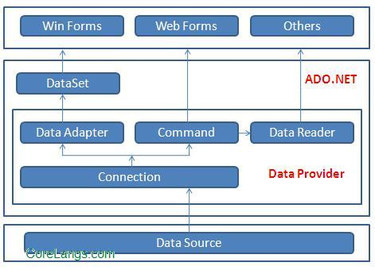
Figure 3.1 Architecture of ADO .NET

3.3.3 SQL-Server
SQL Server is an enterprise-scale, industrial strength, relational database management solution. It contains all the features expected of high-end DBMS systems, as well as XML support.
3.3.3.1 Introduction to SQL Server
To create a database determines the name of the database, its owner (the user who creates the database), its size, and the files and file groups used to store it.
Before creating a database, consider that:
- Permission to create a database defaults to members of the sysadmin and dbcreator fixed server roles, although permissions can be granted to other users.
- The user who creates the database becomes the owner of the database.
- A maximum of 32,767 databases can be created on a server.
- The name of the database must follow the rules for identifiers.
3.3.3.2 Types of File Storage
Three types of files are used to store a database:
- Primary files
These files contain the startup information for the database. The primary files are also used to store data. Every database has one primary file.
- Secondary files
These files hold all the data that does not fit in the primary data file. Databases do not need secondary data files if the primary file is large enough to hold all the data in the database. Some databases may be large enough to need multiple secondary data files, or they may use secondary files on separate disk drives to spread the data across multiple disks.
- Transaction log
These files hold the log information used to recover the database. There must be at least one transaction log file for each database, although there may be more than one. The minimum size for a log file is 512 kilobytes (KB).
When a database is created, all the files that comprise the database are filled with zeros to overwrite any existing data left on the disk by previously deleted files. Although this means that the files take longer to create, this action prevents the operating system from having to fill the files with zeros when data is written to the files for the first time during usual database operations. This improves the performance of day-to-day operations.
It is recommended that you specify a maximum size to which the file is permitted to grow. This prevents the file from growing, as data is added, until disk space is exhausted.

3.3.4 Cloud Azure Emulator
The Microsoft Azure storage emulator provides a local environment that emulates the Azure Blob, Queue, and Table services for development purposes. Using the storage emulator, you can test your application against the storage services locally, without creating an Azure subscription or incurring any costs. When you're satisfied with how your application is working in the emulator, you can switch to using an Azure storage account in the cloud.

How the storage azure emulator
The storage emulator uses a local Microsoft SQL Server instance and the local file system to emulate Azure storage services. By default, the storage emulator uses a database in Microsoft SQL Server 2012 Express LocalDB. You can choose to configure the storage emulator to access a local instance of SQL Server instead of the LocalDB instance. For more information, see the Start and initialize the storage emulator section later in this article. The storage emulator connects to SQL Server or LocalDB using Windows authentication. Some differences in functionality exist between the storage emulator and Azure storage services. For more information about these differences, see the Differences between the storage emulator and Azure Storage section later in this article.
CHAPTER 4
SYSTEM ANALYSIS AND DESIGN

4.1 System Analysis and Design
System Design involves identification of classes their relationship as well as their collaboration. In objector, classes are divided into entity classes and control classes. The Computer Aided Software Engineering (CASE) tools that are available commercially do not provide any assistance in this transition. CASE tools take advantage of Meta modeling that is helpful only after the construction of the class diagram. In the FUSION method, some object-oriented approach likes Object Modeling Technique (OMT), Classes, and Responsibilities. Collaborators (CRC), etc., are used. Objector used the term “agents” to represent some of the hardware and software system.
In Fusion method, there is no requirement phase, where a user will supply the initial requirement document. Any software project is worked out by both the analyst and the designer. The analyst creates the user case diagram. The designer creates the class diagram. But the designer can do this only after the analyst creates the use case diagram. Once the design is over, it is essential to decide which software is suitable for the application.

4.2 SYSTEM ARCHITECTURE

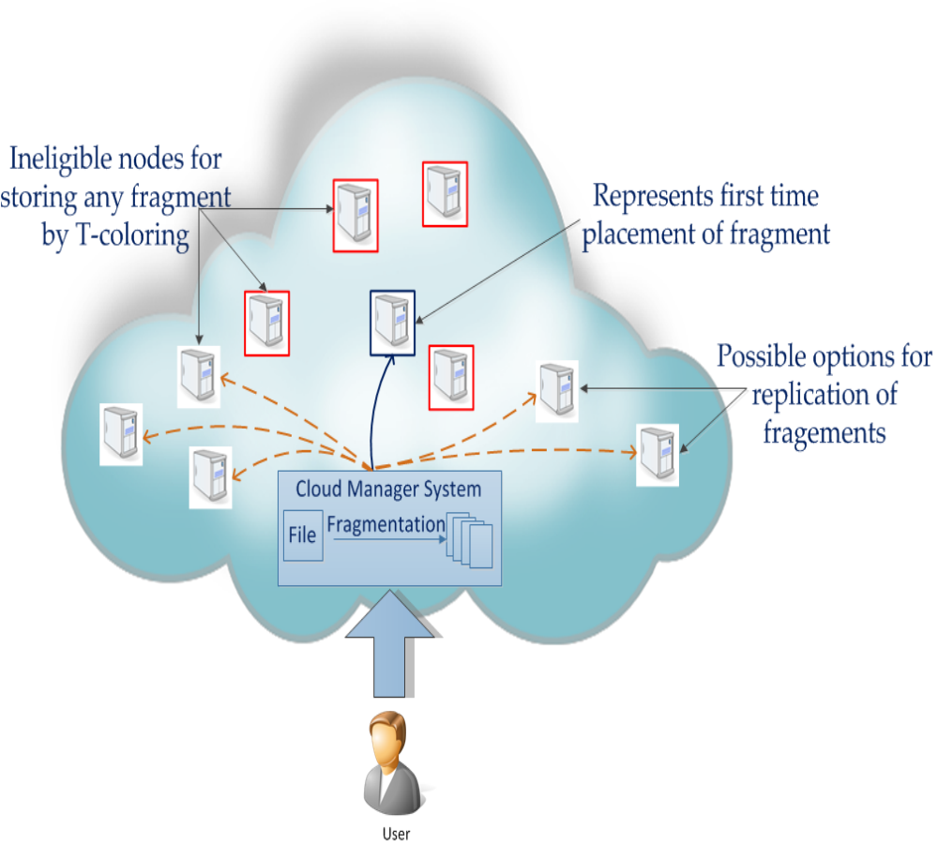
Figure 4.1 System Architecture

The above architecture consist of various nodes in cloud when the user logins in the cloud he uploads are downloads the data from cloud when user upload the data the cloud manager divides the file into small fragment by T-coloring approach and that data is stored in various location of cloud node are server and when the user downloads the file the cloud manager replicates all the file that are stored in different servers in cloud into single file and return the original file to user.
4.3 UML DIAGRAMS
UML is a standard language for specifying, visualizing, and documenting of software systems and created by Object Management Group (OMG) in 1997.There are three important type of UML modeling are Structural model, Behavioral model, and Architecture model. To model a system the most important aspect is to capture the dynamic behavior which has some internal or external factors for making the interaction. These internal or external agents are known as actors. It consists of actors, use cases and their relationships. In this fig, we represent the Use Case diagram for our project.

4.3.1 UML NOTATIONS
S.NO | SYMBOL NAME | NOTATION | DESCRIPTION
1. | Initial activity |  | This shows the starting point or first activity of flow.
2. | Final activity |  | The end of the activity diagram is shown by a bull’s eye symbol.
3. | Activity |  | Represented by a rectangle with rounded edges.
4. | Decision |  | A logic where a decision is to be made.
5. | Use case |  | Describe the interaction between a user and a system
6. | Actor |  | A role that a user plays with respect to system.
7. | Object |  | A real time entity.
8. | Message |  | To send message.
9. | State |  | It represents situations during the life of an object.
10. | Initial state |  | Represents the object’s initial state.
11. | Final state |  | Represents the object’s final state.
12. | Transition |  | Label the transition with the event that triggered it and the action that triggers from it.
13. | Class |  | A set of objects that share a common structure & a common behavior.
  class
14. | Association |  | Relationship btw classes
15. | Generalization |  | Relationship btw more general class & a more specific class
Table 4.1 List of Symbols

4.3.2 DFD Diagram
The Data Flow diagram is a graphic tool used for expressing system requirements in a graphical form. The DFD also known as the “bubble chart” has the purpose of clarifying system requirements and identifying major transformations that to become program in system design. Thus, DFD can be stated as the starting point of the design phase that functionally decomposes the requirements specifications down to the lowest level of detail.
The DFD consist of series of bubbles joined by lines. The bubbles represent data transformations and the lines represent data flows in the system. A DFD describes what that data flow in rather than how they are processed. So, it does not depend on hardware, software, data structure or file organization.

Level 0 DFD
User / Admin
Cloud Storage Manager Application and Azure Cloud
Login / Failure notification
Register / Verifications

Figure 4.2 Level 0 DFD

The above figure 4.2 explains about the user verfication process the user send the request to the cloud manager the cloud verfies that whether that request is valid user are not if vaalid user means then will provide login access to user else will prove failure notification to user

Level 1 DFD
User File Upload
Fragmentations and T-coloring Fragmentations.
Store Fragmentations to multiple cloud nodes
Figure 4.3 Level 1 DFD

The above figure 4.3 explains about the file which is uploaded by user and the fragmentation process the user file is fragmented in several files by using t-coloring approach and stored in multiple cloud location.

Level 2 DFD
User send request to Cloud Manager

Accept request and proceed following user’s action.
Get fragmentations node information of the file id.
Figure 4.4 Level 2 DFD

The above figure 4.4 the user sends the request to cloud manager that request is processed by the manager the cloud manager gathers all the files from various node using there fragmented ID.

Level 3 DFD
Figure 4.5 Level 3 DFD
Replication of File fragmentations.

Set File as Available for user downloading.

Get responses from cloud manager and download a original file from cloud directly.

The above figure 4.5 explains about the file gathers from various location is replicated into single file and the download link is send to user and user then downloads the original file.

4.3.3 Use Case Diagram

UML is simply another graphical representation of a common semantic model. UML provides a comprehensive notation for the full lifecycle of object-oriented of the process of development of the project.
A Use case is a set of scenarios that describing an interaction between a user and a system. A use case diagram displays the relationship among actors.
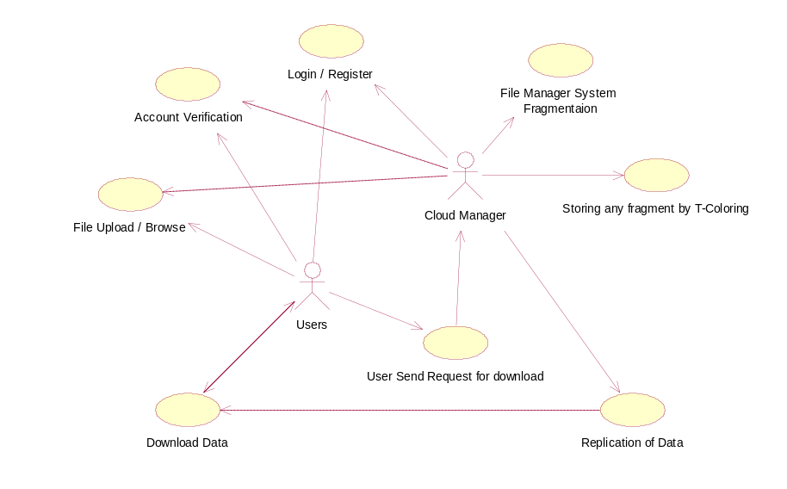
Figure 4.6 Use Case Diagram

The above diagram provides the process done by user and cloud manager the user provides following process login, account verification, upload file, download data, send request. The cloud manager provides services such as validate user, file fragmentation, file replicate, download file.

4.3.4 Activity Diagram
Activity diagram are typically used for business process modeling for modeling the logic captured by a single use case or usage scenario, or for modeling the detailed logic of a business rule. Although UML activity diagrams could potentially model the internal logic of a complex operation it would be far better to simply rewrite the operation so that it is simple enough that you don’t requires an activity diagram.
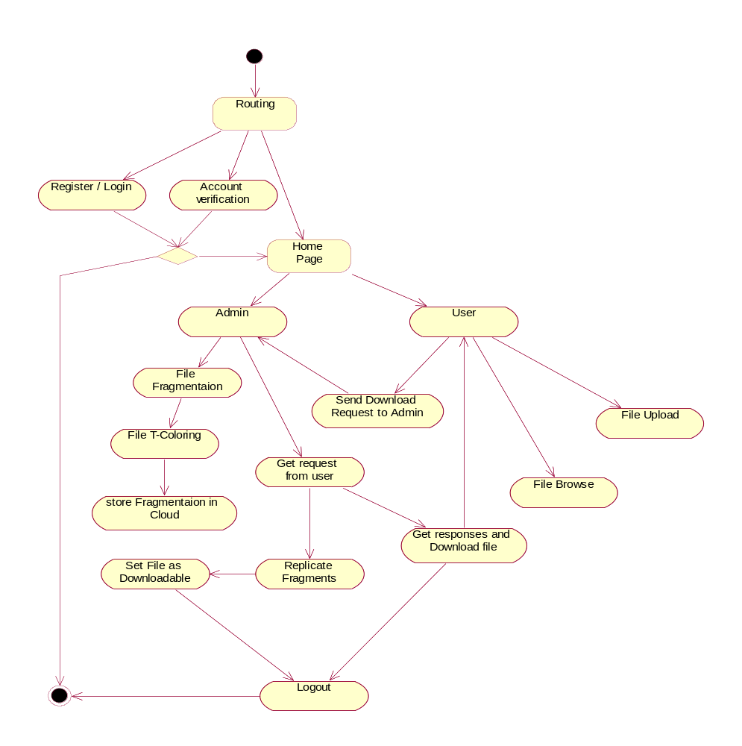
Figure 4.7 Activity Diagram

The above activity diagram provides the flow of project working. In first stage it check whether the user is valid are not. If user is invalid he needs to register an account. The user can upload a file in his dashboard and download when the file is required. The admin then splits the file using T-coloring approach and stored the fragmented file in cloud and when user request the file the cloud manager then replicate the file and give the download link to user

4.3.5 Class Diagram
The class diagram shows how the different entities (people, things, and data) relate to each other; in other words, it shows the static structures of the system. A class diagram can be used to display logical classes.

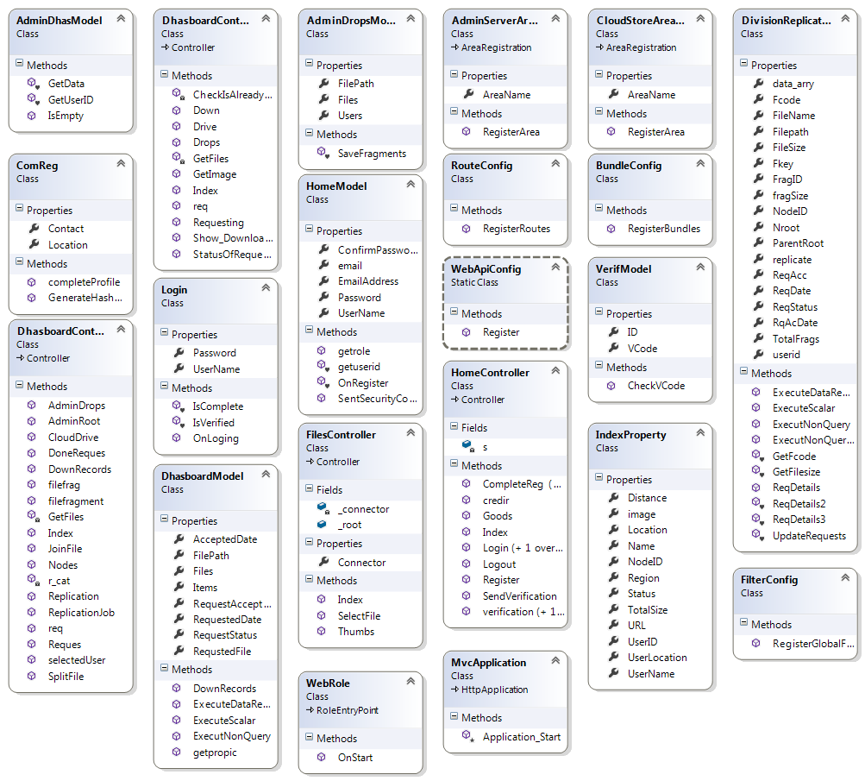
Figure 4.8 Class Diagram
The class diagram provides the information such as methods and variables that are required for the project.it consist of all the class files that are required for the project.

4.3.6 COLLABORATION DIAGRAM
Another type of interaction diagram is the collaboration diagram. A collaboration diagram represents a collaboration, which is a set of objects related in a particular context, and interaction, which is a set of messages exchange among the objects within the collaboration to achieve a desired outcome.
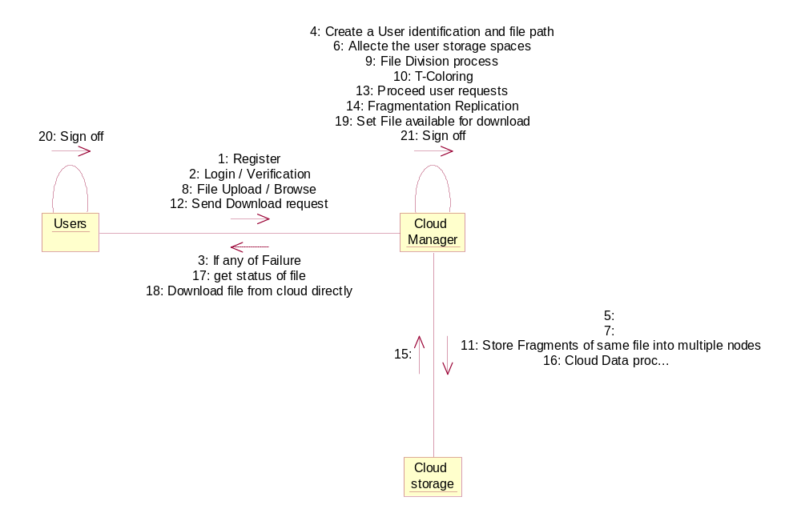
Figure 4.9 Collaboration Diagram
The above collaboration diagram provides the flow of project working. In first stage it check whether the user is valid are not. If user is invalid he need to register an account. The user can upload a file in his dashboard and download when the file is required. The admin then splits the file using T-coloring approach and stored the fragmented file in cloud and when user request the file the cloud manager then replicate the file and give the download link to user

4.4 SYSTEM MODULES
There are few modules which are involved in the implementation of this project. The following are the modules of the project, which is planned in aid to complete the project with respect to the proposed system, while overcoming existing system and also providing the support for the future enhancement.

A modular design reduces complexity, facilities change(a critical aspect of software maintainability), and results in easier implementation by encouraging parallel development of different part of system. Software with effective modularity is easier to develop because function may be compartmentalized and interface are simplified. Software architecture embodies modularity that is software is divided into separately named and addressable components called modules that are intefrated to satisfy problem requirements.

4.4.1 List of Modules

The four modules of the system are:
1. Develop Cloud Manager System.
2. T-coloring and Fragmentations.
3. Requesting and Replication.
4. Managing status and Download Files.

4.4.2 Module Descriptions
4.4.2.1Develop Cloud Manager System

The communicational backbone of cloud computing is the Data Centre Network (DCN). We use the Microsoft Azure Cloud Architecture to evaluate the performance of our scheme on legacy as well as state of the art architectures. We developing an Azure cloud based web application along with corresponding to create multiple nodes in different regions. The managers have all rights about system scalability and update size of the nodes. And also can manage user activities and restrictions. Users need to register account with valid email address. User need to verifying identities for avoiding Sybil or anonymous attackers. Users can upload there any kind of files and can also Downloadable. User can use cloud like a File System basic.
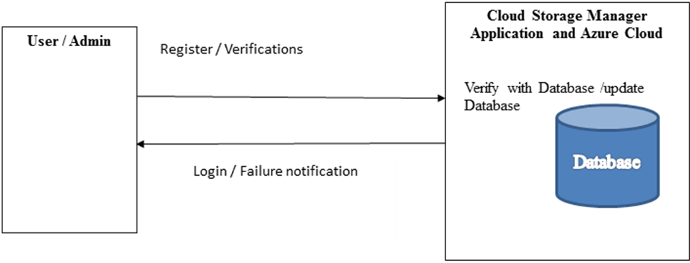
Figure 4.4.1.1 Cloud Manager

4.2.2.2 T-Coloring and Fragmentations

In the DROPS methodology, we propose not to store the entire file at a single node. The DROPS methodology fragments the file and makes use of the cloud for replication. The fragments are distributed such that no node in a cloud holds more than a single fragment, so that even a successful attack on the node leaks no significant information. The DROPS methodology uses controlled replication where each of the fragments is replicated only once in the cloud to improve the security. Although, the controlled replication does not improve the retrieval time to the level of full-scale replication, it significantly improves the security.
Once the file is split into fragments, the DROPS methodology selects the cloud nodes for fragment placement. The selection is made by keeping an equal focus on both security and performance in terms of the access time. We use the concept of T-coloring that was originally used for the channel assignment problem. We generate a non-negative random number and build the set T starting from zero to the generated random number. The set T is used to restrict the node selection to those nodes that are at hop-distances not belonging to T. For the said purpose, we assign colors to the nodes, such that, initially, all of the nodes are given the open color. Once a fragment is placed on the node, all of the nodes within the neighborhoods at a distance belonging to T are assigned close color. In the aforesaid process, we lose some of the central nodes that may increase the retrieval time but we achieve a higher security level. If somehow the intruder compromises a node and obtains a fragment, then the location of the other fragments cannot be determined. The attacker can only keep on guessing the location of the other fragments. However, as stated previously in, the probability of a successful coordinated attack is extremely minute. The process is repeated until all of the fragments are placed at the nodes.
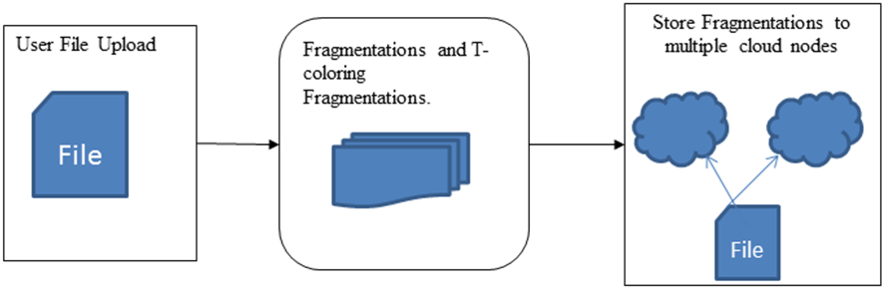
Figure 4.4.1.2 T-coloring and fragmentation

4.2.2.3 Requesting and Replication

In the DROPS methodology, user sends the data file to cloud. The cloud manager system (a user facing server in the cloud that entertains user’s requests) upon receiving the file performs: fragmentation, first cycle of nodes selection and stores one fragment over each of the selected node, and second cycle of nodes selection for fragments replication. The cloud manager keeps record of the fragment placement and is assumed to be a secure entity. The fragmentation threshold of the data file is specified to be generated by the file owner. The file owner can specify the fragmentation threshold in terms of either percentage or the number and size of different fragments.
We also perform a controlled replication to increase the data availability, reliability, and improve data retrieval time. We place the fragment on the node that provides the decreased access cost with an objective to improve retrieval time for accessing the fragments for reconstruction of original file. While replicating the fragment, the separation of fragments as explained in the placement technique through T-coloring, is also taken care off. In case of a large number of fragments or small number of nodes, it is also possible that some of the fragments are left without being replicated because of the T-coloring. As discussed previously, T-coloring prohibits storing the fragment in neighborhood of a node storing a fragment, resulting in the elimination of a number of nodes to be used for storage. In such a case, only for the remaining fragments, the nodes that are not holding any fragment are selected for storage randomly.
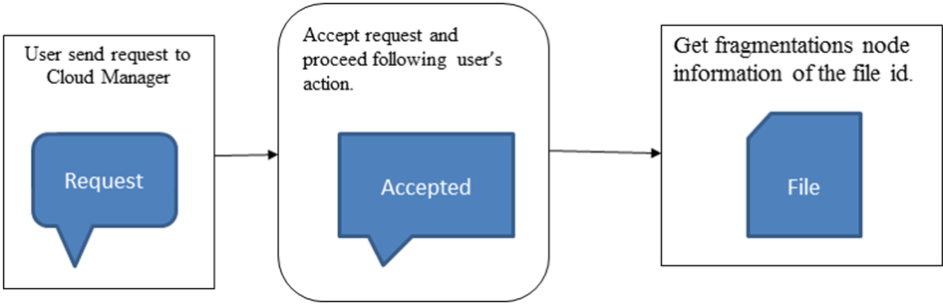
Figure 4.4.1.3 Request and Replicate

4.2.2.4 Managing Status and Download Files

To handle the download request from user, the cloud manager collects all the fragments from the nodes and re-assembles them into a single file. Afterwards, the file is sent to the user. User can download a file on users dashboard show option that file can downloadable. And every downloaded file requests and sent requests are stored in cloud manager server. Request will be subject to change during the process of DROPS methodology.
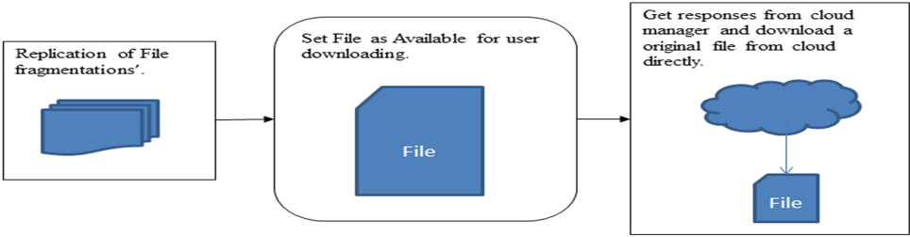
Figure 4.4.1.4 Management and Download

CHAPTER 5
SYSTEM TESTING
5.1 Testing Objectives
The purpose of testing is to discover errors. Testing is the process of trying to discover every conceivable fault or weakness in a work product. It provides a way to check the functionality of components, subassemblies, assemblies and/or a finished product. It is the process of exercising software with the intent of ensuring that the Software system meets its requirements and user expectations and does not fail in an unacceptable manner. There are various types of test. Each test type addresses a specific testing requirement.

5.2 Categories of Software Testing
- Black Box Testing
- White Box Testing
Black Box Testing

Black box testing is a software testing techniques in which functionality of the software under test (SUT) is tested without looking at the internal code structure, implementation details and knowledge of internal paths of the software. This type of testing is based entirely on the software requirements and specifications.

White Box Testing

White Box Testing is the testing of a software solution's internal coding and infrastructure. It focuses primarily on strengthening security, the flow of inputs and outputs through the application, and improving design and usability. White box testing is also known as Clear Box testing, Open Box testing, Structural testing, Transparent Box testing, Code-Based testing, and Glass Box testing.

White Box Testing Techniques
- Statement Coverage - This technique is aimed at exercising all programming statements with minimal tests.
- Branch Coverage - This technique is running a series of tests to ensure that all branches are tested at least once.
- Path Coverage - This technique corresponds to testing all possible paths which means that each statement and branch is covered.

Black Box Testing Techniques
- Equivalence Class Testing: It is used to minimize the number of possible test cases to an optimum level while maintains reasonable test coverage.
- Boundary Value Testing: Boundary value testing is focused on the values at boundaries. This technique determines whether a certain range of values are acceptable by the system or not. It is very useful in reducing the number of test cases. It is mostly suitable for the systems where input is within certain ranges.
- Decision Table Testing: A decision table puts causes and their effects in a matrix. There is unique combination in each column.

5.3 Types of Testing
- Unit Testing
- Functional Testing
- Performance Testing
- Integration Testing
- Objective
- Integration Testing
- Validation Testing
- System Testing
- Structure Testing
- Output Testing
- User Acceptance Testing
5.3.1 Unit Testing
- Unit testing, also known as Module Testing, focuses verification efforts on the module. The module is tested separately and this is carried out at the programming stage itself.
- Unit Test comprises of the set of tests performed by an individual programmer before integration of the unit into the system.
- Unit test focuses on the smallest unit of software design- the software component or module.
- Using component level design, important control paths are tested to uncover errors within the boundary of the module.
- Unit test is white box oriented and the step can be conducted in parallel for multiple components.

5.3.2 Functional Testing
- Functional test cases involve exercising the code with normal input values for which the expected results are known, as well as the boundary values
- The objective is to take unit-tested modules and build a program structure that has been dictated by design.

5.3.3 Performance Testing
- Performance testing determines the amount of execution time spent in various parts of the unit, program throughput, and response time and device utilization of the program unit. It occurs throughout all steps in the testing process.

5.3.4 Integration Testing
- It is a systematic technique for constructing the program structure while at the same time conducting tests to uncover errors associated with in the interface.
- It takes the unit tested modules and builds a program structure.
- All the modules are combined and tested as a whole.
- Integration of all the components to form the entire system and a overall testing is executed.

5.3.5 Validation Testing
- Validation test succeeds when the software functions in a manner that can be reasonably expected by the client.
- Software validation is achieved through a series of black box testing which confirms to the requirements.
- Black box testing is conducted at the software interface.
- The test is designed to uncover interface errors, is also used to demonstrate that software functions are operational, input is properly accepted, output are produced and that the integrity of external information is maintained.

5.3.6 System Testing
- Tests to find the discrepancies between the system and its original objective, current specifications and system documentation.

5.3.7 Structure Testing
- It is concerned with exercising the internal logic of a program and traversing particular execution paths.

5.3.8 Output Testing
- Output of test cases compared with the expected results created during design of test cases.
- Asking the user about the format required by them tests the output generated or displayed by the system under consideration.
- Here, the output format is considered into two was, one is on screen and another one is printed format.
- The output on the screen is found to be correct as the format was designed in the system design phase according to user needs.
- The output comes out as the specified requirements as the user’s hard copy.
5.3.9 User Acceptance Testing
- Final Stage, before handling over to the customer which is usually carried out by the customer where the test cases are executed with actual data.
- The system under consideration is tested for user acceptance and constantly keeping touch with the prospective system user at the time of developing and making changes whenever required.
- It involves planning and execution of various types of test in order to demonstrate that the implemented software system satisfies the requirements stated in the requirement document.

5.4 Test Case Scenario
- Max length should be set for all the text boxes
When the project is tested that whether all textbox for have max length when it exceeds it gives an alert message to the user and email id textbox which accept only at format of alphabet/alphanumric&@&alphabet&.com and the password field is not display for user it is replace by asterisks
- Password field should be masked with asterisks (*****)
When the project tested that whether the password of user is masked with the special character and it ensured that the password is not stored in cookies at web browsers
- Validation error messages should be displayed properly at a correct position.
Project is tested in ways that all error message are displayed to the user when user breaks the rule framed for a textbox or action and the error message are displayed in dialog box and user need to click on ok button
- Check if correct data is getting saved in the database upon successful page submits.
When the project is tested that check whether correct data is stored at database in correct location when the data are submitted or updated at front end by user
- Check file upload functionality with files of different extensions (e.g. JPEG, PPT, DOC etc.)
The project is tested with whether different types of extensions are supported by web application and saved at database with name and correct extensions
- Check values for columns which are not accepting null values
The project is checked that it does not accept null values if an null value is given a input it displays error message

CHAPTER 6
EXPERIMENTAL RESULTS AND DISCUSSION

The below figures show the results of the module implementation. These screenshots show the User Interface through which the modules are being developed

For registration user need to register using valid email Id. The password for the user is sent through email using this user can login in to cloud account.

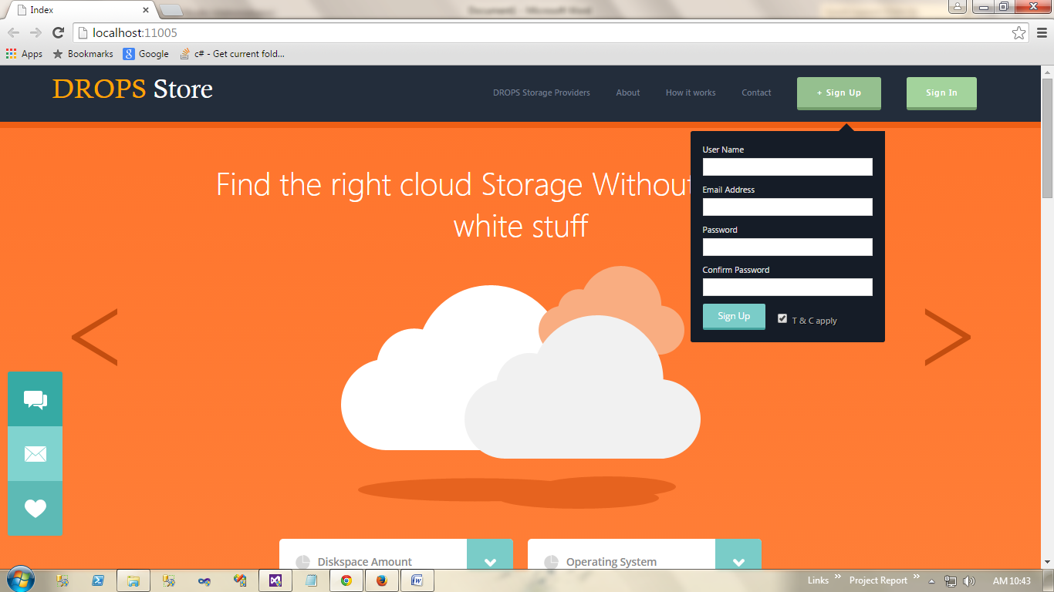
Figure 6.1 Creating a new member

The data provided by the user is stored in cloud before storing the data is fragmented into five pieces. Each piece is given a separate code to identify the data and all data is shuffle. Shuffling of data is done using t-coloring approach .and data is stored in data base using Manchester’s algorithm.

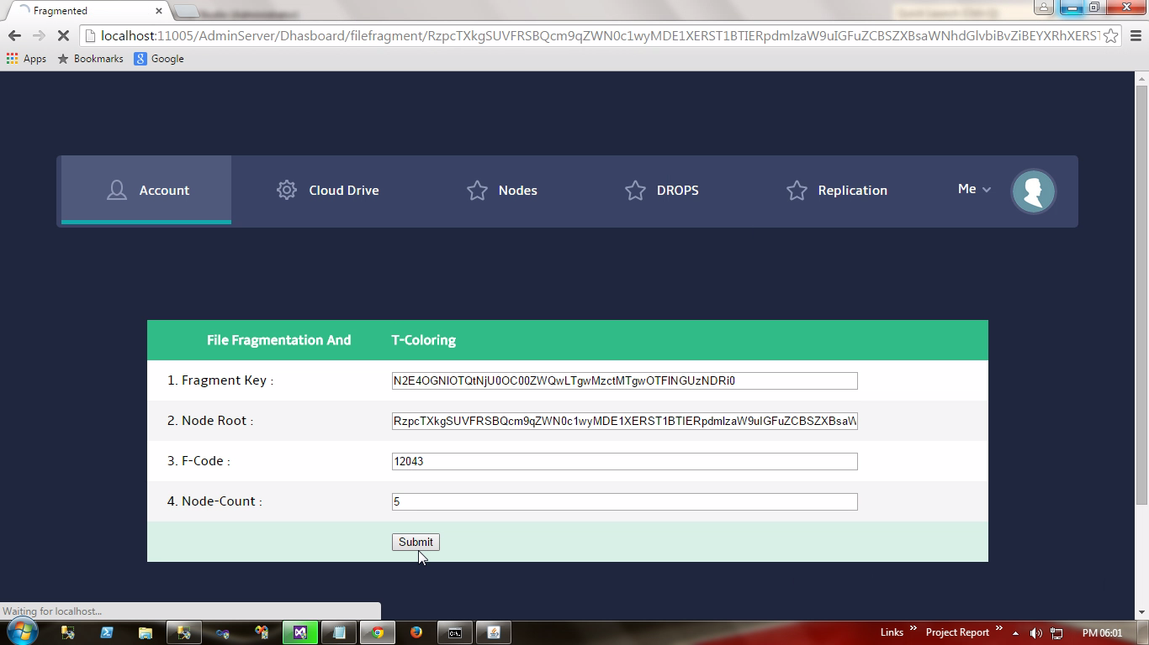
Figure 6.2 Uploading a file

Here the user sends the request to the cloud manager that he needs to download his file which is securely stored in cloud

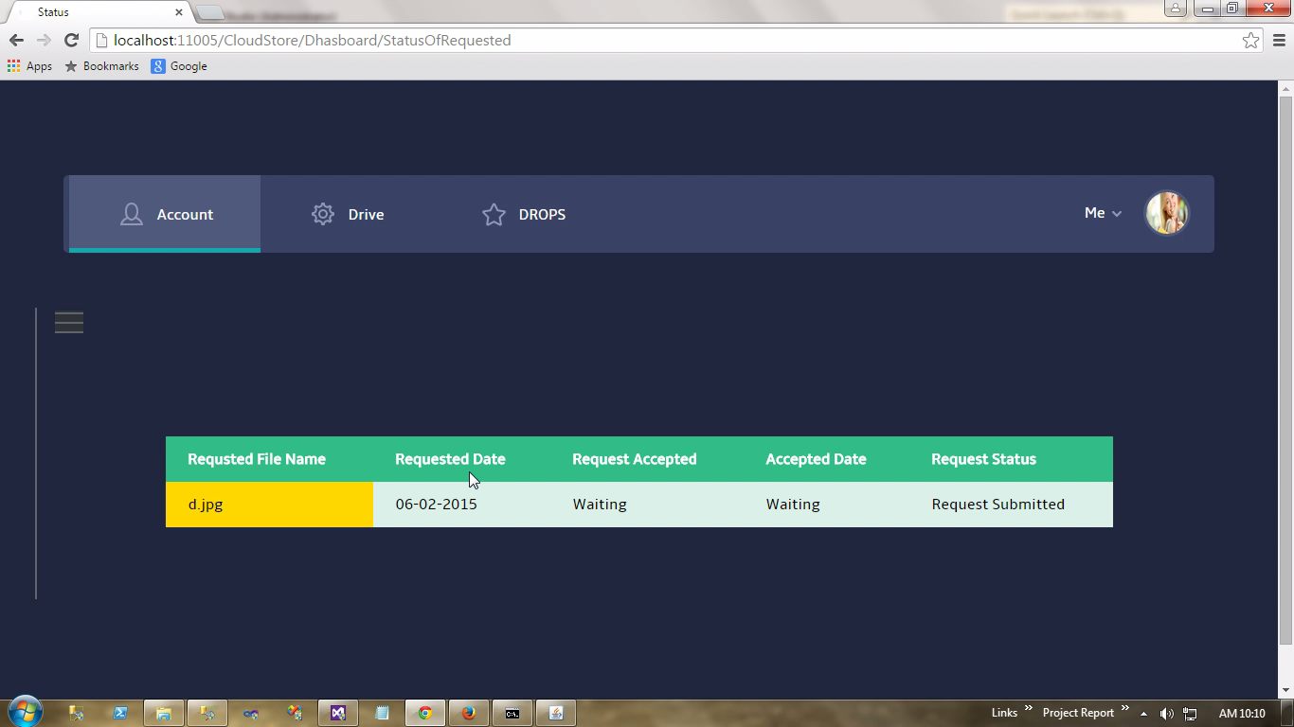
Figure 6.3 Request a file
Here the cloud manager verify the user details and his data in cloud and collect all his data from various location of cloud and arrange it in order and that download link to user and thus the user can download the file from his dashboard

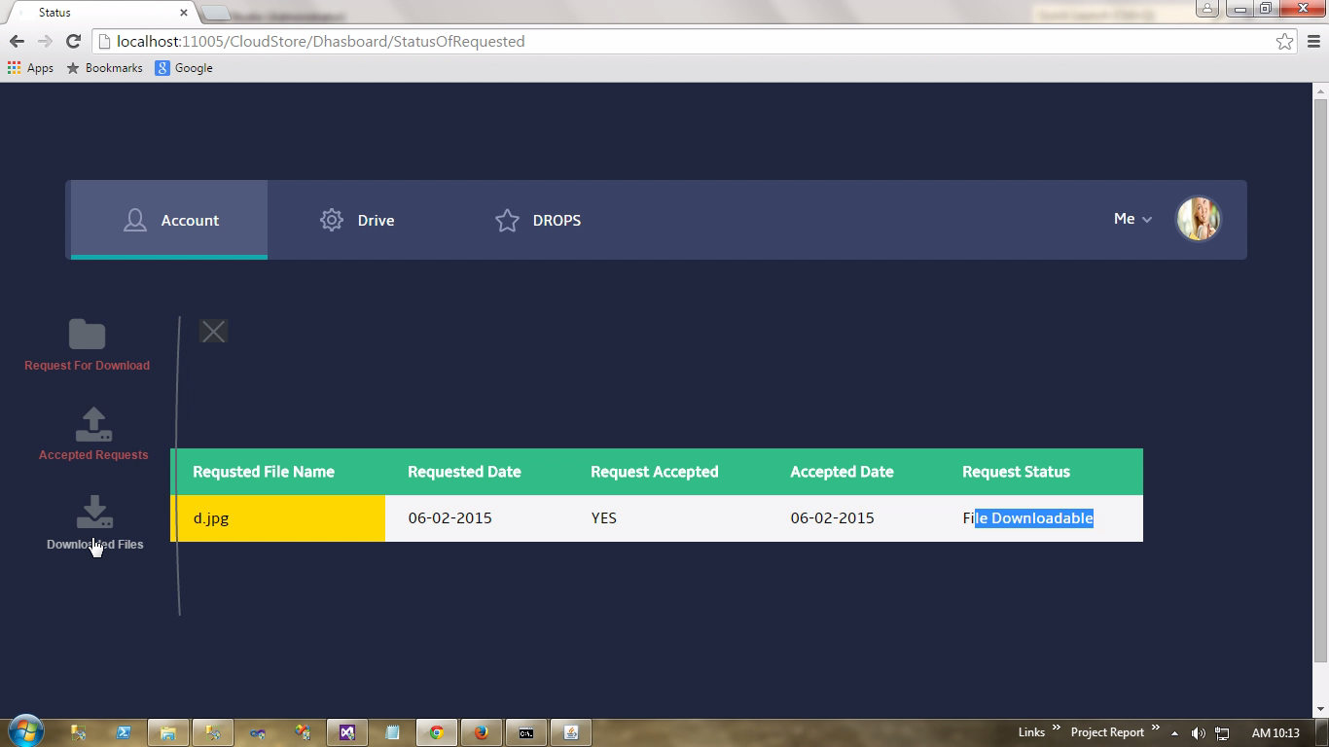
Figure 6.4 Downloading link of a file

Therefore the data from cloud is download by the user which is provide by the cloud manager and can be accessed by the user for father usage of his project are his work.

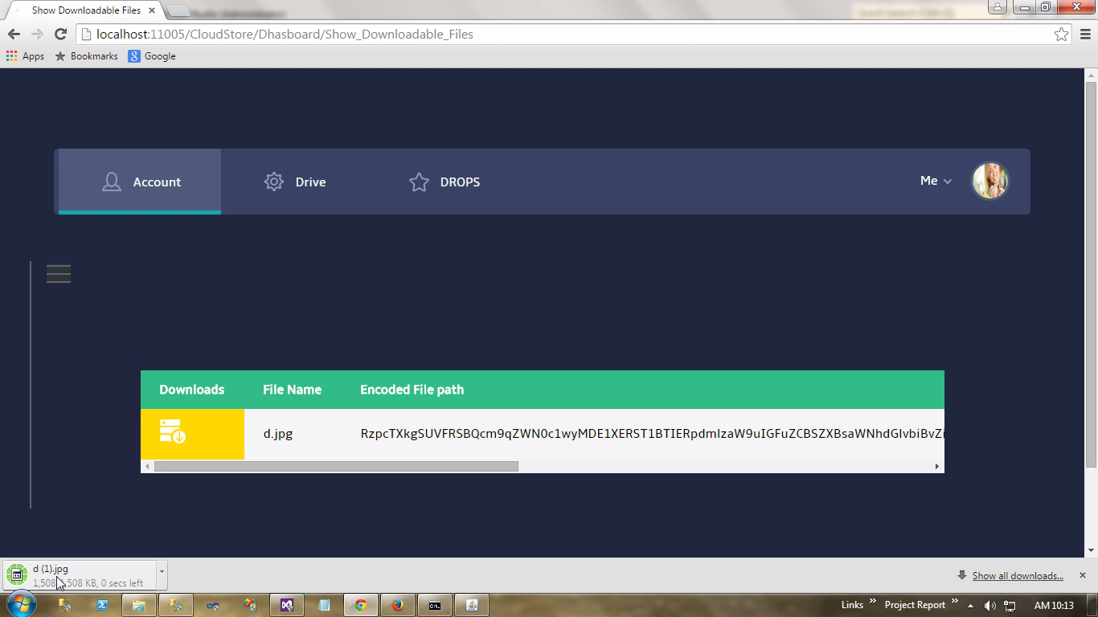
Figure 6.5 Path of download file

It provides downloadable link to user in its dash board then the user can download the file from download link.

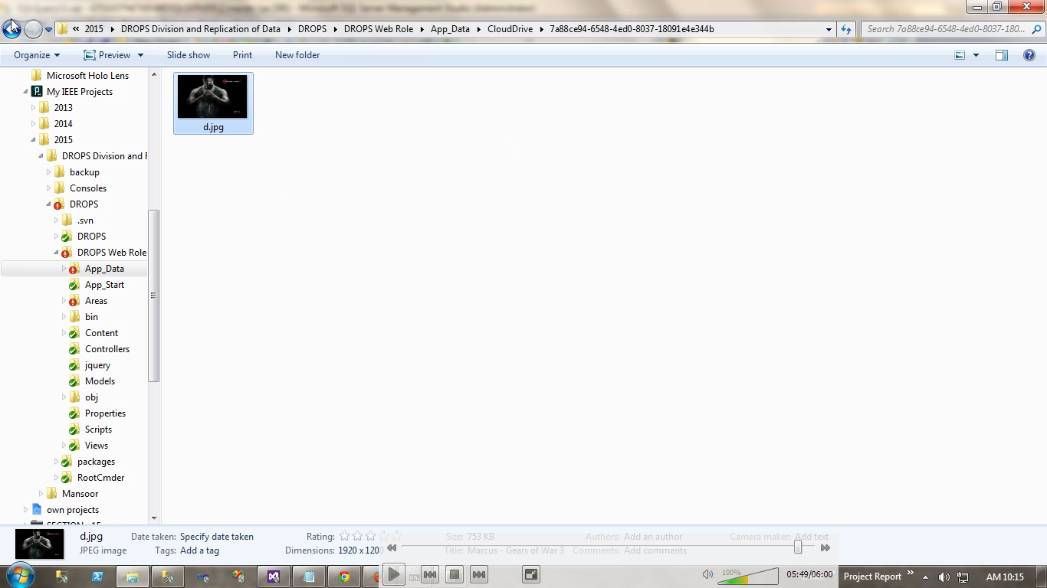
Figure 6.6 User file that he has uploaded

Now the user can download his file from his user account and can use that file for further process.
CHAPTER 7
CONCLUSION

This project focuses on data security on cloud. Now a day most of the people use cloud to store data in cloud there are various security constraint in cloud. Since the data in cloud are not secured the data in cloud are separated and stored in various data centers using Manchester’s algorithm and the data are separated by using t-coloring process and fragmentation key. Thus the data hacking is reduced from cloud.

CHAPTER 8

REFERENCES

[1] K. Bilal, M. Manzano, S. U. Khan, E. Calle, K. Li, and A. Zomaya, “On the characterization of the structural robustness of data center networks,” IEEE Transactions on Cloud Computing, Vol. 1, No. 1, 2013, pp. 64-77.

[2] D. Boru, D. Kliazovich, F. Granelli, P. Bouvry, and A. Y. Zomaya, “Energy-efficient data replication in cloud computing datacenters,” In IEEE Globecom Workshops, 2013, pp. 446-451.

[3] Y. Deswarte, L. Blain, and J-C. Fabre, “Intrusion tolerance in distributed computing systems,” In Proceedings of IEEE Computer Society Symposium on Research in Security and Privacy, Oakland CA, pp. 110-121, 1991.

[4] B. Grobauer, T.Walloschek, and E. Stocker, “Understanding cloud computing vulnerabilities,” IEEE Security and Privacy, Vol. 9, No. 2, 2011, pp. 50-57.

[5] W. K. Hale, “Frequency assignment: Theory and application, Proceedings of the IEEE, Vol. 68, No. 12, 1980, pp. 1497-1514.

[6] W. A. Jansen, “Cloud hooks: Security and privacy issues in cloud computing,” In 44th Hawaii IEEE International Conference on System Sciences (HICSS), 2011, pp. 1-10.

[7] A. Mei, L. V. Mancini, and S. Jajodia, “Secure dynamic fragment and replica allocation in large-scale distributed file systems, ”IEEE Transactions on Parallel and Distributed Systems, Vol. 14, No. 9, 2003, pp. 885-896.

[8] L. M. Kaufman, “Data security in the world of cloud computing, ”IEEE Security and Privacy, Vol. 7, No. 4, 2009, pp. 61-64.

[9] Y. Tang, P. P. Lee, J. C. S. Lui, and R. Perlman, “Secure overlay cloud storage with access control and assured deletion,” IEEE Transactions on Dependable and Secure Computing, Vol. 9, No. 6,Nov. 2012, pp. 903-916.

[10] M. Tu, P. Li, Q. Ma, I-L. Yen, and F. B. Bastani, “On the optimal placement of secure data objects over Internet,” In Proceedings of 19th IEEE International Parallel and Distributed Processing Symposium, pp. 14-14, 2005.

[11] Jens-Matthias Bohli, Nils Gruschka, Meiko Jensen, Luigi Lo Iacono and Ninja Marnau, ”Security and Privacy-Enhancing Multicloud Architectures”, IEEE Transactions on Dependable and Secure Computing, Vol. 10, No. 4, July/August 2013.

[12] Yogesh Sharma, Bahman Javadi, Weisheng Si, ”On the Reliability and Energy Efficiency in Cloud Computing“, Proceedings of the 13th Australasian Symposium on Parallel and Distributed Computing (Aus PDC 2015), Sydney, Australia, 27 - 30 January 2015.

[13] G. Aruna Kranthi, D. Shashi Rekha, ”Protected data objects replication in data grid”, International Journal of Network Security & Its Applications (IJNSA), Vol.4, No.1, January 2012.

[14]Dr. S.G. Bhirud Vijay Katkar, “Novel Architecture for Intrusion-Tolerant Distributed Intrusion Detection System using Packet Filter Firewall and State Transition Tabels, “International Journal of Computer Applications (0975 – 8887) Volume 8– No.11, October 2010.

[15] Dimitrios Zissis, Dimitrios Lekkas, Department of Product and Systems Design Engineering, University of the Aegean, Syros 84100, Greece in 2010

CHAPTER 9

APPENDICES

APPENDIX A – Sample Coding

FILE CONTROLLER

using System.Web.Mvc;
using System.IO;
using RootCmder;
using System;

namespace DROPS_Web_Role.Controllers
{
publicclassFilesController : Controller
{
publicstaticbool _root = false;
privateConnector _connector;

publicConnector Connector
{
get
{
if (Models.HomeModel.getrole(User.Identity.Name) == "Admin")
{
if (_root)
{
if (_connector == null)
{
FileSystemDriver driver = newFileSystemDriver();
DirectoryInfo thumbsStorage = newDirectoryInfo(Server.MapPath("~/App_Data/CloudDrive/thumb/"));
string root = HttpContext.Server.MapPath("~/App_Data/CloudNodes");
if (Directory.Exists(root))
{
driver.AddRoot(newRoot(newDirectoryInfo(root + "//Node_1"), "/Files/")
{
Alias = "Node 1",
StartPath = newDirectoryInfo(root + "//Node_1"),
ThumbnailsStorage = thumbsStorage,
MaxUploadSizeInMb = 20.2,
ThumbnailsUrl = "Thumbnails/"
});
driver.AddRoot(newRoot(newDirectoryInfo(root + "//Node_2"), "/Files/")
{
Alias = "Node 2",
StartPath = newDirectoryInfo(root + "//Node_2"),
ThumbnailsStorage = thumbsStorage,
MaxUploadSizeInMb = 20.2,
ThumbnailsUrl = "Thumbnails/"
});
driver.AddRoot(newRoot(newDirectoryInfo(root + "//Node_3"), "/Files/")
{
Alias = "Node 3",
StartPath = newDirectoryInfo(root + "//Node_3"),
ThumbnailsStorage = thumbsStorage,
MaxUploadSizeInMb = 20.2,
ThumbnailsUrl = "Thumbnails/"
});
driver.AddRoot(newRoot(newDirectoryInfo(root + "//Node_4"), "/Files/")
{
Alias = "Node 4",
StartPath = newDirectoryInfo(root + "//Node_4"),
ThumbnailsStorage = thumbsStorage,
MaxUploadSizeInMb = 20.2,
ThumbnailsUrl = "Thumbnails/"
});
driver.AddRoot(newRoot(newDirectoryInfo(root + "//Node_5"), "/Files/")
{
Alias = "Node 5",
StartPath = newDirectoryInfo(root + "//Node_5"),
ThumbnailsStorage = thumbsStorage,
MaxUploadSizeInMb = 20.2,
ThumbnailsUrl = "Thumbnails/"
});
}
_connector = newConnector(driver);
}
}
else
{

if (_connector == null)
{
FileSystemDriver driver = newFileSystemDriver();
DirectoryInfo thumbsStorage = newDirectoryInfo(Server.MapPath("~/App_Data"));
string root = HttpContext.Server.MapPath("~/App_Data/CloudDrive");
if (Directory.Exists(root))
{

driver.AddRoot(newRoot(newDirectoryInfo(root), "/Files/")
{
IsLocked = true,
//IsReadOnly = true,
//IsShowOnly = true,
Alias = User.Identity.Name + " Root Dirctory",
StartPath = newDirectoryInfo(root),
ThumbnailsStorage = thumbsStorage,
MaxUploadSizeInMb = 2.2,
ThumbnailsUrl = "Thumbnails/"
});

}
_connector = newConnector(driver);
}

}
}
else
{
if (_connector == null)
{
FileSystemDriver driver = newFileSystemDriver();
DirectoryInfo thumbsStorage = newDirectoryInfo(Server.MapPath("~/App_Data"));
string root = HttpContext.Server.MapPath("~/App_Data/CloudDrive/" + Session[User.Identity.Name]);
if (Directory.Exists(root))
{
driver.AddRoot(newRoot(newDirectoryInfo(root), "/Files/")
{
Alias = User.Identity.Name,
StartPath = newDirectoryInfo(root),
ThumbnailsStorage = thumbsStorage,
MaxUploadSizeInMb = 2.2,
ThumbnailsUrl = "Thumbnails/"
});
}
else
{
driver.AddRoot(newRoot(newDirectoryInfo(HttpContext.Server.MapPath("~/App_Data/CloudDrive/Guest")), "/Files/")
{
Alias = User.Identity.Name,
StartPath = newDirectoryInfo(HttpContext.Server.MapPath("~/App_Data/CloudDrive/Guest")),
ThumbnailsStorage = thumbsStorage,
MaxUploadSizeInMb = 2.2,
ThumbnailsUrl = "Thumbnails/"
});
}
_connector = newConnector(driver);
}
}
return _connector;
}
}

[Authorize]
publicActionResult Index()
{
try
{
var s = Connector.Process(this.HttpContext.Request);
return s;
}
catch (Exception e)
{
return RedirectToAction("Index");
}

}

[Authorize]
publicActionResult SelectFile(string target)
{
return Json(Connector.GetFileByHash(target).FullName);
}

[Authorize]
publicActionResult Thumbs(string tmb)
{
return Connector.GetThumbnail(Request, Response, tmb);
}
}
}

CLOUD CONTROLLER

using System;
using System.Collections.Generic;
using System.Data;
using System.Drawing;
using System.IO;
using System.Linq;
using System.Web;
using System.Web.Mvc;
using DROPS_Web_Role.Areas.CloudStore.Models;

namespace DROPS_Web_Role.Areas.CloudStore.Controllers
{
[Authorize]
publicclassDhasboardController : Controller
{
publicActionResult Index()
{
return View();
}

publicActionResult GetImage()
{
Models.DhasboardModel model = newDhasboardModel();
byte[] s = model.getpropic(User.Identity.Name);
return File(s, "image/png");
}

publicActionResult Drive()
{
return RedirectToAction("Goods", "Home", new { area = "" });
}

publicActionResult Drops()
{
return View();
}

[HttpGet]
publicActionResult Requesting()
{
List<Models.DhasboardModel> listbind = newList<Models.DhasboardModel>();
Dictionary<string, string> dataset = newDictionary<string, string>();
if (Session[User.Identity.Name] == null)
{
TempData["PopUpBox"] = " Sorry, but your session has timed out. You will be redirected to the Log On page";
return RedirectToAction("Logout", "Home", new { area = "" });
}
string userid = Session[User.Identity.Name].ToString();
string root = HttpContext.Server.MapPath("~/App_Data/CloudDrive/" + userid);
foreach (string file in GetFiles(root))
{
if (!dataset.ContainsKey(file))
{
long length = new System.IO.FileInfo(file).Length;
if (length >= 1)
{
var key = HttpServerUtility.UrlTokenEncode(System.Text.UTF8Encoding.UTF8.GetBytes(file));
if (CheckIsAlreadyHave(key, userid))
{
dataset.Add(key, Path.GetFileName(file));
}
}
}
}
foreach (KeyValuePair<string, string> dict in dataset)
{
Models.DhasboardModel model = newDhasboardModel();
string s = model.ExecuteScalar("SELECT [RequestStatus] FROM [Requests] WHERE [UserID]='" + userid + "' AND [RequstedFile]='" + dict.Value + "'");
if (s == null)
{
listbind.Add(new Models.DhasboardModel { FilePath = dict.Key, Files = dict.Value });
}
}
return View(listbind.AsEnumerable());
}

privatebool CheckIsAlreadyHave(string key, string userid)
{
Models.DhasboardModel model = newDhasboardModel();
string query = "SELECT [Original File] FROM [Fragments] WHERE [NodeRootID]='" + userid + "' and [Original File Path]='" + key + "'";
string scalar = model.ExecuteScalar(query);
if (scalar != "")
{
returntrue;
}
else
{
returnfalse;
}
}

publicActionResult req(Models.DhasboardModel model)
{
var routedata = RouteData.Values["id"];
string _bool = model.ExecuteScalar("SELECT [RequestStatus] FROM [Requests] WHERE [UserID]='" + Session[User.Identity.Name].ToString() + "'AND [RequstedFile]='" + routedata.ToString() + "'");
if (null == _bool)
{
bool Bool = model.ExecutNonQuery("INSERT INTO [Requests]([UserID],[RequstedFile],[RequestStatus]) VALUES ('" + Session[User.Identity.Name] + "','" + routedata.ToString() + "','Request Submitted')");
}
else
{
// TempData["PopUpBox"] = "Request Sent.";
}
return RedirectToAction("Requesting");
}

staticIEnumerable<string> GetFiles(string path)
{
Queue<string> queue = newQueue<string>();
queue.Enqueue(path);
while (queue.Count > 0)
{
path = queue.Dequeue();
try
{
foreach (string subDir inDirectory.GetDirectories(path))
{
queue.Enqueue(subDir);
}
}
catch (Exception ex)
{
Console.Error.WriteLine(ex);
}
string[] files = null;
try
{
files = Directory.GetFiles(path);
}
catch (Exception ex)
{
Console.Error.WriteLine(ex);
}
if (files != null)
{
for (int i = 0; i < files.Length; i++)
{
yieldreturn files[i];
}
}
}
}

publicActionResult StatusOfRequested(Models.DhasboardModel model)
{
List<Models.DhasboardModel> listbind = newList<Models.DhasboardModel>();
if (Session[User.Identity.Name] == null)
{
TempData["PopUpBox"] = " Sorry, but your session has timed out. You will be redirected to the Log On page";
return RedirectToAction("Logout", "Home", new { area = "" });
}
string userid = Session[User.Identity.Name].ToString();
DataSet dataset = model.ExecuteDataReader("SELECT [RequstedFile],[RequestedDate],[RequestAccepted],[AcceptedDate],[RequestStatus] FROM [Requests] WHERE [UserID]='" + userid + "'");
foreach (DataRow dict in dataset.Tables[0].Rows)
{
DateTime dt = DateTime.Parse(dict["RequestedDate"].ToString());
string dt2 = "";
if (dict["AcceptedDate"].ToString() != "")
{
DateTime dt22 = DateTime.Parse(dict["AcceptedDate"].ToString());
dt2 = dt22.ToShortDateString();
}
listbind.Add(new Models.DhasboardModel
{
RequstedFile = dict["RequstedFile"].ToString(),
RequestedDate = dt.ToShortDateString(),
RequestAccepted = dict["RequestAccepted"].ToString(),
AcceptedDate = dt2,
RequestStatus = dict["RequestStatus"].ToString()
});
}
return View(listbind.AsEnumerable());
}

publicActionResult Show_Downloadable_Files(Models.DhasboardModel model)
{
List<Models.DhasboardModel> listbind = newList<Models.DhasboardModel>();
if (Session[User.Identity.Name] == null)
{
TempData["PopUpBox"] = " Sorry, but your session has timed out. You will be redirected to the Log On page";
return RedirectToAction("Logout", "Home", new { area = "" });
}
string userid = Session[User.Identity.Name].ToString();
DataSet dataset = model.ExecuteDataReader("SELECT Requests.RequstedFile, Fragments.[Original File Path] FROM Fragments INNER JOIN Requests ON Fragments.NodeRootID = Requests.UserID AND Fragments.[Original File] = Requests.RequstedFile WHERE Requests.UserID='" + userid + "' and Requests.RequestAccepted='YES'");
foreach (DataRow dict in dataset.Tables[0].Rows)
{
listbind.Add(new Models.DhasboardModel
{
Files = dict["RequstedFile"].ToString(),
FilePath = dict["Original File Path"].ToString()
});
}
return View(listbind.AsEnumerable());
}

publicActionResult Down(Models.DhasboardModel model)
{
var routedata = RouteData.Values["id"];

string _bool = System.Text.UTF8Encoding.UTF8.GetString(HttpServerUtility.UrlTokenDecode(routedata.ToString()));

bool s = model.DownRecords(Session[User.Identity.Name].ToString(), Path.GetFileName(_bool), routedata.ToString());
if (s)
{
string Originalname = string.Empty;
byte[] FileData = null;

Originalname = Path.GetFileName(_bool);
FileData = System.IO.File.ReadAllBytes(_bool);

Response.AppendHeader("Content-Disposition", "attachment;filename=\"" + Originalname + "\"");
Response.BinaryWrite(FileData);
return File(FileData, "application/x-unknown");
}
else
{
return RedirectToAction("Show_Downloadable_Files");
}

}
}
}

