Project Type:
Cloud Deployment | DevOps | MLOps | AI Integration

Repository:
https://github.com/Gnaneshwarsreepathi/mlops-project

MLOps AI Assistant Deployment using Azure DevOps and Azure App Service

Project Overview
This project demonstrates the end-to-end deployment of an AI-powered MLOps Assistant using Azure DevOps CI/CD pipelines and Azure App Service.

Technologies Used
- Azure DevOps
- Azure App Service
- Azure Resource Manager Service Connection
- Node.js 22 LTS
- Azure Pipelines (YAML)
- Git & GitHub
- Google Gemini API

Architecture
Developer → Azure Repos → Azure Pipelines → Build → Artifact → Deploy → Azure App Service → Live Application

Objectives
- Automate application deployment using CI/CD.
- Deploy a Node.js application to Azure.
- Manage secrets securely.
- Integrate Gemini AI into a cloud-hosted application.
- Gain hands-on experience with DevOps and MLOps workflows.

Step 1: az login --use-device-code

Command
az login --use-device-code

Why?
Azure CLI (Command Line Interface) needs to know:
"Which Azure account am I allowed to work with?"
Just like you log into Azure Portal in a browser, Azure CLI also needs authentication.

What happened?
- Azure CLI generated a code.
- You opened Microsoft login page.
- You authenticated.
- Azure CLI received a security token.
Now Azure CLI can perform actions on your Azure resources.

Real-world use
Without login, commands like:
az group list
az webapp list
az ml workspace list
will fail because Azure doesn't know who you are.

Step 2: az account show --output table

Command
az account show --output table

Why?
After login, we need to verify:
- Which subscription is active?
- Which tenant is active?
- Which account is active?
Think of Azure subscriptions like bank accounts.
You may have:
Subscription A
Subscription B
Subscription C
If Azure CLI points to the wrong subscription:
az webapp create
might create resources in the wrong place.

Output Meaning
You saw:
Field | Meaning
Name | Azure subscription 1
State | Enabled
IsDefault | True
TenantDisplayName | Default Directory
This tells us:
✅ Login successful
✅ Correct subscription selected
✅ Ready for deployment
Why do DevOps engineers always verify this?
Imagine a company has:
Production Subscription
Test Subscription
Development Subscription
If a DevOps engineer accidentally deploys to Production:
🚨 Big problem.
So they always verify:
az account show
before deployment.
Step 3: Create Azure App Service
Create a Resource Group and Azure App Service to host the Node.js application.
Configuration:
• Resource Group: mlops-rg
• App Service Name: app-mlops
• Runtime Stack: Node.js 22 LTS
• Operating System: Linux
• Region: East Asia
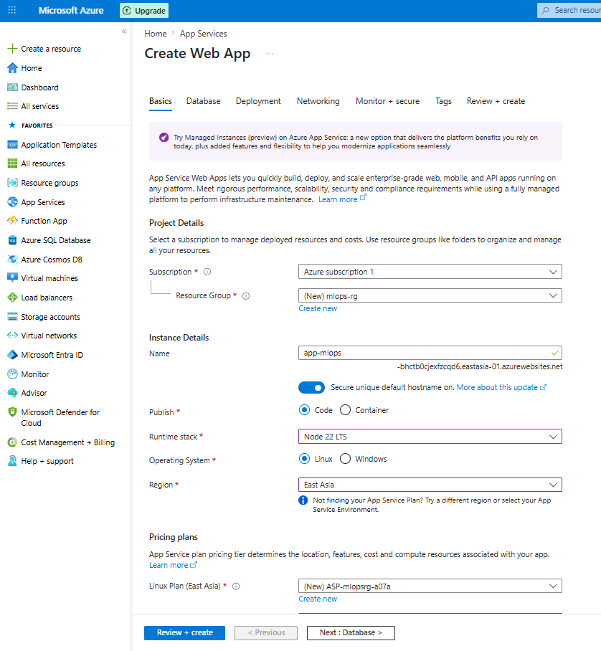

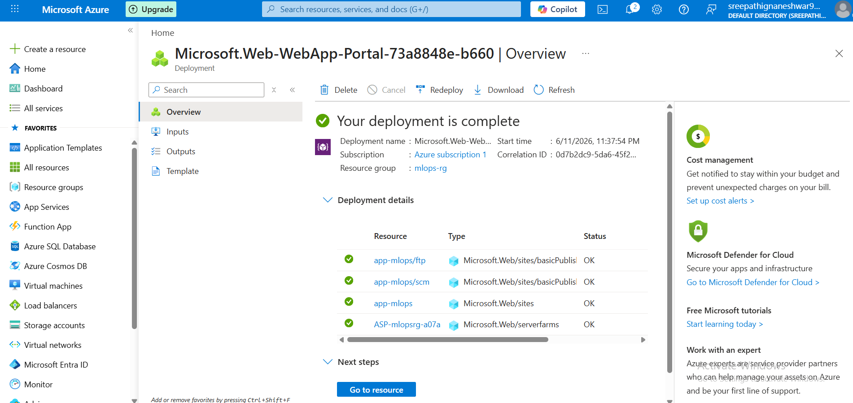
Azure App Service created successfully.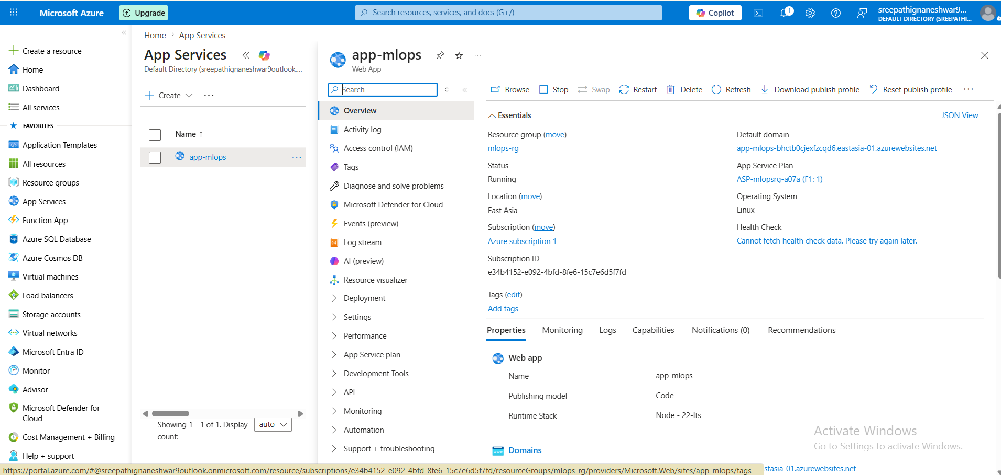

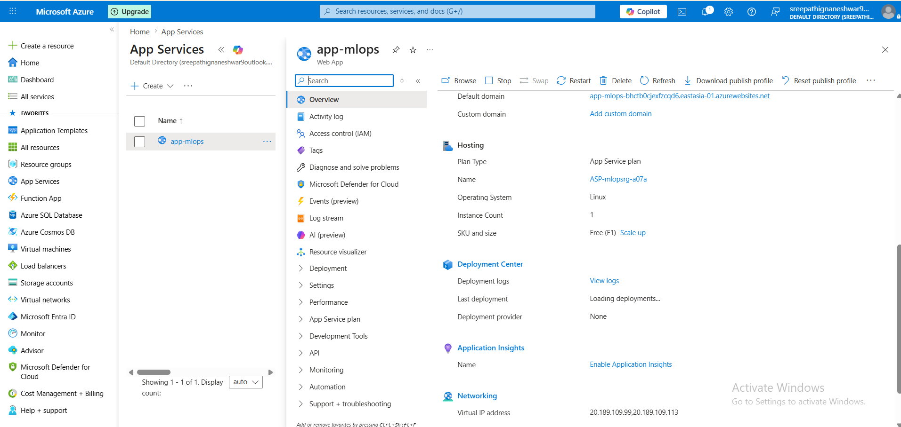

You can see the domain : app-mlops-bhctb0cjexfzcqd6.eastasia-01.azurewebsites.net
check in web so u can see page like below
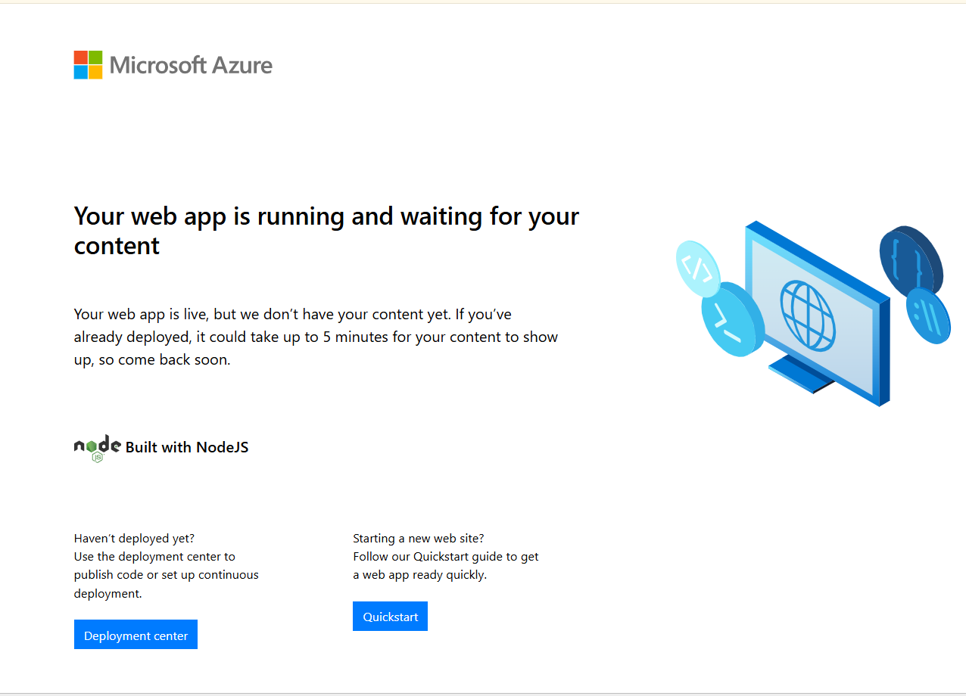

From your screenshot:
✅ Resource Group: mlops-rg
✅ App Service: app-mlops
✅ App Service Plan: ASP-mlopsrg-a07a
✅ Runtime: Node.js 22 LTS
✅ OS: Linux

Step 4: Create Azure DevOps Service Connection

A Service Connection allows Azure DevOps pipelines to securely authenticate and deploy resources into Azure.
Create Azure DevOps Service Connection
Azure DevOps → Project Settings → Service connections → New service connection:
- Type: Azure Resource Manager
- Auth method: Service principal (automatic)
- Select your subscription and resource group
- Name it exactly: app-mlops
- Tick Grant access permission to all pipelines → Save
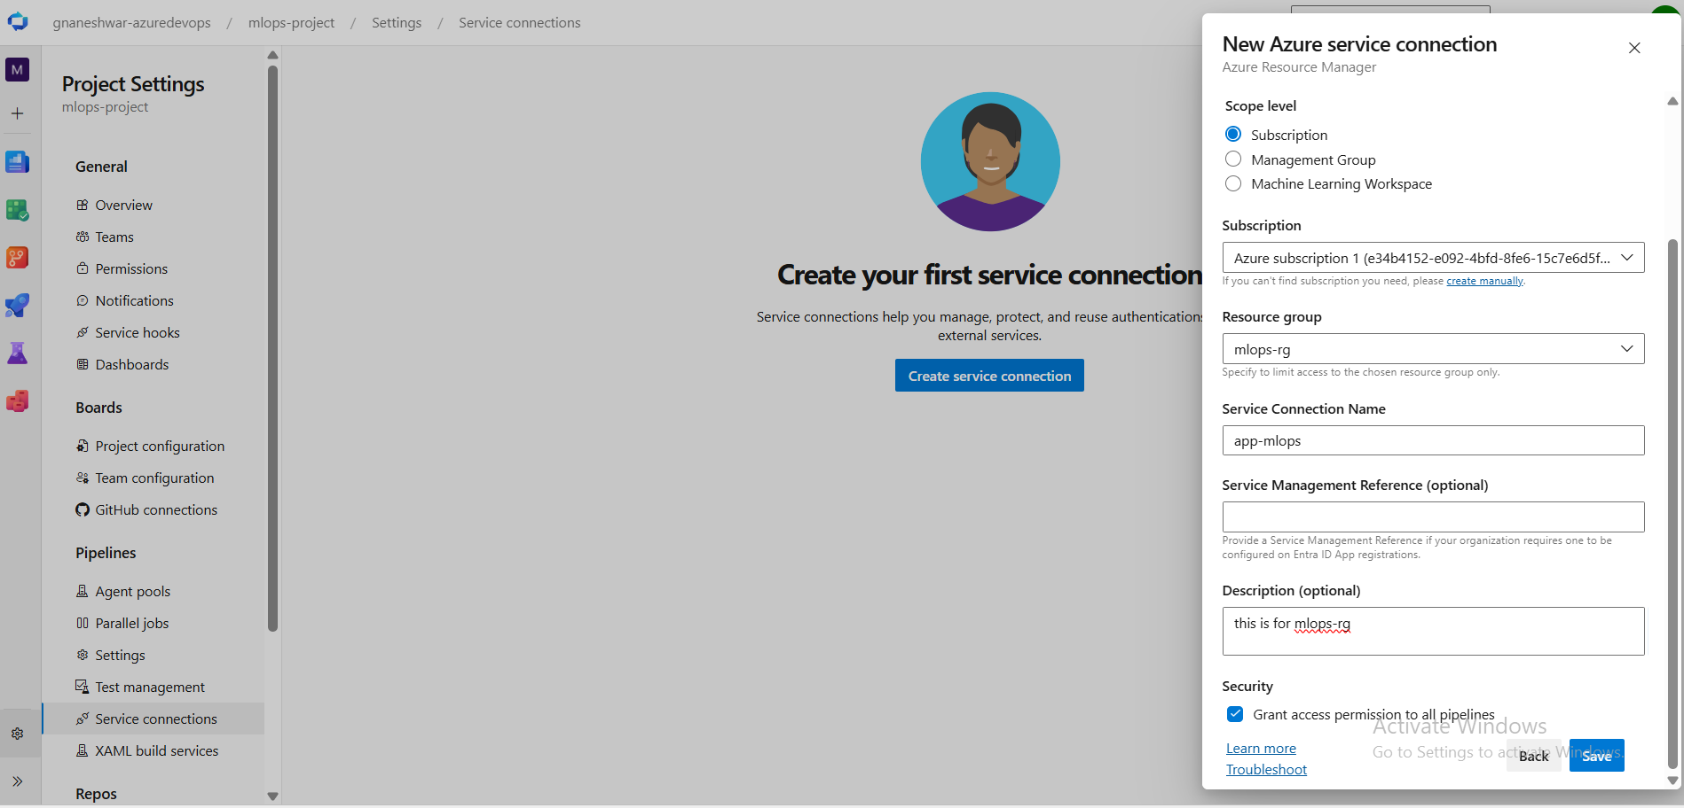

Next, create the Azure DevOps Pipeline.
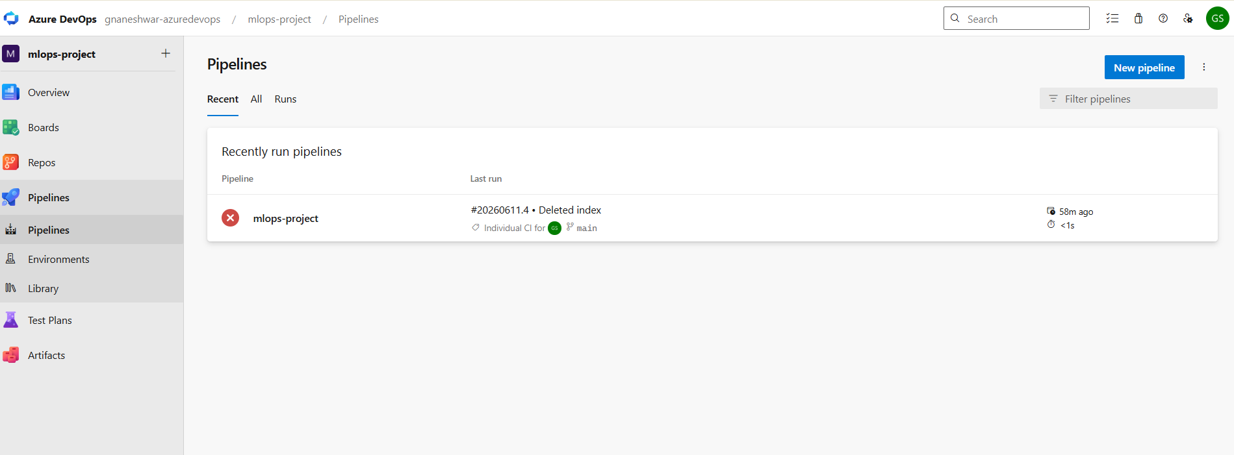
Step 5: Create Azure DevOps Pipeline
1. Navigate to Pipelines → New Pipeline
2. Select Azure Repos Git
3. Choose the repository: mlops-project
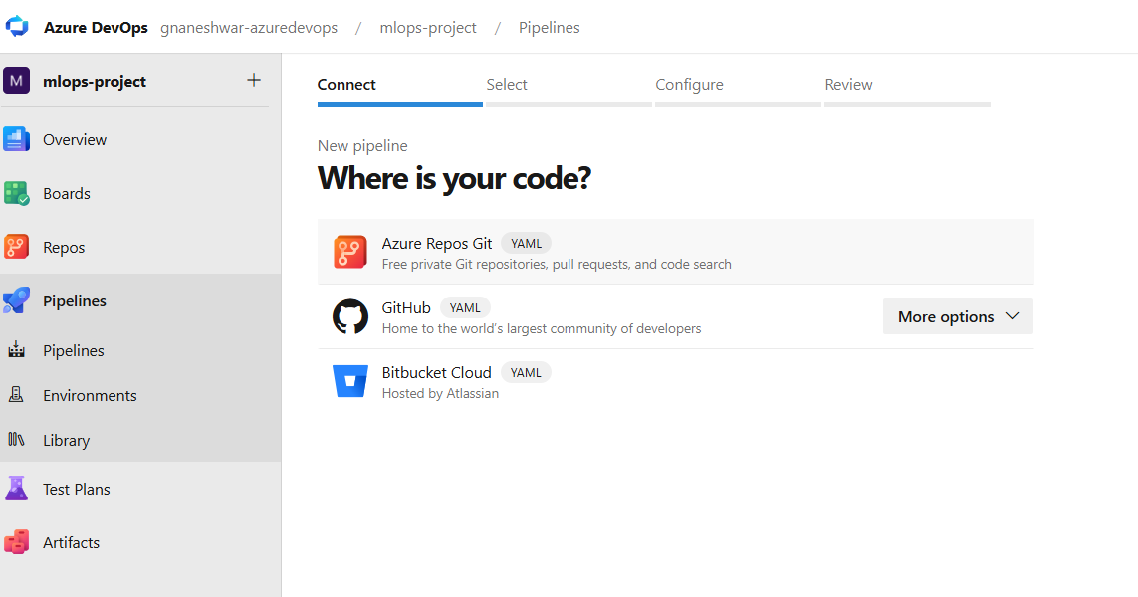Select Azure Repos Git.
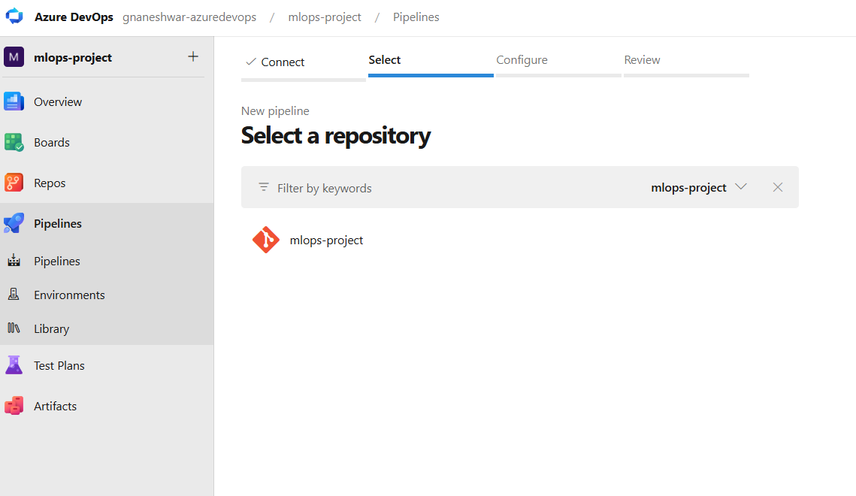
Select mlops-project this we already imported
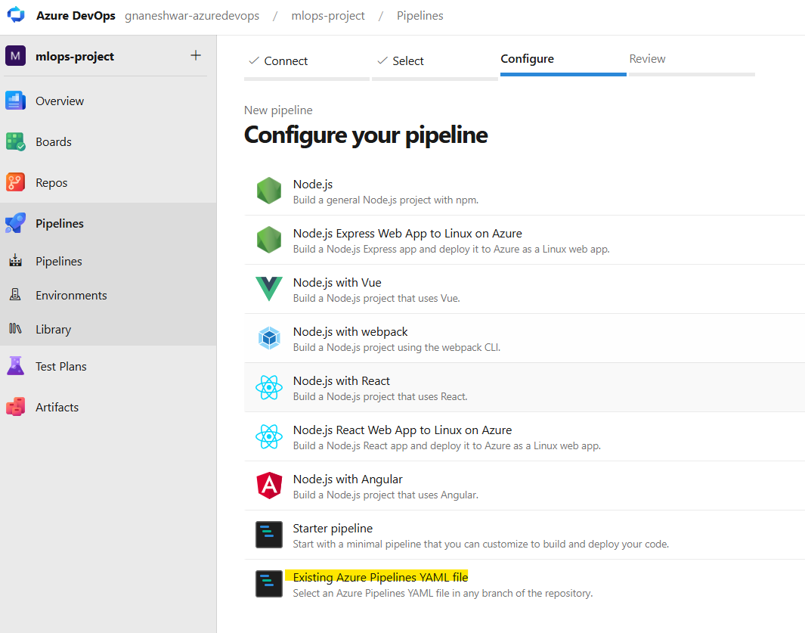

Select existing azure pipeline yaml file
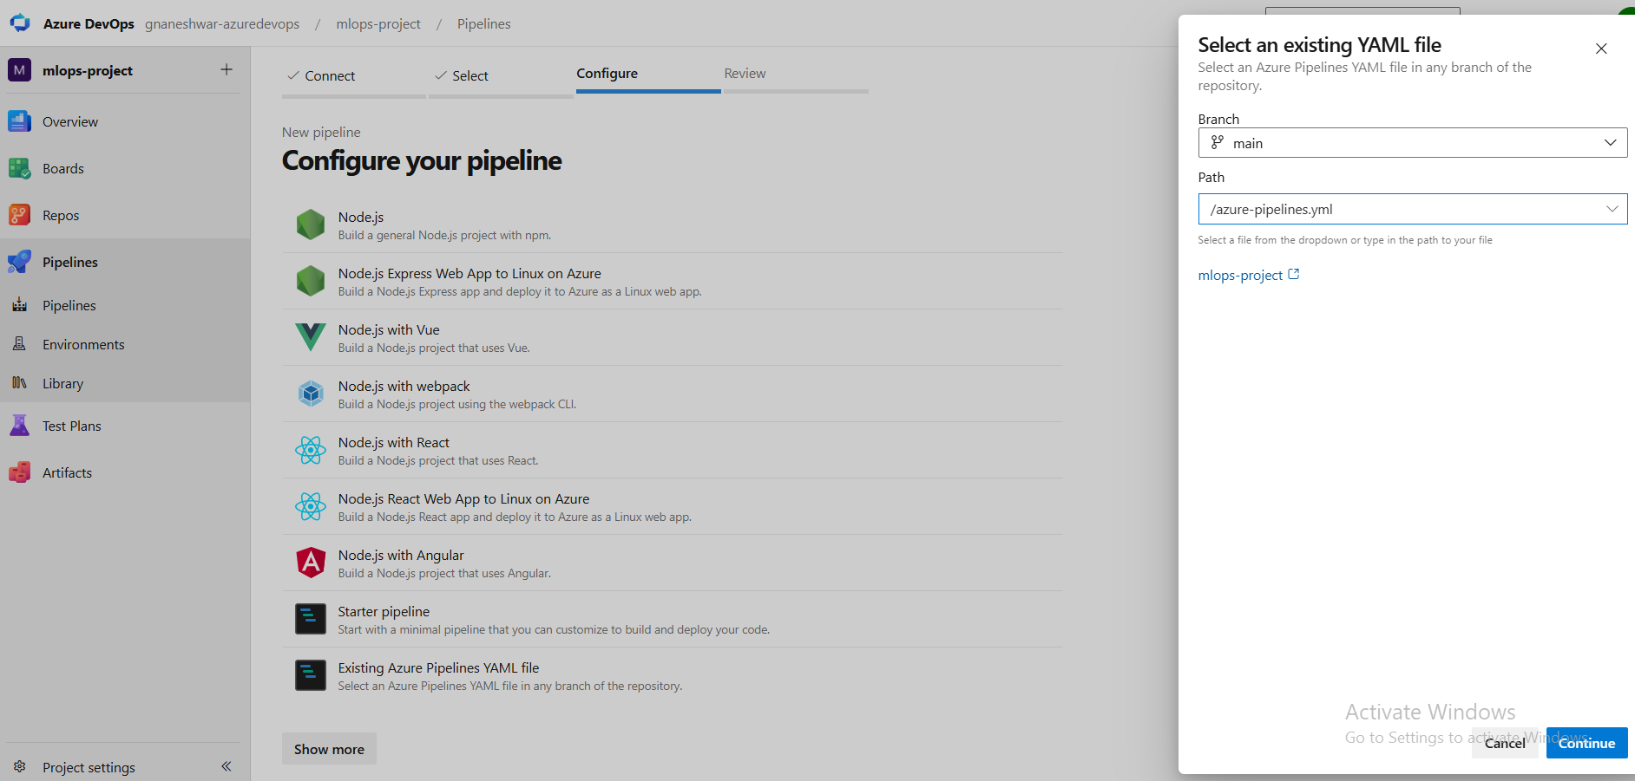
Select the path:
/azure-pipelines.yml
Click Continue.
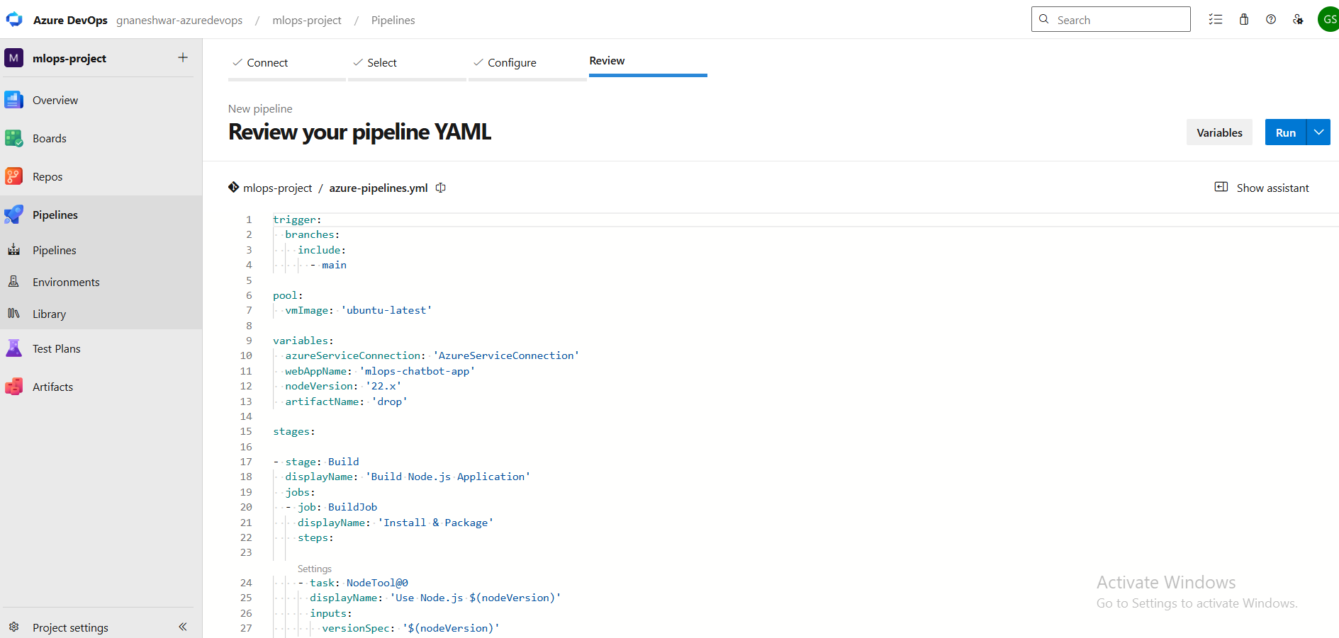

Because your deployment instructions are already written in:
azure-pipelines.yml
Instead of creating a new pipeline manually.
https://microsoftlearning.github.io/mslearn-devops/Instructions/advanced/03-configure-pipelines-code-yaml.html
Reference Documentation:
The following Microsoft Learn guide explains how Azure Pipelines YAML files are structured and configured.

next
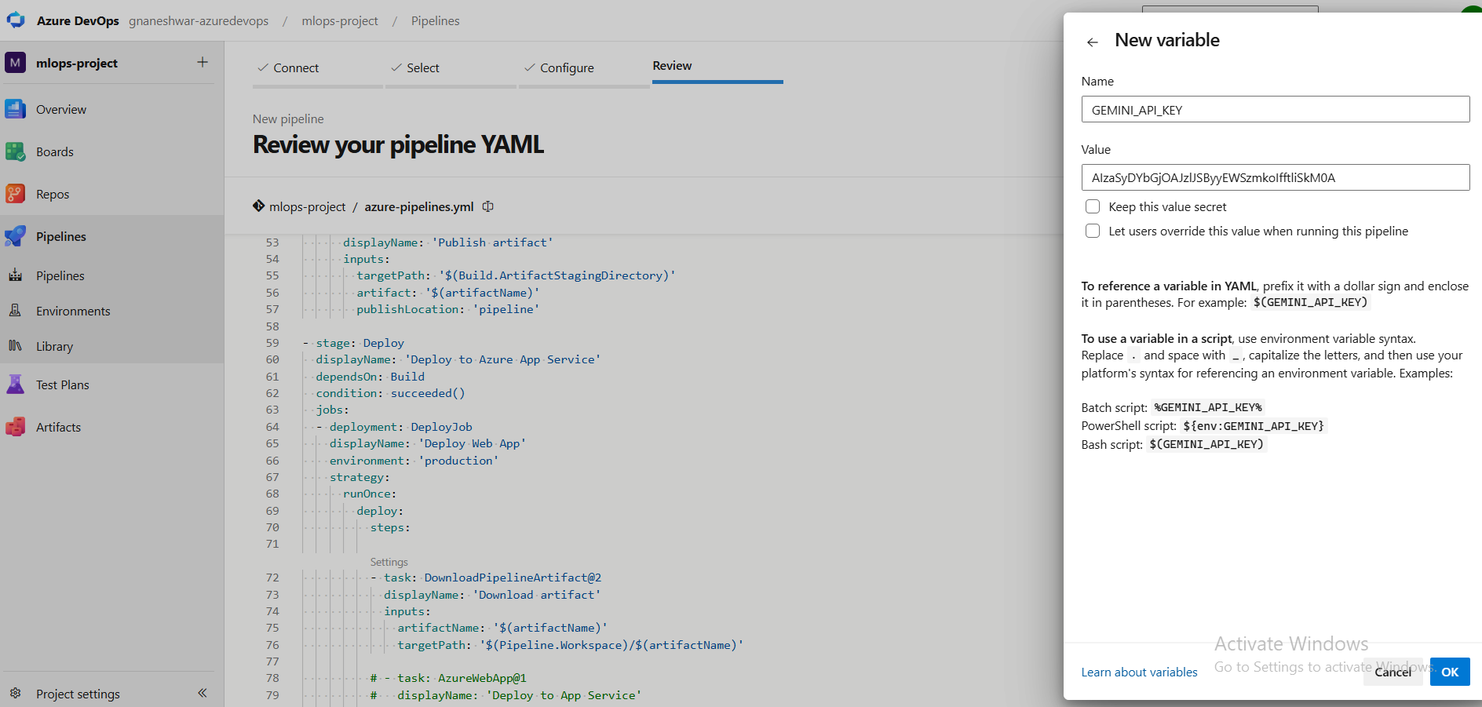
Set Pipeline Secret Variable
Create the GEMINI_API_KEY pipeline variable.

This secret variable is used to securely pass the Gemini API Key to the application during deployment.
Pipelines → your pipeline → Edit → Variables → New variable:
- Name: GEMINI_API_KEY
- Value: your Gemini API key
- Tick Keep this value secret
- Click Save
Step 6: Configure azure-pipelines.yml
The YAML file defines the CI/CD workflow.
Build Stage:
• Install Node.js
• Install dependencies
• Create deployment package (ZIP)
• Publish artifact

Deploy Stage:
• Download artifact
• Connect to Azure using Service Connection
• Deploy application to Azure App Service
https://github.com/Gnaneshwarsreepathi/mlops-project.git --> check the yaml file here

Step 7: Run the Pipeline
Execute the Azure DevOps pipeline.
The pipeline performs:
1. Build the Node.js application
2. Package the application as an artifact
3. Deploy the artifact to Azure App Service
4. Verify deployment success
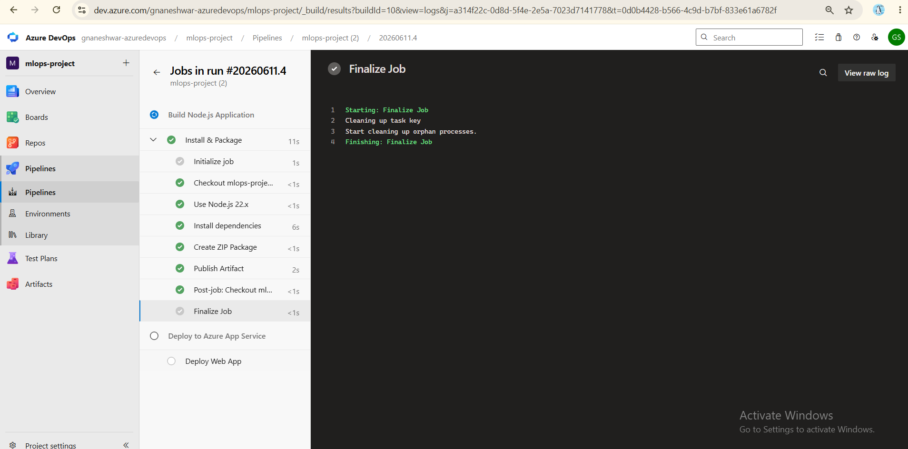

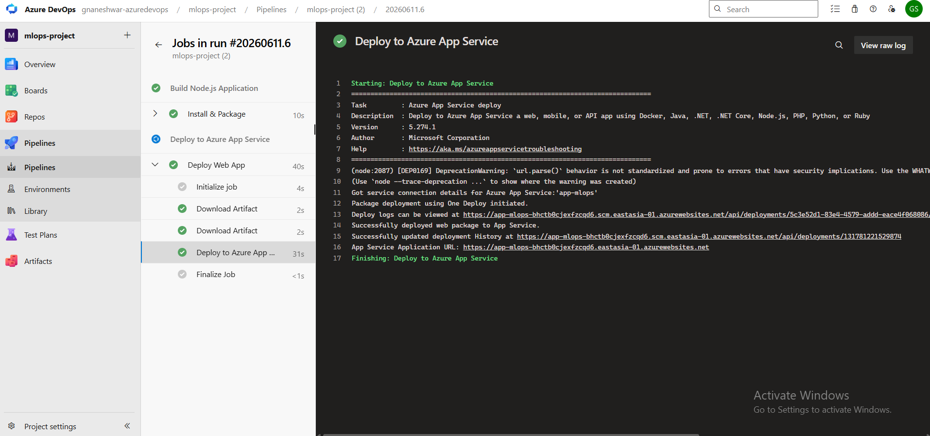

https://app-mlops-bhctb0cjexfzcqd6.eastasia-01.azurewebsites.net/
Open the deployed application URL in your browser.
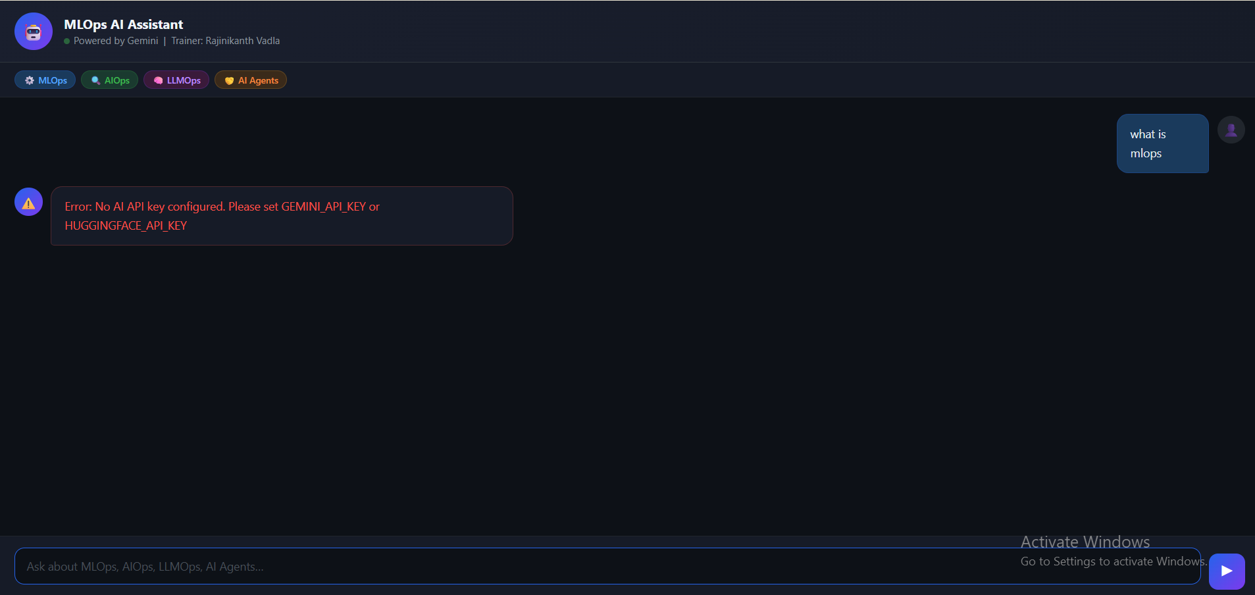

The MLOps AI Assistant is now successfully deployed and accessible through Azure App Service.
Step 8: Application Verification

The application was successfully deployed to Azure App Service and is accessible through the Azure-generated URL.

Note:
The chatbot response functionality was not working because the Gemini API Key was not configured correctly. The deployment itself was successful; however, requests to the Gemini API failed due to missing or invalid API credentials.

To resolve this:
1. Configure GEMINI_API_KEY as an Application Setting in Azure App Service.
2. Restart the App Service.
3. Verify chatbot responses.

Conclusion
In this project, an AI-powered MLOps Assistant was successfully deployed using Azure DevOps and Azure App Service.
Key achievements:
- Created Azure infrastructure resources.
- Configured Azure DevOps Service Connections.
- Implemented CI/CD using Azure Pipelines.
- Automated application build and deployment.
- Managed secrets securely using pipeline variables.
- Integrated Gemini AI into the application.
- Deployed the application to a live Azure-hosted environment.
This project provided practical hands-on experience with DevOps, Cloud Deployment, CI/CD Automation, and MLOps workflows.
Future improvements:
- Configure production-grade secret management using Azure Key Vault.
- Add automated testing stages.
- Implement monitoring and logging with Azure Application Insights.
- Containerize the application using Docker and Kubernetes.

