App Title - Work From Home Assistant

Abstract - A standalone app / pega widget that organizations can distribute among their workforce that will help employees, vendors and customers get access quickly to information regarding essential services in their locations that is authenticated, validated and updated frequently by the workforce community. This will foster a greater sense of community among the workforce and keep them motivated while reducing stress of scouting for the right information when the need arises.

Key Functionalities
- Facility Tracker
Facility Tracker is used to get details of selected facility of a location and to book available slots.
- Facility Admin
Facility Admin is used update the details(name,date,slottimings )of a facility personal of a location.
- Dashboard
Dashboard shows the view of booked slots of selected facility by the users.

Login Credentials
Username : TestUser@tcs.com
Pwd : rules

Facility Tracker
- Select or Detect - Location (City)
- Select Facility
- View Facility Details
- Book a slot

1.Select Location
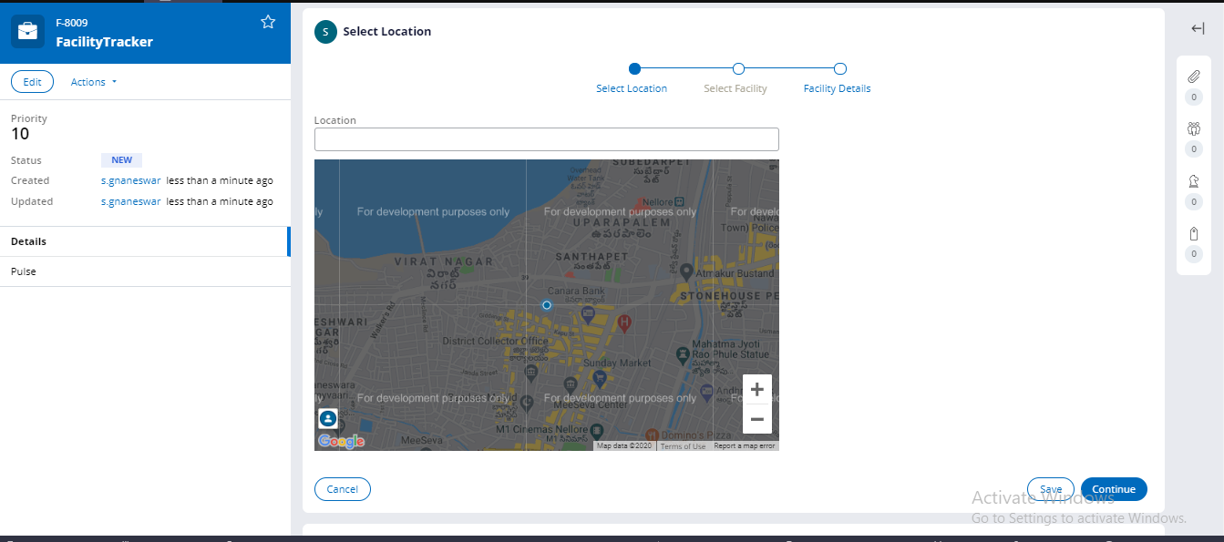

2.Select Facility
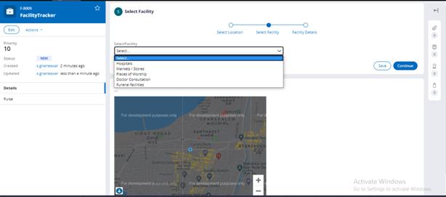
3.Facility Details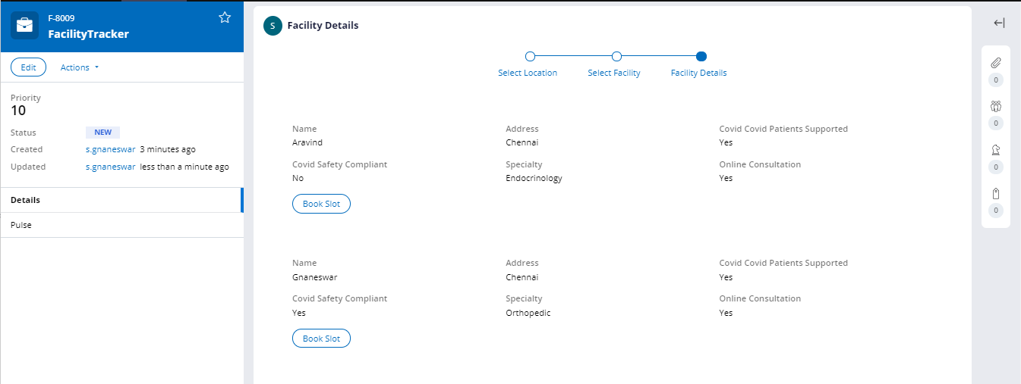
4.Available Slots
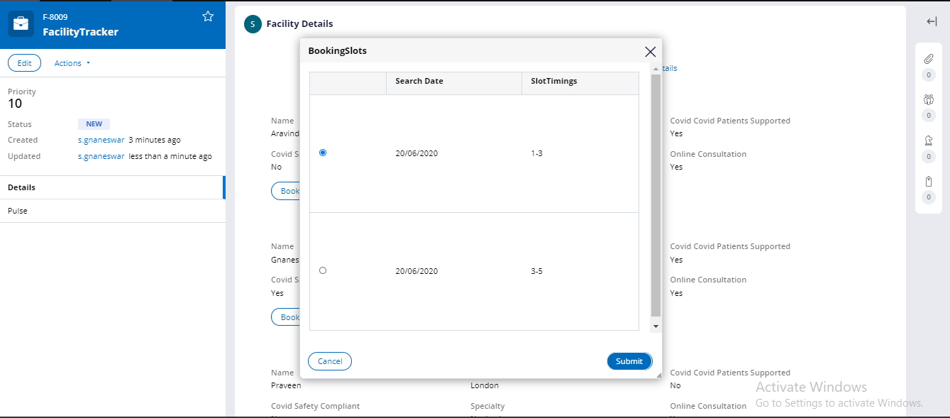

Dashboard view of Booked Slot Details
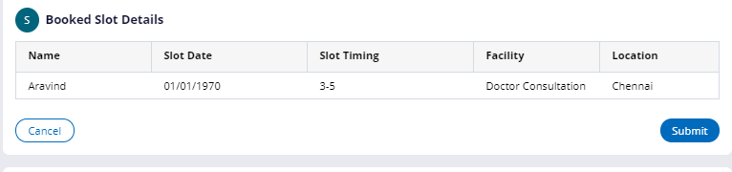

Facility Admin Portal
