Research topic: What is a “boss key”?

According to Wikipedia:

“A boss key, or boss button, is a special keyboard shortcut used in PC games or other programs to hide the program quickly, possibly displaying a special screen that appears to be a normal productivity program (such as a spreadsheet application). One of the earliest implementations was by Friendlyware,[1] a suite of entertainment and general interest programs written in BASIC and sold with the original IBM AT and XT computers from 1982 to 1985. When activated (by pressing F10), an ASCII bar graph with generic "Productivity" and "Time" labels appeared. Pressing F10 again would return to the Friendlyware application.”

As we can see in the previous quote, boss key is implemented in games so that if your boss were passing by, you can change to a work screen, like this one for instance, and get out of a possible trouble.

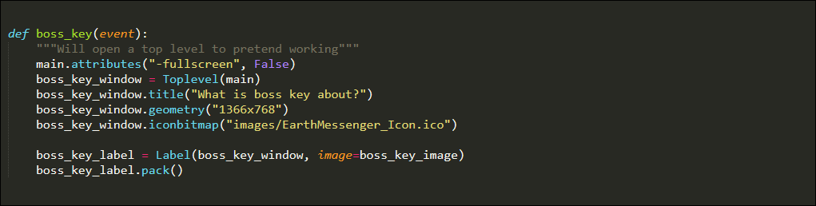Here we can go through with an example code, taking this game’s own code as example: