We need to show the deduction.

Average working hours per week and 20% of that = The Deduction = Karensdag   
Also need to show if we deducted all the hours or if there is a rest (example: average working time per day is 6,5h = Deduction = Karensdag. The slot on the sick day is 5h then there is a rest of 1,5h).

All that need to be shown.

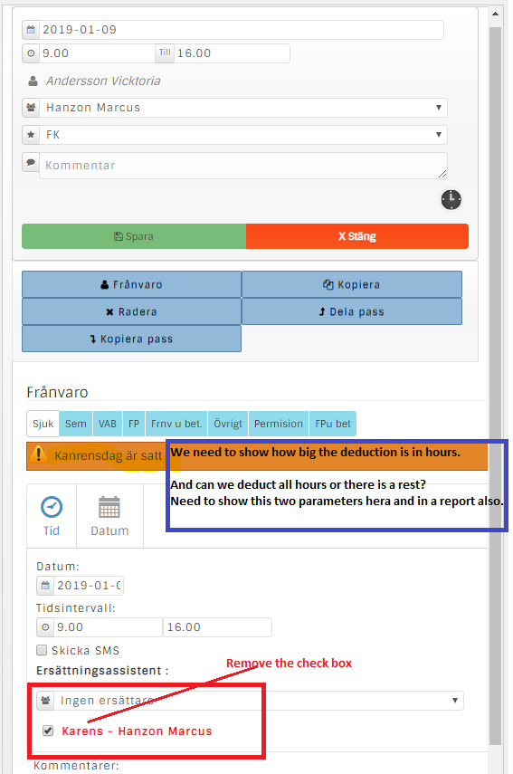

When clicking on the sick slot later on need to show the same data

