集群管理工具C3的安装和使用
- 实验目的
熟悉C3的安装和使用，学习Linux环境下的集群管理。
- C3简介
ORNL is developing user interfaces for assisting in the system management of PC clusters. C3 is a command line interface that may also be called within programs. C2G provides a Python/TK based GUI, that among other features, may invoke the C3 tools. The Cluster Command and Control (C3) tool suite was developed for use in operating the HighTORC Linux cluster at Oak Ridge National Laboratory. This suite implements a number of command line based tools that have been shown to increase system manager scalability by reducing time and effort to operate and manage the cluster.
The current release, v4.x, is multithreaded and designed to improve the scalability of the C3 suite to larger clusters. C3 v4.x also has the ability to administrate multiple clusters from the command line. The combination of the C2G interface and the C3 tools is a start to an end-to-end solution for the system administration and user administration tasks on a cluster. V4.x also has a scalable mode that greatly decreases execution time for large clusters.
简单来说，C3是一个Linux环境下能够提高系统的可扩展性管理基于命令行工具。
更多资料详见附件，或者在http://www.csm.ornl.gov/torc/c3/查看。
- 实验内容
- 所需软件
Before C3 can be installed on a system, you must ensure that the following software is installed on your system. The following software packages are required: Rsync, SSH (or OpenSSH), Python, and Perl. You must also configure that system to support host name resolution of the machines listed in the configuration file (either through DNS or /etc/hosts). Finally, if you wish to use the C3 pushimage command, which pushes system images across a cluster, you must install SystemImager.
简而言之，在C3安装前，请先确保系统中是否已经安装了Rsync,SSH (或 OpenSSH), Python和 Perl，如果没有请安装。（一般来说，操作系统都默认安装了。）

- C3安装
- 首先按照以下步骤在master上进行配置：
分别输入下列指令安装软件：
ssh master rpm -ivh /home/master/c3/c3-4.0.1-1.noarch.rpm
ssh master rpm -ivh /home/master/c3/c3-profiled-4.0.1-1.noarch.rpm
ssh master rpm -ivh /home/master/c3/c3-ckillnode-4.0.1-1.noarch.rpm
注：master为用户名，/home/master/ 为c3文件夹所在目录。
运行截图如下：
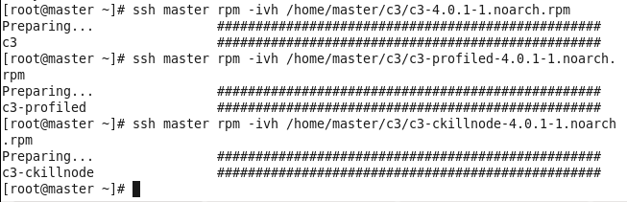
2.安装c3-4.0.1的压缩包
首先输入指令：（其中/home/c3为文件所在路径）
[root@master master]# tar zxvf /home/c3/c3-4.0.1.tar.gz
解压成功将显示压缩包下面的内容，例如：
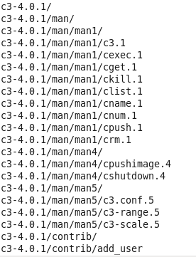
然后进入解压之后的文件夹：（其中/home/c3为文件所在路径）
[root@master master]# cd /home/c3/c3-4.0.1
输入指令进行安装：
[root@master master]# ./Install-c3
3. 编辑c3.conf文件，输入指令：
其中/etc/c3.config为文件所在路径
将如下内容写入c3.conf文件：
cluster local {
master:master #head node
master
slave[1-2] #compute nodes
}
4.按照和master类似的方法配置slave1和slave2。

（三）C3使用
1.cexec指令：A utility that executes a given command string on each node of a cluster
cexec(s) [OPTIONS] [MACHINE DEFINITIONS] command
参考信息为：
- --help –h
  - display help message
- --file -f <filename>
  - alternate cluster configuration file if one is not supplied then /etc/c3.conf will be used
- -i
  - interactive mode, ask once before executing
- --all
  - execute on all the nodes in all the clusters in the c3.conf file, note this ignores the [MACHINE_DEFINITIONS] block
- --head
  - execute command on head node, does not execute on compute nodes

主要操作为：
- 1. To simply execute a command on the default cluster
  - cexec mkdir temp
    - this creates a directory named temp in your home directory
- 2. To execute a command on a subset of nodes on the default cluster
  - cexec :2-6 ls –l
    - this executes ls with the –l option on nodes 2, 3, 4, 5, 6
- 3. Quote position is important
  - cexec ps -aux |grep root
    - will execute ps on each node, sort the output, grep out all the lines with root, and only display those lines to the screen.

cexec mkdir TEST 在当前目录中创建TEST文件夹:
cexec ls可以查看目录：
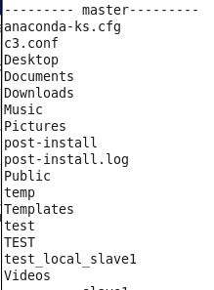
查看集群中某个节点的文件目录：cexec local:1/2 ls -l
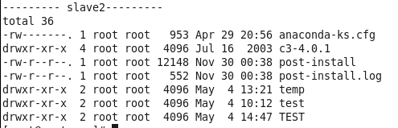
当然，cexec还可以执行其他指令，如：cexec local:0 touch push.txt
即在local中的0节点建立push.txt文件。
通过 cexec loacl:0 ls查看
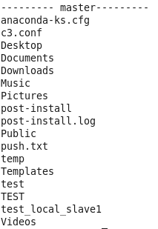
2.cpush指令：A utility to push files from the local machine to the nodes in your cluster
cpush [OPTIONS] [MACHINE DEFINITIONS] source [target]
参考信息有：
- --help –h
- --file -f <filename>
- -i
- --all
- --head
- -l, --list <filename>
  - list of files to push
- --nolocal
  - the source file or directory lies on the head node of the remote cluster
- --blind –b
  - pushes the entire file (normally cpush uses rsync to push changes and then rebuilds the file on the target node)
主要操作为：
- 1. To move a single file
  - cpush /home/filename /home/
- 2. To move a single file, renaming that file on the cluster node
  - cpush /home/filename1 /home/filename2
- 3. To move a set of files listed in a file
  - cpush --list=/home/filelist
    - The file list is a single file per line
    - the first column being the source
    - the second being the target
    - if no target is specified it is assumed to be the same as the source.
在PUSH文件夹下面建立PUSH.txt文件
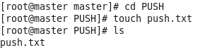
然后用cpush /PUSH/push.txt /TPUSH/ 移除
3.cget指令：A utility that retrieves a specified file from each node of a cluster and places it into the specified target directory
cget [OPTIONS] [MACHINE DEFINITIONS] source [target]
- 1. To retrieve a file from the default cluster
  - cget /tmp/file1
- 2. To retrieve a file from a subset of nodes on the default cluster
    - cget :2-6 /tmp/output /home/user1/data/
- 3. To retrieve a file from a list of clusters
    - cget cluster1: cluster2: /tmp/output
4.crm指令：A utility that deletes files from each cluster node
crm [OPTIONS] [MACHINE DEFINITIONS] pattern
参考信息为：
- --help –h
- --file -f <filename>
- -i
- --all
- --head
- -r -R
  - recursive delete
- -v
  - verbose mode
- -o
  - force delete (equivalent to -f in rm)
主要操作为：
- 1. To remove a single file from the default cluster
  - crm filename
- 2. To remove several files on multiple clusters
  - crm cluster2:2-6 cluster3: '*.obj'
    - this removes *.obj from all of cluster3 an nodes 2, 3, 4, 5, and 6 from cluster 2
5. cshutdown指令：A utility that runs shutdown on each cluster node
cshutdown [OPTIONS] [MACHINE DEFINITIONS] t time [warning-message]
参考信息为：
- --help –h
- --file -f <filename>
- -i
- --all
- --head
- -t sec
  - Tell init(8) to wait sec seconds between sending processes the warning and the kill signal, before changing to another runlevel.
- -k
  - Don't really shutdown; only send the warning messages to everybody.
- -r
  - reboot after shutdown.
- -H
  - Halt after shutdown.
- -a
  - Use /etc/shutdown.allow.
- -sF
  - Skip fsck on reboot.
- -F
  - Force fsck on reboot.
- -c
  - Cancel an already running shutdown.
- --onreboot
  - reboot to specified lilo label

主要操作为：
- 1. To shutdown the default cluster:
  - cshutdown -t 0
    - Shutsdown the nodes immediately
- 2. to reboot the cluster to another lilo label
  - cshutdown --onreboot w2k 0 rebooting to windows 2000 now!
    - This command tells to reboot to windows 2000
- 3. To shutdown several clusters
  - cshutdown -k cluster1: cluster2: -t 5 system going down for updates
    - This will tell shutdown to send the following message but not really shutdown
6.cname指令：
A utility that returns the node names specified by the range specified on the command line
cname [OPTIONS] [MACHINE DEFINITIONS]
参考信息为:
- --help –h
- --file -f <filename>
- --all
主要操作为：
- 1. To search the default cluster:
  - cname :0-5
    - This prints the node names one per line
- 2. To search specific clusters
  - cname cluster1: cluster2:4-8
    - This prints the node names on per line
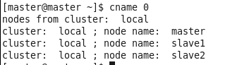
7.cnum指令：
A utility that returns a node index from the given cluster(s) and a name
cnum [OPTIONS] [MACHINE DEFINITIONS] node_name1 [node_name2 node_name3...]
参考信息为：
- --help –h
- --file -f <filename>
- --all
主要操作为：
- 1. To search the default cluster:
  - cnum node2
    - This returns the node name and it's index
- 2. To to search any cluster in the configuration file
  - cnum cluster1: cluster2: node3
    - This returns the node name and it's index for each cluster in the list
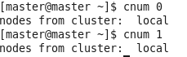
- 问题汇总
- C3安装问题参考: http://www.csm.ornl.gov/torc/C3/;
- C3功能详细介绍: http://www.csm.ornl.gov/torc/C3/C3softwarepage.shtml。

