WHITE PAPER
Evolving Small-Lab AI Agent Architecture
From Tightly Coupled Orchestration to Isolated, Ephemeral, and Scalable Design
October 2026

Abstract
This white paper describes the current and proposed future architecture for a small-lab AI agent system. The current design uses a compact Orchestrator–Planner–Coder/Reviewer loop running across a Server and Worker Node. The future design introduces virtual machine isolation, multi-server deployment, a clear front-end boundary, and ephemeral task containers. The intent is to improve security, scalability, maintainability, and operational cleanliness while preserving OpenWebUI as the primary user interface.

Purpose and Intent
The architecture exists to support reliable, iterative AI agent workflows inside a small laboratory environment. Agents must plan work, write or modify code, review results, and return coherent responses through a familiar chat interface (OpenWebUI).
The current setup proved sufficient for initial experimentation. As the lab’s needs grow—more concurrent tasks, stronger isolation between experiments, easier recovery from failures, and cleaner separation of management from execution—the tightly coupled design becomes a constraint. The future architecture is intentionally designed to address these limitations without abandoning the core agent roles that already work.
Core design intent:
- Keep the user experience simple and stable (OpenWebUI remains the front door).
- Isolate orchestration, planning, and task execution so failures stay local.
- Replace long-lived worker processes with short-lived, clean containers.
- Allow the system to grow across multiple servers while remaining manageable by a small team.
- Preserve the useful Coder–Reviewer loop concept while making its execution disposable and parallelizable.

Current Architecture
The present system consists of two main nodes:

Server
- OpenWebUI provides the chat interface.
- “Oh my pi Harness” sits between the UI and the agent layer.
- The Orchestrator Agent receives user intent, produces a Plan, and later receives the Response.

Worker Node
- OMP and the Planner Agent interpret the Plan.
- A Task Loop runs a Coder and a Reviewer that iterate until the work is acceptable, then return a Response to the Orchestrator.
This design is simple, low-overhead, and effective for single or low-concurrency experiments. Its main limitations are tight coupling, a persistent worker that can accumulate state, limited isolation, and a single point of contention for execution.

Architecture Diagram
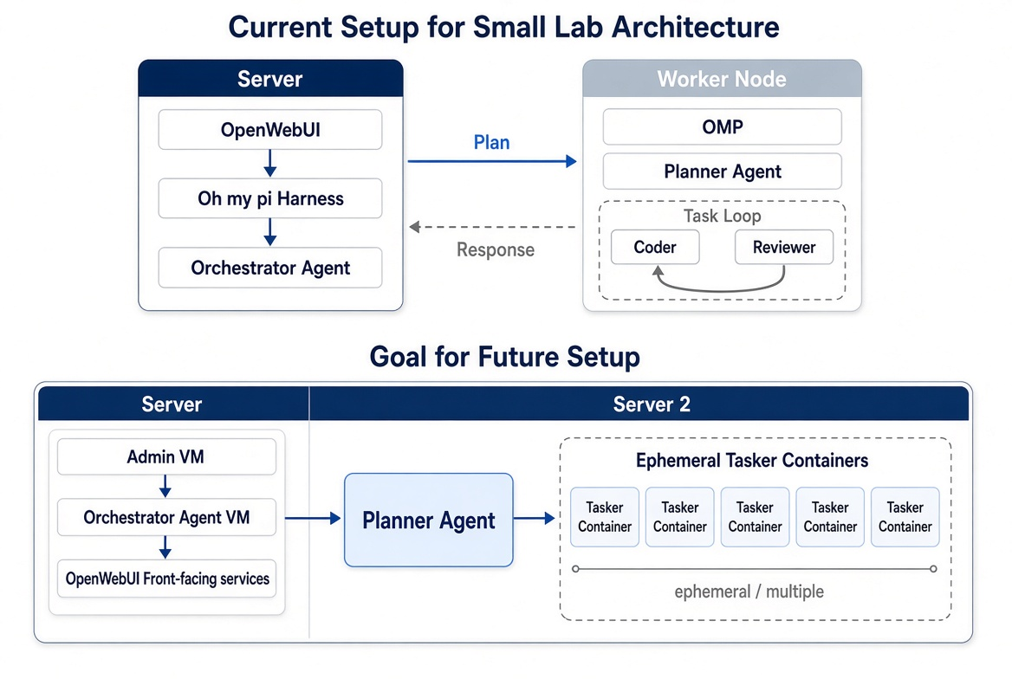
Figure 1: Professional diagram of the current small-lab setup (top) and proposed future setup (bottom).

Future Architecture
The target design introduces clearer boundaries, virtualization, and ephemeral execution while retaining the same high-level agent roles.

Key Components
- OpenWebUI remains the front-facing service, now more clearly separated.
- An Orchestrator agent VM handles high-level coordination.
- An Admin VM provides a dedicated management surface.
- A Planner agent receives work from the Orchestrator and decides how to execute it.
- Ephemeral Tasker containers are launched on demand to perform the actual Coder/Reviewer (or equivalent) work and then disappear.
Multiple physical or virtual servers (labeled Server and Server 2 in the diagram) host these VMs and containers. Communication paths remain explicit so each layer can be observed, restarted, or replaced independently.

Benefits of the Future Design

Isolation and Security
VMs separate administrative, orchestration, and front-end concerns. A compromised or misbehaving task container has a much smaller blast radius than a long-lived worker process sharing the same environment as the Orchestrator.

Ephemeral Execution
Containers start from a known clean state, perform their work, and are destroyed. This eliminates state drift, simplifies cleanup, and makes it natural to run many tasks in parallel.

Scalability and Resource Efficiency
Work can be distributed across servers. Resources are consumed only while tasks are running. The persistent Worker Node bottleneck of the current design is removed.

Maintainability and Resilience
Individual VMs or containers can be restarted or upgraded without taking the entire system offline. The Admin VM gives operators a stable control plane.

Separation of Concerns
Each major function—user interface, orchestration, planning, and task execution—has a clearer home. This makes the system easier to understand, debug, and evolve as the lab’s experiments change.

Design Principles and Intent
The future architecture is guided by a few deliberate principles:
- Minimal change to the user-facing experience.
- Stronger boundaries where state and failure matter most.
- Disposable execution environments for agent loops.
- Incremental path from the working current system rather than a full rewrite.
- Operational simplicity for a small lab team that must also perform research.

Conclusion
The current architecture successfully demonstrated a functional Orchestrator–Planner–Coder/Reviewer pattern behind OpenWebUI. The future architecture keeps that pattern while introducing the isolation, ephemerality, and multi-server structure needed for a more robust and scalable lab environment.
The intent is practical: give the lab a system that remains easy to use for experimentation, yet is safer, cleaner, and able to grow without constant manual cleanup or fear of one task affecting everything else. The diagram’s move from a single Worker Node to Orchestrator/Planner VMs plus Ephemeral Tasker containers is the concrete expression of that intent.
— End of White Paper —

