Please run the create.sql script located at the root folder of the project to create the database. The data will load to the database when the app runs for the first time.

There is 3 menu item on the left. Sample, New Form, and Client Side.

Sample (Default Home Page)

New Form: Submit new sample

Client Side: filter client data with barcode

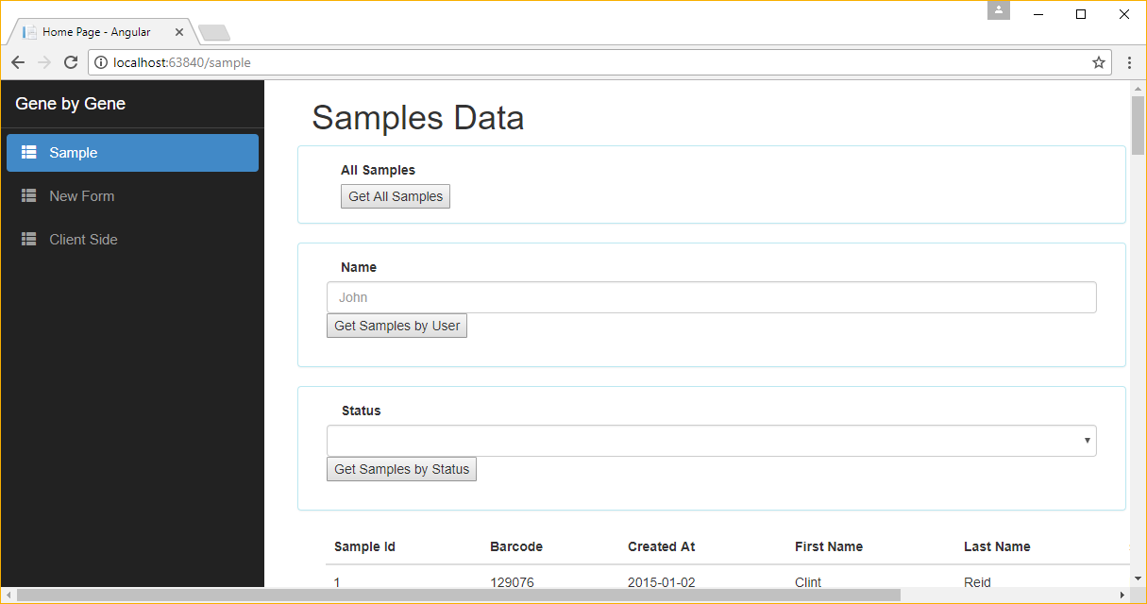

Default Home page is set to Samples

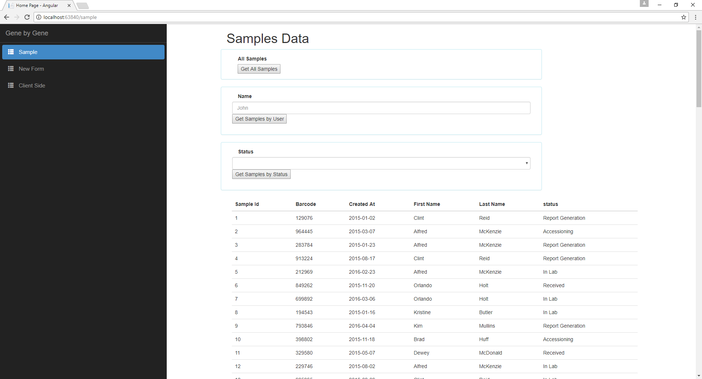

Default is to load all the data.

Three buttons on the page perform different operations. Each action will contact the WebAPI for data.

1. Get All Samples: Output all samples, their status, and the name of the user that created them
2. Get Samples by User: Enter a string in the name text box to search for either first name or last name
3. Get Samples by Status: Output all samples with a given status from the drop down control

New Sample Form:

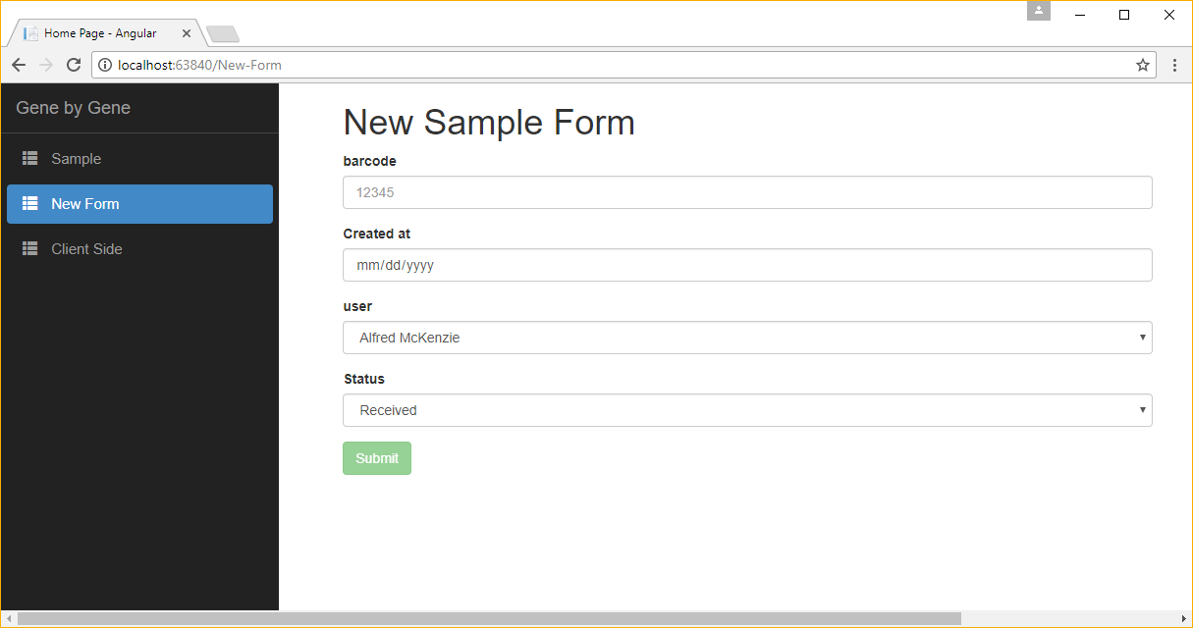

Create a new sample with associated status and user.

Barcode is required with a minimum 1 character up to maximum of 50 characters.

Created At is default to current date if not selected

Client-Side

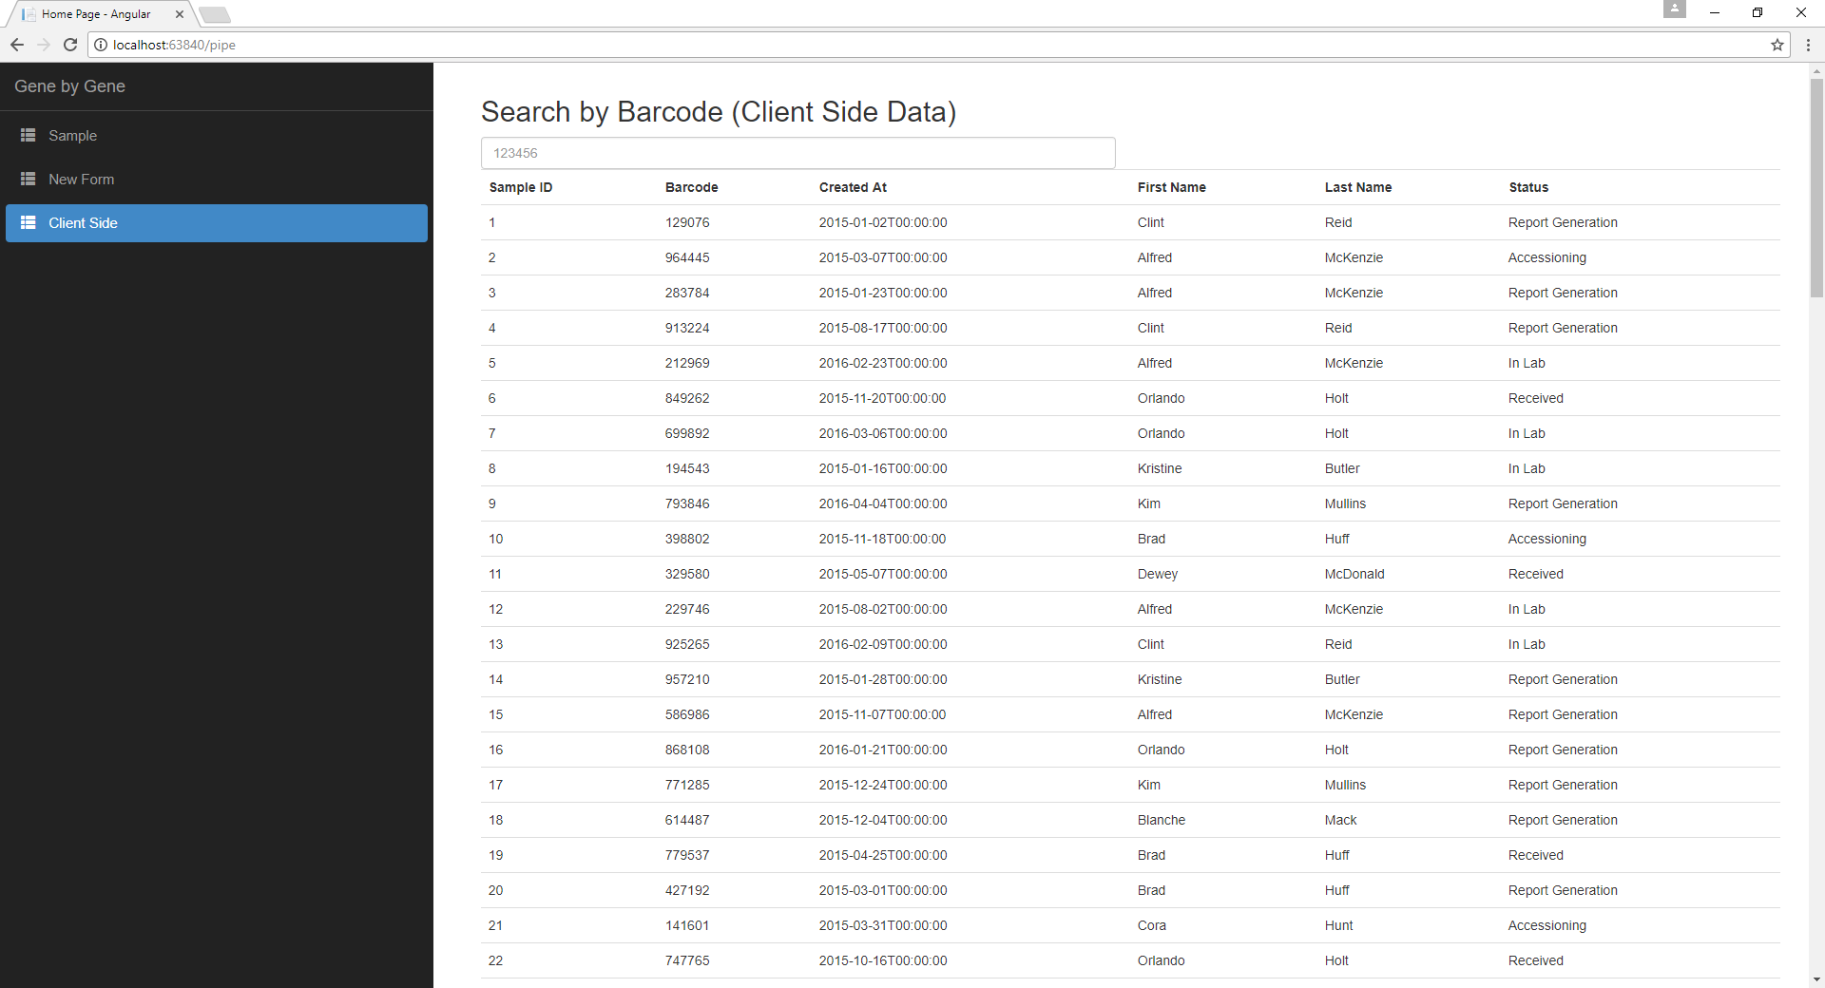

The data is loaded to the client-side once.

Enter any number to filter client-side results returned by the Web API.