Work Weekly Summary

(WK19 2018/5/14-2018/5/18)

By Colin

* Finished Event

1. Event 1：LNW NZ3182

* Detail:

1. Prober Card fatal, on Repairing
2. OI Verify End

* Leftover Things:

1. Production Correlation of NZ3182
2. Multi-duts’ prober card Design
3. Event 1：Able G6037

* Detail

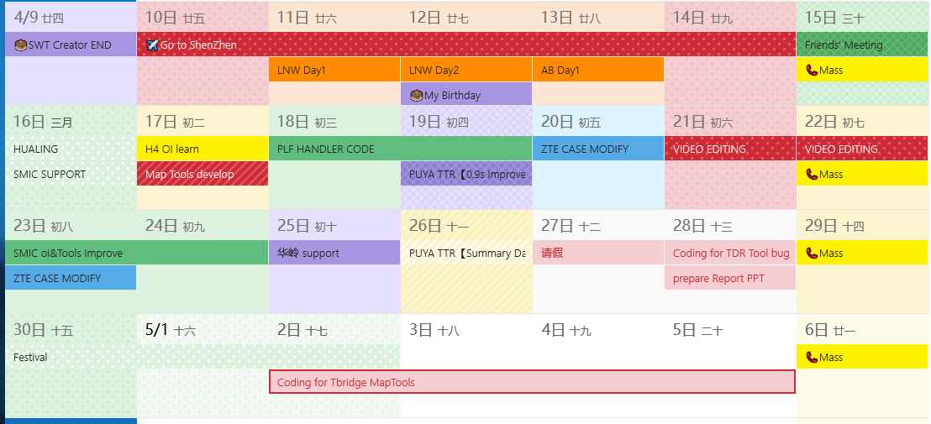

* Plan of Next Week

1. BYD support
2. ABLE support
3. LNW support

* Required Support

1. None