**Autonomous Intelligent Systems**

**„Programming Red Pitaya“**

**Wireless Configuration**

**Created by**

Daniel Schäfer

Inhaltsverzeichnis

1. Goals 3

2. Concept 3

3. Steps of configuration 5

# Goals

The Demo-mode, provided by the latest software (V0.21), is able to establish a connection to the GUI by using a unique sensor number. In this context, the GUI is able to separate the information via UDP into two sources. One source represents a sensor, which is installed to detect a low-level positioned person or a part of a person. The second source represents a higher positioned sensor to detect an object or a human. Both sensors deliver their classification results to the GUI, and the GUI is able to show logical information about the detected small/large object/human.

# Concept

A short drawing of the concept is shown in Figure 1. Two sensors are positioned in different heights to sense whether a human or an object is placed in front. The information of both sensors combined will be used to show an easy to understand display information with coloured background for better visual recognition.

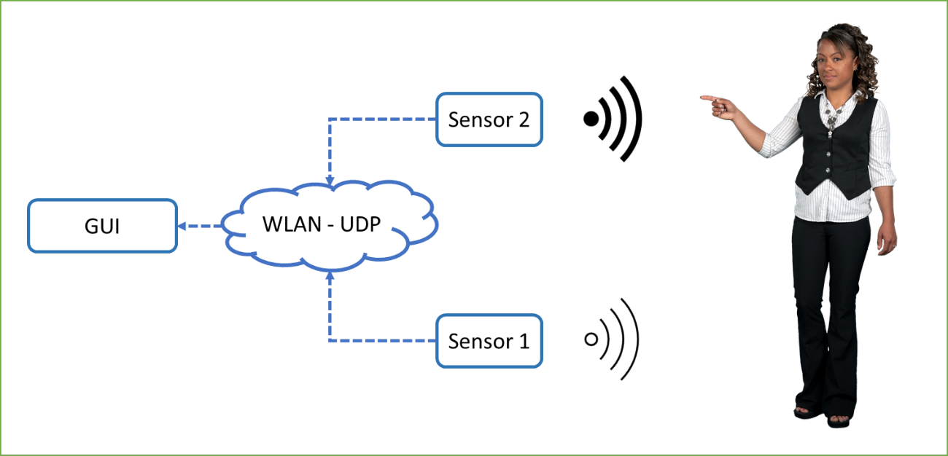

Figure 1 Rough concept of object detection

With a successfully configured RedPitaya-System, the following logic is realized by the GUI, described in Figure 2.

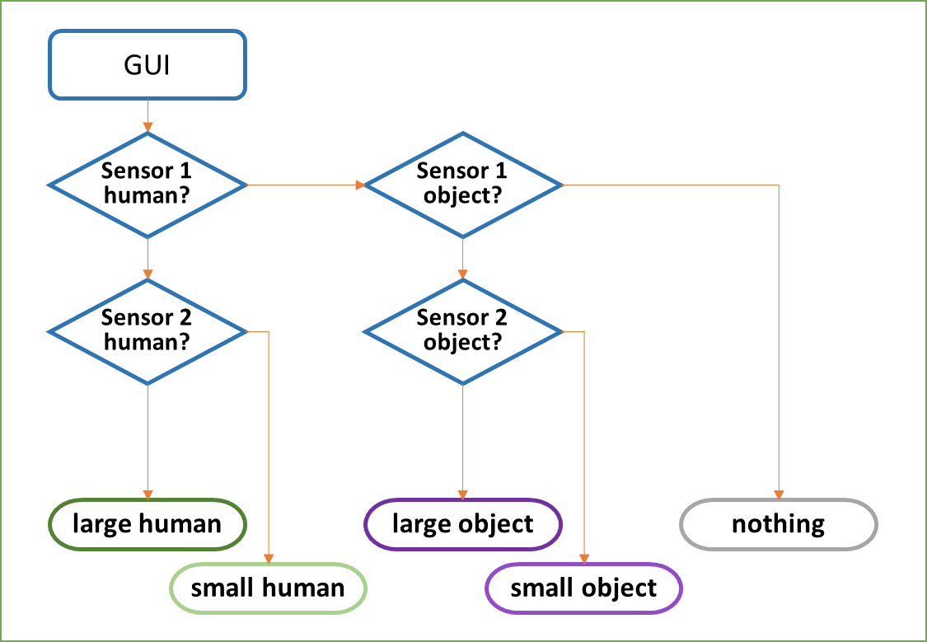

Figure 2 Logic of GUI

All logic depends on sensor 1 in first lane. If sensor 1 does not detect anything, nothing is detected, independent from the result of sensor 2. That intents, that no object will be placed ONLY at the top of the seat. It has to reach from bottom to a defined height. Only if both sensors detect identical object classes, the object is classified as large human or a hard object. That logic intents, that no object can be half human and half hard object. It has to be whether a hard object or a human.

# Steps of configuration

Every sensor has its own access-point to which one logical unit has to connect to. With the background, that very IP-Address must be unique, it is obvious, that both access-points have to provide a different address-range. That leads to one configuration step, that has to be realized before starting-up both sensors including the GUI.

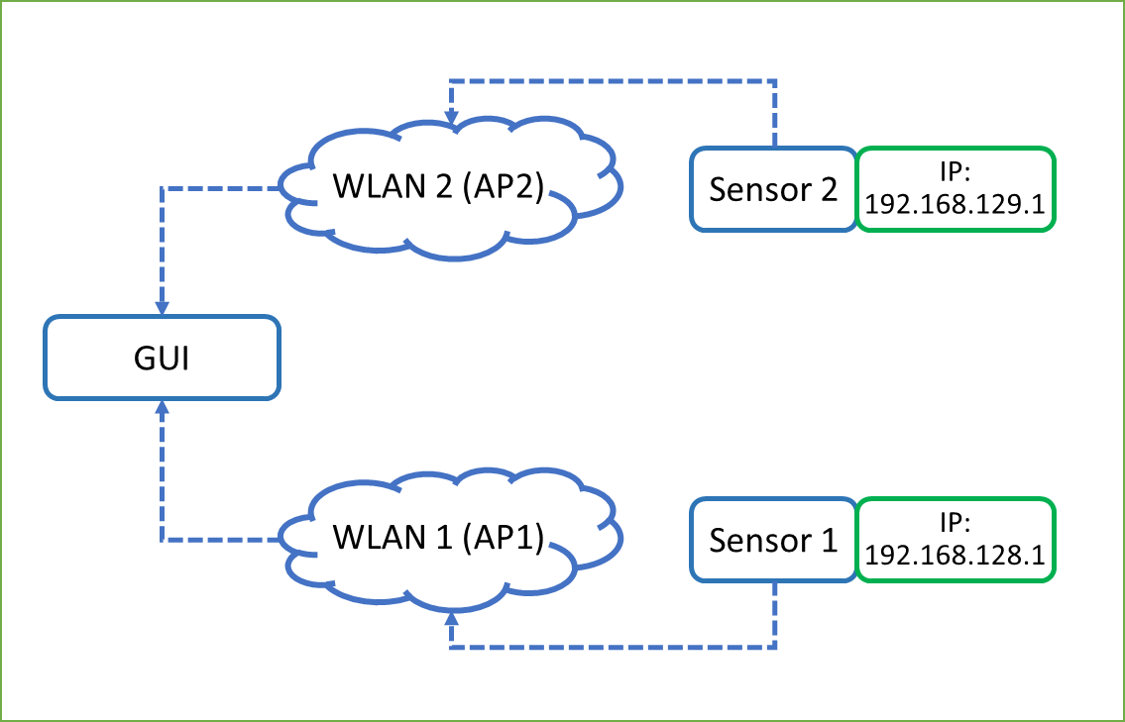

Figure 3 Final configuration of both sensors

Figure 3 shows the optimum configuration. Those steps have to be done:

1. The PC has to be connected to one access point (ONLY one)
2. A connection to RP has to be established via WinSCP
3. Two files have to be changed:
   1. In the file “/etc/network/interfaces.d/wlan0.ap”, the local ip-address has to be changed from **192.168.128.1** to **192.168.129.1**
   2. In the file “/etc/dhcp/dhcpd.conf” all 128 has to be changed to 129
   3. The WinSCP connection can be closed
4. A new connection via SSH has to be established and the command “reboot” hast to be entered.
5. After a successful restart, the access-point has to be entered again (should be done automatically by windows) a “new” IP-address should be received by the RP in the range of **192.168.129.X**, where **X** has to be between 2 and 255.
6. Now the second sensor and the GUI can be started up. In the GUI both sensors can be checked with pushing the button “check sensor connection”
7. If both sensors are active, all configurations are successfully set.