Mobile Application Development Page 1 of 4
Lab Exercise 5
Topic: Android Persistence
As a general guide, you should attempt those exercises by yourself to enhance your mobile app development skills. Only seek help if you cannot resolve the issue. You could use some hours outside normal classes to finish your practice.
1. Implement the Database example from the lecture slides. Using Lecture5 - Android Persistence-SQLite.pptx
2. Change the design of DetailsActivity by using RecyclerView instead of TextView as described in the lecture slides.
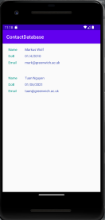
Hints to populate data into RecyclerView:
I. Create resource layout item_person.xml with details like below
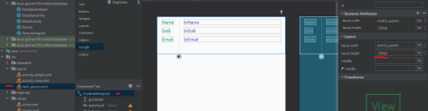Tuan Nguyen
Mobile Application Development Page 2 of 4
II. Create inner class PersonViewHolder of the PersonAdapter class (later on) 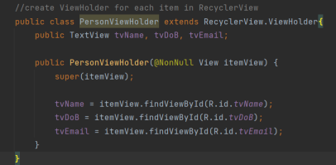III. Create PersonAdapter class which contains class PersonViewHolder as well 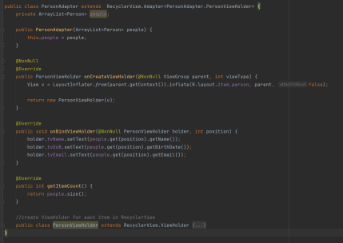IV. Modify DatabaseHelper class to add getDetails() function
Tuan Nguyen
Mobile Application Development Page 3 of 4 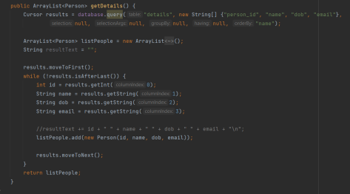V. Modify class DetailsActivity to populate data into RecyclerView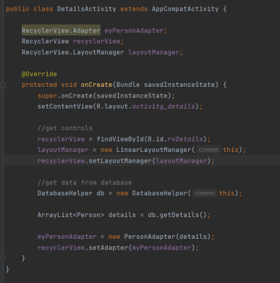Tuan Nguyen
Mobile Application Development Page 4 of 4
3. Amend the ContactDatabase implementation to include a second table called skills and allow the user to input two skills per person which should be stored in the second table.
4. Implement the Preferences example from the lecture slides. Use Lecture5 - Android Persistence - Shared Preferences.pptx
5. Implement the File example from the lecture slides.
Use Lecture5 - Android Persistence - Files.pptx
Tuan Nguyen

