Title: Refining Near-Infrared Spectroscopy for Collagen Quantification: A New Predictive Model for Archaeological Bone

Materials and Methods

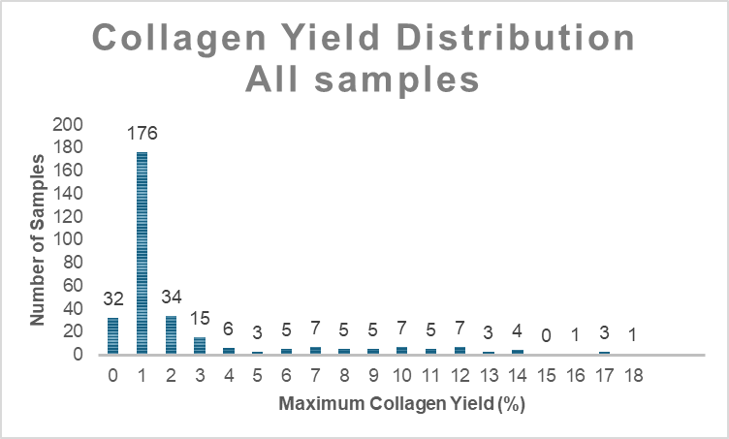
Figure S1. Distribution of known collagen samples in the NIR library. The collagen preservation of the 319 samples ranges from 0% to 17.2% weight collagen.
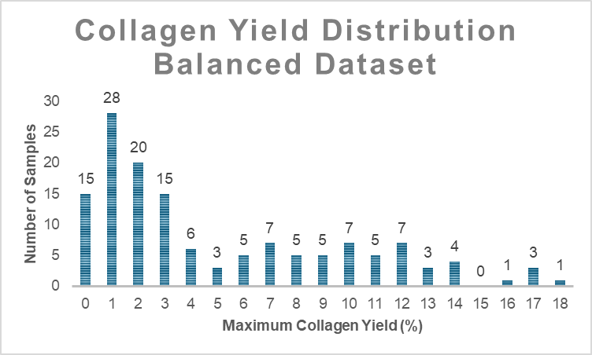
Figure S2. The collagen distribution of the reference samples included in the model development. The dataset comprises 140 known collagen samples, ranging from 0% to 17.2% of collagen.
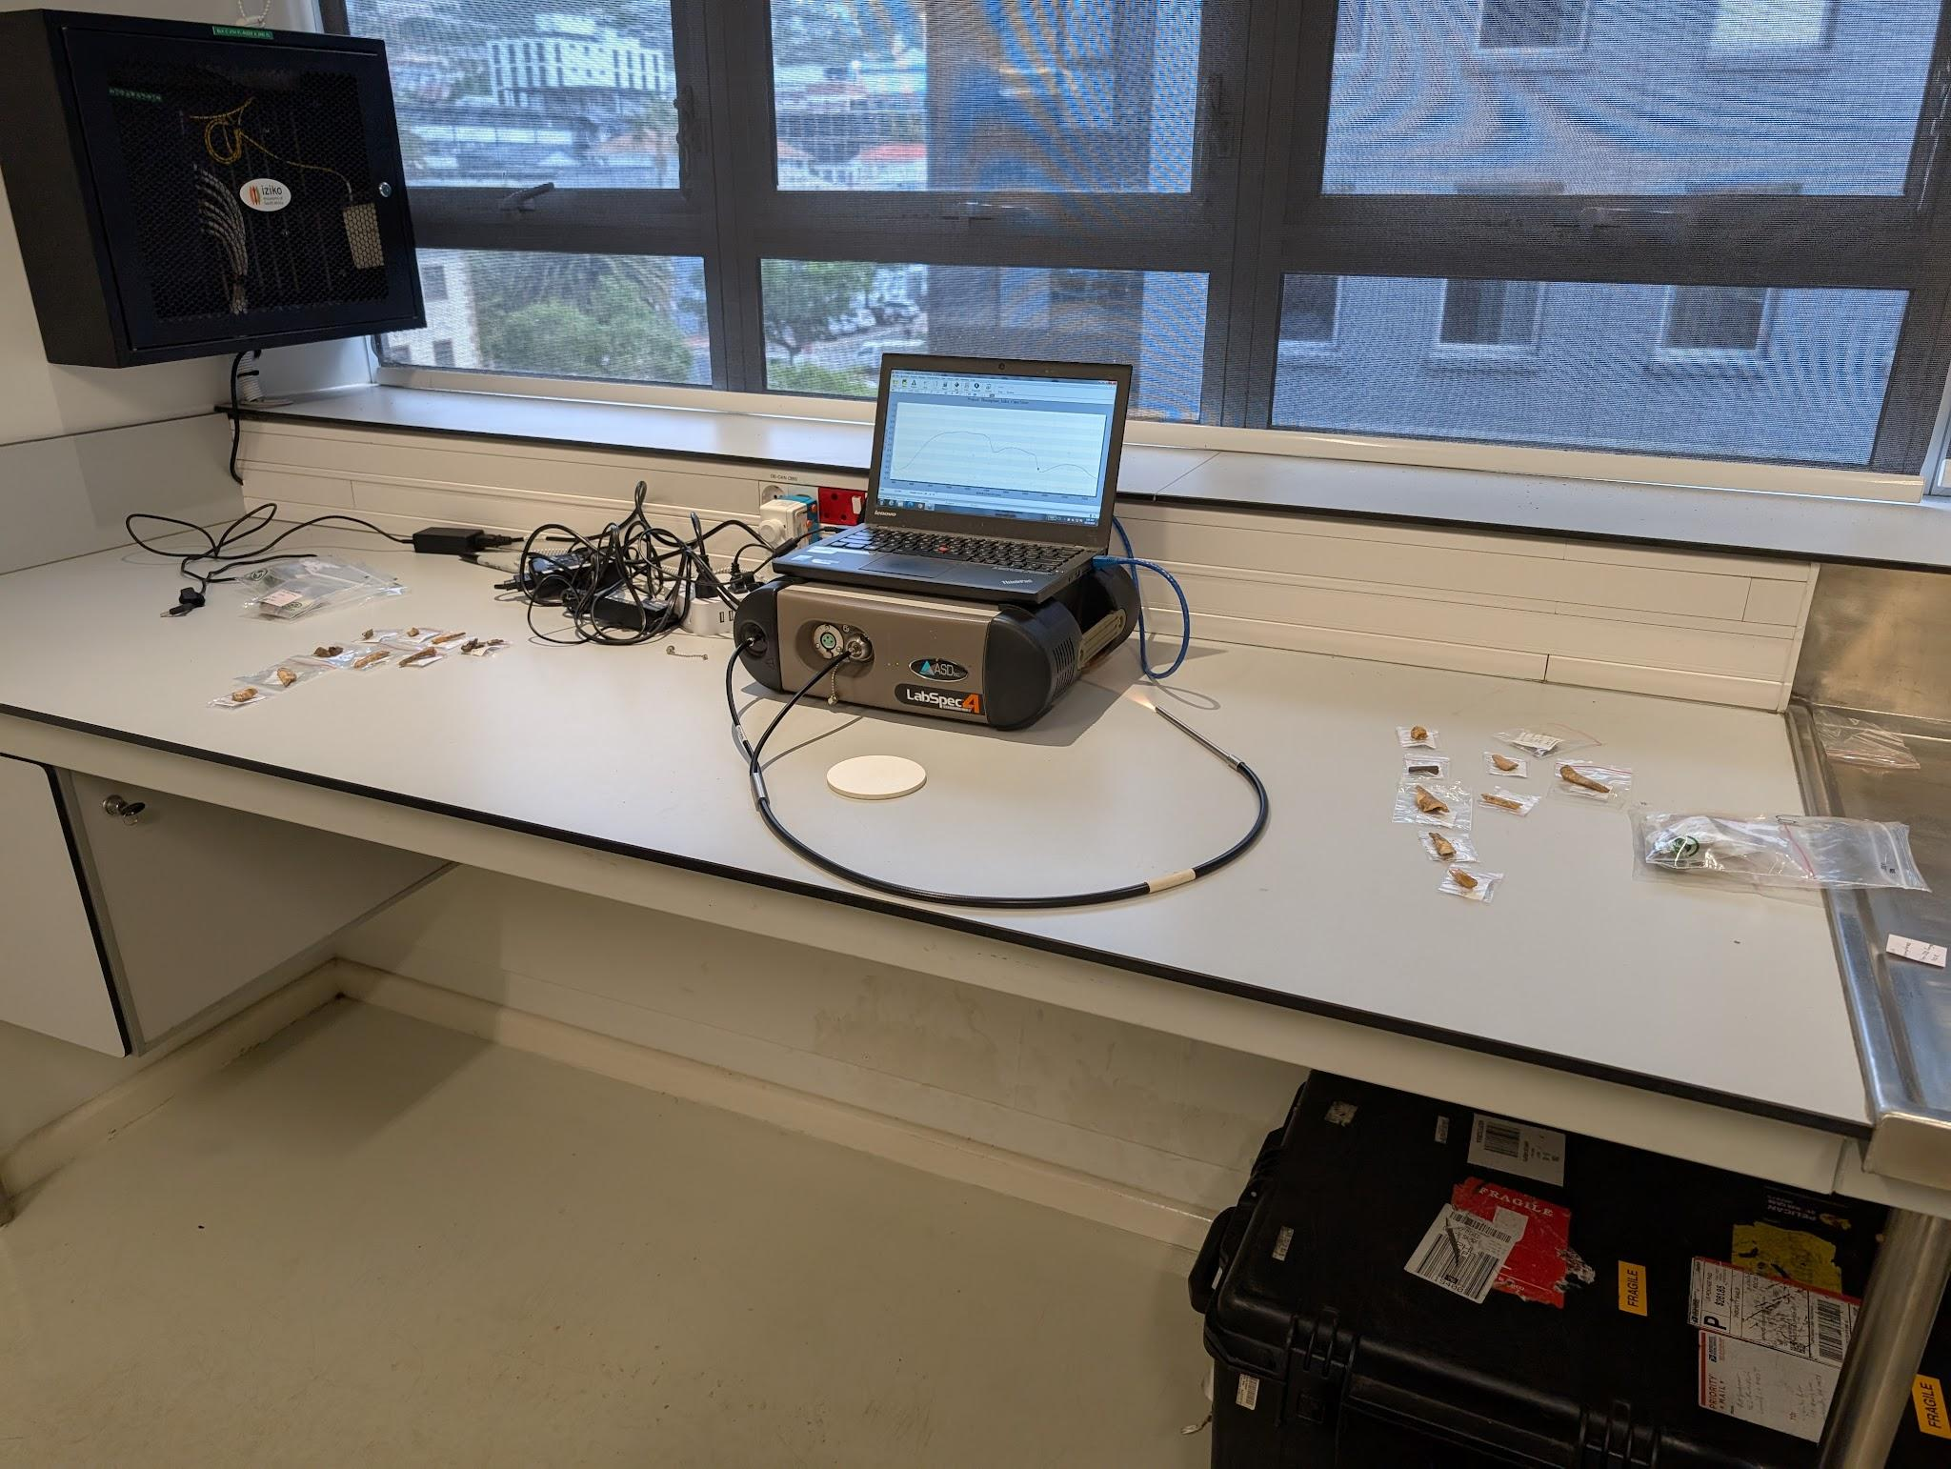
Figure S3. ASD LabSpec 4 Standard Resolution spectrometer (Malvern Panalytical), a portable, field-ready device weighing 5.44 kg (12 lbs), fitted with a fiber-optic probe used for NIR spectra collection.

Collagen Extraction Techniques
All bone samples underwent an acid-base-acid (ABA) collagen extraction protocol to prepare for radiocarbon dating, with samples processed at the Oxford Radiocarbon Accelerator Unit (ORAU) and the Max Planck Institute for Evolutionary Anthropology in Leipzig (MPI) (Table 2). At the ORAU, collagen extraction began with 0.5 to 0.7 grams of coarse crushed or powdered bone; however, up to 1 gram was used if the sample was suspected to be poorly preserved. Decalcification began with the ABA treatment performed at room temperature, using 0.5 M HCl to remove carbonates and 0.1 M NaOH to remove humic acids and other organic contaminants. Between each reagent step, samples were thoroughly rinsed with ultrapure water. Gelatinization then occurred at pH 3 for 20 hours at 75 °C, and the resulting gelatin underwent filtration with a precleaned EZee filter (Elkay Laboratory Products Ltd., UK) to remove large particles. The product was then ultrafiltered with a precleaned Vivaspin™ 15–30 kD MWCO and centrifuged until 0.5 to 1.0 mL of the >30 kD gelatin fraction remained to enhance the purity of the final product. Finally, the >30 kD gelatin was washed with ultrapure water and freeze-dried. The freeze-dried gelatin was weighed, and the value was used to determine the total collagen yield. For a complete description of ORAU’s collagen sampling and pretreatment protocols, see (Brock et al., 2010).
At the Max Planck Institute for Evolutionary Anthropology in Leipzig, the ABA collagen extraction protocol began with decalcifying 0.5 grams of whole bone in 0.5M HCl at 5 °C; the solution was refreshed until no effervescence was observed. Humics and other organic contaminants were removed with a 0.1 M NaOH solution at room temperature for 30 minutes. Finally, decalcification was completed with a 0.5 M HCl step to remove additional carbonates. Gelatinization proceeded at pH 3 for 20 hours at 75 °C, and the resulting gelatin underwent filtration via precleaned EZee filters and ultrafiltration via precleaned Vivaspin™ 15–30 kD MWCO. The final gelatin product was freeze-dried for 48 hours, and then total collagen yields were calculated. The sampling and pretreatment methods were modifications of Method C, detailed in (Talamo and Richards, 2011).

Results

PLSR Calibration and Validation
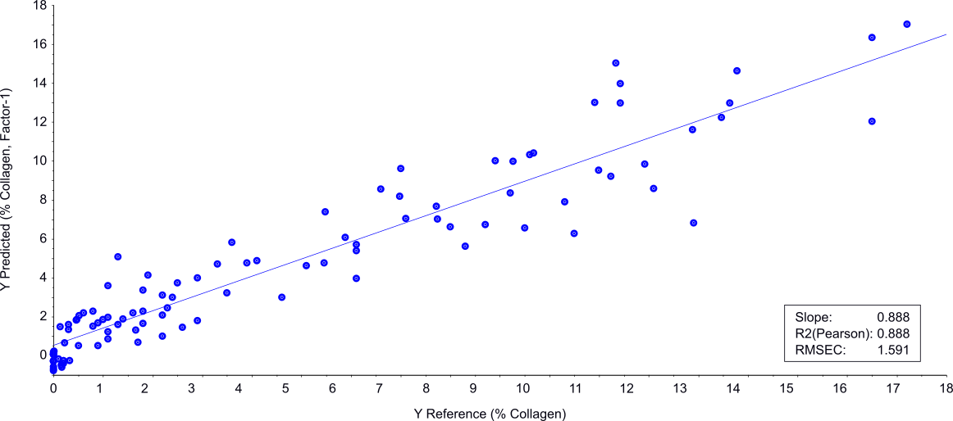
Figure S4. Calibration PSLR predictions. The preferred 2045 nm PLSR results show predicted collagen yields versus actual collagen yields for 100 calibration samples. The model predicts collagen content well (R² = 0.89, RMSEC = 1.59)
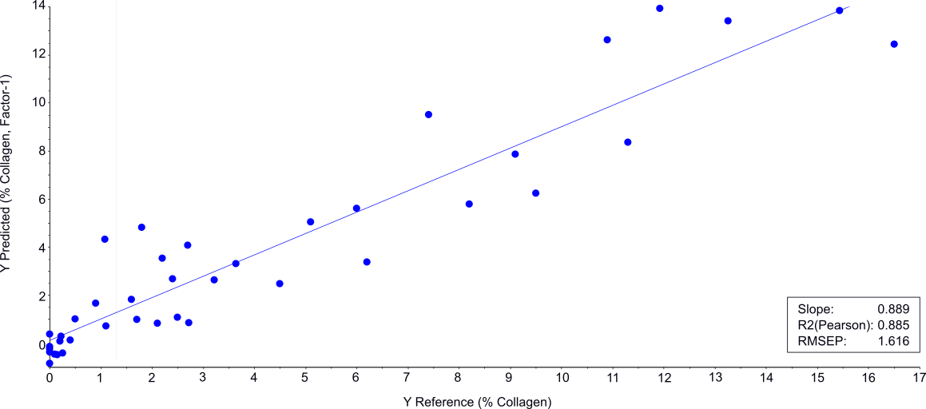
Figure S5. Validation of PLSR predictions. The preferred 2045 nm PLSR results show predicted collagen yields versus actual collagen yields for 40 validation samples. The model predicts collagen content well (R² = 0.89, RMSEC = 1.62)

Machine Learning Calibration and Validation

780-2500

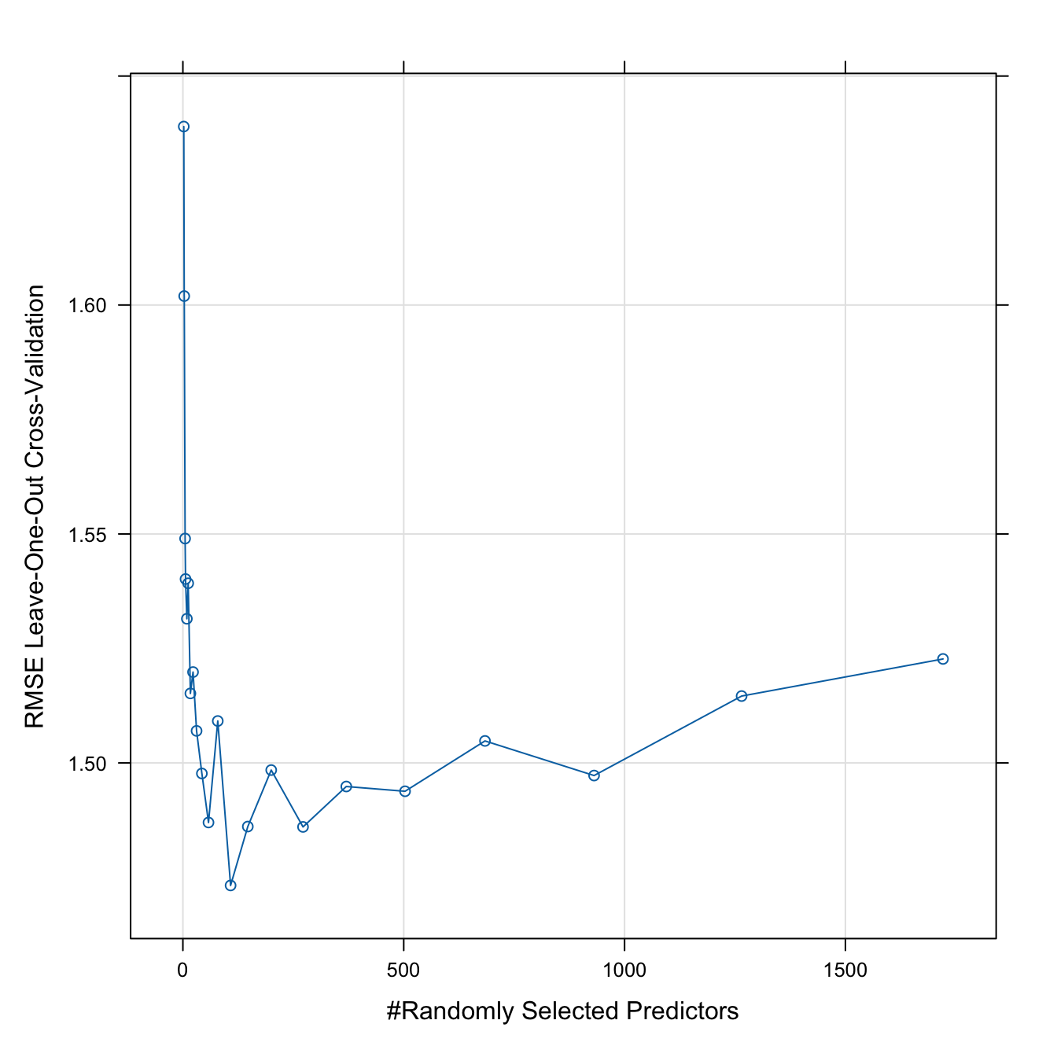
Figure S6. Random Forest RMSE and number of randomly selected predictors. RMSE from repeated cross-validations plotted against the number of randomly selected predictor variables. The RMSE decreases sharply and stabilizes around 108 predictor variables, suggesting that the dataset contains highly informative features capable of strong discrimination.
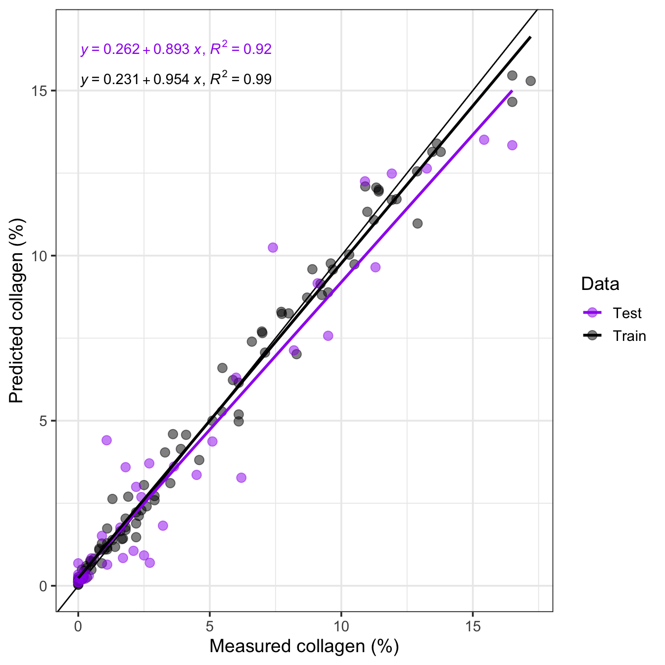
Figure S7. Predicted collagen yield from the random forest model vs. actual collagen values. Among the calibration samples (black dots), the Random Forest model explains 90.41% of the total variation in the data and predicts collagen yield well (R² = 0.99) with a RMSEC = 1.47. The Random Forest model also performs well in predicting the collagen yield of the validation samples (purple dots; R² = 0.92; RMSEP = 1.34).
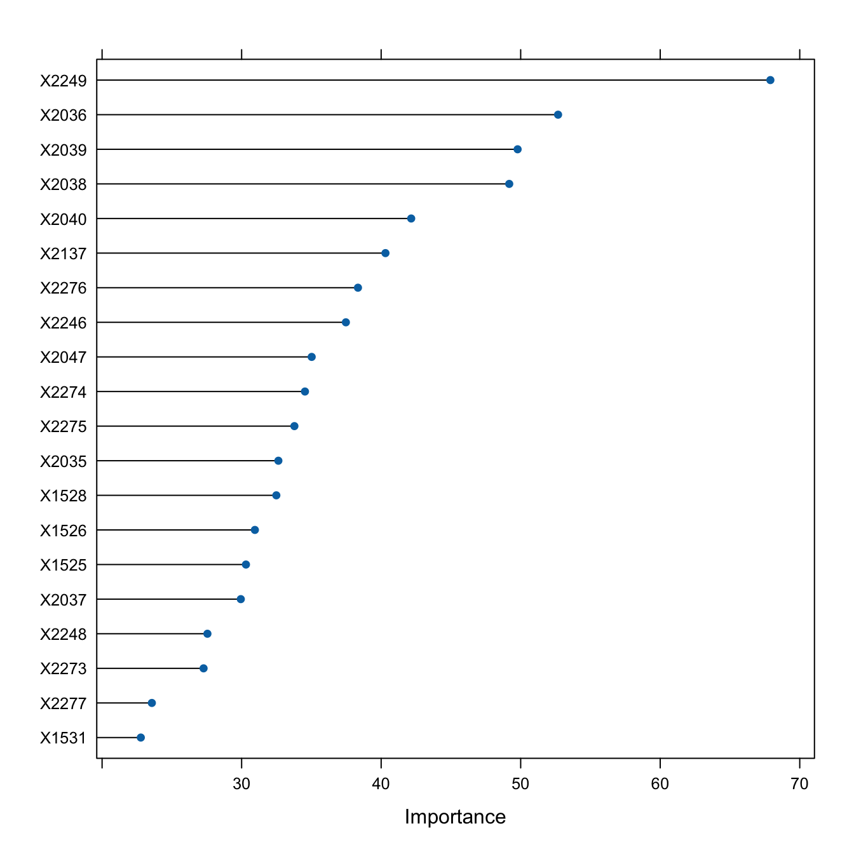
Figure S8. Important variables included in the Random Forest model.

2045 nm
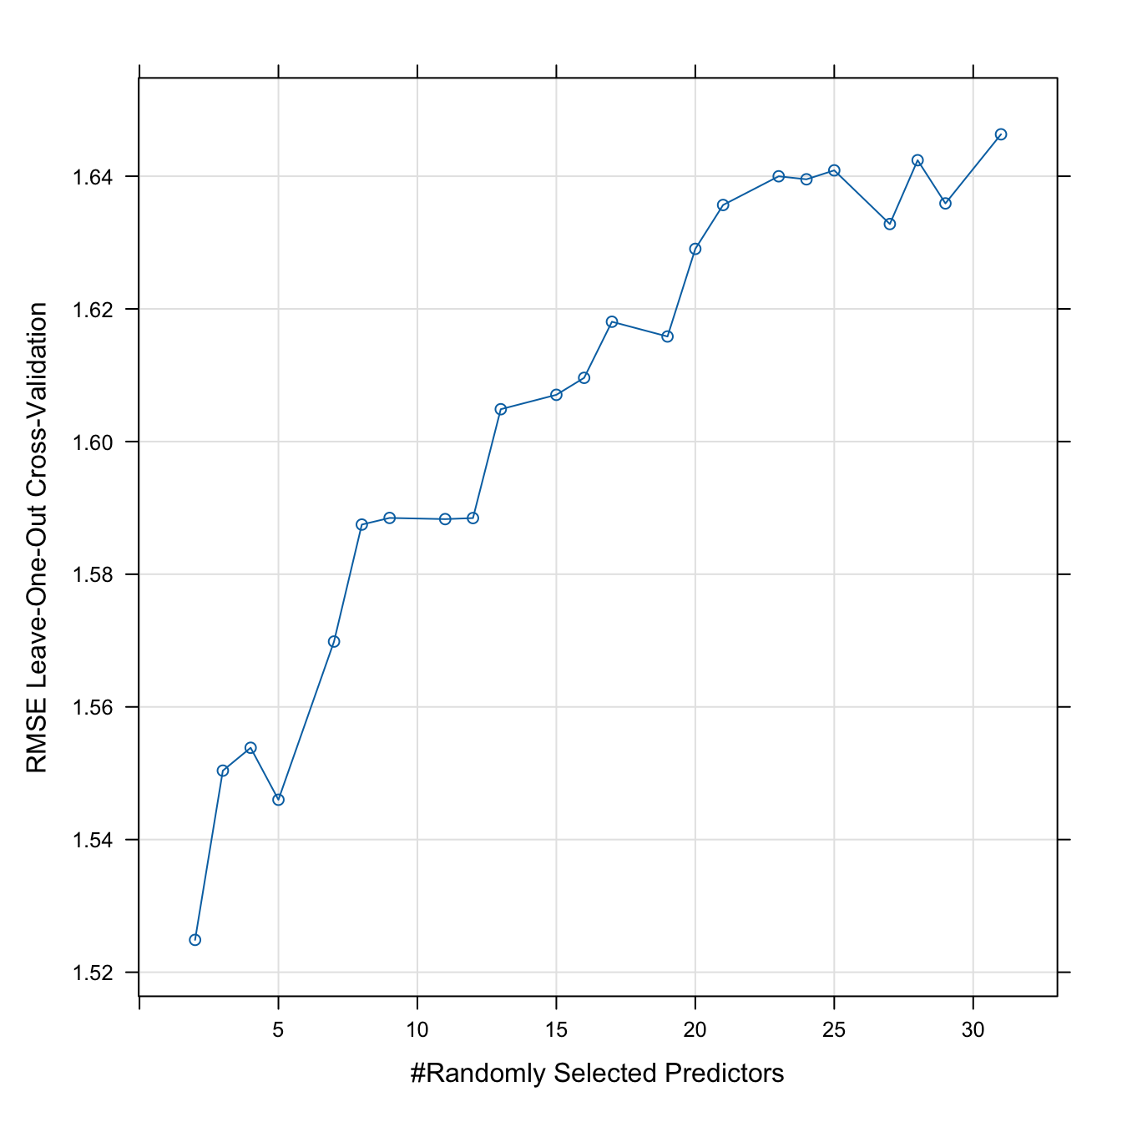
Figure S9. Random Forest RMSE and number of randomly selected predictors. RMSE from repeated cross-validations plotted against the number of randomly selected predictor variables. The lowest RMSE is found at two randomly selected predictors.

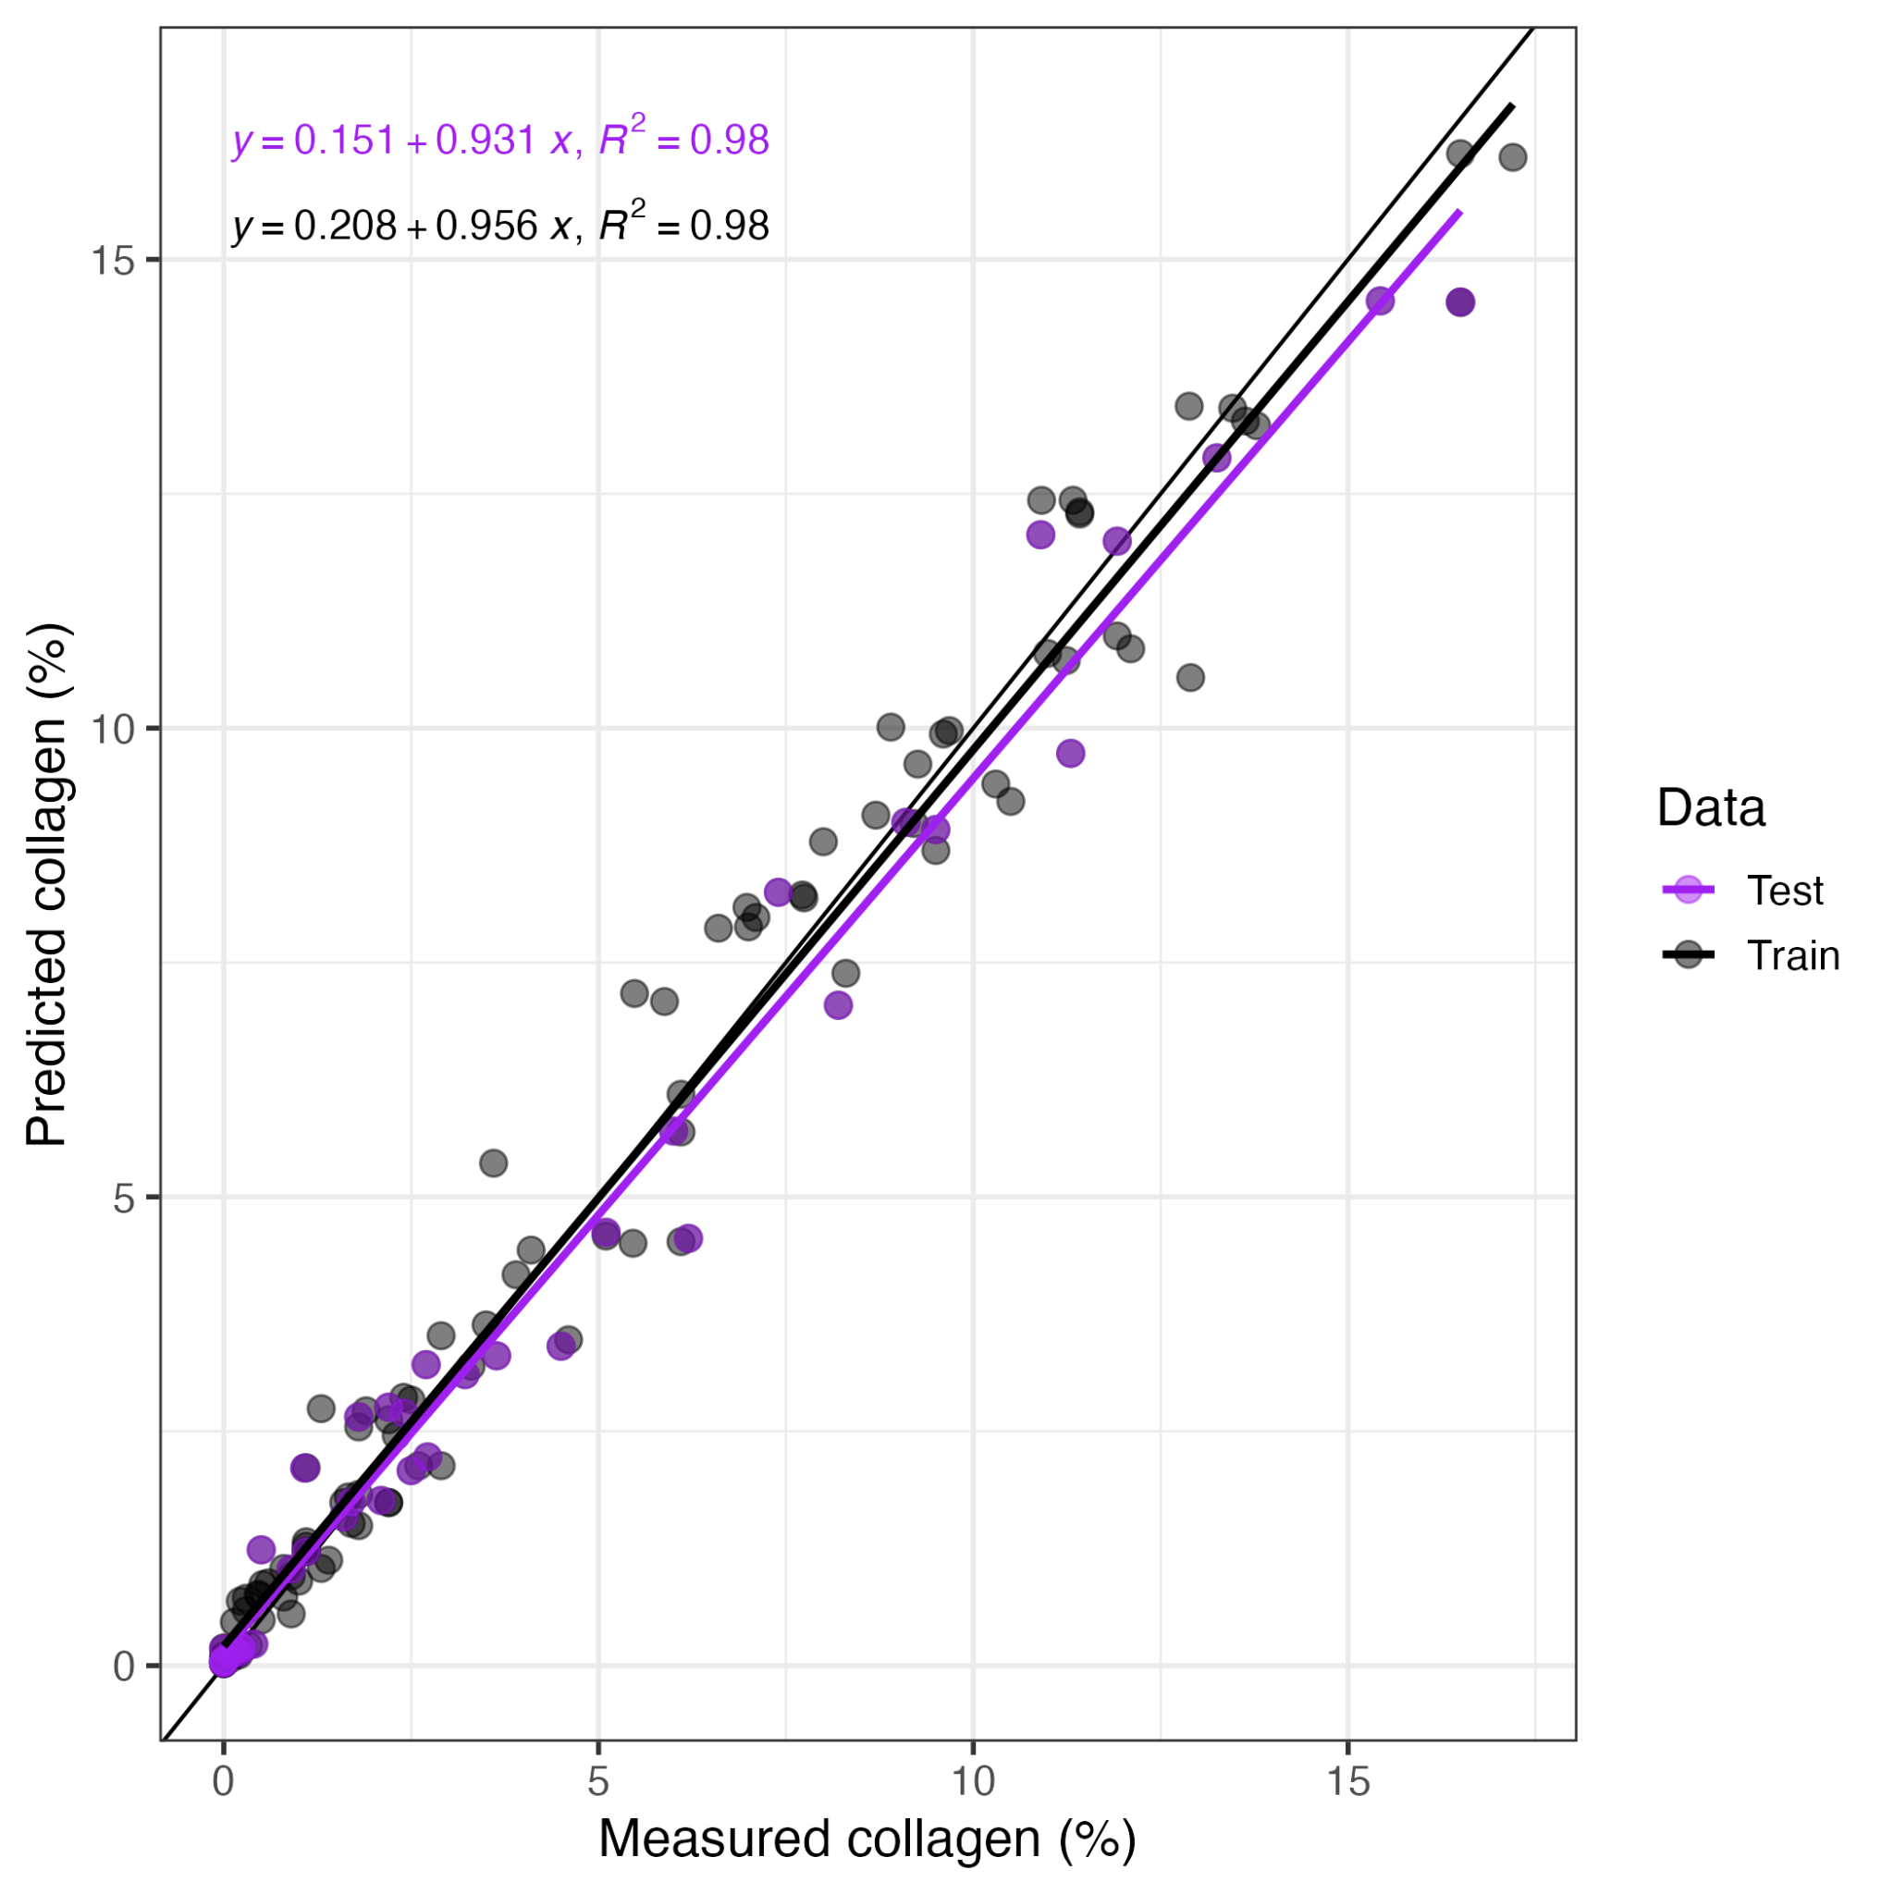
Figure S10. Predicted collagen yield from the random forest model vs. actual collagen values. Among the calibration samples (black dots), the Random Forest model predicts collagen yield well (R² = 0.98) with a RMSEC = 0.72. The Random Forest model also performs well in predicting the collagen yield of the validation samples (purple dots; R² = 0.98 and RMSEV = 0.70). 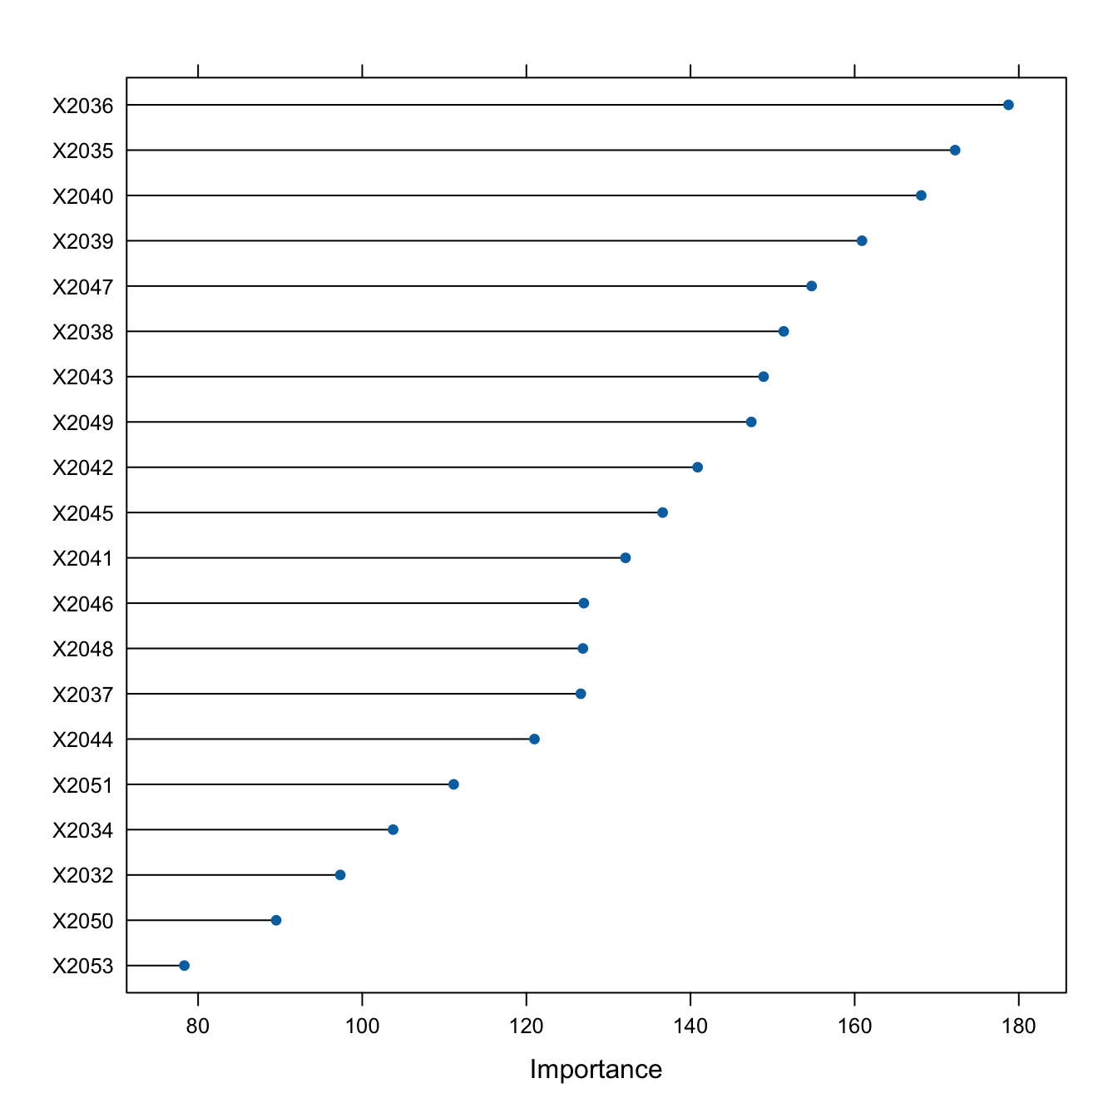
Figure S11. Important variables included in the calibration 2045 nm Random Forest model.

