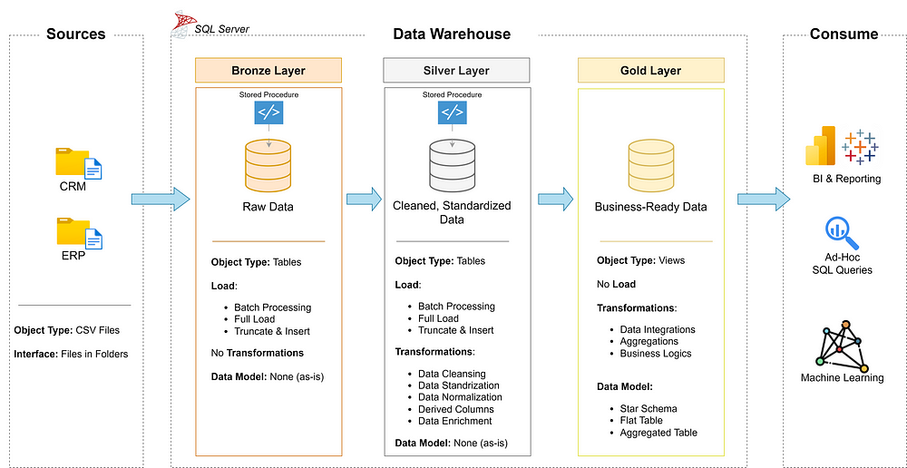
- Data Architecture: Designing a Modern Data Warehouse Using Medallion Architecture Bronze, Silver, and Gold layers.
- ETL Pipelines: Extracting, transforming, and loading data from source systems into the warehouse.
- Data Modeling: Developing fact and dimension tables optimized for analytical queries.
- Analytics & Reporting: Creating SQL-based reports and dashboards for actionable insights.

Layers:
- Bronze Layer: Stores raw data as-is from the source systems. Data is ingested from CSV Files into SQL Server Database.
- Silver Layer: This layer includes data cleansing, standardization, and normalization processes to prepare data for analysis.
- Gold Layer: Houses business-ready data modeled into a star schema required for reporting and analytics.

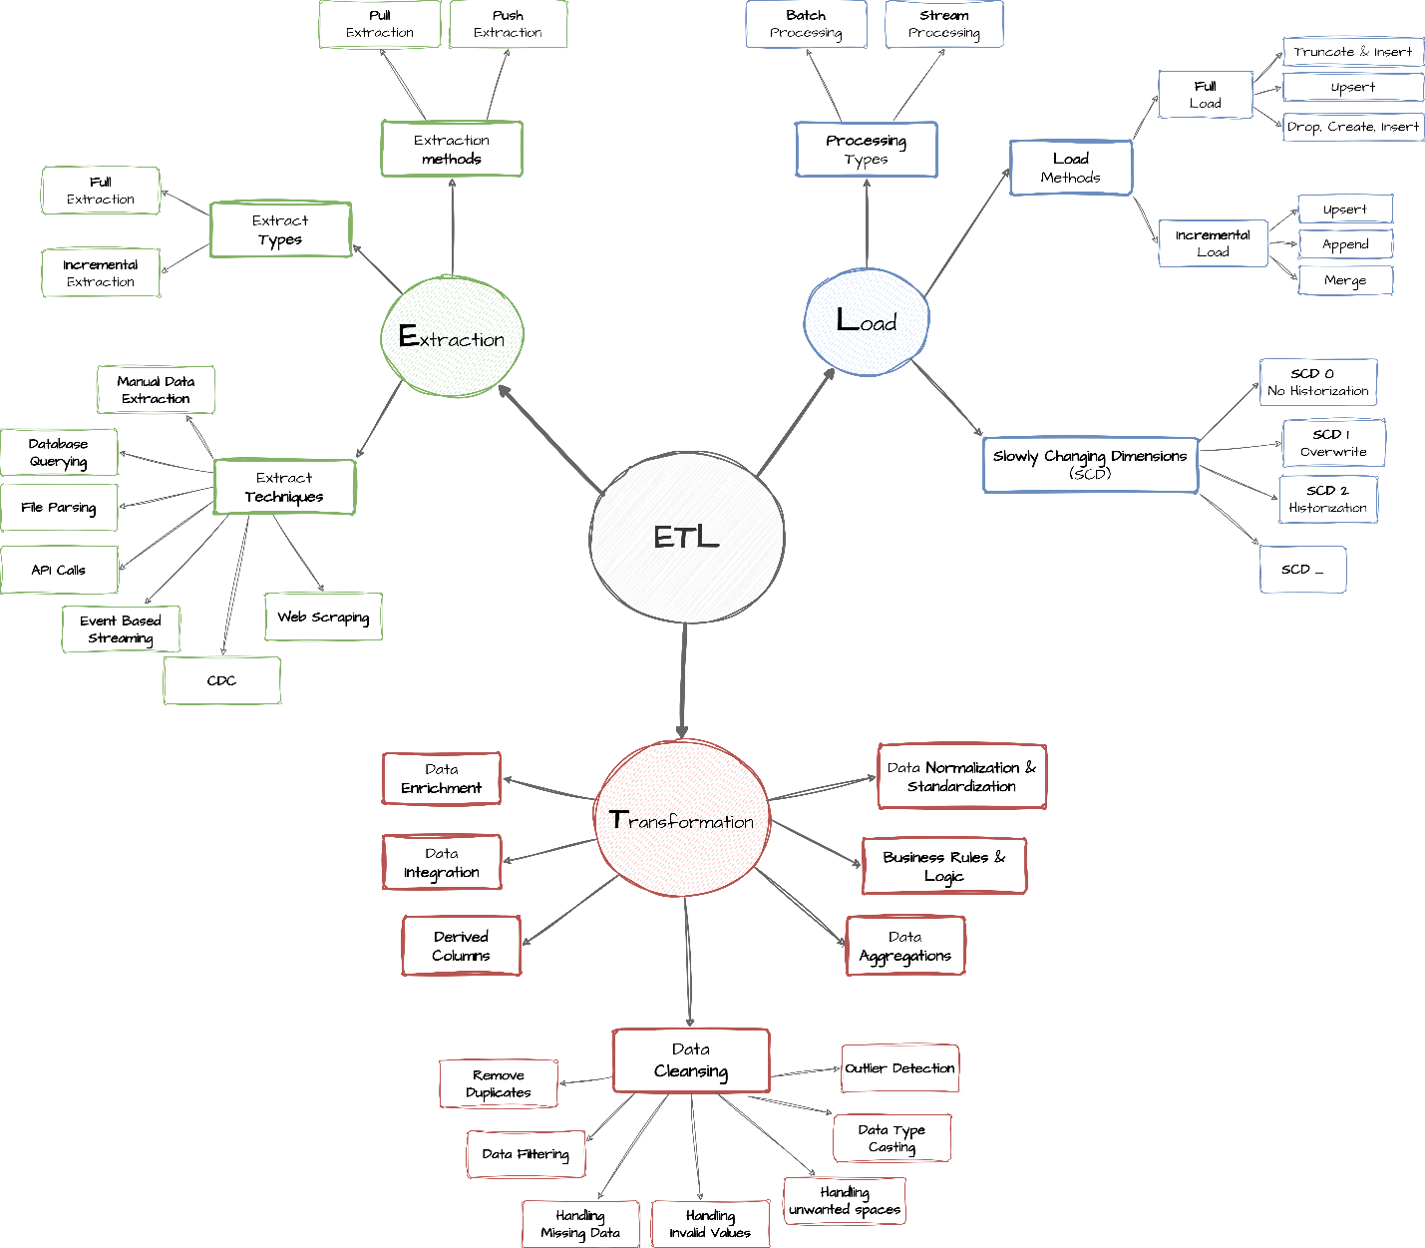

  - Creating data source:
- .CSV file, both CRM and ERP
- CRM (Customer Relationship Management)
- Purpose:
CRM systems manage interactions with customers and potential customers, aiming to improve customer relationships and sales.
- ERP (Enterprise Resource Planning)
- Purpose:
ERP systems manage and integrate core business processes like finance, supply chain, HR, manufacturing, and inventory.

