1)

**INDEX.html**

<!DOCTYPE html>

<!--

To change this license header, choose License Headers in Project Properties.

To change this template file, choose Tools | Templates

and open the template in the editor.

-->

<html>

<head>

<title>TODO supply a title</title>

<meta charset="UTF-8">

<meta name="viewport" content="width=device-width, initial-scale=1.0">

</head>

<body>

<form action="newjsp.jsp">

<input type="text" name="names">

<input type="submit">

</form>

</body>

</html><!DOCTYPE html>

<html>

<head>

<title>TODO supply a title</title>

<meta charset="UTF-8">

<meta name="viewport" content="width=device-width, initial-scale=1.0">

</head>

<body>

<form action="newjsp.jsp">

<input type="text" name="names">

<input type="submit">

</form>

</body>

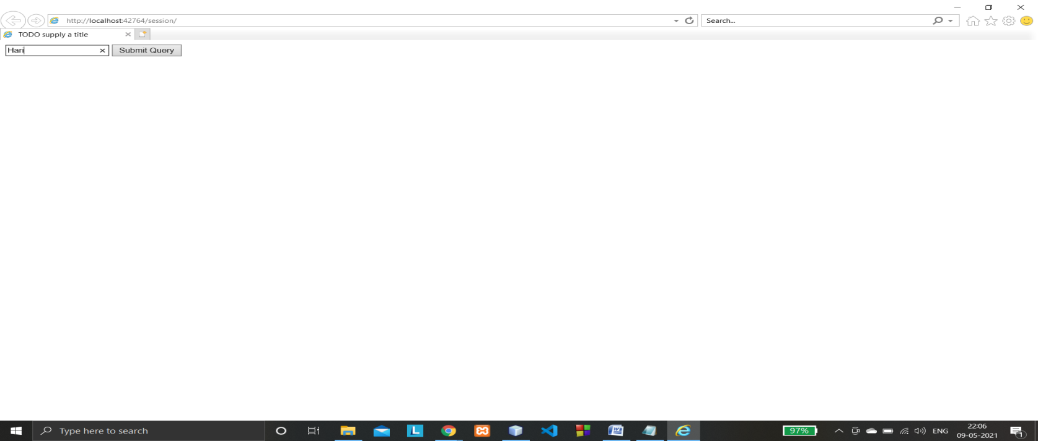</html>

**Newjsp.jsp**

<%@page contentType="text/html" pageEncoding="UTF-8"%>

<%@page import="java.io.*,java.util.Date"%>

<!DOCTYPE html>

<html>

<head>

<meta http-equiv="Content-Type" content="text/html; charset=UTF-8">

<title>JSP Page</title>

</head>

<body>

<% String val = request.getParameter("names");

session.setAttribute("name",val);

out.println(val);

%><br/>

<% Date today = new Date();

%>

Login Time:<%= today.toString() %>

<% session.setAttribute("times",today.toString());%>

<form action="new.jsp">

<input type="submit" value="Logout">

</form>

</body>

</html>

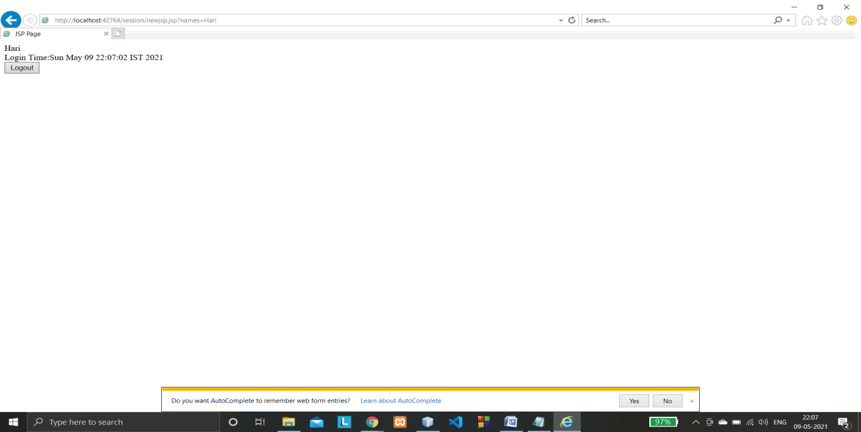

**NEW.jsp**

<%@page contentType="text/html" pageEncoding="UTF-8"%>

<%@page import="java.io.*,java.util.Date"%>

<!DOCTYPE html>

<html>

<head>

<meta http-equiv="Content-Type" content="text/html; charset=UTF-8">

<title>JSP Page</title>

</head>

<body>

<center><h1>

<% String names = (String)session.getAttribute("name");

session.setAttribute("namess",names);

out.println(names);

%><br/>

Start time:

<%

Date today = new Date();

String times = (String)session.getAttribute("times");

out.println(times);%>

<br/>

End time:

<%out.println(today);

session.invalidate();%>

</h1></center>

</body>

</html>

