Welcome to Edge Writings Editor Guidelines. As an EDGE Special Editor, you are expected to pay fine attention to detail and successfully make changes that will help EDGE Clients.

**Please bear in mind that this is the guideline exclusively for EDGE Special Editors, editing PREMIUM Service essays.**

To start off, once a client submits a Premium essay, the Edge administrator will forward an email to you with a web-based version of the essay and three attached documents:

1. This editing guideline

2. The essay in .txt format

3. A Microsoft Word template that looks like this:

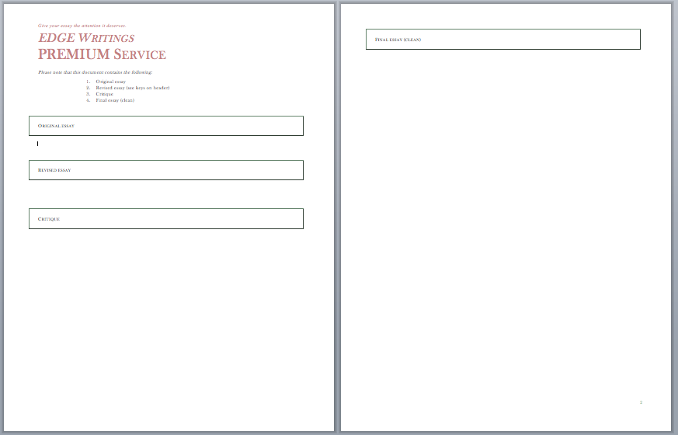

***Preparing the document:***

1. Open the **.txt file** with the essay
2. Copy and Paste the essay under the titles “Original Essay” **and** “Revised Essay” on the **Microsoft Word** template (please refrain from using any other word processor).
3. Make sure you have the **Track Changes** option turned on (Review -> Track Changes -> Final Showing Markup)
4. You will be working on the essay under the title “**Revised Essay**”

***Editing***:

1. With a first reading, correct the **simple spelling and grammar mistakes** you may find and get a good feel of the entire essay. This step will require basic deletions and insertions.
2. Add **comments** about:
   1. Major or frequent spelling and grammar errors
   2. Edits that may need additional explanation

*Depending on type of essay, there may be parts that need to be* ***deleted, changed or added content-wise****. If possible indicate with a comment where these changes need to be made. (Remember that the objective of the Premium Service is to guide the client towards writing a perfect essay, NOT just correcting upon what they have written!)*

1. Write a **critique** of the entire essay. Be detailed and helpful in your critique. (Right click and ‘accept changes’ in order to get rid of any tracked markings)

***Clean Copy***:

1. **Copy the Revised essay** with your comments and tracked changes
2. **Paste** it below the “**Final Essay**” title.
3. **Turn off** Track Changes
4. Right click on the copy-and-pasted final essay and select “**Accept Changes**”.
5. **Delete any comments** that may have been copied with the essay.

**\*In case of a re-submitted essay, read through previous comments as well as any comment written by the client, before going into editing.**

**Checklist: Please check that you have completed the following for the essay.**

**Proofreading** – *This is the initial purpose of Edge Editors. Proofread the paper for any grammatical and structural errors. Provide feedback with the error tracking function in your word processor. Edits will consist of three types: insert, modify, and delete.*

1. Check for grammatical errors
2. Check overall structure
   1. Formatting- indentation, paragraph use
   2. Paragraph form and length
3. Check spelling, punctuation, capitalization, etc.

**Editing** – *The purpose of the editing is to improve the quality of the paper overall. Make sure there is variety in word choice, meaningful content, and smooth transitions.*

1. Check word count and paper length if those are required
2. Check for wordiness (variety, proper usage)
3. Check for repitition of ideas or words
4. Check paper unity and transition
5. Check for plagarism where possible, proper annotation, correct citation, and use of terminology

**Suggestions** – *This allows the editors to further add their input about the direction the essay or paper is taking and how appropriate it is for its purpose. Address some of the writer's issues and suggest solutions.*

1. Provide help if the thesis and supporting examples are not coherent and/or parallel
2. Provide suggestions to increase paper length
3. Provide help in exploring ways to further support a thesis
4. Offer criticism if it is necessary regarding examples and supporting ideas
5. Help guide the essay in the right direction

**Content:** Make sure the author responds properly to the prompt. Does the author follow the guidelines if any are given? Can any part of the essay be re-written to make the paper adhere better to the guidelines provided? If the author seems off-topic or wanders, try to use corrections and suggestions in the first draft to help them better understand what direction they should take their paper in.

**Essay Organization:** Make sure the paper is organized and flows well. Check that paragraphs present thoughts in a logical and linear manner.

**Paragraph Organization:** Ensure that the information in the introduction paragraph is supported well in the body paragraphs. Make sure that the paragraphs following the thesis and its supporting ideas are arranged in the same manner.

**Clarity and Style:** Check the essay for ease of understanding. Make sure that the phrasing, word flow, transitions, and punctuation keep the essay smooth and easy to read. Ensure that there is proper subject-verb agreement and tense consistency.