Git branch feature-1

git branch feature-2

git checkout feature-1

git checkout feature-2

git checkout feature-1

nano main.go

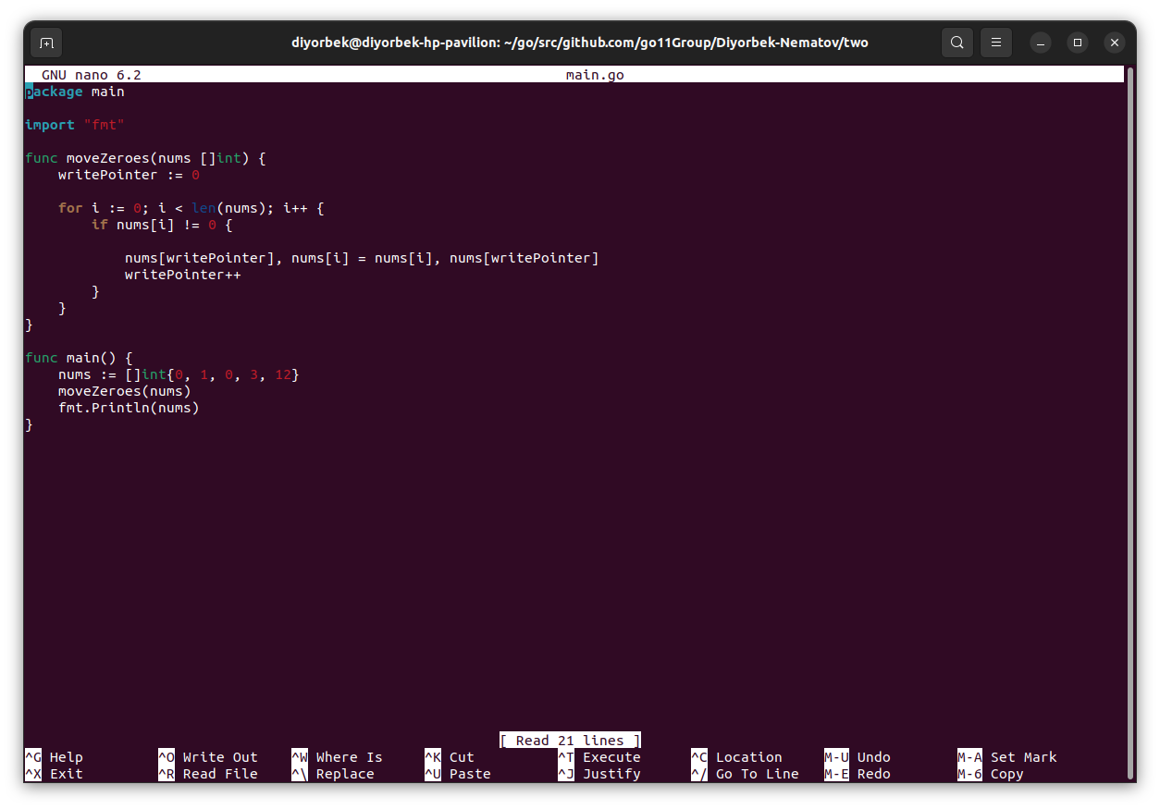,

git add main.go

git commit -m “Changed from feature-1 branch”

git checkout feature-2

nano main.go

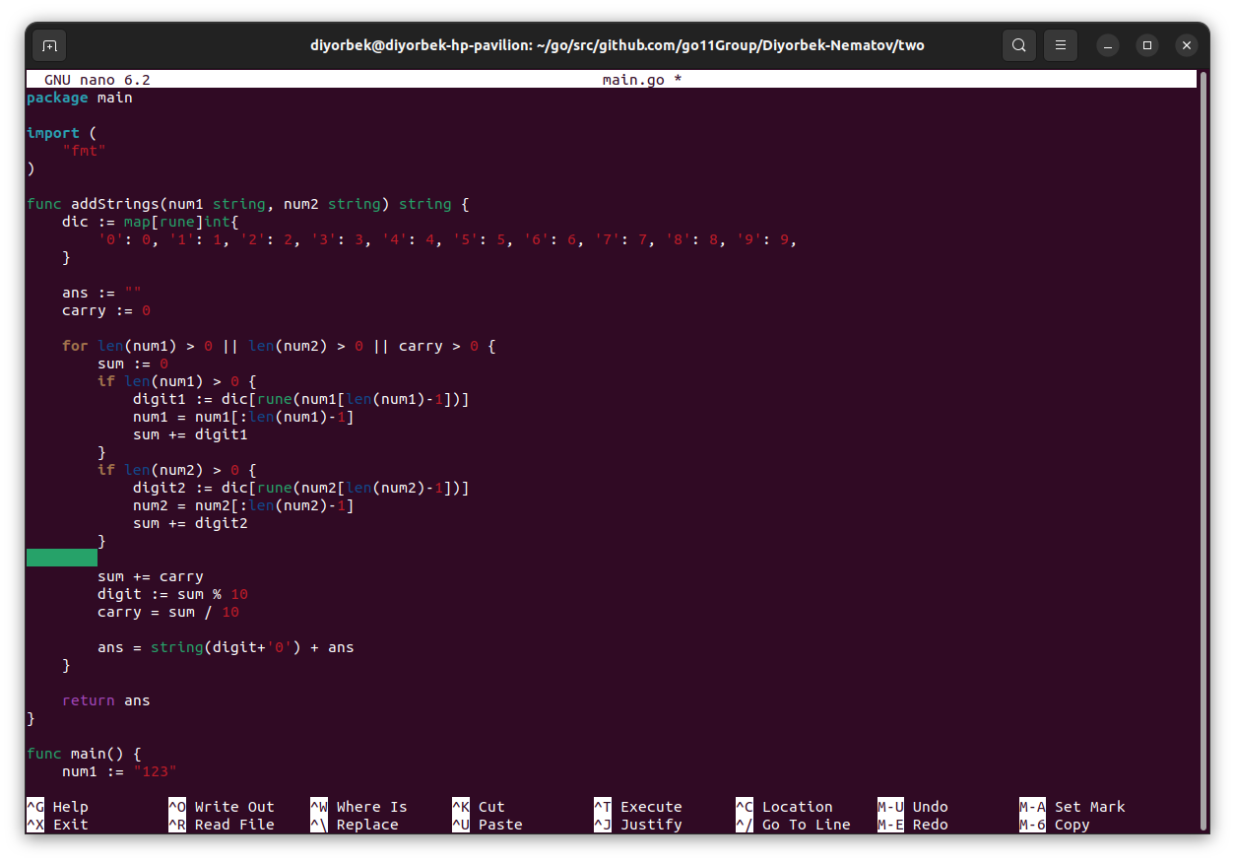.

git add main.go

git commit -m “Changed from feature-2 branch”

git checkout main

git merge feature-1

git merge feature-2

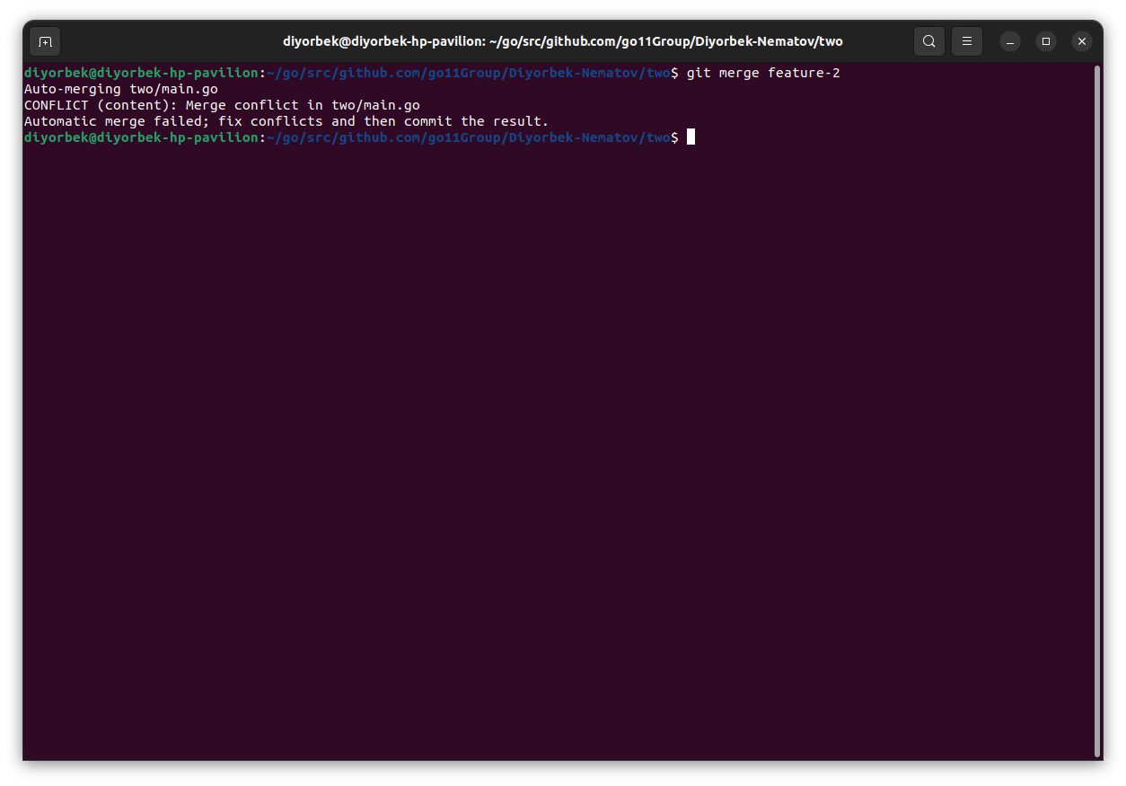.

nano main.go

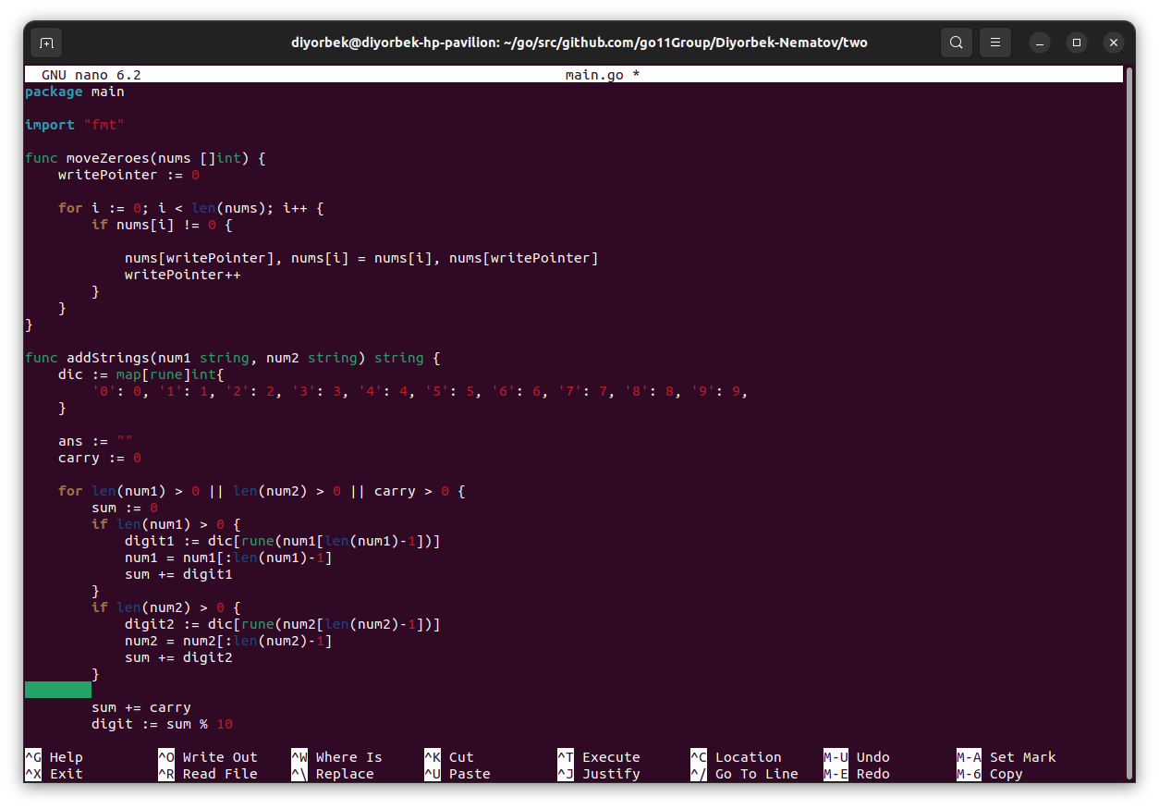

git add .

Git commit -m “Conflict to’g’rilandi”

git branch -d feature-1

git branch -d feature-2

git log

