1.

a)

b)

The principal axis is R3 (0 0 1).

c)

d)

2.

a)

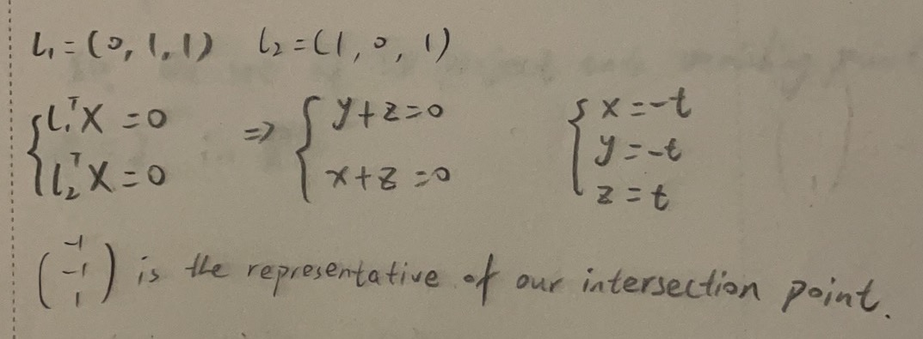

b)

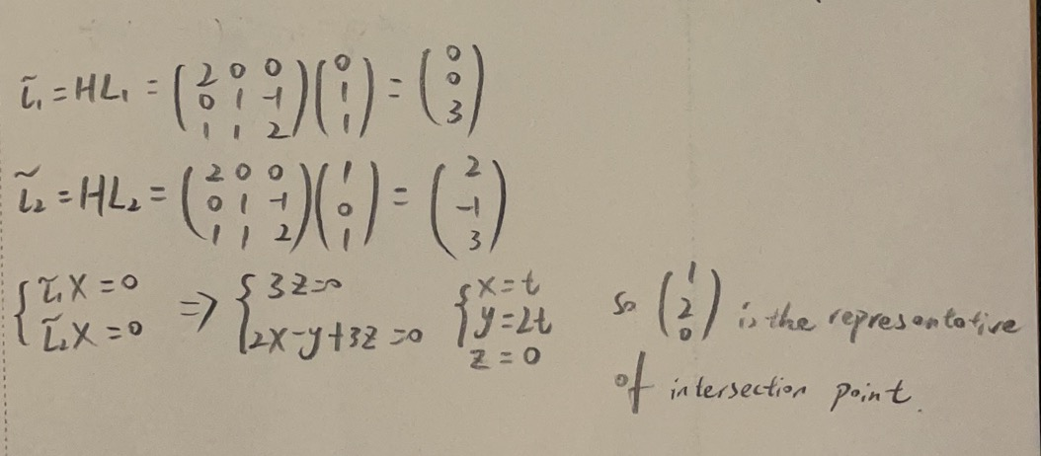

c)

The new intersection point means that the new lines are parallel in R2 and the point is infinity far away in direction (1, 2).

3.

a)

b)

4.

a)

b)

c)

best_E =

5.

a)

b)

c)

The projections of (x, y) and (x̄, ȳ) onto the line joining the epipolars e1 and e2 are collinear. The determinant det () = 0 means that the two corresponding points (x, y) and (x̄, ȳ) lie on a common epipolar line in the two views.

6.

I estimate the normal vector of a plane from corresponding points (I used x1a x2a and x1b x2b) using the given camera matrices P1 and P2.