

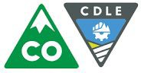

CDLE Oil and Public Safety Data

**Last Updated:** 3/1/2019

**The Colorado Department of Labor & Employment** (CDLE) connects job seekers with great jobs, provides an up-to-date and accurate picture of the economy to help decision making, assists workers who have been injured on the job, ensures fair labor practices, helps those who have lost their jobs by providing temporary wage replacement through unemployment benefits, and protects the workplace - and Colorado communities - with a variety of consumer protection and safety programs. Find us at [**https://www.colorado.gov/cdle**](https://www.colorado.gov/cdle).

Within the Colorado Department of Labor & Employment, **the Division of Oil and Public Safety** (OPS) successfully partners with regulated business owners and operators in Colorado to protect the public and our environment by ensuring the safe storage and use of fuel products and explosives and the safe operation of amusement rides, boilers and conveyances. Find us at [**https://www.colorado.gov/ops**](https://www.colorado.gov/ops).

The OPS Petroleum Program is responsible for protecting human health and the environment from petroleum releases caused by regulated storage tank systems. This includes oversight of assessment and cleanup of regulated substances from both underground storage tank (UST) and above ground storage tank (AST) systems.

# OPS and GoCode Colorado 2019

All of the [Open Petroleum Release Events](https://data.colorado.gov/Environment/Active-OPS-Petroleum-Release-Events-in-Colorado/v5ut-qgp7) from regulated storage tank systems are reported to OPS. These release events are currently being investigated, assessed/remediated or are obtaining closure.

Geodata contained in this dataset can provide insight regarding where petroleum product releases are located in relation to water sources. Since the contact information for OPS technical reviewers is included in this dataset, inquiries may be made directly to them if there are any questions about the release events.

Active and Closed Events

For active and closed events, navigate to the [**Active and Closed Petroleum Release Events**](https://data.colorado.gov/Environment/Active-Closed-OPS-Petroleum-Release-Events-in-Colo/g3jr-97se)[**in Colorado**](https://data.colorado.gov/Environment/Active-Closed-OPS-Petroleum-Release-Events-in-Colo/g3jr-97se) dataset. This dataset is updated monthly from the [**Colorado Storage Tank**](https://opus.cdle.state.co.us/OIS2000/home.asp)[**Information System (COSTIS) database**](https://opus.cdle.state.co.us/OIS2000/home.asp), and the locations are generated from point address based geocoding.

# Working with Petroleum Release Data

Each row in these datasets represents one release record, or rather, one site cleanup. Each release record may be researched further on the public-facing COSTIS database.

# Finding the Data

A user may access the OPS Petroleum Release Events dataset by navigating to [**https://data.colorado.gov/Environment/OPS-Petroleum-Release-Events-in-Colorado/x235-**](https://data.colorado.gov/Environment/OPS-Petroleum-Release-Events-in-Colorado/x235-reiv)[**reiv**](https://data.colorado.gov/Environment/OPS-Petroleum-Release-Events-in-Colorado/x235-reiv), or by navigating to [**https://data.colorado.gov**](https://data.colorado.gov/), searching for OPS and selecting the “OPS Petroleum Release Events in Colorado” dataset.

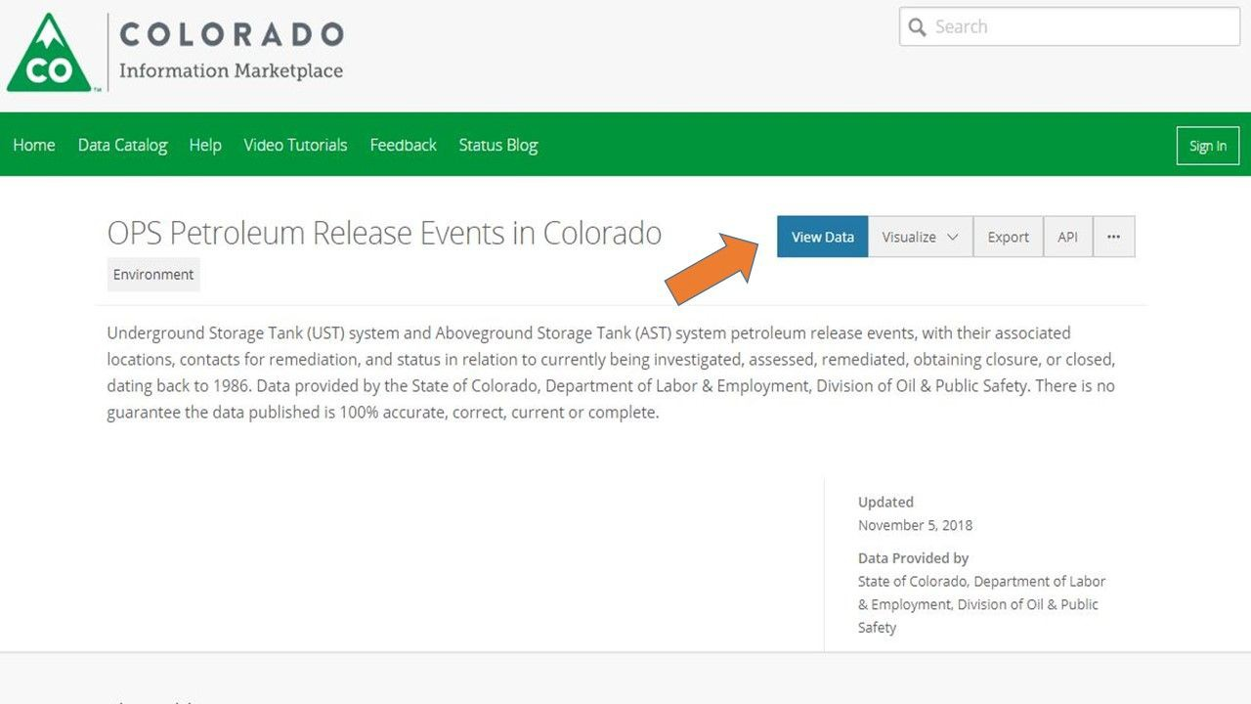

The dataset description is as follows:

Underground Storage Tank (UST) system and Aboveground Storage Tank (AST) system petroleum release events, with their associated locations, contacts for remediation, and status in relation to currently being investigated, assessed, remediated, obtaining closure, or closed, dating back to 1986. Data provided by the State of Colorado, Department of Labor & Employment, Division of Oil & Public Safety. There is no guarantee the data published is 100% accurate, correct, current or complete.

# Insights to Using OPS Release Data

The Status field indicates whether a release event is open or closed.

* If the release is ***closed***, it has occurred through one of the four types of closures:
  + **Tier I Closure:** Chemicals of Concern (COCs) are below the Maximum Contaminant Levels (MCLs) in all medium (groundwater, soil and soil vapor) at the time of closure.
  + **Tier II Closure:** COCs are below the Site Specific Target Levels or MCLs in all medium onsite at the time of closure with no offsite COC impacts
  + **Tier III Closure:** A public roadway property boundary is the only impacted point of exposure
  + **Tier IV Closure:** Property boundaries are the only impacted point of exposure. (Detailed information about the Tiered Closure Types is available in the OPS [**Release Closure Guidance**](http://www.coworkforce.gov/petroleumguidance/%23Release%20Response/Site%20Characterization/Release%20Closure%20Criteria.htm%3FTocPath%3DRelease%2520Response%7C_____9).)
* If a release is ***open***, the type field refers to the site’s current step in the remediation process. The following may be found in the type field:
  + **Assessment** - The site’s remediation plan is being determined.
  + **Brownfield** - The site has been designated as a Brownfield site and is eligible for state funding for redevelopment.
  + **Enforcement** - Actions taken (or not taken) during remediation are out of compliance with State regulations and have invoked an enforcement action from the State.
  + **Implementing CAP/ Implementing CAP OOC** - The site’s Corrective Action Plan (CAP) is being implemented. (OOC = Out of Compliance)
  + **LUST Trust** - The site’s cleanup is financed by the Environmental Protection Agency.
  + **SCR Complete** - The site’s initial contamination report is complete and CAP preparation can begin.
  + **State Lead** - The site has been accepted for State Lead cleanup. For more information about the OPS State Lead Program, please visit [**https://www.colorado.gov/ops/StateLead**](https://www.colorado.gov/ops/StateLead)**.**

# Other Dataset Information

* This dataset was initially posted on the Colorado Information Marketplace in June 2016 to provide improved data accessibility to the public and stakeholders.
* This dataset is updated monthly, usually on the first day of the month. Additional fields have been added to the dataset since its original creation based on user feedback, including county and closure field data.

# More Resources

More detailed release information is available in the [**COSTIS database**](https://opus.cdle.state.co.us/OIS2000/home.asp), which is managed by OPS technical reviewers and administrative staff.

Reports and site maps are also available to the public via a [**request to the OPS Public**](https://www.colorado.gov/ops/PetroleumDataDocuments)[**Records Center**](https://www.colorado.gov/ops/PetroleumDataDocuments).

For more information about the OPS Petroleum Storage Tank program requirements, view the

## [Petroleum Program Guidance](http://www.coworkforce.gov/petroleumguidance/).

CDLE FAQ

[**Colorado Department of Labor and Employment**](https://www.colorado.gov/cdle)[**Colorado Division of Oil and Public Safety**](http://www.coworkforce.gov/petroleumguidance/Default.htm)

If you have any questions about this dataset, please feel free to reach out to the following people:

Melanie Moore 303-318-8524

## [melanie.moore@state.co.us](mailto:melanie.moore@state.co.us)

Mike Kwiecinski 303-318-8512

## [mike.kwiecinski@state.co.us](mailto:mike.kwiecinski@state.co.us)

Amy Miller 303-318-8530

## [amy.miller@state.co.us](mailto:amy.miller@state.co.us)