



**Last updated:** 3/22/2019

Douglas County Data

Douglas County is located south of Denver, with its county seat in Castle Rock. DougCo has [its](https://data.douglas.co.us/) [own public data website](https://data.douglas.co.us/), and much of its data can be found on the [CIM](https://data.colorado.gov/browse?federation_filter=1222).

# Douglas County - Overview of Relevant Datasets

DougCo has quite a variety of datasets available,categories available for browsing include Business Development, Community Development, Demographics, Economic, Education, Election Data, Financials, Fun, Government, Parks Trails and Open Space, Performance, Property Data, Public Safety, Recreation, Tax Data, and Transportation.

# How to Get Started

DougCo data can be found in the following locations:

1. [DougCoData](https://data.douglas.co.us/browse)
2. [Colorado Information Marketplace](https://data.colorado.gov/)
3. [Douglas County’s GeoHub](https://gis-dougco.opendata.arcgis.com/)

# Working with this Data

If you have ever used the Colorado Information Marketplace (CIM), then you will find the DougCo open data website very easy to use. The two websites are laid out almost exactly the same, and are both powered by Socrata.

# Metadata

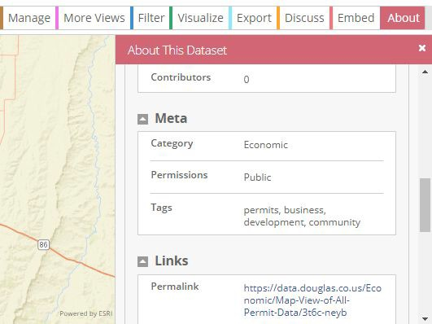Metadata can be found on DougCo’s website by clicking the “About” tab while viewing any dataset.

# Douglas County Roof Permits

This dataset contains building, roofing, electrical, mechanical, demolition, and driveway issued [permits for Douglas County](https://data.douglas.co.us/Economic/Roof-permit/3f4j-vyeh). City-issued permits are not in this dataset. The dataset tracks permits issued dating back to January of 1991, which makes this dataset somewhat older than many other available datasets. Users may find this data useful for the Smart Cities challenge category, as this dataset provides historical context to buildings in a largely suburban county.

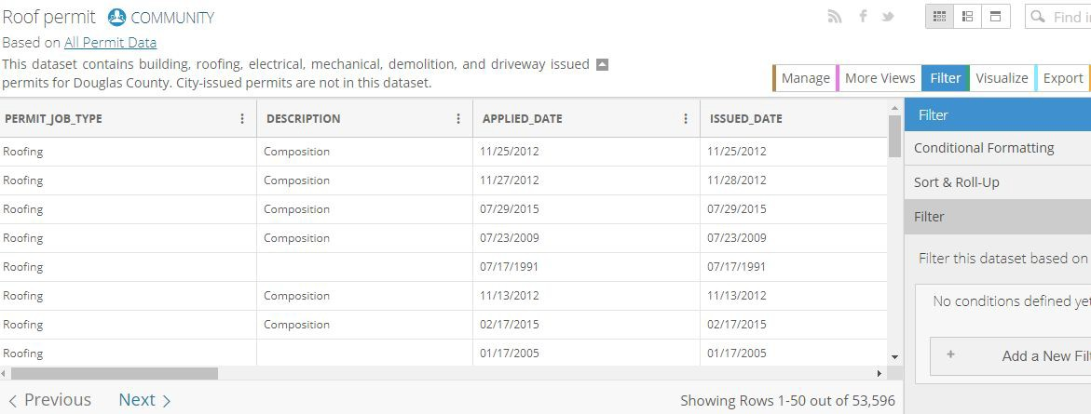

The codes in these 5 fields are shown on the pdf document to be Block Code “B.” The codes for Block code B are shown on page 7 of the pdf under “B. HARMFUL EVENT SEQUENCE.” There are codes 01 through 40, and the following codes relate specifically to ped or bike:

# All Permit Data Douglas County

DougCo has published [a dataset](https://data.douglas.co.us/Economic/Map-View-of-All-Permit-Data/3t6c-neyb) that contains building, roofing, electrical, mechanical, demolition, and driveway issued permits for Douglas County. Town of Castle Rock and Town of Parker permits are also in this dataset. Addition of other city permit data is planned. This dataset is similar to the DougCo Roof Permits Dataset, with they key differences being that it contains geospatial data and more permitting categories outside of roofing. Geospatial attributes include address, city, state, zip code, jurisdiction, and location in decimal degrees. The data is available for export in csv, tsv, xml, JSON, rdf, and rff format.

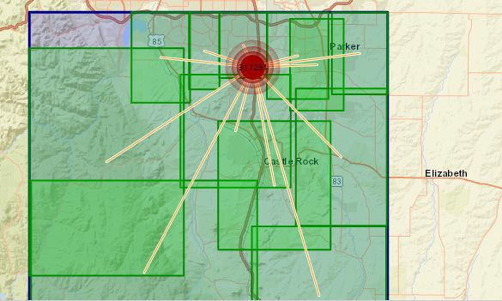

# Douglas County Alexa Requests

This is one of the more unique datasets available that has been provided by DougCo. Simply put, this data is a table for Amazon’s Alexa to provide information about Douglas County from user requests. As of now the table is designed primarily for users making requests for [information about property values and taxes](https://data.douglas.co.us/dataset/Douglas-County-Alexa-Requests/ern2-hudh). The data can be downloaded as a csv, tsv, rff, rss, or xml.

# Douglas County GeoHub

The Douglas County GIS Services Team develops and produces standard maps that are available for internal (Douglas County Departments) and external customers. A wide range of standard maps are available, including transportation, land use, political, geologic, and other information. [The GeoHub](https://gis-dougco.opendata.arcgis.com/) has data on demographic, economic, education, election,

government, health, hydrography, infrastructure, parks & open space, planning, property, public safety, topography, and transportation.

Some interesting sample datasets:

* [Water Supply Zones](https://gis-dougco.opendata.arcgis.com/datasets/f41be83add5f421d98c3d3f43f475a02_0): Map of groundwater supply zones
* [Mental Health Data](https://gis-dougco.opendata.arcgis.com/items/026a751142d44975a2b0d380c66ee927): Suite of data relating to mental health in the area
* 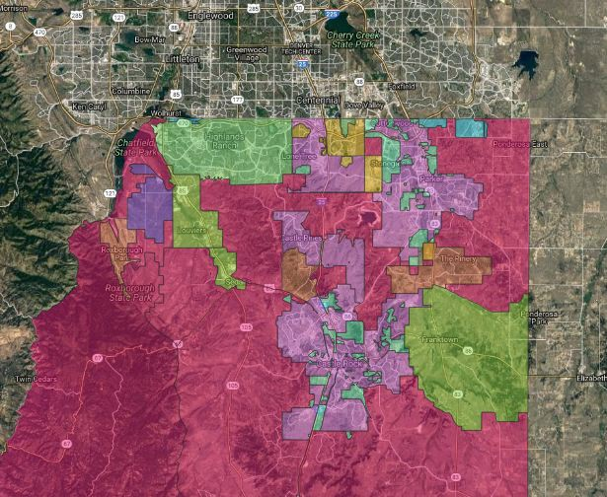[Land Use](https://gis-dougco.opendata.arcgis.com/datasets/3fda53fc9335458bb6c097228130328c_0): Comprehensive MasterPlan 2030 Land Use Management Areas as approved by the Douglas County Planning Commission - April 21, 2008.

# Much More

There’s a lot more on the site - go see for yourself! <https://gis-dougco.opendata.arcgis.com/> <https://data.douglas.co.us/> <https://data.colorado.gov/>