



**Last updated:** 3/22/2019

Grand Junction GIS Data

The City of Grand Junction has a variety of web-based maps available to the public. These maps can be embedded into other web pages and have some analytical capabilities built in.

[City of Grand Junction Maps](https://www.gjcity.org/Maps/)

# The City of Grand Junction GIS

On the City of [Grand Junction’s GIS page](https://arcgis-app.gjcity.org/City%20Map%20External/), a variety of themed maps are available, and each them contains numerous layers for viewing.

These themes include:

* City
* Business
* Development
* Public Safety
* Transportation
* Utilities

# How to Get Started

To choose a themed map, simply click on the dropdown underneath the search bar in the top left corner.

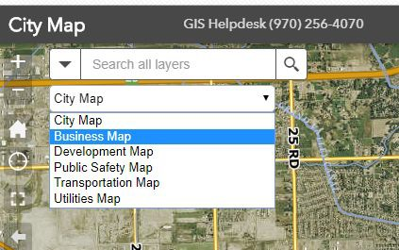

Once a map has been selected, different layers can be toggled by opening the layer list in the top right corner.

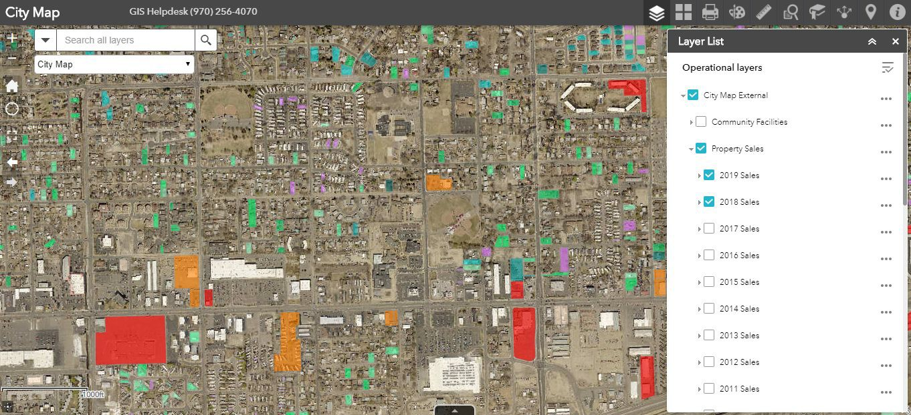Multiple layers can be selected. Below is an example of the Property Sales layer in the City Map theme.

**Working with** Grand Junction GIS Data

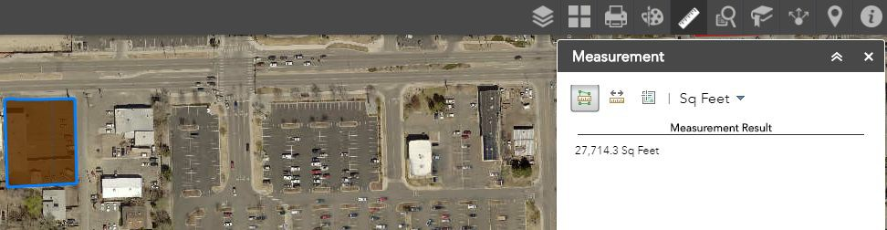For now, download access to this data is not public. However, tools built in to the app can aid in analysis. For example, the Measurement Tool can be be used to measure a line or an area.

# Measurement Tool

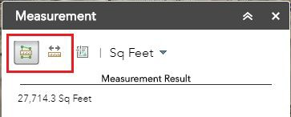To use the Measurement tool, select the tool from the toolbar and then toggle by selecting “Area” or “Distance” to switch between measuring area or distance.

Toggle the units by clicking the dropdown to the right in the Measurement window:

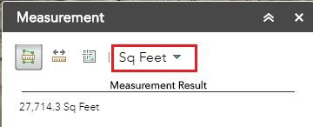

# Reports Tool

The Reports tool can be toggled at this location on the toolbar:

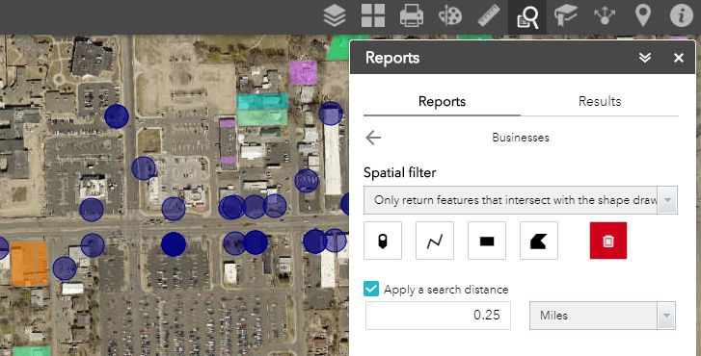Many reports are provided by Grand Junction and can be run as a spatial query/filter on the layer being viewed. For example, the “Businesses” reports can be used to locate businesses within a distance of a point, line, polyline, or polygon.

Each map theme available has many layers to for viewing. Take some time to dive into the many layers that each theme contains on the [City of Grand Junction GIS Web App](https://arcgis-app.gjcity.org/City%20Map%20External/). The many layers provided in combination with the Reports tool could yield many interesting results!