A Project Report On
“Finance Tracker System”
As A Partial Fulfilment For The Degree Of Bachelor Of Computer Application (B.C.A.) Submitted to

C. B. Patel Computer College & J. N. M. Patel Science College
Bharthana, Vesu, Surat
Affiliated To

Veer Narmad South Gujarat University
Surat, Gujarat Academic Year : 2025 – 2026

Guided By:
Prof. Shreya Patel
Submitted By:
Dakoria Rishi (2502)
Tailor Hetvi (3030)

Acknowledgement

We would like to express our sincere gratitude to our respected guide, Prof. Shreya Patel, for her constant guidance, encouragement, and valuable suggestions throughout the development of this project. Her insights and suggestions helped us understand the practical aspects of software development and motivated us to approach the problem with a thoughtful and structured perspective.

We would also like to extend our heartfelt thanks to Prof. Dhananjay Patel, the respected Principal of C. B. Patel Computer College, for providing us with the opportunity to work on a real-world problem-solving project as part of our academic learning. The encouragement and vision of our Principal have helped create an environment where students are motivated to explore practical applications of their knowledge and develop skills beyond the classroom.

Our sincere appreciation also goes to C. B. Patel Computer College & J. N. M. Patel Science College for providing us with the necessary academic environment, resources, and support to successfully complete this project. The college continuously encourages students to engage in innovative learning experiences and practical projects that help bridge the gap between theoretical knowledge and real-world applications.

Working on this project has been a valuable learning experience for us. It allowed us to understand how software solutions can be developed to solve everyday financial management challenges such as tracking expenses, managing income, and maintaining financial records. This experience has not only strengthened our technical knowledge but also improved our problem-solving, teamwork, and project management skills.

Lastly, we would like to thank everyone who directly or indirectly contributed to the successful completion of this project. Their support, encouragement, and cooperation have been greatly appreciated and will always be remembered.

Rishi Dakoria
Hetvi tailor

INDEX

Sr. No | Description | Page No
1 | Acknowledgement
2 | Abstract
3 | 1 Introduction | 1
 | 1.1 Technology Used | 2
 | 1.2 Background of Personal Finance Management | 3
 | 1.3 Problem Statement | 4
 | 1.4 Objectives of the System | 5
 | 1.5 Scope of the Project | 6
 | 1.6 Benefits of the System | 7
4 | 2 Literature Review | 8
 | 2.1 Existing Expense Tracking Methods | 8
 | 2.2 Manual Financial Tracking Systems | 9
 | 2.3 Digital Finance Management Applications | 10
 | 2.4 Limitations of Existing Systems | 11
 | 2.5 Need for an Improved Finance Tracking Solution | 12
5 | 3 System Analysis | 13
 | 3.1 Functional Requirements | 13
 | 3.2 Non-Functional Requirements | 14
 | 3.3 Feasibility Study | 15
 | 3.4 System Constraints | 16
 | 3.5 System Users | 17
6 | 4 Design | 18
 | 4.1 System Design | 18
 | 4.1.1 Overall System Architecture | 18
 | 4.1.2 Frontend Architecture (React) | 20
 | 4.1.3 Backend Architecture (Node.js & Express) | 22
 | 4.1.4 Database Design (MongoDB) | 24
 | 4.1.5 Data Flow Diagrams | 26
 | 4.1.6 Flowcharts | 28
 | 4.1.7 User Interface Design | 30
 | 4.1.8 Admin Interface Design | 41
 | 4.2 Database Design | 43
 | 4.2.1 User Collection | 45
 | 4.2.2 Accounts Collection | 47
 | 4.2.3 Income Collection | 49
 | 4.2.4 Expense Collection | 51
 | 4.2.5 Relationships Between Collections | 53
7 | 5 Implementation | 55
 | 5.1 Frontend Implementation | 57
 | 5.2 Backend Implementation | 62
 | 5.3 API Design | 64
 | 5.4 Authentication System | 66
 | 5.5 Balance Management Logic | 66
8 | 6 Testing | 67
 | 6.1 Unit Testing | 69
 | 6.2 Integration Testing | 71
 | 6.3 Functional Testing | 73
 | 6.4 Test Cases | 75
 | 6.5 Bug Fixing Process | 77
9 | 7 Results and Screenshots | 77
 | 7.1 Login Page | 78
 | 7.2 Registration Page | 79
 | 7.3 Overview Dashboard | 80
 | 7.4 Expense Management | 81
 | 7.5 Income Management | 82
 | 7.6 Account Management | 83
 | 7.7 Statement Page | 84
 | 7.8 Admin Page | 85
10 | 8 System Security and Data | 87
 | Protection 8.1 User Authentication Security | 88
 | 8.2 Input Validation | 89
 | 8.3 Secure Database Storage | 90
 | 8.4 API Security | 91
 | 8.5 Data Privacy | 92
11 | 9 System Performance and Scalability | 91
 | 9.1 Response Time | 92
 | 9.2 Data Processing Efficiency | 93
 | 9.3 Scalability Considerations | 94
 | 9.4 Error Handling and Stability | 95
12 | 10 Deployment and Installation Guide | 96
 | 10.1 Hardware Requirements | 97
 | 10.2 Software Requirements | 98
 | 10.3 Project Folder Structure | 99
 | 10.4 Database Setup | 100
 | 10.5 Running the Backend Server | 101
 | 10.6 Running the Frontend Application | 102
 | 10.7 System Deployment Flow | 103
13 | Conclusion | 104
14 | References | 105

Introduction

The Finance Tracker System is a web-based application designed to help individuals monitor and manage their personal financial activities in an organized and efficient manner. In today's fast-paced digital world, people frequently deal with multiple financial transactions including salaries, daily expenses, investments, and savings. Without proper tracking, individuals often lose visibility over their spending patterns and financial health.

The Finance Tracker system provides users with a centralized platform where they can record income, track expenses, manage accounts, and analyze their financial activities through reports and dashboards. By providing visual insights and structured financial data, the system helps users understand their spending habits and make informed financial decisions.

This project was developed using modern web technologies including React for the frontend, Node.js with Express for the backend, and MongoDB for data storage. The application follows a client-server architecture where the frontend interacts with backend APIs to store and retrieve financial information.

The system includes several key features such as user authentication, income management, expense tracking, account balance monitoring, and financial analytics. Each transaction is associated with a specific account, ensuring accurate balance management across multiple financial sources.

The Finance Tracker system aims to simplify financial management for individuals by providing a simple, secure, and easy-to-use digital platform.

Technology Used

The Finance Tracker System is built utilizing a modern, full-stack JavaScript architecture (MERN Stack). This ensures high performance, seamless data flow, and a responsive user experience.

Frontend Technology:
- React.js: Used to build a dynamic, single-page application (SPA) with reusable UI components. React allows developers to create reusable components that simplify the development process and improve performance.
- Tailwind CSS: Utilized for utility-first styling to ensure the application is fully responsive and visually modern.
- Recharts: A charting library used to render dynamic data visualizations, such as the Category Breakdown Pie Chart on the dashboard.

Backend Technology:
- Node.js: Provides the server-side runtime environment, enabling developers to use the same programming language for both frontend and backend development.
- Express.js: A lightweight web framework built on top of Node.js that simplifies the process of creating server applications and RESTful APIs.

Database:
- MongoDB: A NoSQL database chosen for its flexible, document-based structure (BSON), which perfectly handles dynamic transaction objects (Income, Expenses, Accounts, and Users).

Background of Personal Finance Management

Personal finance management refers to the process of organizing, planning, and controlling an individual's financial resources. It involves tracking income, monitoring expenses, managing savings, and making informed financial decisions. Effective personal finance management is essential for maintaining financial stability and achieving long-term financial goals.
Traditionally, individuals managed their finances using manual methods such as notebooks, diaries, or spreadsheets. These methods required users to manually record every transaction and calculate balances themselves. Although these approaches allowed basic financial tracking, they often lacked accuracy and efficiency. Manual systems are prone to calculation errors, forgotten entries, and difficulty analyzing financial patterns.
With the advancement of technology, digital financial management tools have become increasingly popular. Many modern applications now allow users to track expenses automatically, categorize transactions, and visualize financial data through charts and reports. These tools help individuals gain deeper insights into their financial habits and make better budgeting decisions.
However, many existing financial management applications rely on paid subscriptions or integration with banking systems, which may not always be accessible to all users. In addition, some users prefer simpler applications that focus only on essential financial tracking features.
The Finance Tracker system was developed to provide a simple and efficient personal finance management platform. It allows users to track income, expenses, and account balances while maintaining an organized record of financial transactions. By offering an easy-to-use interface and clear financial reports, the system helps users better understand their financial behavior and maintain control over their finances.

Problem Statement

Managing personal finances effectively can be a challenging task for many individuals. People often handle multiple financial transactions every day, such as purchasing goods, paying bills, receiving salaries, or transferring money between accounts. Without a proper system to track these transactions, individuals may lose control over their financial activities.

One major problem is the lack of accurate financial records. Many people rely on memory or informal methods to remember their expenses. This often results in forgotten transactions and inaccurate estimates of spending. As a result, individuals may struggle to understand where their money is going.

Another issue is the difficulty of managing multiple financial accounts. Individuals often use different accounts such as bank accounts, digital wallets, and cash. Tracking balances across these accounts manually can lead to confusion and inconsistencies.

Traditional tracking methods such as notebooks or spreadsheets require significant effort to maintain. Users must manually record every transaction and calculate totals themselves. This process can be time-consuming and prone to errors.

Furthermore, manual systems do not provide analytical insights that help users understand their financial habits. Without visual reports or summaries, it becomes difficult to identify patterns such as unnecessary spending or frequent expenses in certain categories.

The Finance Tracker system addresses these challenges by providing a digital platform that allows users to store and manage their financial data efficiently. The system records income and expenses, maintains account balances automatically, and provides a clear overview of financial activities. This helps users gain better control over their finances and make more informed financial decisions.

Objectives of the System

The primary objective of the Finance Tracker system is to develop a digital platform that allows users to manage their financial activities effectively. The system aims to simplify the process of recording and analyzing financial transactions by providing a centralized platform for financial management.

One of the main objectives of the system is to provide a secure authentication mechanism that allows users to register and log into the application. This ensures that each user's financial data remains private and accessible only to authorized individuals.

Another objective is to allow users to record income transactions. Users should be able to add details such as the income amount, category, account, and date. This helps users maintain a clear record of their earnings.

The system also aims to provide expense tracking functionality. Users can record expenses along with details such as notes, categories, descriptions, and associated accounts. This allows users to understand where their money is being spent.

Account management is another important objective. The system allows users to create and manage multiple financial accounts such as bank accounts and cash wallets. Each account maintains a balance that is automatically updated when transactions occur.

Additionally, the system aims to provide financial insights through dashboards and reports. Users can view summaries of their transactions and analyze spending patterns using graphical representations.

Overall, the Finance Tracker system aims to improve financial awareness by providing a simple and organized platform for managing personal finances.

Scope of the Project

The scope of the Finance Tracker project focuses on developing a web-based application that allows individuals to manage their personal financial transactions. The system is designed to provide essential financial tracking features while maintaining a simple and user-friendly interface.

The application allows users to create an account and log into the system securely. Once logged in, users can access various features that help them manage their financial activities. These features include recording income transactions, adding expenses, managing accounts, and viewing transaction statements.

The system supports multiple financial accounts, allowing users to track balances across different sources such as bank accounts and cash wallets. Each transaction is associated with a specific account, ensuring that balances are updated automatically whenever a transaction is recorded.

Another important feature within the scope of the project is the dashboard overview. The dashboard provides users with graphical representations of their financial activities. Charts and statistics help users analyze their spending patterns and understand their financial behavior.

The system also includes a statement page that displays a chronological list of income and expense transactions. This allows users to review their financial history and track individual transactions easily.

However, the system does not currently include advanced features such as automatic bank synchronization, investment tracking, or multi-user financial sharing. These features may be considered for future development.

Overall, the scope of the project is limited to providing a reliable and efficient personal finance tracking system that allows users to record, manage, and analyze their financial data.

Benefits of the System

The Finance Tracker system provides several benefits that help users manage their personal finances more effectively. One of the main advantages of the system is that it provides a centralized platform for storing financial data. Users can record all their income and expenses in one place, eliminating the need for multiple notebooks or spreadsheets.

Another benefit is improved accuracy in financial tracking. The system automatically updates account balances whenever income or expense transactions are recorded. This reduces the risk of calculation errors that commonly occur in manual financial tracking methods.

The system also improves financial awareness. By providing a clear overview of income and expenses, users can better understand their spending habits. This helps individuals identify unnecessary expenses and develop better budgeting strategies.

In addition, the dashboard provides visual representations of financial data through charts and graphs. These visual insights allow users to analyze spending patterns quickly and easily. Users can see how their money is distributed across different categories and time periods.

The system also supports multiple financial accounts. This feature allows users to manage funds across bank accounts, cash wallets, and other financial sources. Each account balance is maintained separately, providing a clear picture of available funds.

Another important benefit is accessibility. Since the system is web-based, users can access their financial data from any device with an internet connection.

Overall, the Finance Tracker system helps individuals maintain better control over their finances by providing accurate records, analytical insights, and an organized financial management platform.

Literature Review

Existing Expense Tracking Methods

Expense tracking has always been an important part of personal financial management. Over the years, individuals have used different methods to record and monitor their financial activities. The most common methods include manual bookkeeping, spreadsheet-based tracking, and modern digital applications.

Traditional expense tracking methods primarily involved writing financial transactions in notebooks or personal diaries. In this method, users manually recorded daily expenses such as groceries, bills, transportation, and entertainment. Although this method allowed users to keep basic financial records, it required consistent effort and discipline. Many users eventually stopped maintaining these records due to the time and effort involved.

With the introduction of personal computers, spreadsheet software such as Microsoft Excel and Google Sheets became a popular tool for financial tracking. These tools allowed users to organize expenses in tabular form and perform automatic calculations. Users could categorize expenses, calculate totals, and create simple charts. However, spreadsheet-based systems still required manual data entry and lacked automation.

In recent years, mobile and web-based finance management applications have gained popularity. Applications such as Mint, YNAB, and PocketGuard allow users to track expenses digitally. These applications provide automated features such as transaction categorization, financial reports, and budget monitoring.

Despite these advancements, many existing expense tracking methods still face limitations. Some applications are complex to use, while others require paid subscriptions or access to bank APIs. These limitations highlight the need for simpler and customizable finance management solutions.

The Finance Tracker system developed in this project aims to provide a user-friendly and customizable expense tracking platform that addresses these limitations.

Manual Financial Tracking Systems

Manual financial tracking systems have been widely used for many years as a method for recording personal financial activities. These systems typically involve writing financial transactions in notebooks, diaries, or paper ledgers. Individuals record income, expenses, and savings manually, and calculate totals using basic arithmetic.

One of the main advantages of manual financial tracking is simplicity. Users do not require technical knowledge or digital tools to maintain their financial records. A simple notebook and pen are sufficient to record daily transactions. This method also allows users to maintain complete control over their financial data without relying on software systems.

However, manual financial tracking systems have several limitations. One of the most significant drawbacks is the possibility of human error. Users may make mistakes while calculating totals, recording amounts, or organizing transactions. These errors can lead to inaccurate financial records and incorrect financial analysis.

Another major limitation is the difficulty in analyzing financial data. When financial records are stored in notebooks, it becomes difficult to identify spending patterns or generate financial reports. Users must manually review large amounts of data to understand their financial behavior.

Manual systems also lack automation. Tasks such as calculating totals, categorizing expenses, and tracking account balances must be performed manually. This process can become time-consuming, especially when dealing with a large number of transactions.

Due to these limitations, many individuals have started transitioning from manual financial tracking methods to digital finance management systems that offer automation, accuracy, and analytical insights.

Digital Finance Management Applications

Digital finance management applications have become increasingly popular as technology has advanced and financial transactions have become more digital. These applications provide users with tools to record income, track expenses, manage budgets, and analyze financial behavior through digital platforms.

Most digital finance management applications are available as mobile applications, web applications, or both. These applications allow users to record financial transactions quickly and efficiently. Users can categorize transactions, monitor account balances, and view financial summaries through dashboards and charts.

One of the key features of digital finance management systems is automation. Some applications automatically import financial transactions from bank accounts and credit cards using banking APIs. This reduces the need for manual data entry and ensures that financial records remain accurate and up-to-date.

Digital applications also provide analytical features such as spending reports, category analysis, and financial trend charts. These features help users understand how their money is being spent and identify opportunities to improve financial management.

However, many existing digital finance applications have limitations. Some applications require paid subscriptions to access advanced features. Others require users to share sensitive financial information with third-party services. Additionally, some applications may include complex interfaces that can be difficult for beginners to use.

The Finance Tracker system aims to address these issues by providing a simplified digital financial management platform that focuses on essential features while maintaining ease of use and data privacy.

Limitations of Existing Systems

Although many finance management applications exist today, they still have several limitations that affect their usability and accessibility. One of the most common limitations is the complexity of these systems. Many financial management applications include a large number of features that may be overwhelming for new users. Complex interfaces and navigation systems can discourage users from consistently using the application.

Another limitation is the requirement of paid subscriptions. Many finance applications provide basic features for free but require users to pay for advanced functionalities such as financial analytics, budgeting tools, and automated transaction imports. This restricts access to useful financial management tools for users who cannot afford subscription fees.

Privacy concerns are another major limitation of many existing systems. Some finance applications require users to connect their bank accounts or provide sensitive financial information. Users may hesitate to share this information due to concerns about data security and privacy.

Additionally, some applications rely heavily on bank integrations and internet connectivity. If bank APIs are unavailable or unsupported in certain regions, users may not be able to use these applications effectively.

Customization is also limited in many systems. Users may not be able to modify categories, accounts, or transaction structures according to their personal financial management preferences.

These limitations highlight the need for a finance management system that is simple, customizable, secure, and accessible. The Finance Tracker system developed in this project aims to overcome these limitations by providing a lightweight and flexible solution.

Need for an Improved Finance Tracking Solution

The increasing complexity of financial transactions in modern life has created a growing need for improved financial tracking solutions. Individuals frequently use multiple payment methods including bank accounts, digital wallets, credit cards, and cash. Managing these different financial sources requires an organized and efficient tracking system.

An improved finance tracking solution should provide users with a centralized platform where all financial transactions can be recorded and managed. This platform should allow users to track income, record expenses, monitor account balances, and analyze financial activities easily.

Another important requirement is simplicity. Many existing financial applications include numerous advanced features that may not be necessary for everyday users. A well-designed finance tracking solution should focus on essential features while maintaining a user-friendly interface.

Security and privacy are also important factors in financial management systems. Users must be able to store their financial data securely without exposing sensitive information to third-party services.

Additionally, the system should provide analytical tools that allow users to understand their financial behavior. Features such as transaction summaries, financial statements, and visual charts help users identify spending patterns and make better financial decisions.

The Finance Tracker system was developed with these requirements in mind. The system provides a simple yet powerful platform for managing personal finances while ensuring data privacy, ease of use, and accurate financial tracking.

System Analysis

Functional Requirements

Functional requirements describe the specific features and operations that the Finance Tracker system must perform. These requirements define how the system behaves and how users interact with it to manage their financial activities.

The first functional requirement of the system is user authentication. The system must allow users to register and create an account by providing basic information such as full name, email address, and password. After registration, users should be able to log into the system securely using their credentials. The system must validate user inputs and ensure that only authorized users can access their financial data.

Another important requirement is income management. The system must allow users to add income transactions with details such as amount, category, date, account, note, and description. These transactions should automatically update the balance of the associated account.

The system must also support expense management. Users should be able to record expenses along with details such as category, account, note, description, and date. When an expense is added, the corresponding account balance should decrease automatically.

The system must include account management functionality. Users should be able to create multiple accounts such as bank accounts or cash accounts. Each account should maintain its own balance and transaction history.

Additionally, the system must provide a transaction statement feature that displays a list of income and expense transactions in chronological order.

Finally, the system must include an overview dashboard that displays financial summaries and charts to help users analyze their financial activities.

Non-Functional Requirements

Non-functional requirements describe the quality attributes and performance expectations of the Finance Tracker system. These requirements define how well the system performs its functions rather than what functions it performs.

One of the most important non-functional requirements is system performance. The application should load quickly and respond efficiently to user actions. When users add transactions, view statements, or access dashboards, the system should process requests without noticeable delays.

Another key requirement is usability. The Finance Tracker system should have a simple and intuitive user interface that allows users to navigate the application easily. Users should be able to perform common tasks such as adding income, recording expenses, and viewing financial summaries without confusion.

Security is another critical requirement. Since the system stores financial data, it must ensure that user information remains protected. Authentication mechanisms should be implemented to prevent unauthorized access to financial records.

The system must also ensure data accuracy and reliability. Financial transactions should be stored correctly in the database, and account balances must be updated accurately whenever income or expenses are recorded.

Scalability is another consideration. The system should be designed in a way that allows additional features and users to be added in the future without major modifications to the existing architecture.

Lastly, the system should maintain maintainability, meaning that developers should be able to update and improve the system easily when new requirements arise.

Feasibility Study

A feasibility study evaluates whether the development of the Finance Tracker system is practical and beneficial. It examines several aspects including technical feasibility, economic feasibility, and operational feasibility.

Technical feasibility refers to whether the required technology and tools are available to build the system. The Finance Tracker system is developed using widely used technologies such as React for the frontend, Node.js and Express for the backend, and MongoDB for the database. These technologies are well-supported, widely documented, and suitable for building modern web applications.

Economic feasibility focuses on the cost involved in developing and maintaining the system. Since the system uses open-source technologies and development tools, the cost of implementation is relatively low. The project mainly requires development time and computing resources rather than expensive software licenses.

Operational feasibility evaluates whether the system can be used effectively by its intended users. The Finance Tracker application is designed with a simple user interface that allows individuals with basic computer knowledge to use it easily. Users can quickly record transactions, manage accounts, and view financial reports.

The feasibility analysis shows that the Finance Tracker system is technically achievable, economically affordable, and operationally practical. These factors support the successful development and deployment of the system.

System Constraints

System constraints refer to limitations or restrictions that affect the design and operation of the Finance Tracker system. These constraints must be considered during development to ensure that the system functions effectively within its limitations.

One of the primary constraints is technology limitations. The system is built using specific technologies such as React, Node.js, Express, and MongoDB. While these technologies provide flexibility and scalability, they also require developers to follow certain development patterns and frameworks.

Another constraint is data privacy and security. Since the system stores financial information, developers must ensure that user data is protected. Security measures such as authentication and validation must be implemented to prevent unauthorized access.

The system also has functional limitations. The current version of the Finance Tracker application focuses primarily on recording income and expenses, managing accounts, and generating financial summaries. Advanced features such as automatic bank synchronization, budgeting tools, and investment tracking are not included in the current implementation.

Another constraint is internet dependency. Because the application is a web-based system, users must have an internet connection to access the platform.

Despite these constraints, the Finance Tracker system is designed to function effectively within its defined scope and provides a reliable solution for personal financial tracking.

System Users

The Finance Tracker system is primarily designed for individual users who want to manage their personal finances more effectively. These users may include students, working professionals, freelancers, or anyone who wants to monitor their financial activities.

The main user of the system is the registered user. A registered user creates an account within the application and gains access to all financial management features. Each user has a separate profile where their financial data is stored securely.

Registered users can perform several tasks within the system. They can create financial accounts, record income transactions, track expenses, and view financial statements. The system automatically calculates account balances based on these transactions.

Users can also view a dashboard overview, which displays financial summaries and graphical charts that help them analyze their spending behavior. This feature helps users understand where their money is being spent and how their financial activities change over time.

The system is designed to be simple enough for individuals with minimal technical knowledge while still providing useful financial insights.

In future versions, additional user roles such as administrators or financial advisors could be introduced. However, in the current implementation, the system is designed primarily for single-user financial management.

4 Design

4.1System Design

Overall System Architecture

The overall system architecture of the Finance Tracker application follows a three-tier architecture, which consists of the frontend layer, backend layer, and database layer. This architectural design separates different parts of the system, making the application easier to maintain, scale, and develop.

The frontend layer represents the user interface of the application. It is responsible for displaying information and receiving input from users. In the Finance Tracker system, the frontend is developed using React, a popular JavaScript library used for building modern web interfaces. React allows developers to create reusable components that simplify the development process and improve performance.

The backend layer handles the application logic and processes requests from the frontend. The backend of the Finance Tracker system is built using Node.js and Express.js, which provide a lightweight and efficient environment for building web APIs. The backend processes requests such as adding income, recording expenses, updating accounts, and retrieving transaction data.

The database layer is responsible for storing and managing all application data. The system uses MongoDB, a NoSQL database that stores data in document format. MongoDB allows flexible data structures and is suitable for applications that require dynamic data models.

When a user performs an action such as adding an expense, the request flows from the frontend to the backend API. The backend processes the request, updates the database, and sends a response back to the frontend.

This layered architecture improves system organization and allows each component to be developed independently.

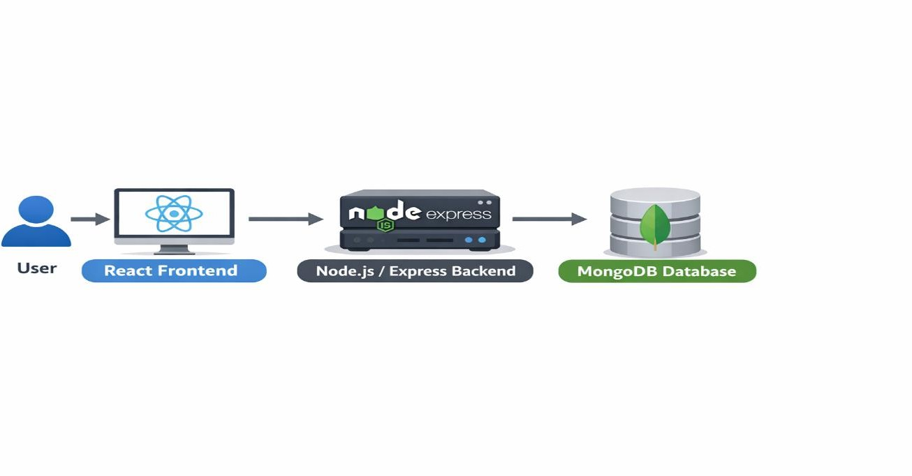

4.1.2 Frontend Architecture (React)

The frontend of the Finance Tracker application is developed using React, which provides a component-based architecture. In React, the user interface is divided into small reusable components that manage specific parts of the application.

The main purpose of the frontend is to provide an interactive interface where users can perform financial management tasks. The interface includes pages such as login, registration, dashboard overview, expense management, income management, account management, and transaction statements.

The React Router library is used to manage navigation between different pages of the application. Each page is mapped to a specific route, allowing users to navigate through the system without reloading the entire application.

The frontend structure is organized into multiple components. For example, the DashboardLayout component provides the navigation menu and layout structure for the application. Other components such as StatsCards, ExpenseCharts, and transaction lists display financial information in a structured format.

React also uses state management to handle dynamic data within the application. For example, when a user adds an expense, the component state updates automatically to display the new transaction in the expense list.

The frontend communicates with the backend using HTTP requests through the Fetch API. These requests send user data to the backend server, which processes the information and returns the required response.

The component-based architecture of React makes the user interface modular, scalable, and easier to maintain.

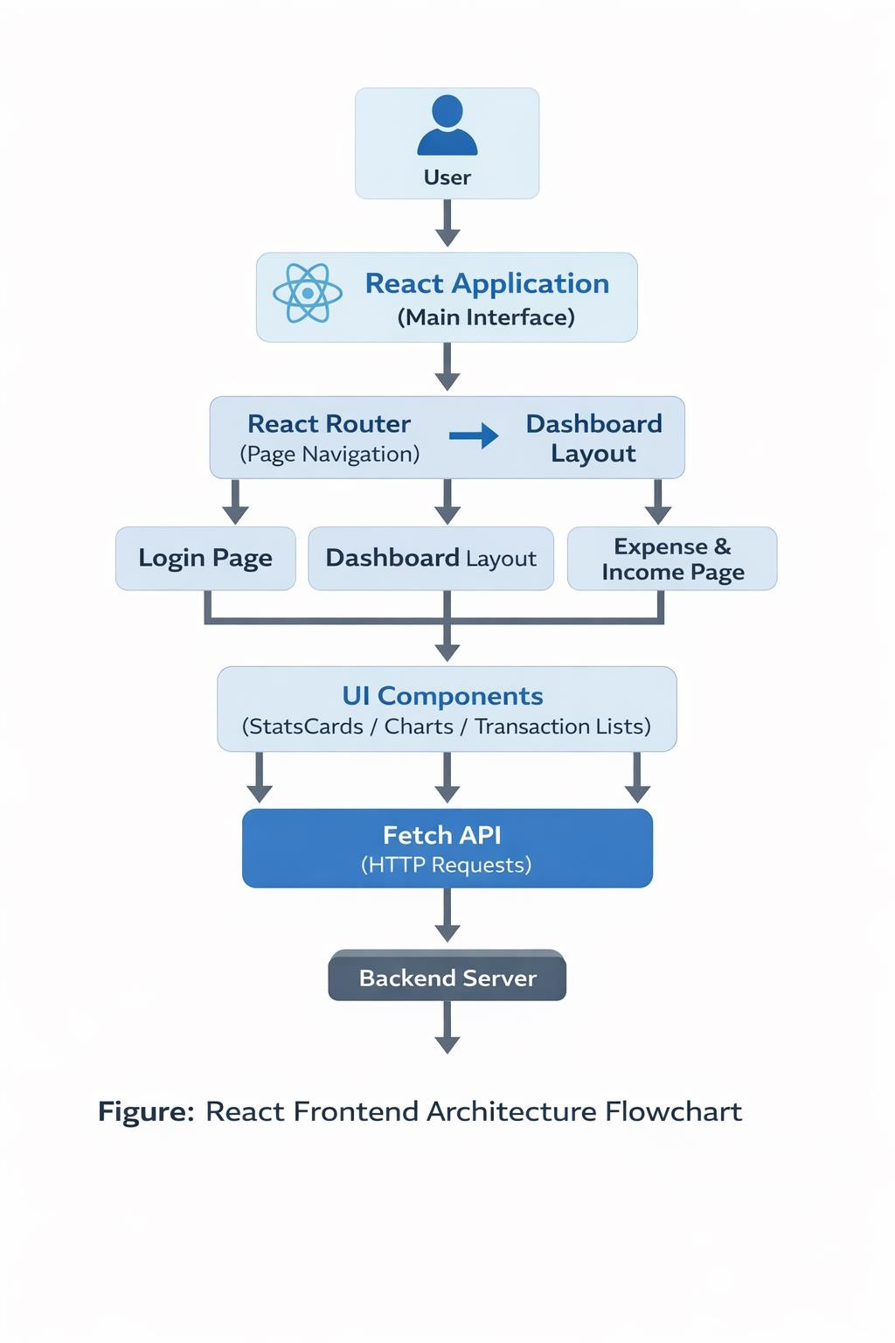

Backend Architecture (Node.js & Express)

The backend of the Finance Tracker system is responsible for handling application logic, processing user requests, and interacting with the database. The backend is developed using Node.js and Express.js, which provide a powerful platform for building RESTful APIs.

Node.js allows JavaScript to run on the server side, enabling developers to use the same programming language for both frontend and backend development. Express.js is a web framework built on top of Node.js that simplifies the process of creating server applications and APIs.

The backend system is structured around RESTful API endpoints. Each endpoint performs a specific operation such as creating accounts, adding income, recording expenses, or retrieving transaction data. These endpoints allow the frontend application to interact with the backend system through HTTP requests.

The backend also performs data validation and business logic processing. For example, when a user adds an expense, the backend verifies the input data and updates the corresponding account balance. If the expense causes the account balance to become negative, the system displays a warning message before processing the transaction.

The backend communicates with the MongoDB database using Mongoose, which provides an object data modeling (ODM) library for MongoDB.

Overall, the backend architecture ensures that financial data is processed securely and accurately while maintaining efficient communication with the frontend.

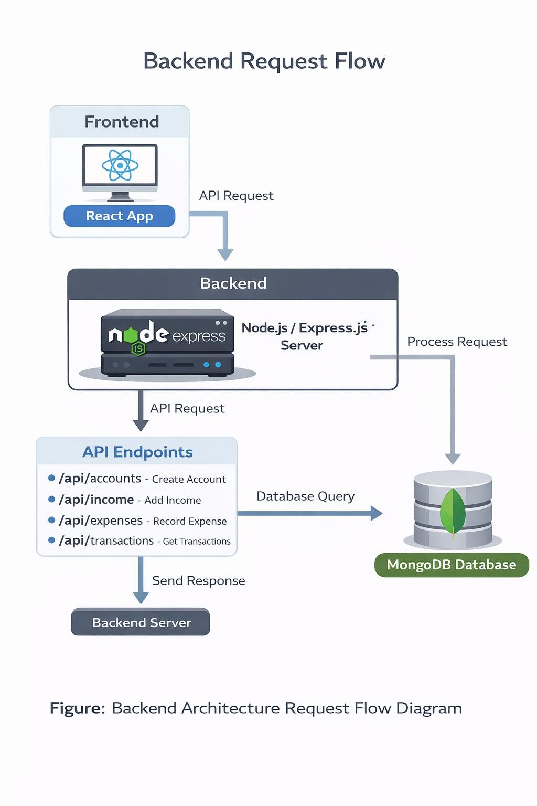

Database Design (MongoDB)

The Finance Tracker system uses MongoDB as its primary database for storing application data. MongoDB is a NoSQL database that stores data in JSON-like documents called BSON (Binary JSON). This structure provides flexibility and allows developers to design dynamic data models.

The database consists of several collections that store different types of data. These collections include Users, Accounts, Income, and Expenses. Each collection stores documents containing information related to specific system entities.

The Users collection stores user account information such as name, email address, and password. Each user document is associated with a unique identifier that links the user to their financial records.

The Accounts collection stores information about financial accounts such as bank accounts or cash accounts. Each account document contains fields such as account type, alias name, last four digits of the account number, and account balance.

The Income collection records all income transactions. Each income document contains information such as amount, category, account reference, date, and additional notes.

The Expenses collection stores expense transactions. Each expense document includes details such as amount, category, account reference, note, description, and date.

MongoDB allows relationships between collections using reference fields such as account IDs and user IDs.

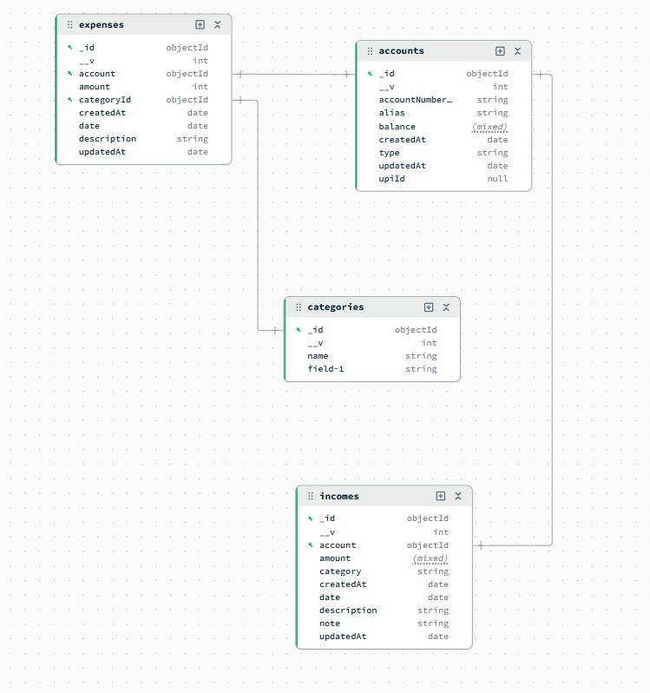

Data Flow Diagrams

Data Flow Diagrams (DFDs) illustrate how data moves through the Finance Tracker system. These diagrams help visualize the interaction between users, system processes, and the database.

In the Finance Tracker system, the primary data flow begins with the user. The user interacts with the frontend interface by entering financial data such as income, expenses, or account information.

The frontend sends this data to the backend server through API requests. The backend processes the request, validates the input, and performs the required operation. For example, when a user adds an expense, the backend checks the account balance and updates the expense record.

After processing the request, the backend updates the MongoDB database with the new information. The updated data is then returned to the frontend, which updates the user interface accordingly.

Data flow diagrams help developers understand how information moves within the system and ensure that data processing follows a structured workflow.

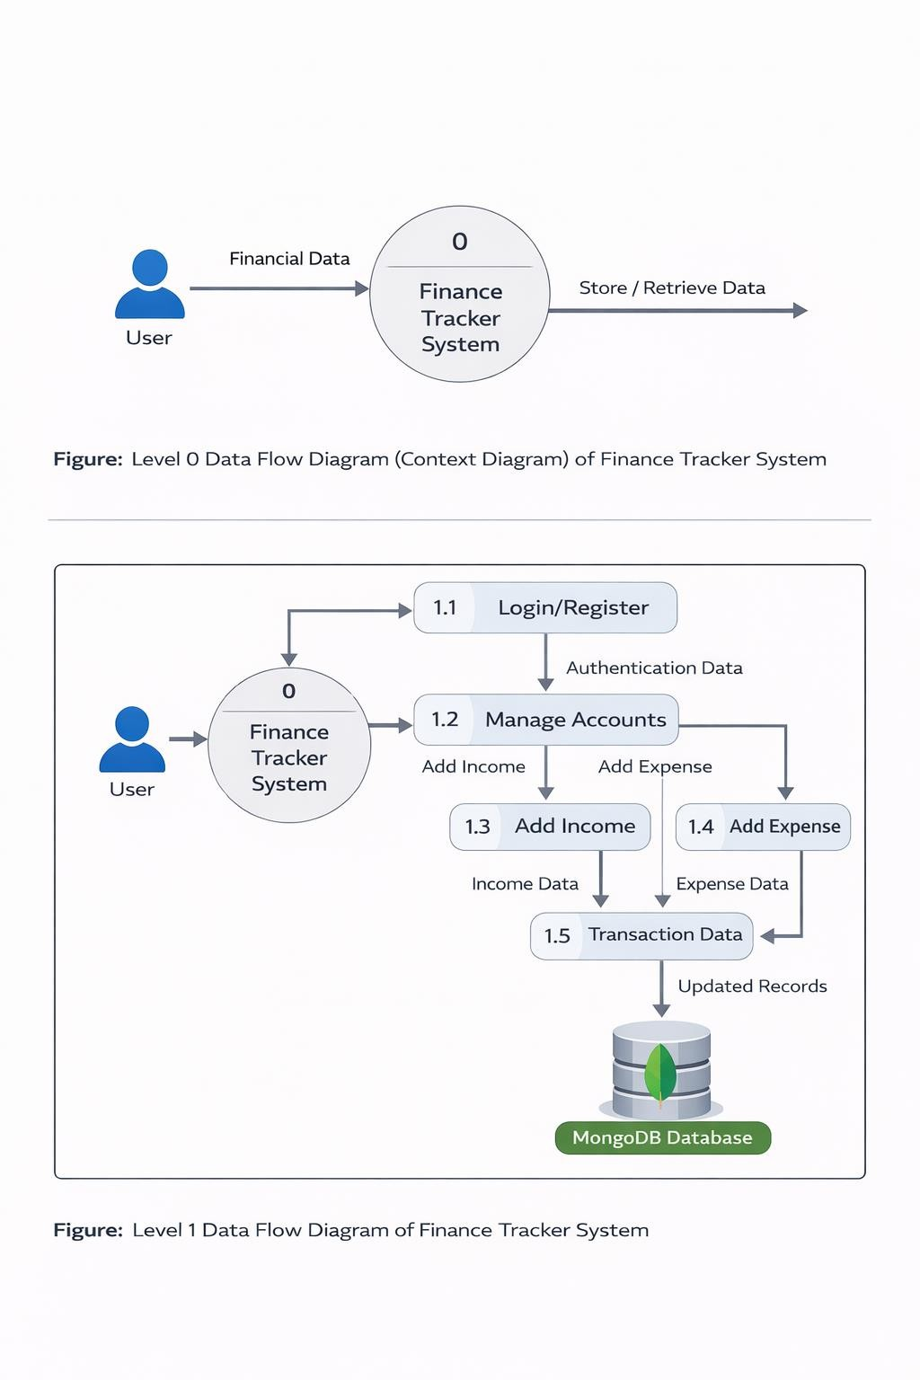

Flowcharts

Flowcharts are used to represent the logical flow of operations within the Finance Tracker system. They help visualize the sequence of steps involved in performing specific tasks such as user login, adding income, or recording expenses.

For example, the User Login Flowchart begins when a user enters their email and password. The system validates the input data and checks the credentials against the database. If the credentials are valid, the user is redirected to the dashboard. If the credentials are incorrect, an error message is displayed.

Another important flowchart is the Add Expense Flowchart. In this process, the user enters expense details such as amount, category, and account. The system validates the input data and checks the account balance. If the transaction results in a negative balance, the system displays a warning message. Otherwise, the expense is saved and the account balance is updated.

Flowcharts simplify complex system logic and make it easier for developers and users to understand the application workflow.

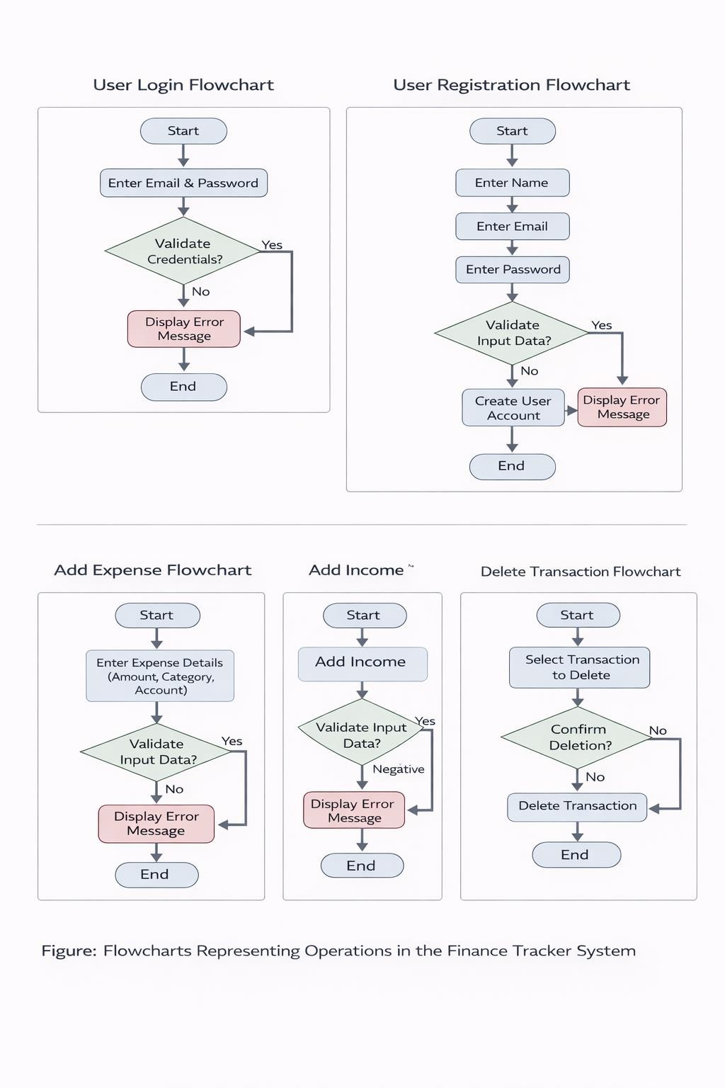

User Interface Design

The user interface (UI) design of the Finance Tracker system focuses on simplicity, usability, and clarity. The interface is designed to ensure that users can perform financial management tasks easily without confusion.

The application uses a dashboard layout structure, which includes a navigation menu and a content area. The navigation menu allows users to switch between different pages such as Overview, Expenses, Income, Accounts, and Statements.

Each page in the application is designed with clear input forms and organized data tables. For example, the expense management page includes a form for adding expenses and a table that displays previously recorded transactions.

The system also includes visual elements such as charts and graphs to help users analyze financial data. The overview dashboard displays financial summaries and graphical insights using chart libraries.

Color schemes and layout spacing are carefully chosen to improve readability and user experience. Important actions such as adding transactions or confirming deletions are highlighted using buttons and modal dialogs.

A well-designed user interface improves user satisfaction and ensures that financial tasks can be performed quickly and efficiently.

Login Page

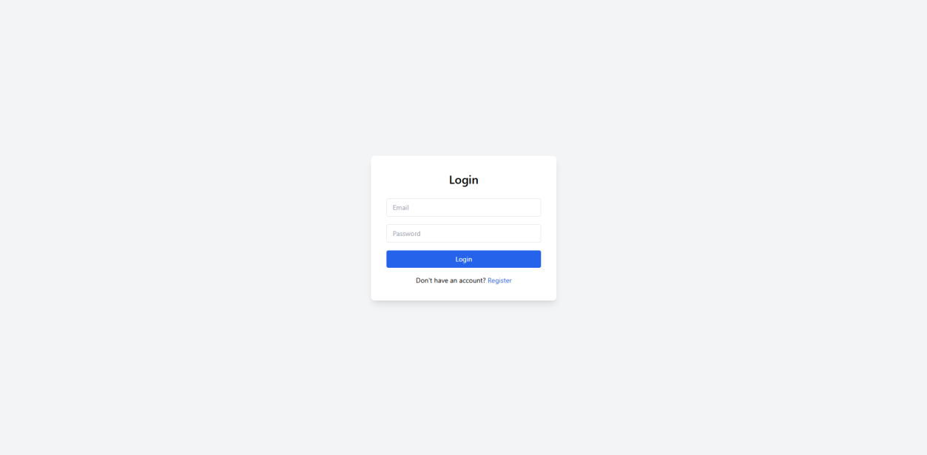

Register Page

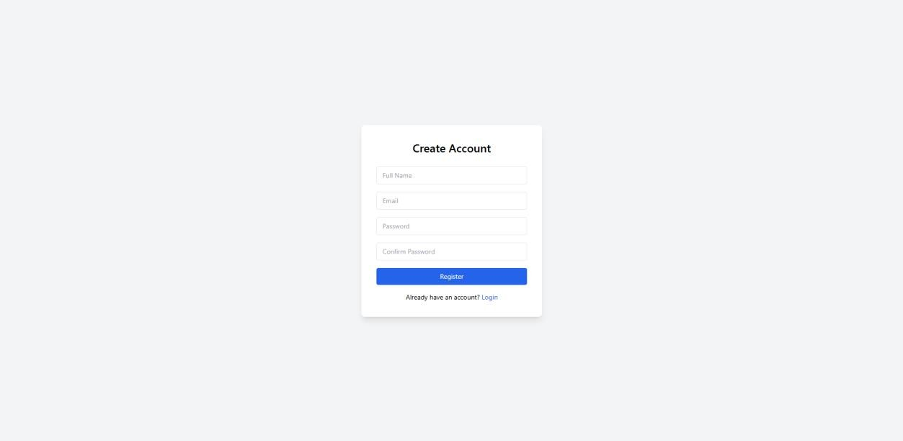

Overview Page

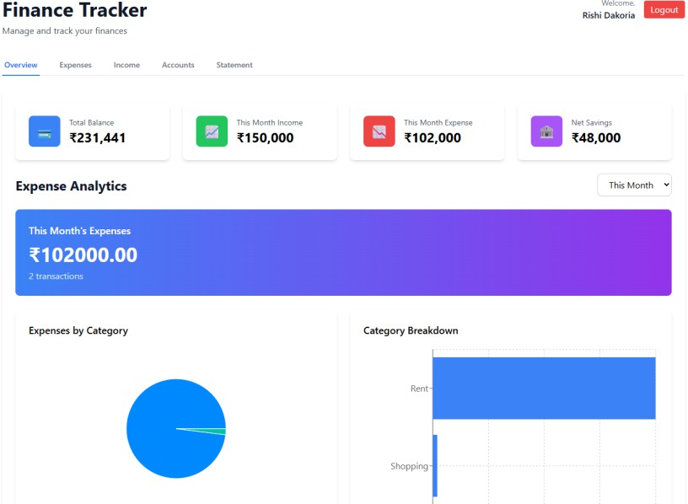

Statement Page

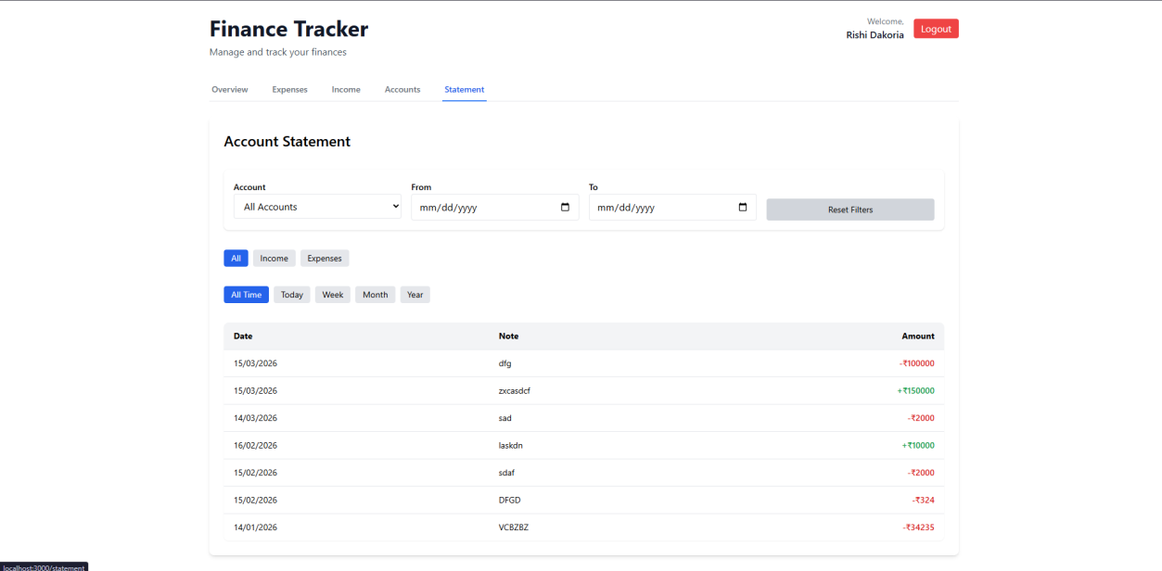

Expense Page

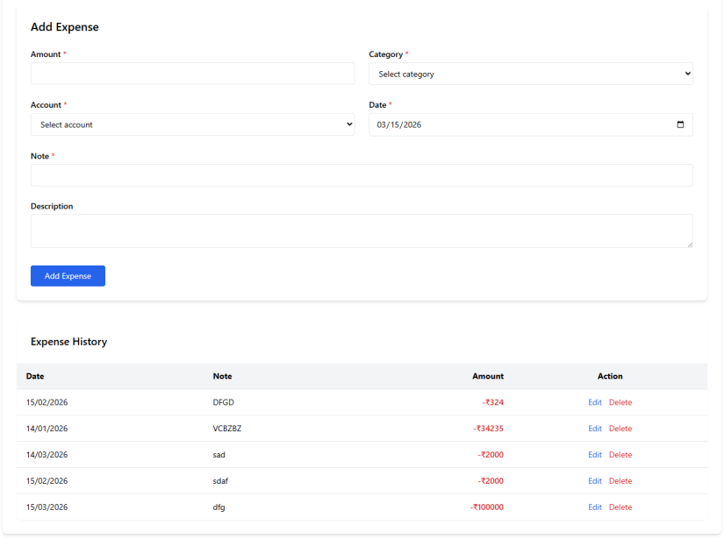

Income Page

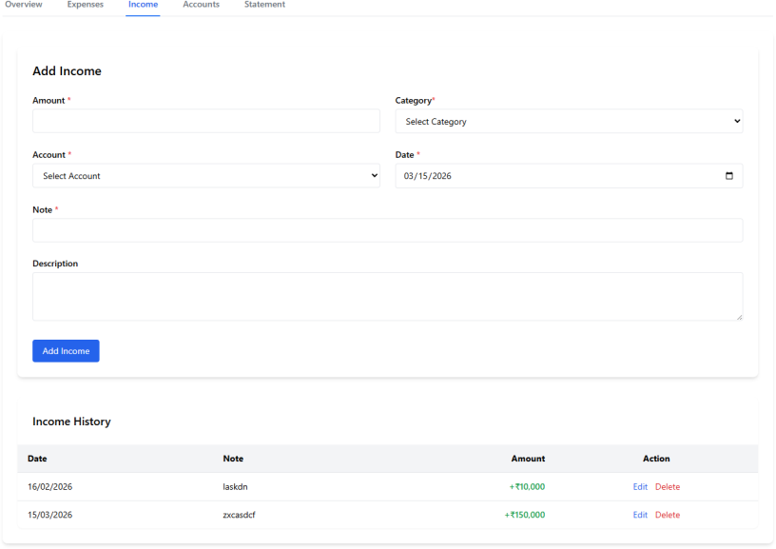

Account Page

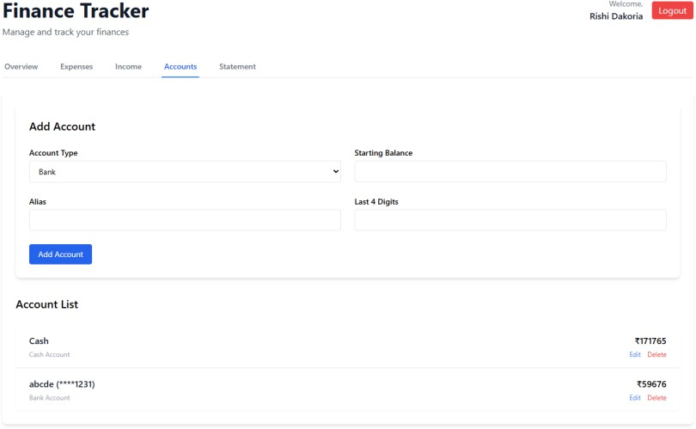

Expense Edit Form

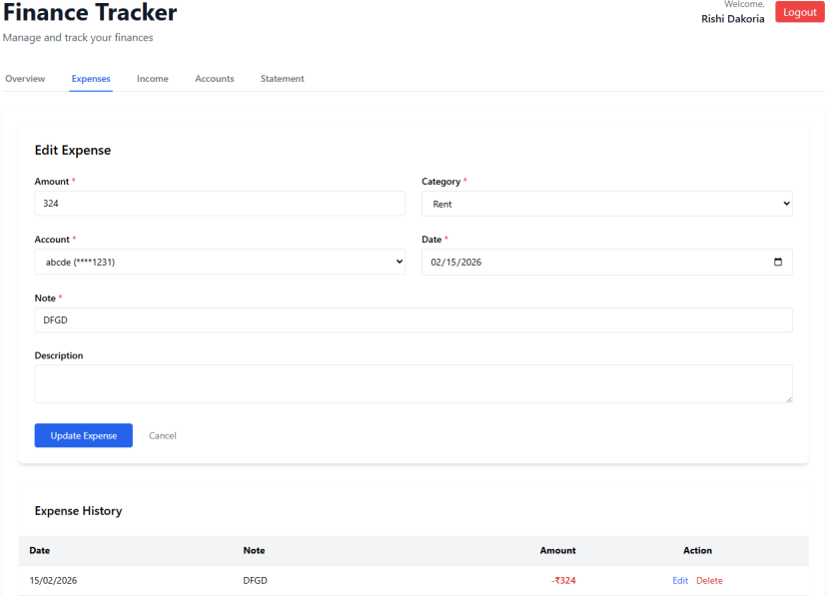

Income Edit Form

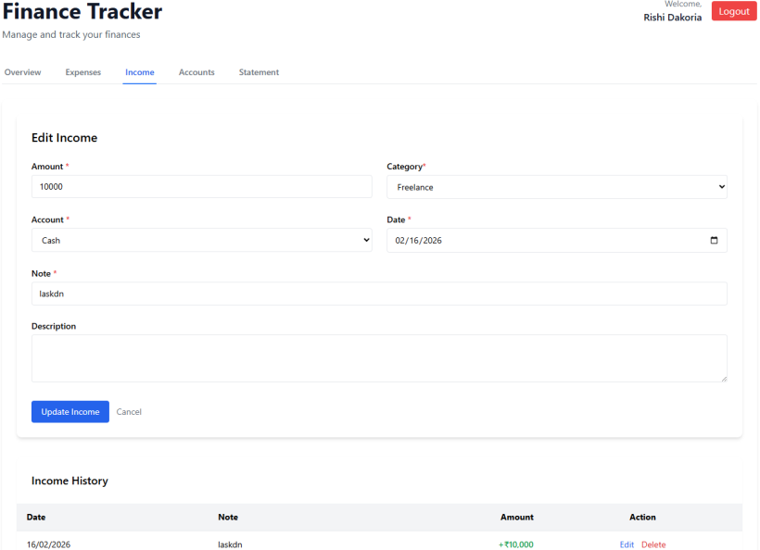

Transaction Details Box

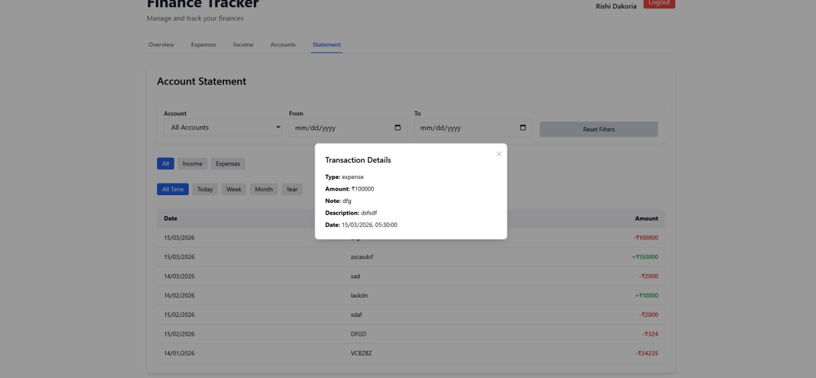

Admin Interface Design

Platform Pulse Page

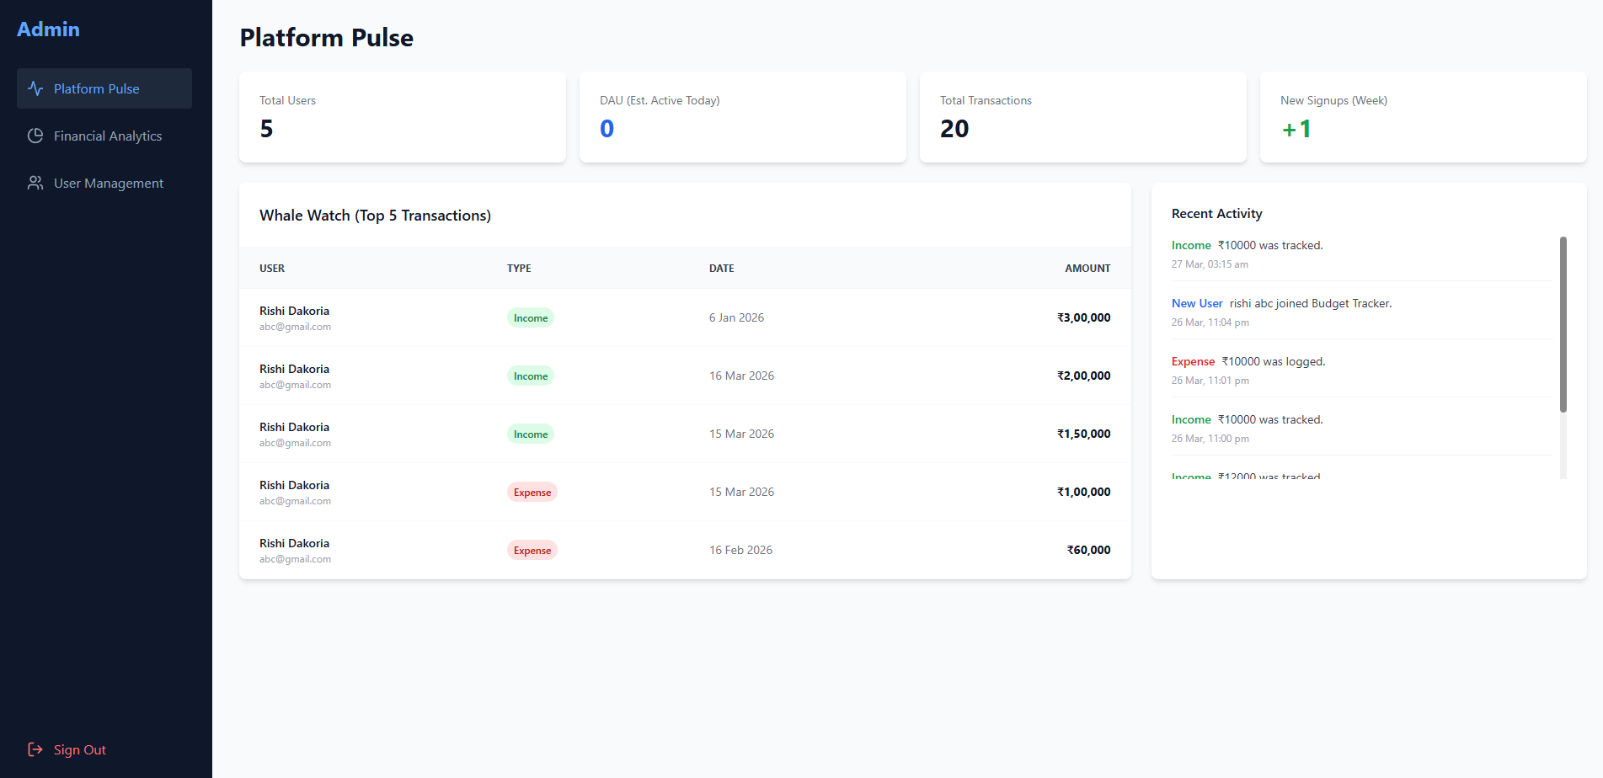

Financial Analystics Page

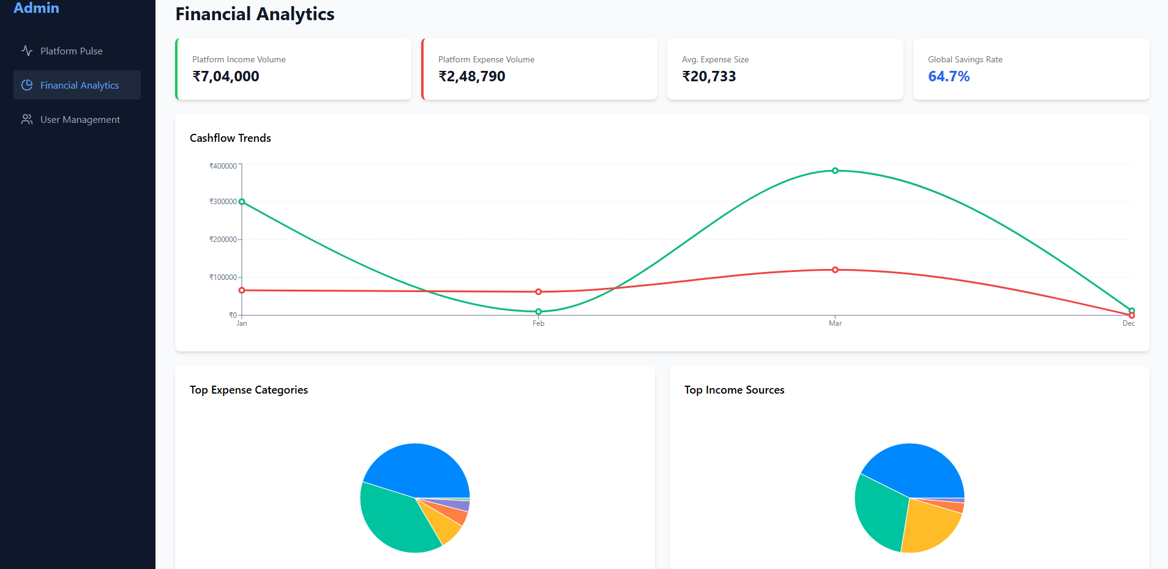

User Management Page

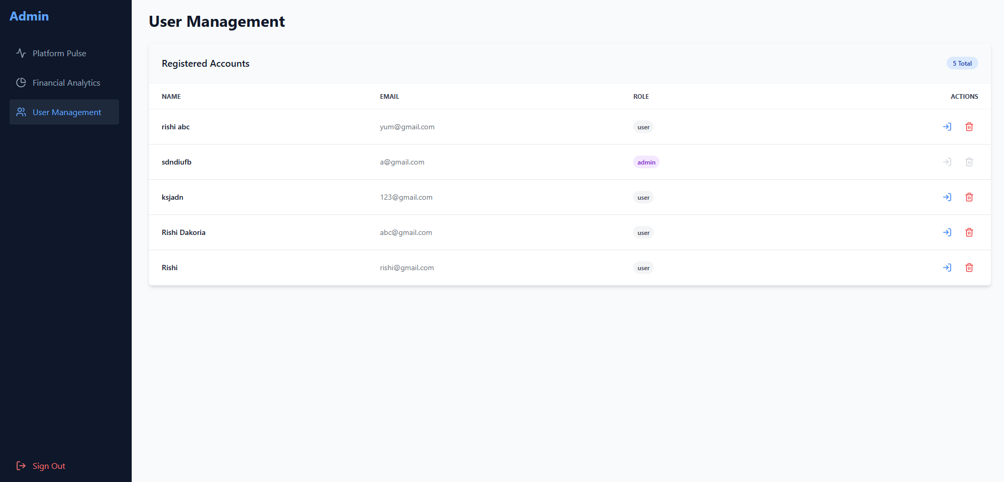

4.2 Database Design

The database design plays a crucial role in the overall functionality and performance of the Finance Tracker system. A well-structured database ensures that financial data such as income, expenses, accounts, and user information are stored efficiently and can be retrieved quickly when needed. The system uses MongoDB, a NoSQL document database, which stores data in the form of flexible JSON-like documents called BSON objects.

Unlike traditional relational databases that rely on rigid tables and relationships, MongoDB allows developers to store structured and semi-structured data in a more flexible format. This flexibility is especially beneficial for applications like a finance tracker where different transactions may contain varying attributes such as notes, descriptions, categories, and account information.

In the Finance Tracker system, each major entity is represented by a collection in MongoDB. The primary collections used in this system include:
- Users
- Accounts
- Income
- Expenses

Each collection stores documents that represent individual records. For example, the Accounts collection stores information about user bank accounts or cash balances, while the Expenses collection stores records of all expense transactions.

MongoDB also supports indexing, which improves the performance of frequently executed queries such as retrieving all expenses for a specific user or filtering transactions by date. By using proper indexing strategies and structured document schemas, the Finance Tracker ensures efficient data retrieval and scalability.

The database design also supports data consistency and financial accuracy. Whenever a transaction is created, updated, or deleted, the system updates the corresponding account balance automatically. This ensures that the displayed balance always reflects the correct financial state.

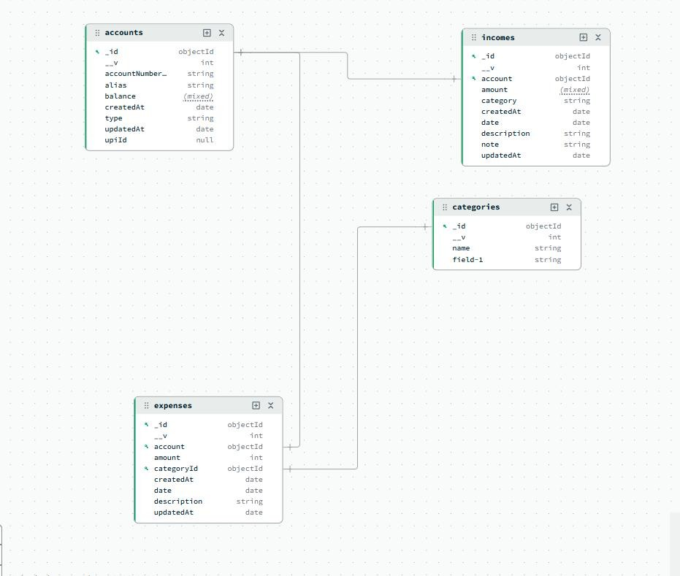

User Collection

The User Collection stores all registered users of the Finance Tracker application. This collection is responsible for managing authentication and maintaining basic information about each user. Every user who registers on the platform has a unique document stored in this collection.

Each user document typically contains fields such as the user’s full name, email address, password, and timestamps that record when the account was created. The email field is usually indexed and stored as a unique value to ensure that two users cannot register with the same email address.

Security is an important aspect of user data management. Therefore, passwords are not stored in plain text. Instead, they are hashed using secure encryption algorithms before being saved in the database. This protects user credentials even if the database is compromised.

The User collection acts as the central entity that connects to other collections in the system. Each account, expense, or income record is associated with a specific user through a user identifier. This relationship ensures that users can only access their own financial data.

A typical User document structure may include:
    - _id – Unique identifier generated by MongoDB
    - name – Full name of the user
    - email – Unique email address
    - password – Hashed password
    - createdAt – Account creation timestamp

This collection enables features such as user registration, login authentication, and personalized financial dashboards.

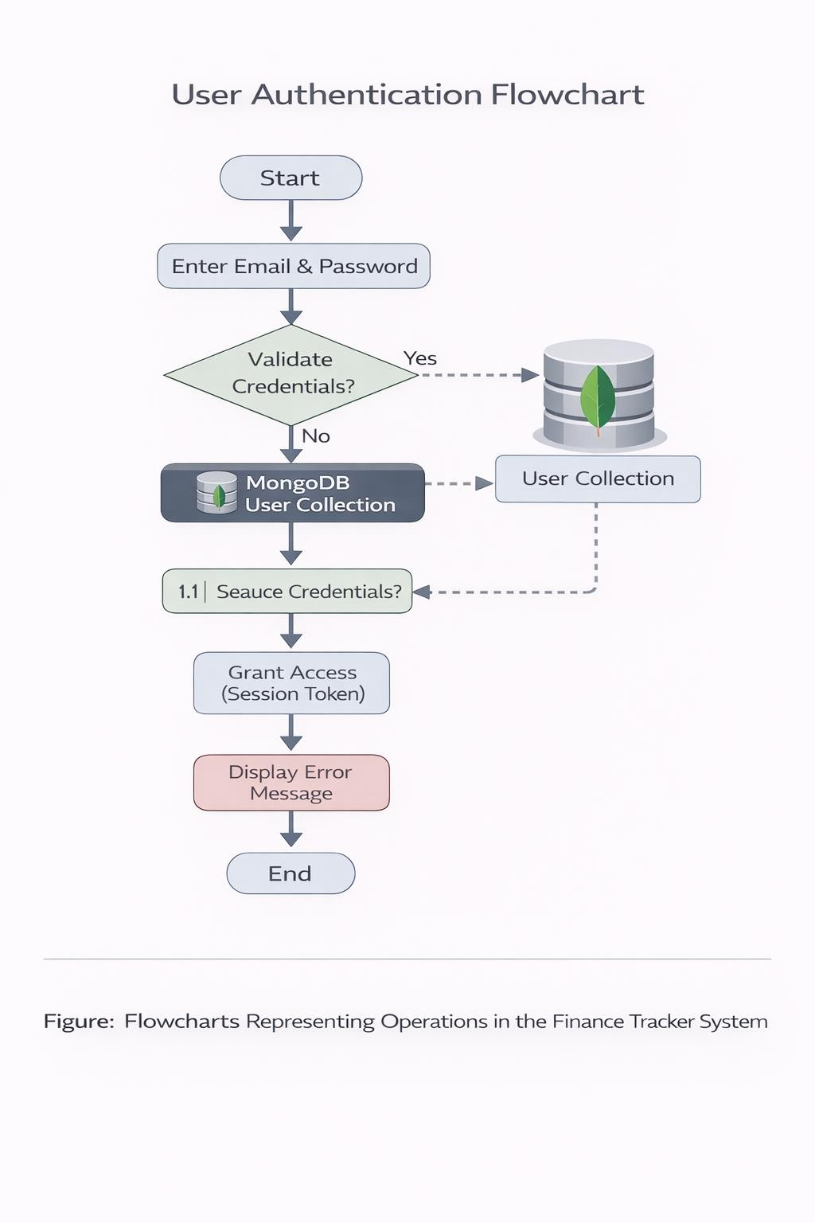

Accounts Collection

The Accounts Collection stores information about the financial accounts used by the user. These accounts represent the different sources where money is stored, such as bank accounts, wallets, or physical cash.

Each account document contains information about the type of account, the alias or nickname of the account, the last four digits of the bank account number (for security purposes), and the current balance available in the account. Users can create multiple accounts within the system, allowing them to manage finances across different financial sources.

The account balance plays an essential role in the finance tracker system. Whenever a user adds an income transaction, the balance of the selected account increases. Conversely, when an expense is recorded, the balance decreases. This dynamic balance update mechanism ensures that the account always reflects the real-time financial status.

The account system also supports two different types of accounts:
- Bank Accounts – These contain an alias and the last four digits of the account number.
- Cash Accounts – These represent physical cash and do not require an account number.

Each account is linked to a specific user through the user identifier field. This ensures that users cannot view or modify accounts belonging to other users.
Typical fields in an account document include:
  - _id – Unique account identifier
  - userId – Reference to the user
  - type – Bank or Cash
  - alias – Account nickname
  - accountNumberLast4 – Last four digits of the account number
  - balance – Current account balance

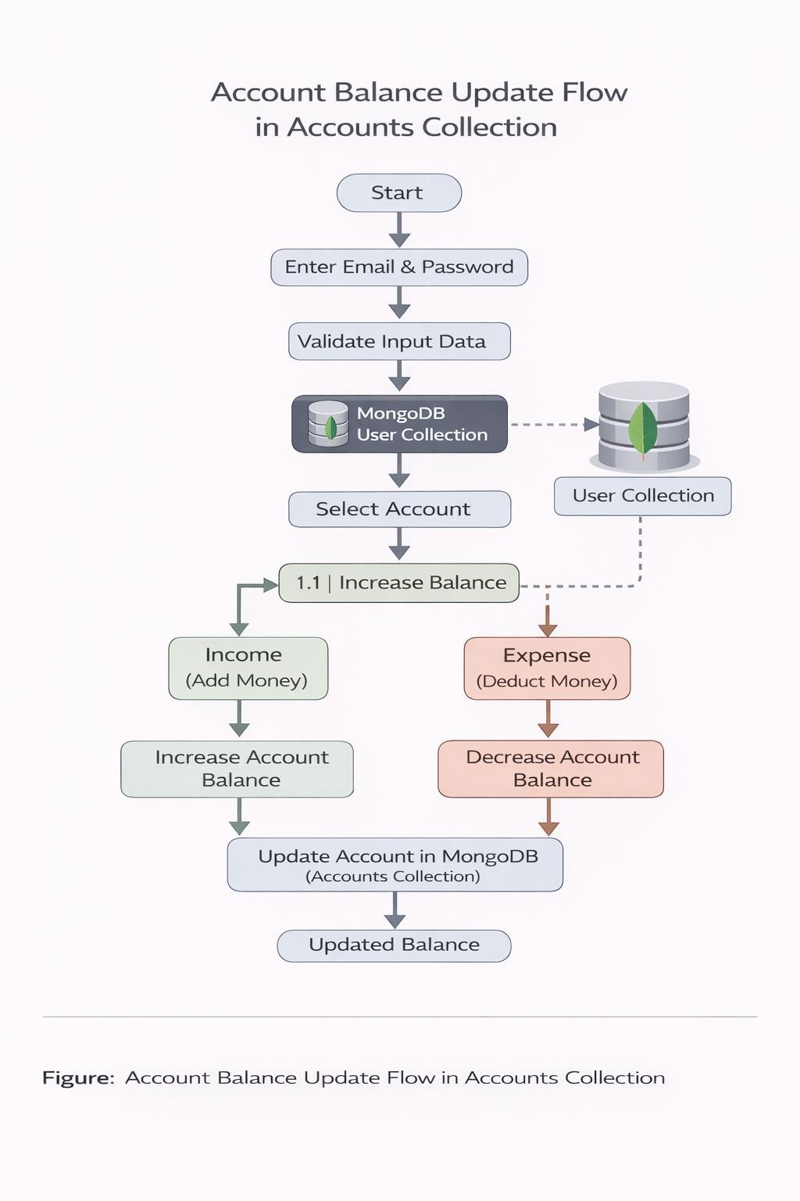

Income Collection

The Income Collection stores all income transactions recorded by users. Income transactions represent any money received by the user, such as salaries, freelance payments, business income, or investment returns.

Each income record contains information such as the amount received, the category of income, the account where the income was deposited, the transaction date, and additional notes or descriptions. These records allow users to maintain a clear history of all incoming financial transactions.

One important design consideration in the income collection is maintaining accurate relationships with the Accounts collection. When an income record is created, the system automatically updates the corresponding account balance by adding the transaction amount.

Income categories help users classify different sources of earnings. For example, income may be categorized as salary, business revenue, freelance income, or investment returns. These categories are useful when generating reports or analyzing income trends.

Typical fields in the Income collection include:
    - _id – Unique transaction identifier
    - userId – User who owns the transaction
    - amount – Income amount
    - category – Type of income
    - account – Associated account
    - date – Date of the transaction
    - note – Short description
    - description – Additional details

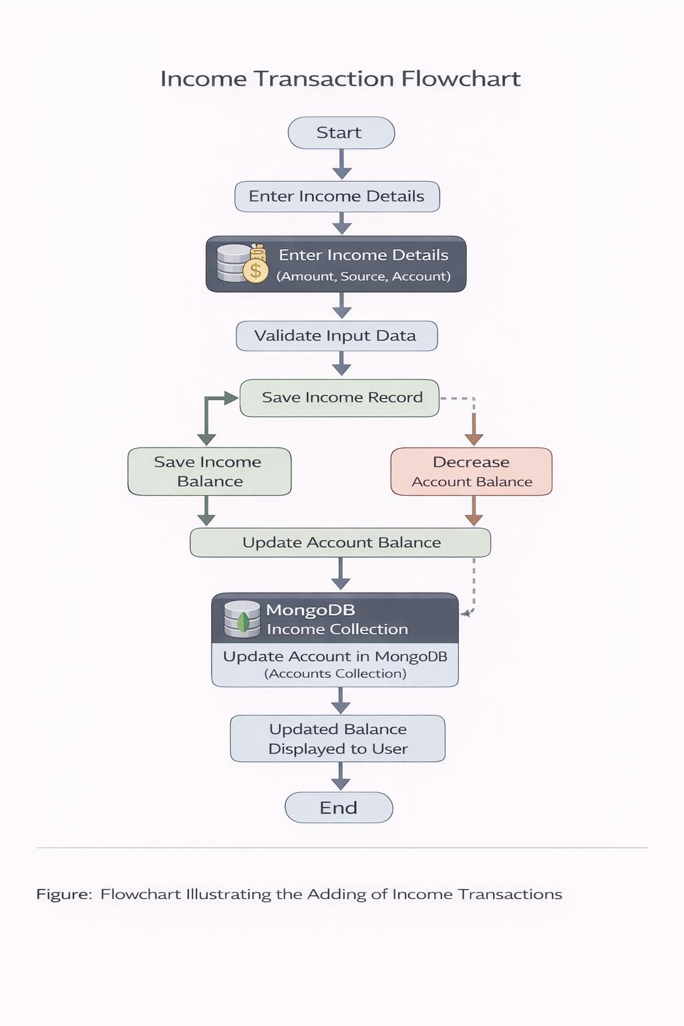

4.2.4 Expense Collection

The Expense Collection stores all expense transactions recorded by users. These transactions represent money spent on various activities such as groceries, utilities, transportation, entertainment, and other daily expenses.

Each expense document contains detailed information about the transaction, including the amount spent, category, account used, date of the expense, and descriptive notes. This structured storage allows users to easily track where their money is being spent.

When a user records a new expense, the system performs validation checks before saving the transaction. One important validation ensures that the account balance does not become negative unless the user explicitly confirms the action. This feature prevents accidental overspending and improves financial awareness.

After a valid expense is added, the system automatically deducts the expense amount from the selected account balance. This ensures that the account balance remains accurate and consistent with the user's financial activities.

Typical fields stored in the Expense collection include:
    - _id – Unique identifier for the expense
    - userId – Owner of the transaction
    - amount – Expense amount
    - categoryId – Expense category reference
    - account – Account used for payment
    - date – Transaction date
    - note – Short note
    - description – Additional details

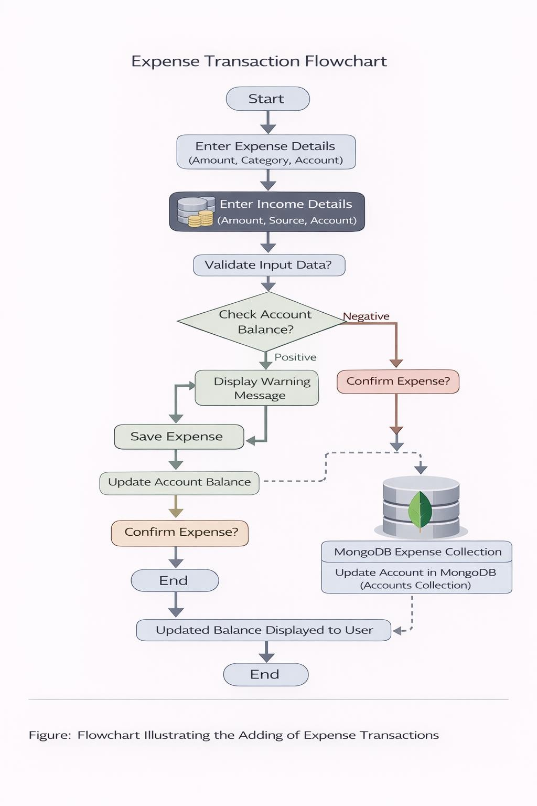

Relationships Between Collections

In the Finance Tracker system, the different collections are interconnected to maintain accurate financial data and ensure proper functionality. These relationships allow the system to associate transactions with users and accounts, enabling personalized financial tracking.

The primary relationship exists between the User collection and the other collections. Each account, income transaction, and expense transaction belongs to a specific user. This relationship is maintained through the userId field stored in each document. When a user logs into the application, the system retrieves only the records associated with that user identifier.

Another important relationship exists between Accounts and Transactions. Each income or expense transaction references an account through the account identifier. This relationship allows the system to update account balances whenever transactions are created, updated, or deleted.

For example:
    - When income is added, the account balance increases.
    - When an expense is recorded, the account balance decreases.
    - When a transaction is edited or deleted, the account balance is recalculated accordingly.

Although MongoDB does not enforce relationships through foreign keys like relational databases, these relationships are maintained through application logic within the backend API.

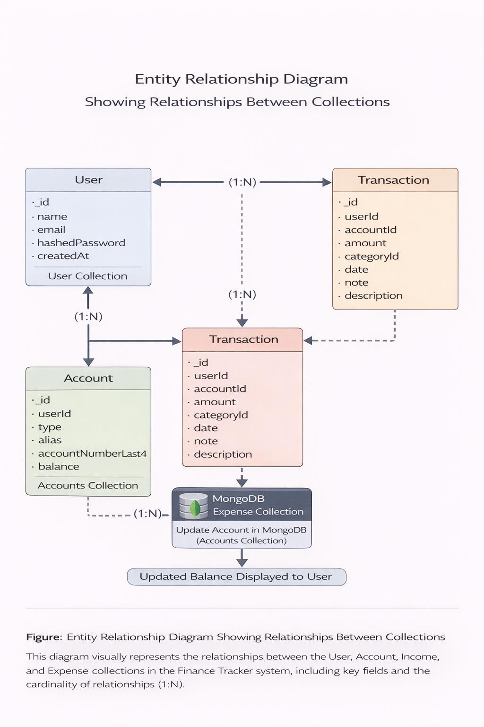

Implementation

The implementation phase involves converting the system design into a fully functional software application. During this phase, the Finance Tracker system was developed using modern web development technologies including React for the frontend, Node.js with Express for the backend, and MongoDB for data storage. These technologies were selected because they allow the development of scalable, responsive, and high-performance applications.

The system follows a client-server architecture, where the frontend interacts with the backend through RESTful APIs. The frontend is responsible for displaying the user interface and handling user interactions, while the backend processes requests, performs validation, manages business logic, and communicates with the database.

The development process involved several stages including building the user interface, creating API endpoints, implementing authentication mechanisms, managing financial transactions, and testing the complete system to ensure accurate functionality. The implementation also focuses on maintaining data consistency, particularly when handling financial operations such as income addition, expense deduction, and account balance updates.

The system ensures that all transactions are recorded correctly and that account balances remain synchronized with the transaction history. Additional features such as input validation, error handling, and confirmation modals were implemented to improve the reliability and usability of the application.

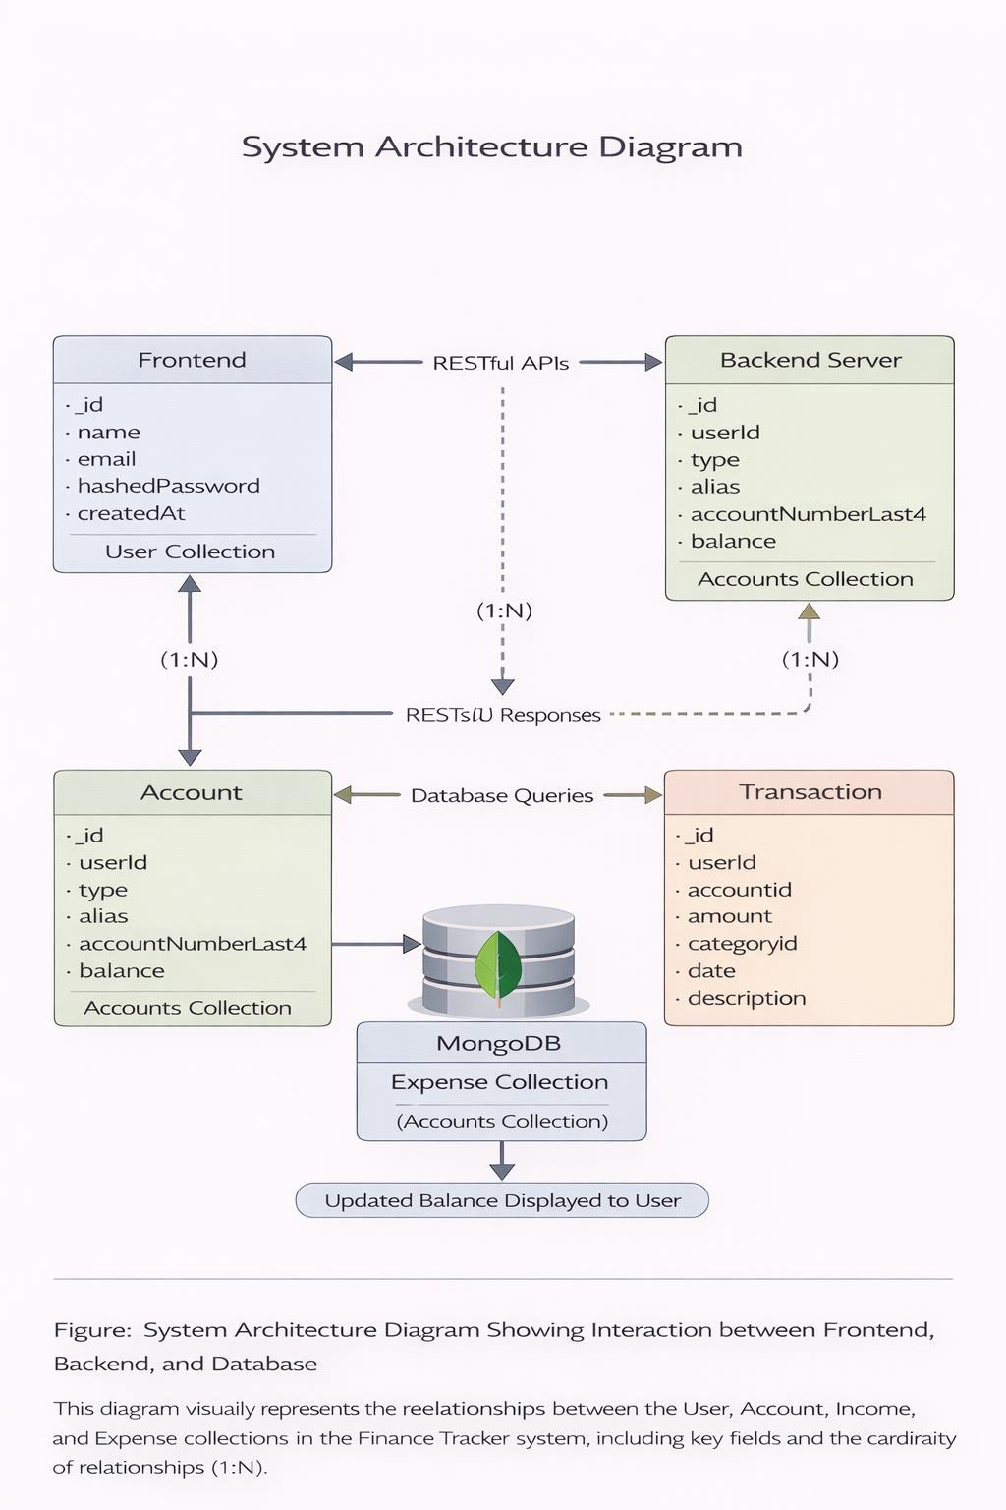

Frontend Implementation

The frontend of the Finance Tracker system was developed using React, a widely used JavaScript library for building interactive user interfaces. React allows developers to create reusable components that simplify the development and maintenance of complex applications.

The frontend is responsible for presenting the application interface to users and handling user interactions such as adding expenses, viewing income history, managing accounts, and analyzing financial data through charts.

The application is organized into multiple components and pages, including:
    - Login Page
    - Registration Page
    - Overview Dashboard
    - Expense Management Page
    - Income Management Page
    - Accounts Page
    - Statement Page

Each page is implemented as a separate React component to maintain modularity and readability. These components communicate with the backend using the Fetch API to send and receive data through HTTP requests.

React hooks such as useState and useEffect are used extensively to manage application state and handle asynchronous data loading. For example, when the Expense page loads, the system automatically fetches the list of expenses from the backend and displays them in a table format.

The frontend also uses Tailwind CSS to create a responsive and visually appealing user interface. Tailwind allows rapid UI development through utility-based styling classes.

Interactive features implemented in the frontend include:
    - Form validation
    - Confirmation dialogs for deleting transactions
    - Warning modals for negative balances
    - Dynamic filtering of financial statements
    - Real-time balance updates

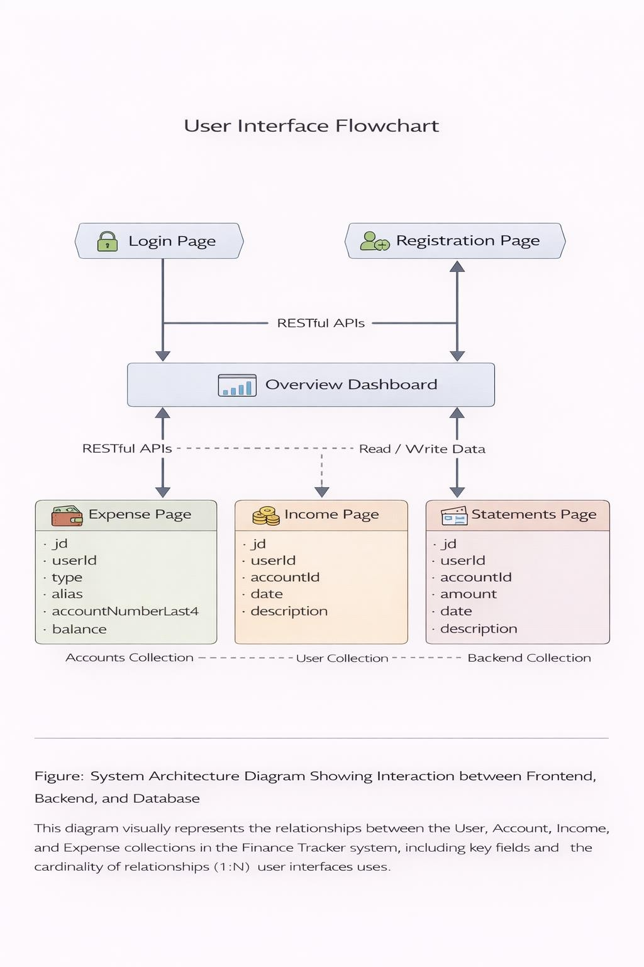

Backend Implementation

The backend of the Finance Tracker system was implemented using Node.js and Express.js, which provide a powerful environment for building scalable server-side applications.

Node.js allows developers to run JavaScript on the server side, enabling seamless integration between the frontend and backend. Express.js, a lightweight web framework for Node.js, simplifies the process of creating RESTful APIs and managing HTTP requests.

The backend server is responsible for several important tasks including:
    - Handling API requests from the frontend
    - Performing input validation
    - Managing business logic
    - Communicating with the MongoDB database

The backend is structured into multiple modules including:
    - Authentication routes
    - Income routes
    - Expense routes
    - Account routes
    - Category routes

Each module contains specific controllers that process requests related to that functionality. For example, the Expense controller handles operations such as adding expenses, updating expense records, deleting expenses, and validating account balances.

The backend also includes middleware functions for error handling and request validation. These middleware components ensure that invalid or incomplete requests are rejected before reaching the database.

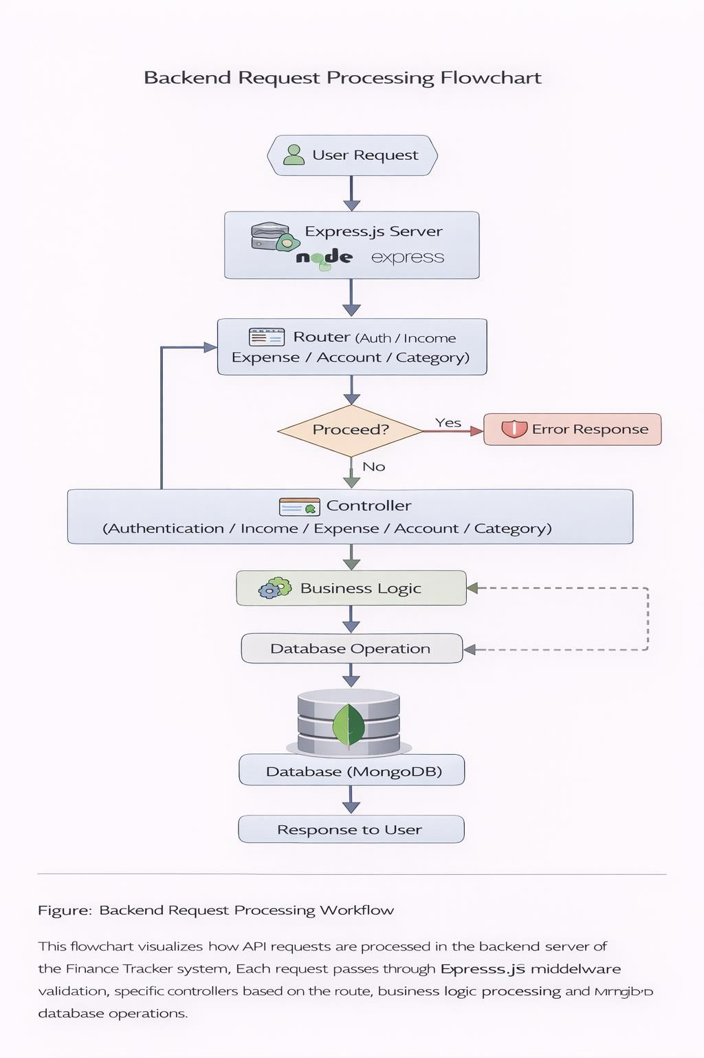

API Design

The Finance Tracker system uses RESTful APIs to enable communication between the frontend and backend. REST APIs provide a standardized method for exchanging data using HTTP methods such as GET, POST, PUT, and DELETE.

Each major system function is implemented as an API endpoint. These endpoints allow the frontend application to perform operations such as retrieving transaction history, creating new income records, updating expenses, and deleting accounts.
Examples of important API endpoints include:

User Authentication
POST /api/auth/register
POST /api/auth/login

Accounts
GET /api/accounts
POST /api/accounts
PUT /api/accounts/:id
DELETE /api/accounts/:id

Income
GET /api/income
POST /api/income
PUT /api/income/:id
DELETE /api/income/:id

Expenses
GET /api/expenses
POST /api/expenses
PUT /api/expenses/:id
DELETE /api/expenses/:id

Each API request follows a structured format containing request parameters, headers, and a request body when necessary. The server processes the request, interacts with the database, and returns a JSON response containing the result.

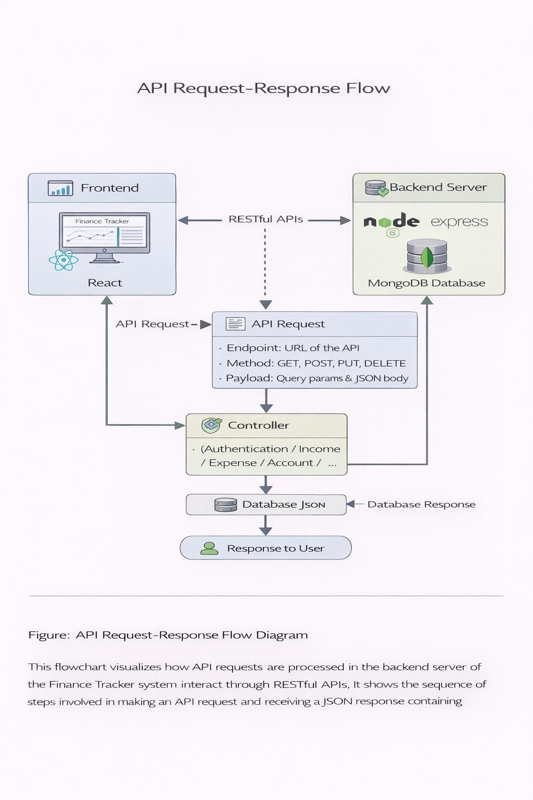

Authentication System

The authentication system ensures that only authorized users can access the Finance Tracker application and their personal financial data. This is achieved through a secure login and registration mechanism implemented in the backend.

When a user registers, the system validates the input fields such as name, email, and password. The password is then encrypted using a hashing algorithm before being stored in the database. This prevents sensitive information from being exposed.

During login, the system verifies the entered email and password against the stored user credentials. If the credentials are valid, the system allows the user to access the dashboard and other application features.

The authentication process also involves maintaining a user session using local storage. When a user logs in successfully, their user information is stored locally in the browser so that the system can identify the logged-in user for future requests.

Security measures implemented in the authentication system include:
    - Input validation for login and registration forms
    - Password hashing before database storage
    - User identity verification during login
    - Restricting data access based on user ID

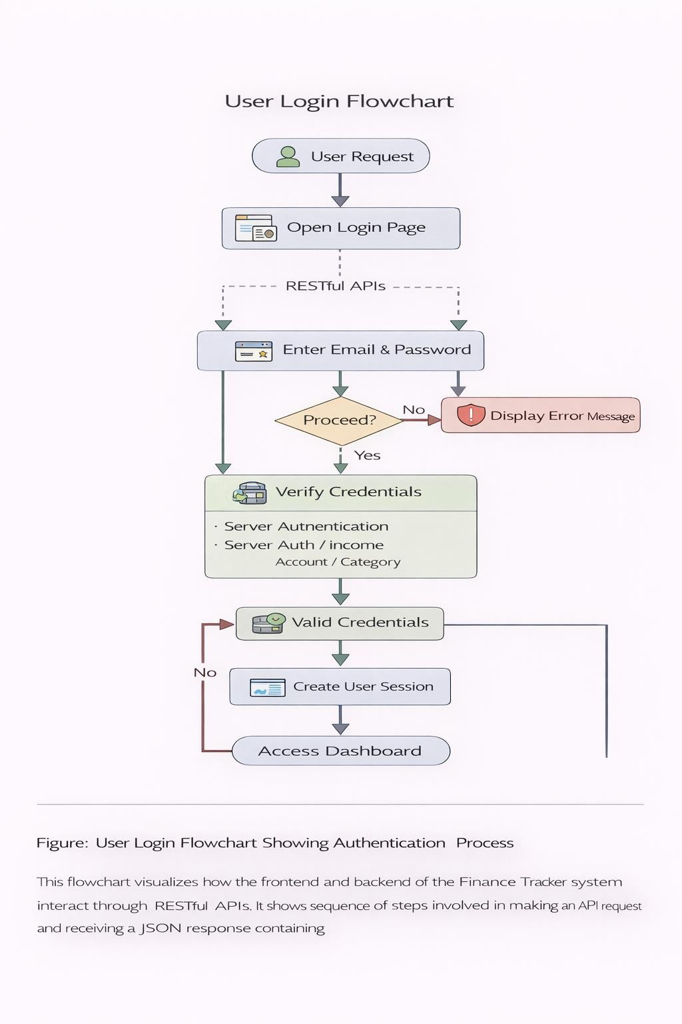

Balance Management Logic

One of the most critical components of the Finance Tracker system is the balance management logic. This logic ensures that the account balance accurately reflects all income and expense transactions.

Whenever a financial transaction occurs, the system updates the account balance accordingly. For example, when a user records an income transaction, the amount is added to the selected account's balance. When an expense is recorded, the amount is deducted from the account balance.

The system also performs validation checks to prevent negative balances unless the user explicitly confirms the transaction. If an expense would cause the account balance to drop below zero, the system displays a warning message allowing the user to either cancel the transaction or proceed with confirmation.

Similarly, when transactions are edited or deleted, the system recalculates the balance by reversing the previous transaction and applying the updated value. This ensures that the financial data remains accurate and consistent.

The balance management logic also supports advanced features such as:
    - Transaction editing
    - Forced balance overrides
    - Confirmation dialogs for risky operations
    - Automatic balance recalculation

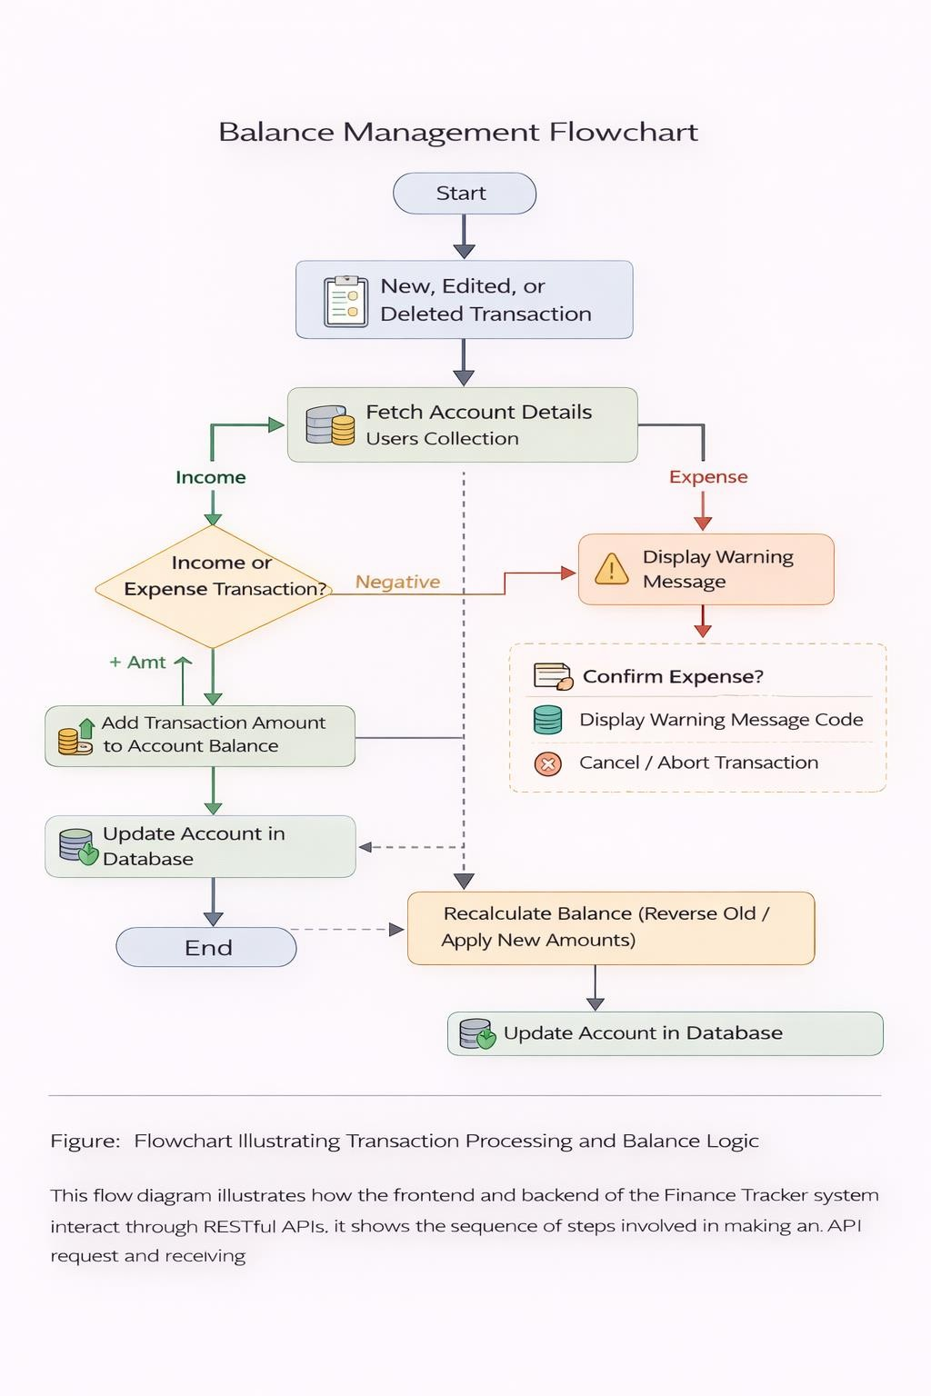

Testing

Testing is an essential phase in the software development lifecycle. It ensures that the system functions correctly, meets user requirements, and operates without errors. In the Finance Tracker system, testing was performed at multiple levels to verify that each component of the application behaves as expected.

The main objective of testing is to identify bugs, validate system functionality, and confirm that financial transactions are processed accurately. Since the application deals with financial data such as income, expenses, and account balances, accuracy and reliability are extremely important.

Different testing techniques were applied throughout the development process. These include unit testing, integration testing, functional testing, and system testing. Each testing method focuses on a specific part of the system to ensure complete coverage.

Testing was conducted for all major system modules including:
- User authentication (registration and login)
- Account management
- Income management
- Expense tracking
- Statement generation
- Balance calculation logic

Special attention was given to testing financial operations to ensure that account balances update correctly whenever transactions are added, edited, or deleted.

Error handling and validation mechanisms were also tested to ensure that the system responds appropriately when invalid data is entered. For example, the application checks whether required fields are filled, ensures that numeric values are entered where required, and prevents invalid transactions that could cause inconsistencies in financial records.

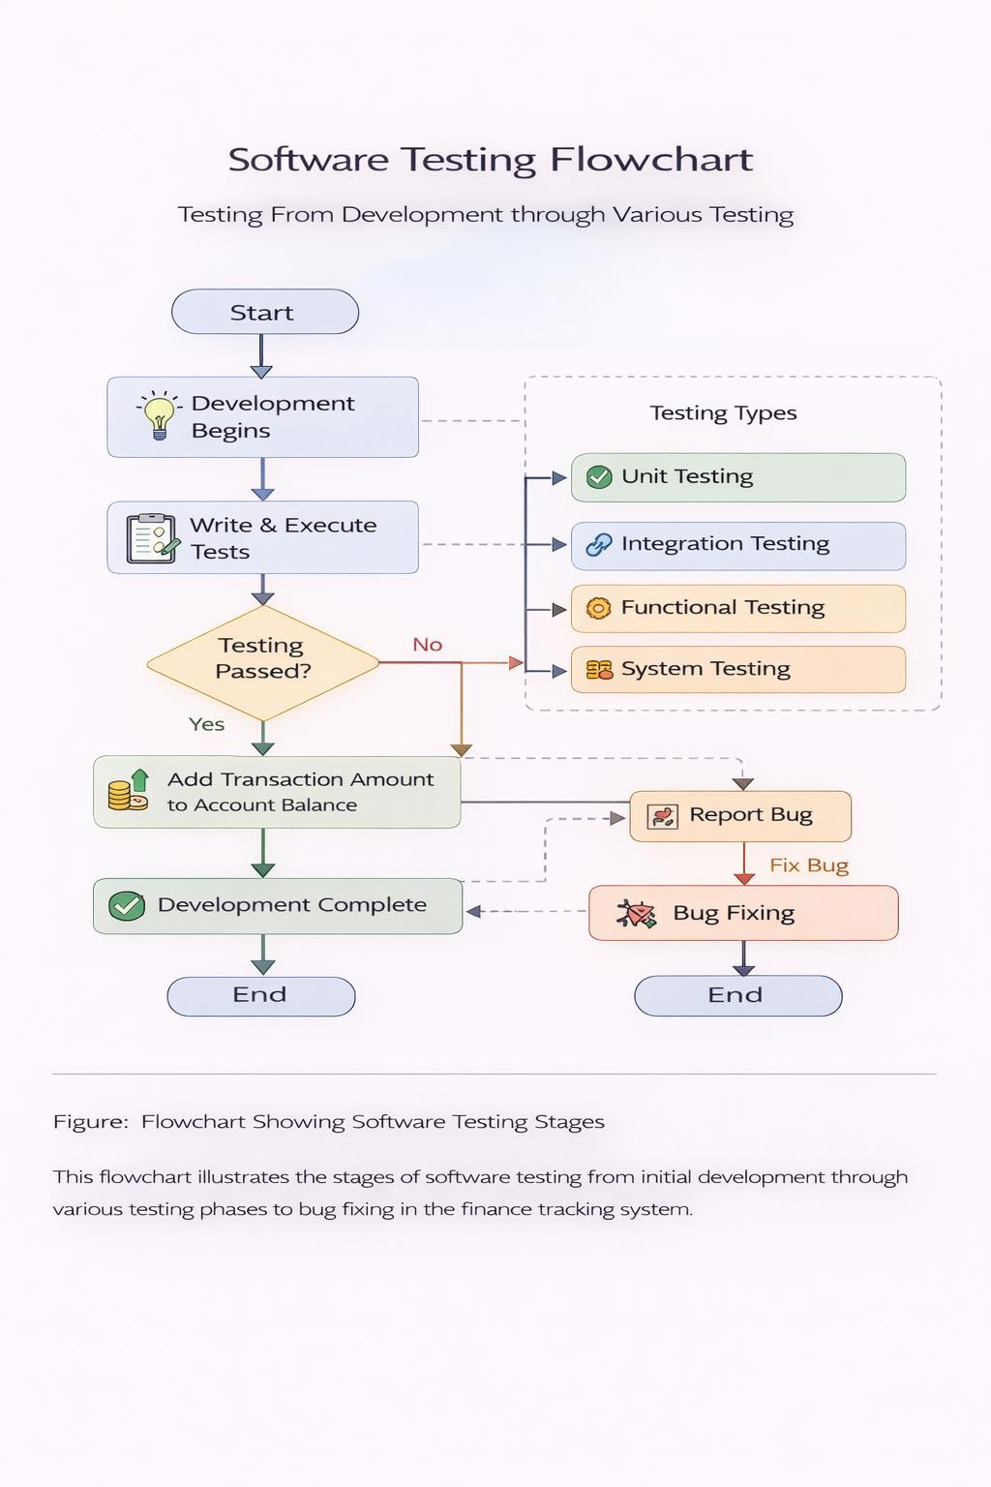

Unit Testing

Unit testing focuses on testing individual components or modules of the application independently. Each function or module is tested separately to ensure that it performs its intended operation correctly.

In the Finance Tracker system, unit testing was performed for critical backend functions such as adding income, recording expenses, updating transactions, and recalculating account balances. These functions are responsible for handling financial data, so ensuring their correctness is crucial.

For example, when testing the expense module, the system verifies whether:
    - The expense amount is properly validated.
    - The selected account exists in the database.
    - The expense is correctly stored in the database.
    - The account balance is updated correctly after the transaction.

Similarly, unit tests were performed for the authentication module to verify that user registration and login processes function correctly. These tests confirm that valid user credentials allow access to the system while invalid credentials are rejected.

Unit testing helps detect errors early in the development process, which reduces the cost and complexity of fixing bugs later. It also improves code quality and ensures that each system component functions correctly before integrating it with other modules.

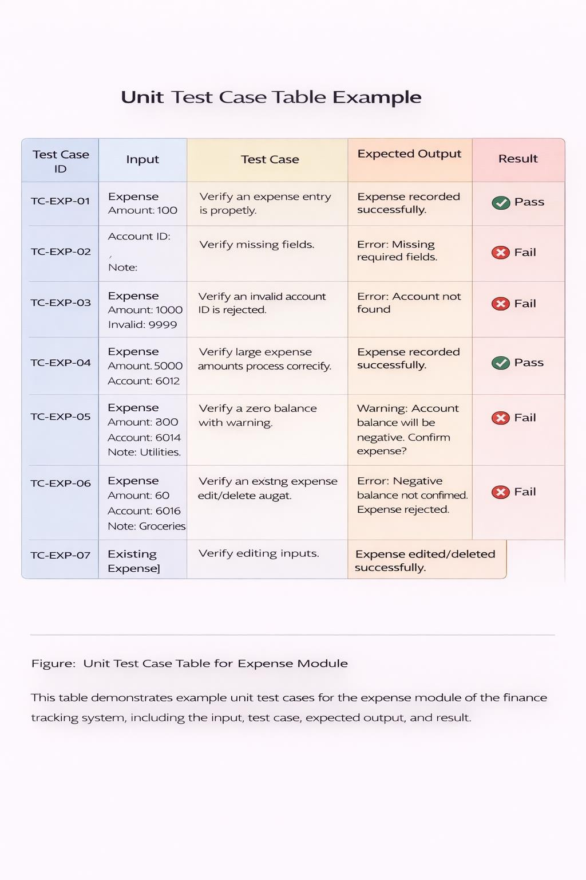

Integration Testing

Integration testing verifies that different components of the system work together correctly. While unit testing focuses on individual modules, integration testing ensures that the interaction between modules does not produce unexpected errors.

In the Finance Tracker system, several components must interact smoothly. For example, when a user adds an expense, the following processes occur simultaneously:
- The frontend sends the expense data to the backend API.
- The backend validates the request.
- The expense record is stored in the MongoDB database.
- The corresponding account balance is updated.
- The updated data is returned to the frontend.

Integration testing ensures that each of these steps works together without causing errors or data inconsistencies.

Testing scenarios included verifying that:
  - Income and expense transactions correctly update account balances.
  - Transaction updates modify both the database record and the account balance.
  - Deleting transactions restores the correct account balance.
  - The statement page correctly combines income and expense data.

Integration testing also confirmed that API communication between the frontend and backend works correctly and that JSON responses are properly processed.

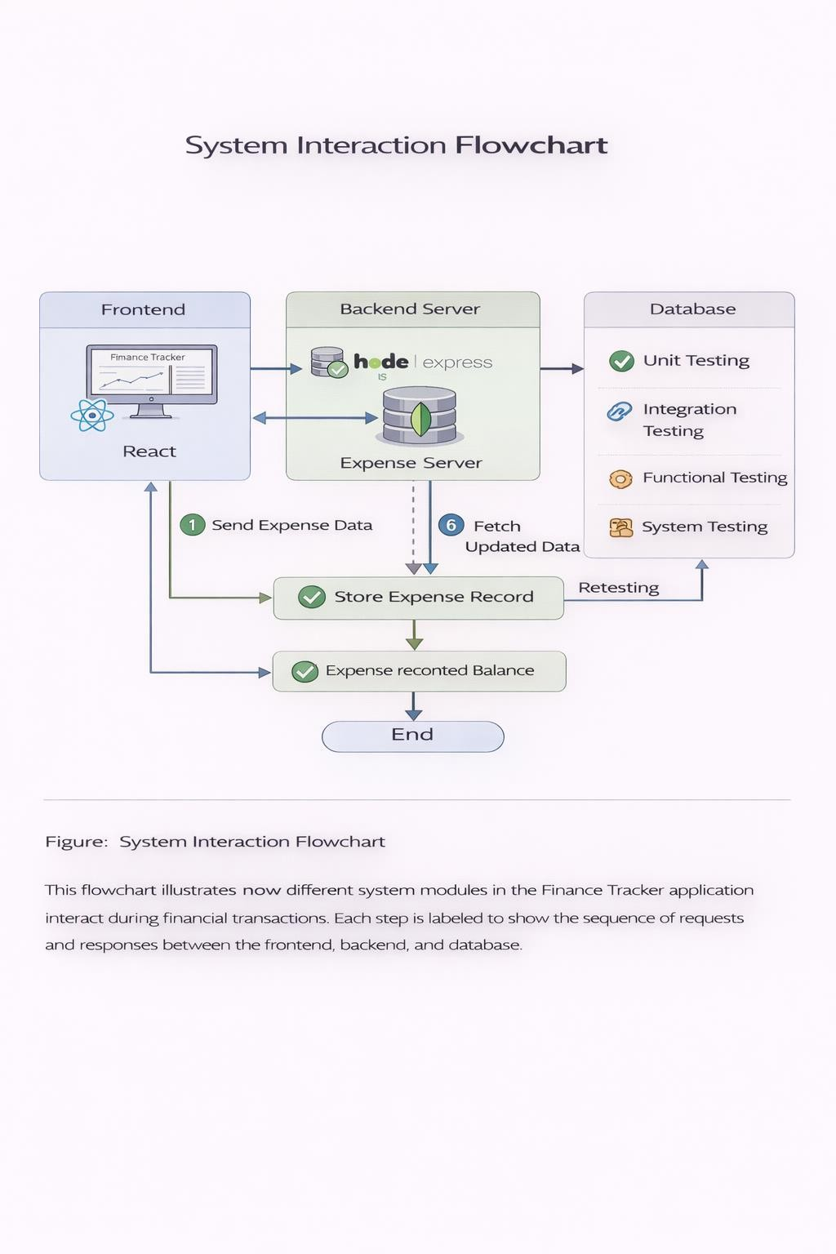

Functional Testing

Functional testing focuses on verifying whether the system features operate according to the specified requirements. This type of testing ensures that users can perform all necessary tasks within the application.

The Finance Tracker system was tested to confirm that all core features function properly. These features include user registration, login authentication, transaction recording, account management, and financial reporting.

During functional testing, testers simulated real user interactions with the system. For example, a user might register an account, create a bank account, add several income transactions, record expenses, and review the generated financial statement.

Functional testing verified that:
    - All forms accept valid inputs.
    - Required fields cannot be left empty.
    - Transactions appear correctly in the transaction history.
    - Account balances update automatically after each transaction.
    - The statement page displays transactions in the correct order.

Functional testing also ensured that warning messages and confirmation dialogs appear when necessary, such as when a transaction might cause a negative account balance.

This type of testing helps confirm that the application meets user expectations and behaves correctly under normal usage conditions.

Test Cases

Test cases are predefined scenarios used to verify that specific system functions work correctly. Each test case includes inputs, expected outputs, and the actual result obtained during testing.

Test cases were created for all major modules of the Finance Tracker system. These tests ensure that each feature behaves correctly under different conditions.

Example test cases include:

Test Case | Input | Expected Result
User Registration | Valid name, email, password | User account created successfully
Login | Correct email and password | User redirected to dashboard
Add Income | Valid amount and account | Income stored and balance increased
Add Expense | Valid amount | Expense stored and balance reduced
Delete Transaction | Existing transaction | Transaction removed and balance restored
Invalid Login | Incorrect password | Error message displayed

Test cases help ensure that the system behaves consistently and that any issues are detected early during development. Including detailed test case tables in the documentation also demonstrates the thoroughness of the testing process.

Bug Fixing Process

During the development and testing of the Finance Tracker system, several bugs and issues were identified and resolved. Bug fixing is an important part of software development because it improves system stability and ensures that users have a smooth experience.

Whenever a bug was discovered, the development process followed a structured approach to identify and resolve the issue. First, the error was reproduced to understand the conditions under which it occurred. The relevant code section was then examined to identify the root cause of the problem.

For example, one issue occurred when deleting an income transaction caused incorrect balance calculations. The problem was traced to a missing validation check in the backend logic. Once the cause was identified, the code was modified to properly update the account balance after deleting the transaction.

Another bug involved date inconsistencies in the statement page, where transactions appeared under incorrect months. This issue was resolved by replacing the createdAt field with the actual transaction date field for filtering and sorting operations.

After fixing each bug, the system was retested to ensure that the issue was fully resolved and that no new problems were introduced.

Documenting the bug fixing process demonstrates how the development team maintained system quality and continuously improved the reliability of the application.

Results and Discussion

The results section presents the final output of the Finance Tracker system after successful implementation and testing. This section explains how the system behaves when used in real-world scenarios and demonstrates the effectiveness of the implemented features.

The Finance Tracker system successfully provides a digital platform where users can manage their financial activities in an organized and efficient manner. The application allows users to register accounts, record financial transactions, manage multiple financial accounts, and view financial statements through an intuitive interface.

The system integrates several modules including authentication, transaction management, account management, and financial analytics. These modules work together to provide a comprehensive financial tracking solution. During testing and demonstration, the system successfully handled multiple financial transactions and maintained accurate account balances.

The application interface is designed to be user-friendly so that individuals with minimal technical knowledge can operate the system without difficulty. Users can easily navigate through different pages such as the dashboard, expenses page, income page, accounts page, and statement page.

Another important result of the project is the ability to provide financial insights through data visualization. The dashboard displays charts and statistical summaries that allow users to understand their spending behavior. These insights help users make better financial decisions and improve their financial planning.

The system also demonstrates effective data management through MongoDB, which stores financial data in structured collections. The backend APIs process transactions efficiently and ensure that account balances are updated correctly whenever financial activities occur.

Overall, the results show that the Finance Tracker system successfully meets its objectives of simplifying financial management and improving financial awareness.

Login Page
The Login Page is the entry point for users who want to access the Finance Tracker system. It allows registered users to authenticate themselves using their email address and password. The login interface is designed to be simple and secure, ensuring that only authorized users can access financial data.

When a user enters their login credentials, the frontend sends a request to the backend authentication API. The backend verifies the email and password by comparing them with the stored user data in the database. If the credentials match, the system grants access and redirects the user to the dashboard.

The login system also includes input validation to ensure that users provide valid credentials. For example, the system checks whether the email format is correct and whether the password field is not empty. If the user enters incorrect credentials, the system displays an error message informing the user that the login attempt failed.

Security is an important aspect of the login system. Passwords are stored in encrypted format in the database to prevent unauthorized access. This ensures that even if the database is compromised, user passwords cannot be easily retrieved.

The login page also provides a link to the registration page for new users who have not yet created an account.
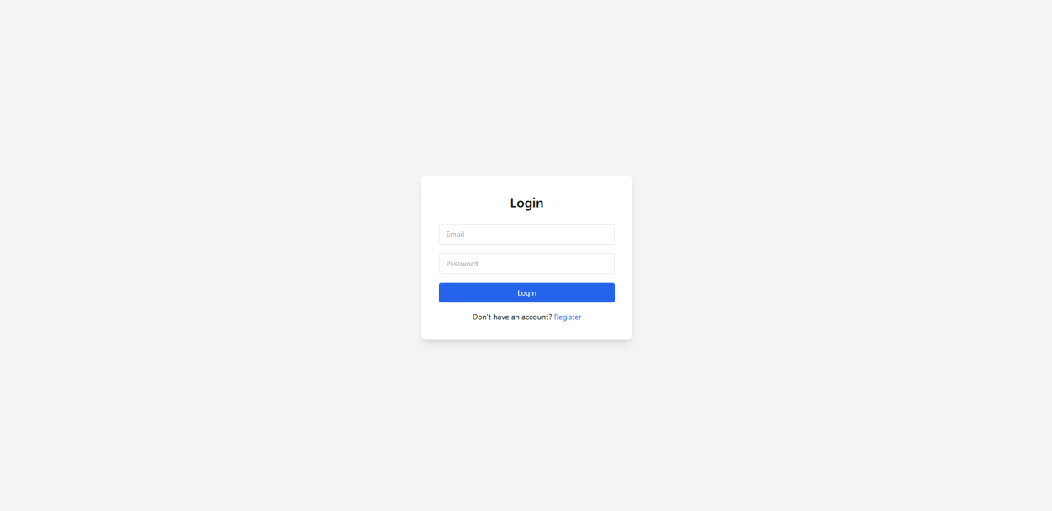

Registration Page

The Registration Page allows new users to create an account in the Finance Tracker system. This page collects basic information such as the user's full name, email address, and password.

During the registration process, the system performs validation checks to ensure that the provided information is valid. For example, the system verifies that the email address follows the correct format and that the password meets the minimum security requirements.

Another validation ensures that users enter their full name correctly. The system requires the name field to contain at least two words to ensure that users provide meaningful identification.

After successful validation, the user information is stored in the database, and the user can proceed to log into the system using the newly created credentials.

The registration feature ensures that each user has a unique account and that financial data is stored separately for each individual user.
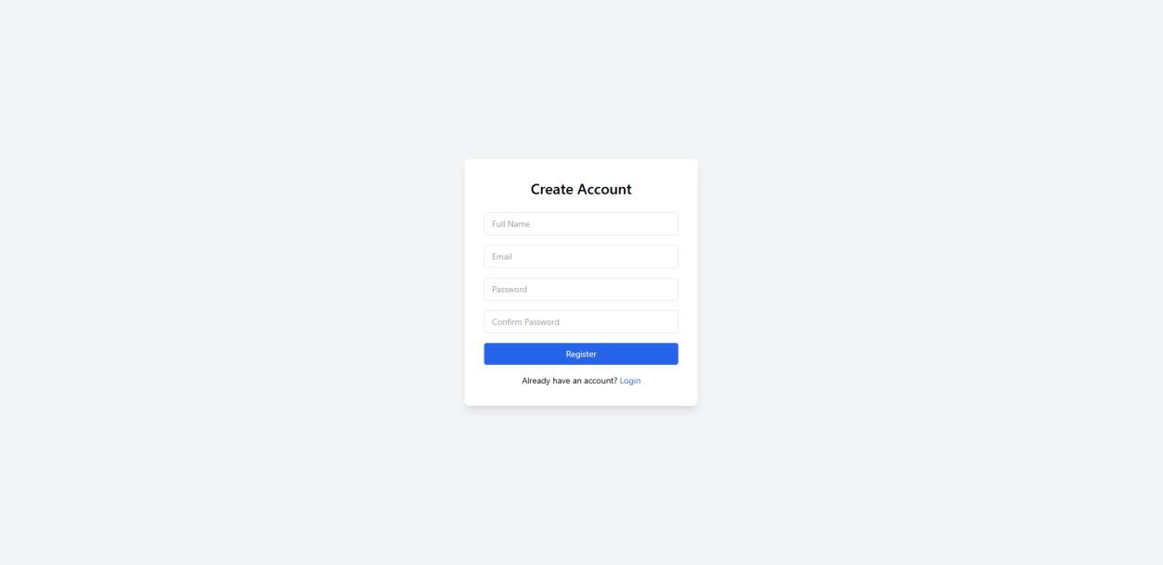

Overview Dashboard

The Overview Dashboard serves as the main page of the Finance Tracker system after a user logs in. It provides a summary of the user's financial activities and displays important financial statistics.

The dashboard displays several key metrics including total expenses, monthly expenses, average expense value, and the top spending category. These statistics help users understand their financial behavior and monitor their spending patterns.

The dashboard also includes graphical visualizations such as pie charts and bar charts. These charts display expense distributions across different categories and provide insights into how money is being spent.

For example, a pie chart may show that a large percentage of expenses are related to food or transportation. This information can help users identify areas where they may need to reduce spending.

The dashboard is designed to provide quick financial insights without requiring users to manually analyze large amounts of transaction data.

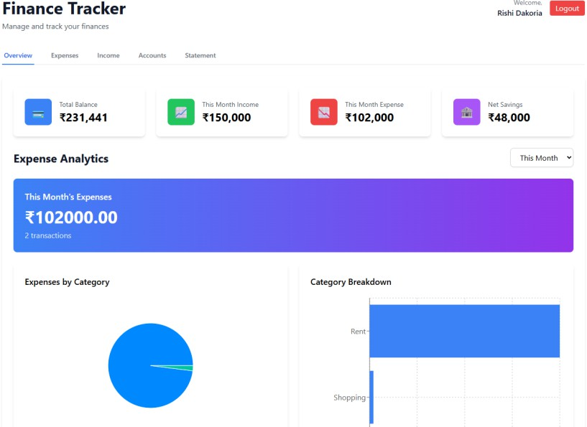

Expense Management

The Expense Management module allows users to record and track their expenses. This module is one of the most important components of the Finance Tracker system because it helps users understand how their money is being spent.

Users can add expenses by entering details such as the expense amount, category, account used for payment, date of the transaction, and a short note describing the expense. Optional descriptions can also be added for additional details.

When a new expense is recorded, the system automatically deducts the amount from the selected account balance. This ensures that the account balance always reflects the current financial state.

The expense management page also displays a list of previously recorded expenses in a structured table format. Each expense record shows the date, note, and transaction amount. Users can edit or delete expense records when necessary.

The system also includes validation to prevent incorrect financial transactions. For example, if an expense would cause the account balance to become negative, the system displays a warning message before allowing the transaction to proceed.
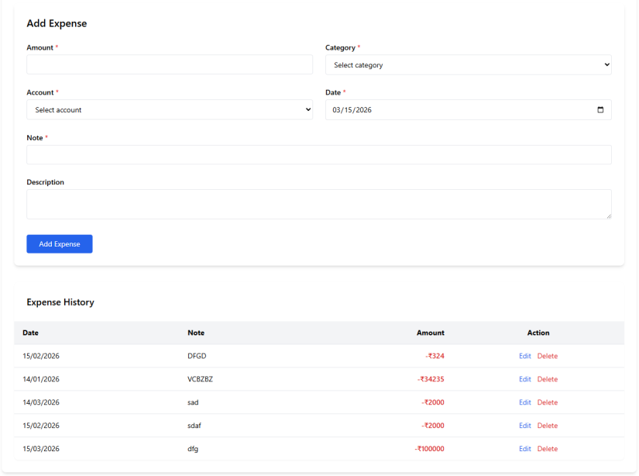

Income Management

The Income Management module allows users to record and manage incoming financial transactions. These transactions represent money received from different sources such as salary payments, freelance work, business income, or investments.

Users can add income records by entering the amount, category, associated account, date, and additional notes. Once the income transaction is saved, the system automatically updates the balance of the selected account by adding the income amount.

The income management page displays a list of all income transactions in chronological order. This allows users to review their earnings history and track different income sources.

Users also have the ability to edit or delete income transactions if corrections are needed. When income records are modified or removed, the system recalculates the account balance to ensure financial accuracy.

This module plays an important role in maintaining a complete financial overview because it records all incoming funds.
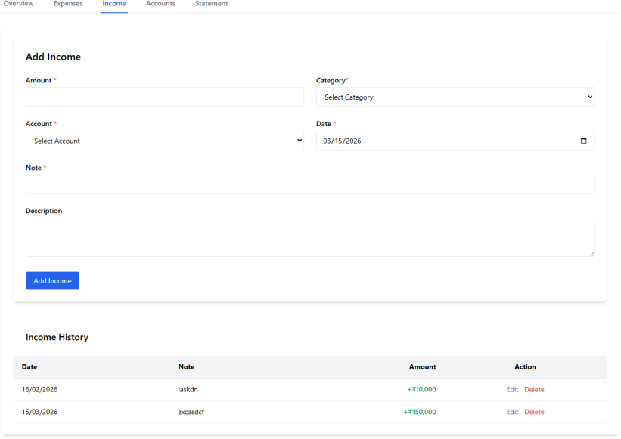

Account Management

The Account Management module allows users to create and manage financial accounts. These accounts represent the different sources where users store money, such as bank accounts or cash balances.

Users can create multiple accounts in the system. Each account contains information such as the account type, alias name, account number (last four digits), and starting balance.

Account balances automatically update when income or expense transactions occur. This ensures that users always see accurate information about their available funds.

The account management page also allows users to edit account information or delete accounts when necessary. When deleting an account, the system displays a confirmation message because deleting an account also removes associated transactions.

This module provides users with a centralized way to manage their financial resources.

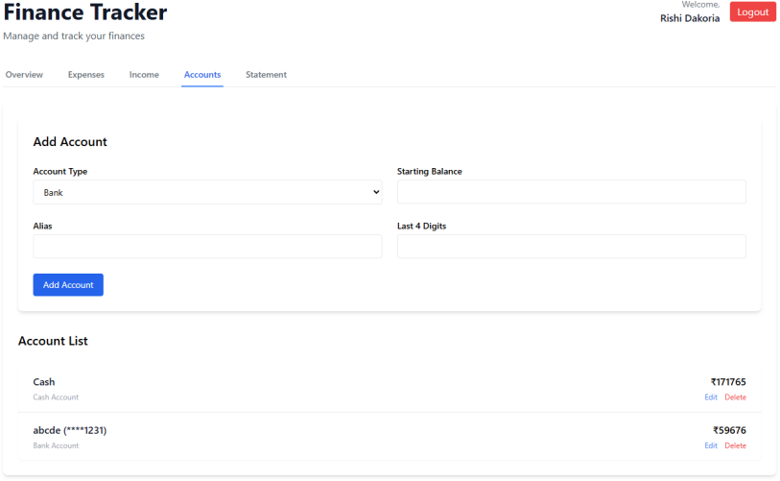

  - Statement Page

The Statement Page serves as the comprehensive financial ledger for the application, providing users with a chronological list of all recorded income and expense transactions in a unified view. This module is essential for users who need to perform a detailed review of their financial history and track individual activities over time. Because it correctly combines both income and expense data from the database, it acts as a reliable audit trail for the user's personal finances.

To enhance usability and data analysis, the Statement Page includes powerful, dynamic filtering capabilities. Users are not forced to scroll through endless records; instead, they can narrow down their transaction history using several specific criteria:
- Account Filtering: Users can choose to view transactions from "All Accounts" or isolate activity to a specific bank or cash account.
- Date Range Selection: Custom "From" and "To" date pickers allow users to generate statements for highly specific periods, alongside quick-access filters like "Today," "Week," "Month," or "Year".
- Transaction Type: Users can toggle the view to display "All" transactions, or exclusively filter for "Income" or "Expenses".

By ensuring that all transactions are displayed in the correct chronological order, the Statement Page provides a clear, accurate, and easily readable summary that empowers users to reconcile their accounts and deeply understand their cash flow

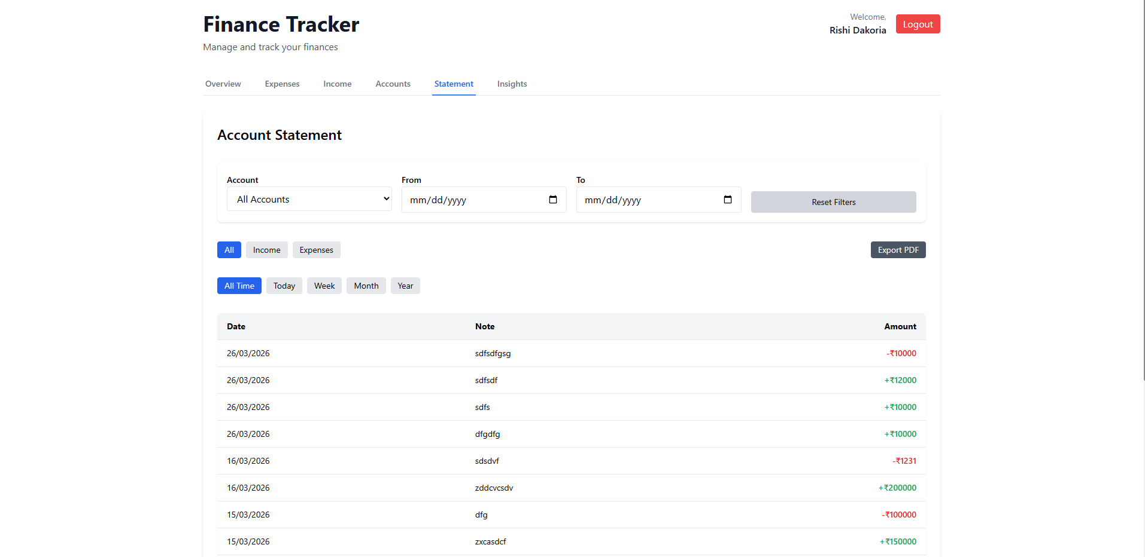

7.8 Admin page

Platform Pulse Page



Financial Analystics Page



User Management Page



System Security and Data Protection

Security is a critical aspect of any financial application. Since the Finance Tracker system stores sensitive information such as financial transactions, account balances, and user credentials, it is essential to implement proper security mechanisms to protect this data.

The Finance Tracker system includes several security measures to ensure that user data remains safe and accessible only to authorized individuals. These measures include authentication mechanisms, input validation, secure data storage, and proper API communication.

Security considerations were applied throughout the system development process. Both frontend and backend components were designed to prevent unauthorized access and protect the integrity of financial records.

One of the primary goals of the security implementation is to ensure that users can safely manage their financial data without risk of data leakage or unauthorized manipulation. The system also prevents malicious inputs and protects the database from harmful queries.

Proper security design helps maintain the reliability and trustworthiness of the Finance Tracker application.

User Authentication Security

User authentication is the first layer of security in the Finance Tracker system. Authentication ensures that only registered users can access the system and manage financial data.

During registration, users create accounts using their full name, email address, and password. The system verifies that the email address is unique and ensures that passwords meet minimum length requirements.

When users attempt to log in, the system validates their credentials against stored user data. If the email and password match, access to the application dashboard is granted.

If incorrect login details are entered, the system prevents access and displays an error message. This prevents unauthorized users from accessing the financial information of others.

Authentication mechanisms also ensure that user sessions remain secure during application usage.

Input Validation

Input validation plays an important role in protecting the system from incorrect or malicious data entries. The Finance Tracker application validates all user inputs before processing them.

For example, when users enter financial transactions, the system verifies that:
    - Amount fields contain numeric values
    - Required fields are not left empty
    - Email addresses follow the correct format
    - Account numbers contain valid digits

These validation rules prevent invalid data from being stored in the database. They also reduce the risk of application errors caused by incorrect input.

Both frontend and backend validation mechanisms are implemented to ensure data integrity.

Frontend validation provides immediate feedback to users when invalid information is entered. Backend validation acts as an additional security layer that ensures all requests sent to the server contain valid data.

Secure Database Storage

The Finance Tracker system uses MongoDB as its database management system. MongoDB stores user data, financial transactions, and account information in structured collections.

Sensitive data such as passwords are stored in encrypted format rather than plain text. This ensures that even if database access is compromised, user passwords cannot be easily retrieved.

Each user has a unique identifier that links their transactions and accounts to their profile. This prevents users from accessing data belonging to other accounts.

The database structure also ensures that financial records remain consistent. Transactions are properly associated with accounts, and account balances update correctly whenever financial operations occur.

These database design practices contribute to secure and reliable financial data storage.

API Security

The Finance Tracker system communicates with the backend server through RESTful APIs. These APIs process requests such as adding transactions, retrieving account information, and updating financial records.

API security ensures that only authorized requests are processed by the server. The system verifies user identity before performing operations that modify financial data.

For example, when a user adds an expense or income record, the API verifies that the request includes a valid user ID and that the account belongs to the authenticated user.

Error handling mechanisms are also implemented to prevent system crashes caused by invalid requests. If an incorrect request is received, the API returns an appropriate error message rather than processing the request.

Secure API design ensures that financial operations remain reliable and protected.

Data Privacy

Data privacy is an important requirement for financial applications. The Finance Tracker system ensures that each user's financial data remains private and accessible only to that user.

User transactions are stored separately using unique user identifiers. When the system retrieves financial data, it filters records based on the logged-in user.

This design prevents users from viewing or modifying financial data belonging to other users.

Additionally, the application avoids exposing sensitive information in public areas of the interface. Only relevant financial data is displayed to the authenticated user.

Maintaining strong privacy protections helps build user trust and ensures that the Finance Tracker system follows responsible data management practices.

System Performance and Scalability

System performance refers to how efficiently the application processes user requests and manages data operations. Since the Finance Tracker system manages financial transactions and account balances, it is important that the system performs calculations accurately and responds quickly to user interactions.

During the development of the Finance Tracker system, performance considerations were taken into account to ensure that the application can handle multiple transactions without slowing down or producing incorrect results.

The system uses a modern web architecture consisting of a React frontend, a Node.js backend server, and a MongoDB database. This architecture allows the application to process requests efficiently while maintaining flexibility for future improvements.

When a user performs an action such as adding an expense or income transaction, the request is sent from the frontend to the backend API. The backend processes the request, updates the database, recalculates the account balance if necessary, and sends a response back to the frontend.

The system was tested with multiple transactions to ensure that performance remains stable even when the transaction history grows large. Database queries were optimized to ensure that retrieving transaction records does not cause delays.

Scalability is another important factor considered during development. The system is designed so that additional features and larger datasets can be supported in the future. MongoDB allows flexible data storage, which makes it possible to expand the system without major changes to the database structure.

Overall, the Finance Tracker system demonstrates reliable performance and provides a stable platform for managing personal financial data.

Response Time

Response time measures how quickly the system processes user actions and displays results. A responsive application improves the user experience and ensures smooth interaction with the system.

In the Finance Tracker application, most operations occur in real time. When a user adds a new income or expense transaction, the system processes the request immediately and updates the user interface without requiring a page refresh.

The average response time for most operations is very low because the system performs lightweight database operations. MongoDB efficiently retrieves and updates transaction data, which contributes to the fast response speed of the application.

Frontend technologies such as React also improve response time by dynamically updating the user interface. Instead of reloading the entire page, React updates only the parts of the interface that change.

This approach reduces unnecessary data loading and improves application speed. As a result, users experience smooth navigation and fast transaction processing.

Data Processing Efficiency

Efficient data processing is essential for financial applications because incorrect calculations can lead to inaccurate financial records.

The Finance Tracker system processes financial transactions using well-defined logic that ensures account balances remain consistent. Whenever a transaction is added, updated, or deleted, the system recalculates the corresponding account balance.

For example, when an expense is recorded, the system subtracts the expense amount from the selected account balance. When an income transaction is added, the system increases the account balance accordingly.

The system also includes validation logic to prevent errors in financial calculations. For instance, if a transaction might result in a negative account balance, the system displays a warning message to inform the user before completing the operation.

These validation mechanisms ensure that the system processes financial data accurately and maintains reliable records.

Scalability Considerations

Scalability refers to the ability of the system to handle increased usage and larger datasets without affecting performance.

Although the Finance Tracker application is designed primarily for personal financial management, the system architecture allows it to scale if the number of users or transactions increases.

MongoDB provides flexible document-based storage that can efficiently manage large volumes of data. This makes it possible for the system to store thousands of transactions without affecting performance.

The backend API structure also supports scalability. Each module of the application, such as income management, expense tracking, and account management, operates independently. This modular structure makes it easier to add new features without affecting existing components.

If the application were deployed for larger audiences in the future, additional improvements such as database indexing, caching, and load balancing could further enhance scalability.

Error Handling and Stability

System stability is important for ensuring that the application continues to function even when unexpected situations occur. The Finance Tracker system includes several mechanisms to detect and handle errors.

For example, the system checks for invalid inputs before processing financial transactions. If a user enters incorrect data, the application displays an appropriate error message instead of allowing the transaction to proceed.

Backend error handling also prevents the application from crashing when unexpected requests are received. The API returns clear error responses that inform the frontend about the problem.

Proper error handling improves the reliability of the system and ensures that users receive clear feedback when something goes wrong.

Deployment and Installation Guide

Deployment refers to the process of setting up the Finance Tracker system so that it can run on a computer or server environment. Proper deployment ensures that the application functions correctly and that all system components work together without errors.

The Finance Tracker application uses a full-stack architecture consisting of a React frontend, a Node.js backend server, and a MongoDB database. Each component must be installed and configured correctly before the system can operate.

The deployment process includes installing necessary software, configuring the database, running the backend server, and launching the frontend application. Once these steps are completed, the application can be accessed through a web browser.

The system can be deployed either on a local machine for development purposes or on a remote server for production usage. In this project, the system was primarily tested and deployed in a local development environment.

The deployment process ensures that the application can be executed consistently across different systems. By following the installation instructions, developers and users can easily run the Finance Tracker system on their own machines.

Proper deployment documentation is important because it allows other developers to understand how the system operates and how it can be installed or modified in the future.

Hardware Requirements

Hardware requirements define the minimum system specifications needed to run the Finance Tracker application efficiently.

Since the system is a web-based application, it does not require high-performance hardware. The application can run on most modern computers that support web browsers and development tools.

Minimum hardware requirements include:
    - Processor: Dual-core processor or higher
    - RAM: Minimum 4 GB (8 GB recommended)
    - Storage: At least 2 GB of free disk space
    - Internet Connection: Required for installing packages and dependencies

These requirements ensure that the application can run smoothly during development and testing.

For production environments where multiple users may access the system simultaneously, higher hardware specifications may be recommended. However, for personal use and academic demonstration, the above hardware configuration is sufficient.

Software Requirements

Software requirements refer to the tools and technologies required to run the Finance Tracker system.

The application depends on several software components that work together to support the system functionality. These include programming environments, database systems, and development tools.

The required software includes:
    - Node.js: Used to run the backend server and manage application dependencies
    - MongoDB: Database system used to store user data and financial transactions
    - React.js: Frontend framework used to build the user interface
    - Visual Studio Code: Development environment used for writing and managing code
    - Web Browser: Used to access and interact with the application interface

Node.js also includes npm (Node Package Manager), which is used to install project dependencies required by both the frontend and backend components.

Using these technologies ensures that the application remains modern, scalable, and maintainable.

Project Folder Structure

The Finance Tracker system is organized into a structured folder hierarchy that separates frontend and backend components. Proper folder organization makes it easier for developers to manage code and maintain the application.

The project structure typically includes the following main directories:
Frontend Folder (React Application) This folder contains all user interface components, pages, and styling files used in the application.

Important frontend directories include:
    - components/ – Reusable UI components such as charts and cards
    - pages/ – Application pages like Login, Expenses, Income, Accounts, and Statement
    - services/ – API service functions used to communicate with the backend
    - App.js – Main application routing configuration

Backend Folder (Node.js Server) The backend folder contains server logic and API routes responsible for processing user requests.

Important backend directories include:
    - routes/ – API endpoints for income, expenses, accounts, and authentication
    - models/ – Database schemas for MongoDB collections
    - controllers/ – Logic used to process API requests
    - server.js – Main backend server file
This modular structure helps maintain clean and organized project code.

Database Setup

MongoDB is used as the database system for storing financial data. Before running the application, MongoDB must be installed and configured.

After installing MongoDB, a database for the Finance Tracker system is created. Within this database, several collections are used to store application data.

These collections include:
    - Users Collection – Stores user account information
    - Accounts Collection – Stores financial account details
    - Income Collection – Stores income transaction records
    - Expenses Collection – Stores expense transaction records

MongoDB uses a document-based structure where data is stored in JSON-like documents. This flexible structure allows the system to store transaction data efficiently and makes it easy to update records when financial operations occur.

The backend server connects to MongoDB using a connection string that specifies the database location and configuration settings.

Running the Backend Server

After installing the required software and configuring the database, the backend server must be started.

The backend server handles API requests from the frontend application and performs operations such as storing transactions and retrieving financial data.

To run the backend server, the following steps are performed:
- Open the backend project folder in the terminal.
- Install dependencies using the command: npm install
- Start the backend server using: npm start

Once the server starts successfully, it listens for incoming API requests on a specified port (commonly port 3001).

The backend server must remain active for the application to function properly.

Running the Frontend Application

The frontend application provides the graphical user interface of the Finance Tracker system. It is built using React and runs separately from the backend server.

To run the frontend application, the following steps are performed:
- Open the frontend project folder in the terminal.
- Install dependencies using: npm install
- Start the React development server using: npm start

After starting the frontend server, the application becomes accessible through a web browser, usually at:
http://localhost:3000

Users can then interact with the application interface to manage financial transactions and accounts.

System Deployment Flow

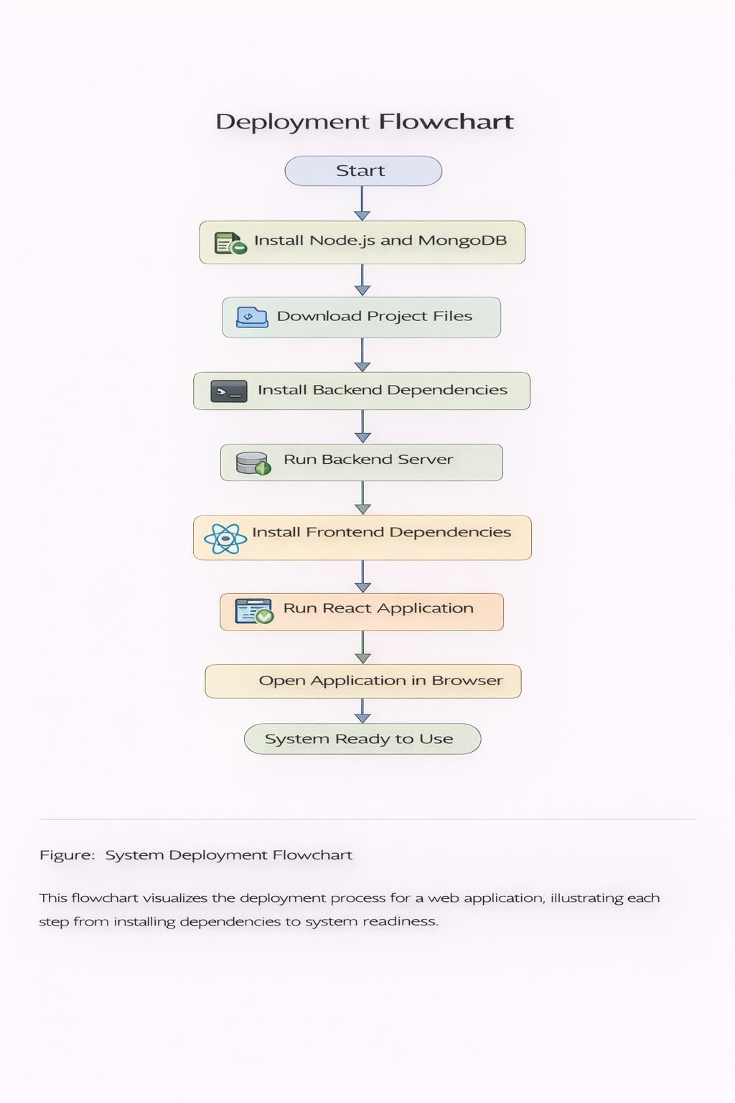

Conclusion

The Finance Tracker system was developed to provide an efficient and user-friendly solution for managing personal financial activities. The main objective of the project was to design a web-based application that enables users to track their income, expenses, and account balances in an organized and structured manner. By using modern web technologies such as React for the frontend, Node.js and Express.js for the backend, and MongoDB for the database, the system successfully demonstrates a full-stack application capable of handling real-world financial management tasks.
The application allows users to create accounts, record financial transactions, and monitor their financial status through a centralized dashboard. Features such as income management, expense tracking, account management, and financial statements provide users with a complete overview of their financial activities. The system also automatically updates account balances whenever transactions are added, edited, or deleted, ensuring that financial records remain accurate and consistent.
Another important aspect of the system is its user-friendly interface. The application is designed to be simple and intuitive, allowing users to navigate through different modules easily. The use of data visualization through charts and statistical summaries helps users understand their spending patterns and financial behavior more effectively.
During the development process, several important software engineering concepts were applied, including system design, database management, API development, validation mechanisms, and testing procedures. These practices helped ensure that the application is reliable, secure, and capable of handling financial data correctly.
In conclusion, the Finance Tracker system successfully fulfills its objective of providing a practical tool for personal financial management. The project demonstrates how modern web technologies can be combined to develop efficient applications that solve everyday problems. With further improvements such as budget planning, mobile integration, and automated expense categorization, the system has the potential to evolve into a more advanced financial management platform in the future.

References

React Documentation
React Team. (2024). React – A JavaScript Library for Building User Interfaces.
Meta Open Source.
Available at: https://react.dev
This official documentation provides detailed explanations of React concepts including components, hooks, state management, and virtual DOM. These concepts were used in the development of the frontend interface of the Finance Tracker application to create interactive user interfaces and dynamic page rendering.

Node.js Official Documentation
Node.js Foundation. (2024). Node.js JavaScript Runtime Documentation.
Available at: https://nodejs.org/en/docs
Node.js documentation explains the server-side JavaScript runtime
environment used to develop the backend of the Finance Tracker system.
It provides information about asynchronous programming, server creation, and package management.

Express.js Framework Guide
Express.js. (2024). Express.js Web Application Framework Documentation.
Available at: https://expressjs.com
Express.js is a minimal and flexible Node.js web framework used to
develop RESTful APIs in the Finance Tracker system. The documentation explains routing, middleware, request handling, and server architecture.

MongoDB Database Documentation
MongoDB Inc. (2024). MongoDB Manual: Database Concepts and Usage.
Available at: https://www.mongodb.com/docs
MongoDB documentation provides detailed guidance on document-based database design, collections, indexing, and data storage.
MongoDB was used in this project to store user data, financial accounts, income records, and expense transactions.

Recharts Data Visualization Library
Recharts Team. (2024). Recharts: Charting Library Built on React.

Available at: https://recharts.org
Recharts documentation explains how to create interactive charts such as pie charts, bar charts, and line charts. These charts were used in the Finance Tracker dashboard to visualize expense statistics and financial trends.

Mozilla Developer Network (MDN) Web Docs
Mozilla Foundation. (2024). JavaScript Guide and Web API Documentation.
Available at: https://developer.mozilla.org
MDN Web Docs provides comprehensive documentation on JavaScript programming concepts including functions, objects, arrays,
asynchronous programming, and event handling, which were extensively used throughout the development of the application.

RESTful Web API Design
Richardson, L., & Ruby, S. (2013). RESTful Web APIs.
O’Reilly Media, Inc.
This book provides guidelines and best practices for designing RESTful APIs. These principles were followed while designing backend API endpoints for handling income, expenses, and account management operations.

Software Engineering Principles
Pressman, R. S., & Maxim, B. R. (2019). Software Engineering: A Practitioner’s Approach (9th Edition).
McGraw-Hill Education.
This book explains core software engineering concepts such as system development life cycle, system analysis, design methodologies, testing strategies, and software project management used during the
development of this project.

Database System Concepts
Silberschatz, A., Korth, H. F., & Sudarshan, S. (2020). Database System Concepts (7th Edition).
McGraw-Hill Education.
This reference explains database design principles, relational and non-relational database structures, and data management techniques
relevant to the database architecture used in this project.

Web Development with JavaScript
Flanagan, D. (2020). JavaScript: The Definitive Guide (7th Edition).
O’Reilly Media.
This book provides detailed explanations of JavaScript programming concepts used in frontend and backend development of the Finance Tracker application.

Modern Full-Stack Web Development
Brown, E. (2020). Web Development with Node and Express (2nd Edition).
O’Reilly Media.
This reference explains how to build full-stack web applications using Node.js and Express, which served as a conceptual guide for designing the backend architecture of the Finance Tracker system.

Financial Management Concepts
Brigham, E. F., & Ehrhardt, M. C. (2021). Financial Management: Theory and Practice (16th Edition).
Cengage Learning.
This book provides an understanding of financial management principles that influenced the design of the transaction tracking and financial
analysis features in the application.

