**Envision: Blueprint of Chinese Semiconductor Industry**

**Analysis of Intellectual and Financial Investment**

Ziyun Lu Yuxin Zhang

**Abstract:** As part of the ambitious “Made in China 2025” blueprint, Chinese officials have set the semiconductor industry a goal of reaching US$305 billion in output by 2030 and meeting 80% of domestic demand. Aiming high, the Chinese semiconductor industry seems frustrating as for its development despite the government’s support. As most commonly known, talents and capital resources are the fundamental drivers for the development of tech-intensive industry. Guided by this concern, our research focuses on the two most important factors determining the prospect of this industry—intellectual training and financial investment. Our project aims to provide deep insights into the current bottlenecks and advise on future development to help achieve the long-term sustainable thriving of the Chinese semiconductor industry.

**Research Question and Significance:**

The semiconductor industry is fundamental for the construction of a high-tech and digitalized society. For years, China relied on the imported CPUs, GPUs, and AI chips for its Information Technology development. And as we look at the whole semiconductor industry globally, we see raw materials dominated by Japan, designing and manufacturing dominated by the US and Europe. However, China’s semiconductor industry seems inanimate and has no apparent sign of surging considering the market share despite the repetitive urging from the government and waves of new companies aiming for breakthroughs. Although it’s hard to penetrate this market considering the oligopoly and capital-intensive market feature, it seems still confusing that there’s no dynamo in the Chinese market as funds and resources seem not to be a problem for a government-pursuing target. Therefore, we want to look at things from the root and try to find the keys that might unlock the unanimity in the Chinese semiconductor industry. Specifically, we would like to focus on two things: Firstly, we would like to evaluate the training of electronic engineering talents in China since a sustainable, up-to-date training is the source for stable development in this industry. Secondly, we would like to look at the general feasibility of funding for nongovernment funding semiconductor companies in China. We believe that although government can provide funding at the beginning, for the long-term sustainable development in this industry, we need the thriving and competition from private sectors, as markets are usually considered as the filter for good and bad companies.

Our research direction is practical in the sense of its timeliness. As the Chinese government has set a very ambitious target for a complete, world-leading IC production chain by the year 2030, our research would give insight into feasibility in achieving those targets. Also, in comparing with the semiconductor industry features in the mature market, we might identify the deficiencies for further improvement, focusing on the fundamental development in education regarding electronic engineering, microelectronics, and the dynamics for the public sector fund-raising.

**Difficulties and our solutions**

**1) Chinese educational system is fundamentally different from that of any other country so that a direct comparison might be biased and unconvincing.**

We previously would like to set up some quantifiable parameters from US semiconductor college education for comparison to discern what went wrong with the Chinese semiconductor college education. However, when we really look into features of the talent development in Chinese and American educational system, this idea diminished quickly. The education of semiconductor talent does not only differ in how they distinguish the different track of talents by setting up different majors, but also in the educational period. During our research, we discovered many programs in US colleges specially targeting at fostering the IC designer talents, while Chinese universities set up courses more broadly. For example, students going for electronic information science and technology could go for chip designing but also wireless communication and more related to the signal processing and broadcasting. Moreover, large portion of the employees in US semiconductor industry hold bachelor degree, yet those in Chinese semiconductor industry has mostly minimum degree of postgraduate. This observation mitigates the significance of the comparison between the employment rate at different degree.

To address this two problem, we design that we should find one quantifiable parameter measuring the overall industrial-talent conversion rate. We would like to use the parameter job suited rate to see the overall industrial-talent conversion ratio, which could be a good measurement for how well the semiconductor education system foster the talents in nationals semiconductor industry.

**2) The capital-raising situation in semiconductor industry are hard to capture**

Unlike the Oligopoly situation in the US or in other parts of the world, Chinese semiconductor industry are featured by some big companies with waves of smaller and younger companies, which mostly receive the venture capital investment and are hard to track the investors and volume of capital. For this reason, we decided to focus on the public companies from which information regarding finance are easier to acquire.

**Approaches and Method**

1) For the first part, we would give an overview on how the semiconductor industry in general are constituted, what’s the pattern of production applied by most firms, some key features regarding the technological and financing aspect of this industry, the subdivision of the product and their features, and the discussion on the potential further developing direction.

2) For the second part, we would focus on evaluating the high-level (college-level) education regarding semiconductor. By focusing on the construction of three majors (Photoelectron Information & Science, Electronic Information Science and Technology, communication engineering, microelectronic). We would like to evaluate their talent fostering system from the following several perspectives.

1. Distribution of majors among Universities

2. Geographic feature of the major distribution

3. Evaluation of the Faculty resources for semiconductor-related majors in Chinese top universities

4. Evaluation of the employment situation among Chinese semiconductor-related majors.

The main purpose of valuations above are attempts to reveal whether the high-education are systematically transmitting qualified talents for the development of Chinese semiconductor industry. And by looking at multiple perspectives such as faculty resource, the employment situation of related major, and the featured distribution of majors geographically, it might be possible to reveal as well the possible point for amendment.

3) The third part will be focused on the financing for the semiconductor companies, including an overview on current financing channels and an evaluation of the dynamics in the capital market for semiconductor companies. We will look into the following aspects:

1. Composition of identified investors, revealing the scale of government support

2. Balance Sheet analysis of selected publicly-listed semiconductor companies, focusing on two parameters, debt ratio and cash ratio, evaluating the financial support from the credit market

3. Market sentiment analysis based on semiconductor stock performance

4. Third board market and equity transaction for small and mid cap companies (policy, growth, typical examples)

**1. An overview of the semiconductor industry Chain:**

The semiconductor industry originates from the silicon valley during 1950s and 1960s. Though the trend of its rising never stops, it’s development is dependent on the technological advancement and innovation on the application side, driving by different forces during different periods. So an overview about what semiconductor industry contains, what the market situation is like for it today, and what might be the next driver for it would fundamentally help the prelude of the discussion regarding the semiconductor industry in China, as it being the largest consumption market as well as a participant of this industry.

**1.1 The product and value-added chain in Semiconductor industry are finely labor-divided**

Supporting industry

Major industry sector

Down-end application

Silicon Wafer

photoresist

Light field mask

CMP polishing material

CMP

Specialty gas

Sputtering target

Material

Equipment

Discrete device

IC

PC

Telecommunication

Medical

IoT

Information security

Automobile

Industry

Single crystal Furnace

Oxidation Furnace

Oidatio

PVD

PECVD

MOCVD

Design

Manufacture

M

Packaging & Testing

CMP

Stepper

Etching Machine

**1.2 On the company side, two production pattern have formed**

Companies like Intel employ a typical vertical production mode(IDM) as they fully involve with the designing, manufacturing, packaging and testing process. Other companies employed a flat mode production(Fabless, Foundry, OSAT) and specialize in only one sector of the whole production chaining, doing either designing, or manufacturing. TSMC is a typical company that specializes in manufacturing the chips. There are pros and cons for each production pattern. The vertical production mode has an advantage of manufacturing with lower yield, speeding up the production process while suffering from possible limitation from capacity and capital. The flat production mode has an advantage from its specialization and scaling while suffering from possible competitors. The trend internationally is that the production pattern is going more and more flat. This enables more participants in the semiconductor industry as the breakdown of the production chain. However, it makes the whole industry more competitive and those venerable easier to be expelled from the competition since the dominant power is harder to acquire.

1.3 **Division of sectors around the world has almost shaped all across the semiconductor industry product chain**

|  |  |  |  |  |
| --- | --- | --- | --- | --- |
| Industry chain position | Category | Name | Country | Companies |
| Upstream | Raw material | photoresist | Japan, US, China, Korea | FUSIFILM Electronic Materials Everlight Chemical |
| Upstream | Raw material | Light Field Mask | Japan, US | Photronics, DNP, Toppean |
| Upstream | Raw material | Specialty gas | US, Germany, France, Japan | Air Products & Chemicals, The Linde Group, Air Liquide |
| Upstream | Equipment | Single crystal Furnace | Germany, US | PVA RePla Ag, Quantum Design |
| Upstream | Equipment | Oxidation Furnace | UK, China | Thermco, Centrothermthermal Solutions, Beijing NAURA Microelectronics Equipment |
| Upstream | Equipment | PECVD | US, Japan | Proto Flex,Tokki |
| Upstream | Equipment | Etching Machine | Dutch, Japan, US | ASML, Nikon, Canon, ABM |
| Midstream | IC | Manufacturing | US, Korea, Taiwan, Japan | Intel, Samsung, Tower Jazz, TSMC, Fujitsu |
| Midstream | IC | Packaging & Testing | US, Singapore, Korea, Taiwan | Amkor Technology, UTAC Group  Nepes, Unisem |

**1.4 Components of semiconductor industry are concentrated in Integrated Circuits**

According to the category, Semiconductors can be divided into Integrated Circuits (IC), Photoelectron, Sensors, Discrete Device. And the Integrated Circuits can be divided into digital Integrated Circuits and simulating Integrated Circuits, in which digital Integrated Circuits can be further divided into microprocessor, Memory and logical Circuits. From the statistics provided by WSTS, the IC dominants 80% of the semiconductor industry, and the memory is the fastest growth subsector in the recent 10 years.

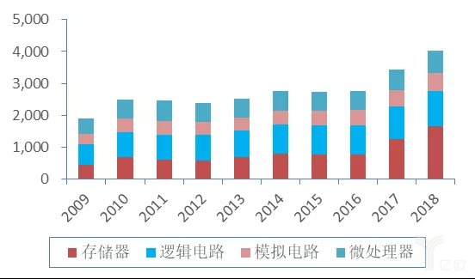(source: IC Insight)

1.5 **Though slowing down, the industry is still having high momentum for the new drivers emerging from the application-end**

According to the prediction of the Gartner released in 2018 Q4, the international semiconductor industry is expected to grow at 2.5%, 8.1%, -1.8%, 3.8% for the following 2019 through 2021. With the slowing down on the PC side, an increase demand from the smart, phone, Automobile, IOT(internet of Things), servers side are changing the component of the driving force. As data from IC Insights shows, the top two fields in the Integrated Circuits, which is a large portion of the midstream of the semiconductor industry are smart phone and PC(32%,25%). With more applications of artificial intelligence, more computing power is needed, adding demand for high-quality semiconductor chips.

**1.6 Capital is intensively required in this industry and the value-add composition seems to be changing**

The semiconductor industry is a capital-intensive industry, and a very top-weighted industry, in which the companies top of the list have the most spending and dominant the rest of the list. Two representative listed Chinese semiconductor companies we choose in our research is SMIC and HiSilicon, yet only SMIC releases its R&D spending in the last financial year. From the chart we can see that being top 3 in China, SMIC’s R&D spending is low in total compared to other world-leading semiconductor companies, while its R&D/Revenue ratio is around the middle level, which indicates that SMIC is dedicated to the fundamental capital-intensive research and aiming at continuously creating innovation breakthroughs.

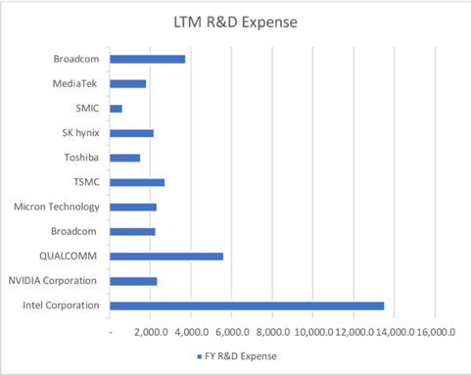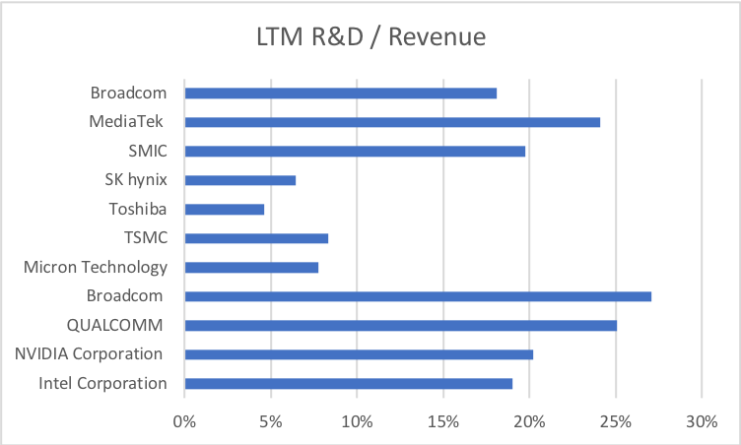

The designing part used to be the highest in the value-added chain, yet in recent years, because of the trend of the flat production mode, specialization enables some cutting-edge OME companies to join the high value-added family. For example, data from last twelve month shows that TSMC has an operating margin of 35.4%, and a net margin of 33.4%, which even exceeds that of Intel (with operating margin of 32.4% and net margin of 29.04%), which is a traditional vertical production mode company.(data until Jul-09-2018 from Capital IQ )

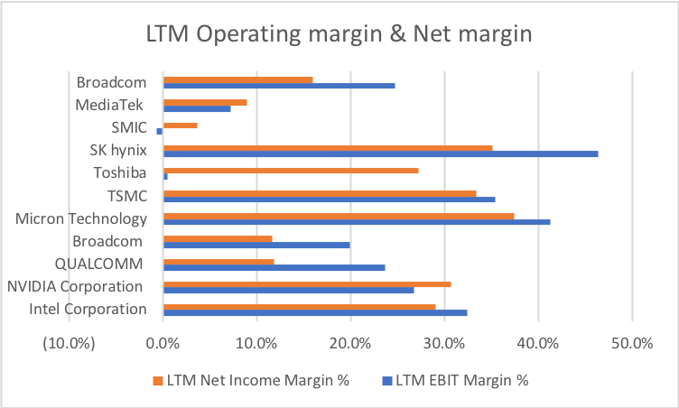

**1.7 Scale is essential for this industry for malleating Competition and raise margin**

A storm of merger and acquisition in the semiconductor industry is carrying on because of the rising competition due to the increasing number of competitors. For the Chip sector along because of the involvement of AI, IOT, more big technology companies such as Amazon, Google, Facebook, Apple, are introducing their own chips using their advantage and familiarity with the application industry, posing large threat on the profit margin of the old chip giants such as intel. And the advancement of designing and manufacturing craft of the once weaker companies and the new-tech obstacle faced by giants are shrinking the technological discrepancies in all participants of the industry. These two forces pushed Giants such as Intel, Micron to seek faster ways of extending their customers and maintaining profit to keep the capital investment chain running.

Some famous Acquisition are the Intel acquiring Altera in 2015, acquiring Mobileye in 2017, and Qualcomm acquiring NXP in 2016.

(Source: Intel 10-k & Qualcomm 10-k)

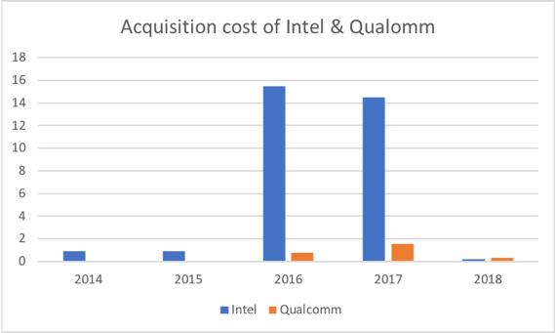

**2. Development of Chinese Semiconductor industry**

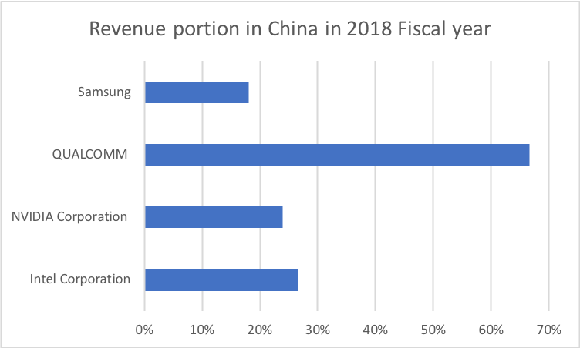As the top two semiconductor product consumer, China is longing for develop a self-supporting complete production chain yet is still admittedly much behind, especially in the high value-added part in the production chain. Looking separately from the production chain, we see that that on the upstream as for the facilities, China is low in supporting itself and is highly dependent on importing from US companies. And as for the materials, some such as the target material is of equal level compared with the advancing ones, yet others like the photoresist still have much room for improvement before complete localization. Looking at the midstream, China is doing great in packaging & testing, yet in the high-end manufacturing and designing, China is much behind and much less complete in product categories. For example, the high-end processors, FPGA, has nearly zero self-supporting ratio.

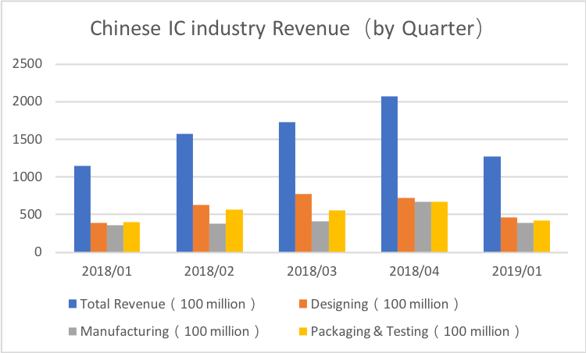

(Source: Samsung, Qualcomm, Nvidia, Intel 10-k)(Source: CSIA)

Looking at the regional revenue of some world leading Semiconductor firms, we can see a large of them captured in the Chinese market. On the one hand, this indicates that the Chinese chips still have much room for improvement on technology advancement as well as the . On the other hand, this suggests that the Chinese semiconductor companies have a huge potential market to grab, as long as they catch up with the leaders.

Though large potential and opportunities are present for Chinese semiconductor firms for catching up and grab, this domestic industry is in reality struggling. Looking at the revenue data merely from IC sector, we see no obvious driving force of surging. In fact, because of the trading tension between China and the US, the IC manufacturing, packaging & testing are in shock. To understand why the semiconductor industry in China, especially the IC sector is so vulnerable, it would be helpful to dig into the current stage of development for Chinese semiconductor industry, spot the weakness and thus targeting at resolving them from multiple approaches.

Below are some features of the current developmental features for Chinese semiconductor industry, concentrating especially on the IC sector.

**2.1 Mobile processors are catching up while high-end CPUs are hard to compete due to lack of technology as well as supporting ecosystem**

With the rise of Hisilicon, China is becoming competitive in the mobile-end processors internationally. However, on the CPU, especially the high-end CPU sector, Intel, AMD have complete dominant power. This partly is due to their much powerful chip performance. However, a greater reason, as we believe, is due to the lack of supporting eco-system. After all, the semiconductor industry is a demand-driven industry. Old participants in this field such as Intel, with its 50 years of development, has created a business-end reliance from building an ecosystem with supporting chip products, architectures, software, locking its business partners inside of it. Considering from this point, China has a long way to go as for taking a bite in the high-end CPU business market as for it requires tech breakthroughs, intelligent business designs and lots of capital support to compete in this market.

It’s even more obvious from the company side to see how important the ecosystem-building as such great influence on the surviving of firms. By our research, the comparatively large Chinese semiconductor firms have basically two categories. One is to do OEM on large-scale. An example of this case is SMIC. Another is to also cover the product on the down-end side such as mobile phones and PCs. An example of this case if HUAWEI. The mobile phone produced by HUAWEI is the ecosystem it builds to consume its HiSilicon chips. The same idea applies for the new semiconductor firm Alibaba just established in 2018. Though not sure whether they would eventually open their product for outside purchases, their primary task is to design for their parent company, rather than for the general market. This would probably limit the category as well as the applicability of their chips, which might not be that helpful for the surge of the whole industry.

**2.2 Memories are dominated by Korean, Japanese, and US companies such as Samsung , Hynix and Micron.**

There are two kinds of memories, DRAM and NAND. And currently China is falling behind from almost all possible aspect in this sector. The patents are fewer than competitors, the yield are much less than competitors, the cost are higher than competitors. It would be a continuously growing frustrating situation if no technological breakthroughs are attained. According to the data provided by TrendForce, until 2018, Samsung , Hynix and Micron dominated at least 95% of DRAM market.

**2.3 Technologies are much weaker in the high-end general-applicable chips such as FPGA, AD/DA**

As more participants enter the competition and more new technology are expected to be applied in chips, more types of chips are demanded. At the very start of this industry, there is only CPU, which is designed for doing the general computing task such as the matrix computing. Now, with the AI, IoT, smart cars and more applicable situation being discussed, more chips are made specially to perform certain tasks or have flexibility in performance at different scenarios. For example, the GPU, also known as the graphic card, is designed to perform the graphic computing. For example, FPGA, also known as Field Programmable Gata Array, is designed to provide flexibility for the function of certain chips.

Because of the weakness in basic chips sector and lack of supporting ecosystem, the advancement into the high-end and more subdivided chip sectors are not just impossible, but unwise. Though markets are lost because of this, it’s better to start from the basics and by experience accumulation, to catch up and surpass eventually.

**2.4 On OEM side, low side companies are competing while high-end manufacturing craft not penetrated**

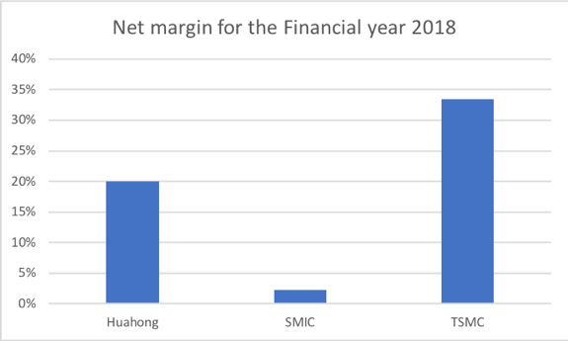If we concentrate our focus and look at the IC manufacturing sector along, we find some common features about Chinese IC manufacturing companies. In our research, we used the top two IC manufacturing companies in China by its market value. They are SMIC、Huahong Semiconductor and their main business is mostly to manufacture based on other companies’ design. According to our industrial-wide research, the most value-added part in the semiconductor industry production chain is the designing part, of which the net margin is around 30%. And among the OEM companies, the sector leader, which is TSMC, has net margin around 33.4% as well, but this is high margin is only attained by their mature and scalable production chain industry-leading craft technics, such as the 7nn manufacturing craft. To get an idea of how SMIC, Huahong stand on their peers (OEM companies), we given a look at their net margin for the financial year of 2018.

(Source: Huahong 10-k,SMIC 10-K,TSMC 10-k)

**3. Intellectual investment of semiconductor talents**

As a high-tech intensive industry, the development of Chinese semiconductor industry requires consistent flow of high-quality semiconductor talents being created by the educational system, especially from the high-end education institutions – Universities. To evaluate the university system of such talents, we decide to look at the following aspect of semiconductor education in colleges.

**3.1 the related major set-up in Chinese universities**

As for the major set-up in universities, we specifically dig into those highly related to the semiconductor talent development, which are Photoelectron Information & Science, Electronic Information Science and Technology, microelectronic. We crowned data from a public database containing major information from all Chinese universities(<https://gkcx.eol.cn/>). And the data we are mostly interested in are from the following perspectives: School, Major, School Quality, Major Quality, Location.

The quality of universities in China are generally measured by two standard – Whether it is credited with title of “985” and whether it is credited with title of “211”, which are two projects in China officially rating the quality of university education. Project “985” contains in total 39 top universities in China, and project “211” contains 112 universities in China. And all “985” universities are also “211” universities.

Major quality is measured by whether this major is rated as “important major” in this universities. As it is usually the case, important majors are usually put on more talent and capital resources and are thus of better quality.

Besides, the location of those universities and the possible concentration pattern of equal university might reveal information of the regional clustering of semiconductor industry, or reveal the unequal emphasis different provincial leaders put on semiconductor industry development.

(data until Jul-09-2019)

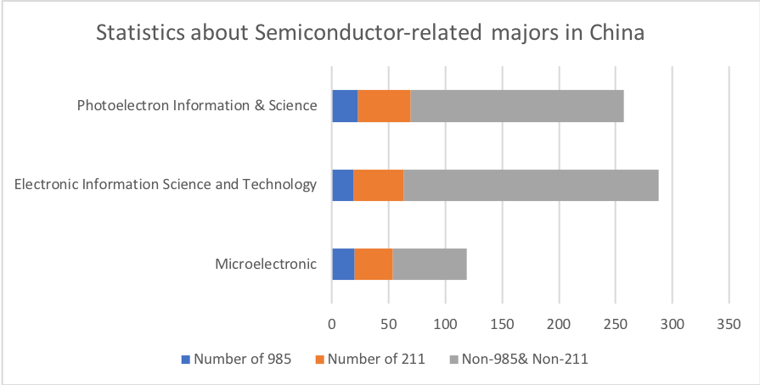

Considering the in total 820 universities (not including the authorized independent academies), the Electronic Information Science and Technology is the most prevalently offered semiconductor-related major in Chinese Universities. This is largely due to its generality feature. The least popular one microelectronic major is much less prevalent for several reasons, largely due to its shorter period of establishment.

To give an insight into how those universities are distributed across China, we statistically process the data we have above and count them by province

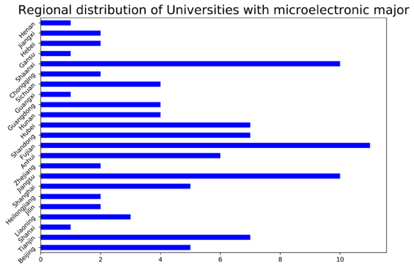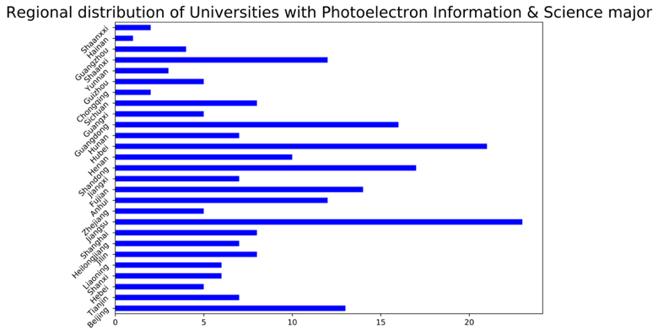

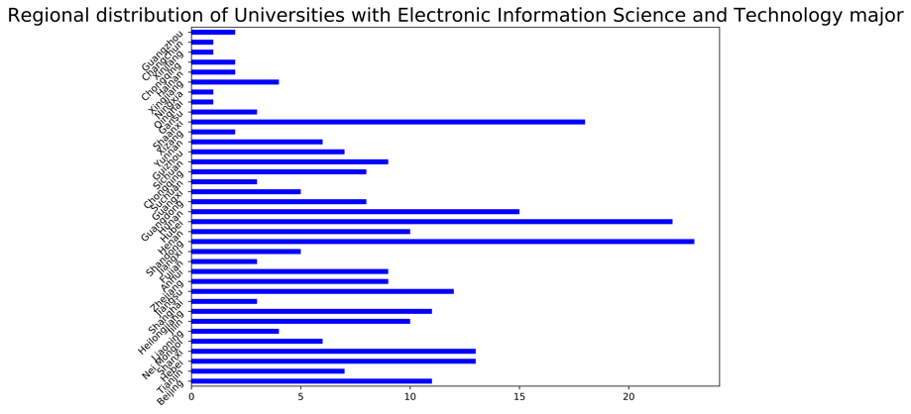

Although seemingly divergent majors, their university density distribution has similar patterns. If we only consider the top three provinces in the rank of number of universities opening certain major. We have Hubei, Jiangsu, Guangdong for Photoelectron information & Science major; Hubei, Shandong, Shaanxi for Electronic Information Science and Technology; Fujian, Shaanxi, Jiangsu for microelectronics. The reason of such concentration pattern in Universities offering semiconductor-related majors are complex yet are generally linked to the educational & economic resources, the industrial practical resources, commercials and transportations. For example, Shandong, Jiangsu ,Fujian, Guangdong, a large portion among the top several offering related majors, are all distributed along the coastal area, where there are more semiconductor industry doing business internationally.

To get a closer look at how the major distributions are related to the economic regionality feature in China, we statistically plot the number of universities offering in the east, middle, and west part of China.

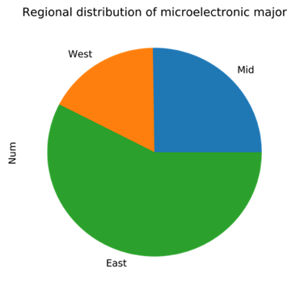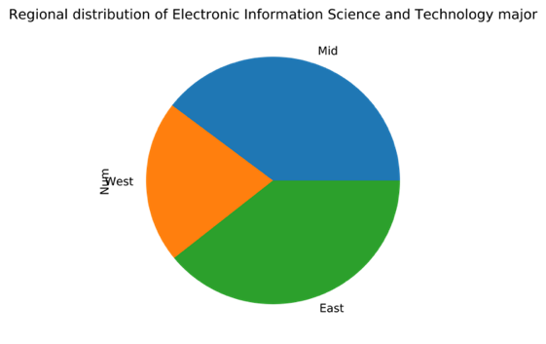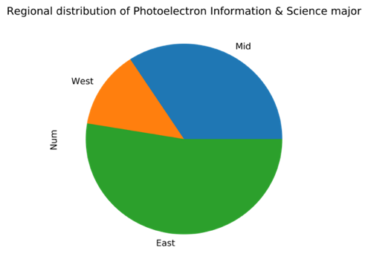

From the plot, we can clearly see that the east part of China, including the capital Beijing and the Financial center Shanghai, have the most universities offering semiconductor-related courses, which might explain why tech talents are most populated in the eastern coast of China, helping creating dynamic business opportunities, thus attracting more talents and creating a positive cycle of talents, business and education.

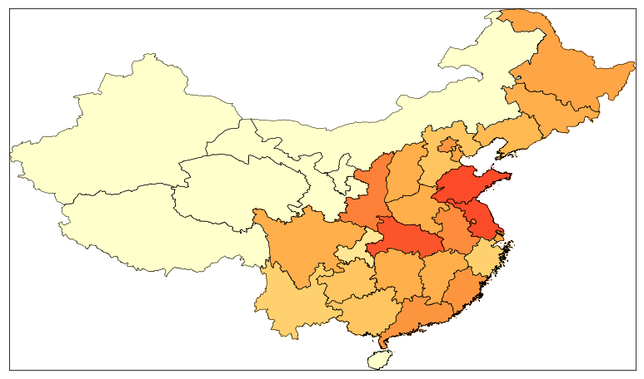

Combining all three majors and look at the semiconductor-related major development as a whole, we want to not only focus on whether a universities offer such major, but also measure to some extent how well such majors are constructed in those universities.

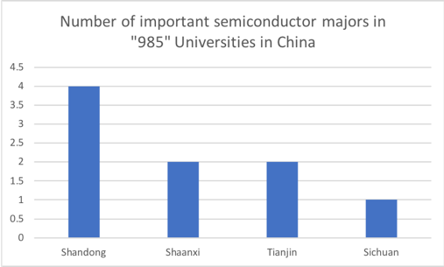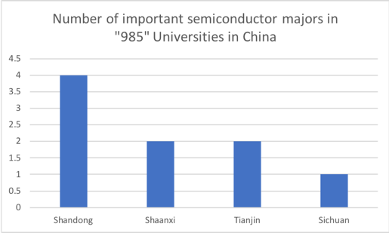

It seems from the statistics that not many top universities are putting much concentration on developing semiconductor-related majors, with most such universities located at Shaanxi, Sichuan and eastern coastal areas(Jiangsu, Tianjin, Shandong). But this does not imply that those majors are developing poorly in Chinese Universities, to further look at how well they are developed, we must scrutinize into it and in our research, we focuses on two major weighing features: the faculty quality and the employment situation of those majors since after all, talents need to be productive either in the research or industrial field to add value to the semiconductor industry.

In conducting searches on this two aspects, we decided to filter the universities we have at hand and choose “985” level universities to take a look at first, as they seems to have the most resources and talents to develop those majors well. There are in total 33 “985” universities with such majors offering.

**3.2 Faculty resource evaluation in Chinese University regarding semiconductor majors**

From the perspective of the faculty resources, We evaluate their industrial-experience by counting the number of patents applied and proved by the patent bureau.

From the previous industrial-wide research, we made it clear that the semiconductor industry is a talent-intensive and application capacity intensive field thus the college should have offered opportunities for its students inside of the course system to have rich industrial-side intern experience to have them prepared for graduation and career. But if we would like to evaluate the quality of faculties, it’s only plausible to investigate their technique-application ability by looking at the patents that they have created in their teaching experience. This is because the common measurement for the college faculty resources, such as the number of SCIs they’ve published can hardly be applied as they only reflect the research ability, which is not what semiconductor industry value most. However, the path of getting a patent is the process of converting knowledge into practice, which is what’s best we can find as a measurement for the applicability of faculty resources.

To measure this, we would like to know the number of semiconductor-related patents all colleges across China have applied over the years. But unfortunately the National Intellectual Property Administration only has publicly released patent recording until 2013. So we decided to look at the trend from 2009 to 2013, sampling 2000 IC-related patents. We would like to focus on the two features in the sampling dataset. Firstly, we would like to look at the general trend of the number of patents applied in each year from 2009 to 2013. Secondly, we would like to focus especially on the ratio of the number of patents applied by universities to that in total, thus to observe whether the education-to-industry transformation educational structure has been improved by semiconductor-related majors in universities. This also indicates the applicability of faculties employed by universities as they are the major participants of patent applicant.

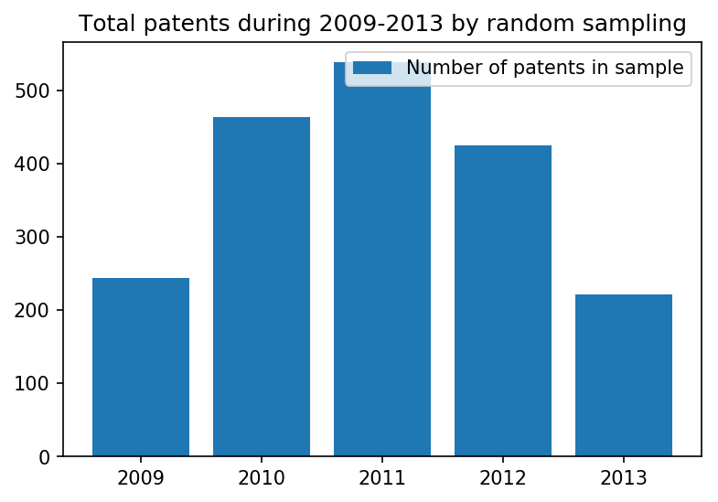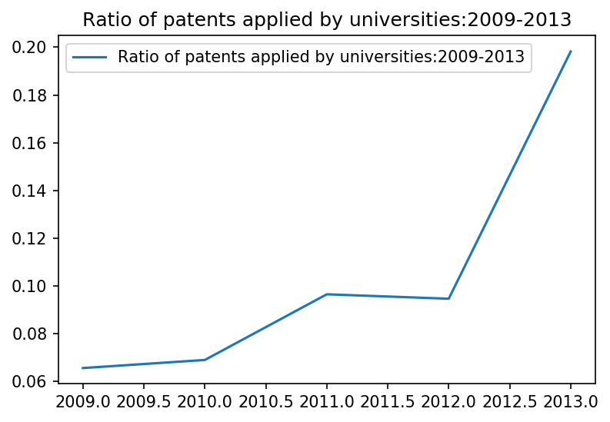

Of the 2000 samples to randomly draw from IC patent database from 2009 to 2013, we see a peak at the year 2011 and a downward trend afterwards. This is surprising as we expect a rising pattern for the number of patents in the IC industry. This might be explained by the more strict censorship in the National Intellectual Prosperity administration in approving the applications, and also might be explained by the selection error.

The next step is to investigate how the applicability of the universities have as a relative number of the total. This is proposed for the fear that even if the number of patents applied by colleges rise over the year, if that number as a portion of the total number of patents applied that year, it still indicates the decrease in the quality of the college education as for those majors. From the sample we collected, the ratio of the patents applied by universities from 2009 to 2013 has a rapid increase in between the years, surging from 2012 to 2013. With the consideration of a relatively calm market and industry development from 2009 to 2013 in IC sector, this suggests that the development and application ability of universities as for their faculty and students are rising in general, which is a good sign for the advancement of the semiconductor-related majors.

This could be due to several reasons, one of which being the course systems are becoming more and more mature and improvised, compared to the very beginning. The second reason could be of universities extending more corporation with local semiconductor companies to smooth the transition from school to industry for students. A third reason could be that universities started focusing more on the recruitment of application-style talents instead of focusing on research capacity for those majors discussed.

**3.3 The Employment evaluation of Chinese University regarding semiconductor majors**

The employment of the graduates and their choice of career path of further education is an reflection of how well the university education, have trained them for jobs. We are especially interest in how well the college training has prepare students for the suited jobs(major-matched). According to the released 2018 data from Zhaopin.com, which is a recruitment website, the job-suited rate for the general electronic information majors are around 30.88%, which wasn’t low compared to some majors such as bioengineering (13.56%), but is comparatively low compared to accounting-related majors (64.17%).

This number (30.88%) is achieved by universities giving out questionnaires for all their graduates regarding how much they think their jobs are related to their major. But the measurement for this somewhat subjective and vague since only three choices “very related” “somewhat related” “not related at all” are set. Though we might question the precision of the statistics, this number can still reveal the low industrial talent conversion ratio in Chinese universities concerning the three majors under discussion.

We would like to further investigate into the employment situation at different level of education among those three majors, as a reference to how well different period of education are transmitting good talents to industry. More precisely, we would like to look at the employment rate at different education level for these three majors. For this purpose, we selected all “985” universities with these three majors as our study data set. We pull the related data from their released Employment Quality Report for the year of 2018. Of the filtered 33 “985” universities who set those three majors, we would only able to pull out the relevant actual employment rate (excluding those going for graduate school) from 23 of them (2 universities didn’t release the Employment Quality Report and 8 didn’t only offer the employment rate containing those going for further study). From the statistics we can see the average actual employment ratio after bachelor graduation for semiconductor-related majors is only 42.1%, with Tsinghua University ranking the lowest at 5.9%. This reveals that the bachelor degree education for semiconductor talents aren’t proven enough for going into career directly for most students pursuing those majors. Considering the industrial-application feature of the relevant jobs, we doubt that this is due to the course set-ups among those majors and the lack of adequate faculty resources.

A recent new released by the CSIA has it that among the 8 million graduates of semiconductor-related majors, from bachelor degree to PHD degree, only 30 thousand eventually get into and contribute to the development of this industry, which is strikingly only 0.375%. However, we might be biased as for only blaming the educational system in China as the demand side power also involves in the employment situation in the semiconductor industry. So we would like to investigate the employment situation for university graduates from the demand-supply perspective. Specifically, from the supply side, we would like to see the trend of regarding number of graduates transmitted by universities and those employed by industry. To investigate the graduation-employment situation all across time can give a direct idea of how the universities are doing in improvising their educational system and how the universities graduates are accepted by the market. From the demand side, we would like to investigate the attractiveness of the semiconductor-related jobs, focusing especially on the salary attractiveness. And by comparing to the relative pecuniary attractiveness of semiconductor-related jobs and other jobs, it’s possible to give insight into the future of this industry from the talent side.

**3.3.1From the supply side, Has the college education made its Students’ qualified for the semiconductor industry**

The majors are broadly set and students can easily be converted to other more attractive / easier-entering business. With this consideration, we would like to see the trend of employment/graduation for semiconductor-related majors from the times-series perspective. This employment/graduation ratio shift according to time measures industrial conversion rate for the semiconductor related major education, and can somewhat reveal the advancement of college education of these majors after central government issued a detailed documentation “China Manufacturing 2025”, which sets detailed deadline and target for the independency of Chinese semiconductor industrial chain.

To understand the employment situation of the semiconductor industry, we decided to data from the top public listed companies in China according to their capitalization, we selected 40 of them based on the situation in 2019. From their employment construction structure, we selected the number of Technician Employees, as we consider it most relevant to the majors under stud. We used their sum by year as an indicator for the whole industry’s total employment volume. And as we track it annually, we would be able to see the trend of market expansion and rise in talent demand.

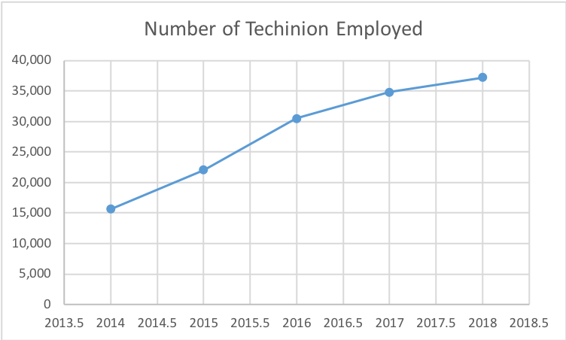

Dividing by the critical year of 2015, we see a relatively steady increase in employment as revealed by Technician employment for the selected 40 public companies. But this trend seems to be slowing down in recent years. It could be because of the saturation of the industry or because of the inadequacy from the college training. Yet as we discussed about the large whole in the industry demand, it would be more probable that this situation is due to the efficiency in university training.

But to further determine the inadequate training has the tendency of improving after 2015, since the central government’s document urges colleges to enforce the talent development in universities, we also need the data of number of college graduates from 2014-2019 regarding those relevant majors. But to address the consistency problem as for majors considered here, we decide to look specially at the top 5 universities with microelectronics major since this is the major most targeted at semiconductor industry & IC. The five Universities in our sample are Tsinghua University, Peking University, University of Electronic Science and Technology of China, Xidian University and Dongnan University. They are chosen in out sample for the following two reasons. They all have microelectronic majors open from 2014 -2018, which makes graduation data available through 5 our chosen five years. And they are the top 5 universities considering this major, so that their graduation data trend could be considered as representatively of the whole university education of semiconductor-related majors.

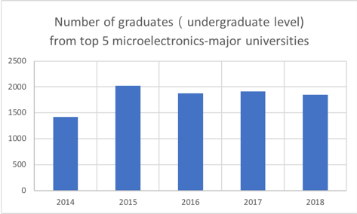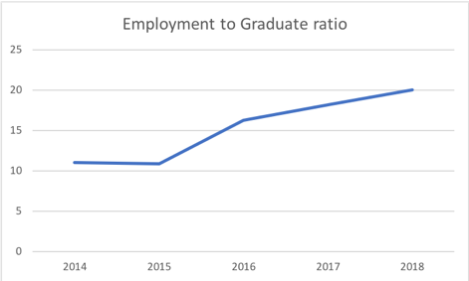

The first graph is an illustration of the total number of graduates from microelectronics majors from the sampled 5 universities. The number of graduation seems to be static and even has the sign of decline, which could be due to the more selective and focused feature of such education urged by the central government. And when we look at the Employment to Graduation ratio, we could see an obvious increase from the critical year of 2015. This is a good sign for the related-major education as it indicates the periodical triumph the universities achieved in developing a more industrial-oriented education for semiconductor talent development after the demand from the central government.

**3.3.2 The treatment for semiconductor talents in the industry**

A look into the demand side might be good to start at the salary condition, as it being the one of the most important attraction for talents.

As mentioned above, the low talent conversion rate from the university education to the industrial talents can be partially attribute to the immature educational system. Yet from the other side, it might be because of the low attraction of jobs in this industry. To further evaluate this, we would like to look at the salary for the semiconductor-related jobs offered by companies in this industry, as salary being the most direct measurement for how attractive a jo might be.

For this purpose, we decided to use 51job website as a data source. We crowed 901 raw data by putting “semiconductor” as a key word for job searching, and after we filtered the null data and those related to sale and administration, we got 358 usable data for jobs most related to the “chip designing”, “chip manufacturing” “semiconductor facility manufacturing”. Then we plot the histogram for the salary distributions for the data set selected.

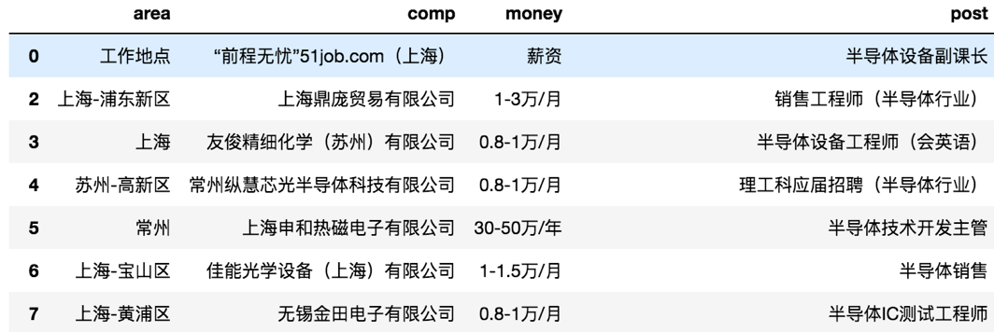

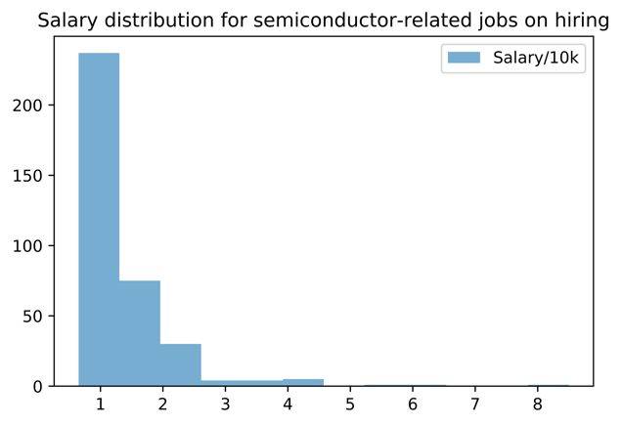

If calculating the average salary, we get an average salary of 13.76k RMB. But because of the right skewness of this salary distribution, the high-paid jobs are super rarely offered and the most jobs has a salary around 10k RMB per month. According to a report released by 51job officially at the third quarter 2018, the average salary for the financial industry is about 10.389k with very small skewness. This might suggest that the salary attraction for semiconductor-related industry was less attractive considering the fact that it is more intelligent-intensive than other jobs.

One possible takeaway from the salary research is that for this industry to continuously attract more talents, it could be good to raise the general salary level for talents.

**Next move**

**Time series analysis of the salary of IC related sector**

**series analysis of the salary of IC related sector relative to IT industry (as a trend) to measure the relative attractiveness**

**4. Financial Investment**

4.1 Composition of identified investors

Among the identified institutional investors in Chinese semiconductor industry, the following state-owned investment vehicles are the largest players in this capital market.

National Integrated Circuit Industry Investment Fund

Launched in 2014, the National Integrated Circuit industry Investment Fund Phase 1 raised 138.72 billion yuan from 16 institutional shareholders. The phase 1 fund completed its investment and the phase 2 fund, which was expected to raise 150-200 billion yuan, was launched in 2019 to provide further financial support for the industry, and especially for IC designers. According to the statistics of the phase 1 fund distribution, 67% went into IC manufacturers, 17% were pocketed by IC designers, and 10 % for IC encapsulation and test providers and 6% for equipment and material producers. Various investment types include public and non-public equity investment, funding mergers and acquisitions and direct investment in companies’ subsidiary funds, among which 23 are public investments, 29 are non-public investments, and the total number of effective investment projects is about 70.

China Investment Corporation

(TBC)

4.2 Balance Sheet analysis

Relative low debt to asset ratio: difficulty with raising capital from the credit market

In China’s credit market, China's four state-owned commercial banks are in a dominant position in terms of asset size and local branches. Due to structural reasons, the majority of their commercial loans are issued to state-owned enterprises. It is much more difficult for small and mid cap companies to receive financial support from commercial banks. Nearly all banks have unanimously withdrawn from the small-scale loan business. With the complexity of procedures being the same, it inevitably increases the costs of loans for small and mid cap companies. Additionally, from the perspective of risk management within commercial banks, issuing loans to small and mid cap companies increases their monitoring costs compared to large, state-owned enterprises. To achieve the same return, banks have to make loans to a number of companies, hiring more staff to monitor the loans and undertake higher risks. These have all made commercial banks less motivated to lend to small and mid cap companies.

Progress report on Durf (7.25)

Yuxin Zhang

For the intellectual evaluation of the semiconductor industry, we focuses on researching the industry conversion ratio of related undergraduate-level education. To achieve this, we selected a few universities with top semiconductor-related majors and gathered data on the number of graduates each year between 2014 to 2018. Meanwhile, we gathered Technion Employment data from top listed Chinese semiconductor firms. By checking the trend of Employment to graduation ratio, we can see how the university education are doing in transmitting adequate talent to industry. And from the observation we find that this ratio is low but improving, to further determine how this low ratio forms, thus to resolve it, we split out investigation into two parts, both from the supply and demand side of semiconductor talents.

From the supply side, we value the undergraduate-level applicability of semiconductor-related majors by investigate the change in portion for university-applied patents among the total patents applied each year.

From the demand side, we value the relative attractiveness of semiconductor related jobs by looking at the relative salary level it has in compared to other jobs(IT jobs) over the years(2014-2018).

The demand side research is still underway.

In the supply side research, there is one issue with the data resources for the patent information. The public data for Chinese patents are not up to date (the full database is released latest to 2013) and this database is anti-crowing. We only managed to use a script to randomly pull data from this database and we currently has 2000 patent information as out sample. We understand this would be a bias bbut currently haven’t found a better way.